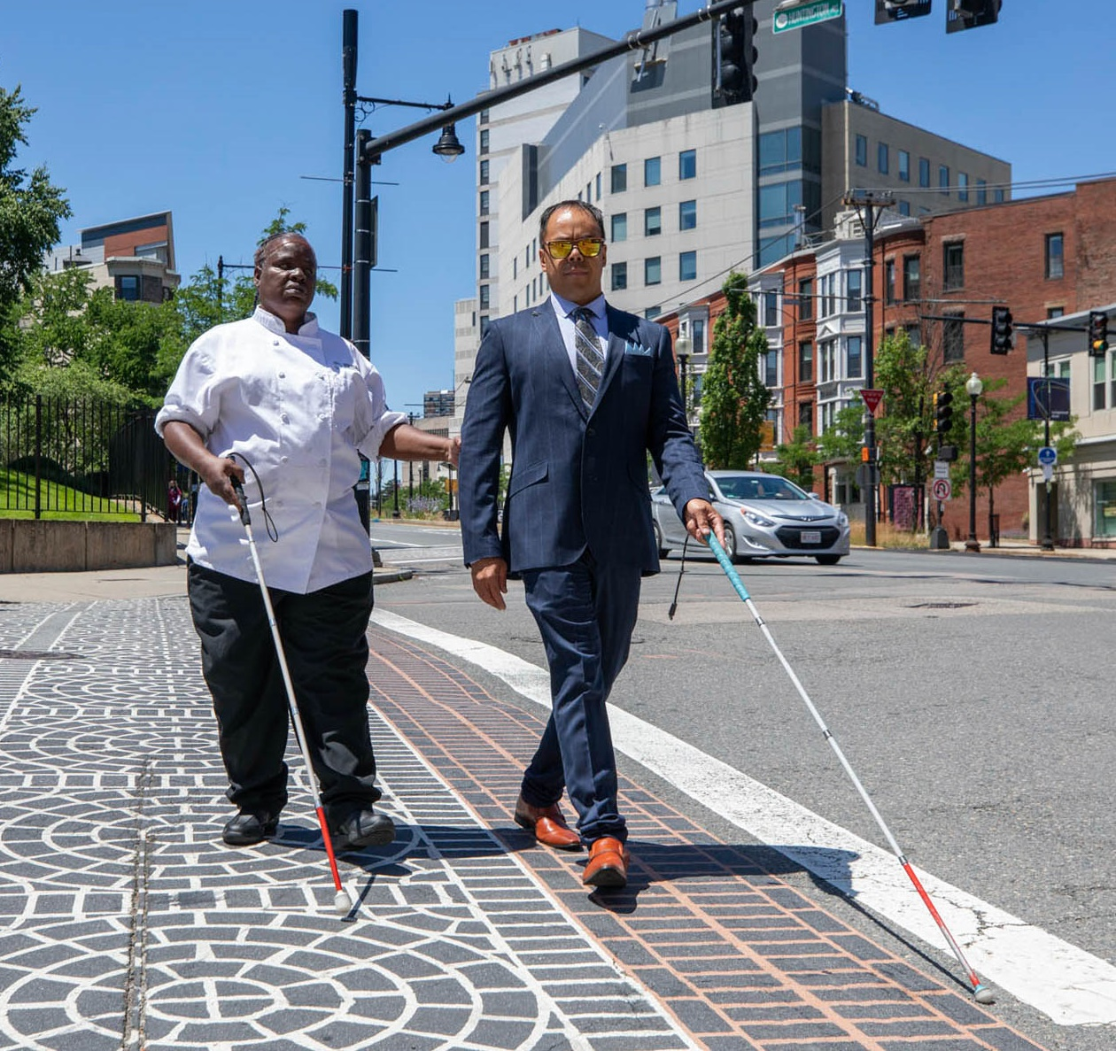
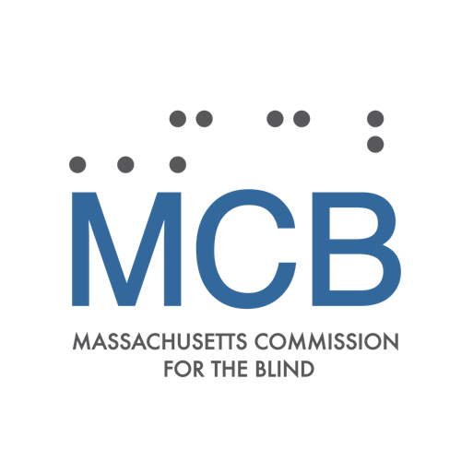

All Consumer Survey
June 30, 2023
Submitted to

The Massachusetts Commission for the Blind

Prepared by

The MassINC Polling Group
www.massincpolling.com

June 30, 2023

The MassINC Polling Group is a nonpartisan public opinion research firm serving public, private, and social-sector clients. MPG elevates the public's voice with cutting edge methods and rigorous analysis.

Based in Boston, MPG serves a nationwide client base.

Table of Contents
Introduction 6
About Massachusetts Commission for the Blind 6
Survey Background 6
Executive Summary: Key Findings and Implications 7
Ability to See 7
Visual Aid Tools and Resources 8
Satisfaction with Services 8
Quality of Life and Social Relationships 9
Lifestyle 10
Medical Diagnosis 10
Methodology 11
APPROACH 11
Unique Identification Number 11
Email 12
SMS 12
Call Center 13
Mail 13
Events 14
QUESTIONNAIRE DESIGN 15
INCENTIVE DISTRIBUTION 17
ACCESSIBILITY 17
REPRESENTATIVE SAMPLE 17
Survey Results and Analysis 18
ABILITY TO SEE 19
VISUAL AID TOOLS AND RESOURCES 23
OFFERED SERVICES? 26
SATISFACTION WITH SERVICES 29
Social Rehabilitation Services 30
Vocational Services 32
Assistive Technology Services 35
Rehabilitative Teaching Services 38
Mobility Services 41
Desired Services 45
QUALITY OF LIFE 47
Community Group Membership 52
Friendships 56
Relationships and Social Activities 60
Impediment to Social Activities 63
COVID-19 66
LIFESTYLE 67
Living Situation 67
Assistance Needed 70
Work 73
Transportation 75
Internet Usage 77
MEDICAL DIAGNOSIS 79
Conclusion 84
Appendices 85
Appendix I: Survey Mode Schedule, Responses, and Response Rates 85
Appendix II: Email Template in English and Spanish 86
Appendix III: Phone Script for Questions Where Script Required 88
Appendix IV: Mailed Surveys in English and Spanish 90
Appendix V: Survey Topline Results 110
Appendix VII: MCB’s Long Form Survey 128
Appendix VIII: Demographic Targets and Survey Results 137

Introduction

About Massachusetts Commission for the Blind

Massachusetts Commission for the Blind serves more than 30,000 residents of the Commonwealth who are legally blind by providing access to employment opportunities and social rehabilitation with the goal of increasing independence and full community participation.
The Massachusetts Commission for the Blind (MCB) was established on July 13, 1906. The organization was originally comprised of three men and two women, including Ms. Helen Keller. This group functioned as a board of directors and was established as a state agency to provide services to individuals who were blind. The original agency was organized around two residential workshops for the blind, one for men, the other for women. In 1919, the Commission was incorporated into the State Department of Education and renamed the Division of the Blind. In 1966, the agency was reestablished as the separate commission that it remains today. Currently, MCB is one of eleven agencies in the Executive Office of Health and Human Services (EOHHS).

Survey Background

MCB commissioned the MassINC Polling Group (MPG) to design, conduct, manage, and provide analysis of a comprehensive survey of its consumers. This included the collecting, analysis, and reporting of data that may lead to improved outcomes for MCB consumers. The goal is to utilize data for the purpose of developing, improving, and providing programs and services that enhance the independence and self-determination for MCB’s consumers.

Executive Summary: Key Findings and Implications

The MassINC Polling Group surveyed a total of 3,069 consumers in MCB’s case management system through a variety of methods: email, SMS text message, mail, telephone, and in person. A full methodology description follows this executive summary. The survey questions, developed in collaboration with MCB, asked about consumers’ visual impairments, their use of and satisfaction with MCB services, their quality of life and social relationships, and various lifestyle and demographic questions.

The survey results are a sober reminder of many of the challenges facing people who are blind and visual impaired, but also of MCB’s ability to make a meaningful difference in the lives of its consumers. Most consumers (74%) have received services from MCB, and those who have received services report high levels of satisfaction. Perhaps more importantly, consumers who have received various MCB services report a better quality of life, higher level of satisfaction with social relationships, greater rates of independent living, and use of multiple modes of transportation. There is ample evidence that MCB is providing quality services that are making an appreciable, and appreciated, difference in consumers’ lives.

But as in any complex social services undertaking, there is room to grow and improve, and there are populations who end up underserved compared to others. The survey identifies some important demographic differences among MCB consumers who have utilized services and those who have not. There are also important demographic differences on key measures of well-being like quality of life and social relationships. These differences suggest opportunities for MCB to target certain populations for additional outreach, to ensure that every consumer has the chance to benefit from MCB’s services.

Below are key findings from each section of the survey. These are expanded in more detail in the Analysis section that follows the Methodology description, both after this Executive Summary.

Ability to See

MCB serves consumers who have a wide range of visual impairments. While many consumers can read regular (9%) or large print (31%) with corrective lenses, the majority report more severe impairment, including 13% with no vision at all. There are demographic differences, particularly by age. With the exception of total blindness, the more severe levels of visual impairment are most common among consumers aged 75 and older.

Visual impairment is closely related to many measures of well-being. Quality of life, ease of, and satisfaction with social relationships decline as visual impairment increases, except for consumers with no vision (many of whom may have lived with their condition since birth). Consumers who are more visually impaired report needing more assistance with everyday activities. This is an important reminder that MCB serves consumers with a wide spectrum of visual impairments, and the needs of consumers with different levels of blindness can vary dramatically.

Visual Aid Tools and Resources

Consumers use a wide range of visual aids, with over half using large print or talking materials (52%) and magnifiers (60%). Consumers who are Black, Latino, and Asian American or Pacific Islander are using some kinds of visual aid tools at lower rates than white consumers. Specifically, they are all using magnifiers, sunglasses, and telescopic or prescriptive lenses less frequently, and are more likely to state that they use “none of the above.” Consumers with a lower level of education, especially those who have a high school degree or less, are also less likely to use visual aid tools and resources. This is true of all aid tools mentioned in the survey. This presents an opportunity for MCB to reach out to these demographic groups to make sure that they have all the visual aid tools and resources that they need.

Additionally, in the open-ended question asked about services consumers would like to receive that they are not receiving from MCB, 7% of consumers requested a specific product or aid. This is a small share of the total responses, but it does present an opportunity for MCB to check in more frequently with its consumers to ensure that they have the tools that they need.

Satisfaction with Services

All the MCB services provided received high satisfaction rates, with the majority of those who have received a given service saying they are “very satisfied” with each service except for vocational services (46%). With a few exceptions, satisfaction levels for services are statistically similar across most demographic groups. This all suggests that MCB services are well received and appreciated by those who have gotten them. There is also evidence that the services are making a difference in consumers’ lives. For each service offered, consumers who received that service report better quality of life and satisfaction with their social relationships compared to those who have not received that service. The fact that MCB services are making a difference further highlights the need to make sure that services are being offered to all consumers equitably.

The survey does suggest some room for improvement. A minority (13%) of consumers surveyed want to work but are not currently working. A majority (54%) of these would-be workers have not received vocational services, and those who have received vocational services report a lower level of satisfaction with the vocational services they have received.

Consumers who have not received rehabilitative teaching services are more likely to say they need a lot of assistance with everyday activities. While this suggests MCB’s rehabilitative teaching services are helping consumers to live independently, it also suggests an opportunity for outreach. Those with higher levels visual impairment also report lower satisfaction levels with rehabilitative teaching services. This provides an opportunity for MCB to reassess available services to determine innovative ways to address the needs of people with lower levels of vision.

When asked what kind of services consumers want that they are not currently receiving, the majority (62%) of respondents did not have any requests. Among the 38% who did respond, the most frequently cited service is technology support and training (23%). Other services that MCB provides that were mentioned were transportation / mobility support (16%), vocational / employment support (10%), and rehabilitative teaching services (7%). This provides an opportunity to reach out to consumers to make sure that they are able to access the services that MCB already provides.

Additionally, a number of consumers either asked for more information about the services provided (8%), mentioned that they have not received services at all or for many years (4%), requested check-ins (3%), or said that they did not know of the services provided by MCB (12%). These comments were a minority of the survey respondents, but they do highlight the importance of follow-through in providing social services.

Finally, of those that made a request, some consumers requested help with other sorts of social services, such as help with housing (3%), access to support groups (8%), and help filling out paperwork, finances, and benefits, and help with legal aid (6%).

Quality of Life and Social Relationships

When asked to rate their quality of life, 34% of MCB consumers rate it as “good”. A similar number say it is better than that -- either “excellent” (11%) or “very good” (25%), while 29% rate it as only “fair” (23%) or “poor” (6%). Consumers are a little more positive about their social relationships: 39% say their relationships are “excellent” or “very good”, 29% say they are “good”, and 28% say they are only “fair” or “poor.” Three-quarters (77%) say they have friends, but only 32% report being part of any formal or informal community groups such as church groups, book clubs, or hobby clubs.

There are many factors that impact quality of life, but consumers who have received services from MCB report higher quality of life and satisfaction with social relationships. Consumers who are non-white, older, and those with a lower level of education and income report a lower quality of life. These demographic groups are also more likely to say they have not been offered services. Redoubling efforts to reach these populations could have a real impact on their quality of life.

A majority of consumers (57%) report that COVID-19 has made it more difficult to engage in social activities. For consumers, whatever benefits may have come from the remote or virtual interactions seem to have been outweighed by the limits on in-person interactions. Now that pandemic restrictions have largely lifted, it is important for MCB to check-in with its consumers and help them reengage after what for many was likely a period of sustained social isolation.

Lifestyle

A majority of consumers (57%) live with family members or a domestic partner, while a third (33%) report living alone. Consumers who have received social rehabilitation services are more likely to live alone than those who have not (36% versus 28%). This implies that social rehabilitation services are helping consumers to live independently.

A majority of consumers need either “a lot” (34%) or “some” (46%) help with everyday activities. Only 18% say they need “no help.” Those who have been registered with MCB longer and those who have received services are less likely to report needing “a lot” of assistance with everyday activities.

Eight-in-ten (82%) consumers report getting a ride from family and / or friends as a mode of transportation. Those who have been registered with MCB for longer periods of time tend to use additional modes of transportation more frequently, including walking, using public transportation, using the RIDE or other paratransit services, ride sharing, or using a taxi. Consumers who have received mobility services also use more transportation modes, another sign that MCB services are making a difference.

A majority (57%) of consumers use the internet at least once a month, but a large minority (40%) do not. Non-internet users are much older than consumers overall, with lower levels of education and income. They also report a lower quality of life and satisfaction with social relationships. Non-internet users are also less likely to have received MCB services, suggesting that their lack of internet use or access may be an impediment to MCB’s outreach efforts to them.

Medical Diagnosis

The survey did not ask about medical diagnoses, but we were able to merge in diagnosis information from MCB’s case management system to inform our analysis. There are major demographic differences across diagnoses: 80% of consumers with macular degeneration (the most common major diagnosis) are 75 or older, while consumers with glaucoma and diabetic retinopathy are more likely to be Black or Latino.

Consumers with different diagnoses report varying quality of life. Consumers with the congenital condition retrolental fibroplasia, 48% of whom have no vision at all, report a very high quality of life, with 63% saying they have an “excellent” or “very good” quality of life. On the other hand, those who have developed glaucoma and diabetic retinopathy report having a “fair” or “very poor” quality of life at much higher rates than other diagnoses, 38% and 40% respectively. They also report having received services at lower rates than consumers with other diagnoses. There is clearly an opportunity for MCB to improve its outreach and service to the relatively more diverse population afflicted by these two conditions.

Methodology

APPROACH

The MassINC Polling Group and its subcontractor Archipelago Strategies Group (ASG) deployed a mix of modes to contact consumers, including email, SMS text messages, live telephone inbound and outbound calls, mail, and in-person events. The survey was offered in each mode in both English and Spanish. The online survey tool, Alchemer, was used for online survey distribution via email and SMS text message. It was also used to input survey data from the call center, mailed surveys, and in-person events.

Each of these modes were sent exclusively to consumers who are 18 years or older in MCB’s case management system. The case management system was modified by removing those who no longer have an address match based on the National Change of Address case management system, and by only contacting those ages 104 years and younger. The 104-year-old cut off age was derived from the 20,000 limit for the number of mailed surveys. Everyone in the case management system aged 104 and younger with a correct mailing or email address who currently lives in the state of Massachusetts had an opportunity to take the survey using at least one of these methods. Using these combined methods, MPG reached out to a total of 24,364 consumers.

MCB’s logo and branding style were utilized to build trust in the survey and encourage consumers to participate. MCB internally informed their staff that the survey was being distributed so they could field questions and forward questions or concerns that MPG could address.

The survey fielded from April 10 – June 5, 2023. To achieve a robust sample, the target sample size was N=1500. MPG was able to obtain 3,069 total responses, for an overall response rate of 12.6%.

Please see Appendix I for a full timeline, number of responses, and response rates for each of the modes.

Unique Identification Number
Each consumer was given a 6-digit unique identification number, which was provided in the SMS, email, and on the bottom right-hand corner of the printed and mailed surveys. There were several reasons for including a unique identification number:

- To ensure that consumers did not take the survey multiple times, and to prevent sending incentives twice.
- To screen for bad cases such as those who are not blind or in the case management system and may have received the survey some other way.
- To match the respondent anonymously to demographic information available in the case management system, such as zip code, date of registration, and diagnosis.
- To confirm addresses and email addresses for incentive distribution.

Survey results were checked daily to remove duplicate responses or bad cases.

Email

MPG emailed every consumer with an email on file in the case management system via Constant Contact. The initial email with a link to the online survey was sent on April 10, 2023, to 4,553 email addresses in English and 65 email addresses in Spanish. Spanish emails were sent to those who had Spanish identified in the case management system as their primary language. The total number of responses to the first email was 455, resulting in a 9.9% response rate.

- Subject: MCB Wants to Hear from You!
- Pre header: $20 gift card for the first 1,000 people who complete the survey!
- From and reply address: info@massincpolling.com
The second email was sent to those who had yet to complete the survey or who had not unsubscribed to the mailing list on April 18, 2023. In English, the email was sent to 3,818 consumers, and in Spanish the email was sent to 56 consumers. The total number of responses to the second email excluding duplicate cases was 119, resulting in a 3.1% response rate.

- Subject: Reminder: MCB Wants to Hear from You!
- Pre header: $20 gift card for the first 1,000 people who complete the survey!
- From and reply address: info@massincpolling.com

Please see Appendix II for images of the email in English and Spanish.

SMS
SMS messages were sent in both English and Spanish. Spanish texts were sent to those who had Spanish identified as their primary language in the case management system. A total of three SMS messages were sent out on April 11, 2023, April 14, 2023, and June 1, 2023. The first SMS was sent to 7,028 consumers and led to 329 completed surveys, for a 4.7% response rate. The subsequent SMS messages were sent only to people who had not yet taken the survey or unsubscribed. The second SMS was sent to 6,425 consumers, yielding 149 completes, a 2.3% response rate. The third SMS was sent to 5,998 consumers, yielding 75 completed surveys, a 1.2% response rate.

The first SMS had a total of 6,357 SMS messages either delivered or successfully sent. Those who did not send may be due to carriers denying the messages or bad phone numbers. The second SMS had a total of 5,884 SMS messages successfully delivered or sent, and the third SMS had a total of 5,398 delivered or sent.

In English, the SMS read “Massachusetts Commission for the Blind survey: $20 to the first 1,000 responses. Use ID # xxxxx. LINK”, in Spanish it read “Encuesta de la Comisión de Massachusetts para Ciegos: $20 para las primeras 1.000 respuestas. Usa el número de identificación xxxxx. LINK.”

All SMS messages were sent by MPG’s subcontractor The Archipelago Strategy Group.

Call Center

The call center was used for a total of 6 weeks, from April 10 – May 19, 2023. The first week was dedicated solely to inbound calls generated by including the phone numbers in the email outreach. The following 5 weeks the call center carried out both inbound and outbound calls.

The call center received 117 inbound calls from consumers calling the number included in the emails and the mailed surveys. The call center contacted 2,993 consumers via outbound calls. They received weekly updates of which consumers had already completed the survey to avoid duplicate survey completions and to be respectful of consumers’ time. A total number of 115 consumers took the survey using the outbound calling center, resulting in a response rate of 3.8%.

The call center was operated by The Archipelago Strategies Group.

Please see Appendix III for the phone script used.

Mail

Mail was sent via Business Return Mail to everyone with a mailing address noted in MCB’s case management system that was 104 years old or younger and who did not have an email address on file. The original number for intended mailed surveys was 20,000. After address checking, 50 people that moved out of Massachusetts were removed from the mailing list. Addresses for 298 consumers were adjusted based on the National Change of Address case management system. Additionally, 204 consumers who had bad addresses were removed from the mailing list: people who moved without sending a change of address or had an address that USPS considers “invalid.” In all, 19,746 surveys were delivered by mail, including 326 Spanish surveys sent to consumers whose primary language was identified as Spanish in the case management system.

The printed surveys included the call center phone number, a QR code, and the link to the online survey so that consumers would have the option to take the survey using a different mode. Mail was sent on April 24, 2023.

MCB received a total number of 1,689 mailed in surveys or surveys completed online using the mail in link or QR code by June 1, 2023 – the cut-off date for mailed surveys – excluding duplicates of consumers who had already filled out the survey via email, SMS, or phone call. This resulted in a total response rate of 8.5% for mail surveys.

Please see Appendix IV for images of printed and mailed surveys in English and Spanish.

Events

Surveys were also administered in person at two pop-up events. On May 6, 2023, representatives from ASG attended the NFB of Greater Springfield Walk-A-Thon event. At this event, 11 people completed the survey online using tablets. On May 12, 2023, ASG and MPG collected surveys at the Berkshire Benevolent Association for the Blind Dining in the Dark event. At this event, 10 people completed the survey via paper copies due to problems with the internet. We are grateful to Western Massachusetts Regional Director Keri Davidson for connecting us with these two opportunities.

The original data collection plan called for additional in-person data collection on an as-needed basis. However, the strong response from the email, SMS, and mail waves of the survey made this unnecessary. In coordination with MCB, MPG and ASG shifted resources from in-person outreach to data entry for mail surveys.

QUESTIONNAIRE DESIGN

The survey was designed in collaboration with MCB based on questions in their short-form and long-form intake questionnaires for new MCB consumers. Additional questions about consumer satisfaction with specific services and additional services desired, as well as questions about the effects of COVID-19 and technology use were added. The survey was designed to fit ten pages – five pages double sided – with 16-point font for accessibility purposes. Question and section order was determined with consultation from MCB.

The following question was taken verbatim from the short form:
- What is your current living situation?

The following questions were taken verbatim from the long form:
- How would you describe your ability to see in adequate light (with glasses or regular visual aids)? Source: CMS Vision Codes (adapted)
- In general, would you say your quality of life is… Source: General Social Survey (GSS), 2018
- Are you part of any formal or informal community groups such as church groups, book clubs, or hobby clubs? Source: National Core Indicators, 2008 (adult in-person survey)
- Do you have any friends you like to talk to or do things with? Source: National Core Indicators, 2008 (adult in-person survey)
- In general, how would you rate your satisfaction with your relationships and social activities? Source: General Social Survey (GSS), 2018
- How much assistance with everyday activities do you generally need? Things like preparing meals, housework, shopping or taking your medications. Source: National Core Indicators- Aging and Disabilities
The following questions were taken from the long form and modified:
- Do you use any of the following to help with your visual impairment? Select all that apply.
  - Modification: MPG added “A guide dog”, “A sighted guide” and “Braille” as response options. Source: NHIS, 2002 (adapted)
- Because of a physical, mental, or emotional condition, do you have difficulty participating in social activities such as visiting friends, attending clubs and meetings, or going to parties? Source: National Health Interview Survey, 2019
  - Modification: MPG changed from question wording “In general, how difficult is it for you to participate in social activities such as visiting friends, attending clubs and meetings, going to parties?” and response options to reflect updated National Health Interview Survey question wording.

The following questions were taken from the short form and modified:
- If you are not currently working, retired, or unable to work because of illness or disability, do you want to work?
  - Modification: MPG condensed the following three questions into one to save space: “Do you have a paid job?”, “(IF NOT CURRENTLY EMPLOYED) What is your employment situation now?”, and “(IF NOT CURRENTLY EMPLOYED) Do you want to work?”.
- Which of the following do you use to get around? Select all that apply.
  - Modification: MPG added the response option “Walking”, changed the question wording from “What is your primary means of transportation” to reflect that walking is not a form of transportation, and included “Select all that apply” to gauge all the ways that consumers get around.

The following were new questions developed in collaboration by MCB and MPG to gauge consumer satisfaction with MCB services:
- Have you received services from MCB?
- How satisfied are you with the social rehabilitation services (assistance meeting goals towards living independently) you have received from MCB?
- How satisfied are you with the vocational services (assistance with finding and retaining employment) you have received from MCB?
- How satisfied are you with the assistive technology services (connecting you with technology and training that support your goals) you have received from MCB?
- How satisfied are you with the rehabilitative teaching services (skills to live independently, such as cooking and cleaning) you have received from MCB?
- How satisfied are you with the mobility services (skills to move around in different places) you have received from MCB?
- Are there any services that you are not receiving from MCB that you would like to receive?

The following were new questions and were developed in collaboration by MCB and MPG:
- Would you say that the COVID-19 pandemic has made it easier or harder to engage in social activities?
- Do you use a computer, tablet, or smartphone to access the internet at least once a month?

Please see Appendix V for a topline with full question response options.
Please see Appendix VI for the short form and Appendix VII for the long form.

INCENTIVE DISTRIBUTION

Incentives of $20 gift cards from Giftogram were offered to the first 1,000 consumers who completed the survey. They could choose to receive these either by mail or email. The budget for incentives was $40,000 and MPG distributed beyond the promised 1,000 until the funds were gone, which included a $3.50 handling fee for mailed gift cards. The total number of incentives distributed was 1,855.

ACCESSIBILITY

Accessibility played a key role throughout the design and execution of the survey. Accessibility requirements for each mode were developed and tested in collaboration with MCB staff. The online survey was tested by MCB and MPG and modified as needed to make it accessible on two common screen reader software programs, JAWS and NVDA. Font size on the mailed survey, the online survey, and the emails were 16-point font. Accessibility training was provided to the call center staff and the event staff. Inbound calling was made available to all consumers. Each respondent was offered the opportunity to receive a version of the survey in Braille. One consumer requested and was sent the braille survey.

REPRESENTATIVE SAMPLE

The sampling frame for this survey was based on the MCB case management system of consumers, specifically, those aged 104 and under. Certain demographic information is included for each consumer within the case management system. This information was used to develop demographic and geographic targets.
The case management system only included race information for 76% of consumers. Another 39 records did not contain gender. As such, MPG considered other sources for a target for race, specifically the latest 5-year American Community Survey (ACS) (2017-2021). The ACS estimates that approximately 125,000 residents aged 18 or older report a visual impairment – a much broader number than MCB’s target population of residents who are registered as legally blind. Because this sampling frame would clearly be much larger than the number of consumers in the case management system, and because the demographics diverged from what was known from the case management system itself, the ACS data was not used to develop population parameters.
During fielding and at the conclusion of fielding, MPG reviewed key demographics (gender, age, race, county within Massachusetts) and compared them against the information contained in the case management system. After this analysis and taking into consideration certain issues with the information available in the case management system, we decided not to weight the survey data after fielding. The data in this report and attached topline and crosstabs are presented unweighted.
Please see Appendix VIII for more on final targets and final survey results.

Survey Results and Analysis
The analysis of survey results below follows the order in which questions were presented in the survey, beginning with consumers’ ability to see or level of visual impairment and what aids they use to help with their vision.
The next section asked consumers whether they were offered and utilized MCB services, and, if so, their satisfaction with the services they have received.
The third section covers a variety of questions related to consumers’ quality of life, followed by questions about consumers lifestyle, such as work, transportation, and living situation.
Finally, anonymized information from the case management system was used in the aggregate to highlight differences in responses based on the most common diagnoses and causes of blindness among respondents to the survey. Great care was taken in this phase to ensure anonymity and not associate a specific diagnosis with any individual consumer.
Please see Appendix V for a topline with full question response options.

ABILITY TO SEE

MCB consumers report a wide range of visual ability and impairment. Some have better vision: 31% can see large print but not regular print, and 9% can see regular print with glasses or other visual aids. However, 60% report a more severe impairment, with 16% reporting the ability to identify objects or the ability to accurately detect motion. Fewer, 13%, report that they can see lights, color, and shapes but cannot detect motion or don’t have any vision (Figure 1). Note that these do not add up to 100% because those that selected “prefer not to say” (3%) were excluded.

Figure 1: Wide range of visual impairments served by MCB

% who describe _______ as their ability to see in adequate light

Q: How would you describe your ability to see in adequate light (with glasses or other visual aids)?

Loss of vision often progresses with age, and the survey found differences in visual impairment by age. Consumers under age 75 report less severe impairment, but also higher percentages of total blindness. For consumers over age 75, there is more of a spectrum of impairments and a lower incidence of total blindness (Figure 2).

Figure 2: Higher age correlates with lower ability to see

% who describe _______ as their ability to see in adequate light by age
 | Overall |  | 18-29 | 30-44 | 45-59 | 60-74 | 75-89 | 90+
Can see regular print in newspaper and books | 9% |  | 14% | 16% | 12% | 10% | 7% | 4%
Can see large print but not regular print | 31% |  | 36% | 35% | 38% | 35% | 27% | 21%
Not able to see newspaper headlines but can identify objects | 16% |  | 8% | 12% | 12% | 12% | 20% | 23%
May not identify objects accurately but can detect motion | 16% |  | 13% | 10% | 10% | 11% | 19% | 25%
Can see some lights, colors and shapes but can’t always detect motion | 13% |  | 9% | 7% | 10% | 11% | 16% | 17%
No vision | 13% |  | 15% | 17% | 14% | 18% | 10% | 7%
Q: How would you describe your ability to see in adequate light (with glasses or other visual aids)?

There is a relationship between visual impairment and the quality of life that consumers report. Consumers who say they have a lower quality of life report more severe levels of visual impairment, while those who report having a higher quality of life have lower levels of visual impairment. The one exception is consumers who have no vision (Figure 3).

Figure 3: Better quality of life correlates with higher ability to see

% who describe _______ as their ability to see in adequate light by quality of life
 | Overall |  | Excellent / very good | Good | Fair / poor
Can see regular print in newspaper and books | 9% |  | 15% | 9% | 4%
Can see large print but not regular print | 31% |  | 34% | 34% | 23%
Not able to see newspaper headlines but can identify objects | 16% |  | 15% | 17% | 16%
May not identify objects accurately but can detect motion | 16% |  | 10% | 16% | 23%
Can see some lights, colors and shapes but can’t always detect motion | 13% |  | 10% | 12% | 18%
No vision | 13% |  | 14% | 11% | 13%
Q: How would you describe your ability to see in adequate light (with glasses or other visual aids)?
Q: In general, would you say your quality of life is…

There is also a relationship between impairment and the amount of assistance consumers say they need. Consumers who need a lot of assistance with daily tasks report greater levels of visual impairment, and those who need no assistance have lower levels of visual impairment (Figure 4).

Figure 4: Assistance needed correlated with ability to see

% who describe _______ as their ability to see in adequate light by level of assistance needed
 | Overall |  | A lot of assistance needed | Some assistance needed | No assistance needed
Can see regular print in newspaper and books | 9% |  | 3% | 9% | 22%
Can see large print but not regular print | 31% |  | 18% | 37% | 39%
Not able to see newspaper headlines but can identify objects | 16% |  | 15% | 18% | 11%
May not identify objects accurately but can detect motion | 16% |  | 23% | 14% | 7%
Can see some lights, colors and shapes but can’t always detect motion | 13% |  | 19% | 10% | 7%
No vision | 13% |  | 18% | 10% | 11%
Q: How would you describe your ability to see in adequate light (with glasses or other visual aids)?
Q: How much assistance with everyday activities do you generally need? Things like preparing meals, housework, shopping or taking your medications.

VISUAL AID TOOLS AND RESOURCES

MCB consumers utilize a wide variety of tools and resources to manage their impairment. Magnifiers (60%) and large print or talking materials (52%) are the most commonly used tools. Only 10% report not using any of the resources asked about in the survey (Figure 5). Braille (7%) and guide dogs (3%) are the least used resources (Figure 5).

Figure 5: Variety of visual aid tools used to help with visual impairment

% who say they use _______ to help with visual impairment

Q: Do you use any of the following to help with your visual impairment?

Consumers who are white report using some tools more than consumers of color, including magnifiers, large print or talking materials, sunglasses, and telescopic or prescriptive lenses. Consumers of color are also more likely to report using none of the tools listed. In all, 8% of consumers who are white said they did not use any of the tools compared 16% of consumers who are Black, 13% of consumers who are Latino, and 21% of consumers who are Asian American and Pacific Islander (Figure 6). This could suggest a gap in awareness of the resources available that MCB could work to rectify by increasing outreach to consumers of color.

Figure 6: Fewer tools used by consumers of color

% who say they use _______ to help with visual impairment by race
 | Overall |  | White | Black | Latino | AAPI
Magnifiers | 60% |  | 63% | 47% | 45% | 42%
Large print or talking materials | 52% |  | 54% | 46% | 50% | 44%
Sunglasses | 44% |  | 46% | 34% | 41% | 31%
White Cane | 36% |  | 35% | 41% | 38% | 40%
Telescopic or prescriptive lenses | 32% |  | 34% | 26% | 28% | 22%
A sighted guide | 18% |  | 19% | 14% | 15% | 22%
CCTV | 14% |  | 14% | 15% | 13% | 9%
Braille | 7% |  | 7% | 8% | 5% | 12%
A guide dog | 3% |  | 3% | 2% | 4% | 1%
None of the above | 10% |  | 8% | 16% | 13% | 21%
Don't know / refused | 1% |  | 1% | 1% | 1% | 0%
Q: Do you use any of the following to help with your visual impairment?

Consumers with lower levels of education are more likely to say they do not use any of the visual aids mentioned: 14% of consumers with a high school degree or less use no visual aids, compared to less than 10% among consumers with more education (Figure 7).

Figure 7: Fewer tools used by consumers with lower education

% who say they use _______ to help with visual impairment by education
 | Overall |  | HS or less | Some college | BA | Advanced degree
Magnifiers | 60% |  | 56% | 63% | 64% | 63%
Large print or talking materials | 52% |  | 44% | 58% | 60% | 66%
Sunglasses | 44% |  | 38% | 48% | 48% | 52%
White Cane | 36% |  | 30% | 40% | 41% | 44%
Telescopic or prescriptive lenses | 32% |  | 28% | 34% | 37% | 38%
A sighted guide | 18% |  | 13% | 18% | 23% | 29%
CCTV | 14% |  | 9% | 16% | 19% | 21%
Braille | 7% |  | 4% | 5% | 12% | 13%
A guide dog | 3% |  | 1% | 3% | 5% | 6%
None of the above | 10% |  | 14% | 7% | 4% | 5%
Don't know / refused | 1% |  | 2% | 1% | 1% | <1%
Q: Do you use any of the following to help with your visual impairment?

OFFERED SERVICES?

About three quarters (74%) of consumers say they have received services from MCB at some point. Although MCB reaches out to all new consumers, 15% say that they have never been offered services (Figure 8). At point of contact, some consumers deny services or ask for no more additional contact. Often these consumers will reach back out to MCB when they are ready to receive services. There are multiple agencies in Massachusetts that offer services for the blind, which may create confusion for some consumers as to whether they have received services from MCB or another provider.

Figure 8: About three-quarters say they’ve received services from MCB

% who say they ____________ received services from MCB

Q: Have you received services from MCB?

Consumers who are non-white, those with a high school diploma or less education (18%), and those who are 90 years old or older (18%) are more likely to say they have not been offered services (Figure 9). There is an opportunity for MCB to enhance its outreach to these demographic groups to ensure that every consumer in the case management system is aware of available services.

Figure 9: Some demographic groups claim to have never been offered services at higher rates

% who say they have not been offered services from MCB by demographic group

Q: Have you received services from MCB?

Among the 74% of consumers who do utilize services, social rehabilitation is the most widely used, with 55% using this service. Just under half (47%) utilize assistive technology services, and 39% use mobility services. Rehabilitative teaching and vocational services are used less frequently, with 28% and 24% using respectively (Figure 10).

Figure 10: Social rehabilitation and assistive technology most used services

% who say that they have received ______ service from MCB

Q: Have you received services from MCB?
Q: How satisfied are you with the ________ services ([SERVICE DESCRIPTION]) you have received from MCB?

SATISFACTION WITH SERVICES

Overall, MCB consumers who have received services report high levels of satisfaction, with 50% or more saying they are “very satisfied” with mobility, social rehabilitation, assistive technology, and rehabilitative teaching services. Vocational services are the only services where under half (46%) of consumers do not report being “very satisfied.” However, 71% report being at least “somewhat satisfied” with the vocational services they receive (Figure 11).

Figure 11: Consumers who have received services are broadly satisfied

% who say they are ______ with each service

Q: How satisfied are you with the ________ services ([SERVICE DESCRIPTION]) you have received from MCB?

Social Rehabilitation Services

Social rehabilitation services are the most widely used service MCB offers, and satisfaction with these services is high. Over half of recipients (54%) report being “very satisfied”, and 31% report being “somewhat satisfied” (Figure 12). There are no major differences in satisfaction with social rehabilitation services across demographics like race, age, gender, education, or income.

Figure 12: Over half “very satisfied” with social rehabilitation services

% who say that they are ______ with the social rehabilitation services they received from MCB

Q: How satisfied are you with the social rehabilitation services (assistance meeting goals towards living independently) you have received from MCB?

Some groups of consumers report higher satisfaction levels. The subgroups that report the highest satisfaction with social rehabilitation services have lower visual impairment (they can read regular print), report an excellent or good quality of life, do not need assistance with everyday activities, have been registered with MCB for 1 year or less, and those who have no difficulty participating in social activities (Figure 13).

Figure 13: Some groups more satisfied than others

% who say that they are ______ with the social rehabilitation services they received by group

Q: How satisfied are you with the social rehabilitation services (assistance meeting goals towards living independently) you have received from MCB?

See topline (Appendix V) for full questions wording for each group.

Vocational Services

Of those consumers who utilize MCB’s vocational services, 46% report being “very satisfied” and another 25% report being “somewhat satisfied” (Figure 14).

Figure 14: Nearly half “very satisfied” with vocational services

% who say that they are ______ with the vocational services they received from MCB

Q: How satisfied are you with the vocational services (assistance with finding and retaining employment) you have received from MCB?

Vocational services are the least utilized service, with 24% reporting that they have used them. Consumers in their “working years” (i.e., those under age 60) are much more likely to report using vocational services than older consumers. Older consumers make up the bulk of the MCB consumers, which is a key reason vocational services are used at lower rates. Consumers under age 45 are more likely to be “somewhat satisfied” with vocational services, but no more likely to be “very satisfied.”

Consumers who are white are less likely to be “very satisfied” (44%) with vocational services than consumers who are Black (51%), Latino (56%), or Asian American or Pacific Islander (58%) (Figure 15).

Figure 15: Some racial groups more satisfied than others

% who say that they are ______ with the vocational services they received from MCB by race

Q: How satisfied are you with the vocational services (assistance with finding and retaining employment) you have received from MCB?

A small portion of consumers (13%) report that they are not working and want to. These consumers are more likely to be Black (17%) and Latino (12%). Just under half (46%) of these consumers have received vocational services, while 54% have not. Of those who received services, satisfaction is lower than average, perhaps because they are not currently employed (Figure 16). This is a small subgroup within the survey, but it does suggest that there is some segment that would benefit from additional outreach for vocational services.

Figure 16: Those who want to work are less satisfied

% who say that they are ______ with vocational services by whether or not they want to work

Q: How satisfied are you with the vocational services (assistance with finding and retaining employment) you have received from MCB?
Q: If you are not currently working, retired, or unable to work because of illness or disability, do you want to work?

Assistive Technology Services

About half (51%) of consumers who have received assistive technology services say they are “very satisfied” while another 30% say they are “somewhat satisfied” (Figure 17). Consumers who received this type of service are more likely to report using certain technology-based tools such as large print or talking materials, or a CCTV, and users of those technologies report higher levels of satisfaction with assistive technology services. There are no major differences in satisfaction with assistive technology services across demographics groups like race, gender, education, or income.

Figure 17: About half “very satisfied” with assistive technology services

% who say they are __________ with assistive technology services received from MCB

Q: How satisfied are you with the assistive technology services (connecting you with technology and training that support your goals) you have received from MCB?

As with social rehabilitation services, consumers with relatively less visual impairment are more likely to be “very satisfied” with the technology help they have received. These include those who can read regular print (63%), those who do not need assistance with everyday activities (60%), and those who have no difficulty participating in social activities (59%) (Figure 18).

Figure 18: Some groups more satisfied with assistive technology services

% who say they are __________ with assistive technology services by group

Q: How satisfied are you with the assistive technology services (connecting you with technology and training that support your goals) you have received from MCB?

See topline (Appendix V) for full questions wording for each group.

At the other end of the spectrum, groups facing more challenges are less likely to be “very satisfied” with assistive technology services, although a majority say that they are at least “somewhat satisfied.” The share of consumers who are “very satisfied” with these services is lowest among those aged 90 or older (43%), those who cannot participate in social activities at all (39%), and those who have a “fair” or “poor” quality of life (35%) (Figure 19). Some of these lower ratings may be due to other factors – many older people struggle with technology regardless of their impairment – but it still suggests an opportunity for MCB to improve its outreach to their harder-to-serve subgroups.

Figure 19: Some groups less satisfied with assistive technology services

% who say they are __________ with assistive technology services by group

Q: How satisfied are you with the assistive technology services (connecting you with technology and training that support your goals) you have received from MCB?

See topline (Appendix V) for full questions wording for each group.

Rehabilitative Teaching Services

Overall, satisfaction levels with rehabilitative teaching services are high. Of those who utilize this service, 50% report being “very satisfied” and an additional 29% report being “somewhat satisfied” (Figure 20). There are no major changes in satisfaction with rehabilitative teaching services across demographics groups like race, age, gender, education, or income.

Figure 20: Half “very satisfied” with rehabilitative teaching services from MCB

% who say they are _________ with the rehabilitative teaching services received from MCB

Q: How satisfied are you with the rehabilitative teaching services (skills to live independently, such as cooking and cleaning) you have received from MCB?

Consumers who have received rehabilitative teaching services are less likely to report they need “a lot” of assistance with everyday activities than those who have not received rehabilitative teaching services (28% and 36%, respectively). However, they report needing “some” assistance (53%) at a higher rate than those who have not received this service (43%) (Figure 21). This suggests that rehabilitative teaching may be succeeding at bringing consumers some level of independence but moving from needing “some” help to “none” is a more difficult challenge to overcome.

Figure 21: Fewer using rehabilitative teaching services need “a lot” of assistance

% who say they need _____ assistance by if they have received rehabilitative teaching services

Q: How satisfied are you with the rehabilitative teaching services (skills to live independently, such as cooking and cleaning) you have received from MCB?
Q: How much assistance with everyday activities do you generally need? Things like preparing meals, housework, shopping or taking your medications.

There is a relationship between consumers’ difficulty participating in social activities and their satisfaction with rehabilitative teaching services. The less difficulty consumers have participating in social activities, the more they report higher rates of satisfaction with rehabilitative teaching services. Although those who cannot participate in social activities at all report lower rates of satisfaction with rehabilitative teaching services, 72% still report that they are at least “somewhat satisfied” (Figure 22).

Figure 22: Difficulty participating in social activities correlates with satisfaction with rehabilitative teaching

% who say they are _________ with rehabilitative teaching services by difficulty participating in social activities

Q: How satisfied are you with the rehabilitative teaching services (skills to live independently, such as cooking and cleaning) you have received from MCB?
Q: Because of a physical, mental, or emotional condition, do you have difficulty participating in social activities such as visiting friends, attending clubs and meetings, or going to parties?

Mobility Services

Of those surveyed, 39% of consumers have received mobility services, and their satisfactions levels are high, 59% report being “very satisfied” and 26% say they are “somewhat satisfied” (Figure 23). This satisfaction level does not vary much across racial groups, gender, or education.

Figure 23: High satisfaction levels with mobility services

% who say they are _____ with the mobility services they have received from MCB

Q: How satisfied are you with the mobility services (skills to move around in different places) you have received from MCB?

Satisfaction levels remain high for those under the age of 75 but wane among older consumers. Only 55% of consumers aged 75-89 and only 40% of those 90 or older are “very satisfied”, (Figure 24). This may be due to frustration with increased difficulty with mobility that comes naturally with age, but it does suggest an opportunity for MCB to consider tailoring this service to address mobility challenges that involve both age and visual impairment.

Figure 24: Satisfaction with mobility services wanes after age 75

% who say they are _______ with the mobility services they have received by age

Q: How satisfied are you with the mobility services (skills to move around in different places) you have received from MCB?

Consumers who earn more than $75,000 annually are 10 percentage points more likely than those that earn less to report that they are “very satisfied” with mobility services. However, a majority (56%) of those that earn less still report being “very satisfied” (Figure 25). These wealthier consumers may be better able to afford rideshare and taxis, so they may have benefited from mobility training to help access these modes.

Figure 25: Satisfaction higher for higher income consumers

% who say they are _______ with the mobility services they have received by income

Q: How satisfied are you with the mobility services (skills to move around in different places) you have received from MCB?

Consumers who have received mobility services use all modes of transportation more than those who have not (Figure 26). They are much more likely to take public transportation, to use the RIDE or other paratransit services, to ride share using Uber or Lyft, to take a taxi, or to walk. Of those who have not received mobility services, 23% walk to get around, whereas 36% of those who have received mobility services walk.

Figure 26: Those who received mobility services use more modes to get around

% who say they use __________ to get around by whether they have received mobility services
 | Overall | Have received mobility services | Have not received mobility services
Get a ride from family and/or friends | 82% | 83% | 82%
Public transportation | 25% | 34% | 19%
The RIDE or other paratransit services | 25% | 35% | 19%
Ride sharing, for example, Uber or Lyft | 18% | 29% | 11%
Taxi | 10% | 13% | 8%
Walk | 28% | 36% | 23%
Some other way | 9% | 8% | 10%
Q: How satisfied are you with the mobility services (skills to move around in different places) you have received from MCB?
Q: Which of the following do you use to get around?

Desired Services

When asked an open-ended question about what services they are not receiving from MCB, a majority of consumers (62%) said none, nothing, or not applicable. Excluding these and focusing on the 38% who gave a substantive response to this question, several patterns arise. Many request services that MCB already provides – such as technology support and training (23%), transportation and mobility support (16%), vocational and employment support (10%), and rehabilitative training support, such as cleaning and cooking (7%). Some request support with other types of services, such as finding support groups (8%), assistance with paperwork, finances, benefits, and legal aid (6%), and housing support (3%) (Figure 27).

Some consumers took this opportunity to offer opinions about MCB itself, with 8% reporting lack of follow-up and issues with case management, and 5% offering praise for MCB. Some consumers say that they are uninformed about the services available, with 12% not knowing what services are offered. Consumers also make direct requests, with 17% requesting a specific product or aid, such as sunglasses or a white cane, 8% requesting to be contacted with information about MCB, and 3% requesting a check in or visit. Additionally, 4% of consumers state that they have not received any services from MCB or have not received services in many years (Figure 27).

To be clear, these comments represent a minority of the consumers who took the service, however, they do suggest there are opportunities for MCB to improve on outreach and follow-up on a case-by-case basis.

Figure 27: Tech training and specific requests most requested services

% of those offering a response (excluding none or N/A) who requested ______ services that they are not receiving from MCB

Q: Are there any services that you are not receiving from MCB that you would like to receive?

QUALITY OF LIFE

A plurality (34%) of MCB consumers report a “good” quality of life – the middle of the 5-point scale offered on this question. The remaining two-thirds were divided on either side, with a slight tilt towards the more positive: 36% report an “excellent” (11%) or “very good” (25%) quality of life, while 29% say only “fair” (23%) or “poor” (6%) (Figure 28).

Figure 28: Plurality of consumers have good quality of life

% who say their quality of life of life is __________

Q: In general, would you say your quality of life is…

Some demographic groups report having a lower quality of life than others. Older consumers, those with lower levels of education, and those with a lower annual income all report a lower quality of life. Less than 7% of consumers aged 75 or older – a group that comprises 44% of MCB consumers in this survey – report having an “excellent” quality of life (Figure 29). Additionally, consumers who are Black, Hispanic, and AAPI are about 10 percentage points less likely than white consumers to report an “excellent” or “very good” quality of life.
There is a relationship between quality of life and visual impairment, with more impaired consumers reporting a lower quality of life. The exception to this trend is consumers with no vision. This group skews younger and likely comprises consumers who were born blind or lost their vision at a very young age. These consumers may have acclimated to their condition, whereas consumers who have aged into severe impairment may be having a harder time adjusting. They may also be contending with other age-related challenges that are impacting their quality of life.

Figure 29: Quality of life varies by demographic group

% who report excellent or very good quality of life, by each demographic group

Q: In general, would you say your quality of life is…

Fortunately, there is some evidence that MCB services are making a positive difference in terms of consumers’ quality of life. For each type of service offered, consumers who have received that service are more likely to report an “excellent” or “very good” quality of life than those who have not. The difference is most pronounced among those who have received vocational services. Only 8% of those who have not receive vocational services report an “excellent” quality of life and 23% report “very good”, as opposed to those who have received vocational services where 17% report an “excellent” quality of life and 31% report “very good” (Figure 30). This may be because vocational service recipients are younger, and younger consumers generally report a better quality of life.

Figure 30: Consumers who receive services report a higher quality of life

% who say their quality of life is ______ by whether or no they have received _______ service

Q: In general, would you say your quality of life is…
Q: Have you received services from MCB?

Among those who have received services, there is a clear relationship between quality of life and their satisfaction with the services provided by MCB. Those who have received services and report a lower quality of life are also reporting lower levels of satisfaction with services across all services offered. However, even of those who report a “fair” or “poor” quality of life, over half report that they are at least “somewhat satisfied” with each service (Figure 31).

Consumers reporting a lower quality of life are likely facing challenges completely unrelated to MCB, and their overall life experience may be influencing their views of MCB services. Nonetheless, these patterns present a challenge for MCB to engage with these consumers and in a way that improves their quality of life and, hopefully, their views of MCB services as well.

Figure 31: Consumers with higher quality of life report higher satisfaction with MCB services

% very and somewhat satisfied with each service, by perceived quality of life.

Q: In general, would you say your quality of life is…
Q: How satisfied are you with the ________ services ([SERVICE DESCRIPTION]) you have received from MCB?

Consumers who have been registered with MCB for longer periods of time report a better quality of life (Figure 32). This may be because new consumers are adjusting to a new diagnosis of blindness, whereas consumers who have been registered with MCB for longer periods of time have had more time to adapt. About a quarter (26%) of consumers registered 26 years or more have no vision, likely due to a congenital or early-onset condition.

Figure 32: Consumers who have been registered longer have higher quality of life

% who report excellent or very good quality of life, by number of years registered with MCB

Q: In general, would you say your quality of life is…

Community Group Membership

A majority (66%) of consumers are not involved in any formal or informal community groups (Figure 33). The 32% of consumers that do belong to a group report a much higher quality of life – 50% report an “excellent” or “very good” quality of life, compared to just 29% among those who do not belong to a group. Many consumers face issues with group participation due to their visual impairment. Consumers who report needing more assistance and more difficulty participating in social activities are less likely to be involved in a community group. Excluding “no vision” consumers, group participation declines as visual impairment increases.

Figure 33: Majority of consumers not involved in a community group

% who say they are _______ part of an informal or formal community group

Q: Are you part of any formal or informal community groups such as church groups, book clubs, or hobby clubs?

As with quality of life generally, there is evidence that MCB services may be able to bridge these social divides. Across all services offered by MCB, those who have received each service are more likely to be involved in community groups by at least 10 percentage points (Figure 34).

Figure 34: Consumers who received services more involved in community groups

% who say they are part of a community group by whether they have received each service

Q: Are you part of any formal or informal community groups such as church groups, book clubs, or hobby clubs?
Q: Have you received services from MCB?

Some demographic groups have more involvement in community groups. Consumers who are Black are particularly likely to be involved (40%). Older people are less likely to be involved, particularly those who are 90 years of age or older, only 25% of whom report they are involved in community groups. There is a relationship between both education and income with involvement. Those with higher incomes and a higher level of education are more likely to be involved in community groups (Figure 35).

Figure 35: Some demographic groups more involved than others

% who say they are part of an informal or formal community group by demographic

Q: Are you part of any formal or informal community groups such as church groups, book clubs, or hobby clubs?

Technology may also help solve this problem – 39% of consumers who use the internet report being involved in community groups, as opposed to 22% among those who are not online (Figure 36). This may be because many community groups meet online, or that information disseminated about where to meet for community groups is more widely available on the internet. These two factors have also been heightened due to the change in the way people communicate and meet due to COVID-19.

Figure 36: Use of the Internet correlated with involvement

% who say they are part of an informal or formal community group by internet use

Q: Are you part of any formal or informal community groups such as church groups, book clubs, or hobby clubs?
Q: Do you use a computer, tablet, or smartphone to access the internet at least once a month?

Friendships

Although there is a low level of involvement in community groups, 77% of consumers report that they have friends they like to talk to or do things with (Figure 37). Having friends is an important component of quality of life: 87% of consumers with an “excellent” or “very good” quality of life report having friends, compared to just 62% among those with a “fair” or “poor” quality of life.

Figure 37: Three-quarters have friends they like to talk to or do things with

% who say _____, they have friends they like to talk to or do things with

Q: Do you have friends you like to talk to or do things with?

Consumers who have received services from MCB report that they are more likely to have friends across all services offered (Figure 38). As with social groups, it appears that MCB services are either reaching consumers who are more socially connected, or they are helping to facilitate social connections, or some combination of both. Whichever way the correlation runs, there is both a challenge and an opportunity for MCB to offer services to those who are not currently receiving them, in hopes of helping them forge social connections that could improve their quality of life.

Figure 38: Consumers who receive services more likely to report having friends

% who say they have friends by whether they received services from MCB

Q: Do you have friends you like to talk to or do things with?
Q: Have you received services from MCB?

Certain demographic groups are less likely to report having friends they like to talk to or do things with. Two-thirds of consumers who are Latino (66%) and Asian American or Pacific Islanders (67%) report that they have friends compared to 75% of consumers who are Black and 80% of consumers who are white. Consumers with higher levels of education and income are more likely to report having friends (Figure 39).

Figure 39: Some demographic groups more likely to report having friends

% who say they have friends by demographic group

Q: Do you have friends you like to talk to or do things with?

There is a relationship between the amount of assistance needed with everyday activities and whether consumers have friends they like to talk to or do things with. Those who need more assistance report having friends at a lower rate (66%). Those who need “some” or “no” assistance with everyday activities report having friendships at a higher rate, 83% and 85% respectively (Figure 40). This is an area where MCB services could make a difference. As we saw earlier, consumers who received rehabilitative teaching services were less likely to need “a lot” of help. Getting over that hurdle may help those consumers to make social connections.

Figure 40: Consumers who need more assistance report fewer friendships

% who say they have friends by how much assistance is needed with everyday activities

Q: Do you have friends you like to talk to or do things with?
Q: How much assistance with everyday activities do you generally need? Things like preparing meals, housework, shopping or taking your medications.

Relationships and Social Activities

Two-thirds (68%) of consumers rate their satisfaction with relationships and social activities as at least good, including 14% rate their satisfaction as “excellent”, 24% rate it as “very good”, and 29% rate it as “good” (Figure 41).

Consumers 90 years old or older report lower levels of satisfaction (9% “excellent”, 19% “very good”), but those who have been registered with MCB longer report higher satisfaction. Consumers who have been registered for 11-25 years or longer are more likely to rate their social relationships as “excellent” (14% and 18% respectively) or “very good” (27%, 30%).

Income is also related to satisfaction. Only 12% of consumers making less than $50,000 report their relationships are “excellent”, compared to 29% among those making $100,000 or more.

Figure 41: Majority rate satisfaction with relationships at least good

% who say they rate their satisfaction with relationships and social activities _______

Q: In general, how would you rate your satisfaction with your relationships and social activities?

Consumers who have received services from MCB report higher levels of satisfaction with their relationships and social activities across all services offered (Figure 42).

Figure 42: Satisfaction with relationships/social activities higher for those received services
% who rate their satisfaction with relationships and social activities ______ by services received

Q: In general, how would you rate your satisfaction with your relationships and social activities?
Q: Have you received services from MCB?

Those who have lower satisfaction with social activities and relationships report a much lower quality of life. Only 2% of consumers with a “fair” or “poor” quality of life rate their satisfaction level as “excellent.” Additionally, there is a relationship between the amount of assistance consumers need with everyday activities and satisfaction with relationships and social activities. The less assistance needed, the more satisfied consumers are. Internet users are also more likely to rate their satisfaction higher, with 19% rating “excellent” as opposed to 9% for those who do not use the internet (Figure 43).

Figure 43: Less assistance and more internet use yields satisfaction with relationships / social life
% who say they their satisfaction with relationships and social activities is _____, by each group

Q: In general, how would you rate your satisfaction with your relationships and social activities?
Q: How much assistance with everyday activities do you generally need? Things like preparing meals, housework, shopping or taking your medications.
Q: Do you use a computer, tablet, or smartphone to access the internet at least once a month?

Impediment to Social Activities

A quarter (25%) of consumers state that they have “no difficulty” participating in social activities due to physical, mental, or emotional condition. A plurality (37%) state that they have “some difficulty”, 26% have “a lot of difficulty”, and 9% cannot participate in social activities at all (Figure 44).

Figure 44: Majority have at least some difficulty participating in social activities

% who say they have _______ participating in social activities

Q: Because of a physical, mental, or emotional condition, do you have difficulty participating in social activities such as visiting friends, attending clubs and meetings, or going to parties?

Consumers who are not receiving MCB services report more difficulty participating in social activities (Figure 45). This could be because the challenges these consumers are facing may also be an impediment to engaging with MCB services. This differentiation is seen primarily in those who experience “some” or “a lot” of difficulty. On the other hand, MCB services may help to reduce consumers social difficulty from “a lot” to “some.” Either way, if MCB can reach these more socially isolated consumers, there is a chance that they can help improve their situations.

Figure 45: Those receiving services express less difficulty participating

% who say they have _______ participating in social activities by service received

Q: Because of a physical, mental, or emotional condition, do you have difficulty participating in social activities such as visiting friends, attending clubs and meetings, or going to parties?
Q: Have you received services from MCB?

Consumers with lower income and education levels express more difficulty participating. Consumers who make less than $50,000 annually express that they “can’t do [social activities] at all” at a higher rate than those making $100,000 or more (11% and 2%, respectively). Consumers who have a high school degree or less are also more likely to report that they “can’t do [social activities] at all” (13%) (Figure 46).

Figure 46: Some demographic groups have more difficulty participating

% who say they have _______ participating in social activities by demographic group

Q: Because of a physical, mental, or emotional condition, do you have difficulty participating in social activities such as visiting friends, attending clubs and meetings, or going to parties?

COVID-19

Only 5% reported that the COVID-19 pandemic made it easier to socialize in activities. A majority (57%) of consumers reported that COVID-19 made it more difficult for them to participate in social activities, and 34% reported that COVID-19 made “no real difference” in how easy it was to socialize (Figure 47). COVID was particularly isolating for consumers who are Black and Latino, two-thirds of whom said the pandemic made it harder to socialize – 65% and 67% respectively. There is also a clear progression by income, with 60% of consumers making less than $25,000 annually saying COVID made socializing more difficult, compared to 51% of those making $100,000 or more.

Figure 47: Majority report COVID-19 made it harder to socialize

% who say COVID made it _______ to participate in social activities

Q: Would you say that the COVID-19 pandemic has made it easier or harder to engage in social activities?

Internet users and non-users answered this question similarly to the overall figures. Nor was there much of a difference between consumers who had received assistive technology services or not. Whatever opportunities for virtual or remote interaction that the pandemic mainstreamed seem not to have made much of an impact with the MCB population, or they were not accessible enough to enable much participation from the visually impaired. Or, to the extent that consumers were able to use them, whatever benefit they brought was outweighed by the negative impacts of COVID on face-to-face socialization.

LIFESTYLE

The final section of the survey asked consumers about their living situations, how they get around, whether they work, and finally basic demographics like age, gender, race, education, and income.

Living Situation

A majority (57%) of consumers report living with a family member or domestic partner, and 33% report living alone. A small fraction lives either with roommates, in a group home, in a nursing facility, in an institution, or are homeless (Figure 48). There are no major differences across different levels of visual impairment and living situation.

Figure 48: Majority live with family or domestic partner

% who say their living situation is ______

Q: What is your current living situation?

Consumers who are older, women, and consumers who have a lower annual income tend to live alone at higher rates (Figure 49).

Figure 49: Some demographic groups live alone at higher rates

% who say they live _________ by demographic group

Q: What is your current living situation?

Over one-third (36%) of those who have received social rehabilitation services report that they live alone, an increase compared to the 28% who report that they have not received social rehabilitation services (Figure 50).

Figure 50: Social rehabilitation consumers are more likely to live alone

% who say they live ________ by whether they received social rehabilitative services

Q: What is your current living situation?
Q: Have you received services from MCB?

There are not major differences between consumers living alone and living with family on measures of satisfactions such as quality of life and quality of social relationships. Consumers living alone are a few percentage points more likely to report that they participate in groups and have friendships. For most consumers, it appears that living alone is a neutral-to-positive experience compared to living in other situations, and MCB services that help consumers to live independently are having a positive impact on consumers’ quality of life.

Assistance Needed

Over three-quarters (80%) of consumers need “at least some” assistance with everyday activities, such as preparing meals, housework, shopping, or taking medications. Only 18% report that they need “no assistance” with daily activities (Figure 51).

A majority (53%) of consumers who are Latino report needing “a lot” of assistance. Additionally, younger (18-29 years old) consumers report needing “a lot” of assistance at higher rates (50%), as well as those who are 90 years or older (48%). Those who have a higher annual income ($100,000+) report needing “a lot” of assistance at lower rates (19%), while those who make under $50,000 report needing “a lot” of assistance at higher rates (38%).

Figure 51: Eight-in-ten consumers require at least some assistance

% who say they need ______ of assistance with everyday activities

Q: How much assistance with everyday activities do you generally need? Things like preparing meals, housework, shopping or taking your medications.

Consumers who have received MCB services report that they need “a lot” of assistance at lower rates across all services offered (Figure 52).

Figure 52: Those who received services require less assistance with daily activities

% who reported they need “a lot” of assistance with daily activities

Q: How much assistance with everyday activities do you generally need? Things like preparing meals, housework, shopping or taking your medications.
Q: Have you received services from MCB?

There is a relationship between the number of years consumers have been registered with MCB and the amount of assistance needed with everyday activities. Consumers registered for 10 years or less report needing “a lot” of assistance at higher rates, whereas consumers who have been registered longer were less likely to need “a lot” of assistance (Figure 53). This may be due to the fact that consumers who have been registered for a long time have had more access to services or have been blind the majority of their lives and have had time to adjust.

Figure 53: Consumers registered longer with MCB report needing less assistance

% who reported _________difficulty with everyday activities by years registered with MCB

Q: How much assistance with everyday activities do you generally need? Things like preparing meals, housework, shopping or taking your medications.

Work

A large majority of MCB consumers are content with their work situation, meaning they are either currently working, or are retired or unable to work (46%) and another 38% do not want to work. Only 13% would like to work but are not presently (Figure 54).

Figure 54: Majority of consumers working or do not want to work

% who say ___________

Q: If you are not currently working, retired, or unable to work because of illness or disability, do you want to work?

Looking at consumers who are typical working ages shows a different picture. Over one-third (37%) of consumers aged 18-29, 27% of 30–44-year-olds, and 26% of 45–59-year-olds say they would like to work but are not. Consumers who are Latino (23%) and Black (24%) are more likely to want to work than consumers who are white (11%) and Asian American or Pacific Islander (14%) (Figure 55). These numbers suggest an opportunity for MCB to do even more with vocational services and job placements for working-age consumers and consumers of color.

Figure 55: Racial demographic difference in who wants to work

% who say _______ by race

Q: If you are not currently working, retired, or unable to work because of illness or disability, do you want to work?

Transportation

Getting a ride from family or friends is by and far the most frequently used form of transportation, with 82% reporting that is one of the ways they get around. A quarter of consumers or more report that they walk (28%), use public transportation (25%), or use the RIDE or other paratransit services (25%). Less frequently used are ride sharing services (18%), or taxis (10%) (Figure 56).

Figure 56: Getting a from family/friends most frequently used transportation

% who say they use ________ to get around

Q: Which of the following do you use to get around?

Consumers who have been registered with MCB for longer report using a wider variety of transportation options (Figure 57). These consumers have lived with their visual impairment longer and likely have more comfort walking, riding transit, or using ridesharing or a taxi. Consumers with higher levels of education and income are also more likely to use public transit, rideshare, and taxis.

Figure 57: Consumers registered longer use more types of transportation

% that use _______ to get around by number of years registered with MCB
 | Overall |  | 1 year or less | 2 - 5 years | 6 - 10 years | 11 - 25 years | 26+ years
Get a ride from family and/or friends | 82% |  | 87% | 84% | 79% | 82% | 77%
Walk | 28% |  | 20% | 22% | 26% | 34% | 42%
Public transportation | 25% |  | 15% | 18% | 21% | 32% | 39%
The RIDE or other paratransit services | 25% |  | 18% | 22% | 25% | 27% | 38%
Ride sharing, for example, Uber or Lyft | 18% |  | 12% | 14% | 18% | 23% | 24%
Taxi | 10% |  | 8% | 8% | 7% | 10% | 15%
Q: Which of the following do you use to get around?

Internet Usage

A majority (57%) of consumers report using the internet at least once a month, but still 40% do not. There are relationships with age, level of visual impairment, education, and income with internet usage. Older consumers, consumers with higher levels of visual impairment, consumers with lower levels of education, and consumers who have a lower annual income are less likely to use the internet (Figure 58).

Figure 58: Internet usage declines with age, increases with education and income

% who say ________ at least once a month

Q: Do you use a computer, tablet, or smartphone to access the internet at least once a month?

Consumers who have received MCB services are more likely to use the internet than those who do not (Figure 59). This suggests a potential service gap for MCB to address by offering services through mail, telephone, and in-person contact, and by helping consumers without the internet gain access through assistive technology and other services.

Figure 59: Consumers who have received services more likely to use the internet

% who say they use the internet by whether they have received each service

Q: Do you use a computer, tablet, or smartphone to access the internet at least once a month?
Q: Have you received services from MCB?

MEDICAL DIAGNOSIS

We did not ask consumers about their medical diagnosis in the survey, but that information is included in the case management system. Using the unique anonymous ID code provided to consumers when taking the survey, MPG was able to marry diagnosis information with the survey data without bringing in consumers’ names or other personal information. This allows us to analyze survey responses among consumers with the most common diagnoses.

There was a wide variety of diagnoses present among survey respondents. With guidance from MCB, MPG created categories of respondents with the most common diagnoses. The data that follows focuses only on consumers with the 7 most commons diagnoses, covering 74% of consumers surveyed.

Macular degeneration is by far the most common diagnosis of the consumers who took the survey, affecting 31% of survey respondents. Glaucoma (13%) is the second most common diagnosis (Figure 60).

Figure 60: Macular degeneration is the most common diagnosis among survey respondents

% of total number of respondents with each diagnosis in the case management system

There are demographic differences across diagnoses: consumers with glaucoma and diabetic retinopathy are more likely to be Black or Latino, while 80% of consumers with macular degeneration (the most common major diagnosis) are aged 75 or older (Figure 61).

Figure 61: The prevalence of common diagnoses varies by age and race

% in each age and race group among consumers with each diagnosis
 | Overall | Cataract | Retrolental fibroplasia | Glaucoma | Macular degeneration | Optic nerve | Retinitis pigmentosa | Retinopathy
18-29 | 7% | 3% | 19% | 1% | 1% | 18% | 4% | 1%
30-44 | 9% | 6% | 22% | 2% | 2% | 19% | 12% | 8%
45-59 | 12% | 12% | 9% | 9% | 4% | 18% | 25% | 17%
60-74 | 25% | 31% | 37% | 31% | 10% | 28% | 37% | 33%
75-89 | 28% | 30% | 12% | 36% | 43% | 11% | 16% | 33%
90+ | 16% | 15% | 0% | 19% | 37% | 2% | 3% | 5%
Don't know / refused | 3% | 3% | 1% | 3% | 4% | 4% | 3% | 2%
White | 77% | 73% | 86% | 61% | 92% | 75% | 73% | 64%
Black / African American | 9% | 12% | 5% | 21% | 2% | 10% | 9% | 15%
Latino or Hispanic | 7% | 6% | 4% | 10% | 2% | 9% | 7% | 14%
Asian or Pacific Islander | 3% | 4% | 3% | 4% | 1% | 2% | 7% | 3%
Some other race | 2% | 2% | 1% | 2% | 1% | 2% | 4% | 3%
Don't know / refused | 4% | 5% | 1% | 5% | 3% | 5% | 3% | 2%

There are no major differences in satisfaction with each of the services provided by MCB by diagnosis. However, the type of services received by each diagnosis varies (Figure 62). Those with retrolental fibroplasia and retinitis pigmentosa utilize MCB services more than other diagnoses. Consumers with macular degeneration are less likely to use any of the services provided, particularly vocational services, rehabilitative teaching, and mobility services. Given that macular degeneration tends to manifest in older adults, it makes sense that this group would not need vocational services, but there may be an opportunity to increase the uptake of mobility and rehabilitative services with this population.

Figure 62: MCB services received varies by diagnosis

% who say they have received __________ service by diagnosis
 | Overall | Cataract | Retrolental fibroplasia | Glaucoma | Macular degeneration | Optic nerve | Retinitis pigmentosa | Retinopathy
Social rehabilitation | 55% | 44% | 62% | 51% | 54% | 57% | 61% | 56%
Vocational | 24% | 25% | 47% | 21% | 12% | 33% | 32% | 20%
Assistive technology | 47% | 47% | 59% | 44% | 42% | 51% | 52% | 43%
Rehabilitative teaching | 28% | 27% | 38% | 29% | 22% | 33% | 37% | 29%
Mobility | 39% | 40% | 58% | 38% | 25% | 46% | 56% | 37%
` Q: Have you received services from MCB?

Reported quality of life varies majorly by medical diagnosis. Those with retrolental fibroplasia report a higher quality of life, 63% report an “excellent” or “very good” quality of life. Consumers with glaucoma and retinopathy report a lower quality of life; 38% and 40% report a “fair” or “poor” quality of life, respectively (Figure 63).

Figure 63: Quality of life varies by diagnosis

% who say their quality of life is ______ by diagnosis

Q: In general, would you say your quality of life is…

Difficulty participating in social activities also varies slightly by medical diagnosis. Those with glaucoma report that they “can’t [participate in social activities] at all” at a higher rate than any other diagnosis (15%). Those with retrolental fibroplasia report “no difficulty” at a higher rate (34%) than any other diagnosis (Figure 64).

Figure 64: Difficulty participating in social activities varies by diagnosis

% who say they have _____ participating in social activities by diagnosis

Q: Because of a physical, mental, or emotional condition, do you have difficulty participating in social activities such as visiting friends, attending clubs and meetings, or going to parties?

Conclusion

MCB serves a wide variety of consumers, both in terms of their demographics and their levels of visual impairment. This survey provides valuable information about how these consumers are living with their vision loss and how it is impacting their independence and quality of life.
The survey also documents that, by many measures, the services that MCB offers consumers are making a positive difference in their lives. Consumers who have received services are satisfied with the services they have received. For all but one service offered by MCB, over half of consumers who received that service report that they are “very satisfied.”
Perhaps more importantly, consumers who have received MCB services report a higher quality of life, greater satisfaction with their social relationships, and less difficulty participating in social activities. They are more likely to belong to community groups and more likely to say they have friends. There is also evidence that specific services are having a positive effect: those who have received mobility services use more types of transportation, and those who received assistive technology services use more tools and are more likely to use the internet.
All these results validate that MCB is making a positive difference in consumers’ lives. The opportunity going forward is to improve and expand outreach to ensure that all consumers can benefit from services. If consumers who receive MCB services have a higher quality of life, then the inverse is also true: those who have not received services have lower quality of life. MCB could improve the quality of life of many consumers by increasing their outreach efforts, including broadening their modes of contact. Those who have not received services report using the internet less frequently than those who have. MCB’s outreach should consider alternative ways to contact consumers to ensure equitable access to services.
Living with blindness can be challenging. This survey shows that MCB is succeeding at making that challenge a little easier for most consumers. The charge for MCB going forward is to make sure even more consumers can benefit from that help.

Appendices

Appendix I: Survey Mode Schedule, Responses, and Response Rates

Date | Item | # Sent | # Responses | Response Rate
April 10, 2023 | First Email | 4,618 | 455 | 9.9%
April 10 – May 19, 2023 | Inbound Calls | N/A | 117 | N/A
April 11, 2023 | First SMS | 7,028 | 329 | 4.7%
April 14, 2023 | Second SMS | 6,425 | 149 | 2.3%
April 17 – May 19, 2023 | Outbound Calls | 2,993 | 115 | 3.8%
April 18, 2023 | Second Email | 3,874 | 119 | 3.1%
April 24 – June 1, 2023 | Mail | 19,746 | 1,689 | 8.5%
May 6, 2023 | NFB of Greater Springfield Walk-a-thon event | N/A | 11 | N/A
May 12, 2023 | Berkshire Benevolent Association for the Blind Dining in the Dark event | N/A | 10 | N/A
June 1, 2023 | Third SMS | 5,998 | 75 | 1.2%

Appendix II: Email Template in English and Spanish
Designed and translated by Archipelago Strategies Group.
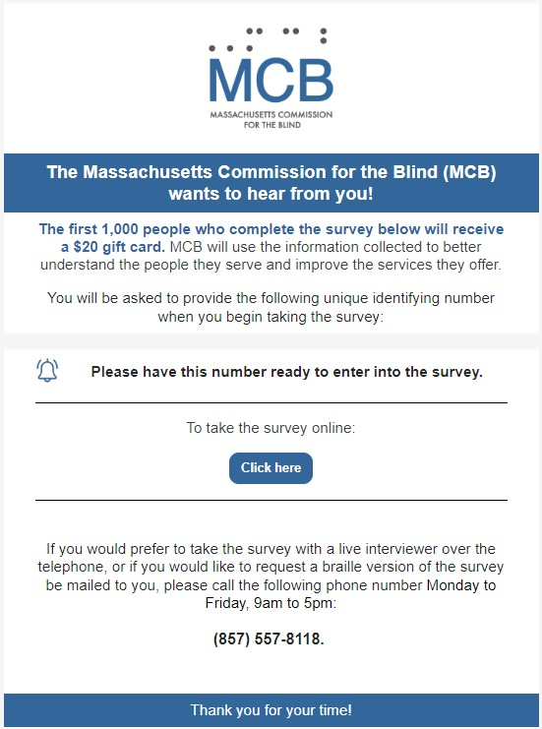
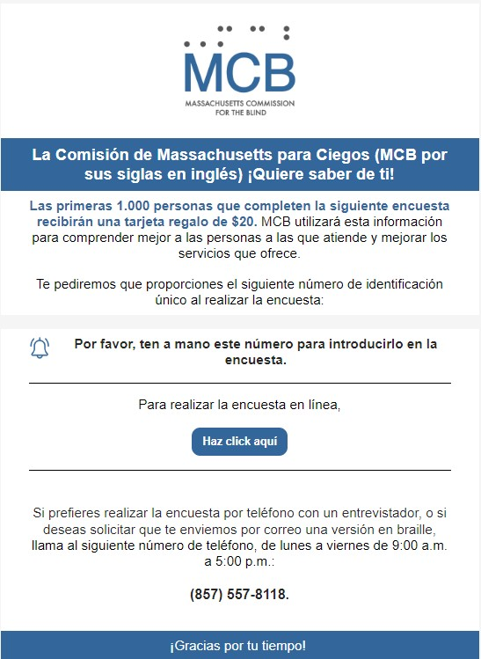

Appendix III: Phone Script for Questions Where Script Required

INTRO TEXT FOR OUTBOUND CALLS:
Hello, is this INSERT NAME HERE?
IF NOT: My I please speak with INSERT NAME HERE?
IF WRONG NUMBER Sorry about that, I must have the wrong number. Have a great day. NOTE IN CASE MANAGEMENT SYSTEM THAT PHONE NUMBER IS NO LONGER ACTIVE.
IF CORRECT PERSON. Hello, my name is YOUR NAME HERE, I am calling because The Massachusetts Commission for the Blind has commissioned a survey to help better understand the needs of the people it serves. The first 1,000 respondents will receive a $20 gift card if they complete the entire survey. Do you have a few minutes to take this survey over the phone with me at this time? IF YES, PROCEDE.
IF NO, ASK IF THERE IS A BETTER TIME TO CALL BACK. IF DECLINES SURVEY: OK, thank you for your time, have a wonderful day.
INTRO TEXT FOR INBOUND CALLS:
Hello, thank you for calling. May I please ask who I am speaking with? Hello, INSERT NAME HERE. We are looking forward to having you take The Massachusetts Commission for the blind survey. As a reminder, the first 1,000 respondents will receive a $20 gift card if they complete the entire survey. Let’s begin!
**NOTE: DO NOT READ "PREFER NOT TO SAY" RESPONSE OPTION, ONLY SELECT IF RESPONDENT CHOOSES NOT TO ANSWER.

ASK ONLY FOR INBOUND CALLS, FOR OUTBOUND CALLS ENTER THE ID NUMBER YOURSELF. IF INBOUND, READ BACK ID NUMBER TO CONFIRM. To begin, please enter the unique identification number you were provided here:

OPEN END. RECORD VERBATIM. READ BACK TO CONFIRM. Are there any services that you are not receiving from MCB that you would like to receive?

FOR BRAILLE: QUESTION HAS CHANGED SINCE BRAILLE PRINTED. TALK RESPONDENT THROUGH NEW QUESTION AND RESPONSE OPTIONS. Because of a physical, mental, or emotional condition, do you have difficulty participating in social activities such as visiting friends, attending clubs and meetings, or going to parties?

FOR BRAILLE: QUESTION WAS ADDED AFTER PRINTING BRAILLE. TALK RESPONDENT THROUGH NEW QUESTION. What is your age?

FOR BRAILLE: QUESTION WAS ADDED AFTER PRINTING BRAILLE. TALK RESPONDENT THROUGH NEW QUESTION. How would you describe your gender?

FOR BRAILLE: QUESTION WAS ADDED AFTER PRINTING BRAILLE. TALK RESPONDENT THROUGH NEW QUESTION. How would you describe your race? Select all that apply.

How would you like to receive your 20 dollar gift card if you're one of the first 1,000 respondents? RECORD VERBATIM EMAIL OR MAILING ADDRESS. READ BACK TO CONFIRM.

Appendix IV: Mailed Surveys in English and Spanish
Designed and translated by Archipelago Strategies Group.
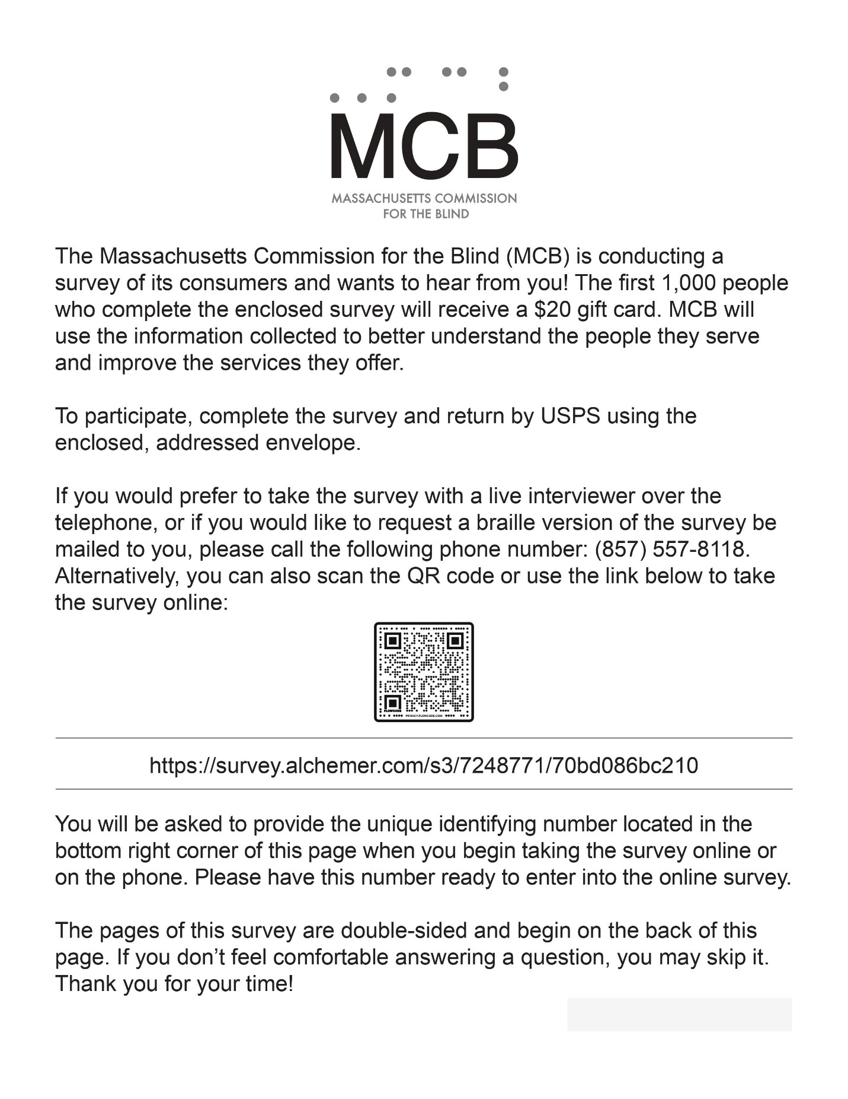
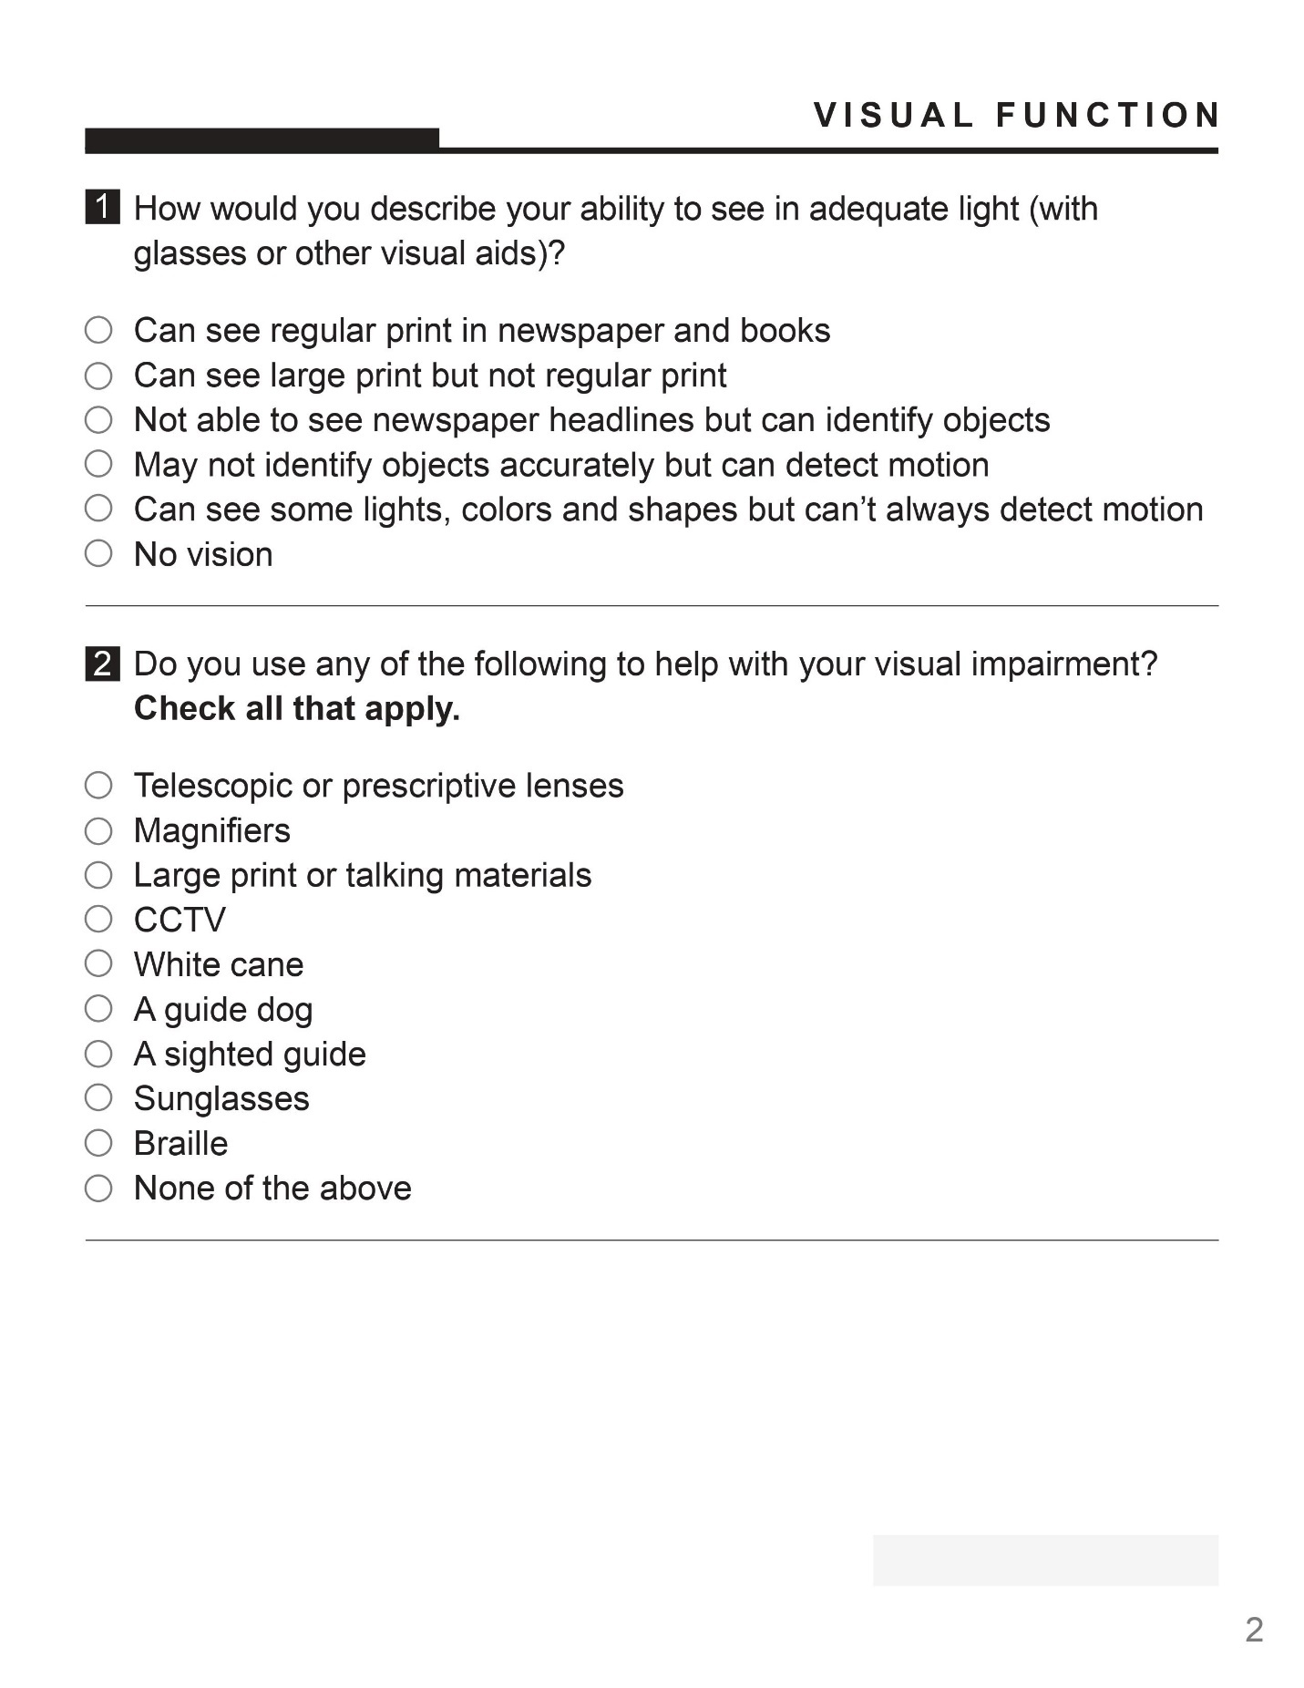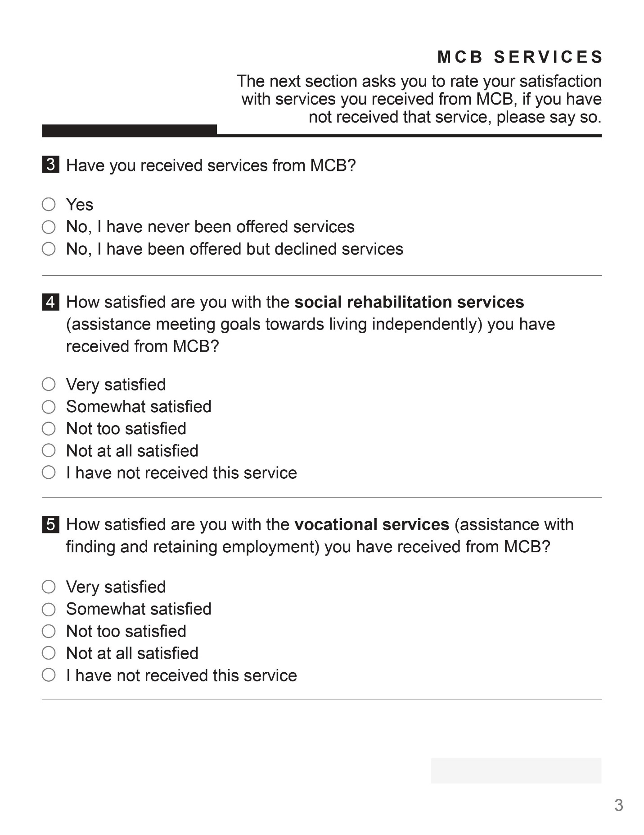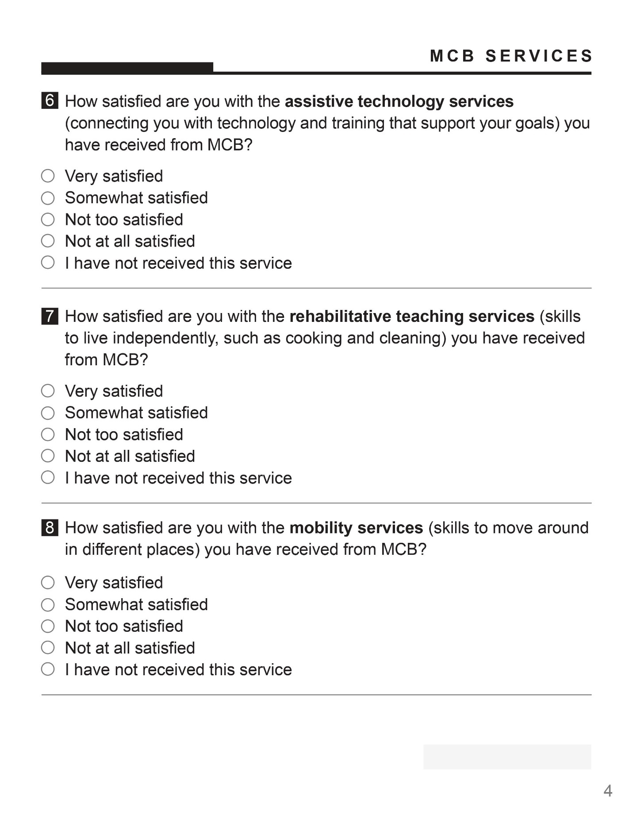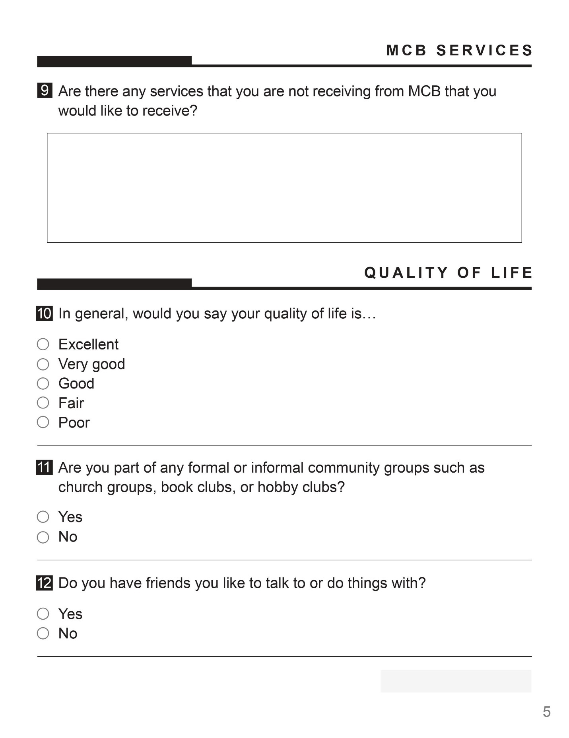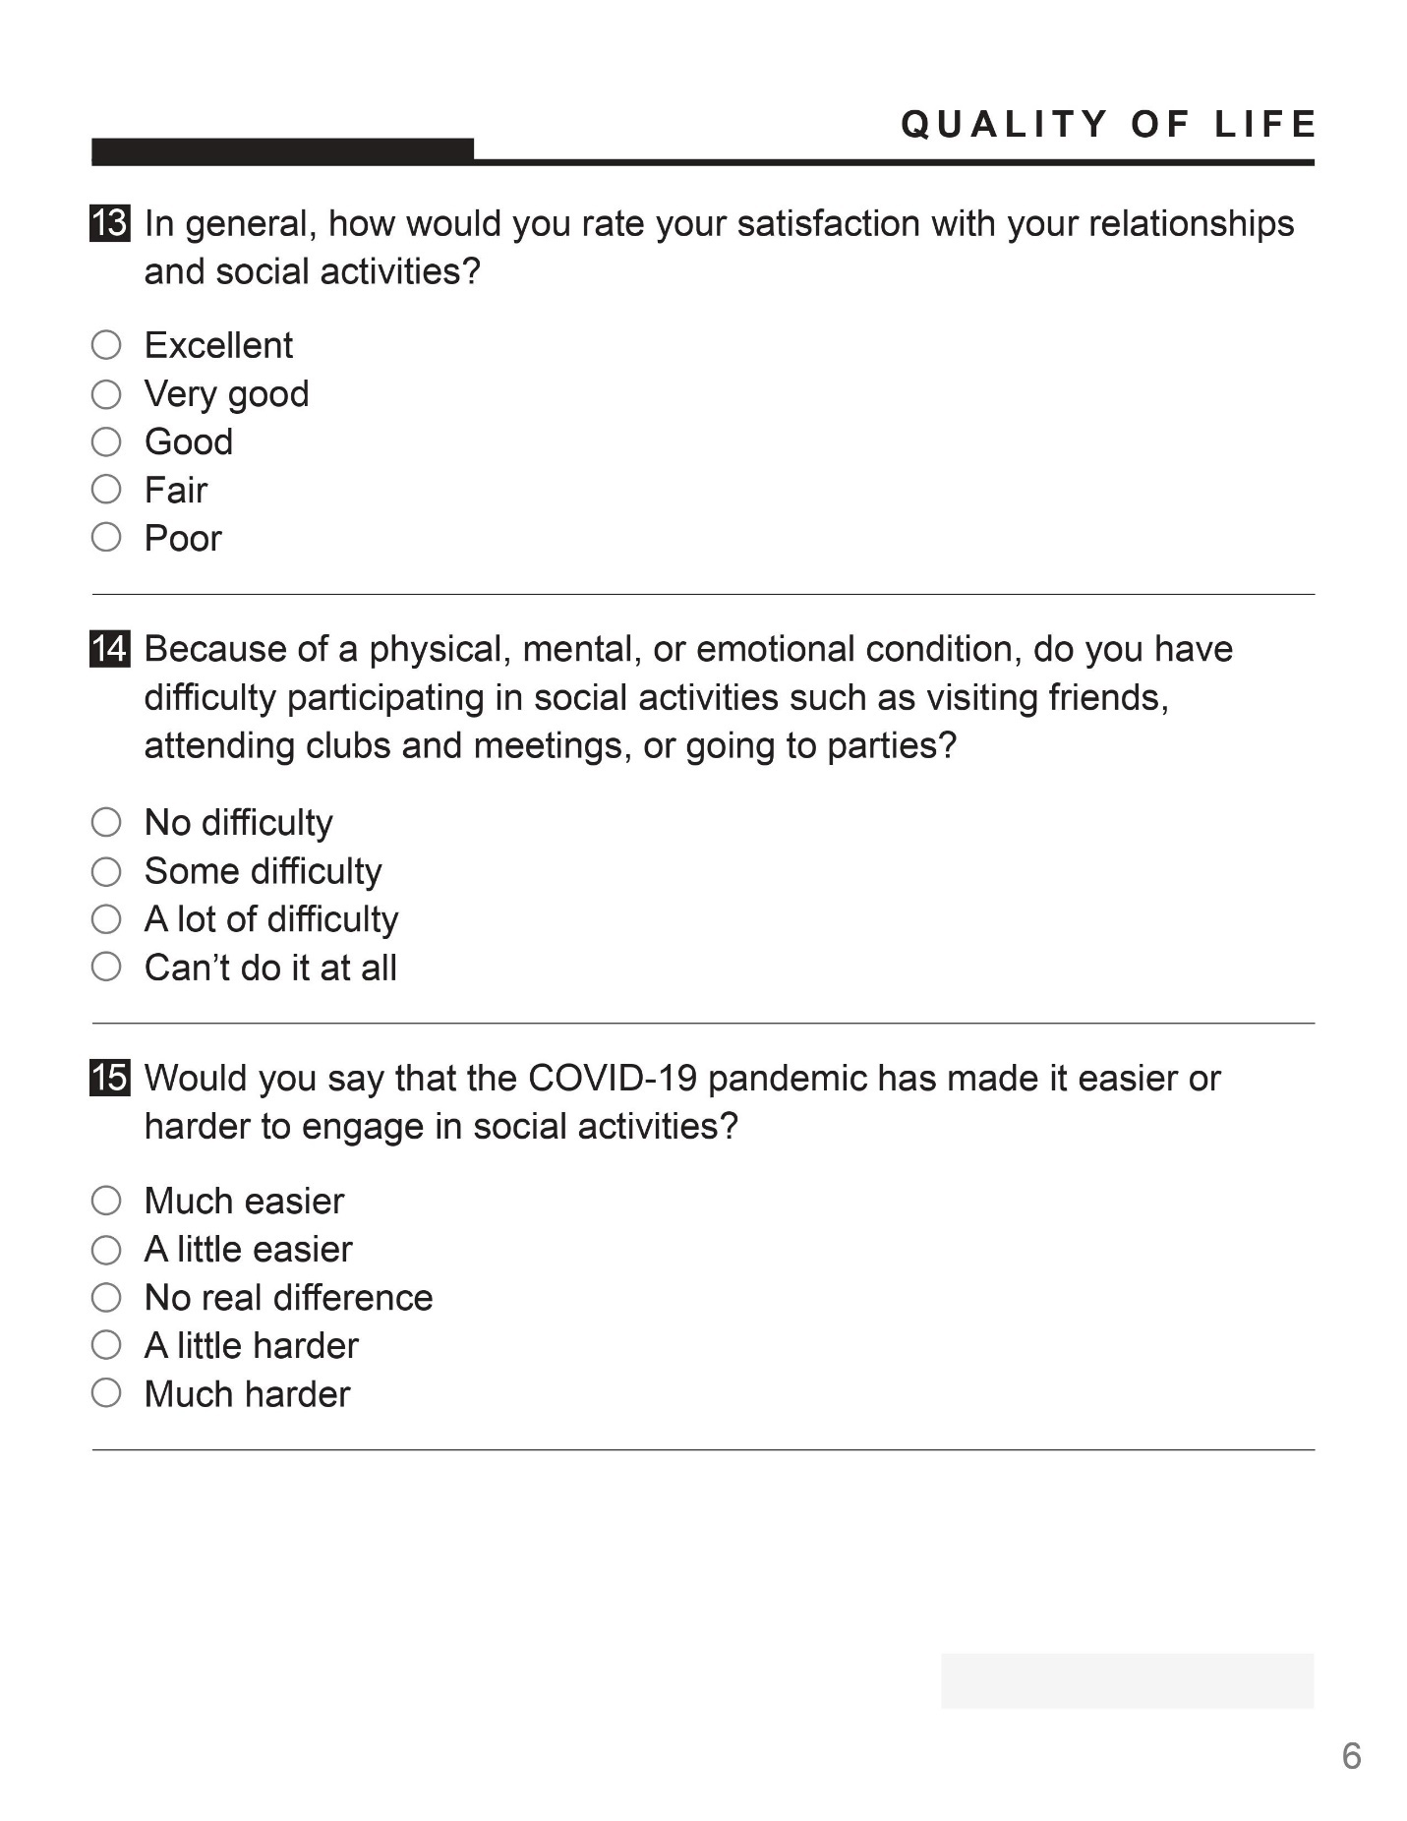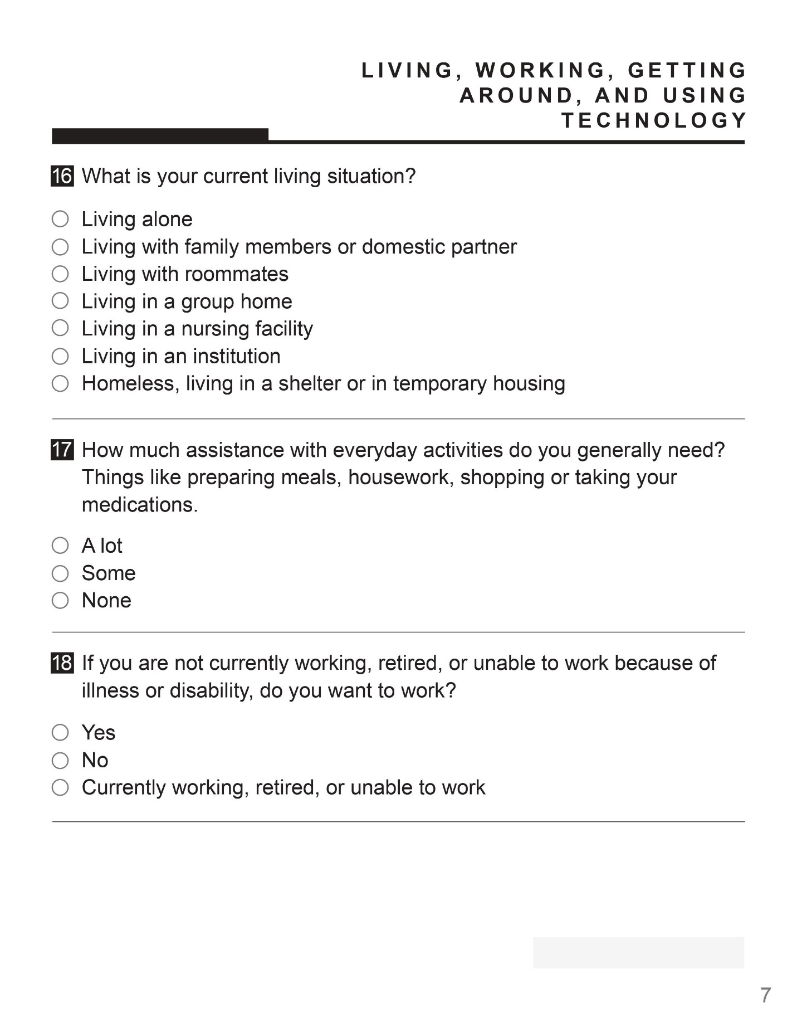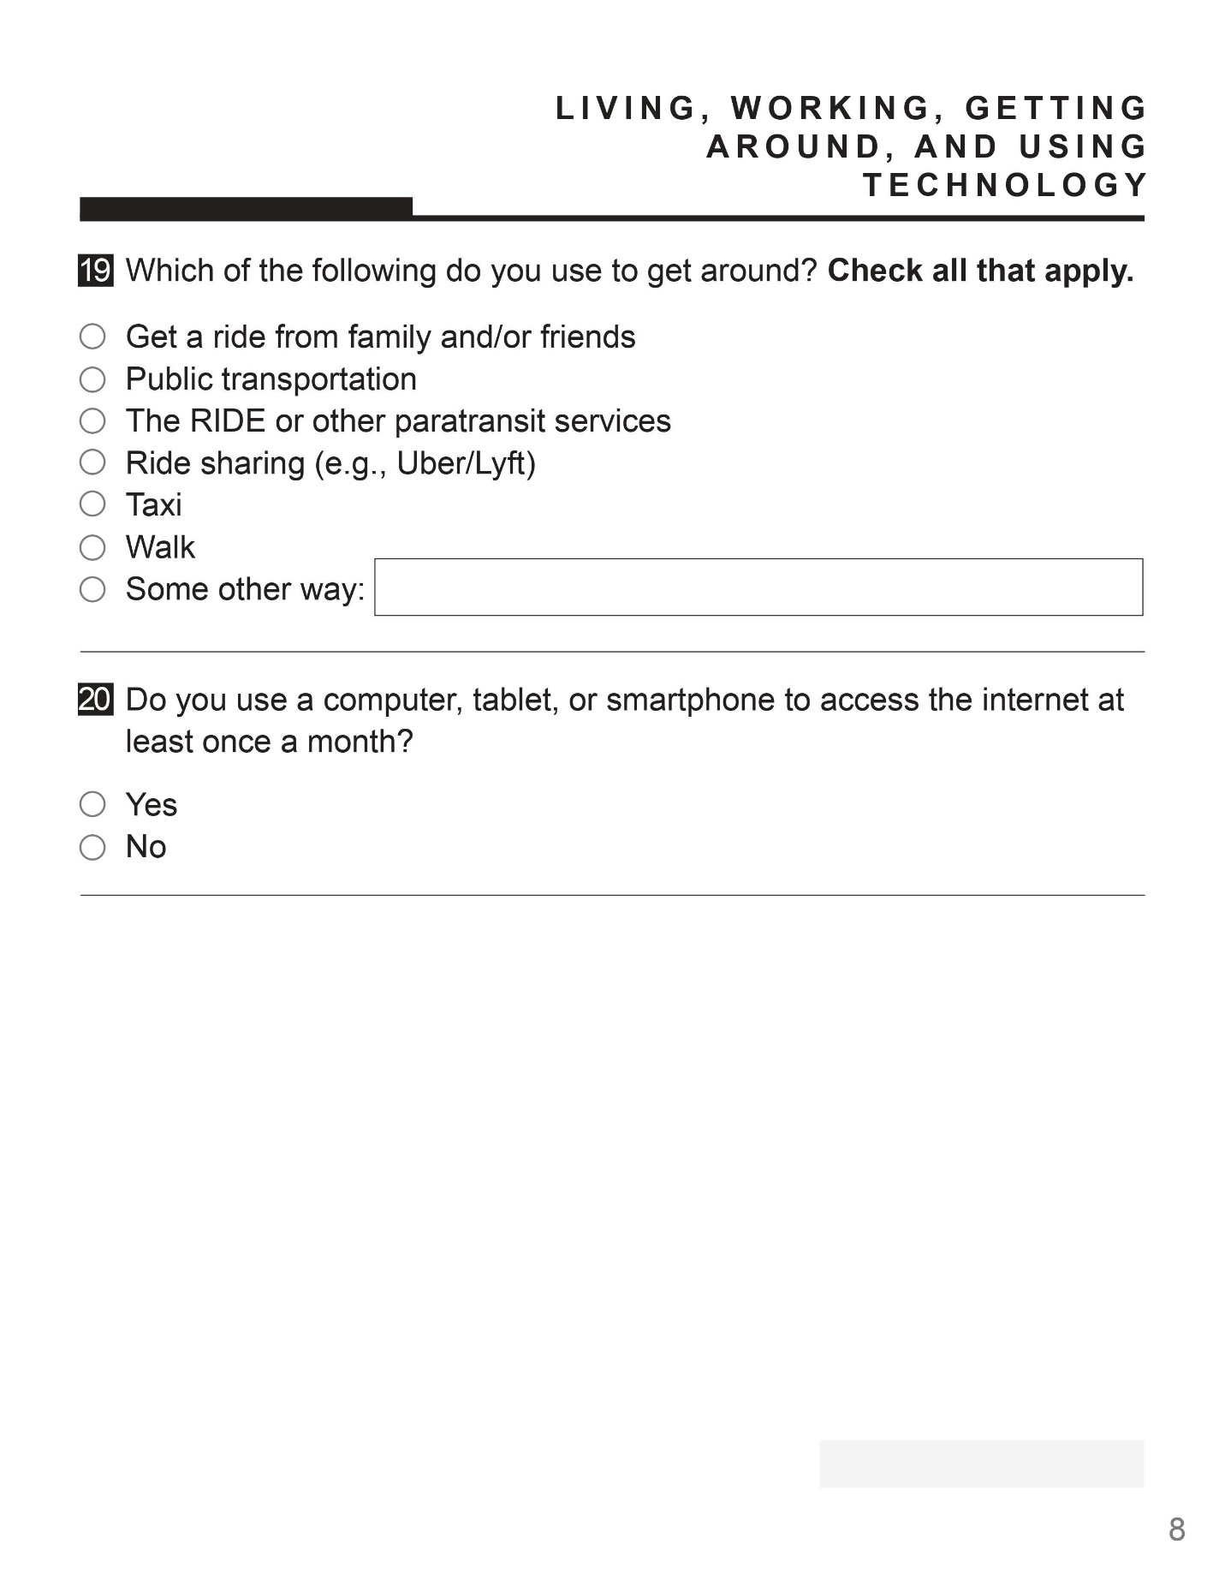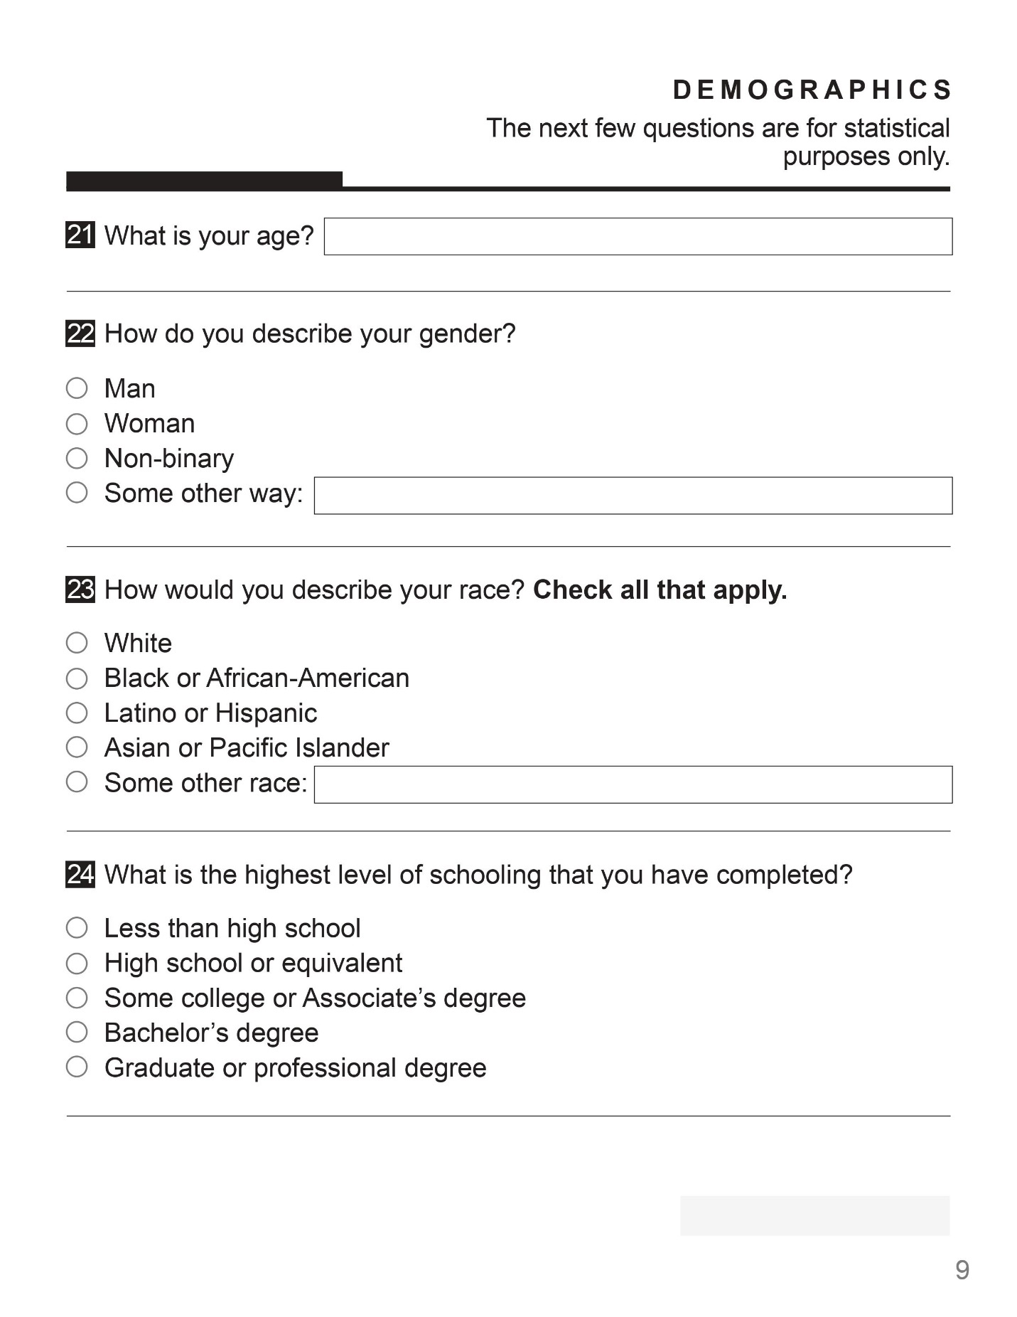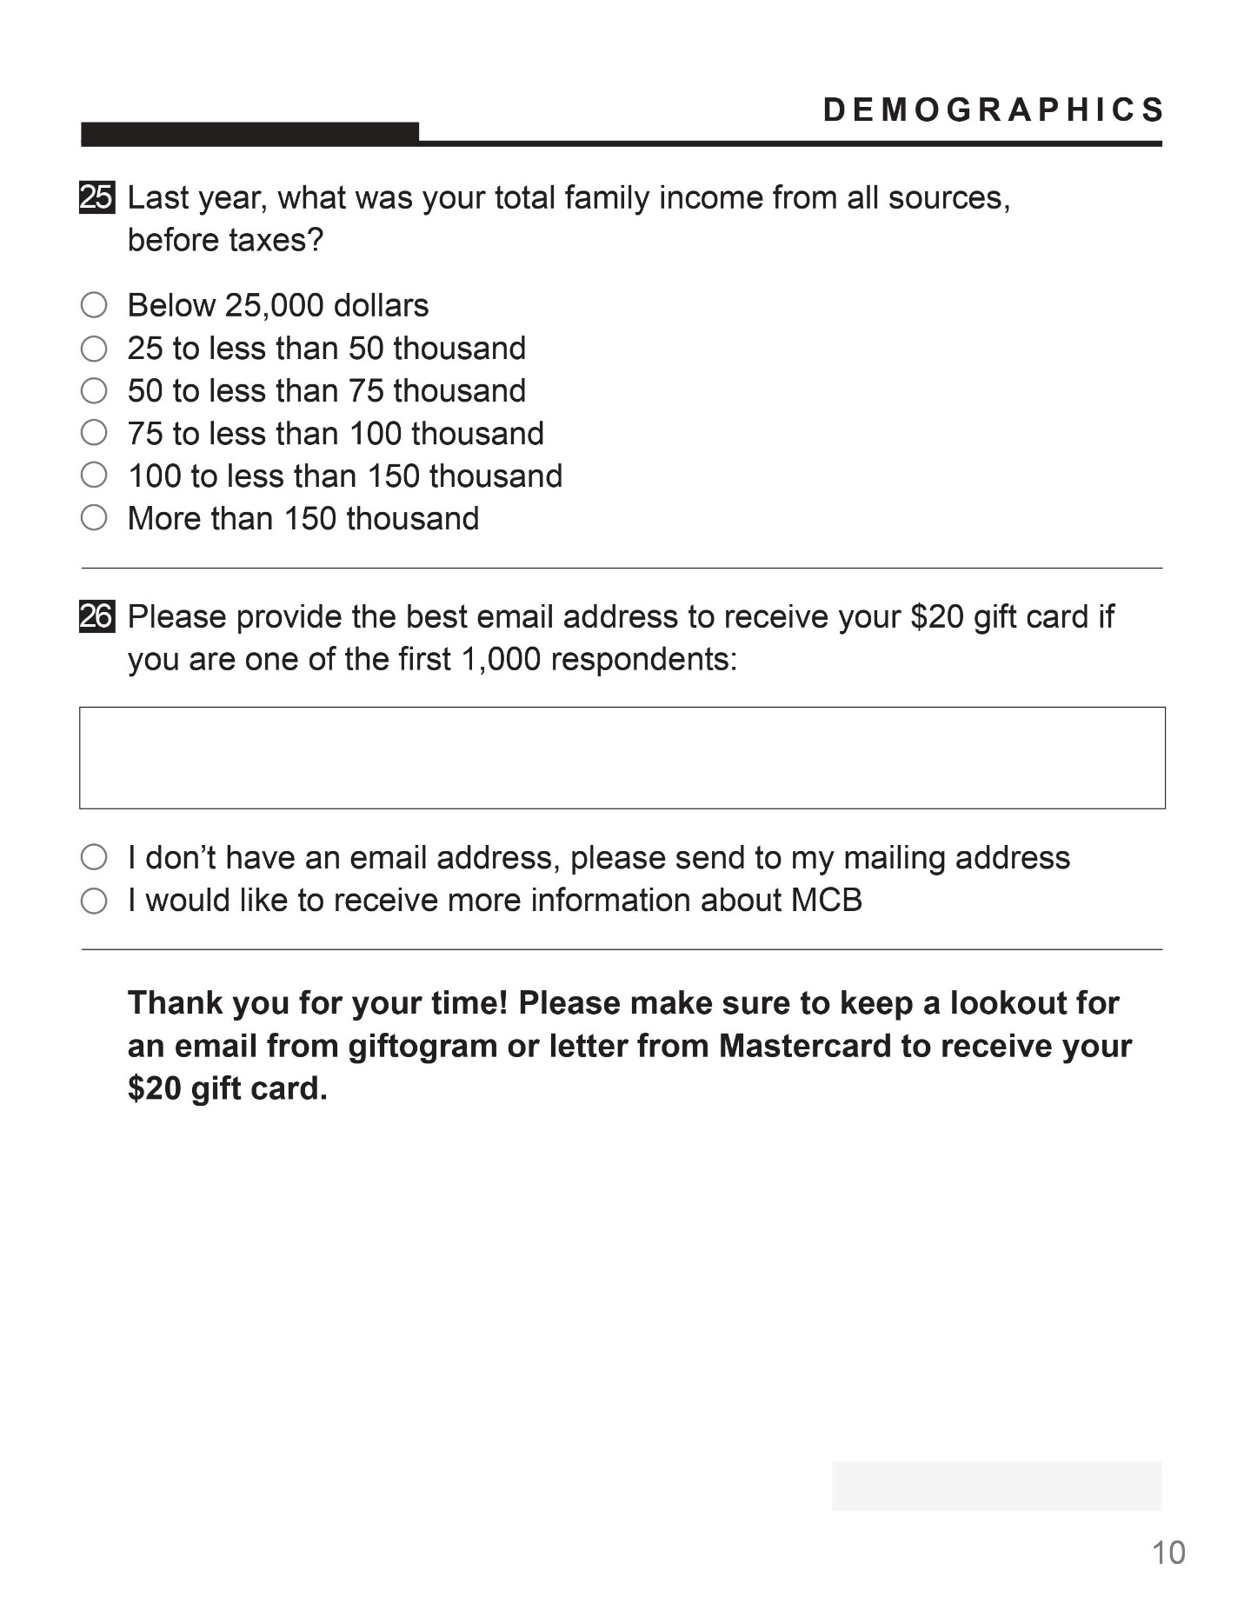
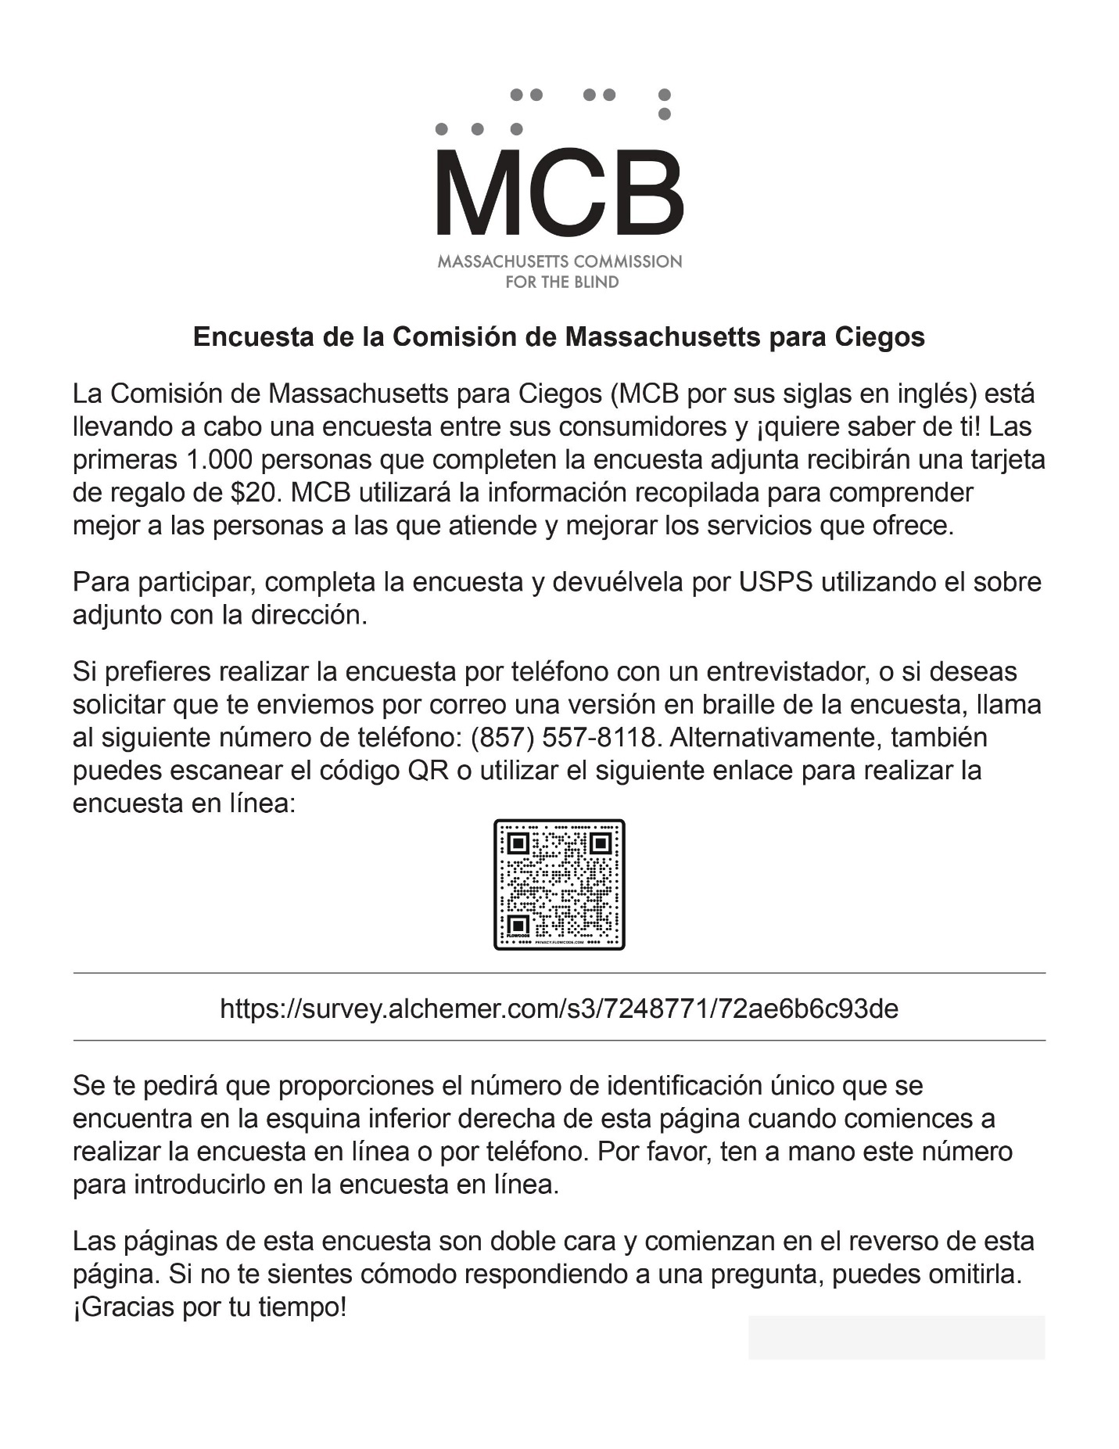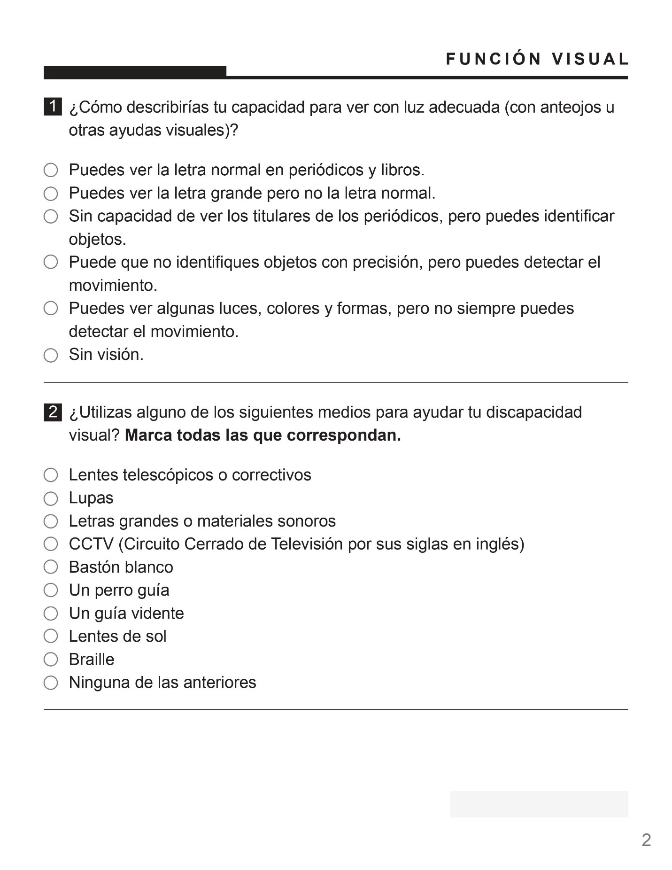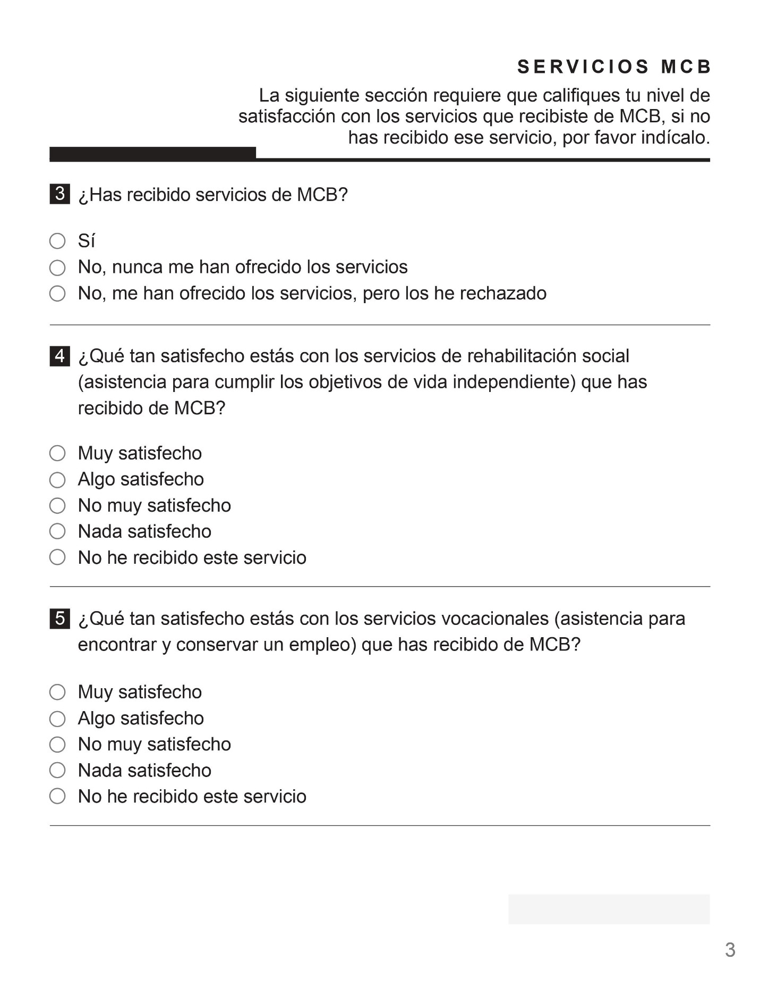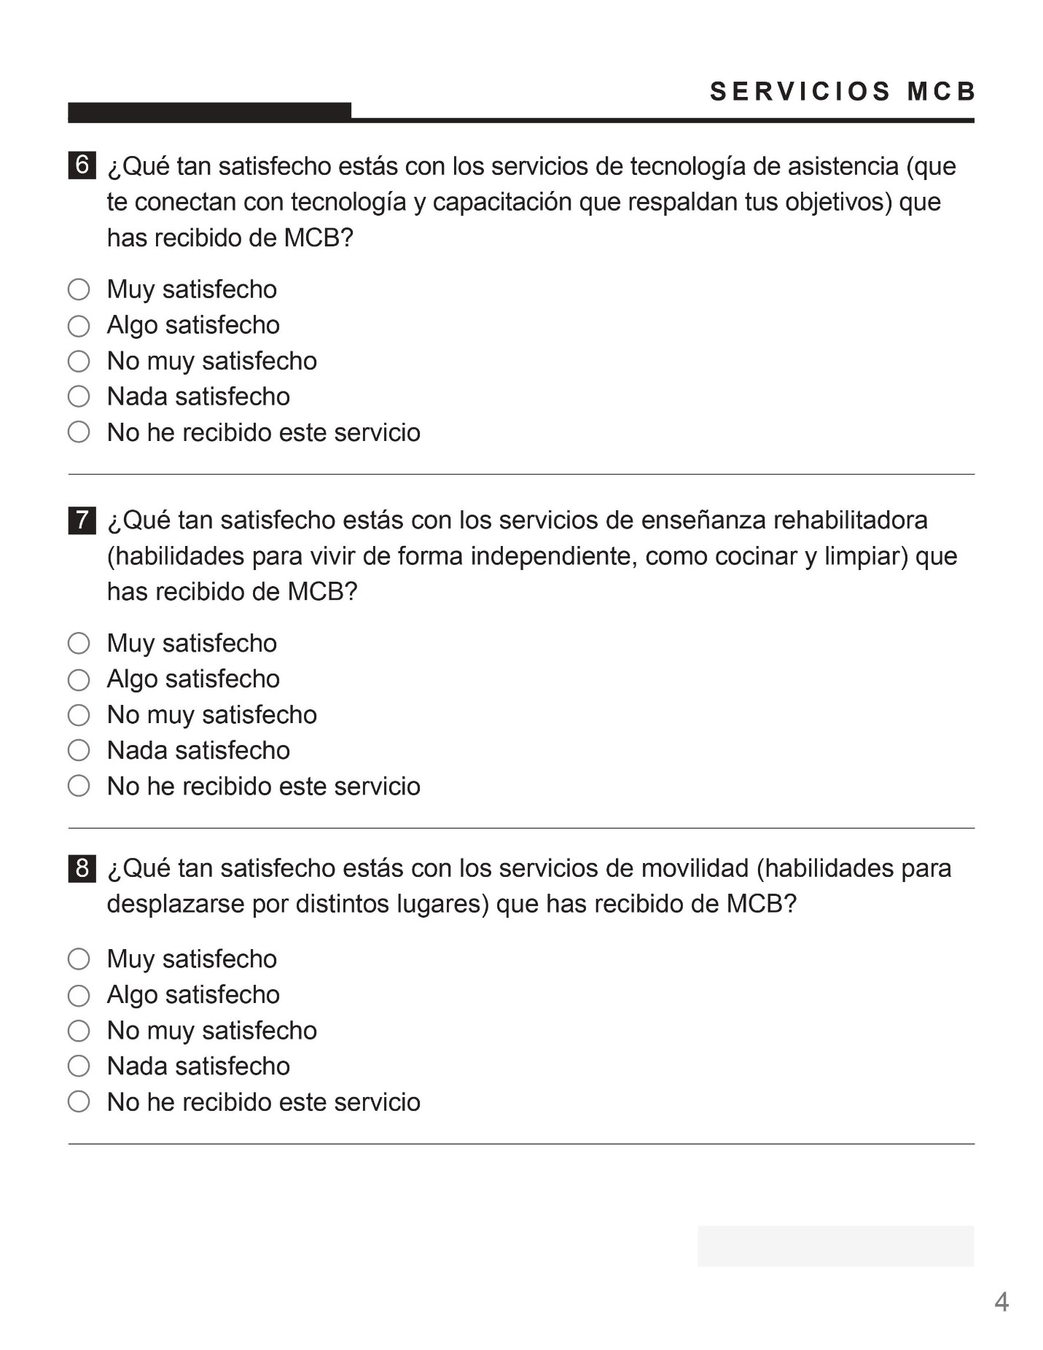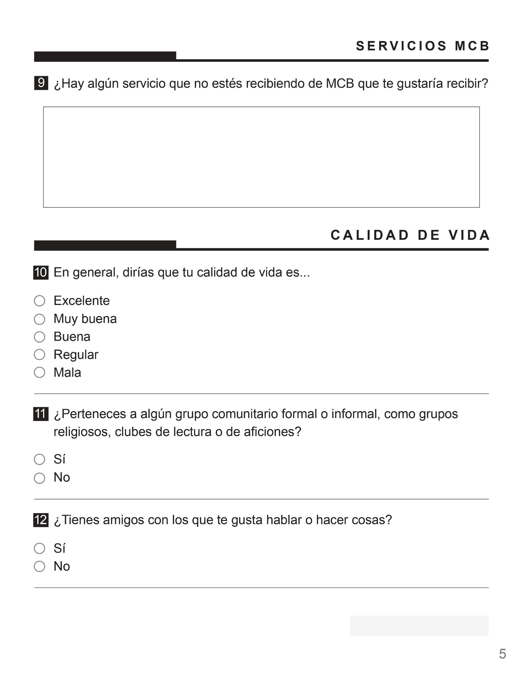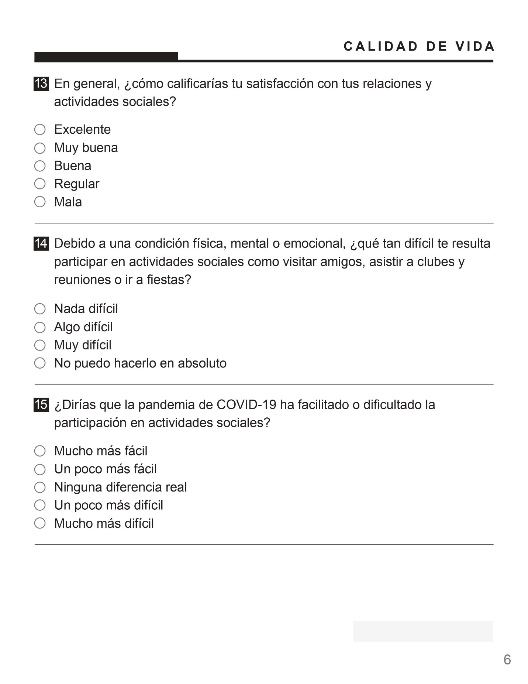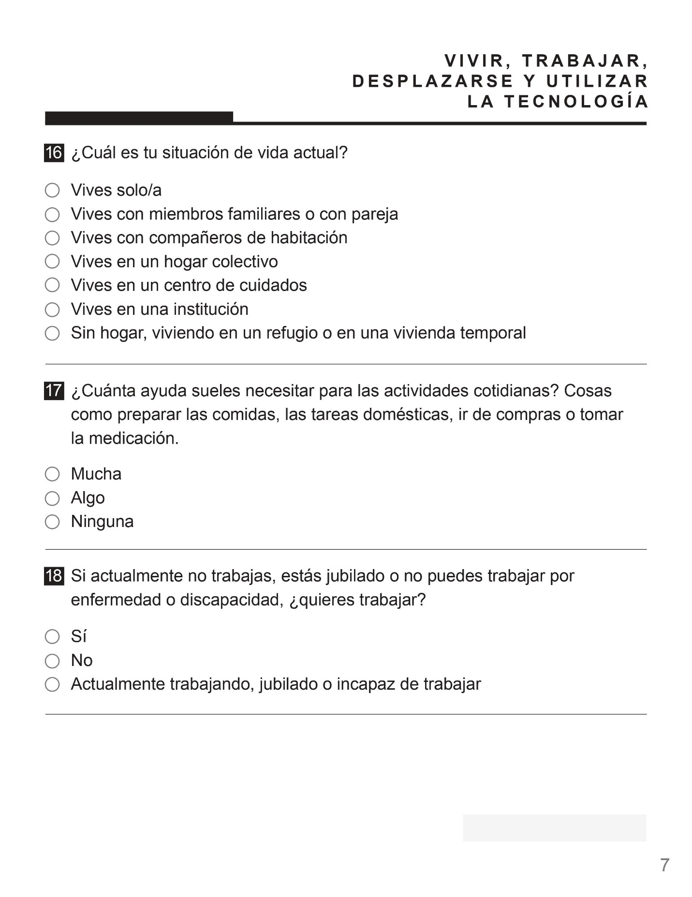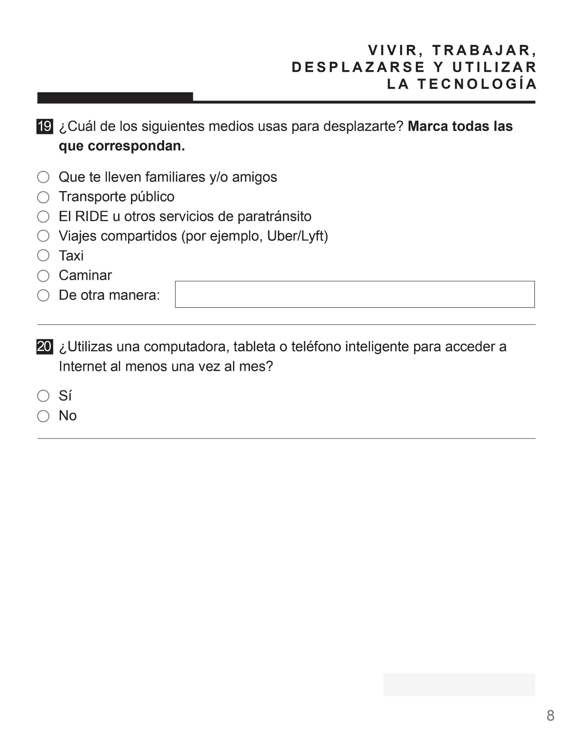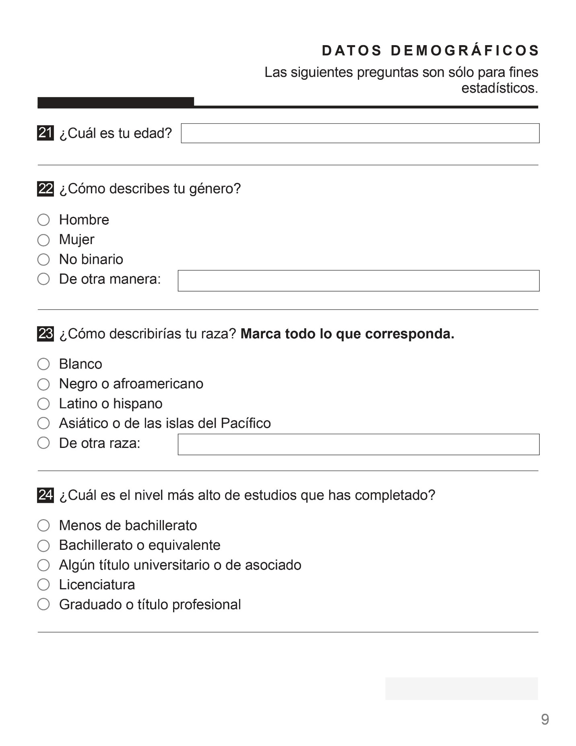
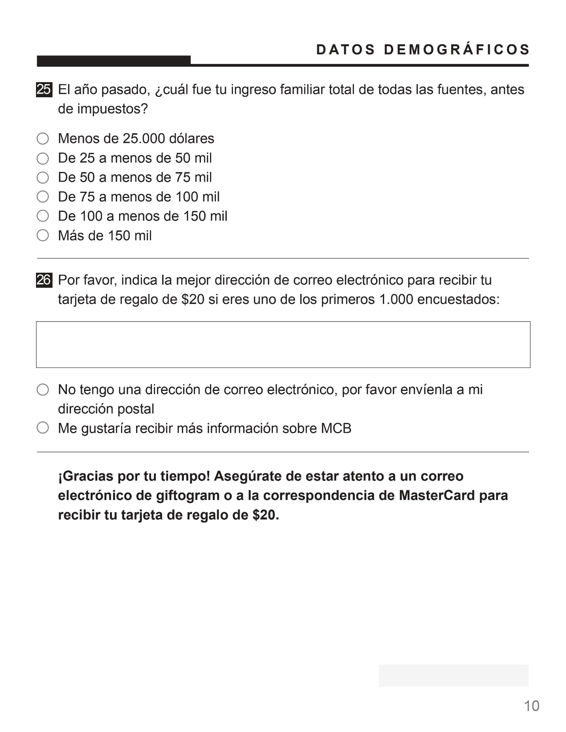

Appendix V: Survey Topline Results

The MassINC Polling Group
The Massachusetts Commission for the Blind
Survey of 3,069 Massachusetts Commission for the Blind Consumers
Field dates: April 10 – June 5, 2023

Welcome! The Massachusetts Commission for the Blind has commissioned this survey to help better understand the needs of the people it serves. The first 1,000 respondents will receive a 20 dollar gift card. Please be sure to complete the entire survey. At the end we will ask how you would prefer to receive your gift card if you are one of the first 1,000 respondents.

First we are going to ask you some questions about your visual function.
How would you describe your ability to see in adequate light (with glasses or other visual aids)?

Can see regular print in newspaper and books | 9%
Can see large print but not regular print | 31%
Not able to see newspaper headlines but can identify objects | 16%
May not identify objects accurately but can detect motion | 16%
Can see some lights, colors and shapes but can’t always detect motion | 13%
No vision | 13%
Prefer not to say | 3%

Do you use any of the following to help with your visual impairment? Select all that apply.

Telescopic or prescriptive lenses | 32%
Magnifiers | 60%
Large print or talking materials | 52%
CCTV | 14%
White cane | 36%
A guide dog | 3%
A sighted guide | 18%
Sunglasses | 44%
Braille | 7%
None of the above | 10%
Prefer not to say | 1%

The next section asks you to rate your satisfaction with services you received from MCB, if you have not received that service, please say so.

Have you received services from MCB?

Yes | 74%
No, I have never been offered services | 15%
No, I have been offered but declined services | 8%
Prefer not to say | 3%

ASK FOLLOWING 5 QUESTIONS IF RECEIVED SERVICES.

How satisfied are you with the social rehabilitation services (assistance meeting goals towards living independently) you have received from MCB?

Very satisfied | 40%
Somewhat satisfied | 23%
Not too satisfied | 6%
Not at all satisfied | 3%
I have not received this service | 26%
Prefer not to say | 3%

How satisfied are you with the vocational services (assistance with finding and retaining employment) you have received from MCB?

Very satisfied | 17%
Somewhat satisfied | 9%
Not too satisfied | 3%
Not at all satisfied | 3%
I have not received this service | 63%
Prefer not to say | 5%

How satisfied are you with the assistive technology services (connecting you with technology and training that support your goals) you have received from MCB?

Very satisfied | 33%
Somewhat satisfied | 19%
Not too satisfied | 5%
Not at all satisfied | 3%
I have not received this service | 36%
Prefer not to say | 4%

How satisfied are you with the rehabilitative teaching services (skills to live independently, such as cooking and cleaning) you have received from MCB?

Very satisfied | 20%
Somewhat satisfied | 11%
Not too satisfied | 3%
Not at all satisfied | 1%
I have not received this service | 60%
Prefer not to say | 4%

How satisfied are you with the mobility services (skills to move around in different places) you have received from MCB?

Very satisfied | 32%
Somewhat satisfied | 14%
Not too satisfied | 3%
Not at all satisfied | 2%
I have not received this service | 47%
Prefer not to say | 3%

ASK EVERYONE.

Are there any services that you are not receiving from MCB that you would like to receive? OPEN END.

None / Not Applicable | 62%
Technology support / training | 9%
Request for specific product / aid | 7%
Transportation / mobility support | 6%
Doesn't know what services are offered | 5%
Vocational / employment support | 4%
Request for info / contact | 3%
Support groups / social rehabilitiation / emotional wellbeing | 3%
Lack of follow-up / poor case mgmt / red tape | 3%
Rehabilitative teaching services / cooking, cleaning, errands | 3%
Help with paperwork / finances / benefits / legal aid | 2%
Praise for MCB or staff | 2%
Other | 2%
Haven't received services / only received years ago | 1%
Request check-in / visit | 1%
Housing | 1%

The next several questions will be about your quality of life.
In general, would you say your quality of life is…

Excellent | 11%
Very good | 25%
Good | 34%
Fair | 23%
Poor | 6%
Prefer not to say | 2%

Are you part of any formal or informal community groups such as church groups, book clubs, or hobby clubs?

Yes | 32%
No, | 66%
Prefer not to say | 2%

Do you have friends you like to talk to or do things with?

Yes | 77%
No, | 20%
Prefer not to say | 3%

In general, how would you rate your satisfaction with your relationships and social activities?

Excellent | 14%
Very good | 24%
Good | 29%
Fair | 20%
Poor | 8%
Prefer not to say | 3%

Because of a physical, mental, or emotional condition, do you have difficulty participating in social activities such as visiting friends, attending clubs and meetings, or going to parties?

No difficulty | 25%
Some difficulty | 37%
A lot of difficulty | 26%
Can’t do at all | 9%
Prefer not to say | 3%

Would you say that the COVID-19 pandemic has made it easier or harder to engage in social activities?

Much easier | 2%
A little easier | 4%
No real difference | 34%
A little harder | 26%
Much harder | 31%
Prefer not to say | 3%

This next section is about living, working, getting around, and technology use.
What is your current living situation?

Living alone | 33%
Living with family members or domestic partner | 57%
Living with roommates | 2%
Living in a group home | 2%
Living in a nursing facility | 2%
Living in an institution | 1%
Homeless, living in a shelter or in temporary housing | 1%
Prefer not to say | 2%

How much assistance with everyday activities do you generally need? Things like preparing meals, housework, shopping or taking your medications.

A lot | 34%
Some | 46%
None | 18%
Prefer not to say | 2%

If you are not currently working, retired, or unable to work because of illness or disability, do you want to work?
Yes | 13%
No | 38%
Currently working, retired, or unable to work | 46%
Prefer not to say | 2%

Which of the following do you use to get around? Select all that apply.

Get a ride from family and/or friends | 82%
Public transportation | 25%
The RIDE or other paratransit services | 25%
Ride sharing, for example, Uber or Lyft | 18%
Taxi | 10%
Walk | 28%
Some other way: __________________ | 9%
Prefer not to say | 2%

Do you use a computer, tablet, or smartphone to access the internet at least once a month?

Yes | 57%
No | 40%
Prefer not to say | 2%

Demographics

Age

18 - 29 | 7%
30 - 44 | 9%
45 - 59 | 12%
60 - 74 | 25%
75 - 89 | 28%
90+ | 16%
Prefer not to say | 3%

Gender

Man | 42%
Woman | 56%
Non-binary | <1%
Other | <1%
Prefer not to say | 2%

Race. Select all that apply.

White | 77%
Black / African American | 9%
Latino or Hispanic | 7%
Asian or Pacific Islander | 3%
Other | 2%
Prefer not to say | 4%

Education

Less than high school | 12%
High school or equivalent | 34%
Some college or Associate degree | 22%
Bachelor’s degree | 13%
Graduate or professional degree | 16%
Prefer not to say | 4%
Income
Below 25,000 dollars | 38%
25 to less than 50 thousand | 19%
50 to less than 75 thousand | 9%
75 to less than 100 thousand | 5%
100 to less than 150 thousand | 4%
More than 150 thousand | 3%
Prefer not to say | 22%

Appendix VI: MCB’s Short Form Survey

Demographics
- Date of birth (mm/dd/yyyy): |__|__| / | __|__| / |__|__|__|__|
- Gender (DO NOT READ OUT THE RESPONSE CATEGORIES OR MAKE ANY ASSUMPTIONS BASED ON APPEARANCE OR VOICE. RECORD THE RESPONSE EXACTLY AS IT IS GIVEN.)
  - Female
  - Male
  - Other [specify ]
- Race (SELECT ALL THAT APPLY):
  - White
  - Black or African American
  - American Indian or Alaska Native
  - Asian
  - Native Hawaiian or Pacific Islander
  - Some other race [specify ]
- Are you of Hispanic, Latino, or Spanish origin?
  - Yes
  - No

- Are you a citizen of the United States?
  - Yes (SKIP TO Q #6)
  - No (CONTINUE WITH Q #5a)

5a. Which of the following best describes your current immigration status?
  - Lawful permanent resident (LPR/Green Card holder)
  - Lawful temporary resident
  - Has approved employment authorization.
  - Other [specify ]
IF YOUNGER THAN AGE 14, CONTINUE WITH THE SR CHILD MODULE. IF AGE 14 OR OLDER, CONTINUE WITH Q #6 BELOW)
- What is your marital status?
  - Married or in a domestic partnership, currently living with spouse/partner.
  - Married or in a domestic partnership, currently NOT living with spouse/partner.
  - Single, never married.
  - Single, divorced.
  - Single, widow/widower
- (ONLY ASK IF AGE 17 OR OLDER) Did you ever serve on active duty in the U. S. Armed Forces?
  - Yes, currently on active duty.
  - Yes, on active duty in the past but not now.
  - Never served.

- How well do you speak English?
  - Very well (SKIP TO Q #9)
  - Well (SKIP TO Q #9)
  - Not well (CONTINUE WITH Q #8a)
  - Not at all (CONTINUE WITH Q #8a)
8a. (IF DOESN’T SPEAK ENGLISH WELL) Will an English-speaker be available to translate when a counselor visits your home?
  - No
  - Yes
- What is your current living situation?
  - Living alone
  - Living with family members or domestic partner
  - Living with roommates
  - Living in a group home
  - Living in a nursing facility
  - Living in an institution
  - Homeless, living in a shelter or in temporary housing
Education
- What is the highest degree or level of school you have completed?
  - Less than high school
  - High school or equivalent
  - Some college or Associate degree
  - Bachelor’s degree
  - Graduate or professional degree

Labor Force and Income
- Do you have a paid job?
  - Yes, currently working full-time, that is, 35 hours or more per week (SKIP TO Q #12)
  - Yes, currently working part-time (SKIP TO Q #12)
  - No, worked for pay in the past but not currently (CONTINUE WITH Q #11a)
  - No, never had a paid job (CONTINUE WITH Q #11a)
11a. (IF NOT CURRENTLY EMPLOYED) What is your employment situation now?
  - On layoff from a job
  - Waiting for a new job to begin
  - Retired
  - Taking care of home and family full-time
  - In school full-time
  - Not able to work because of illness or disability.
  - Something else [specify ]
11b. (IF NOT CURRENTLY EMPLOYED) Do you want to work?
  - No
  - Yes

- Thinking of your total household income from all sources last year (before taxes), in what range would you say it was? Would you say it was…?
  - Below $20,000
  - Between $20,000 and $50,000
  - Above $50,000
Source: Question wording – General Social Survey (GSS), 2018; response options customized for MCB
Health and Wellness
- Are you deaf or do you have serious difficulty hearing?
  - Yes
  - No
- Because of a physical, mental, or emotional condition, do you have serious difficulty concentrating, remembering, or making decisions?
  - Yes
  - No
- Do you have serious difficulty walking or climbing the stairs?
  - Yes
  - No
- Do you have difficulty dressing or bathing?
  - Yes
  - No

- (ONLY ASK IF AGE 15 OR OLDER) Because of a physical, mental, or emotional condition, do you have difficulty doing errands alone such as visiting a doctor’s office or shopping?
  - Yes
  - No
- In general, how would you rate your physical health?
  - Excellent
  - Very good
  - Good
  - Fair
  - Poor
Visual Function
- Which statement best describes your vision (while wearing glasses or contact lenses)?
  - A little trouble seeing.
  - A lot of trouble seeing.
  - No usable vision
- When did you first notice having vision difficulties?
  - Had vision difficulties since birth.
  - Vision difficulties developed later in life [specify what age: _____________________________________ ]

Information and Communication Technology Use
- Do you have access to the internet?
  - No (SKIP TO Q #22)
  - Yes (CONTINUE WITH Q #21a AND #21b)
21a. How often do you use the Internet?
  - Every day
  - Several times a week
  - Several times a month
  - Several times a year
  - I don’t use it at all.
21b. How often do you check your email account (if you have one)?
  - Every day
  - Several times a week
  - Several times a month
  - Several times a year
  - I don't have an email account.

- Which of the following do you frequently use? (select all that apply)
  - Large-print publications
  - Tools that read text aloud (like text-to-speech readers)
  - Screen reader (like JAWS)
  - Braille tools
  - Screen magnification software or system settings (such as applications that allow you to magnify the content of your computer, tablet, or smart phone)
  - Browser zoom controls (settings on Internet browsers that magnify the pages as you browse)
  - Browser text sizing settings (settings on Internet browsers that enlarge the text on the screen)
  - Browser settings to change color (settings on Internet browsers that allow you to select your preferred colors for text and background)
  - High contrast mode or settings (settings on your computer or hand-held device that allow you to increase the contrast between background and text or objects)
  - Custom styles (like Stylish, Stylus, user style sheets)
  - Tools that highlight text as it is read.
  - Other [Specify__________________________ ]
Source: WebAIM, Survey of Users with Low Vision, 2018 (response options adapted for MCB)

- Do you use the accessibility settings (including large text) or accessibility software on a mobile phone or tablet (if you use one)?
  - Yes
  - No
  - I don’t use mobile phones or tablets.
Source: WebAIM, Survey of Users with Low Vision, 2018 (response options adapted to MCB)
Transportation
- What is your primary means of transportation?
  - Family
  - Public transportation
  - The RIDE
  - Ride sharing (e.g., Uber/Lyft)
  - Friends
  - Taxi
  - Other [Specify___________________]
- Do you feel safe travelling or cross streets by yourself?
  - Yes
  - No

Service Utilization
- Do you currently receive services from any of the following state agencies? (Select all that apply)
  - Department of Developmental Services (DDS)
  - Department of Children and Families (DCF)
  - Department of Transitional Assistance (DTA)
  - Department of Mental Health (DMH)
  - MA Rehabilitation Commission (MRC)
  - MA Commission for the Deaf and Hard of Hearing (MCDHH)
  - Other state agency (Specify _________________)
CONCLUDING SCRIPT AND FEEDBACK QUESTION:
“That was the last question. Thanks a lot for answering these questions. Do you have any further thoughts, comments, or feedback on what we talked about or how these questions were asked?”
RECORD RESPONDENT’S COMMENTS (IF ANY):
___________________________________________
___________________________________________
___________________________________________

Appendix VII: MCB’s Long Form Survey

Long Form Questions to be Combined With the Adult Short Form to Design a Survey Instrument

- [If indicated that degree attained] What year did you graduate? _________

- Are you currently enrolled in a vocational or on-the-job training program?
  - Yes, full time
  - Yes, part time
  - No
Source: HSRI developed
- In general, how would you rate your mental health, including your mood and your ability to think?
- Excellent
- Very good
- Good
- Fair
- Poor
Source: General Social Survey (GSS), 2018

- In general, would you say your quality of life is…..
- Excellent
- Very good
- Good
- Fair
- Poor
Source: General Social Survey (GSS), 2018
Involvement in Social Activities [Questions 5-9 are for MCB to review and select from]
- Are you part of any formal or informal community groups such as church groups, book clubs, or hobby clubs?
  - Yes
  - No
Source: National Core Indicators, 2008 (adult in-person survey)
- Do you have friends you like to talk to or do things with?
  - Yes
  - No
Source: National Core Indicators, 2008 (adult in-person survey)

- In general, how would you rate your satisfaction with your social activities and relationships?
  - Excellent
  - Very good
  - Good
  - Fair
  - Poor
Source: General Social Survey (GSS), 2018
- In general, how difficult is it for you to participate in social activities such as visiting friends, attending clubs and meetings, going to parties?
  - Not at all difficult
  - Only a little difficult
  - Somewhat difficult
  - Very difficult
  - Can’t do it at all
Source: National Health Interview Survey, 2018 (adult questionnaire)
- How often do you feel like you don’t have anyone to talk to?
  - Very often
  - Sometimes
  - Rarely
  - Never
Source: National Health Interview Survey, 2018 (adult questionnaire)

- Are you currently covered by any of the following types of health insurance or health coverage plans? (select all that apply)
- State (MassHealth) or Federal Affordable Care Act Exchange
- Medicare
- Medicaid or CHIP
- Self-paid private insurance plan
- Employer-provided insurance plan
- VA health care
- TRICARE or other military health plan
- Indian Health Service
- Any other type of insurance (Specify_______________)
Source: ACS, 2018 (additional response categories from AWARE)
- How would you describe your ability to see in adequate light (with glasses or other visual aids)?
- Can see regular print in newspaper and books
- Can see large print but not regular print
- Not able to see newspaper headlines but can identify objects
- May not identify objects accurately but can detect motion
- Can see some lights, colors and shapes but can’t always detect motion
- No vision
Source: CMS Vision Codes (adapted)

- Do you use any of the following to help with your visual impairment? (select all that apply)
- Telescopic or prescriptive lenses
- Magnifiers
- Large print or talking materials
- CCTV
- White cane
- Sunglasses
Source: NHIS, 2002 (adapted)
- Which of the following do you regularly use? (select all that apply)
- A computer
- A cell phone (not Smartphone)
- A Smartphone
- Bank ATM machines
- The Internet
- Email
Source: Lawton-Brody Instrumental Activities of Daily Living Scale (IADL), Information and Communication Technologies (ICT) subscale (adapted)

- Which of the following is your primary device for navigating the web?
- Desktop
- Laptop
- Chromebook
- Smartphone
Source: WebAIM, Survey of Users with Low Vision, 2018 (adapted)
- Which of the following is your primary mobile/table screen reader?
- Don’t use a mobile screen reader
- VoiceOver
- TalkBack for Android
- Mobile Accessibility for Android
- Other (Specify_____________)
Source: WebAIM, Survey of Users with Low Vision, 2018

- What assistive technologies do you currently use?
- Communication devices
- Hearing aid
- Assistive listening devises
- Talking watches
- Electronic aids to daily living
- Large print material
- Text-to-speech screen reader
- Alternative keyboard and mouse
- Head pointing devise
- Voice recognition software
- Screen magnification software
- Adaptive learning tools
Source: Survey of Assistive Technology Users’ Needs in Massachusetts, 2006
- In addition to the devices that you are using now, are there any additional assistive technology devices or services that would help you?
- No
- Yes (Specify_________________)
Source: Survey of Assistive Technology and Information Technology Use and Needs by Persons with Disabilities in the United States, 2001 (adapted)

- We are interested in how people get information about events in the news. Where do you get most of your information about current news events?
- Newspapers
- Magazines
- The Internet
- Books/other printed material
- TV
- Radio
- Government agencies
- Family
- Friends/colleagues
- Social media
- Other
Source: General Social Survey (GSS), 2018
- Do you need help with any of the following activities or do you usually do them by yourself?
- Move around the house
- Take a walk outdoors
- Prepare meals
- Do house cleaning
- Wash and iron clothes
- Do grocery shopping
- Source: Groningen Activities Restriction Scale (GARS) for Measuring Disability (adapted)

- How much assistance with everyday activities do you generally need? Things like preparing meals, housework, shopping or taking your medications.
  - A lot
  - Some
  - None
Source: National Core Indicators- Aging and Disabilities
- How much assistance do you need in managing your finances, such as everyday purchases, major purchases, bank transactions, etc.?
  - None
  - Some
  - A lot
Source: Lawton-Brody Instrumental Activities of Daily Living (IADL) – Finances subscale (adapted)

Appendix VIII: Demographic Targets and Survey Results

 | Target | Survey
Female | 56% | 56%
Male | 44% | 42%
White | 83% | 77%
Black | 12% | 9%
Hispanic or Latino | 8% | 7%
Asian or Pacific Islander | 4% | 3%
Other | 2% | 2%
18-29 | 6% | 7%
30-44 | 8% | 9%
45-59 | 12% | 12%
60-74 | 20% | 25%
75-89 | 26% | 28%
90+ | 29% | 16%
Barnstable | 4% | 4%
Berkshire | 2% | 3%
Bristol | 9% | 9%
Dukes | 0% | <1%
Essex | 11% | 10%
Franklin | 1% | 1%
Hampden | 10% | 11%
Hampshire | 2% | 3%
Middlesex | 20% | 19%
Nantucket | 0% | 0%
Norfolk | 9% | 10%
Plymouth | 7% | 6%
Suffolk | 12% | 11%
Worcester | 11% | 11%
These targets reflect demographics from MCB’s case management system for consumers under age 104 with an address, the criteria MPG used for inclusion in the sample universe. Only 76% of case management system cases had a race listed, which is why we chose not to use it as a target for weighting.

On age, the 29% who are 90+ likely includes consumers who have passed away but who had not yet been removed from the case management system. These older respondents are also more likely to be white, so their presence in the case management system is likely also skewing the racial figures to be more white.

Apart from the 90+ category, the age distribution of survey responses matches the case management system reasonably well. Gender and county also closely match targets. Given the missing racial data and the discrepancy on age, we decided not to weight the survey results back to what is available in the case management system.

