Phish Alert Button (PAB) Tutorial

A Phish Alert Button (PAB) has been rolled out for end-users across the Executive Branch. The PAB provides end-users a safe and automated way to forward suspected email threats to EOTSS’s Security Operations Center (SOC) for analysis while automatically deleting the potential threat from the user’s inbox to prevent future exposure.

Please see below for instructions on how to use the PAB across Desktop, Web, and Mobile app versions of Microsoft Outlook.

You are no longer required to manually forward suspect messages to the EOTSS SOC. Per EOTSS’s new incident reporting processes, the PAB should now be the primary method by which you report suspected malicious messages.

Desktop

1. The PAB icon () should be visible in the Outlook ribbon at the top of your screen.
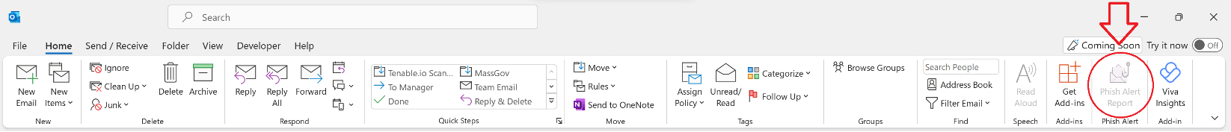
2. When viewing a suspected message, click the PAB to the initiate the reporting process.
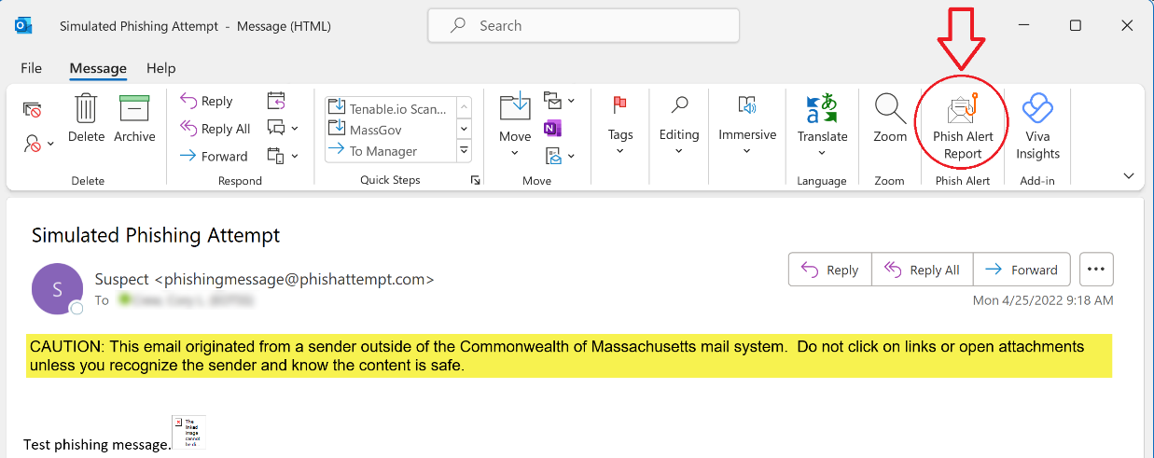
3. You will now have the option to classify the message as either Phish/Suspicious, Spam, or Unknown and enter comments up to 360 characters in length (optional).
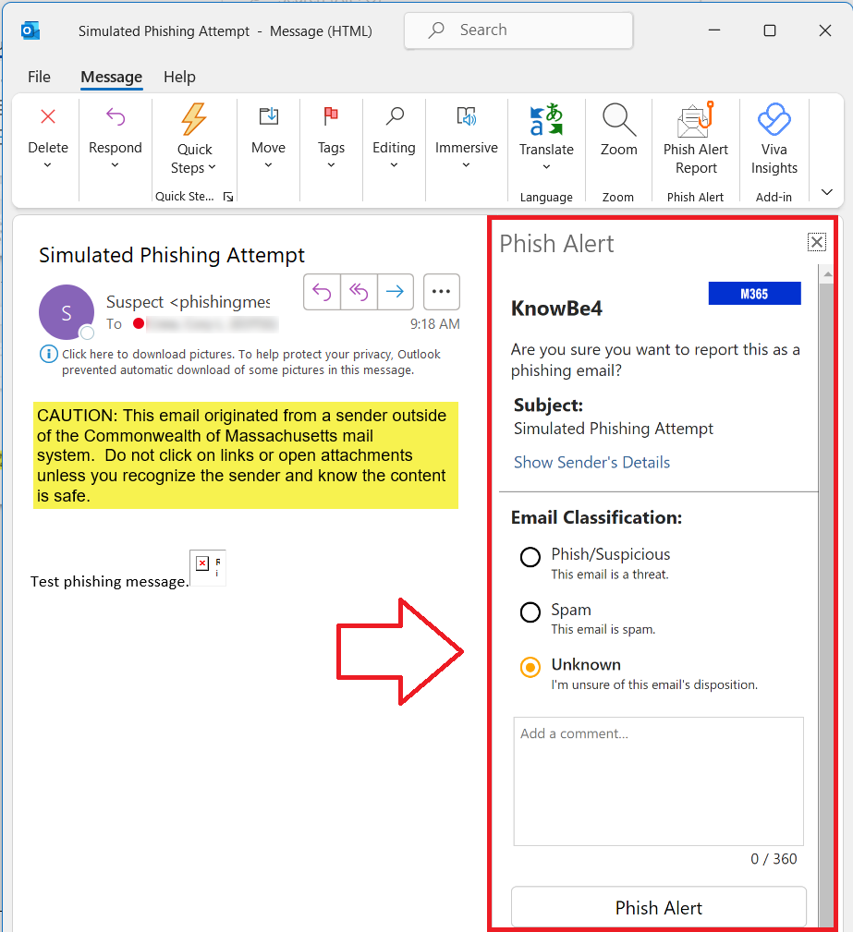
4. After classifying the suspect message and entering your comments, click the Phish Alert button.
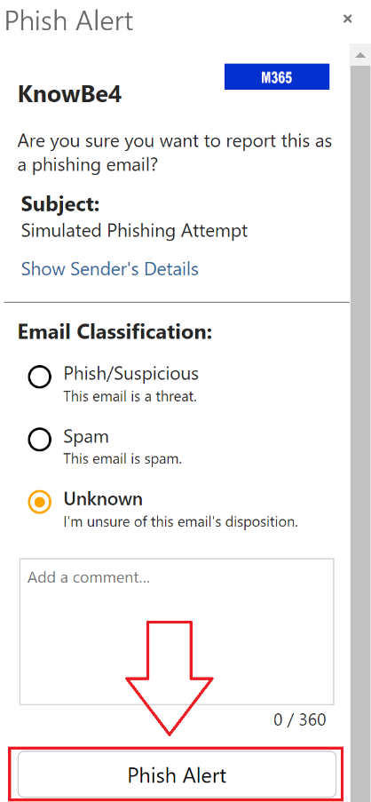
5. After clicking the Phish Alert button you will receive a confirmation popup that the suspect message was successfully reported to the EOTSS SOC.
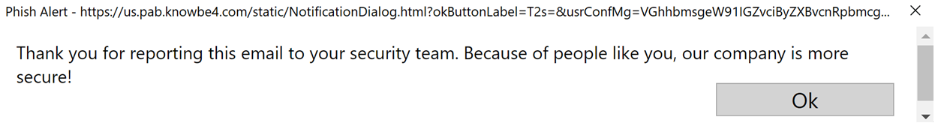

Web
1. With a message selected, the PAB icon () should be visible on the righthand side of the screen.
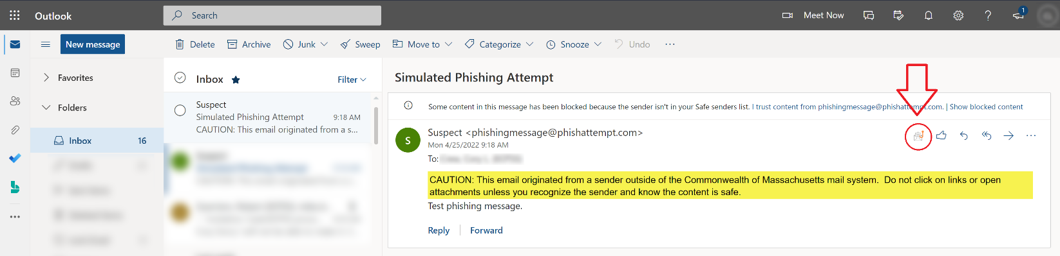
2. When viewing a suspected message, click the PAB to the initiate the reporting process. This will allow you to classify the message as either Phish/Suspicious, Spam, or Unknown and enter comments up to 360 characters in length (optional). After classifying the suspect message and entering your comments, click the Phish Alert button.
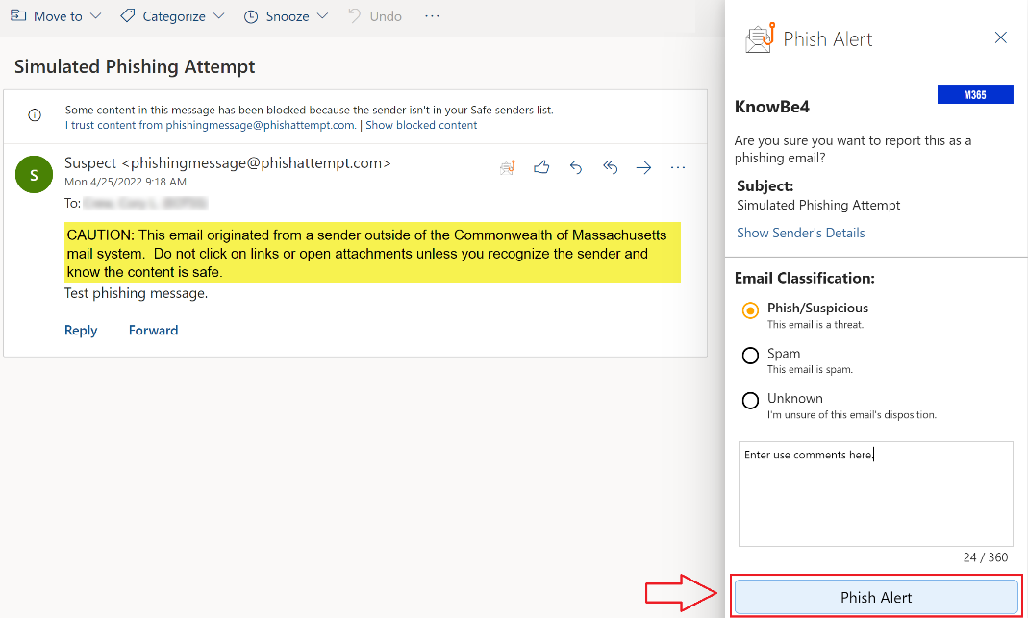
3. After clicking the Phish Alert button you will receive a confirmation popup that the suspect message was successfully reported to the EOTSS SOC.

Mobile (/ )

*The PAB is accessible on Commonwealth issued iPhones only via the Outlook mobile app, not the native mail app.
1. After selecting a suspect message, bring up the menu by clicking the three dots ( or ).
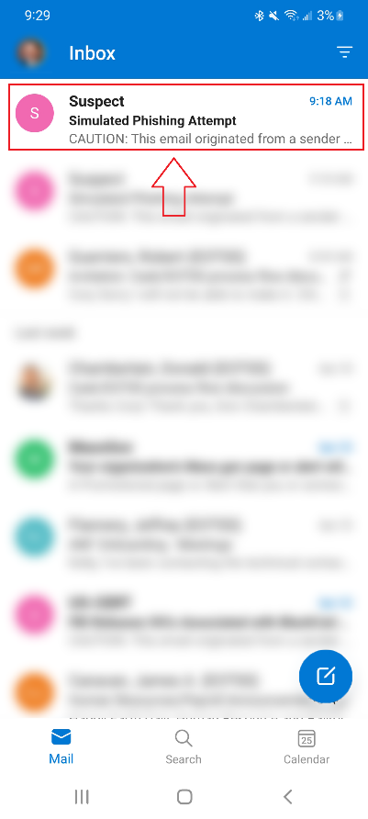
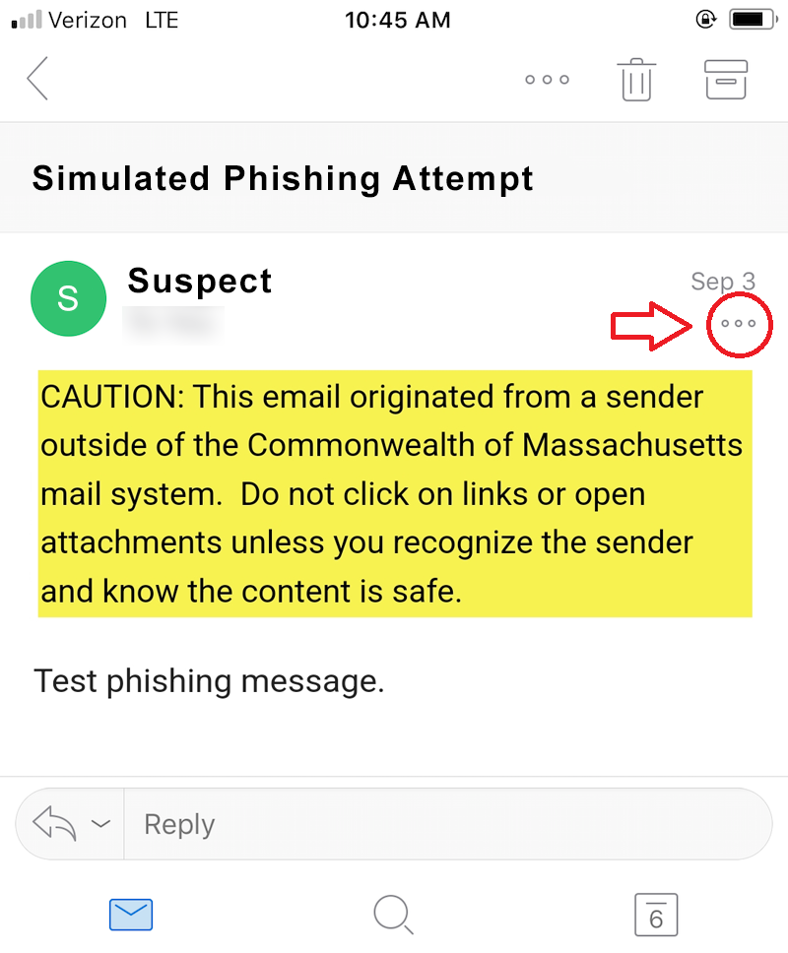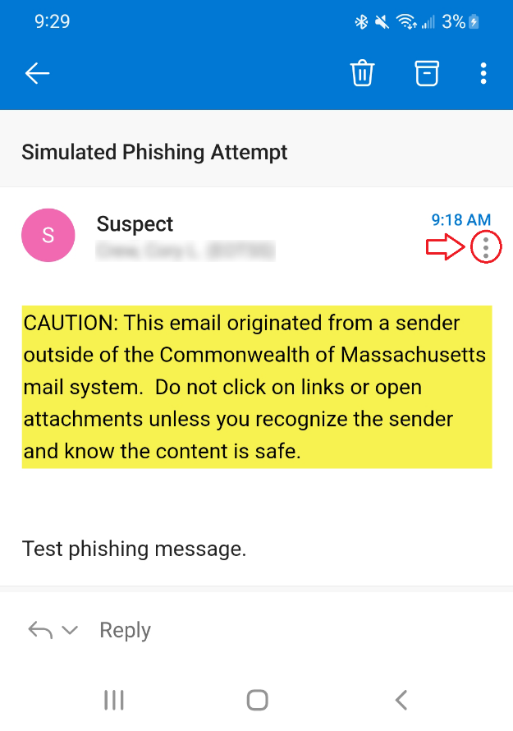

2. After opening the menu, select the PAB icon ().
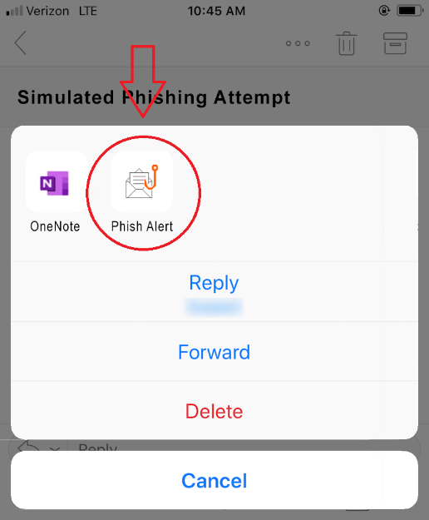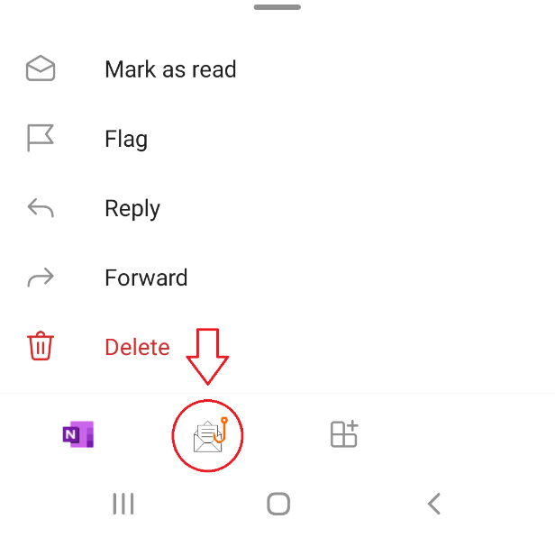

3. Classify the message as either Phish/Suspicious, Spam, or Unknown, enter your comments up to 360 characters in length (optional), and click the blue Phish Alert button.
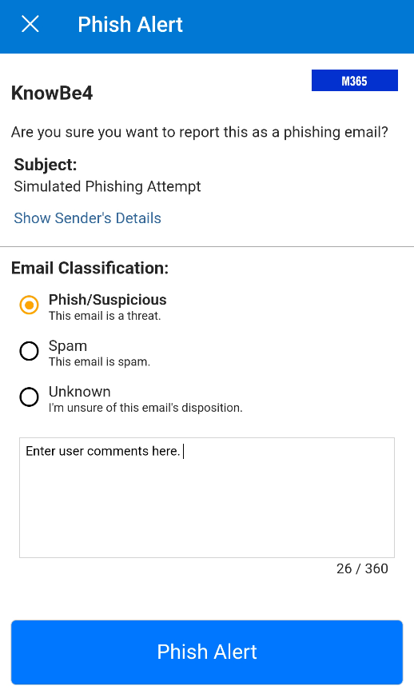
4. After clicking the Phish Alert button you will receive a confirmation that the suspect message was successfully reported to the EOTSS SOC.
