Springfield, MA Pediatric Specialty Care

November 20, 2020

Shriners Hospitals for Children—Springfield is a 40-bed pediatric specialty hospital that serves the needs of pediatric patients for a range of orthopaedic, neuromuscular, cleft lip and palate, urology, and other specialty conditions. The Hospital provides services to its patients on both an inpatient and an outpatient basis. The Hospital has a 20-bed Pediatric Inpatient Acute Rehabilitation Service (the “Inpatient Rehabilitation Service”) and a 20-bed Pediatric Service. The Hospital also provides Ambulatory Care Services, including outpatient rehabilitation. We have made the decision to discontinue the Inpatient Rehabilitation Service due to low utilization. The discontinuance of the Inpatient Rehabilitation Service will not affect current provision of inpatient Pediatric Services or Ambulatory Care Services, including outpatient rehabilitation services.

Discontinuing the Inpatient Rehabilitation Service constitutes the discontinuation, in substantial part, of an essential health service pursuant to the Department’s Hospital Licensure Regulations. In accordance with the Regulations, we are providing you with 30 days advance notice of our intent to submit to the Department a formal 90-day notice of our intent to discontinue the Inpatient Rehabilitation Service. We anticipate filing this 90-day notice on December 21, 2020. Following receipt of our notice, the Department will publish a public notice and schedule a public hearing.

Shriners Hospitals for Children - Springfield remains committed to our mission of providing the highest quality care for children with neuromusculoskeletal conditions and other special healthcare needs within a compassionate, family-centered and collaborative environment, to provide for the education of physicians and other healthcare professionals, and to conduct research to discover new knowledge that improves quality of care and quality of life of children and families regardless of the ability of a patient or family to pay.

We welcome any questions or concerns you might have and will work with the Department of Public Health throughout the process in the coming months.

Sincerely,
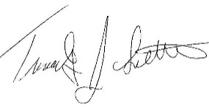
Timothy John Luttrell Chairman, Board of Governors
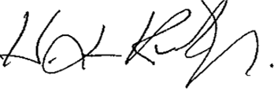
H. Lee Kirk, FACHE Hospital Administrator

516 Carew Street
Springfield, MA 01104-2396
Tel: 413-787-2000
www.shrinershospitalsforchildren.org

