May 27, 2021

Via Email
Sherman Lohnes, Esq., Director
Division of Health Care Facility Licensure and Certification
Massachusetts Department of Public Health
67 Forest Street
Marlborough, MA 01752

Re: Anna Jaques Hospital – Closure of Inpatient Pediatric Service

Dear Attorney Lohnes:
This letter is submitted on behalf of Anna Jaques Hospital (license #2006), located at 25 Highland Avenue, Newburyport, MA 01950 (the “Hospital”). Pursuant to 105 CMR 130.122, the Hospital hereby informs the Department of Public Health (“Department”) that on June 26, 2021, it intends to submit a formal ninety-day (90) notice of the proposed discontinuation of the Hospital’s Inpatient Pediatric Service.
Please note that in compliance with the Department’s regulations, the Hospital through separate correspondence is sending notice today to the Hospital’s patient and family council, each staff member of the Hospital, and every labor organization that represents the Hospital’s workforce during the period of the essential services closure process. Notice is being sent today to the members of the General Court who represent the City of Newburyport, as well as the City of Newburyport’s Mayor and City Council President.
Thank you for your attention to this matter.
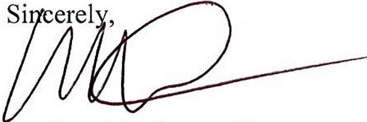
Sincerely,

Mark Goldstein, President

cc: Honorable Diana DiZoglio (Senator)
Honorable James M. Kelcourse (Representative)
Donna D. Holaday, Mayor, City of Newburyport
Jared J. Elgerman, President, City Council, City of Newburyport

S. Boyd, Esq., AJH
R. Maki, AJH
M. Schuyler, AJH

M. Taberner, Esq., AJH
S. Davis, DPH
E. Kelley, DPH
W. Mackie, DPH
R. Rodman, Esq., DPH

