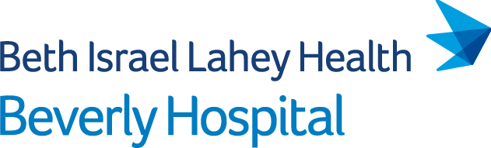
May 11, 2022
Via E-Mail
Stephen Davis, Director
Division of Health Care Facility Licensure & Certification
Massachusetts Department of Public Health
67 Forest Street
Marlborough, MA 01752
Stephen.davis@mass.gov
Re: Beverly Hospital- Closure of Birth Center Services
Dear Mr. Davis:
This letter is submitted on behalf of Beverly Hospital (license #V93D) located at 85 Herrick Street Beverly, MA 01915 (the "Hospital"). Pursuant to 105 CMR 130.122, the Hospital hereby informs the Department of Public Health ("Department") that on June 10, 2022, it intends to submit a formal ninety (90) day notice of the proposed discontinuation of the Hospital's outpatient Birth Center Service.
Please note that in compliance with the Department's regulations, the Hospital through separate correspondence is sending notice today to the Hospital's patient and family council, each staff member of the Hospital, and every labor organization that represents the Hospital's workforce during the period of the essential services closure process. Notice is being sent today to the members of the General Court who represent the City of Beverly as well as the City of Beverly's Mayor and City Council President.
Thank you for your attention to this matter.

Sincerely,
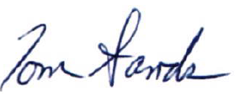
Tom Sands, President
cc: Honorable Joan Lovely (Senator)
Honorable Jerry Parisella (Representative)
Michael P. Cahill, Mayor, City of Beverly
Julie R. Flowers, President, City Council, City of Beverly
M. Cosgrove, Sr. Associate General Counsel, Beth Israel Lahey Health
M. Gendreau, Chief Medical Officer, Beverly Hospital
K. Perryman, Chief Nursing Officer, Beverly Hospital
M. Schuyler, Vice President, Government Affairs, Beth Israel Lahey Health
T: 978-922-3000
85 Herrick Street
Beverly, MA 01915
beverlyhospital.org

