9001 Liberty Parkway
Birmingham, AL 35242
205.967.7116 encompasshealth.com
November 2, 2020
Attn: Walter Mackie
Licensure Unit Coordinator
Division of HealthCare Facility Licensure – Certification
Massachusetts Department of Public Health
67 Forest Street
Marlborouhgh, MA 01752
Re: 120 Day Notice of Intent to Submit 90 Day Notice to Discontinue Services
Encompass Health Rehabilitation Hospital of New England (Hospital)
2 Rehabilitation Way, Woburn, MA 01801
State License Number: 2329
Encompass Health Rehabilitation Hospital of New England Outpatient Clinic at Billerica
267 Boston Road, Suite 20, Billerica, MA 01862
Dear Mr. Mackie,
Pursuant to 105 CMR 130: 122, I am writing to inform you of our intent to close outpatient services at Encompass Health Rehabilitation Hospital of New England. Encompass Health Rehabilitation Hospital of New England outpatient services are located at 2 Rehabilitation Way, Woburn, MA and off site at 267 Boston Road, Suite 20, Billerica, MA.
The effective date for closure is March 2, 2021 which will meet the 120 day notice of intent to discontinue services. The Final Notice to the Department will be submitted at least 90 calendar days prior to March 2, 2021.
Should you have any questions or need additional information at this time, please contact me at the information below.
Sincerely,
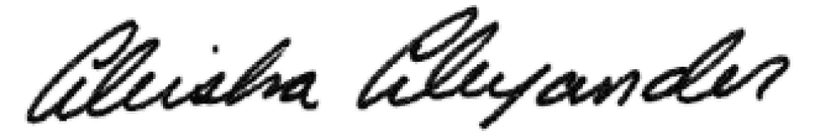
Aleisha Alexander
Provider Enrollment Specialist
O 205 970-7739 IF 205 262-7201 IE aleisha.alexander@encompasshealth.com
Encompass Health Corporation
9001 Liberty Parkway I Birmingham, Al 35242

