Suggested citation:
Bureau of Infectious Disease and Laboratory Sciences
Hepatitis C Virus Infection Surveillance Report, 2017 – 2021

Massachusetts Department of Public Health, Bureau of Infectious Disease and Laboratory Sciences. Hepatitis C Virus Infection 2017-2021 Surveillance Report. http://www.mass.gov/eohhs/gov/departments/dph/programs/id/. Published January 2023. Accessed [date].

Bureau of Infectious Disease and Laboratory Sciences
Massachusetts Department of Public Health
Jamaica Plain Campus/State Public Health Laboratory 305 South Street
Jamaica Plain, MA 02130

To speak to the on-call epidemiologist
Tel: (617) 983-6800

Questions about infectious disease reporting
Tel: (617) 983-6801

Requests for additional data
https://www.mass.gov/infectious-disease-surveillance-reporting-and-control

Acknowledgments
This report was prepared by the following MDPH staff: Erin Mann, MPH
Kate Hamdan, MPH

Massachusetts Department of Public Health Bureau of Infectious Disease and Laboratory Sciences

Hepatitis C Virus (HCV) Infection Data Summary 2017-2021

Table of Contents
Introduction and Case Definition Overview 1
Number of HCV Cases by Year 5
Number of Perinatal HCV Cases by Year 6
Graph of Number of HCV Cases by Year 7
Number and Rate of HCV Cases by Year and Age Group 8
Number of HCV Cases by Race and Year 9
Number of HCV Cases by Hispanic Ethnicity and Year 10
Number of Confirmed HCV Cases by Risk Factor and Year 11
Graph of HCV Cases by Age and Sex 2018 12
Graph of HCV Cases by Age and Sex 2021 13
Graph of HCV Cases by Age and Risk Factor 2018-2021 14
Number and Rate of HCV Cases Aged 15-39 by Year 15
Graph of Number and Rate of HCV Cases Aged 15-39 by Year 16
Graph of Percent of HCV Cases Aged 15-39 Years by Sex and Year 17
Number of HCV Cases by County and Year 2017-2021 18
Map of Number of HCV Cases by City/Town 2021 19
Rate of HCV Cases by County and Year 2017-2021 20
Map of Rate of HCV Cases by City/Town 2021 21
Number of HCV Cases Aged 15-39 Years by County and Year 2017-2021 22
Map of Number of HCV Cases Aged 15-39 by City/Town 2021 23
Rate of HCV Cases Aged 15-39 by County and Year 2017-2021 24
Map of Rate of HCV Cases Aged 15-39 by City/Town 2021 25
Map of Number of Recent Evidence of HCV Infection 2017-2021 26
Map of Rate of Recent Evidence of HCV Infection 2017-2021 27
Map of Number of Recent Evidence of HCV Infection in those Aged 15-39 2017-2021 28
Map of Rate of Recent Evidence of HCV Infection in those Aged 15-39 2017-2021 29

Massachusetts Department of Public Health Bureau of Infectious Disease and Laboratory Sciences

Hepatitis C Virus Infection Data Summary 2017-2021

Introduction

This data summary contains detailed tables and figures describing hepatitis C virus (HCV) infections in Massachusetts (MA) between the years 2017 and 2021. HCV infections continue to account for significant morbidity and mortality in the Commonwealth and nationwide.

Several notable findings in this report include:

- The highest number of confirmed and probable HCV cases reported in Massachusetts was found among those aged 29-40 years, with a majority being male (see graphs on pages 12 and 13);
- The graph on page 16 demonstrates that the 15-39 age group has a higher rate of HCV infection compared to all other age groups combined; and
- Data stratified by county and city as seen on pages 18-23 continue to show that HCV infections occur statewide, in rural, suburban, and urban communities.

New to this report is a table on page 6 of confirmed perinatal HCV infections, applying the 2018 case definition. While case counts are low, screening practices for infection among infants born to HCV-positive persons are not yet comprehensive nor uniform in their application, leading to incomplete case ascertainment. Since standardized classification of perinatal cases was not possible until 2018, figures on pages 12-14 exclude 2017 data in order to accurately represent the burden of reported HCV infection among infants.

Beginning in 2016, a revised surveillance case definition for the reporting of acute and chronic HCV infections was adopted. It contained significant differences from prior definitions, primarily focusing on improving acute case capture and specifying what is considered evidence of infection for confirmed cases. An updated definition applied in 2020 allowed for more permissive identification of acute cases, removing the requirement for specific symptoms to be associated with a case report. Please refer to the

2016 surveillance report (available at www.mass.gov/hepc) for additional detail on the changes to the case definition.

There are a few nuances to consider when reading and interpreting this report, which include the following:

- The first table of this report displays the number of confirmed acute and chronic cases as well as probable acute and chronic cases, but excludes perinatal cases (see pages 3-4 for case definitions.) For the remainder of the report, the case count combines acute, chronic, and perinatal infection.

- The graph on page 7 displays a noticeable downward trend in total HCV cases, with the most notable decrease occurring between 2018 and 2020. An increase in RNA reflex testing, including automatic HCV RNA reflexing at the State Public Health Laboratory as of July 2018, has allowed for a more resolute classification of those cases. The numbers in 2018 and 2019 are a clearer representation since RNA results verify active or resolved infections. Additionally, exploratory analysis of the data available showed that there was no single variable driving (confounding) the change; after controlling for age, gender, race, ethnicity, risk, geographic location, and examination of lab data, HCV case counts were still decreasing. This indicates that case counts are truly decreasing and suggests that prevention efforts are having a positive impact.

- It is critical to note the COVID-19 pandemic’s effect on identification of HCV cases beginning in 2020. Significant changes in access to medical services, including HCV testing, likely account for some portion of the decreases observed in HCV case counts in 2020. The 2021 case count is slightly higher, potentially evidence of individuals seeking services that were delayed due to the pandemic. Data from 2020 and 2021 should thus be interpreted with caution.

- The table on page 11 describing reported risk factors focuses only on confirmed cases, as forms requesting risk history data for

Massachusetts Department of Public Health Bureau of Infectious Disease and Laboratory Sciences

Hepatitis C Virus Infection Data Summary 2017-2021

probable cases were no longer sent beginning in 2016. The graph displayed on page 14, in contrast, describes both confirmed and probable cases by age and risk factor.

- The tables describing the number of confirmed and probable HCV infections displayed by county and year (on page 18) show an increase in the number of cases with an unknown county of residence in 2017 and 2018. This issue is related to federal regulations [42 CFR Part 2] that protect the confidentiality of a patient’s substance use disorder treatment records (which include a person’s address) for any person who has sought treatment, or been diagnosed with substance use disorder, at a federally assisted program. Many of these programs had not obtained client consent to disclose information, thus resulting in missing data for those years; this issue was resolved for 2019 data onward.

- This report continues with the same methodology as the previously published report of including incarcerated individuals for reporting case count and rate data for the maps on pages 19, 21, 23, and 25-
29. A unique border is used to indicate which cities and towns include correctional facilities, to help explain why some jurisdictions may have a higher count than others.

- There are a variety of maps included in this report, each representing a different set of data: (1) The maps on pages 19 and 21 display all confirmed and probable cases; (2) the maps on pages 23 and 25 display the highest incidence population only (those aged 15-39 at the time of diagnosis), and; (3) the maps on pages 26-29 display the number and rate of individuals with recent evidence of ongoing HCV infection (i.e., those with positive RNA or genotype results between 2017 and 2021, and without subsequent negative results indicative of clearance of infection). This represents individuals who could have been diagnosed and reported prior to 2017, but who have ongoing infection as evidenced by laboratory results obtained between 2017 and 2021. On pages 28 and 29, only the 15-39 age group is shown.
- When data are displayed by city/town, please note that each case is reported by their place of residence at the time of diagnosis and does not necessarily represent the place the case acquired infection.

- New to this report is the use of denominators estimated by the University of Massachusetts Donahue Institute using a modified Hamilton-Perry model instead of the 2010 Census Bureau data that was used in previous reports. Therefore, the rates and trends calculated using previous methods cannot be compared to these.

References

  - Centers for Disease Control and Prevention. National Notifiable Diseases Surveillance System (NNDSS). Retrieved March 15, 2018, from https://wwwn.cdc.gov/nndss/conditions/hepatitis-c- acute/

  - Centers for Disease Control and Prevention. National Notifiable Diseases Surveillance System (NNDSS). Retrieved March 15, 2018, from https://wwwn.cdc.gov/nndss/conditions/hepatitis-c- chronic/

  - Centers for Disease Control and Prevention. National Notifiable Diseases Surveillance System (NNDSS). Retrieved November 20, 2020, from https://wwwn.cdc.gov/nndss/conditions/hepatitis-c- perinatal-infection/case-definition/2018/

  - Massachusetts Virtual Epidemiologic Network (MAVEN), Bureau of Infectious Disease, Massachusetts Department of Public Health, 305 South Street, Jamaica Plain, MA 02130

Massachusetts Department of Public Health Bureau of Infectious Disease and Laboratory Sciences

Hepatitis C Virus Infection Data Summary 2017-2021

Hepatitis C (2016)
Case Definitions
has no report of test conversion, AND has a positive HCV NAT or HCV antigen test.

Hepatitis C (2020)

Clinical criteria – An illness with discrete onset of any sign or symptom consistent with viral hepatitis (e.g., fever, headache, malaise, anorexia, nausea, vomiting, diarrhea, and abdominal pain) AND a) jaundice OR b) a peak elevated serum ALT level >200 IU/L during the period of acute illness.

Laboratory criteria for diagnosis
- A positive test for antibodies to HCV
- HCV detection test: NAT for HCV RNA positive, including qualitative, quantitative, or genotype testing)
- A positive test indicating presence of HCV antigen when and if a test for HCV antigen is approved by FDA and available

Acute (2016)
Probable – A case that meets clinical criteria AND has a positive anti-HCV antibody test, but has no reports of a positive HCV NAT OR positive HCV antigen tests AND does not have test seroconversion within 12 months OR has no report of test conversion.

Confirmed – A case that meets clinical criteria AND has a positive HCV NAT OR HCV antigen, OR a documented negative HCV antibody, HCV antigen OR NAT laboratory test result followed within 12 months by a positive result of any of these tests (test conversion)

Chronic (2016)

Probable – A case that does not meet clinical criteria OR has no report of clinical criteria, AND does not have test conversion within 12 months OR has no report of test conversion, AND has a positive anti-HCV antibody test, but no report of a positive HCV NAT or positive HCV antigen test.

Confirmed – A case that does not meet clinical criteria OR has no report of clinical criteria, AND does not have test conversion within 12 months OR
Clinical Criteria - All HCV cases in each classification category should be
- 36 months of age, unless known to have been exposed non-perinatally, and have one or more of the following: Jaundice, OR peak elevated total bilirubin levels ≥ 3.0 mg/dL, OR peak elevated serum ALT levels >200 IU/L, AND the absence of a more likely diagnosis (which may include evidence of acute liver disease due to other causes or advanced liver disease due to pre-existing chronic HCV infection or other causes, such as alcohol exposure, other viral hepatitis, hemochromatosis, etc.)

Laboratory criteria for diagnosis
  - Confirmatory laboratory evidence - Positive hepatitis C virus detection test: Nucleic acid test (NAT) for HCV RNA positive (including qualitative, quantitative, or genotype testing), OR a positive test indicating presence of hepatitis C viral antigen(s) (HCV antigen)
  - Presumptive laboratory evidence - A positive test for antibodies to hepatitis C virus (anti-HCV).

No epidemiologic linkage is required for case classification.

Chronic (2020)
Probable - A case that does not meet OR has no report of clinical criteria, AND has presumptive laboratory evidence, AND has no documentation of anti-HCV or RNA test conversion within 12 months, AND does not have an HCV RNA detection test reported.

Confirmed - A case that does not meet OR has no report of clinical criteria, AND as confirmatory laboratory evidence, AND has no documentation of anti-HCV or HCV RNA test conversion within 12 months.

Massachusetts Department of Public Health Bureau of Infectious Disease and Laboratory Sciences

Hepatitis C Virus Infection Data Summary 2017-2021

Acute (2020)

Probable - A case that meets clinical criteria and has presumptive laboratory evidence, AND does not have a hepatitis C virus detection test reported, AND has no documentation of anti-HCV or HCV RNA test conversion within 12 months.

Confirmed - A case that meets clinical criteria and has confirmatory laboratory evidence, OR a documented negative HCV antibody followed within 12 months by a positive HCV antibody test (anti-HCV test conversion) in the absence of a more likely diagnosis, OR a documented negative HCV antibody OR negative hepatitis C virus detection test (in someone without a prior diagnosis of HCV infection) followed within 12 months by a positive hepatitis C virus detection test (HCV RNA test conversion) in the absence of a more likely diagnosis.

Hepatitis C, Perinatal (2018)

Laboratory criteria for diagnosis
  - HCV RNA positive test results for infants between 2 to 36 months of age; OR
  - HCV genotype test results for infants between 2 to 36 months of age or greater; OR
  - HCV antigen test results for infants between 2 to 36 months of age or greater.

Confirmed – An infant who has a positive test for HCV RNA nucleic acid amplification test (NAAT), HCV antigen, or detectable HCV genotype at
≥2 months and ≤36 months of age and is not known to have been exposed to HCV via a mechanism other than perinatal.

Massachusetts Department of Public Health
Bureau of Infectious Disease and Laboratory Sciences

Number of Confirmed and Probable Acute and Chronic HCV Cases Reported by Year, Massachusetts, 2017-2021

 | 2017 | 2018 | 2019 | 2020 | 2021
Confirmed Acute | 169 | 183 | 174 | 180 | 160
Confirmed Chronic | 4775 | 4328 | 3242 | 2044 | 2324
Probable Acute | 6 | 7 | 6 | 11 | 12
Probable Chronic | 2564 | 1979 | 1332 | 1301 | 1556
Total Cases | 7514 | 6497 | 4754 | 3536 | 4052

N=26,353
Data are current as of September 28, 2022 and are subject to change
Perinatal cases not included
The COVID-19 pandemic has had measurable impacts on infectious disease surveillance. Data from 2020-2021 should be interpreted with caution.

Massachusetts Department of Public Health
Bureau of Infectious Disease and Laboratory Sciences

Number of Confirmed Perinatal HCV Cases Reported by Year, Massachusetts, 2018-2021

 | 2018 | 2019 | 2020 | 2021
0 to <6 months old | 3 | 0 | 2 | 4
6 to <12 months old | 2 | 1 | 2 | 0
12 to <18 months old | 1 | 0 | 0 | 0
18 to <24 months old | 8 | 4 | 2 | 5
24 to <30 months old | 1 | 0 | 0 | 0
30 to <=36 months old | 1 | 0 | 1 | 0
Total Cases | 16 | 5 | 7 | 9

N=37
Data are current as of September 28, 2022 and are subject to change
The COVID-19 pandemic has had measurable impacts on infectious disease surveillance. Data from 2020-2021 should be interpreted with caution.

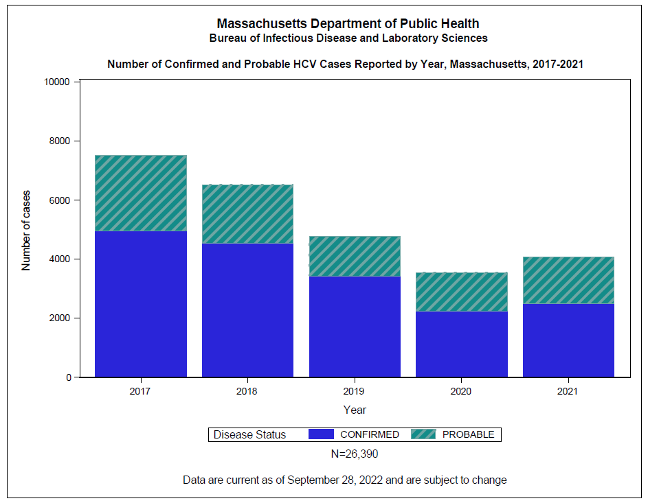
The COVID-19 pandemic has had measurable impacts on infectious disease surveillance. Data from 2020-2021 should be interpreted with caution.

Massachusetts Department of Public Health
Bureau of Infectious Disease and Laboratory Sciences

Number and Rate per 100,000 Population of Confirmed and Probable HCV Cases Reported by Year and Age Group,
Massachusetts, 2017-2021

 | 2017 N | 2017Rate | 2018 N | 2018 Rate | 2019N | 2019Rate | 2020 N | 2020Rate | 2021N | 2021Rate
0-9 | 41 | 5.6 | 25 | 3.4 | 16 | 2.2 | 13 | 1.8 | 20 | 2.7
10-19 | 102 | 11.8 | 53 | 6.1 | 38 | 4.4 | 20 | 2.3 | 26 | 3.0
20-29 | 1975 | 192.1 | 1537 | 149.5 | 968 | 94.1 | 631 | 61.4 | 586 | 57.0
30-39 | 1981 | 216.4 | 1917 | 209.4 | 1425 | 155.7 | 1065 | 116.3 | 1263 | 138.0
40-49 | 1008 | 119.9 | 918 | 109.2 | 767 | 91.2 | 574 | 68.3 | 785 | 93.4
50-59 | 1124 | 117.5 | 967 | 101.1 | 694 | 72.5 | 530 | 55.4 | 628 | 65.6
60-69 | 934 | 111.0 | 793 | 94.2 | 579 | 68.8 | 508 | 60.4 | 537 | 63.8
70+ | 241 | 30.4 | 221 | 27.8 | 197 | 24.8 | 180 | 22.7 | 195 | 24.6

308 cases with missing age were excluded from analysis.
BIDLS calculates rates per 100,000 population using denominators estimated by the University of Massachusetts Donahue Institute using a modified Hamilton-Perry model (UMDI Oct 2016: Strate S, et al. Small Area Population Estimates for 2011 through 2020, report published Oct 2016.) Note that
rates and trends calculated using previous methods cannot be compared to these.
Data are current as of September 28, 2022 and are subject to change
The COVID-19 pandemic has had measurable impacts on infectious disease surveillance. Data from 2020-2021 should be interpreted with caution.

Massachusetts Department of Public Health
Bureau of Infectious Disease and Laboratory Sciences

Number and Proportion of Confirmed and Probable HCV Cases Reported by Race and Year, Massachusetts, 2017-2021

 | 2017  N | 2017  % | 2018  N | 2018  % | 2019  N | 2019% | 2020  N | 2020% | 2021  N | 2021  %
American Indian/Alaskan Native | 10 | 0.1 | 12 | 0.2 | 6 | 0.1 | 1 | 0.0 | 9 | 0.2
Asian | 104 | 1.4 | 100 | 1.5 | 80 | 1.7 | 65 | 1.8 | 84 | 2.1
Black | 416 | 5.5 | 393 | 6.0 | 313 | 6.6 | 237 | 6.7 | 346 | 8.5
White | 3803 | 50.6 | 3313 | 50.9 | 2316 | 48.7 | 1712 | 48.3 | 2052 | 50.5
Other | 823 | 11.0 | 695 | 10.7 | 618 | 13.0 | 465 | 13.1 | 509 | 12.5
Unknown | 2358 | 31.4 | 2000 | 30.7 | 1426 | 30.0 | 1063 | 30.0 | 1061 | 26.1

Data are current as of September 28, 2022 and are subject to change
'Other' includes Native Hawaiian/Pacific Islander, races marked as other, and individuals who are listed as more than one race
The COVID-19 pandemic has had measurable impacts on infectious disease surveillance. Data from 2020-2021 should be interpreted with caution.

Massachusetts Department of Public Health
Bureau of Infectious Disease and Laboratory Sciences

Number and Proportion of Confirmed and Probable HCV Cases Reported by Hispanic Ethnicity and Year
Massachusetts, 2017-2021

 | 2017 N | 2017% | 2018 N | 2018 % | 2019 N | 2019 % | 2020 N | 2020  % | 2021  N | 2021  %
Hispanic | 734 | 9.8 | 684 | 10.5 | 5225 | 11.0 | 376 | 10.6 | 455 | 11.2
Not Hispanic | 3666 | 48.8 | 3267 | 50.2 | 2508 | 52.7 | 1861 | 52.5 | 2229 | 54.9
Unknown | 3114 | 41.4 | 2562 | 39.3 | 1726 | 36.3 | 1306 | 36.9 | 1377 | 33.9

Data are current as of September 28, 2022 and are subject to change
The COVID-19 pandemic has had measurable impacts on infectious disease surveillance. Data from 2020-2021 should be interpreted with caution.

Massachusetts Department of Public Health
Bureau of Infectious Disease and Laboratory Sciences

Number and Proportion of Confirmed HCV Cases Reported by Risk Factor and Year, Massachusetts, 2017-2021

 | 2017 N | 2017 % | 2018 N | 2018 % | 2019 N | 2019% | 2020  N | 2020% | 2021  N | 2021%
Injected drugs ever | 1922 | 38.9 | 1680 | 37.1 | 1244 | 36.4 | 585 | 26.2 | 658 | 26.4
Other risk history, excluding IDU | 74 | 1.5 | 40 | 0.9 | 42 | 1.2 | 18 | 0.8 | 20 | 0.8
No or unknown history reported | 750 | 15.2 | 627 | 13.9 | 470 | 13.7 | 271 | 12.1 | 290 | 11.6
No response | 2198 | 44.5 | 2180 | 48.2 | 1665 | 48.7 | 1357 | 60.8 | 1525 | 61.2

Risks included in 'Other' category include: receiving blood products prior to June 1992, receiving an organ transplant prior to 1992, receiving clotting factor concentrates produced prior to 1987, ever being on long-term hemodialysis, ever being a sexual contact of a confirmed or suspected HCV case, ever being a household contact of a confirmed or suspected HCV case, and ever being employed in a medical or dental field involving direct contact with human blood.

Note that 'No or unknown history reported' indicates that a case report form was received for the case, with 'No' or 'Unknown' marked for all relevant questions in the risk history. 'No response' indicates that no case report form was received for the case.

Data are current as of September 28, 2022 and are subject to change
The COVID-19 pandemic has had measurable impacts on infectious disease surveillance. Data from 2020-2021 should be interpreted with caution.

Massachusetts Department of Public Health
Bureau of Infectious Disease and Laboratory Sciences

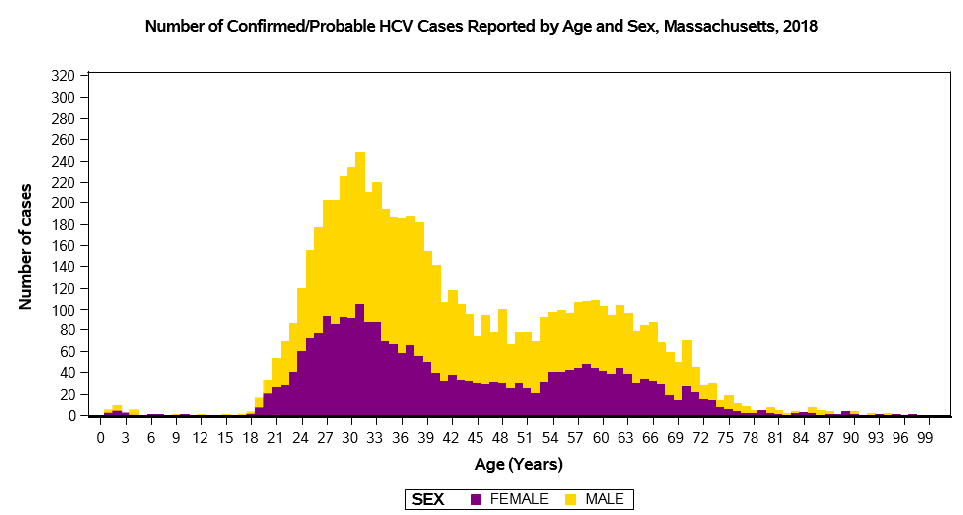

N=6,395 | 118 cases with missing age and/or sex were excluded from analysis.
Cases reported as transgender (N=5) are not depicted separately due to small numbers. Note the number of transgender individuals is likely an underestimate due to underreporting of current gender.
Data are current as of September 28, 2022, and are subject to change
The COVID-19 pandemic has had measurable impacts on infectious disease surveillance. Data from 2020-2021 should be interpreted with caution.

Massachusetts Department of Public Health
Bureau of Infectious Disease and Laboratory Sciences
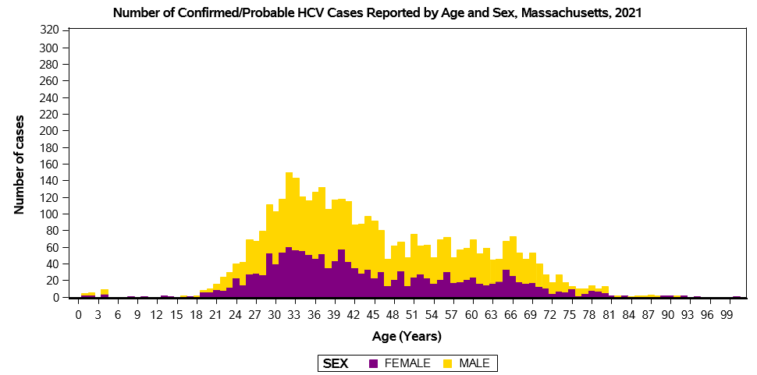

N=3,997 | 64 cases with missing age and/or sex were excluded from analysis.
Cases reported as transgender (N=7) are not depicted separately due to small numbers.
Note the number of transgender individuals is likely an underestimate due to underreporting of current gender.
Data are current as of September 28, 2022 and are subject to change

The COVID-19 pandemic has had measurable impacts on infectious disease surveillance. Data from 2020-2021 should be interpreted with caution.

Massachusetts Department of Public Health
Bureau of Infectious Disease and Laboratory Sciences

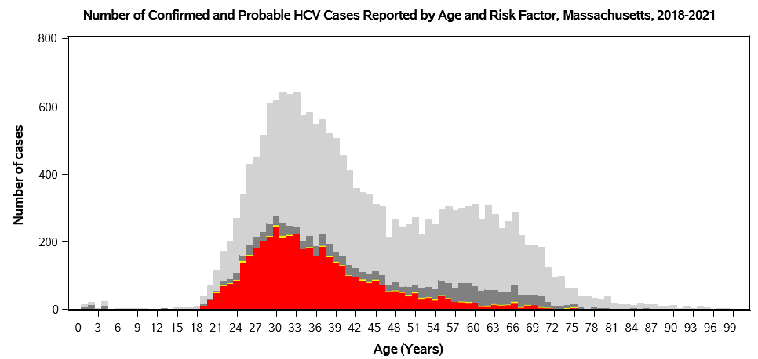
Risk
Injected drugs ever
No or unknown history reported
Other risk history, excluding IDU
No response

N=18,653 | 223 cases with missing age were excluded from analysis.
Data are current as of September 28, 2022, and are subject to change

The COVID-19 pandemic has had measurable impacts on infectious disease surveillance. Data from 2020-2021 should be interpreted with caution.

Massachusetts Department of Public Health
Bureau of Infectious Disease and Laboratory Sciences

Number and Rate per 100,000 Population of Confirmed and Probable HCV Cases Ages 15-39 vs. All Other Age Groups
Reported by Year, Massachusetts, 2017-2021

 | 2017 N | 2017Rate | 2018 N | 2018 Rate | 2019 N | 2019 Rate | 2020N | 2020Rate | 2021  N | 2021Rate
15-39 years | 4053 | 168.4 | 3505 | 145.6 | 2428 | 100.9 | 1714 | 71.2 | 1872 | 77.8
All other age groups | 3353 | 73.5 | 2926 | 64.2 | 2256 | 49.5 | 1807 | 39.6 | 2168 | 47.5

308 cases with missing age were excluded from analysis.
BIDLS calculates rates per 100,000 population using denominators estimated by the University of Massachusetts Donahue Institute using a modified Hamilton-Perry model (UMDI Oct 2016: Strate S, et al. Small Area Population Estimates for 2011 through 2020, report published Oct 2016.) Note that
rates and trends calculated using previous methods cannot be compared to these.
Data are current as of September 28, 2022 and are subject to change
The COVID-19 pandemic has had measurable impacts on infectious disease surveillance. Data from 2020-2021 should be interpreted with caution.

Massachusetts Department of Public Health
Bureau of Infectious Disease and Laboratory Sciences

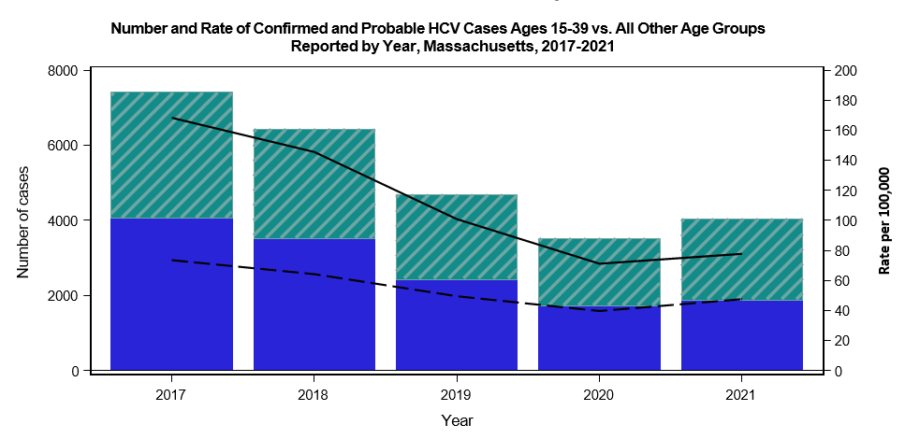

Age Group
15-39 years
15-39 years
All other age groups
All other age groups
N=26,082 | 308 cases with missing age were excluded from analysis. Data are current as of September 28, 2022, and are subject to change

The COVID-19 pandemic has had measurable impacts on infectious disease surveillance. Data from 2020-2021 should be interpreted with caution.

Massachusetts Department of Public Health
Bureau of Infectious Disease and Laboratory Sciences

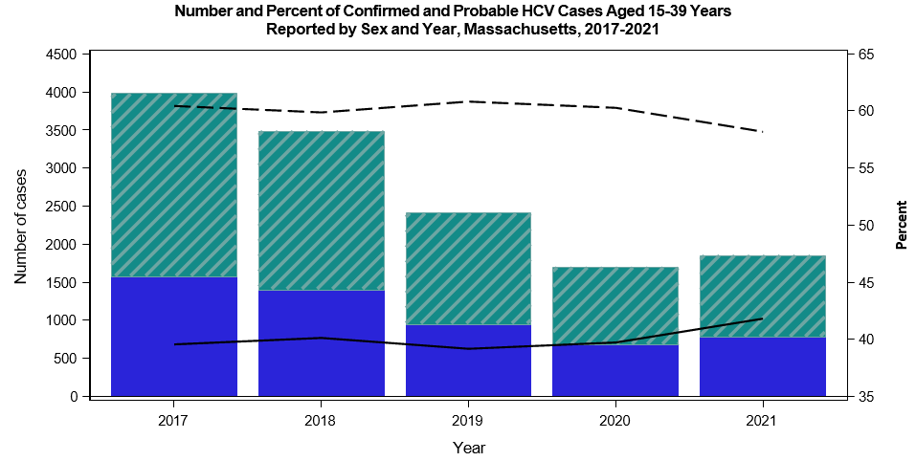

N=13,412 | 160 cases are missing sex and were excluded from analysis. Data are current as of September 28, 2022, and are subject to change

The COVID-19 pandemic has had measurable impacts on infectious disease surveillance. Data from 2020-2021 should be interpreted with caution.

Massachusetts Department of Public Health
Bureau of Infectious Disease and Laboratory Sciences

Number of Confirmed and Probable HCV Cases Reported by County and Year, Massachusetts, 2017-2021

 | 2017 | 2018 | 2019 | 2020 | 2021
BERKSHIRE COUNTY | 163 | 177 | 134 | 113 | 152
BRISTOL COUNTY | 823 | 688 | 426 | 313 | 351
CAPE AND ISLANDS | 272 | 209 | 163 | 108 | 108
ESSEX COUNTY | 707 | 592 | 446 | 303 | 339
FRANKLIN COUNTY | 77 | 69 | 59 | 43 | 43
HAMPDEN COUNTY | 585 | 600 | 482 | 385 | 345
HAMPSHIRE COUNTY | 91 | 105 | 62 | 60 | 53
MIDDLESEX COUNTY | 1249 | 954 | 706 | 543 | 565
NORFOLK COUNTY | 550 | 446 | 331 | 230 | 289
PLYMOUTH COUNTY | 495 | 442 | 333 | 230 | 256
SUFFOLK COUNTY | 975 | 809 | 645 | 543 | 932
WORCESTER COUNTY | 927 | 802 | 547 | 386 | 397
UNKNOWN COUNTY | 600 | 620 | 425 | 286 | 231
TOTAL | 7514 | 6513 | 4759 | 3543 | 4061

N=26,390
The Cape and Islands are comprised of Barnstable, Dukes, and Nantucket Counties.
Data are current as of September 28, 2022 and are subject to change
The COVID-19 pandemic has had measurable impacts on infectious disease surveillance. Data from 2020-2021 should be interpreted with caution.

19
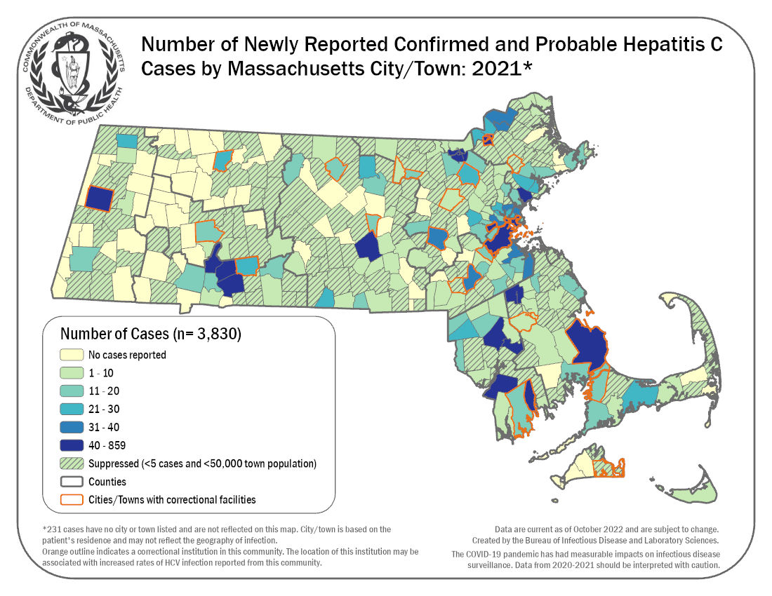

Massachusetts Department of Public Health 20
Bureau of Infectious Disease and Laboratory Sciences

Rate per 100,000 Population of Confirmed and Probable HCV Cases Reported by County and Year, Massachusetts, 2017-2021

 | 2017 | 2018 | 2019 | 2020 | 2021
ALL MASSACHUSETTS | 99.2 | 84.6 | 62.2 | 46.8 | 55.0
BERKSHIRE COUNTY | 128.7 | 139.7 | 105.8 | 89.2 | 120.0
BRISTOL COUNTY | 144.1 | 120.4 | 74.6 | 54.8 | 61.4
CAPE AND ISLANDS | 110.8 | 85.2 | 66.4 | 44.0 | 44.0
ESSEX COUNTY | 88.6 | 74.2 | 55.9 | 38.0 | 42.5
FRANKLIN COUNTY | 108.0 | 96.8 | 82.8 | 60.3 | 60.3
HAMPDEN COUNTY | 124.4 | 127.6 | 102.5 | 81.9 | 73.4
HAMPSHIRE COUNTY | 55.2 | 63.7 | 37.6 | 36.4 | 32.2
MIDDLESEX COUNTY | 76.8 | 58.7 | 43.4 | 33.4 | 34.7
NORFOLK COUNTY | 76.9 | 62.3 | 46.3 | 32.1 | 40.4
PLYMOUTH COUNTY | 93.7 | 83.7 | 63.0 | 43.5 | 48.5
SUFFOLK COUNTY | 120.1 | 99.7 | 79.5 | 66.9 | 114.8
WORCESTER COUNTY | 110.7 | 95.7 | 65.3 | 46.1 | 47.4

BIDLS calculates rates per 100,000 population using denominators estimated by the University of Massachusetts Donahue Institute using a modified Hamilton-Perry model (UMDI Oct 2016: Strate S, et al. Small Area Population Estimates for 2011 through 2020, report published Oct 2016.) Note that
rates and trends calculated using previous methods cannot be compared to these. The Cape and Islands are comprised of Barnstable, Dukes, and Nantucket Counties.
Does not include cases where county is unknown.
Data are current as of September 28, 2022 and are subject to change.
The COVID-19 pandemic has had measurable impacts on infectious disease surveillance. Data from 2020-2021 should be interpreted with caution.

21
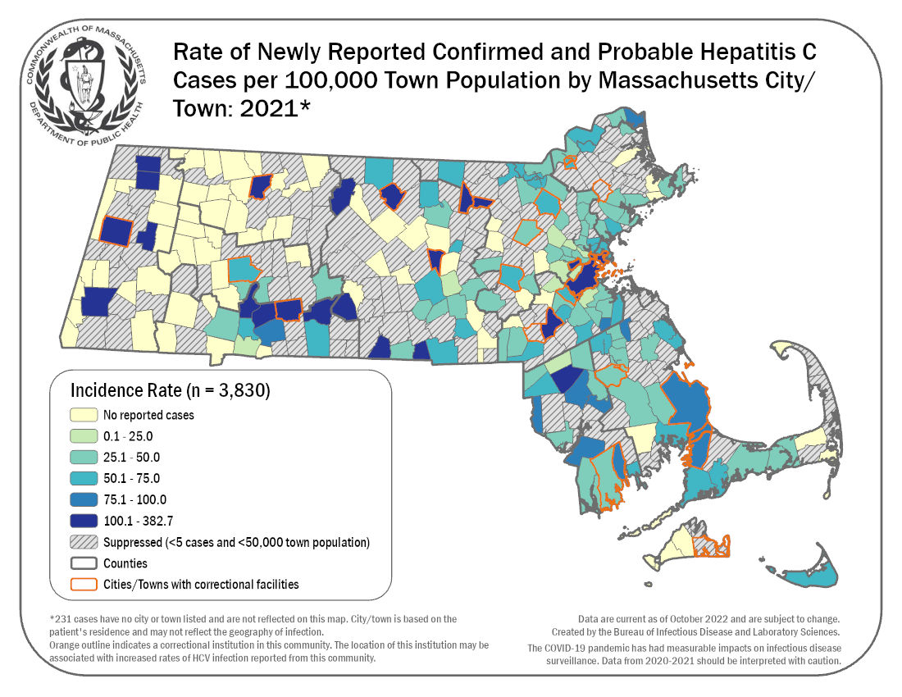

Massachusetts Department of Public Health 22
Bureau of Infectious Disease and Laboratory Sciences

Number of Confirmed and Probable HCV Cases Aged 15-39 Years Reported by County and Year, Massachusetts, 2017-2021

 | 2017 | 2018 | 2019 | 2020 | 2021
ALL MASSACHUSETTS | 4053 | 3505 | 2428 | 1714 | 1872
BERKSHIRE COUNTY | 89 | 116 | 77 | 69 | 79
BRISTOL COUNTY | 488 | 387 | 234 | 154 | 173
CAPE AND ISLANDS | 139 | 110 | 81 | 63 | 57
ESSEX COUNTY | 364 | 312 | 209 | 132 | 146
FRANKLIN COUNTY | 43 | 42 | 37 | 20 | 25
HAMPDEN COUNTY | 329 | 323 | 245 | 191 | 170
HAMPSHIRE COUNTY | 47 | 57 | 42 | 27 | 23
MIDDLESEX COUNTY | 624 | 476 | 353 | 253 | 242
NORFOLK COUNTY | 298 | 231 | 163 | 108 | 126
PLYMOUTH COUNTY | 274 | 246 | 169 | 121 | 124
SUFFOLK COUNTY | 495 | 421 | 325 | 251 | 413
WORCESTER COUNTY | 549 | 431 | 285 | 177 | 182
UNKNOWN COUNTY | 314 | 353 | 208 | 148 | 112

The Cape and Islands are comprised of Barnstable, Dukes, and Nantucket Counties.
Data are current as of September 28, 2022 and are subject to change.
The COVID-19 pandemic has had measurable impacts on infectious disease surveillance. Data from 2020-2021 should be interpreted with caution.

23
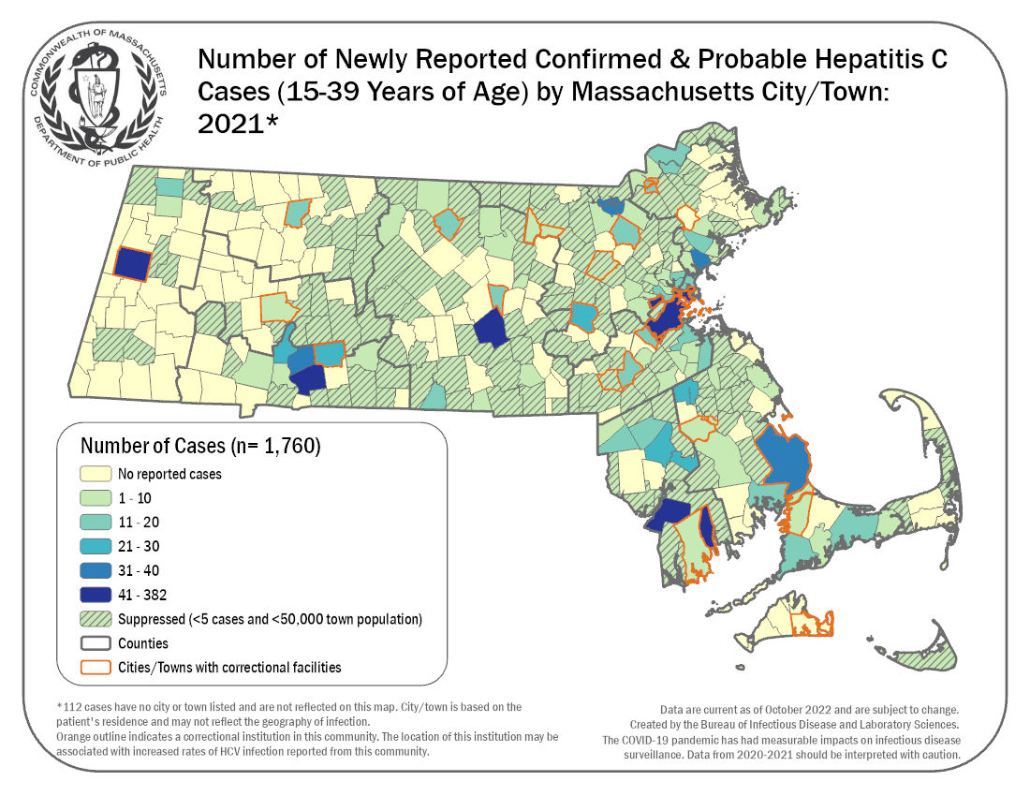

.

Massachusetts Department of Public Health 24
Bureau of Infectious Disease and Laboratory Sciences

Rate per 100,000 Population of Confirmed and Probable HCV Cases Aged 15-39 Years Reported by County and Year,
Massachusetts, 2017-2021

 | 2017 | 2018 | 2019 | 2020 | 2021
ALL MASSACHUSETTS | 155.3 | 131.0 | 92.2 | 65.1 | 73.1
BERKSHIRE COUNTY | 237.0 | 308.9 | 205.1 | 183.7 | 210.4
BRISTOL COUNTY | 267.5 | 212.1 | 128.3 | 84.4 | 94.8
CAPE AND ISLANDS | 231.6 | 183.3 | 135.0 | 105.0 | 95.0
ESSEX COUNTY | 144.3 | 123.7 | 82.8 | 52.3 | 57.9
FRANKLIN COUNTY | 206.3 | 201.5 | 177.5 | 95.9 | 119.9
HAMPDEN COUNTY | 208.3 | 204.5 | 155.1 | 121.0 | 107.7
HAMPSHIRE COUNTY | 66.6 | 80.7 | 59.5 | 38.2 | 32.6
MIDDLESEX COUNTY | 107.4 | 81.9 | 60.7 | 43.5 | 41.6
NORFOLK COUNTY | 129.0 | 100.0 | 70.6 | 46.8 | 54.5
PLYMOUTH COUNTY | 173.0 | 155.3 | 106.7 | 76.4 | 78.3
SUFFOLK COUNTY | 131.6 | 112.0 | 86.4 | 66.8 | 109.8
WORCESTER COUNTY | 197.0 | 154.7 | 102.3 | 63.5 | 65.3

BIDLS calculates rates per 100,000 population using denominators estimated by the University of Massachusetts Donahue Institute using a modified Hamilton-Perry model (UMDI Oct 2016: Strate S, et al. Small Area Population Estimates for 2011 through 2020, report published Oct 2016.) Note that
rates and trends calculated using previous methods cannot be compared to these. The Cape and Islands are comprised of Barnstable, Dukes, and Nantucket Counties.
Does not include cases where county is unknown.
Data are current as of September 28, 2022 and are subject to change.
The COVID-19 pandemic has had measurable impacts on infectious disease surveillance. Data from 2020-2021 should be interpreted with caution.

25
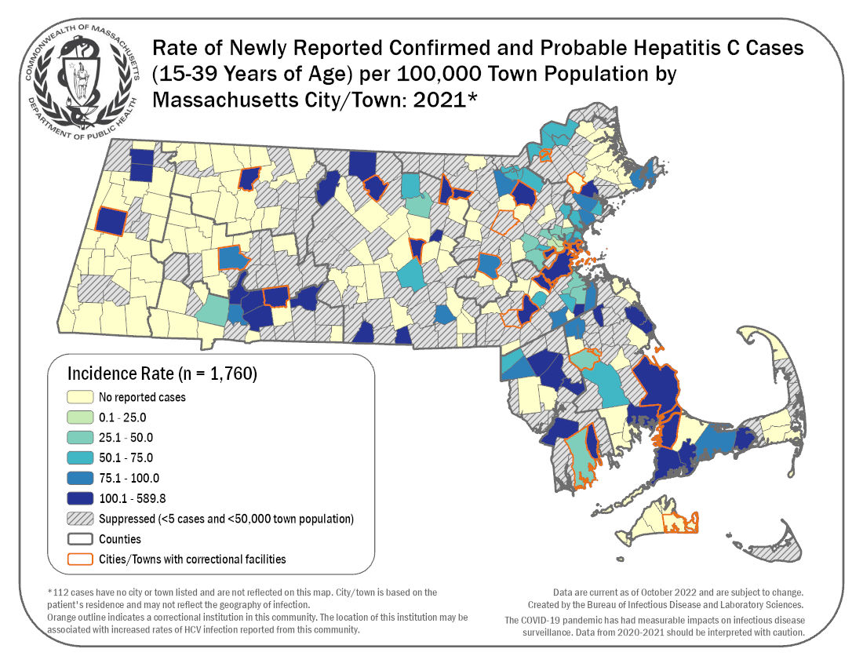

26
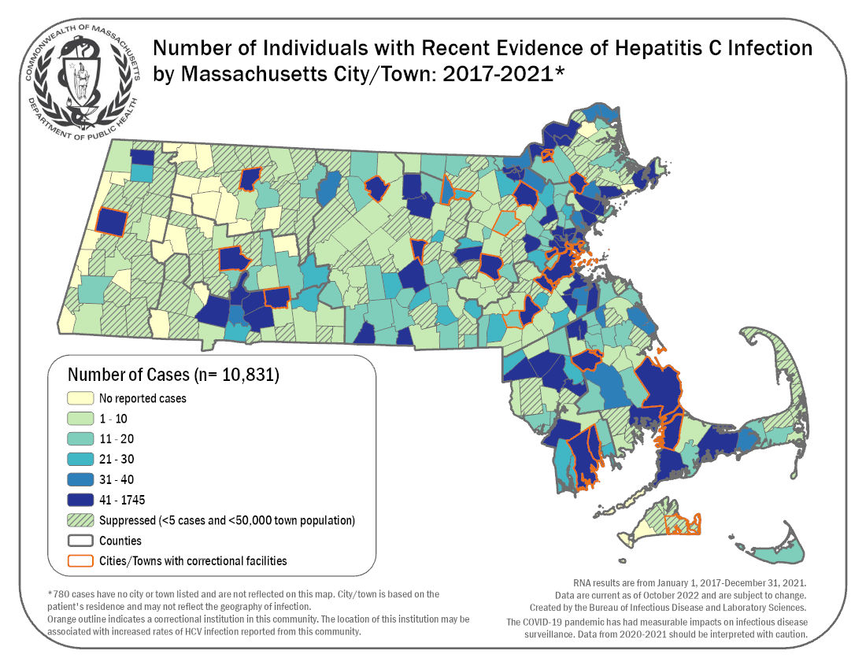

27
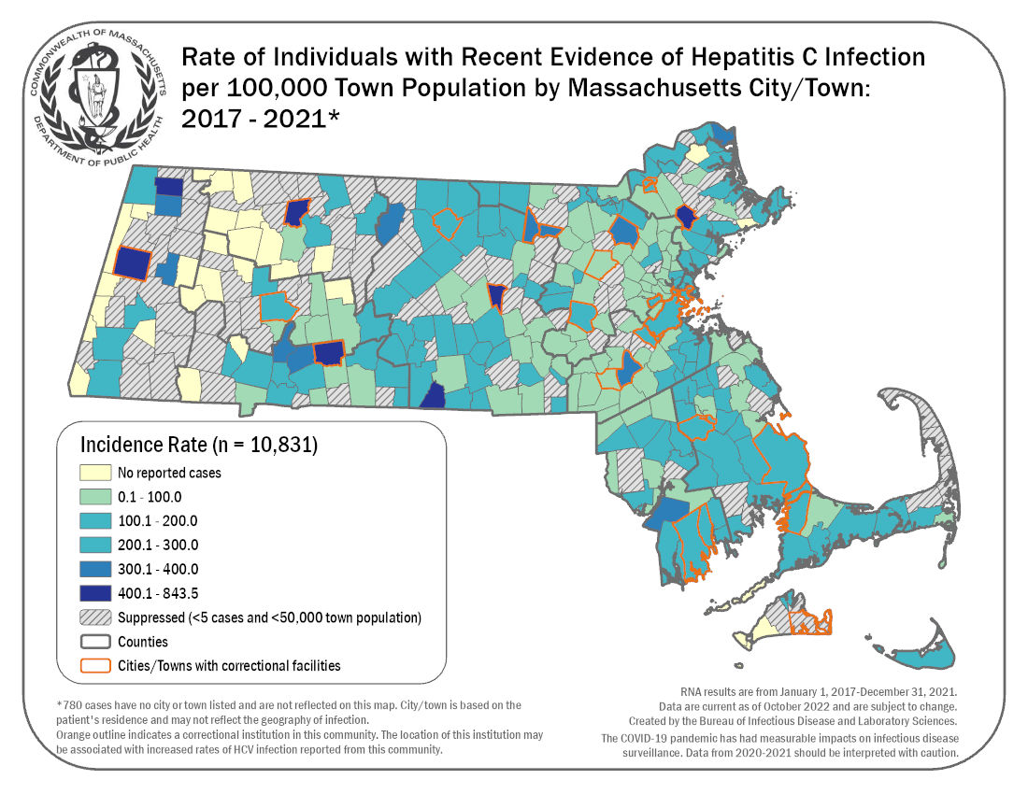

28
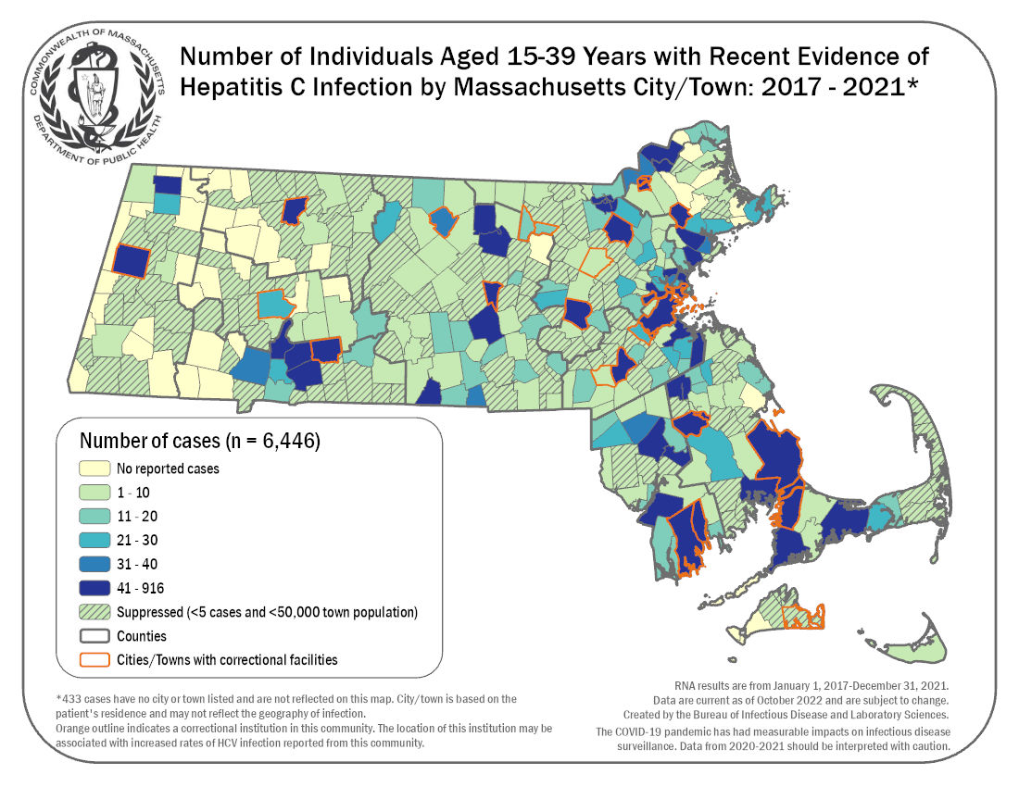

29
