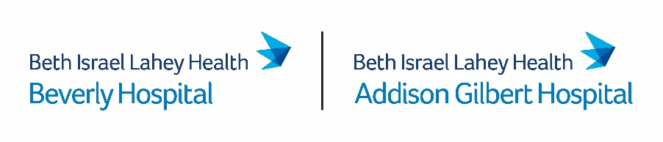
June 10, 2022

Via E-Mail

Stephen Davis, Director
Division of Health Care Facility Licensure & Certification
Massachusetts Department of Public Health
67 Forest Street
Marlborough, MA 01752
Stephen.davis@mass.gov

Re: Beverly Hospital- 90-day Notice of Closure of Birth Center Services
Dear Mr. Davis:
This letter is submitted on behalf of Beverly Hospital (license #V93D) located at 85 Herrick Street Beverly, MA 01915 (the “Hospital”) in follow up to the initial essential services closure notice that the Hospital filed with the Department of Public Health (the “Department”) on May 11, 2022. Pursuant to 105 CMR 130.122(B), the Hospital hereby provides the required ninety (90) day notice to the Department of its intent to discontinue operation of its outpatient Birth Center Service (the “Service”).
As required by the Department’s regulations, below please find: (i) current utilization rates for the Service; (ii) the anticipated impact for individuals in the Hospital’s service area; (iii) the date set for discontinuation; (iv) the names and addresses of any organized health care coalitions and community groups known to the Hospital as of the date of this notice; and (v) a detailed account of any community engagement and planning that has occurred prior to submission of this notice.
- Current Utilization Rates. The following table details the Service for the last three fiscal years (“FY”), including FY22 through May. As evidenced by the data below, less than 30% of Birth Center patients, on average, have delivered at the Birth Center location in the last three fiscal years. Rather, well over 70% of Birth Center patients have delivered at the Hospital.
 | FY19 | FY20 | FY21 | FY22 through May
Total Birth Center Patient Deliveries (both at Birth Center and at Hospital) | 217 | 188 | 228 | 139
Total Birth Center Patient Deliveries at the North Shore Birth Center | 51 | 55 | 77 | 9
Total Birth Center Patient Deliveries at the Hospital | 166 | 133 | 151 | 130

- Impact of Discontinuance. The Hospital does not anticipate a negative impact on patient access following the closure of the Service, especially since the vast majority of Birth Center patients have delivered at the Hospital in the last few years. Following the closure of the Service, patients will continue to have access to professional midwifery services through the Hospital’s affiliated OB/GYN providers. In addition, the Hospital will continue to ensure that patient-engaged doulas are available for patients delivering at the Hospital. Finally, the Hospital is working diligently to explore options for water births for patients who desire a water birth.

- Date of Discontinuance. This ninety (90) day notice is hereby provided for a target closure date of September 8, 2022.

- Health Care Coalitions and Community Groups. The Hospital anticipates that the following community groups may have an interest in the discontinuation of the Service:

Campaign to Save the North Shore Birth Center
Lead Contact: Emilee Regan, emileearegan@gmail.com

- Community Engagement and Planning Activities Prior to the Notice of Closure. The Hospital has undertaken the following community engagement and planning activities with respect to the planned closure:

- May 11, 2022 – Communicated with state and local representatives and officials, including Senator Joan Lovely, Senator Bruce Tarr, Representative Jerry Parisella, Representative Ann-Margaret Ferrante, Mayor Michael Cahill (Beverly), Mayor Greg Verga (Gloucester), and Beverly City Council President Julie Flowers regarding the Hospital’s plans to close the Service.

- May 11, 2022 – Communicated with the Hospital’s Board of Trustees regarding the closure of the Service.

- May 11, 2022 – Email notice of closure provided to the Hospital’s medical staff and employees, Massachusetts Nurses Association (MNA), Massachusetts Senators and Representatives for Beverly, local officials of Beverly, Beverly City Council members, and the Hospital’s Patient Family Advisory Committee (PFAC).

- June 3, 2022 – Hospital leadership hosted a virtual listening session with members of the Campaign to Save the North Shore Birth Center.

If you require further information with respect to this matter, please contact Meg Cosgrove, Senior Associate General Counsel at (781) 510-1363.
Sincerely,

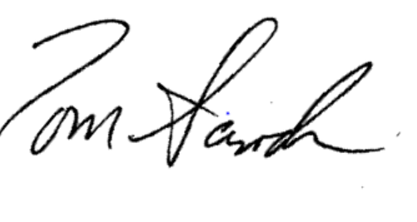

Tom Sands, President, FACHE

cc: M. Gendreau, Chief Medical Officer, Beverly Hospital
K. Perryman, Chief Nursing Officer, Beverly Hospital
M. Schuyler, Vice President, Government Affairs, Beth Israel Lahey Health
Health Policy Commission
Office of the Attorney General
Center for Health Information and Analysis
Executive Office of Labor and Workforce Development
Campaign to Save the North Shore Birth Center

