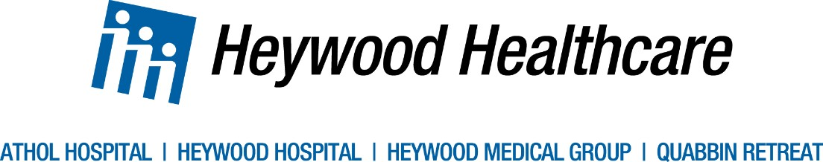

March 31, 2023

To: Stephen Davis, Division Director
Division of Health Care Facility Licensure and Certification Department of Public Health
67 Forest Street
Marlborough, MA 01752

Judy Bernice, Licensing Unit Manager
Division of Health Care Facility Licensure and Certification Department of Public Health
67 Forest Street
Marlborough, MA 01752

Dear Mr. Davis and Ms. Bernice:

This letter is submitted on behalf of Henry Heywood Memorial Hospital, Inc (d/b/a Heywood Hospital), located at 242 Green Street, Gardner, MA 01440 regarding its licensed Pediatric sub-unit. Heywood Hospital is a 134-bed general community hospital, which has been serving the needs of Central Massachusetts since 1907.

The pediatric sub-unit consists of 7 licensed beds. The sub-unit has not had any admissions since early March, 2020, and has been temporarily closed since April 1, 2021. The Hospital has had repeated open RN positions on that unit. In an effort to keep the unit operational, the Hospital implemented numerous initiatives to recruit individuals to fill open, needed RN positions. Unfortunately, those initiatives have not been successful. Those initiatives have included: (i) in September-October, 2020, having Heywood medical/surgical RN’s orient at UMass in on UMass’ pediatric unit; (ii) pursuing constant, ongoing, traditional recruitment efforts for pediatric skilled nurses; (iii) modifying medical/surgical RN job postings to include pediatric experience; (iv) posting more than forty-five (45) RN positions since January 1, 2021 that included pediatric experience; (v) again offering medical/surgical nurses the opportunity to orient to pediatrics at UMass; and (vi) working with Heywood’s human resources department on other recruitment efforts. The Hospital continues to be unable to fill needed positions and continues to be unable to admit pediatric patients.

Because the pediatric sub-unit has had zero utilization since March 2020, there is no anticipated impact on individuals in Heywood Hospital’s service area, if the inpatient sub-unit closes. Pediatric care in the service area is primarily outpatient, and where inpatient referrals by local pediatricians are needed, those referrals have generally been made to UMass in Worcester or Children’s Hospital in Boston. That referral pattern is expected to continue in the event of closure of the sub-unit. The status of the pediatric sub-unit has been a subject of ongoing correspondence with the Department.

In light of the foregoing, please accept this letter as the ninety (90) day notice, referenced in 105 CMR 130.122, of the proposed permanent closure of the Pediatric sub-unit, effective July 3, 2023. The Hospital intends to re-designate the 7 licensed pediatric beds to the general medical-surgical population, resulting in no change in the total number of licensed beds at the Hospital.

The following are the names and addresses of organized health care coalitions and community groups known to the Hospital, and who will be copied on this letter: Health Equity Partnership of North Central Massachusetts, Gardner Area Interagency Team, and Gardner Community Action Team.

Thank you for your attention to this matter. Please do not hesitate to contact us if you have any questions or require any additional information.

Sincerely,

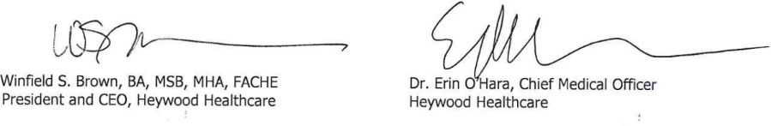

Cc: Walter Mackie walter.mackie@state.ma.us Stephanie Carlson stephanie.carlson@state.ma.us
Health Policy Commission, HPC-DPHfilings@mass.gov
Office of Attorney General, Health Care Division-Health Care and Fair Competition Bureau Center for Health Information and Analysis, Legal@chiamass.gov
Executive Office of Labor and Workforce Development, att’n Office of General Counsel Health Equity Partnership of North Central Mass
Gardner Area Interagency Team Gardner Community Action Team

Bc: Alan Einhorn aeinhorn@foley.com

