Quick Reference Card

How to Favorite a Page - Microsoft Edge
Recently, the state Human Resource Division (HRD) launched its new collaboration with Workpartners to request new, continuous or intermittent leaves and day-to-day sick time. This Quick Reference will help you bookmark important web pages.

Step 1. Open the web page you would like to make a favorite:
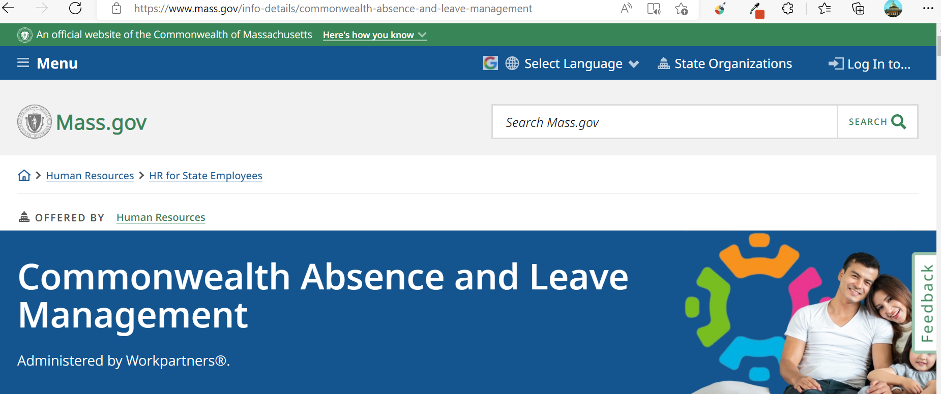

Step 2. Click on the star icon to the right of the web page path.
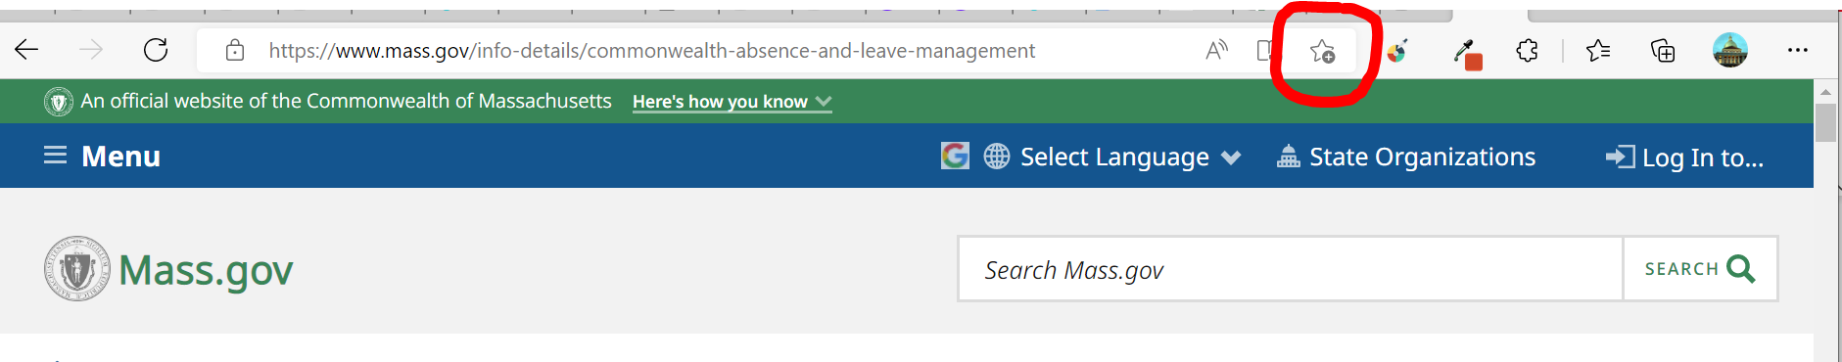

Step 3. A box will appear containing the web page name and where the favorite will be saved. You can change either one of these. Choose “Done” if it looks ok.
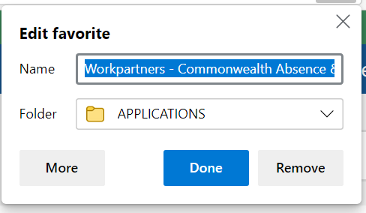
Your web page will now have a blue star indicting it is a favorite.
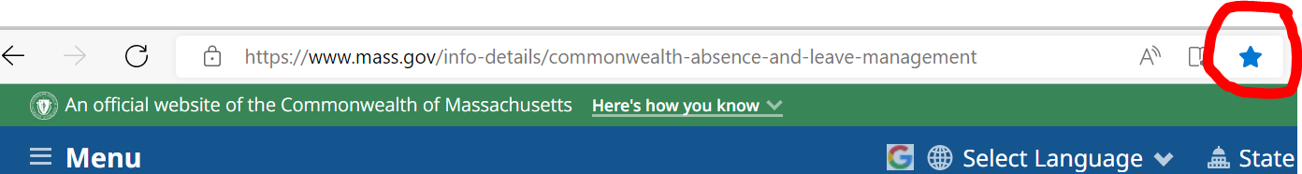

To get your list of favorites when you need them:

Step 4. Open a browser.
Step 5. At the top of the page, click on the star icon with the wavy lines.
Step 6. This opens a list of favorite pages. Find Workpartners and click on it to open the page.
