The Commonwealth of Massachusetts
Executive Office of Health and Human Services
Department of Public Health
Bureau of Health Care Safety and Quality
Division of Health Care Facility Licensure and Certification
67 Forest Street, Marlborough, MA 01752

CHARLES D. BAKER
Governor
KARYN E. POLITO
Lieutenant Governor

MARYLOU SUDDERS
Secretary
MARGRET R. COOKE Commissioner

Tel: 617-624-6000
www.mass.gov/dph

November 10, 2022

Tom Sands, President
Beth Israel Lahey Health – Beverly Hospital
85 Herrick Street
Beverly, MA 01915

BY EMAIL ONLY

Re: Review of Response Following Essential Services Finding
Facility: BILH-Beverly Hospital
Services: Outpatient Birth Center Services, North Shore Birth Center (NSBC)
Ref. #: V93D-021

Dear Mr. Sands:

On November 1, 2022, the Department of Public Health (the "Department") received your response to our August 4, 2022 letter indicating that BILH-Beverly Hospital (the “Hospital”) must at least, 30 days prior to new proposed closure date: i) submit written notice to the Department and the parties outlined in 105 CMR 130.122(B)(1)-(5) of new proposed closure date of North Shore Birth Center (the “NSBC”), and ii) submit a plan to the Department that details how access to the services provided by NSBC will be maintained for the residents of the Hospital’s service area. Thank you for responding to our request in a timely and comprehensive manner.

Pursuant to 105 CMR 130.122(G) the Department has completed its review of the submitted access plan. As a result of this review, the Department has prepared the following comments and determined that, contingent on submission of responses to the Department’s comments, the plan appropriately assures access to the essential service in question following the closure of Birth Center Services:

- Access to midwifery care and birth center-like services at the Hospital: In your response dated November 1, 2022, you noted that the Hospital has committed to leasing the NSBC building to an independent midwifery practice until April 2025. The Department requests you provide specific information about what outreach efforts are planned to inform the community and solicit interest in leasing the NSBC building. Additionally, the Department requests information on other long-term space options that the Hospital has identified as available, as discussed during the workgroup meeting, to extend the April 2025 deadline.
- Support for access to birth centers: In your response dated November 1, 2022, you noted that the Hospital will provide $1.5 million in grant funding to one or more community organizations to create, expand, or reopen birth centers licensed by the Department. The Department requests that the Hospital provide information on the grant making/approval process including description of any technical assistance the Hospital plans to provide applicants.
- Establishment of a BILH system-wide maternal quality initiative: In your response dated November 1, 2022, you noted that the Hospital will establish a system-wide Maternal Care Quality Council—with representation across hospitals and incorporating physicians, nursing, midwifery, and allied health professions and a maternal newborn patient and family advisory council (PFAC). The Department requests that the Hospital provide information on how it intends to insure diverse representation on both the Maternal Care Quality Council and the PFAC.
- Continued Communication Post-closure of the Service: During the past 90 days the Hospital has engaged in dialogue with members of the community, representatives from EOHHS and DPH and elected officials regarding the future of the North Shore Birth Center. While these formal sessions have come to an end, the Department requests the Hospital provide information on an appropriate vehicle for future communication and reporting to the Department and the community.

Under the provisions of 105 CMR 130.122(G), the Hospital must submit a timely response to the comments of the Department. Please submit your comments within 10 days of your receipt of this letter to my attention, in order that we may complete our review of the pending closure.

Thank you for your continued cooperation in this process. If you have any questions, please contact me at Stephen.Davis@Mass.Gov.

Sincerely,
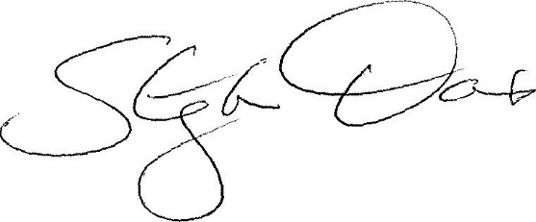
Stephen Davis
Division Director

cc: E. Kelley, DPH
A. Mehlman, DPH OGC
M. Cosgrove, BILH

