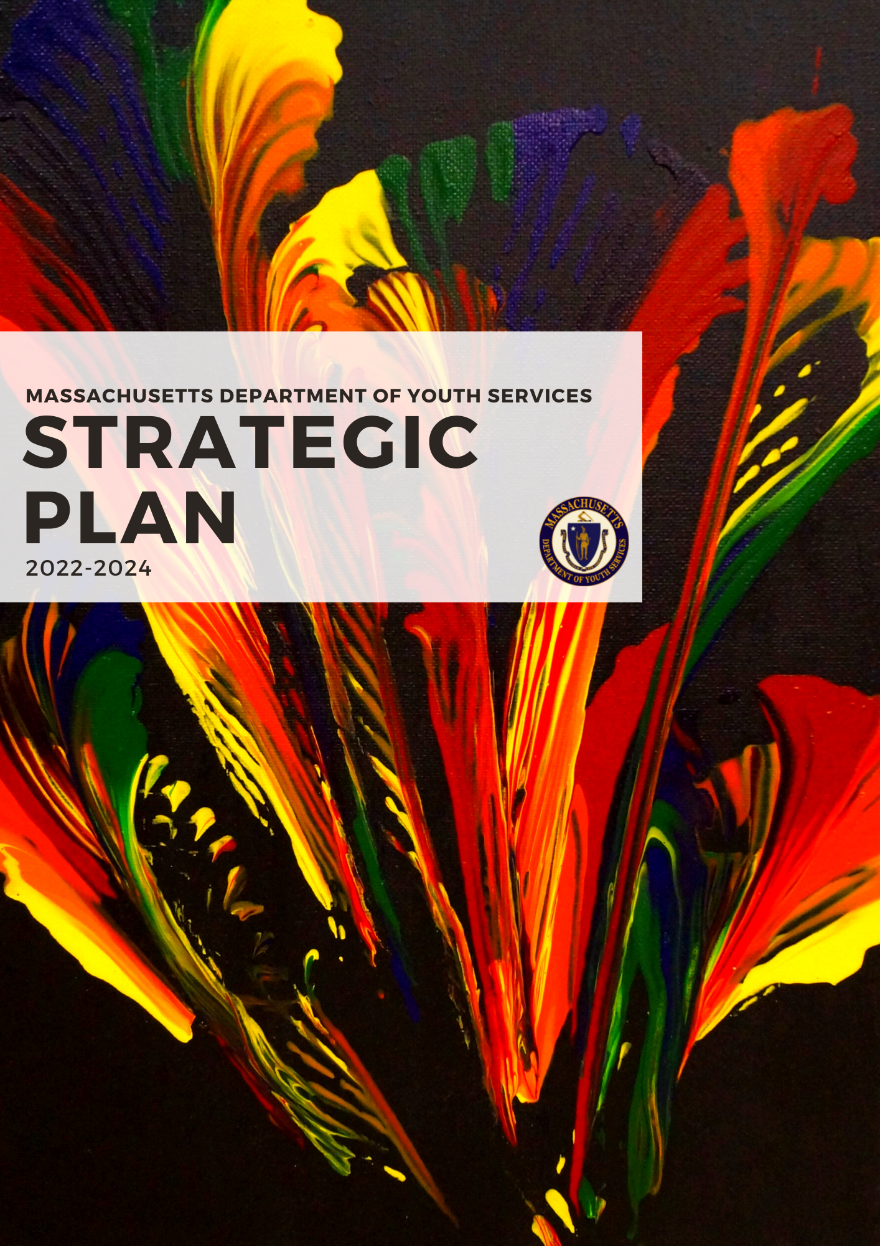
Acknowledgements

The development of the Department of Youth Service Strategic Plan covering the period 2022-2024 process was led by Strategy Matters LLC. The advancement of the strategic plan followed an all-inclusive and participatory process which included; consultations with DYS staff and stakeholder interviews, several workshops and discussions on the various strategic themes. The agencies below were involved in an on-going basis.
- Executive Office of Health and Human Services
- Department of Children and Families
- Northwestern District Office
- Hampden District Attorney
- Berkshire District Attorney
- Essex County District Attorney’s Office
- Massachusetts Juvenile Probation
- Center for Children’s Law and Policy.
- Georgetown University Center for Juvenile Justice Reform
- Boston University
- Massachusetts Juvenile Court
- Community for Public Counsel Services
- Justice Resource Institute
- Department of Elementary and Secondary Education
- Office of the Child Advocate
- Community Resource for Justice
- Youth Opportunities Upheld
- Roxbury Youth Works
- Holyoke Public Schools
- Peace Institute
- Citizens for Juvenile Justice
- Community Solutions Inc.
- Crime Justice Institute

Special thanks to DYS Youth, Adrianna, who created the art used for the cover page.

Contents

Message from the Acting Commissioner
Introduction
Methods
Question I: Where are we now?
SWOT Analysis
Question II: Where do we want to go?
Question III: How will we get there?
Strategic Plan
Values
Vision
Mission
Goals and Objectives
Strategy

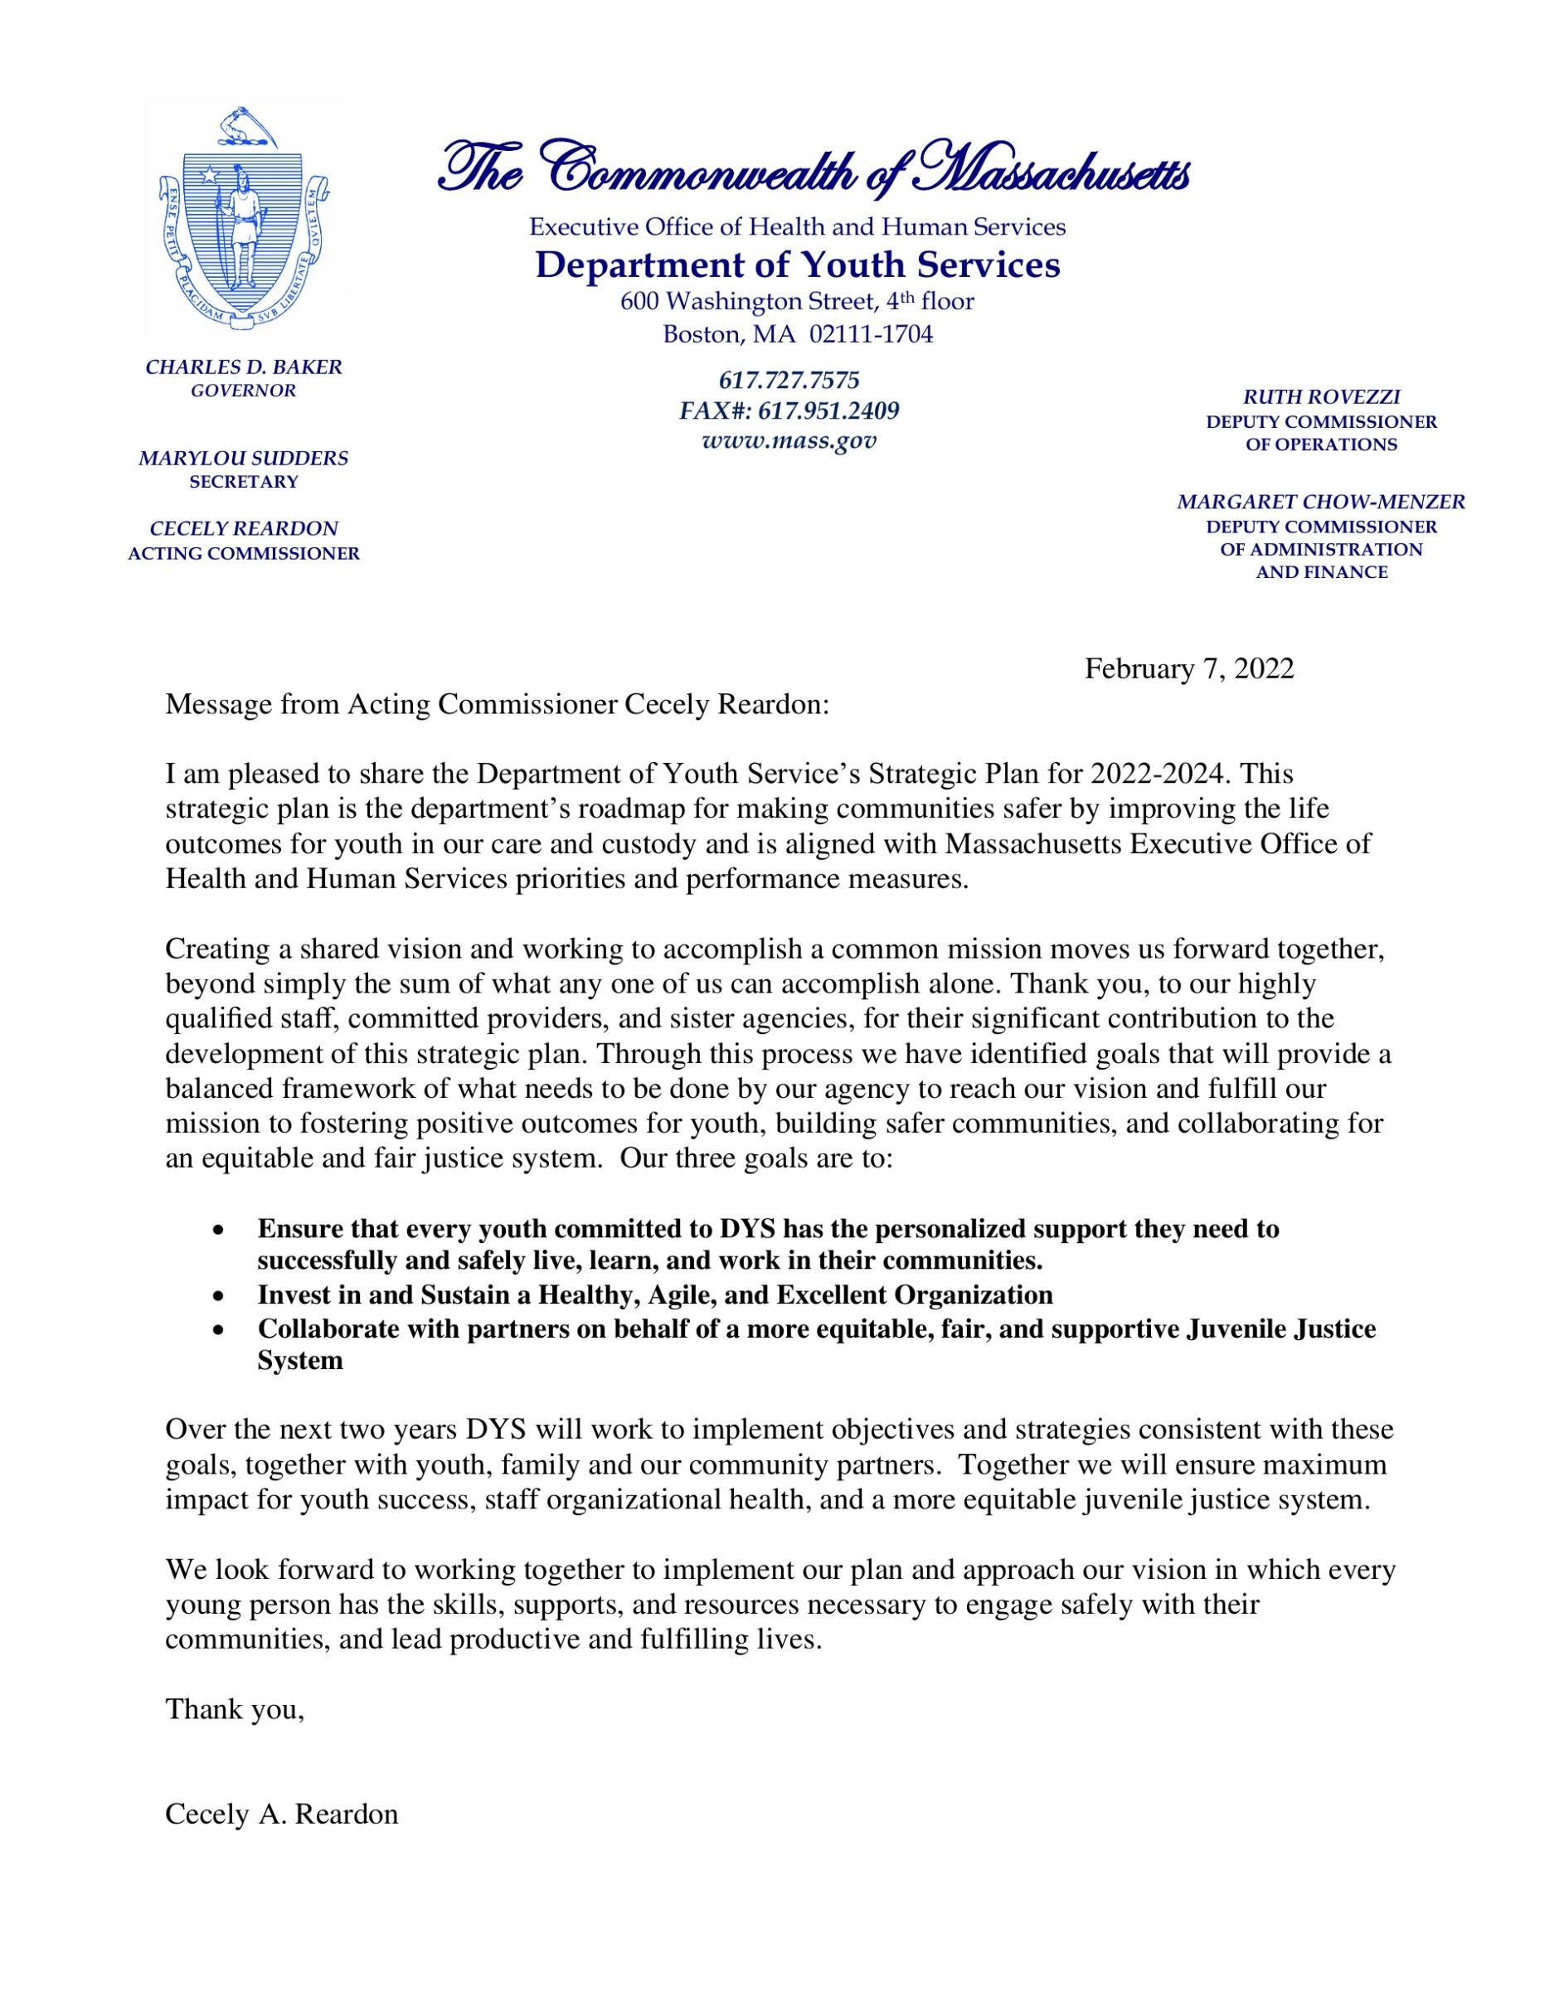

Introduction

Department of Youth Services

The Department of Youth Services (DYS) is the juvenile justice agency for the Commonwealth of Massachusetts. Our dedicated team serves youth committed as juvenile delinquents or youthful oﬀenders and detained youth awaiting judicial action.

Massachusetts was home to the nation’s ﬁrst juvenile correctional system in the mid-19th century. This means that the history of our agency spans many stages in the development of and thinking behind approaches to juvenile delinquency and rehabilitation, and the Department has been instrumental in many of the evolutionary steps that have led the ﬁeld to where it is today: truly committed to rehabilitation through skill development and informed by contemporary scientiﬁc principles concerning trauma and adolescent brain development.

Today, DYS enhances community safety across the Commonwealth by improving the life outcomes of youth in our care and custody. We do this by investing in highly qualiﬁed staﬀ, partnering with committed providers, collaborating with sister agencies, and working in alignment with our local unions. Through this powerful range of relationships, we provide a service continuum that engages youth, families, and communities.

All DYS programs are developed using a Positive Youth Development (PYD) approach, an awareness of youth and adolescent brain development, and best practices in trauma responsiveness. Our programs address the unique educational, psychological and health needs of youth across a continuum of supervision and services, ranging from healthcare, behavioral health treatment, and substance abuse treatment, to continuing education and job training. We aspire, through all these eﬀorts, to support youth in developing the skills and competencies required to lead meaningful, fulﬁlling lives in their communities.

These services are delivered through a variety of residential programs, including both staﬀ and hardware secure facilities, community-based service networks, and 22 District Oﬃces operating in ﬁve regions across the Commonwealth (Central, Metropolitan, Northeast, Southeast, and Western). Each region has its own continuum of services and supervision with the overarching goal of serving youth as close to their home communities and families as possible.

Demand for DYS services has been on the decline for 19 years straight, reﬂecting a growing recognition of the eﬃcacy of alternatives to restrictive settings for many youth. The decline in our census, however, has meant that the youth who do end up in our care and custody are typically those with significant challenges requiring carefully developed treatment plans and who have overlapping involvement with other state agencies. So, while our caseload has been reduced numerically, our work has become increasingly complex, reflecting what a stakeholder in an interview referred to as a “distilled population.”

Another challenge has emerged in tandem with the shrinking census at DYS. While we and our partners have been very successful in finding safe, effective, and minimally restrictive solutions for youth, we have observed increased racial and ethnic disparities among the youth in our care and custody. Other things being equal, one would expect to find that the racial demographics of youth committed to the care and custody of DYS correspond to the racial demographics of the state overall. So, if 70% of the state population is White, you would expect to find that 70% of the committed population of DYS is white. This is not, however, what one finds. As the chart below shows, Black and Hispanic/Latinx youth are drastically overrepresented.
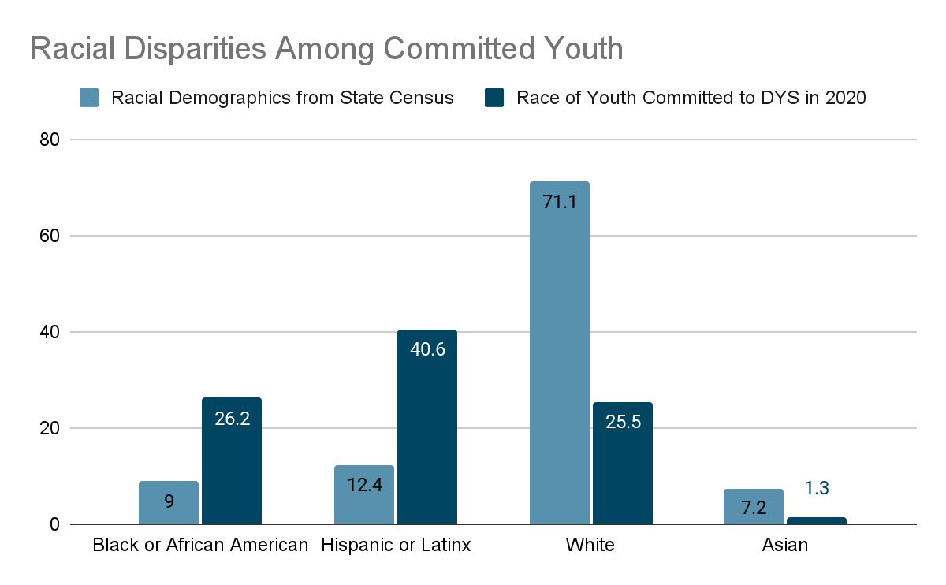
In response to this trend, we have placed an increasingly high priority on implementing strategies to reduce racial and ethnic disparities. We have instituted a monthly Equity and Fairness Group for senior leadership and management staff; offered JDAI’s race equity listening sessions to direct care staff; incorporated a racial and ethnic disparity and youth self-identification training into Basic training for new and existing staff; established regional based diversity book clubs and youth identity work groups; executed a racial trauma conference for educators, and have begun to evaluate hiring policies and practices through a racial equity lens. Fulfilling and expanding upon this commitment to reduce, and ultimately eliminate racial and ethnic disparities was a driving force of this strategic planning process.
Despite some challenges, DYS has been extremely successful over the past decade, due to the dedication and professionalism of our staff members. Our success is a product of our staff’s commitment to safety and Positive Youth Development (PYD), investments in ensuring excellent educational oﬀerings, deep collaboration with other justice and human services agencies. Nowhere has this been more evident than in our response to the COVID-19 pandemic. Our staff have gone above and beyond expectations on many occasions to ensure the safety and wellbeing of their colleagues and the youth in their care and custody.

Over the past six years, we have expanded our support for youth transitioning back to their home communities through the Youth Engaged in Services (YES) program, a voluntary service option oﬀered to all youth at the completion of their DYS commitment. The program aims to reduce recidivism by concentrating on the high-risk window of the ﬁrst six months post-discharge from state juvenile justice custody and supervision.

The YES program oﬀers youth the opportunity to receive services, on a volunteer basis, that are ordinarily provided only to those who are committed and under community supervision status. Services include coaching and case management from an agency caseworker, ﬁnancial support for educational tuition and supplies, transitional housing, and a host of other options that support young people transitioning to a productive adulthood. Today, close to half of all youth leaving DYS care and custody voluntarily stay connected to DYS through YES - a testament to the value of the relationships and the services youth gain through their mandated work with the agency.

One of the most important ways DYS nurtures growth among the youth in our care and custody is through educational services. Some highlights of this work from 2021 include 72 youth who successfully earned their Certificate of Completion, High School diplomas or Hi-Set. 98 youth participated in post-secondary educational opportunities across both residential and community settings. Youth earned 172 Industry Recognized Credentials in areas including CPR, First Aid, ServSafe, and OSHA. 152 youth enrolled in Leadership, Employment, and Advocacy Development (LEAD), an initiative that supports positive youth development through community engagement, work readiness opportunities, and employment activities.

Safety of youth and staff remains a top DYS priority. For youth to become responsible adults, they need a safe environment where they can build positive relationships and participate in positive experiences. DYS is committed to providing safe settings where youth can connect and build trusting relationships with staff. A safe environment supports the well-being of the workforce who serve as mentors, advocates, coaches, and role models for youth as they work on developing the interpersonal and life skills they need to become positive and productive members of their communities.

At DYS we believe that lasting positive change for the youth in our care and custody requires continuous investment in our workforce. Only through the dedication, commitment, and skill of our workforce are we able to create an environment for our youth that will lead to positive outcomes in education, vocational training, and interpersonal and life skills. DYS staff and providers need to be assured of their safety and to have access to the resources they need to promote wellbeing and resilience in an often-challenging work environment.

It is important to note that as DYS was in the midst of developing this plan, the COVID-19 pandemic settled in, changing our world and our work in enduring ways. As we neared completion of the planning process, and amid the growing global public health crisis, people across the country took to the streets, and gathered in protest of the murder of George Floyd and to draw attention to the systemic issues of racial bias and its negative consequences. Protecting the health of our staff and young people during the pandemic and addressing racism are at the heart of our work.

The protests calling for racial justice give voice to the trauma and justiﬁed anger in communities of color aﬀected by centuries of racism. As the pandemic called mainstream media attention to layoﬀs, high unemployment, lack of health resources, challenges in education, and insecure housing, we know that communities of color across the Commonwealth have had to contend with these challenges as daily facts of life. These realities are not separate from DYS’ work. Many members of DYS staﬀ are themselves from communities of color, and live and work alongside the families and friends of DYS youth.

The rapid pace with which unjust systems have been laid bare in the last year highlights our unique responsibility to challenge ourselves to do all we can to rectify wrongs, stand for justice, and do the work of building a better world.

In the words of an interviewee in the stakeholder engagement phase of this planning process, “DYS stands out for its ability to hold up a mirror and look honestly at its own conduct and make real change if there is something that is not working.” One of our most important strengths is our ability to adapt to changing circumstances, and to listen and evolve in response to changing communities' needs. We remain committed to confronting the challenges of systemic racism and bias that we know aﬀect the communities we serve. Through, JDAI we launched a race, equity, and inclusion statewide committee, focused on collaboratively working with our Juvenile Justice/child welfare system partners to identify strategies that move our agencies from racial justice theory to practice with the goal of advancing equitable policies and practices in the Massachusetts Juvenile Justice/child welfare system. We also remain committed to maintaining organizational agility so that we can meet future needs as they arise, even those that are presently beyond our imagination.

This plan is written from our shared values and outlines our speciﬁc and concrete commitments to ensuring that our work brings about a more equitable, more just, and better system in the coming years. This plan seeks to continue the great work of the past decade, leading the DYS team, its partner agencies, providers, and unions, to even greater accomplishments in supporting successful life outcomes for every justice involved youth in the Commonwealth.

Methods

The consulting team used a ﬁve phase planning process designed to draw on organization and sector research, and to engage a wide range of stakeholders and key informants. The process, outlined below, was designed to support DYS in developing answers to three core questions.

- Where are we now? What is the current state of aﬀairs for the youth in our care and custody, their families and communities, and the staﬀ and providers with whom we work? What assets do we have that we can best leverage on behalf of those we serve? What areas of our work do we need to improve upon in order to carry out our mission?

- Where do we want to go? What do we hope to accomplish for and with the youth in our care and custody, their families and communities, and the staﬀ and providers with whom we work? What do we need to do as an organization to be most eﬀective?

- How will we get there? What exactly is our role in accomplishing the work we see as being most important to our stakeholders? How best to achieve o

- ur aspirational goals?
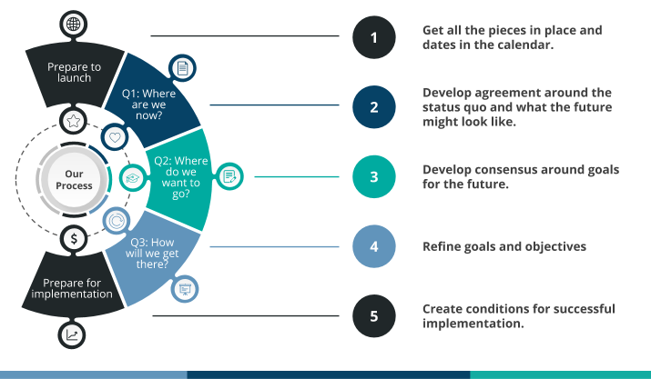

Question I: Where are we now?

During the ﬁrst phase of the process the consulting team worked with DYS’s strategic planning committee to conﬁrm the project plan, to set parameters for sector research, and to develop a plan for engaging stakeholders and key informants. The purpose of research and stakeholder and key informant engagement is to support development of a SWOT analysis. The SWOT analysis is a synopsis of the organization’s Strengths, Weaknesses, Opportunities, and Threats. In a strategic planning process, the SWOT analysis is important because it provides a common foundation on which teams involved in the planning process can depend to understand the range of factors relevant to planning and decision making.

The process for engaging stakeholders and key informants was detailed and comprehensive. The consulting team visited staﬀ secure, and community-based service networks, and every hardware secure facility in the Commonwealth, meeting staﬀ, leadership, youth, and families in the process.

Stakeholders and Key Informants
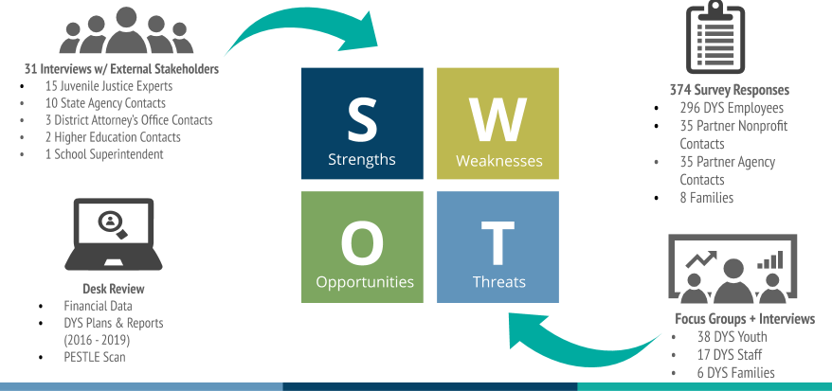

SWOT Analysis

Because DYS’ work is so complex, and takes place across so many domains, we have divided our SWOT analysis (Strengths, Weaknesses, Opportunities, and Threats) into three broad categories:

- Youth, family, and community impact: how can DYS best support positive changes in the lives of the youth in our care and custody, for their families, and for communities? How can we continue to invest in eliminating racial and ethnic disparities (RED) in youth outcomes?

- Organizational health: how can DYS best organize, support, and structure their organizational talents and resources to eﬀect the sorts of changes prioritized above for youth, families, and communities? How can we best ensure that our staﬀ, and our partners are supported in doing the challenging work of the agency? How can we ensure that DYS is truly a diverse, equitable, and inclusive organization?

- Juvenile justice system: how can DYS best leverage their vital role in the juvenile justice system of Massachusetts on behalf of a more safe, equitable, and just Commonwealth? How can DYS inﬂuence other parts of the justice system to increase racial justice and reduce racial and ethnic disparities (REDs)?

Summary findings in each category are included here. The full set of findings and data are included as an appendix.

Youth, Family, and Community Impact
JDAI and other eﬀorts to reduce youth populations in restrictive settings have created a “distilled” population of youth at higher risk, with more complex needs. DYS achieves remarkable results with this population. Work with families is improving; there are opportunities to do more with communities to support transition and mitigate racial and ethnic disparities
- Youth Assets: Educational achievement is strongly supported, vocational training is an area of interest for youth, staﬀ, and other stakeholders, and an area identiﬁed as needing expansion and improvement.
- Youth Agency: Youth show improvement in self-image, self-advocacy, and ability to plan; there are opportunities to better understand and track these changes and the interventions that enable them.
- Youth Contributions: There are some instances of youth engaging in impromptu peer mentoring. There may be opportunities to facilitate more of this.
- Enabling Environments: Cases of strong, positive, reciprocal relationships between staﬀ and youth. Recent focus on family engagement may be moving the needle. Many youth report feeling “set up to fail” when transitioning back to communities.
Organizational Health
DYS is a healthy agency, held in high regard by many for “walking the walk”. There are notable areas of strength, and several areas of opportunity which might be leveraged in service to addressing agency goals across the board.
- Purpose: There is substantial alignment across the agency regarding DYS’ mission, vision, and values. There is noteworthy agreement about the value of PYD, and widespread implementation of principles, with pockets of concern or confusion about the role of accountability within the PYD framework.
- People and Teams: Staﬀ feel safe and supported in working with our youth and very comfortable raising issues with managers when they see them (a very important indicator for managing risk); communication across the agency is adequate.
- Policy, Practices, Places: Management is strong; there may be opportunities to distribute decision-making and improve eﬃciency. Many older facilities are struggling to maintain their condition and meet modern standards, others are in reasonably good condition.
Juvenile Justice System
- Inter-Agency Communication and Collaboration: There are opportunities for better integration among juvenile justice and adjacent systems. Barriers obstructing communication and collaboration exist among many agencies. Regardless, DYS does well serving justice-involved youth, though there are negative impacts on youth and families as well as staﬀ when services are not well coordinated, and quality is uneven.
- Juvenile Justice Reform: DYS is seen as a leader in this ﬁeld, and a responsible agency managing a complex mission. This means there is a lot of political and social capital in the bank.
- Disparities (race, ethnicity, gender identity): DYS is viewed as a forward-thinking agency in the context of reducing racial and ethnic disparities in all areas of operations and has active investments in continuing to reduce them. However, there are complex challenges within and around DYS in achieving these goals. Areas of potential future focus may include ﬁne-tuning some processes and procedures related to use of restraint and room conﬁnement, and potentially piloting mechanisms to use DYS processes to reduce persistent racial disparities in adjacent public safety, justice, and correctional systems.

There are also important connections between the racial, ethnic, and gender experiences of youth and those of DYS staﬀ. First, it will be important to continue efforts to diversify staﬀ in all parts of DYS to reflect the demographics of committed and detained youth, particularly among leadership, clinicians, and educational staﬀ. Second, Following the upsurge of racial unrest in the nation, DYS initiated the JDAI “Listening Series” which was five regional led conversations on race equity that provided staff a safe space to discuss how race impacts their individual self and their role at DYS. These conversations challenged staff to begin addressing their own personal experience with racial and ethnic disparities in the workplace and asked staff to identify current agency policies and practices that may result in disparate outcomes for youth of color. In order to continue addressing issues related to race, ethnicity, and gender among youth, it will be necessary to continue to examine the ways racial, ethnic, and gender identities impact staﬀ experiences at DYS and continue to invest in internal diversity, equity and inclusion (DEI) work at the staﬀ level.

Question II: Where do we want to go?

During this phase of the project, the consulting team worked with DYS staﬀ and a large group of stakeholders, including representatives from sister agencies, provider partners, and DYS union representatives to make sense of the SWOT analysis, and then to sketch provisional goals and objectives for the emerging strategic plan. These provisional goals and objectives have, through a process of reﬁnement, and revision, become the goals and objectives that make up the content of the strategic plan below.

Question III: How will we get there?

Finally, the consulting team worked with the DYS leadership, the strategic planning committee, and staﬀ from across the system to identify the speciﬁc activities that will enable the organization to reach its ambitious and important goals. The team worked through backwards planning exercises to identify the high level and also more granular tasks to be undertaken in service to the goals outlined below. It is important to note that some of what appears in the plan is a continuation or expansion of work already well underway at DYS, and some of it is indicative of new commitments to new activities and approaches. All of it is consistent with the organization’s newly crafted “core identity statements” (the DYS mission, vision, and values).

Strategic Plan

The strategic plan itself has four main parts:

- Statements describing organizational values, which are the fundamental moral commitments that provide the foundation for all of DYS decision making.

- A vision statement that describes the more perfect future DYS intends to work towards.

- A mission statement that describes DYS’ role in achieving its vision.

- Goals and objectives that describe the concrete steps DYS intends to take over the coming three years.

Values

- Fairness: We value fairness in our treatment of youth in our care, their families and community supports, and our staﬀ and partners. We support increased fairness across all aspects of our justice system through strong and transparent relationships with our partners and collaborators.

- Transparency: We believe that the processes by which we make our consequential decisions matter, and we are open and forthcoming about what information is informing our decisions, and who is the ﬁnal authority.

- Racial Equity: We believe that racial equity is the condition that would be achieved if our racial identities no longer predicted how we fare in life. Achieving this state requires absolute elimination of all policies, practices, attitudes and cultural messages that lead to diﬀerential outcomes by race. We strive to ensure that the impacts of our work reduce and mitigate racial and other disparities within DYS, within our communities, in our justice system, and beyond.

- Integrity: We value honesty, fair processes, and full accountability for our actions.

Vision

We envision a Commonwealth in which every young person has the skills, supports, and resources necessary to engage safely with their communities, and lead productive and fulfilling lives.

Mission

The Department of Youth Services fosters positive outcomes for youth, builds safer communities, and collaborates for an equitable and fair justice system.

Goals and Objectives

The Department of Youth Services has set goals and objectives in three areas. These goals and objectives have been designed to answer the following questions.

- Youth, family, and community impact: how can DYS best support positive changes in the lives of the youth in their care and custody, for their families, and for communities?

- Staff and Organizational health: how can DYS best organize, support, and structure their organizational talents and resources to eﬀect positive changes for youth, families, and communities? How can we best ensure that our staﬀ, and our partners are supported in doing the challenging work of the agency?
- Juvenile justice system: how can DYS best leverage their vital role in the juvenile justice system of Massachusetts? What partnerships can DYS develop to help reduce disparate outcomes for Black and Brown youth after their involvement with DYS?

Youth, Family, and Community Impact

1. Goal: Ensure that every youth committed to DYS has the personalized support they need to successfully and safely live, learn, and work in their communities. There has been a dramatic reduction in the number of youth committed to residential care in the DYS system over the past ten years. The COVID 19 crisis accelerated the reduction of the DYS residential population. Additionally, the state task force on “emerging adults” made strong recommendations regarding the expansion of community-based alternatives to residential care, and our own work with youth and families has pointed to the need to have more, and more eﬀective, community-based options for youth in our care.

DYS has also invested signiﬁcant time, research, training and resources to reducing racial and ethnic disparities within our system, and within adjacent systems impacting young people, e.g., education, social services. In 2018, DYS worked with consultants from Promoting Good to design training for staff to raise awareness of the impact of racism on our work and to move to self-identification of race and ethnicity by young people. In 2020, DYS contracted with All Aces, a consulting group, to address and enhance our DEI efforts agency-wide, including evaluating our procedures, developing training, and facilitating workgroups and education, in our efforts to continue our work on race, racial trauma and disparity within our agency. With the commitment of our staﬀ, our partners, and our communities, we have made progress, and yet, there is much more work to do.

The challenge and the opportunity ahead is for the DYS system to continue to diversify our community based options, while ensuring that every youth also has direct and easy access to the full spectrum of services (educational, health, vocational, life skills, social-emotional, community and family connections) that they need to be competent, safe, stable, and ultimately successful in transitioning to adulthood.

- DYS ﬁrst meets youth after they have already engaged with partners and other agencies in many settings, e.g., through arrest (police), or family services (DCF), or probation. We have, and will continue to invest in, strong collaborative relationships to support consistency across settings in treatment philosophy. Speciﬁcally, we hope to deepen our collaboration and connections with other agencies to ensure that the Positive Youth Development (PYD) approach which is so vital to our success with young people is also guiding and informing the work of others working with DYS youth. We hope to support a set of system improvements which will ensure that PYD informs all adult-youth interaction from the youth’s ﬁrst contact with the justice system through transitioning back to their community. Speciﬁc examples of current and future collaboration in this area include:
  - Collaboration with the Office of the Child Advocate on the development of diversion programs.

  - Continued willingness, and open invitations, to coordinate with police, probation, and sheriffs to ensure effective and appropriate policies and practices are in place for working with youth.

- Ensure that all youth are in the right setting at the right time and get the right mix of services to ensure their successful transition to and engagement with their community.

  - Use a balanced approach to placement that uses multiple factors to determine risk. We will place youth based on a thorough and holistic understanding of their individual strengths and challenges that focuses on ensuring equity across race, ethnicity, and gender identity, and across DYS facilities and programs. We will continue to invest in data gathering to ensure fairness in placement decisions, and to identify any barriers to equitable outcomes. This data will inform future training and policy development as needed.

  - Develop personalized plans for each youth that:
    - are informed by agency expertise in youth and adolescent development and youth and family input,
    - offer excellent, developmentally appropriate support in all settings
    - offer excellent educational and vocational programming for all, including expansion of credential earning options (diplomas, certiﬁcate, licenses)

  - Develop agency-wide understanding of the effective and appropriate role of restorative practices and implement them.

  - Redesign the repair process in ways that balance accountability for harmful behavior with understanding and compassion for mistakes.

  - Ensure all staff have training to synthesize and effectively implement restorative practices, PYD, Dialectical Behavior Therapy (DBT), and trauma informed care.

  - Ensure that youth are able to build trust and rapport with clinical and educational staff members with whom they share cultural and ethnic backgrounds, and racial and gender identities.

    - One way to accomplish this may be to invest in training and advancement opportunities for current staff members of color.
    - Another way to accomplish this may be to position DYS as a valuable learning site for early career clinicians and educators.

- Prepare and support all youth in living safely and stably in communities after discharge from commitment. Our staﬀ team will work to stay connected to youth in whatever way is most supportive to future success as youth navigate school, family life, employment and engagement in their communities, post-commitment. Here are some of the ways we will do this:

  - Reﬁne and increase family engagement and treat guardians and parents as partners.
    - This may include oﬀering parent training related to our PYD framework, and in the central concepts of our clinical approaches, like DBT.
    - This should include providing forums in which DYS staff can hear from parents and guardians about what, in their experience, has and has not worked well to support their children and families.

- Develop partnerships with communities, and other organizations which will enable us to expand foster home network and provide PYD training for parents, guardians, and foster families, develop partnerships for youth employment placements, oﬀer safe and continuous educational pathways across multiple settings/transitions, ensure housing stability, and

- Expand YES and increase YES participation rates year over year.

Organizational Health

2. Goal: Invest in and Sustain a Healthy, Agile, and Excellent Organization DYS is a large, complex, geographically dispersed organization, operating in times of rapid change and uncertainty about the future on multiple levels. The success of this plan, and any initiatives that DYS hopes to undertake, will require a serious and sustained commitment to staﬀ well-being, and an investment of resources to ensure that staﬀ safety is ensured and that staff needs are met.

One of the clearest lessons from the COVID era is that there is no way to develop a plan that provides for every possible contingency. Instead, the focus must be on developing organizational capacity to eﬃciently and eﬀectively adapt to whatever changes manifest in the future. Organizational success in implementing this plan will rely upon the agency’s ability to operate eﬃciently and eﬀectively despite a daunting array of challenges.

One constant across change, however, must be an unwavering commitment to safety and addressing racial and ethnic disparities. This ongoing body of work will require investment in DYS’ workforce. Promotions of persons of color continued to reflect more than half of all promotions at DYS. In FY2020, minorities represented 69.2% and women represented 34.6% of total promotions. The percentage of women hired in relation to total hires continues to trend above 20%. Most recently in FY2021 Q3, DYS continued progress in our EEO/AA efforts with persons of color representing 64% and Women representing 50% of new hires; Persons of color represented 83% and Women represented 50% of promotions in FY21 Q3.

The objectives below are designed to support DYS’ investments in its workforce, its teams, and its practices to stay healthy and agile, and in turn, to deliver excellent services to the youth in our care and custody, and support for communities.

- Support DYS staff as they build upon the work they have already undertaken to deliver a spectrum of services in ways that are consistent with the agency’s commitment to reducing racial and ethnic disparities
  - Support retention and development of current DYS staﬀ:
    - Training: restorative practices; trauma-responsiveness with a focus on racial trauma; a consistent interpretation of PYD with a focus on understanding the role of accountability in the PYD framework.
    - Wellness: the demands placed on staﬀ are great, even without the added challenges of a global pandemic. In order to ensure that staﬀ are best equipped to support DYS youth, it will be important to have a robust wellness program in place. One important part of this may be ensuring training and support designed to ensure that DYS is a “trauma-informed workplace.”
    - Improved internal communications.
    - Succession planning.

  - Attract new, well-qualified, and mission aligned members to DYS’ staff.
    - This should be undertaken in ways that accelerate DYS’ efforts to diversify staff. This will be especially important at the level of organizational leadership and among clinical and educational staff, since these are the areas where diversity is least evident.

  - DYS families (foster families and families of committed youth): develop case and systems mapping and increase family engagement in managing youth transitions, skill development, and treatment throughout their commitment.

- Develop data and information systems capable of supporting our strategic goals
  - Collect data to support eﬀorts to reduce bias in decision making/reduce racial and ethnic disparities, and modernize existing technology systems (JJEMS, MassCareers, SSTA)

  - Communications systems to support consistent, easy communication across sites, regions, levels and with/among partners

  - Evaluation and outcomes tracking systems to illuminate what is working, and why (community safety, youth successes)

- Increase alignment between our physical assets and our strategic goals
  - Master planning for improved facilities
    - Some speciﬁc areas of focus will include: ensuring that physical spaces are ﬂexible, since needs and service delivery methods change over time; to the extent possible, design physical spaces in ways that allow for natural movement, perhaps in a “campus-style” setting.

  - Ensure that physical infrastructure meets the actual needs of youth.
    - Reducing investments in hardware secure facilities will make it possible to invest more heavily in community-based services.

Juvenile Justice System

3. Goal: Collaborate with partners on behalf of a more equitable, fair, and supportive Juvenile Justice System DYS is one part of a complex network of organizations, policies, laws, institutions, agencies, and other entities which together comprise our “juvenile justice system.” DYS and some willing partners have launched highly successful collaborations over the last decade to sustain equity and fairness. Since 2017 to date, DYS, through JDAI, has been conducting screenings of the Seeing RED documentary, accompanied by a facilitated discussion of racial equity in the system for staff in the Juvenile Justice/ Child Welfare and community agencies. Following the discussions, 92% of participants strongly agreed or agreed with the statement: “I will bring back pieces I’ve learned to my workplace” and 92% of participants strongly agree or agree with the statement: “This forum inspired me to address issues of race/ethnicity in MA's juvenile justice system.”

There remains work to do, however, and this work will require the active participation of partners from across the juvenile justice system and will require establishing inter-agency communication and collaboration as high priorities.

Amidst this challenging terrain there are many drivers of racial, ethnic, and gender disparities in outcomes for young people who are involved in any part of this “system.” The fact that this system lacks overall coherence makes intervention in these disparities especially challenging. Consequently, DYS’s eﬀorts to support a more equitable, fair and supportive juvenile justice system will be most eﬀectively leveraged through two commitments. First, DYS will commit to address the racial and ethnic disparities internal to the agency, and areas where support is inadequate. Second, DYS will commit to working collaboratively and creatively with partner agencies and organizations to interrupt drivers of disparities, and to create a just, fair system for all.

- Understand all our decision points as opportunities to reduce or amplify racial and ethnic disparities
  - Map all the decision points within DYS
  - Gather and analyze data on racial and ethnic disparities regularly
  - Use findings to make programmatic, policy, and practice changes

- Deepen collaboration with partners around shared commitments to reducing racial and ethnic disparities
  - JDAI has helped create needed changes and has aligned judges and practitioners around important commitments. More work remains to be done, however, to aggressively pursue alternatives to restrictive settings while ensuring that racial equity is achieved in the system’s impacts and outcomes. To broaden the impact of JDAI, DYS is committed to collaborating with all interested parties in counties across the Commonwealth.
  - Create mechanisms to ensure that community partners (contractors/providers) are aligned with our work in reducing racial and ethnic disparities (application, contracting, monitoring, support).
  - Continue to work with state systems and partners in data gathering, analysis and planning around racial and ethnic disparities across DCF, DYS and the adult correctional system.

- Continue to work regionally and nationally on justice reform initiatives. Including, for example, the following:

  - Interstate Commission on Juveniles
  - Citizens for Juvenile Justice
  - Center for Juvenile Justice Reform
  - Annie E. Casey Foundation
  - Council of Juvenile Justice Administrators
  - Coalition for Juvenile Justice
  - The Governor’s Juvenile Justice Advisory Committee

Strategy

The impact of DYS’ work is evident in places far beyond the institutional boundaries and the walls of DYS facilities. Nearly all youth that enter the care and custody of DYS will return to their communities. It is therefore vital to success that from the moment a youth comes into contact with DYS, focus is placed on engaging with them, their families, and their communities in ways that will support their successful and engaged participation in those same communities when their time with DYS ends.

The vast majority of youth who are committed to DYS live in community settings, and the success of these supportive services is most visible in homes, schools, businesses, and communities when young people can successfully engage in learning and working there.

Consequently, the overall strategy for achieving the goals in this plan is to maintain deep focus in every aspect of DYS work on facilitating a life of meaning, purpose, and engagement for youth within their
communities.

Implementing this strategy involves more than achieving the goals and objectives outlined above. It requires that staﬀ, providers, and leaders embrace a mindset and method for making decisions at every point of contact with youth that is informed by a commitment to facilitating a successful life for each youth in their home community. This commitment will enable DYS to continually draw the connection between the educational opportunities provided in facilities with the likelihood of family sustaining wage employment options later, or to focus on the appropriateness of the speciﬁc counseling services oﬀered to the particular types of trauma youth have experienced and may indeed be exposed to again upon separating from DYS.

To achieve the important and highly aspirational goals outlined here through this shift in focus, we will need to invest in building a culture and a workforce which is highly and expertly attuned to both the current realities of young people's lives today, and able to quickly adapt and adjust to constantly changing circumstances.

See the DYS enabling legislation here: https://malegislature.gov/Laws/GeneralLaws/PartI/TitleII/Chapter18a

