Estimating Carbon for Forest Stewardship Climate Plans

Estimating Carbon Stocks
Landowners are increasingly interested in the amount of carbon stored in and sequestered by their woodlands. One of the requirements of the Forest Stewardship Climate Plan is to provide an estimate of carbon stocks for the education of landowners. This document provides tables for estimating carbon stocks based on stand basal area.
While there are many factors that influence carbon stocks in forests —within Massachusetts Ecoregions (see figure)— basal area typically explains 80% or more of the variation in live and standing dead tree carbon stocks, and thus provides a good first-order predictor. The document Managing Forests for Carbon in Massachusetts provides a summary of forest carbon inventory, as well as resources for foresters who are interested in more precise carbon inventory. The Securing Northeast Forest Carbon Program has additional information on the topic and is developing an online tool for calculating forest carbon stocks following the methods described here.
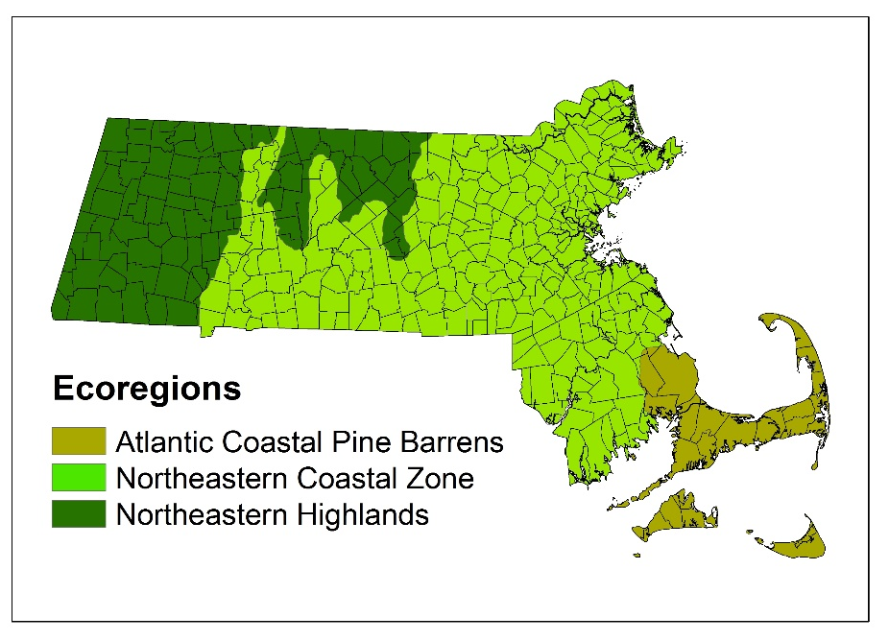
This document provides tables (one for live trees and one for standing dead trees within each ecoregion) relating carbon stocks in tons per acre (ton/ac) to basal area in square feet per acre (ft²/ac). These tables can be used to estimate carbon stocks for your Forest Stewardship Climate Plan. Additional tables provide the percentiles that correspond to basal area and carbon stocks for the given ecoregion. As an example, a stand with a basal area that corresponds to the 50th percentile, has as much or more carbon than 50% of stands within the corresponding ecoregion within Massachusetts. These tables can be used to compare a given stand’s carbon stocks to others within the same ecoregion.

Figure 1. The three ecoregions of Massachusetts with outlines of municipal borders.

Carbon Sequestration Rates
Carbon sequestration rates, the rate at which stands take up carbon, are difficult to assess without repeated measurements. When these are not available, a rough idea of changes in stand sequestration rate can be derived from the net growth of live-tree carbon stocks. Because stand age is often not precisely known and sequestration rates represent a complex interaction between carbon pools, estimating carbon sequestration is imprecise. The accompanying figure shows the general trend of live tree carbon sequestration with stand age for Massachusetts forests. This figure can provide an indication of how stand sequestration rates may change in correlation with stand age given the significance of the live tree carbon pool. While it is not required to report a carbon sequestration rate in the Forest Stewardship Climate Plan, we provide this resource as an educational tool.
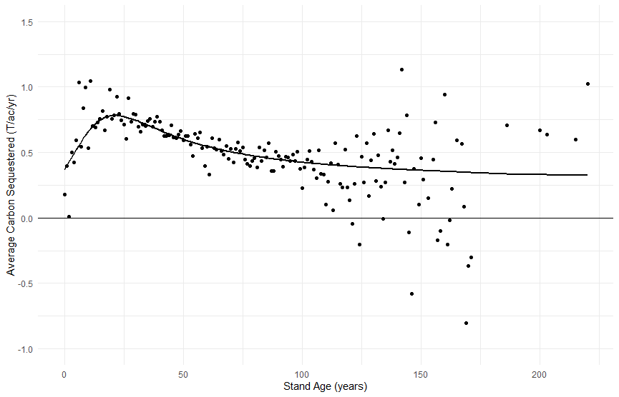Average carbon
Figure 2. Live-tree carbon sequestration rate changes with stand age. Points represent the average net carbon sequestered for each stand age (one year increments) from FIA data for northeastern U.S. states, while the line represents the best fit model to the point data.

When Stands Differ from the Average
The tables and figures describing forest carbon storage and sequestration show trends for average stands in Massachusetts and the surrounding region. It may be helpful to consider when a specific stand may have higher or lower storage and sequestration than is typical. Managed stands in particular may diverge from the values given here.
Forest carbon stocks are determined by wood volume and wood density. The volume of a stand is a function of the stem diameter, height, and crown width of the trees in the stand. A stand with taller trees than average for a given stand basal area will have a greater volume and consequently more carbon. Hardwood trees in general have denser wood than softwood trees, and density varies from species to species. Management can manipulate both the relationship between stand BA and volume and the species composition of the trees that make up the stand. For example, the residual trees in a stand that was thinned from below will likely be larger (taller and with larger crowns) than an unthinned stand with the same basal area, and therefore greater aboveground carbon stocks.
Carbon sequestration rates are directly related to forest growth. Any site factors that lead to trees having higher sequestration rates will result in faster growth, for example, richer soils or more mesic conditions. Sequestration rates are also dependent on the total leaf area in the forest, and leaf area is itself dependent on forest structure. Forests with greater structural diversity in general have greater productivity and carbon sequestration. The relationship between stand age and sequestration in Figure 2 reflects the typical way that stand structure changes as stands develop over time. Silvicultural practices (or partial natural disturbances) that result in greater vigor of trees at all levels of the canopy will increase sequestration rates relative to this average. For more information on management impacts on forest carbon stocks and sequestration see Managing Forests for Carbon in Massachusetts.
Atlantic Coastal Pine Barrens

BA (ft²/ac) | C Prediction (ton/ac)
0 | 0.0
10 | 2.8
20 | 5.7
30 | 8.5
40 | 11.3
50 | 14.1
60 | 17.0
70 | 19.8
80 | 22.6
90 | 25.4
100 | 28.3
110 | 31.1
120 | 33.9
130 | 36.7
140 | 39.6
150 | 42.4
160 | 45.2
170 | 48.0
180 | 50.9
190 | 53.7
200 | 56.5
210 | 59.3
220 | 62.2
230 | 65.0
240 | 67.8
250 | 70.7
260 | 73.5
270 | 76.3
280 | 79.1
290 | 82.0
300 | 84.8
Table 1: Predicted Live Tree Carbon Stock by Basal Area
Percentile | BA (ft²/ac) | C Prediction(ton/ac)
0 | 4.8 | 1.4
1 | 7.2 | 2.0
2 | 12.3 | 3.5
3 | 14.4 | 4.1
4 | 16.0 | 4.5
5 | 19.0 | 5.4
10 | 37.0 | 10.4
15 | 52.6 | 14.9
20 | 62.0 | 17.5
25 | 73.8 | 20.8
30 | 78.7 | 22.2
35 | 84.2 | 23.8
40 | 84.9 | 24.0
45 | 90.4 | 25.5
50 | 101.0 | 28.6
55 | 105.5 | 29.8
60 | 108.7 | 30.7
65 | 113.7 | 32.1
70 | 118.7 | 33.5
75 | 123.8 | 35.0
80 | 133.4 | 37.7
85 | 149.6 | 42.3
90 | 175.5 | 49.6
95 | 198.7 | 56.1

Table 2. Percentile Live Tree Carbon stocks in Atlantic Coastal Pine Barrens by Basal Area

Atlantic Coastal Pine Barrens
Table 3: Predicted Dead Tree Carbon Stock by Basal Area

Table 4. Percentile Dead Tree Carbon stocks in Atlantic Coastal Pine Barrens by Basal Area

BA (ft²/ac) | C Prediction(ton/ac)
0 | 0
5 | 0.6
10 | 1.1
15 | 1.7
20 | 2.3
25 | 2.8
30 | 3.4
35 | 4
40 | 4.5
Percentile | BA (ft2/ac) | C Prediction(ton/ac)
0 | 0 | 0
5 | 0 | 0
10 | 0 | 0
15 | 0 | 0
20 | 0 | 0
25 | 0 | 0
30 | 0 | 0
35 | 0.2 | 0
40 | 1.2 | 0.1
45 | 1.5 | 0.2
50 | 2.3 | 0.3
55 | 3.5 | 0.4
60 | 5.3 | 0.6
65 | 7.9 | 0.9
70 | 10.1 | 1.1
75 | 12 | 1.4
80 | 16.1 | 1.8
85 | 18.8 | 2.1
90 | 20.7 | 2.3
95 | 30.9 | 3.5

Northeastern Coastal Zone

BA (ft²/ac) | C Prediction (ton/ac)
0 | 0.0
10 | 3.5
20 | 6.9
30 | 10.4
40 | 13.8
50 | 17.3
60 | 20.8
70 | 24.2
80 | 27.7
90 | 31.1
100 | 34.6
110 | 38.1
120 | 41.5
130 | 45.0
140 | 48.4
150 | 51.9
160 | 55.4
170 | 58.8
180 | 62.3
190 | 65.8
200 | 69.2
210 | 72.7
220 | 76.1
230 | 79.6
240 | 83.1
250 | 86.5
260 | 90.0
270 | 93.4
280 | 96.9
290 | 100.4
300 | 103.8
Table 5: Predicted Live Tree Carbon Stock by Basal Area
Percentile | BA (ft²/ac) | C Prediction (ton/ac)
0 | 0.0 | 0.0
1 | 7.0 | 2.4
2 | 14.6 | 5.0
3 | 24.1 | 8.3
4 | 34.0 | 11.8
5 | 44.3 | 15.3
10 | 65.3 | 22.6
15 | 80.3 | 27.8
20 | 89.6 | 31.0
25 | 100.2 | 34.7
30 | 106.5 | 36.8
35 | 112.1 | 38.8
40 | 116.3 | 40.2
45 | 122.0 | 42.2
50 | 127.9 | 44.3
55 | 133.8 | 46.3
60 | 140.5 | 48.6
65 | 147.7 | 51.1
70 | 155.5 | 53.8
75 | 163.7 | 56.6
80 | 171.0 | 59.2
85 | 182.6 | 63.2
90 | 197.5 | 68.3
95 | 223.6 | 77.4

Table 6. Percentile Live Tree Carbon stocks in Northeastern Coastal Zone by Basal Area

Northeastern Coastal Zone
Table 7: Predicted Dead Tree Carbon Stock by Basal Area

Table 8. Percentile Dead Tree Carbon stocks in Northeastern Coastal Zone by Basal Area

BA (ft²/ac) | C Prediction(ton/ac)
0 | 0
5 | 0.6
10 | 1.3
15 | 1.9
20 | 2.5
25 | 3.1
30 | 3.8
35 | 4.4
40 | 5
Percentile | BA (ft²/ac) | C Prediction (ton/ac)
0 | 0 | 0
5 | 0 | 0
10 | 0 | 0
15 | 0 | 0
20 | 0 | 0
25 | 0.9 | 0.1
30 | 1.7 | 0.2
35 | 2.4 | 0.3
40 | 3.2 | 0.4
45 | 4.2 | 0.5
50 | 5.2 | 0.7
55 | 6.3 | 0.8
60 | 7.5 | 0.9
65 | 9 | 1.1
70 | 10.4 | 1.3
75 | 12.5 | 1.6
80 | 15 | 1.9
85 | 18.2 | 2.3
90 | 24.2 | 3
95 | 35.6 | 4.5

Northeastern Highlands

BA (ft²/ac) | C Prediction (ton/ac)
0.0 | 0.0
10.0 | 3.2
20.0 | 6.5
30.0 | 9.7
40.0 | 12.9
50.0 | 16.2
60.0 | 19.4
70.0 | 22.7
80.0 | 25.9
90.0 | 29.1
100.0 | 32.4
110.0 | 35.6
120.0 | 38.8
130.0 | 42.1
140.0 | 45.3
150.0 | 48.6
160.0 | 51.8
170.0 | 55.0
180.0 | 58.3
190.0 | 61.5
200.0 | 64.7
210.0 | 68.0
220.0 | 71.2
230.0 | 74.4
240.0 | 77.7
250.0 | 80.9
260.0 | 84.2
270.0 | 87.4
280.0 | 90.6
290.0 | 93.9
300.0 | 97.1
Table 9: Predicted Live Tree Carbon Stock by Basal Area
Percentile | BA (ft²/ac) | C Prediction (ton/ac)
0 | 0.0 | 0.0
1 | 22.1 | 7.2
2 | 39.9 | 12.9
3 | 52.9 | 17.1
4 | 59.2 | 19.2
5 | 66.3 | 21.4
10 | 78.5 | 25.4
15 | 92.1 | 29.8
20 | 102.1 | 33.0
25 | 109.7 | 35.5
30 | 114.4 | 37.0
35 | 121.2 | 39.2
40 | 126.6 | 41.0
45 | 133.7 | 43.3
50 | 140.4 | 45.4
55 | 145.8 | 47.2
60 | 153.3 | 49.6
65 | 159.3 | 51.6
70 | 166.2 | 53.8
75 | 174.6 | 56.5
80 | 184.9 | 59.8
85 | 194.0 | 62.8
90 | 208.7 | 67.6
95 | 231.0 | 74.8

Table 10. Percentile Live Tree Carbon stocks in Northeastern Highlands by Basal Area

Northeastern Highlands
Table 11: Predicted Dead Tree Carbon Stock by Basal Area Table

12. Percentile Dead Tree Carbon stocks in Northeastern Highlands by Basal Area

BA (ft²/ac) | C Prediction (ton/ac)
0 | 0.0
5 | 0.5
10 | 0.9
15 | 1.4
20 | 1.8
25 | 2.3
30 | 2.7
35 | 3.2
40 | 3.7
Percentile | BA (ft²/ac) | C Prediction (ton/ac)
0 | 0 | 0
5 | 0 | 0
10 | 0 | 0
15 | 1.7 | 0.2
20 | 2.5 | 0.2
25 | 3.6 | 0.3
30 | 5.1 | 0.5
35 | 6.5 | 0.6
40 | 7.8 | 0.7
45 | 9.2 | 0.8
50 | 10.5 | 1
55 | 11.9 | 1.1
60 | 13.8 | 1.3
65 | 15.1 | 1.4
70 | 17.8 | 1.6
75 | 20 | 1.8
80 | 23.2 | 2.1
85 | 26.9 | 2.5
90 | 32.2 | 2.9
95 | 41.1 | 3.8

Methods: Calculating Carbon Predictions
Estimating carbon stocks in forest stands can be complex; with additional uncertainty caused by comparing estimates generated using different methods or volume and biomass models. To overcome these hurdles, the relationship between basal area, tree volume and biomass provided predictions by using the nation’s tree census – the database of the USFS Forest Inventory and Analysis program (FIADB).
The database was queried and conditions (which would ordinarily be considered a stand with a unique combination of owner, forest type, size class, tree density, etc.) were treated as separate observations. The per-acre estimates of live tree basal area (ft²), aboveground carbon, and below ground carbon, along with sampling weights (i.e., acres), were queried from FIADB. Within these data tons C in live trees having DBH ≥ 1.0 in. was estimated using the component ratio method (CRM, Heath and others 2009). Ordinary least squares regression was used on the observations and their weights to predict a linear relationship of the form a*[BA]=[CARBON]. One standard error prediction intervals (68.3%) were also calculated. Separate relationships were fit to observations within different US Forest Service Ecological Subsections that occur within Massachusetts, and grouped by different physiographic regions within Massachusetts that share similar characteristics of forest growth (e.g., species, productivity, disturbance patterns) that correspond with live tree forest biomass stocks. These regions were:
- the Cape Cod Coastal Lowland and Islands ecological subsection in the Lower New England ecological section, which corresponds to the Atlantic Coastal Pine Barrens ecoregion;
- the remaining ecological subsections in the Lower New England ecological section, which correspond to the Northeastern Coastal Zone ecoregion; and
- the New England Piedmont, and Green-Taconic-Berkshire Mountains, ecological sections, which correspond to the Northeastern Highlands ecoregion.

The process was repeated for standing dead trees having DBH ≥ 1.0 in. Quantiles were also produced from the weighted empirical distribution of the basal area observations. In this way, foresters can:
- rapidly and reasonably estimate and predict live and standing dead tree forest carbon stocks, with minimal additional effort relative to measurements they’re already collecting;
- generate a reasonable comparison of the subject stands to similarly situated forest land, using methods and models already in place, that can be kept current;
- avoid some of the pitfalls when comparing estimates generated using different models (e.g., CRM vs. Jenkins vs. others, which can vary by >10% over the same trees); and
- utilize the strength of the predictive power of tree diameter as the squared term of volume and biomass estimates, that’s readily explainable to a wide audience; sacrificing some technical accuracy for efficiency and minimizing the need to learn the application of complex models.

A comparable procedure was used to extract estimates across FIA’s entire NERS region of mean aboveground and belowground live and standing dead tree carbon stocks, and mean rate of net growth (gross growth minus natural mortality (not harvesting)) of live trees, all with DBH ≥ 1.0 in., per acre, as a function of FIA’s stand age variable stored at the condition level. While this would include all the effects of prior disturbance, management, etc.; FIA’s stand age variable does not force delineation of a separate condition; and FIA’s stand age variable is not necessarily representative of time since last disturbance but represents a weighted average of the age of the plurality of all live trees, seedlings, and saplings not overtopped in the predominant stand size class of the condition observed on the plot; it is still a helpful indicator and shows strong relationships with measures of stand structure and dynamics.

This information and approach were collaboratively developed and reviewed by Mass Audubon, NIACS, and DCR forest scientists.

References, background, and supplemental information

FIADB documentation:
Burrill, Elizabeth A.; DiTommaso, Andrea M.; Turner, Jeffery A.; Pugh, Scott A.; Menlove, James; Christiansen, Glenn; Perry, Carol J.; Conkling, Barbara L. 2021. The Forest Inventory and Analysis Database: database description and user guide version 9.0 for Phase 2. U.S. Department of Agriculture, Forest Service. 1024 p. [Online]. Available at web address: https://www.fia.fs.fed.us/library/database-documentation/current/ver90/FIADB%20User%20Guide%20P2_9-0_final.pdf
(see Appendix K for information on CRM).

FIADB Population Estimation documentation:
O’Connell, Barbara M.; Conkling, Barbara L.; Wilson, Andrea M.; Burrill, Elizabeth A.; Turner, Jeffrey A.; Pugh, Scott A.; Christensen, Glenn; Ridley, Ted; Menlove, James. 2017. The Forest Inventory and Analysis Database: Population Estimation User Guide (Edition: March, 2017). 136 p. [Online]. Available at web address: https://www.fia.fs.fed.us/library/database-documentation/current/ver70/FIADB%20Population%20Estimation%20user%20guide_final.pdf

FIA NRS Field Data Collection Methods:
Forest Service Staff. 2021. Forest Inventory and Analysis National Core Field Guide Volume I: Field Data Collection Procedures for Phase 2 Plots: Northern Research Station (Version 9.1, September 2021). 572 p. [Online]. Available at Web Address: https://www.nrs.fs.fed.us/fia/data-collection/.

Documentation of CRM and adjustments for standing dead trees:
Heath, Linda S.; Hansen, Mark; Smith, James E.; Miles, Patrick D.; Smith, Brad W. 2009. Investigation into calculating tree biomass and carbon in the FIADB using a biomass expansion factor approach. In: McWilliams, Will; Moisen, Gretchen; Czaplewski, Ray, comps. Forest Inventory and Analysis (FIA) Symposium 2008; October 21-23, 2008; Park City, UT. Proc. RMRS-P-56CD. Fort Collins, CO: U.S. Department of Agriculture, Forest Service, Rocky Mountain Research Station. 26 p. Available at web address: https://www.fs.usda.gov/treesearch/pubs/33351.

Domke, Grant M.; Woodall, Christopher W.; Smith, James E. 2011. Accounting for density reduction and structural loss in standing dead trees: Implications for forest biomass and carbon stock estimates in the United States. Carbon Balance and Management. 6:14. [11 p.] Available at web address: https://www.fs.usda.gov/treesearch/pubs/40208.

USFS Ecomap ecological land unit geographic delineations:
https://data.fs.usda.gov/geodata/edw/datasets.php; See Ecological Provinces/Sections/Subsections

