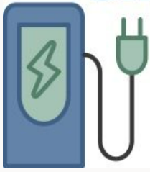
ELECTRIC VEHICLE DRIVER QUICK GUIDE
Agency logo here
Before you hit the road…
Nov. 2022

The difference between driving an EV and gasoline-powered vehicle
In general, driving an EV is just like driving an internal combustion engine vehicle except that EVs are significantly quieter, have significantly more torque, and usually handle much better due to the lower center of gravity resulting from all those batteries. Some EVs come with a one-pedal driving option that can be toggled on or off; this feature allows the driver to utilize varying pressure on the pedal to speed or slow the vehicle down and even come to a full stop. One-pedal driving helps to efficiently regenerate energy to the battery and can result in elongating vehicle range; some find this feature difficult to get used to, while others find it a much easier and more efficient way to drive. Otherwise, an EV acts similarly to vehicles you’ve been driving your whole life.

When, where, and how to charge
The EV will display the approximate battery capacity or estimated range at any given time, corresponding to the mileage remaining on a single charge. Many EV drivers plug in whenever they park to stay topped and keep the battery warm. Sometimes you may need to charge the EV on route, relying on DC fast chargers. Use resources such as PlugShare (www.PlugShare.com) to identify charging locations either at or on the way to your destination, planning to stop partway if traveling a significant distance. It is good practice to chart out your daily trip mileage and identify the location of active charging stations on the route you have planned if needed. Charging times vary depending on the size of the battery, the charging station output, and the vehicle model. EVs use their charging port and onboard charger to convert external power into battery charge; to charge an EV, you’ll need to plug it into a charging station or an applicable outlet, in which you can use the vehicle’s separate charging cable (many models include one to keep in the vehicle). Charging stations and cords are required to meet specific fire and electrical safety standards to prevent injury.

Once the vehicle is parked, connect the vehicle with the cord connected to the charging station or the one included with the vehicle. Depending on the location, you can initiate charging simply by plugging in or by using an app, contactless card, or RFID card. Charge as long as you have time to if parked or until you get the range you need. Use of frequent fast charging can negatively impact battery performance so should be used only when needed, and fast chargers should generally only be used to reach 80% of battery capacity – after that, charging time slows significantly. There is no harm in keeping a vehicle plugged into a Level 1 or Level 2 charger as all vehicles come with battery management systems that regulate battery temperature and stop charging when the vehicle reaches 100% battery capacity.

Charging station types
The main types of charging stations you’ll be using on the road and at state facilities are Level 2 (AC) charging and DC Fast Charging. The main difference between them is the rate at which charging occurs; Level 2 charging gets you approximately 20-30 miles of range per hour of charge, while DC Fast Charging can get you anywhere from 50-100 miles of range in 15 minutes. Variability in charging times will depend on the vehicle battery and the capacity of the charging station. All Level 2 stations use a standard plug that all EVs use, while most EVs (not including Tesla) use one of two charging types (see below). Level 1 charging (also called trickle charging) through a standard 110V outlet can sometimes also be available in a facility – just note that this will only get you 3-5 miles of range per hour. Availability of station types will vary, with Level 2 being more common in parking lots and garages and DC Fast Charging stations growing quickly along major roadways.

Factors that may impact the EV battery range
Your EV will let you know where its battery range is at and some models will project remaining milage; if there’s an onboard option to input your destination, some EVs will even plot charging stations along the route. The primary factors that will impact the battery performance are cold weather and the use of cabin temperature controls (particularly heating). Other potential factors include repeated rapid acceleration, vehicle speed, payload, hills, and strong headwinds. These factors are akin to those that affect gasoline powered vehicles, you might just see the impact more directly in an EV. Many EVs come with heated seats and steering wheels that use much less energy than cabin heating and will not really affect vehicle range. In some cases, those features may be enough to keep you warm without using cabin heating.
Last but not least --- Familiarize yourself with the specific manufacturer requirements and guidance for operation and charging, including the vehicle’s range and whether it is compatible with DC Fast Charging. Also check with your fleet manager about agency-specific charging policies and to determine when and where to plug the vehicle back in when bringing it back to its garaged location.

EV Charging Port Reference Guide
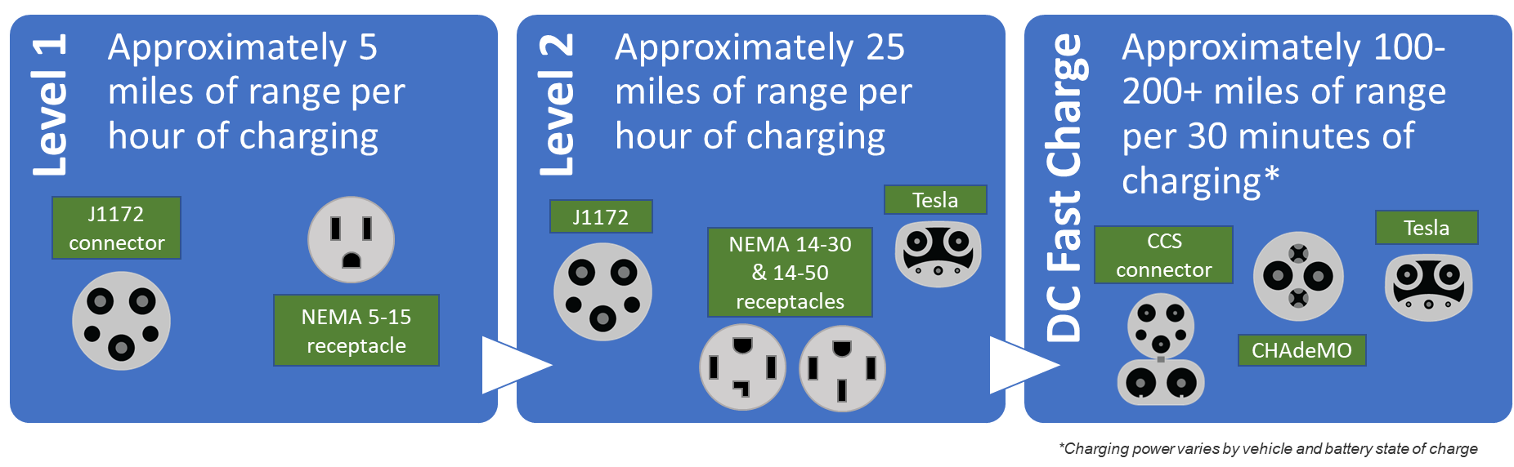

Additional Guidance for EV Charging
An agency may wish to add more specific fleet operations information to this page such as:
- Use of fuel (WEX) cards for charging and whether drivers will need to use specific app or fob when charging offsite.
- When and where to charge vehicles at the end of the day.
- Where to leave key fobs.
- Asking drivers to log the charge level/remaining range if not plugging back in at the end of the day.
- Asking drivers to conduct a quick inspection of the charging cord and connector at the end of vehicle trips.
- Guidance for driving EVs in agency-specific contexts (e.g., driving on multi-use paths in DCR parks as an example).
- What to do if involved in a crash.

