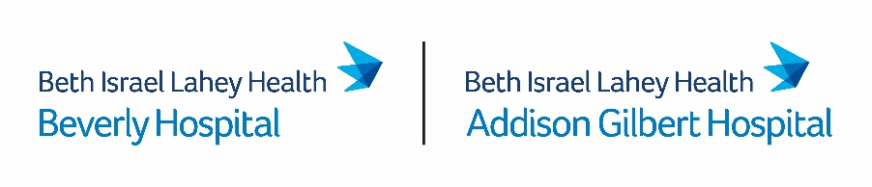
November 18, 2022

Via E-Mail

Stephen Davis, Director
Division of Health Care Facility Licensure & Certification
Massachusetts Department of Public Health
67 Forest Street
Marlborough, MA 01752
Stephen.davis@mass.gov

Re: Beverly Hospital Response to Comments on Post-Closure Birth Center Service Access Plan
Dear Mr. Davis:
This letter is submitted on behalf of Beverly Hospital (license #V93D), located at 85 Herrick Street Beverly, MA 01915 (the “Hospital”), in response to the Department of Public Health’s (the “Department”) November 10, 2022 letter regarding the Hospital’s proposed access plan for outpatient birth center services (the “Service”) post-closure of the Service on December 1, 2022. In its letter, the Department specifically asked the Hospital to comment upon the following four (4) aspects of its post-closure plan:
- Access to midwifery care and birth center-like services at the Hospital. The Department requested that the Hospital provide specific information about its proposed outreach efforts to inform and solicit interest from the community about the Hospital’s commitment to lease the building where the Service is currently housed to an independent midwifery practice until April 2025. The Department also requested that the Hospital provide information on other long-term space options that may be available.

The Hospital’s outreach plans for the lease of the building on its campus include: (i) posting information for interested parties on the Hospital’s current landing page for the North Shore Birth Center; (ii) outreaching to the Executive Office of Health and Human Services (“EOHHS”) workgroup members, elected officials, and appropriate community groups to inform them of the leasing opportunity; and (iii) alerting its community benefit advisory committee (“CBAC”) of the leasing opportunity. The current building where the Service is located is the appropriate and best-suited space for such a lease. The Hospital is, however, willing to work with its real estate team to identify if there is alternative, preferable unoccupied space that the Hospital currently owns or leases within its service area.

- Support for access to birth centers. The Department asked the Hospital to provide additional details on the grant making/approval process related to its commitment to provide $1.5 million in grant funding to one or more community organizations to create, expand, or reopen birth centers licensed by the Department. The Department also asked the Hospital to include a description of any technical assistance the Hospital plans to provide applicants.

The Hospital anticipates utilizing a structured grant process that is similar to its established process for its community benefits investment grant awards. The Hospital will use the same outreach plan as described above for the building lease but will also message this upcoming funding opportunity with the ten Beth Israel Lahey Health (BILH) CBACs, representing geographies/municipalities and neighborhoods on the North Shore, Boston and surrounding communities, and the South Shore, at their quarterly meetings in December. Additionally, information on the grant and a request for proposal (“RFP”) will be available on the Hospital’s website by the first quarter of 2023. At a minimum, applicants must be able to demonstrate how the requested funds will be used to: (i) create, expand, or reopen an outpatient birth center licensed by the Department, and (ii) prioritize unmet needs for maternity care in underserved communities. Once the RFP is posted, applicants will have a period of time to submit questions to the Hospital and the Hospital will provide technical assistance to applicants in the form of frequently asked questions. Upon notice of an award, awardee(s) would be required to submit an invoice(s) to BILH to receive the grant funds, identify BILH as a co-sponsor of the project in any media, community and/or public relations efforts, and submit quarterly reports to BILH on agreed upon metrics and progress on the project. BILH anticipates making the initial funding award(s) in the second or third quarter of 2023 and disbursing all funds through a similar RFP process on or before December 2025.

- Establishment of a BILH system-wide maternal quality initiative. The Department has asked the Hospital to comment upon how it intends to ensure diverse representation on both the BILH Maternal Quality Council and the Hospital’s Maternal Newborn Patient and Family Advisory Council (“PFAC”).

With respect to the Maternal Quality Council, BILH plans to ensure diversity of representation not only by discipline (e.g., including representation from obstetrics, midwifery, nursing, and doulas) but also by specialty (e.g., including representation from psychiatry and social work). To ensure diversity on its newly formed Maternal Newborn PFAC, the Hospital plans to identify and engage with community-based organizations that represent families from diverse backgrounds. This outreach will be done through targeted outreach to identified groups in the community, posting flyers in public forums, and through online outreach. To make it easier for individuals from underserved communities to participate in the PFAC, the Hospital will ensure that interpreters are available and that there is both an in-person and online option for meetings.

- Continued communication post-closure of the Service. The Department has asked the Hospital to describe how it plans to update the Department and the community on the progress of the Hospital’s commitments to ensure access to substantially similar services post-closure of the Service. As part of the Hospital’s post-closure access plan, the Hospital will provide an annual summary for three years to the Department, EOHHS leadership, elected officials, and the Campaign to Save the North Shore Birth Center on the progress of its post-closure commitments including detail on the utilization of Hospital OB/GYN services and an update on any transportation or other access barriers identified post-closure. During the first year post-closure, the Hospital will provide two updates- one on June 1, 2023 and one on December 1, 2023. Thereafter, such updates will be given annually on December 1st for the remaining two year period.
The Hospital appreciates the opportunity to respond to the Department’s feedback on its post-closure access plan. It remains committed to maintaining choice and providing access to equivalent midwifery services for all birthing people in its community post-closure of the Service. If you require further information with respect to this matter, please contact Meg Cosgrove, Senior Associate General Counsel at (781) 510-1363.
Sincerely,
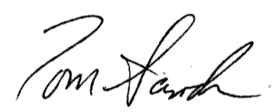
Tom Sands, President, FACHE

cc: M. Gendreau, Chief Medical Officer, Beverly Hospital
K. Perryman, Chief Nursing Officer, Beverly Hospital
M. Schuyler, Vice President, Government Affairs, Beth Israel Lahey Health

Community groups identified include but are not limited to the Campaign to Save the North Shore Birth Center, the Bay State Birth Coalition, MassMidwives, the Massachusetts Midwives Alliance, American Association of Birth Centers, National Partnership for Women & Families, National Association of Certified Professional Midwives, Midwives Alliance of North America, and North American Registry of Midwives.

