Massachusetts Department of Public Health

Health Professions Licensing System

External User Manual
1/15/2023
V1.2

Table of Contents
2. Introduction 3
3. Creating an Account 3
3.1 How Do I Create an Account? 3
3.2 How Do I Log in to My Account? 4
3.3 How Do I Log out of My Account? 5
3.4 How Do I Reset My Password? 5
3.5 How Do I Retrieve My Username? 7
4. Managing an Account 8
4.1 How Do I Update My Account Information? 8
4.2 How Do I Change My Password? 9
4.3 How Do I Link My License to My Account? 10
4.4 How Do I View Notifications in My Account? 11
5. Online Functions for Applicants and Licensees 12
5.1 How Do I Apply for a New License? 12
5.2 How Can I View My Application or License Status? 14
5.3 How Do I Withdraw My Application? 15
5.4 How Do I Renew My License? 16
5.5 How Do I Amend Information on My License? 19
5.6 How Do I Print My License Card or Wall Certificate? 22

Introduction
The Health Professions Licensing System allows users to apply, renew, and amend their professional licenses online.
Users are able to review notifications related to their license applications and update their account information.
This document provides step-by-step instructions for the system’s functions.

Creating an Account

3.1 How Do I Create an Account?
In order to use the system, all users will need to create an account. To create an account, follow the steps below:
Step 1: Open a browser and navigate to this website https://HealthProfessionLicensing.mass.gov
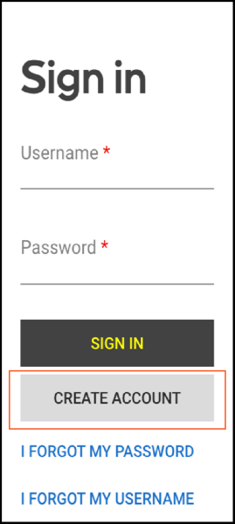
Create Account Button
Step 2: Click the “Create Account” button.
Step 3: On the next screen, fill in the required fields.
Step 4: Please note, the password requirements are as follows:
- Must be at least 10 characters
- Must contain 1 lowercase
- Must contain 1 uppercase character
- Must contain 1 number
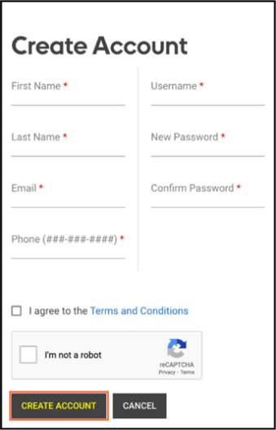
Create Account page
Step 5: Click the “Create Account” button after filling in all the required fields.
A pop-up will appear with the option to add an alternative email address. Add an alternative email address or click “Skip” to proceed.
Step 6: On the next screen, verify your email address. An email was sent to you containing a verification code.
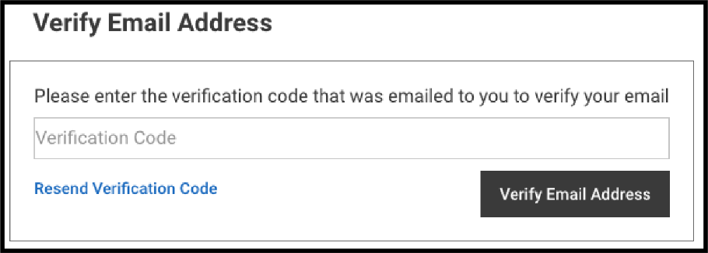
Email Verification Code field
Step 7: Copy the verification code from the email and paste it in the Verification Code field.
Step 8: Click the “Verify Email Address” button.

3.2 How Do I Log in to My Account?
After creating an account, follow these steps to sign in:
Step 1: Open a browser and navigate to this website https://HealthProfessionLicensing.mass.gov
Step 2: Enter your username and password.
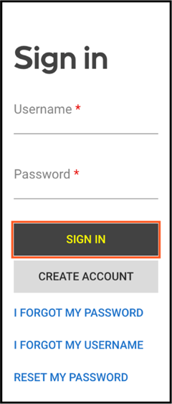
Sign In Page
Step 3: Click the “Sign In” button.

3.3 How Do I Log out of My Account?
Follow these steps to log out of your account:
Step 1: Click on the icon in the upper right corner containing your initials.
Step 2: Click on the “Log Out” option from the drop-down menu.
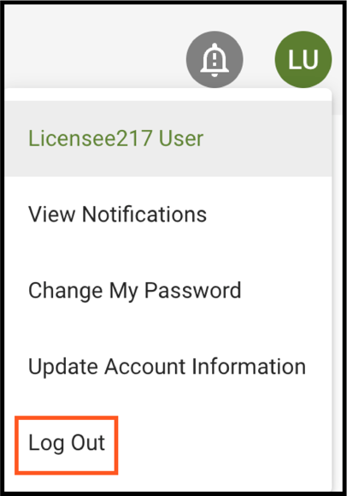
Log Out Page

3.4 How Do I Reset My Password?
To reset your password, follow the steps below:
Step 1: Open a browser and navigate to this website https://HealthProfessionLicensing.mass.gov

Step 2: Click on “I Forgot My Password”.
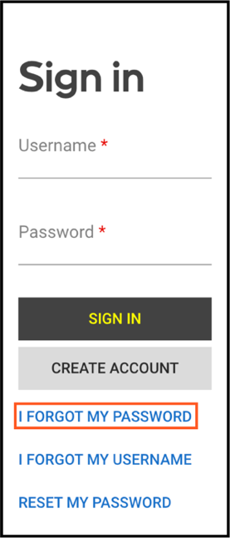
I Forgot My Password button
Step 3: Enter the email related to your account and click the “Reset Password” button. Then the Reset Password screen will appear and an email is sent to you containing a temporary password.
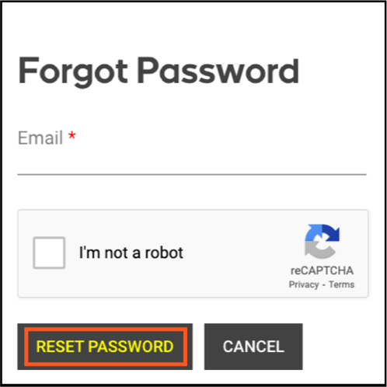
Forgot Password Pop-up
Step 4: Please check your inbox, junk, and spam folders for the email containing a temporary password.
Step 5: On the “Reset Password” screen, please do the following:
- Copy the temporary password from the email you received and paste it in the Temporary Password field
- Enter your username in the Username field
- Enter the new password in the fields for New Password and Confirm Password. Please note that the password requirements are as follows:
- Must be at least 10 characters
- Must contain 1 lowercase character
- Must contain 1 uppercase character
- Must contain 1 number
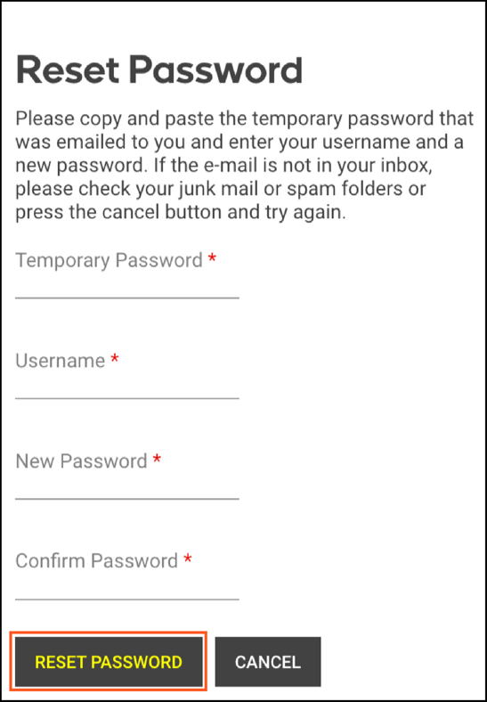
Reset Password button
Step 6: Click the “Reset Password” button.

3.5 How Do I Retrieve My Username?
Follow these steps to retrieve your username:
Step 1: Open a browser and navigate this website https://HealthProfessionLicensing.mass.gov
Step 2: Click on “I Forgot My Username”.
Step 3: On the next screen, in the “Email” field enter the email address associated with your account and mark the checkbox for the captcha.
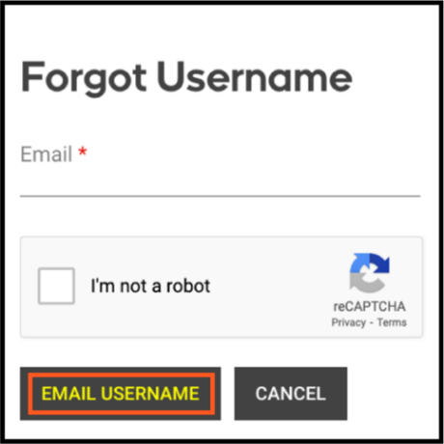
Forgot Username Pop-up
Step 4: Click the “Email Username” button.
Step 5: An email is then sent to you containing your username. Please make sure to check your inbox, junk, and spam folders for the email containing your username.

Managing an Account

4.1 How Do I Update My Account Information?
You can update your primary email, alternative email, and phone number related to your account. To update your account information, follow these steps:
Step 1: Click on the icon containing your initials at the top right corner of the page.
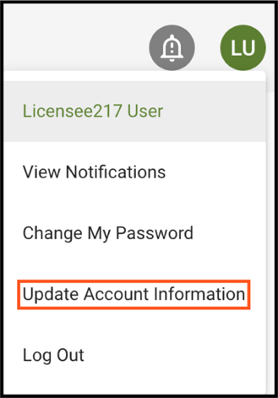
Update Account Information option
Step 2: Click on the “Update Account Information” option from the dropdown menu.
Step 3: In the pop-up, update your primary email, alternative email, and/or phone number.
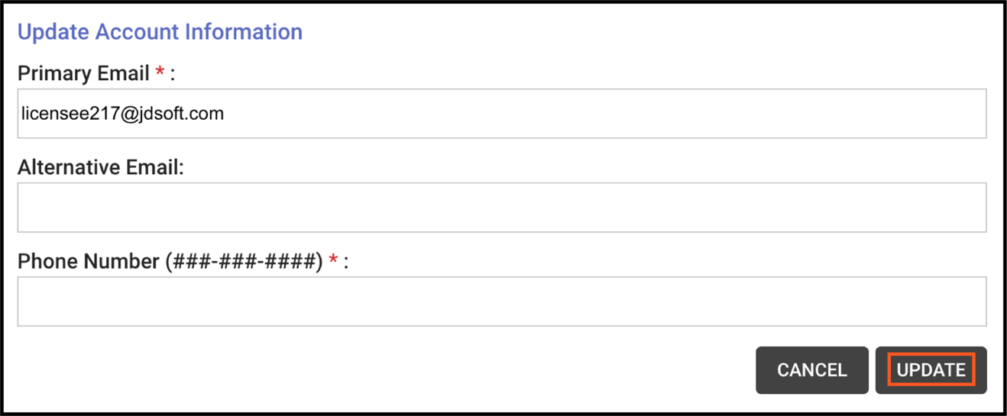
Update Account Information pop-up
Step 4: Click the “Update” button.

4.2 How Do I Change My Password?
To change your password, follow these steps:
Step 1: Click on the icon containing your initials at the top right corner of the page.
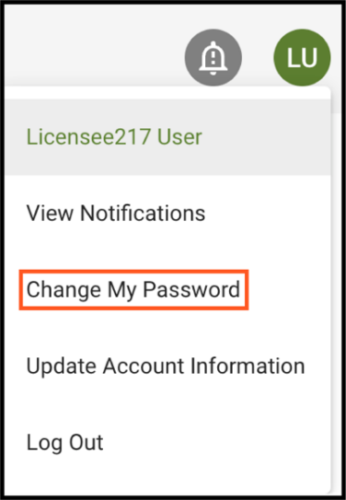
Change My Password option
Step 2: Click on the “Change My Password” from the dropdown menu.
Step 3: Then you will be prompted to type in your current password, a new password, and to confirm the new password.
Please note the following password requirements:
- Must be at least 10 characters
- Must contain 1 lowercase character
- Must contain 1 uppercase character
- Must contain 1 number
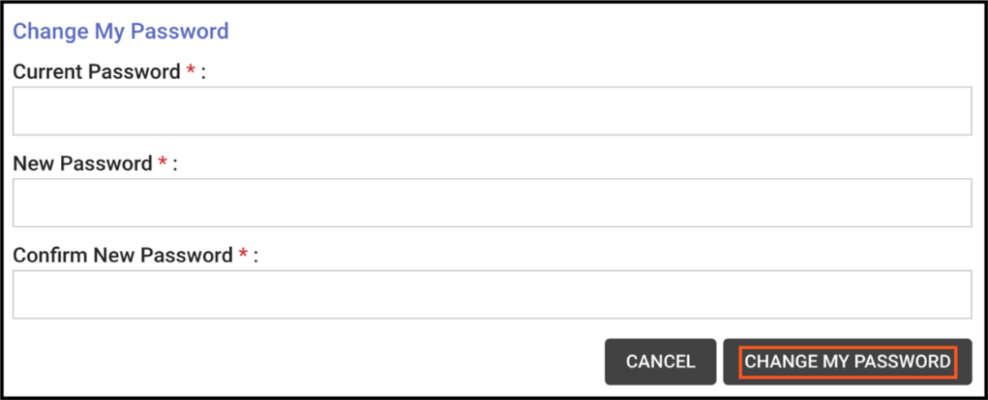
Change My Password Form
Step 4: Click on “Change My Password”.

4.3 How Do I Link My License to My Account?
If you had a license prior to the implementation of this system, you will need to link your existing license(s) to your new account. Please note, each license must be linked one at a time.
To link your license to your account, follow these steps:
Step 1: Log in to the system and click the “Link License to My Account” button.

Link License to My Account button
Step 2: On the next screen, please do the following:
- select your license type from the “License Type” dropdown menu; and
- enter your license number in the “License Number” field.
- License numbers can be entered with or without the license number prefix. For example, a Chiropractor can use the format 12345 or CHI12345 for their license number.

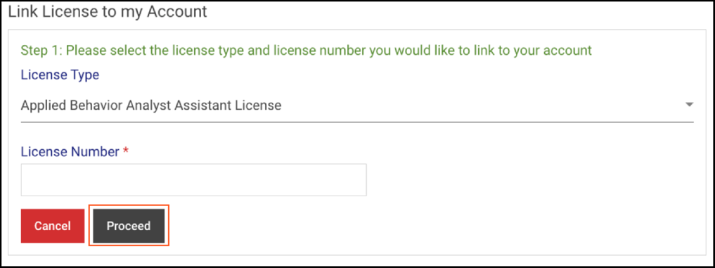
Link License to My Account page
Step 3: Click the “Proceed” button.
Step 4: On the following screen, enter your Date of Birth (Format: MM/DD/YYYY) and Social Security Number (Format: 111-11-1111).
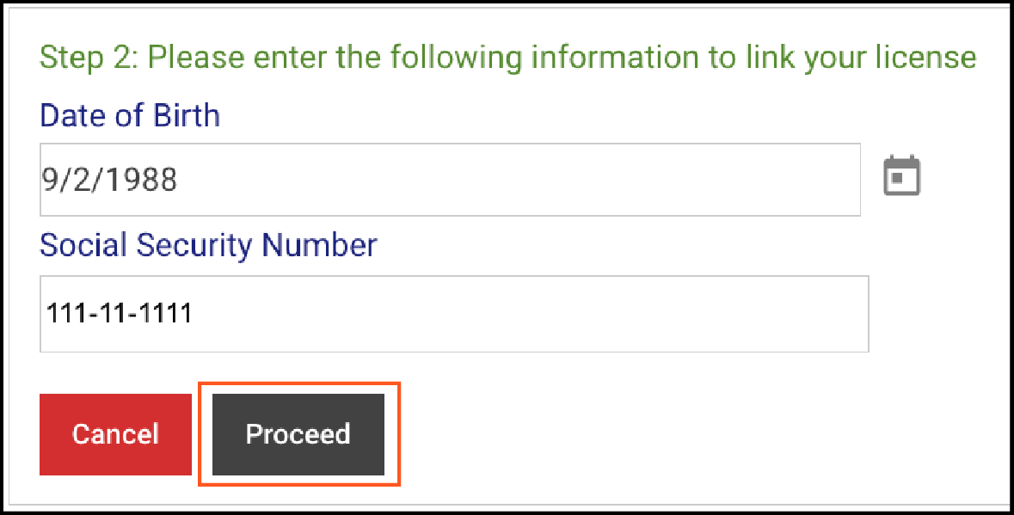
DOB and SSN fields
Step 5: Click the “Proceed” button.
Step 6: On the next screen, review your license information
Step 7: Click the “Yes, Link License” button to link your license to your account.
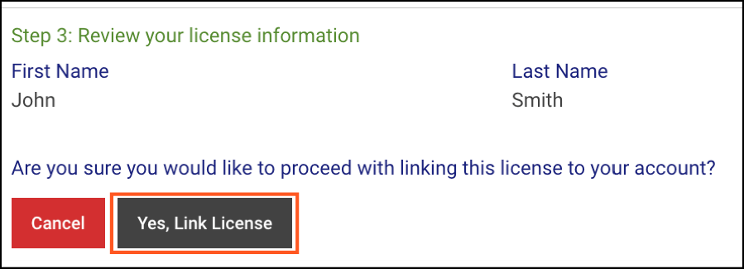
Yes Link License button
Step 8: On the next screen, a message displays stating that you have successfully linked your license. Click the “OK” button to continue or the “Link Another License” button to link another license to your account.
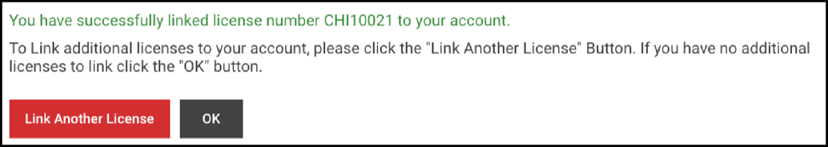
Successfully Linked License message

4.4 How Do I View Notifications in My Account?
If you have unread notifications, the bell icon at the top right corner of the page will be red and show the count of unread notifications. Follow these steps to view notifications:
Step 1: Click on the bell icon at the top right corner of the page.
Notifications Icon
Step 2: On the notifications page, you have the option to view “Unread Only” and “All” notifications.
OR
Step 2A: Click on the icon containing your initials at the top right corner of the page.
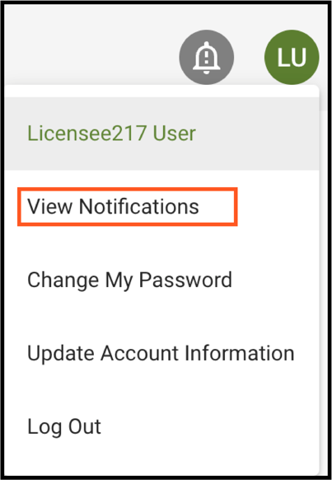
View Notifications link
Step 2B: Click on “View Notifications” from the drop-down menu.

Online Functions for Applicants and Licensees

5.1 How Do I Apply for a New License?
To apply for a license, follow these steps:
Step 1: If you already have a license linked to your account, you will need to click the “View Other Types” button on the “Other License, Certification, and Registration Types” card.
If you do not have a license linked to your account, you will go to this page when you log in.
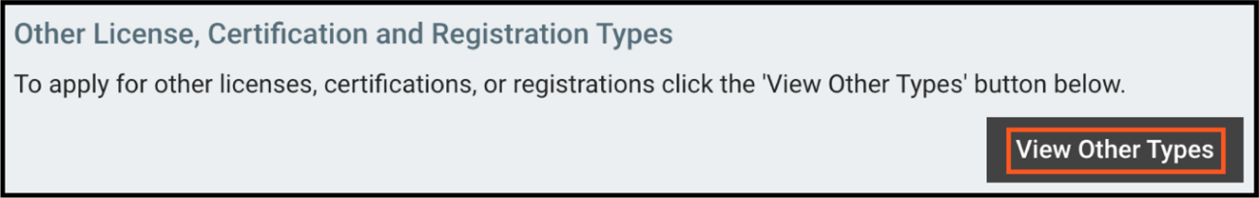
“Other License, Certification, and Registration Types” Card
Step 2: Click on the “View More” button under the applicable licensing board.
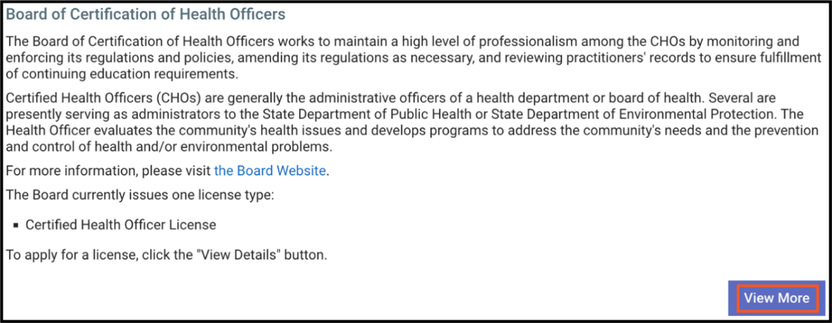
View More button
Step 3: Click on the “Start Application” button under the applicable license application card.
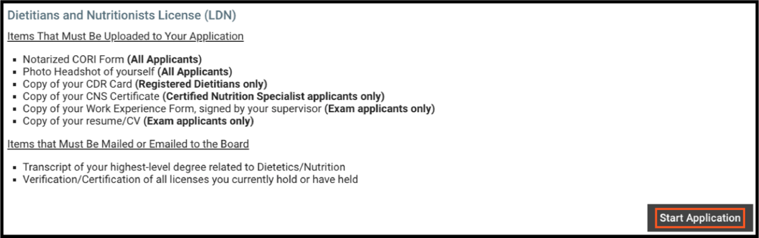
Start Application button
Step 4: Continue through the application following the instructions on each page, completing the required fields, and uploading the required documents.
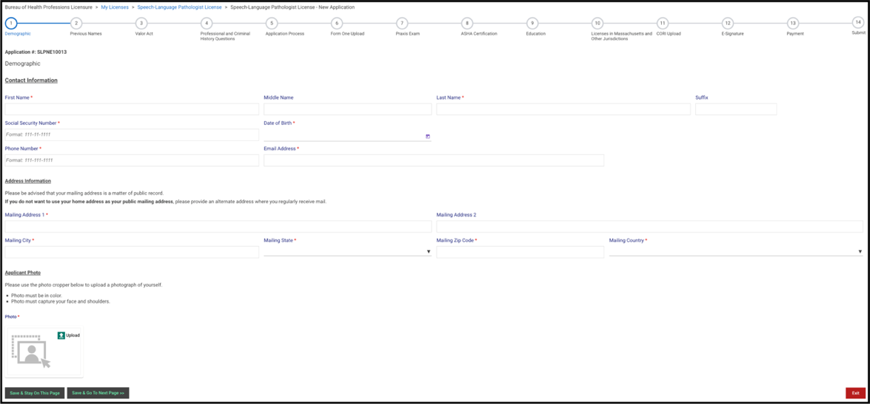
Application Page
Step 5: If applicable, you must pay the application fee before you can submit the application. On the Payment page, click the “Pay Fee” button to be directed to the third-party payment vendor’s page.
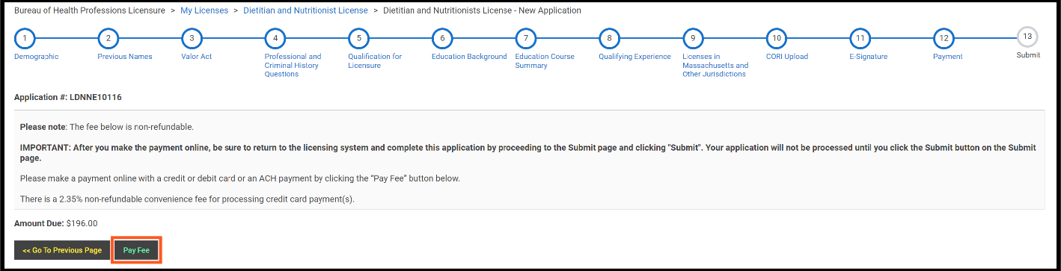
Pay Fee button
Step 6: Complete the payment information, mark the checkbox to agree to the terms and conditions, and click the “Submit Payment” button at the bottom of the page.
Step 7: After paying, you will automatically be returned to the licensing system.
Please note, you must submit the application or it will not be processed.
Step 8: Click on the “Go to Next Page” button.
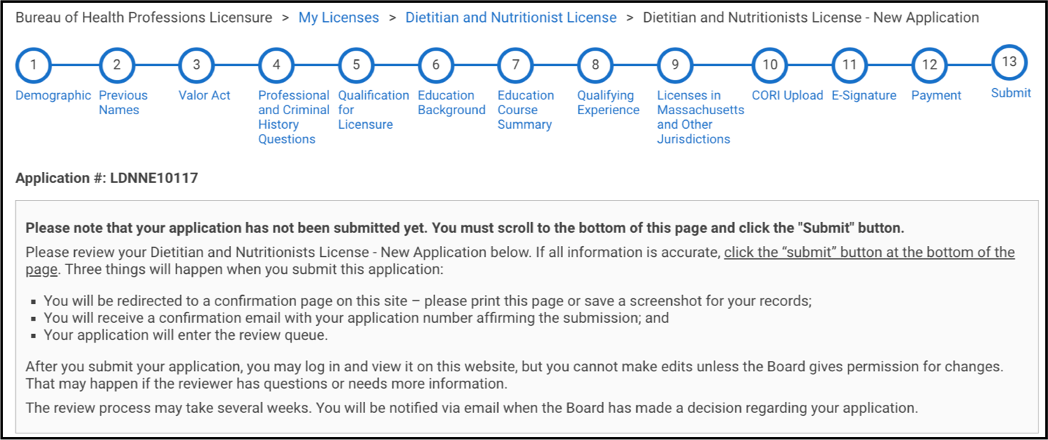
Application Submission Page
Step 9: Review the information and click the “Submit” button at the bottom of the page. The final step for every application is to click the “Submit” button to send in the application.

5.2 How Can I View My Application or License Status?
Follow these steps to view your application or license status:
Step 1: Click the “Show Details” button under the respective license type card.

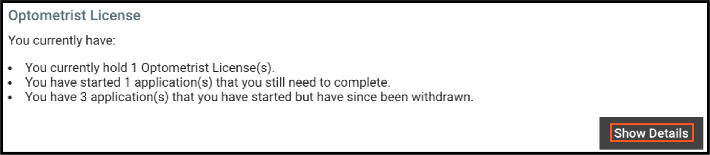
Show Details button
Step 2: If you have a license that is linked to your account, you will see your license status on the license information card. If you have an application that is pending, incomplete, or reopened you will see its status on a card inside the license card.
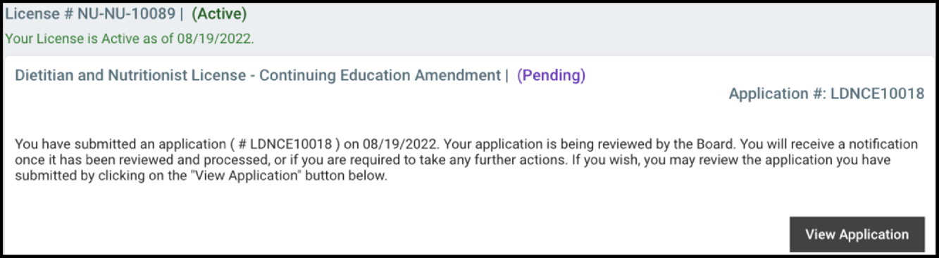
License Status and Application Status

5.3 How Do I Withdraw My Application?
You can only withdraw an application that has not been submitted yet. Follow these steps to withdraw an application:
Step 1: Click on the “Show Details” button under the respective license.
Show Details button
Step 2: Click the “Withdraw this Application” link.
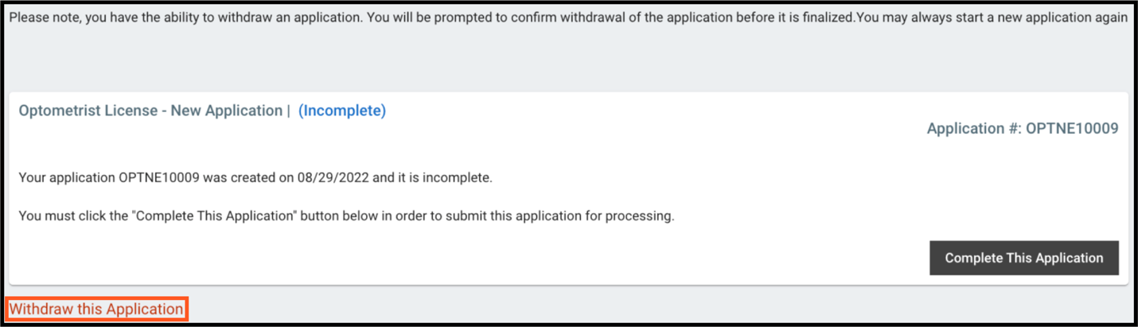
Withdraw This Application link
Step 3: In the pop-up, enter the application number (Ex. #ABC112546) in the text field.
Step 4: Then click the “Withdraw” button.
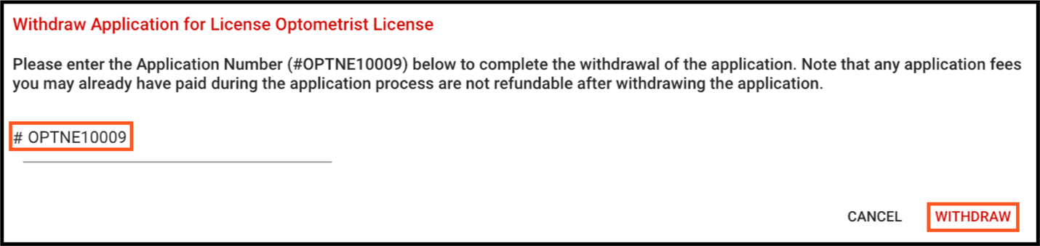
Withdraw button
Step 5: A pop-up confirms the application was successfully withdrawn. Click the “OK” button to close the pop-up.
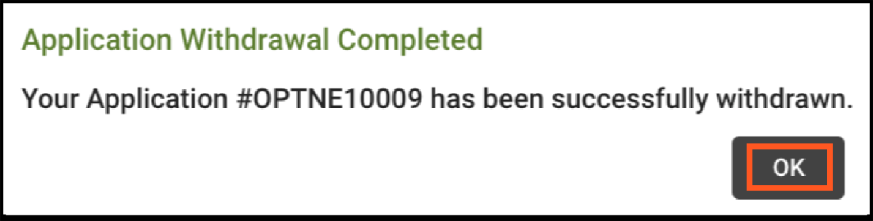
Application Withdrawal Confirmation

5.4 How Do I Renew My License?
To renew your license, follow these steps:
Step 1: Click on the “Show Details” button under the respective license.
Show Details button
Step 2: Click on the link for the renewal application.
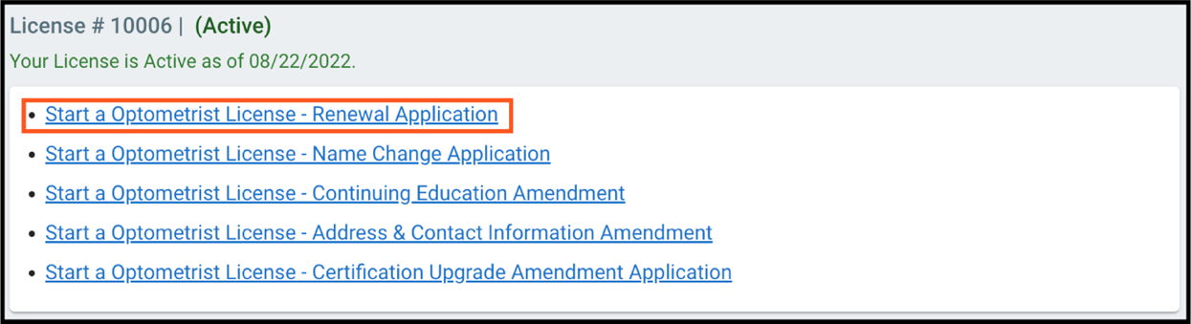
Renewal Application link
Please note that the renewal application link will only be available when your license is in the renewal period. For most license types the renewal period starts 90 days before the license expiration date.
Step 3: Click the “Start Application” button.
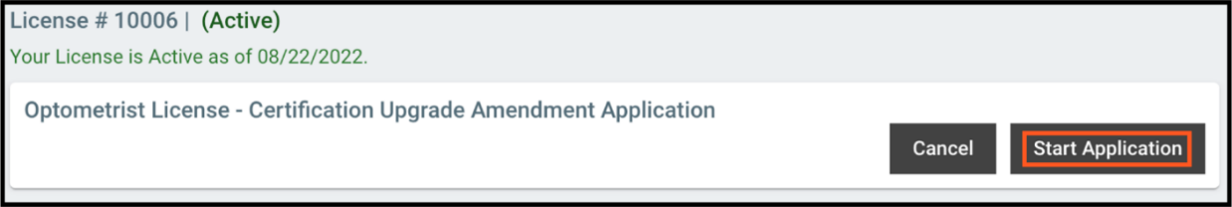
Start Renewal Application
Step 4: Continue through the renewal application following the instructions on each page, completing the required fields, and uploading the required documents (if applicable).

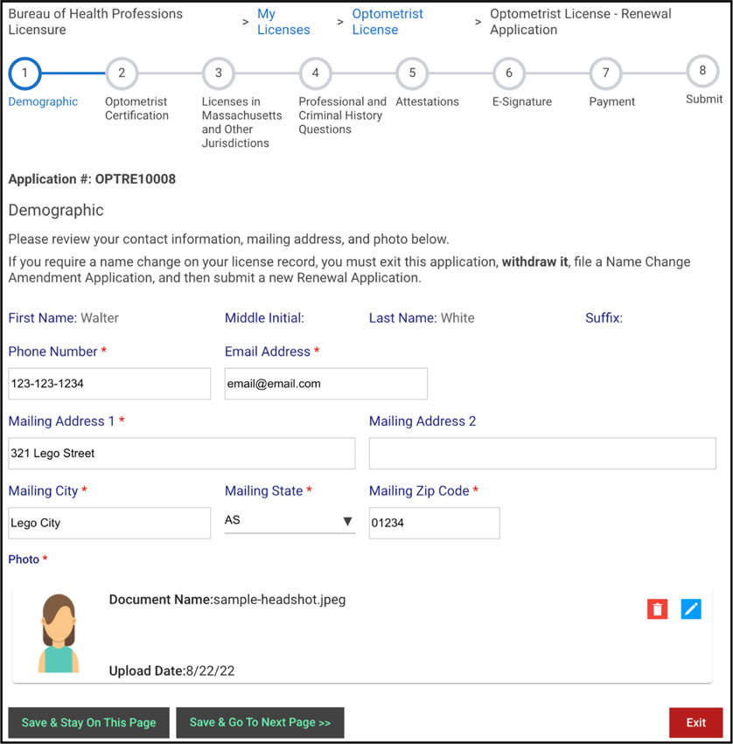
Renewal Application page
Step 5: If applicable, you must pay the renewal application fee before you can submit the renewal application. On the Payment page, click the “Pay Fee” button to be directed to the third-party payment vendor’s page.
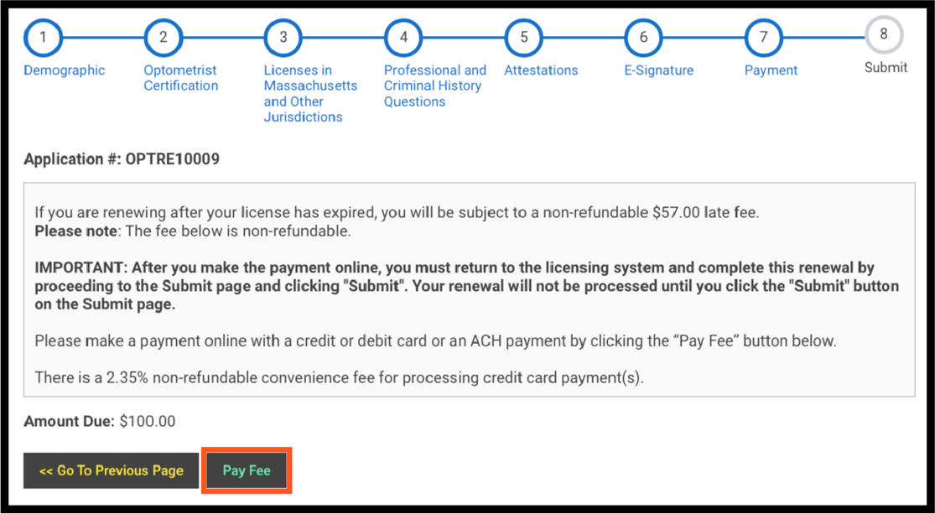
Pay Fee button
Step 6: Complete the payment information, mark the checkbox to agree to the terms and conditions, and click the “Submit Payment” button at the bottom of the page.
Step 7: After paying, you will automatically be returned to the licensing system.
Please note, you must submit the renewal application or it will not be processed.
Step 8: Click on the “Go to Next Page” button.
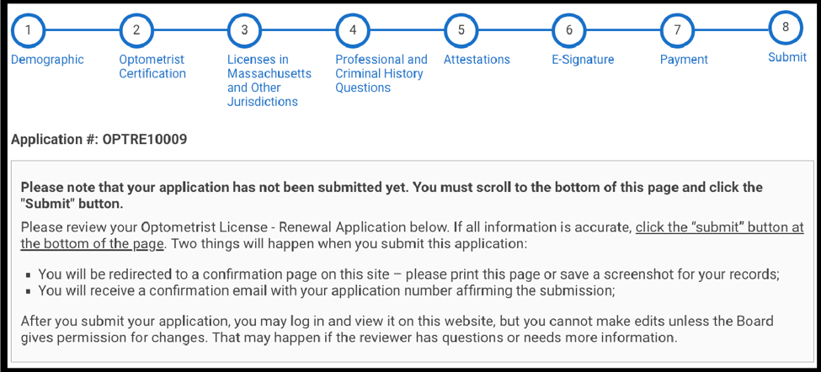
Submit button
Step 9: Review the information and click the “Submit” button at the bottom of the page. The final step for every application is to click the “Submit” button to send in the application.

5.5 How Do I Amend Information on My License?
To amend information on a license, follow these steps:
Step 1: Click the “Show Details” button under the respective license.
Show Details button
Step 2: Select the link for the appropriate amendment application.

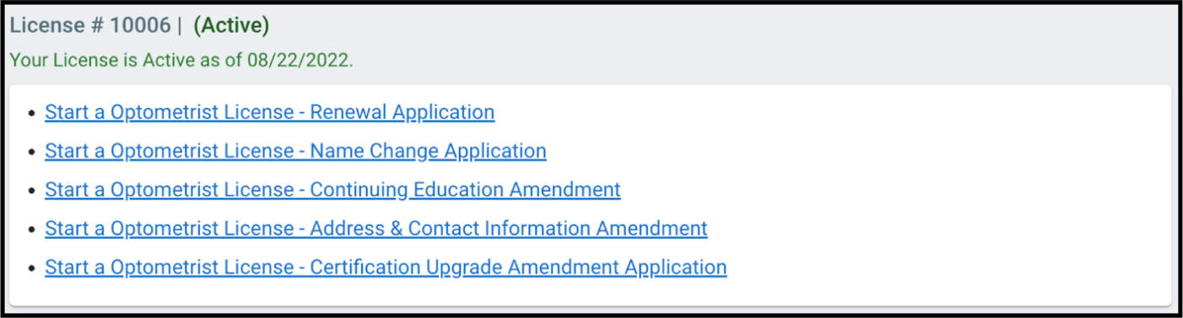
List of Amendment Applications
Step 3: Click the “Start Application” button.
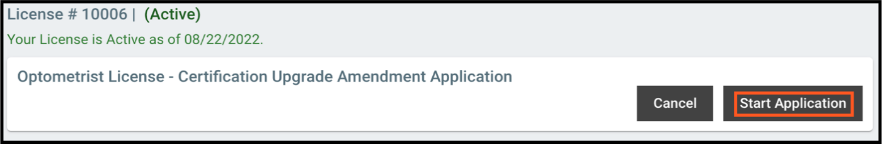Start Application button
Step 4: Continue through the amendment application following the instructions on each page, completing the required fields, and uploading the required documents (if applicable).
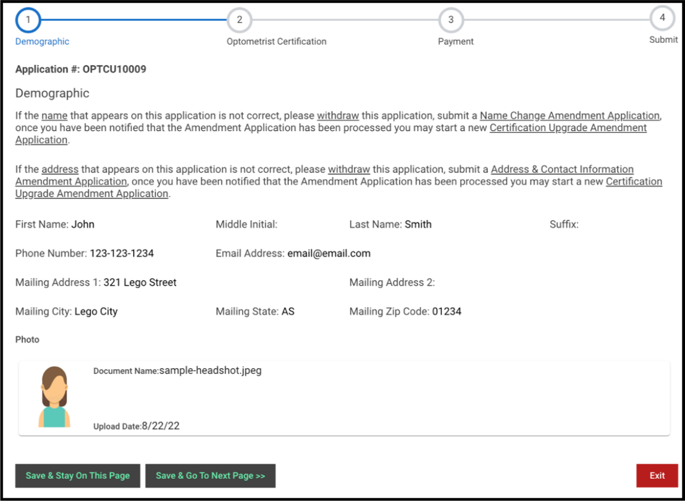
Amendment Application page
Step 5: If applicable, you must pay the amendment application fee before you can submit the renewal application. On the Payment page, click the “Pay Fee” button to be directed to the third-party payment vendor’s page.
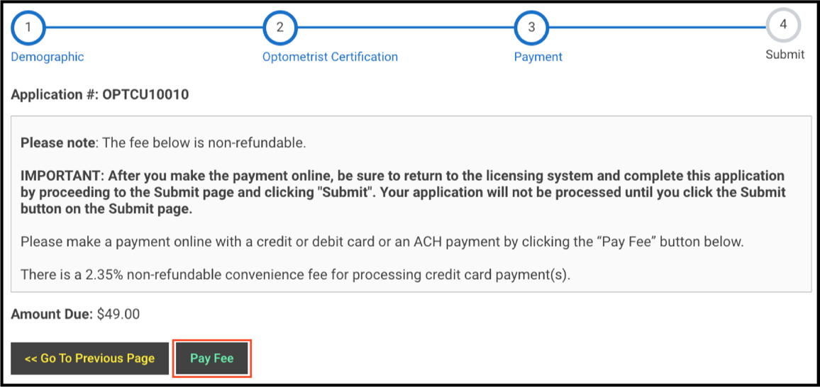
Pay Fee button

Step 6: Complete the payment information, mark the checkbox to agree to the terms and conditions, and click the “Submit Payment” button at the bottom of the page.
Step 7: After paying, you will automatically be returned to the licensing system.
Please note, you must submit the amendment application or it will not be processed.
Step 8: Click on the “Go to Next Page” button.
Step 9: Review the information and click the “Submit” button at the bottom of the page. The final step for every application is to click the “Submit” button to send in the application.
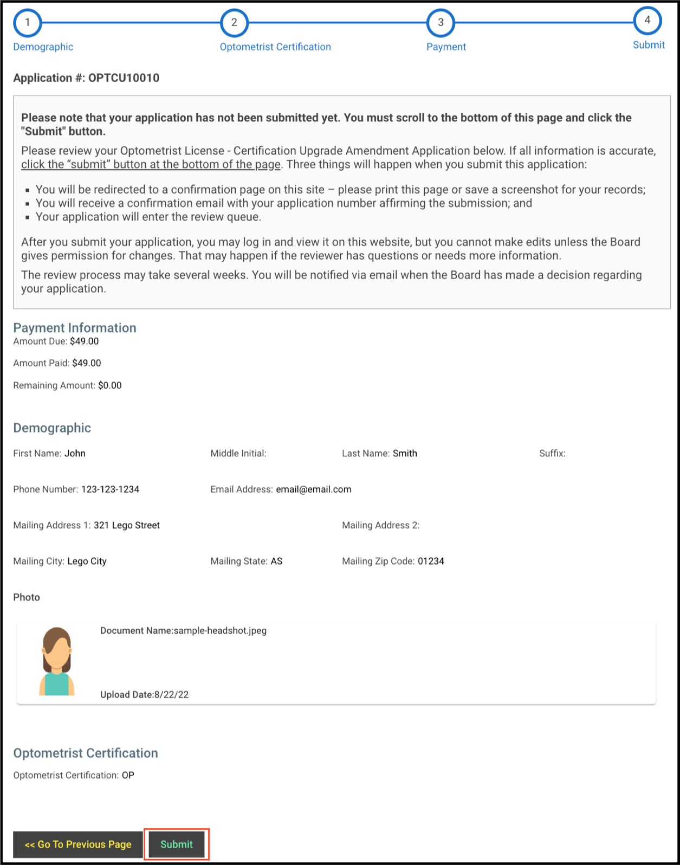
Submit button

5.6 How Do I Print My License Card or Wall Certificate?
Follow these steps to print your license card or wall certificate:
Step 1: Click the “Show Details” button under the respective license.
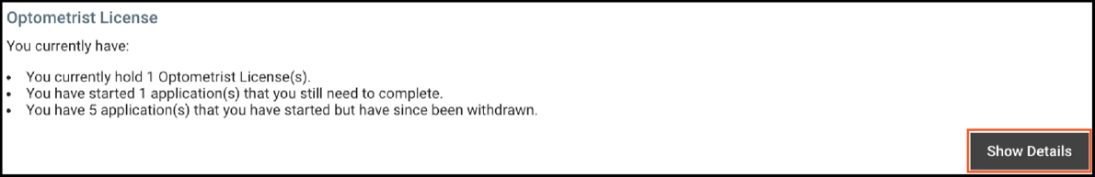
Show Details button
Step 2: On the lower left, select the appropriate document from the License Type dropdown menu.
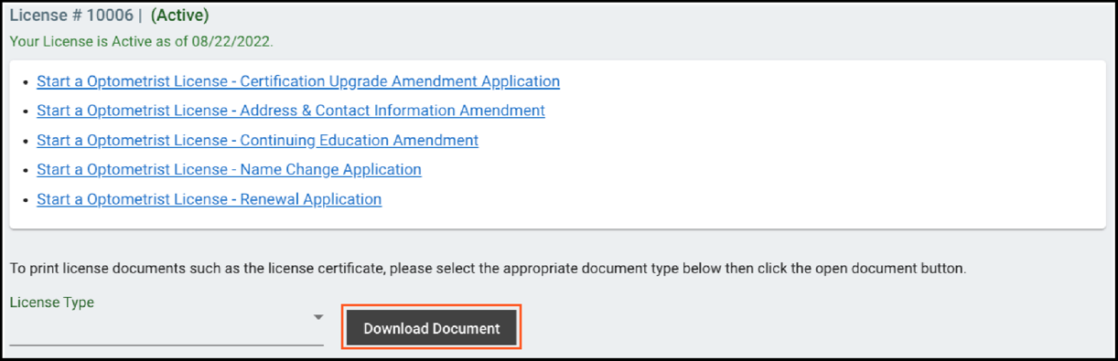
License Type dropdown menu & Download Document button
Step 3: Click the “Download Document” button.

