Hepatitis C
Hepatitis C Virus (HCV) Testing and Treatment in Massachusetts:
Key Findings from Analysis of Medical Claims Data, 2016-2020

August 2023
The Massachusetts Department of Public Health estimates that there are 250,000 people in Massachusetts with hepatitis C infection. Treatment for HCV infection is curative for more than 95% of people and requires only 8-12 weeks of simple oral therapy. Testing is critical in engaging people in treatment and preventing transmission.
To assess testing for and treatment of HCV infection, the Massachusetts Department of Public, in collaboration with forHealth Consulting at UMass Chan Medical School (formerly Commonwealth Medicine), undertook analysis of medical claims data using the Massachusetts All-Payers Claims Database (APCD v10.0), which includes claims for the years 2016-2020. Massachusetts has near universal health insurance coverage, and the APCD is the most comprehensive source of health claims data from public and private payers in the state. Key findings from this analysis are presented below.
Testing for HCV Infection is not sufficient. Between 2016 and 2020, analysis shows that cumulatively, only 13.7% of residents had been tested at least once for HCV infection, and 2.3% had been tested two or more times. During this same period, approximately 3%-3.5% of Massachusetts residents were tested each year.
Testing uptake varied by age, gender, and payer type (Figure 1). In 2020, individuals ages 19-34 years and 35-44 years had the highest percentage of testing with 4.5% and 4.4% tested, respectively. A higher percentage (3.5%) of females were tested compared to males (2.3%). A higher percentage of MassHealth members (3.7%) were tested for HCV infection, compared to those with private health insurance (3.1%).
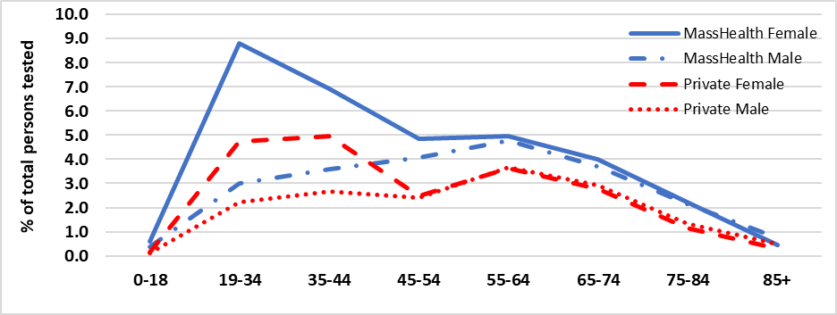

Figure 1. Percentage of HCV Testing by Age, Gender, and Payer Type

MassHealth members were also more likely than individuals with private insurance to be tested multiple times (Figure 2 on next page).

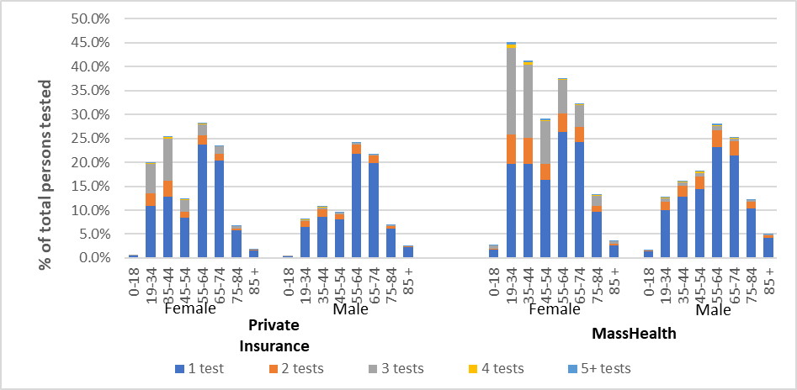
Figure 2. MA Residents with Multiple Lifetime HCV Tests,
2016-2020 by Age, Gender,
and Payer Type

Treatment for HCV infection: To examine treatment uptake, we used Current Procedural Terminology (CPT) codes to identify all testing. National Drug Codes (NDC) were used to identify Direct Acting Antivirals (DAA). Because claims data do not include test results, we used RNA tests performed and medication dispensed to impute HCV infection status. Among the 247,843 individuals receiving an HCV antibody test in 2019, RNA testing was performed for 4.9% suggesting a positive antibody result. Of those with RNA tests performed, HCV genotyping was performed for 24.5% suggesting a positive RNA test result and intent to treat. Of those with genotype tests performed, only 40.7% were treated (i.e., DAA dispensed) within one year.
Recommendations: Since 2020, CDC has recommended one-time testing for HCV infection for all adults, and periodic testing for other individuals based on risk exposure. Treatment for HCV infection is curative for more than 95% of people and requires only 8-12 weeks of simple oral therapy.
Clinicians are urged to increase testing for HCV infection, including conducting repeat tests for individuals with ongoing risk for infection. Supplemental HCV RNA testing is necessary to identify current HCV infection and start treatment. Clinicians are encouraged to adopt the recommended testing algorithm and order reflex to RNA testing for all antibody positive test results. Antibody and RNA testing should be performed on samples collected from a single draw rather than requiring patients to return a second time.
Clinicians are urged to start treatment for HCV infection following diagnosis. For most people, treatment for HCV infection is uncomplicated and highly effective. There is no need to wait for potential viral clearance.
Resources:
- CDC testing recommendations: cdc.gov/mmwr/volumes/69/rr/rr6902a1.htm#B1_down
- Recommended testing sequence: cdc.gov/hepatitis/hcv/pdfs/hcv_flow.pdf
- Updated operational guidance for HCV testing: cdc.gov/mmwr/volumes/72/wr/mm7228a2.htm
- HCV infection treatment guidelines: hcvguidelines.org
- Toolkit for hepatitis testing and treatment in primary care: mass.gov/info-details/enhancing-hepatitis-c-testing-and-treatment-for-young-injection-drug-users

