 | Massachusetts Department of Environmental Protection  Bureau of Water Resources – Drinking Water Program  Laboratory Availability Survey  For Non-business Emergency Hours |  |  |  | Date
Instructions: | If you are a MassDEP-Certified Laboratory and would like your laboratory to be listed on the MassDEP Drinking Water Program website and made available to Massachusetts Public Water Systems for emergency (non-business hour) operations, please complete and return the questionnaire below. You can provide updates to your emergency days and hours whenever your services or information changes by emailing an updated form to program.director-dwp@mass.gov. (Subject: Lab Emergency Availability Survey)
 | Laboratory Information
Important: When filling out forms on the computer, use only the tab key to move your cursor - do not use the return key.
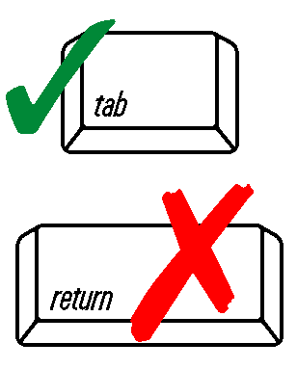
 | Laboratory Name |  |  | MassDEP-Certified Lab ID #
 | Street Address
 | City |  | State |  |  | Zip Code
 | Emergency Contact Person |  | Contact person's title
 | Emergency 24-hour phone |  | E-mail Address
 | Are you available for drinking water analysis outside of normal working hours?
 | Yes No
 | If yes, please specify your emergency days and hours of operation (e.g., 24/7, weekends, Saturdays only, evenings until midnight, etc.) and which analyses are available:
 | Parameter | Analytical Method | Emergency Hours of Operation
 | Example Entries Only (Please delete when entering your information)
 | Total Coliform / E. Coli | EPA 1604 | 24/7
 | Metals | EPA 200.8 | Saturdays only
 | VOCs | EPA 534.2 | Evenings until 11PM
 | Parameter | Analytical Method | Emergency Hours of Operation
 | Please use another form if you have additional parameters
 | How should a PWS contact you for this?
 | Do you require prior notification? Yes No
 | If yes, what is the deadline for prior notification?
 | For question, please contact the MassDEP Drinking Water Program at: program.director-dwp@mass.gov
 | Email to: program.director-dwp@mass.gov (Subject: Lab Emergency Availability Survey)

