Meningococcal Conjugate Vaccine

(MenACWY) Requirement for School Entry

Starting in the 2022-2023 school year, all students entering Grades 7–12 need the meningococcal conjugate vaccine, MenACWY (brand names Menveo or MenQuadfi), for school entry.

Grade 7–10: 1 dose; 1 dose MenACWY (formerly MCV4) required; Meningococcal B vaccine is not required and does not meet this requirement

Grade 11–12: 2 doses; second dose MenACWY (formerly MCV4) must be given on or after the 16th birthday and ≥ 8 weeks after the previous dose; 1 dose is acceptable if it was given on or after the 16th birthday; Meningococcal B vaccine is not required and does not meet this requirement

Frequently Asked Questions
Why require meningococcal conjugate vaccine?
MA school requirements generally follow the recommendations of the Advisory Committee on Immunization Practices (ACIP). ACIP recommends that children receive a dose of MenACWY at 11-12 years and a booster dose at 16 years.

What if a student is not 16 at the start of Grade 11?
Students who are not 16 when they enter Grade 11 will need a booster dose once they turn 16.

What if my school has ungraded classrooms?
In ungraded classrooms, Grade 7 requirements apply to all students ≥12 years, and Grade 11 requirements apply to all students ≥16 years.

Does the meningococcal vaccination waiver apply to the new requirement?
No. The waiver is for residential students only. However, students are allowed medical or religious exemptions.

What about Meningococcal B Vaccine?
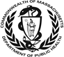
The Meningococcal B vaccine (brand names Bexsero or Trumenba) does not satisfy the MenACWY requirement.
School Immunization Surveys
Will my school have to report on the meningococcal vaccine in my Grade 7 immunization survey?
Yes. The Grade 7 survey includes a question about meningococcal vaccine for all students.

I’m at a residential school. Will I still need to complete a separate residential survey in addition to my Grade 7 survey?
No. The residential school immunization survey is incorporated into the Grade 7 survey.

Will there be an immunization survey for high school students?
Yes. The immunization survey is administered in grade 12 to assess compliance with immunization requirements for grade 11.

If you have any questions about vaccines or immunization requirements/recommendations, please contact the MDPH Immunization Program at ImmAssessmentUnit@mass.gov. Address questions about enforcement with your legal counsel; enforcement of requirements is at the local level.

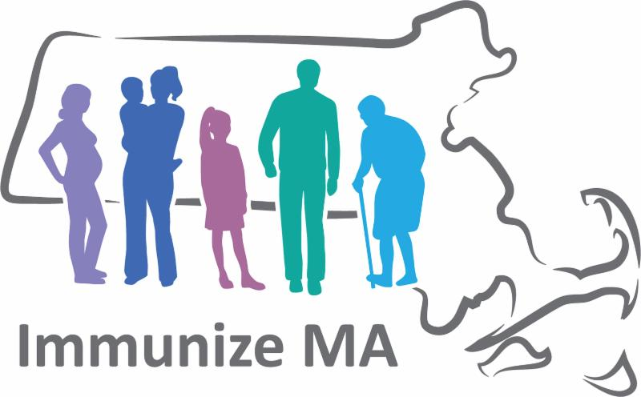
Visit the MDPH website at https://www.mass.gov/info-details/school-immunizations

