Massachusetts Department of Public Health
Nurse Aide Registry Inquiry System

USER MANUAL FOR AUTHORIZED END-USERS
(Healthcare Facilities/Employers)
09/09/2019
V1.0

Contents
1. General Overview 2
2. User Account 2
2.1 Create a new account 2
2.1.1 Create account – Existing Organization with Access Code 2
2.1.2 Recover Password – New Organization without Access Code 4
2.2 Account Approval 6
2.3 Forgot Password 6
2.4 Change Password 8
2.5 Update User Profile 9
2.6 View Organization Information 11
3. Lookup Employee Status 12
4. View Search History 14
5. View Notifications 15

1. General Overview

2. User Account

2.1 Create a new account

2.1.1 Create account – Existing Organization with Access Code
Follow the steps below if your organization currently has an access code for the Nurse Aide Inquiry Response Phone System.
Step 1: On the Login page, click on “Register as a new user” link. 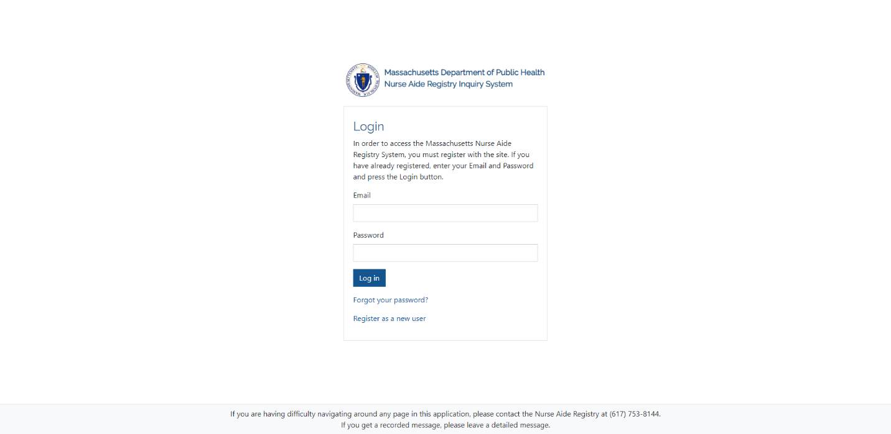
Step 2: Fill-out the registration form including:
- First and Last Name.
- Phone Number.
- Email and Password.
- Your password must be:
  - At least 12 characters long.
  - Must contain at least one special character, one Upper Case, one Lower Case, and one Number.
  - Must not contain your Email, first name or last name.
Step 3: Accept the terms & conditions then complete the CAPTCHA and click on the “Register” button. 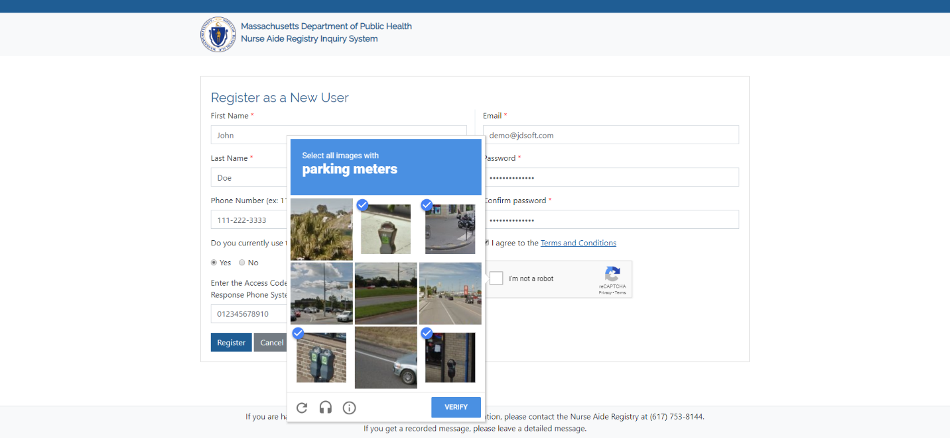
Step4: You will be prompted to update some information about your organization. Once you fill the form, click on “Update Organization Information”. 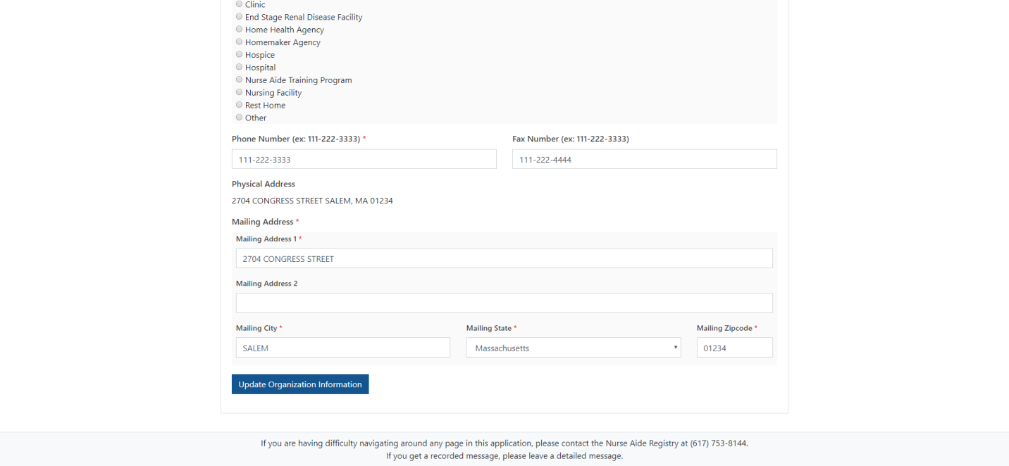

Step 5: Your request to create an account will be pending approval by the Massachusetts Department of Public Health. Please allow time for validation of your account. If you have a question concerning the status of your validation, contact the Nurse Aide Registry at (617) 753-8144. You will be notified via email when your account has been approved. Please note: approval of your account is contingent upon your submission of the “Contact Admin Form” mailed to you as well as creation of an online account.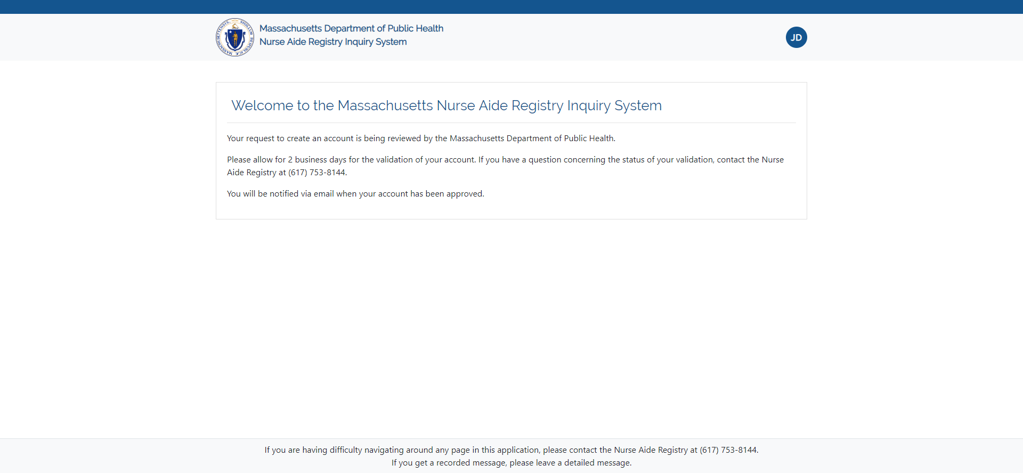

2.1.2 Recover Password – New Organization without Access Code
Follow these steps if your organization does not currently have an access code for the Nurse Aide Inquiry Response Phone System, and you would like to register your organization for the first time.
Step 1: On the login page click on “Register as a new user” link.
Step 2: Fill-out the registration form including your:
- First and Last Name.
- Phone Number.
- Email and Password.
- Your password must be:
  - At least 12 characters long.
  - Must contain at least one special character, one Upper Case, one Lower Case, and one Number.
  - Must not contain your Email, first name or last name.
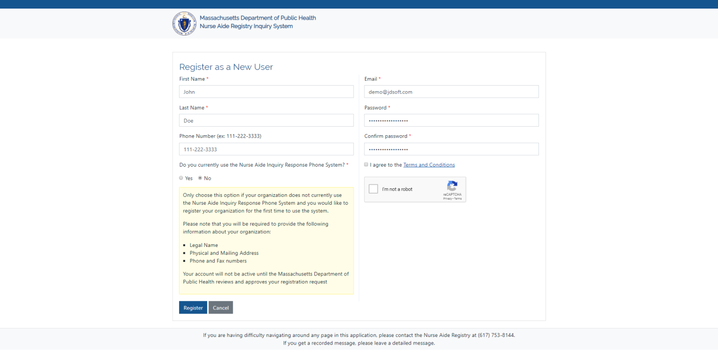

Step 3: Once you fill in your user information, then accept the terms and conditions, complete the CAPTCHA and click on the "Register” button. 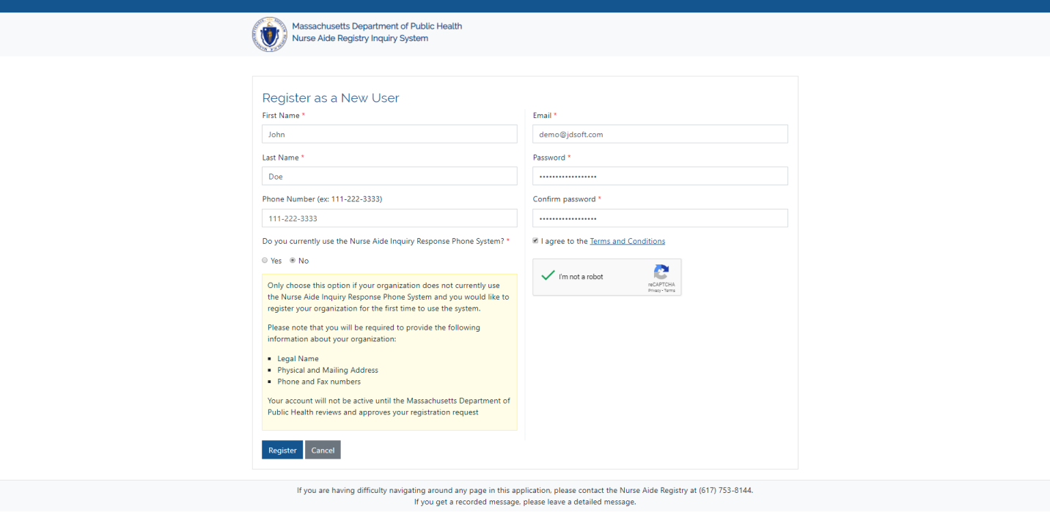
Step 4: Enter your organization's information and click on “Register My Organization”.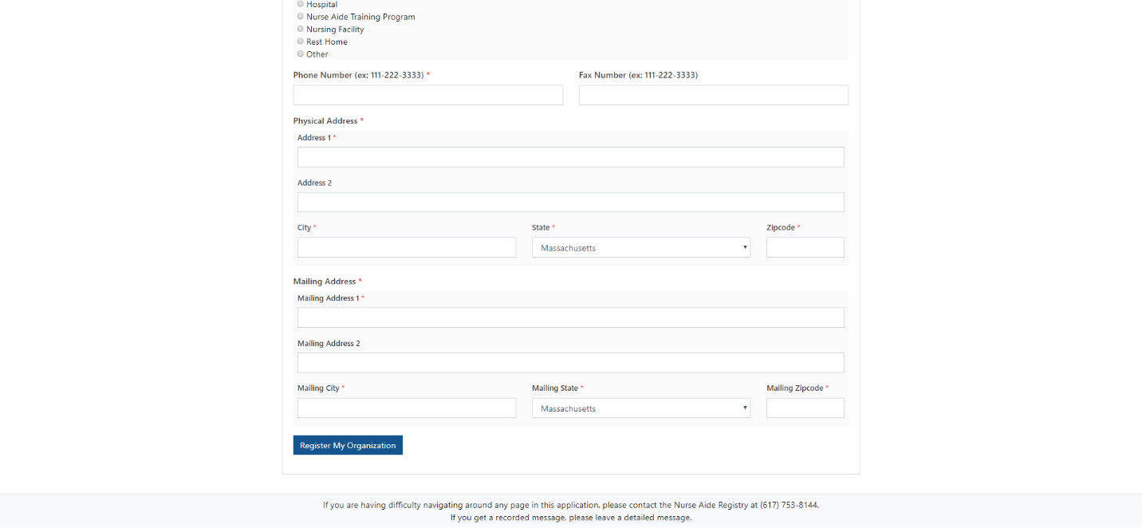
Step 5: Your request to create an account will be pending approval by the Massachusetts Department of Public Health. Please allow time for validation of your account. If you have a question concerning the status of your validation, contact the Nurse Aide Registry at (617) 753-8144. You will be notified via email when your account has been approved.

2.2 Account Approval
When you first register, the request to create an account will be pending approval by the Massachusetts Department of Public Health. Please allow time for validation of your account. If you have a question concerning the status of your validation, contact the Nurse Aide Registry at (617) 753-8144. You will be notified via email when your account has been approved.

2.3 Forgot Password
Follow the steps below if you forgot your password. Please note: your account will be locked out for 30 minutes if you enter the wrong password 5 consecutive times. Please allow 30 minutes to receive a password reset link via email.
Step 1: On the Login page, click on “Forgot your password?” link. 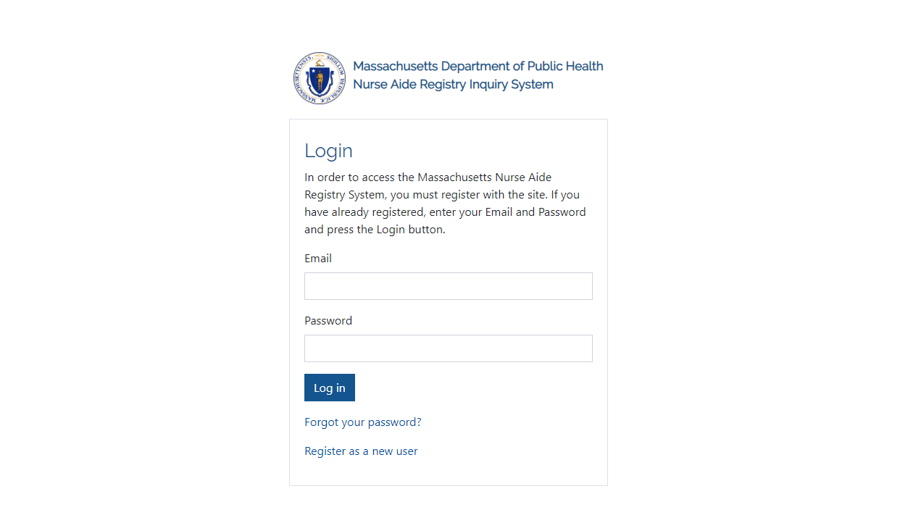

Step 2: Enter your Email, and click the “Submit” button.
Step 3: You will receive an email with a password reset link (Note that this link is only valid for 15 minutes). Open your email, and click on “reset my password” link.

Step 4: Enter your current email and the new password. Your new password must be:
- At least 12 characters long.
- Must contain at least one special character, one Upper Case, one Lower Case, and one Number.
- Must not contain your Email, first name or last name.

Once you reset your password, you will be able to log into your account again.

2.4 Change Password
Step 1: Click on the top-right menu with your initials, and select “Change Password”. 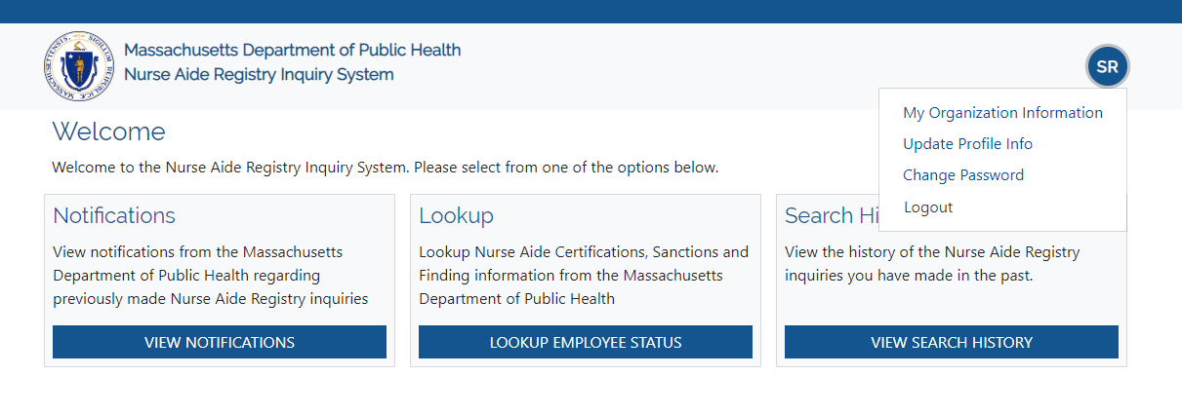

Ste

Step2: Type your current and new password, and click on “Update password.” 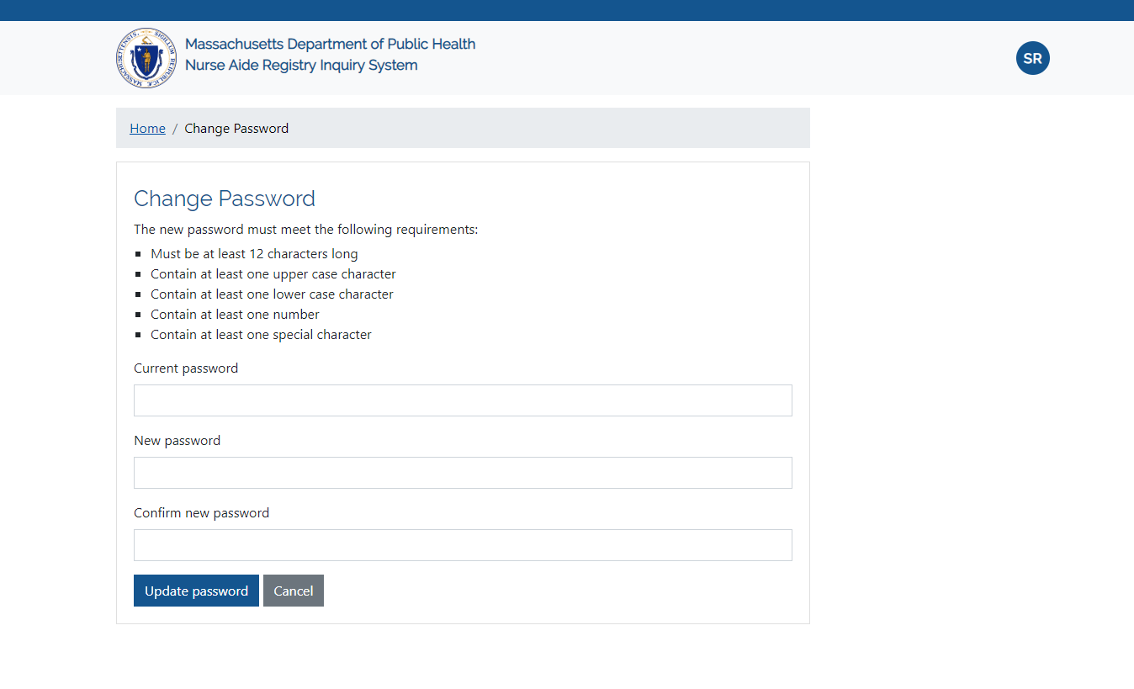

2.5 Update User Profile
Step 1: Click on the top-right menu with your initials, and select “Update Profile Info”.

Ste

Step2: Type your new information and click on “Update Profile Info”. 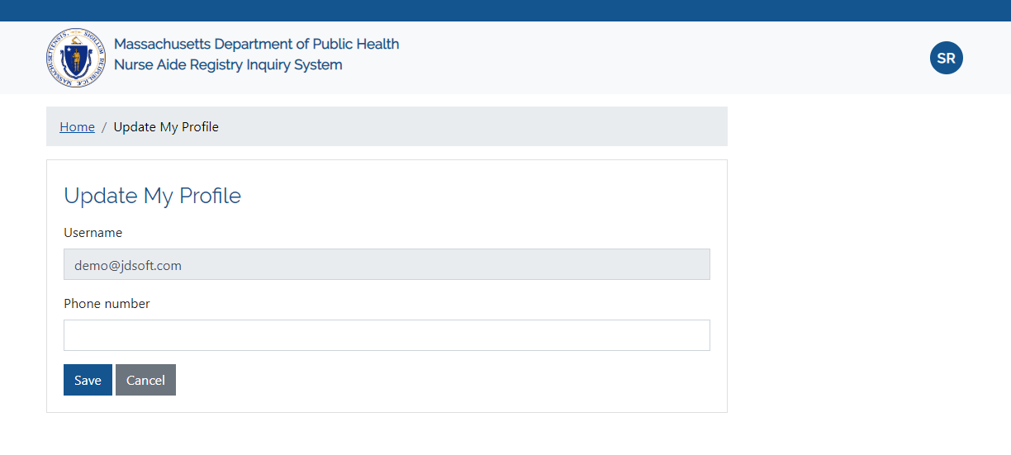

2.6 View Organization Information
Step 1: Click on the top-right menu with your initials, and select “My Organization Information”.

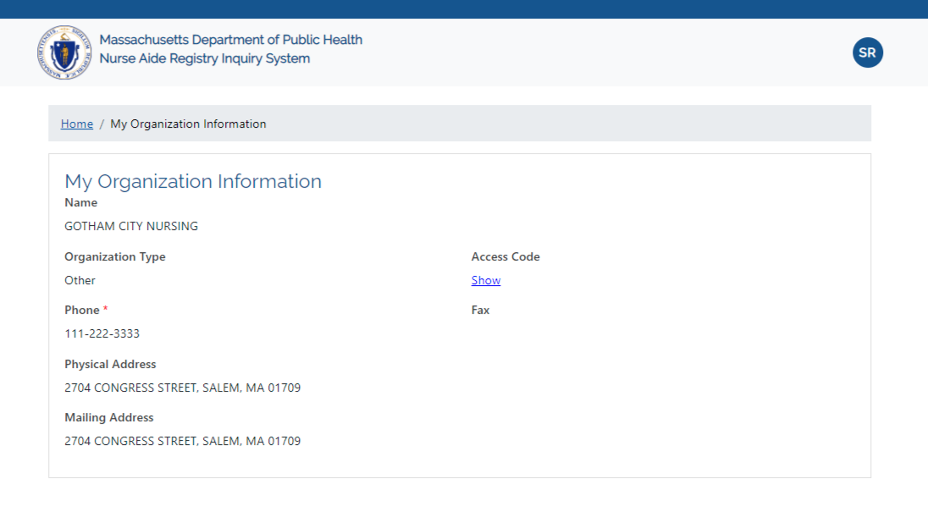

3. Lookup Employee Status
Follow the steps below to lookup nurse aide certification, sanction and finding information from the Massachusetts Department of Public Health.
Step 1: Click on the "Lookup Employee Status" button.
Step 2: Enter the Social Security Number of the employee in the textbox, and click the search button.
Step 3: If there is a matching record, you will see the "Certification Information", "Education Information" and "Sanctions and Finding Information," if there are any. 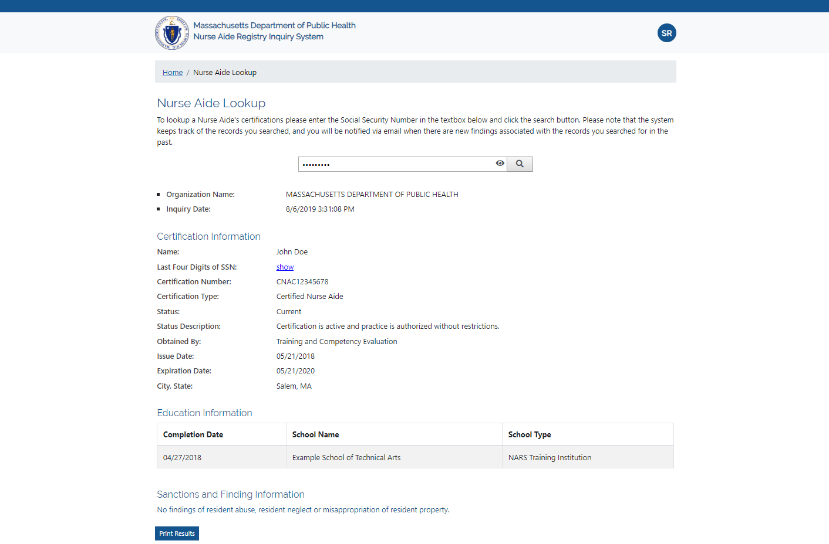
Step 4: To print the result, click the “Print Results” button.
Please note that the system keeps track of the records you searched, and you will be notified via email when there are new findings associated with the records you searched for in the past.

4. View Search History

The system keeps track of the records you searched, and you will be notified via email when there are new findings associated with the records you searched for in the past.
To view the history of the Nurse Aide Registry inquiries you have made in the past, follow the steps below.
Step 1: On the main menu, click on “View Search History” button.
Step 2: You will see a table that contains all the searches made by your organization. You may navigate the history pages by clicking the page number buttons at the bottom of the table. You may also search for a record by using the “Search” button at the top left of the table. To export the search history to an Excel file, click the “Export” button.
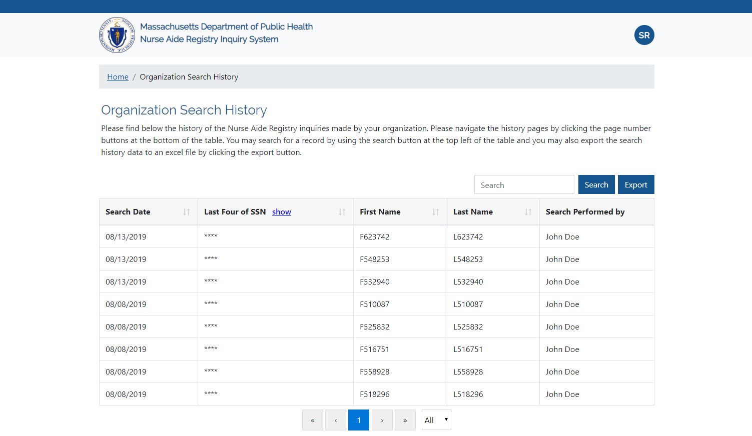

5. View Notifications

If a sanction is added to a nurse aide record that you searched for in the past, all users of your organization will be notified via email.
Step 1: To view notifications from the Massachusetts Department of Public Health regarding previously made Nurse Aide Registry inquiries click on the "View Notifications" button.
Step 2: Click on "View Details" to view the latest Nurse Aide status Information. Please note that once a record is viewed, it will be automatically removed from the notifications table.
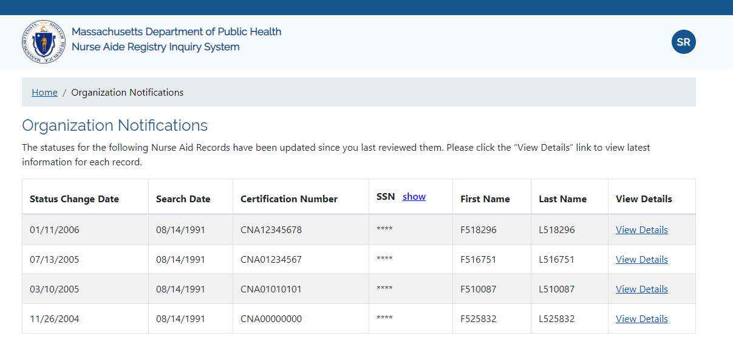
When you are done, always remember to log out to help keep your account secure.

