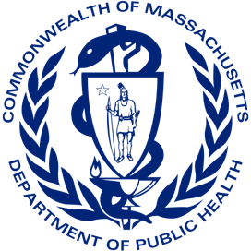

A Message from Margret Cooke, Public Health Commissioner
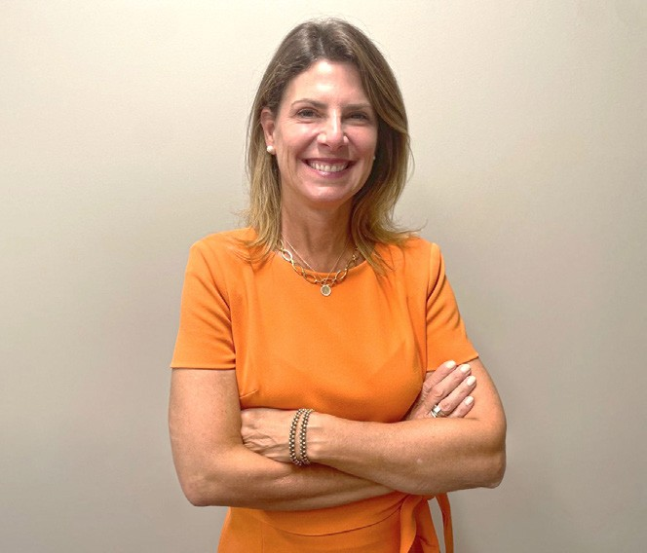
The Office of Problem Gambling Services is overseen by the Department of Public Health. I’m so proud of the work of this office and am pleased to share this document which outlines our Fiscal Year 2023 budget.
The $11.7M budget comes to us from multiple funding sources, with a significant portion coming from the Public Health Trust Fund.
These critical funds are used for surveillance, resources, prevention, intervention, treatment, and recovery support services for the residents of Massachusetts experiencing problem gambling and related issues.
The FY23 budget of $11.7 million represents an overall budget increase for the Office of Problem Gambling Services up from FY22 of $10.6 million. Since 2016, OPGS has engaged over 2,000 individuals and 40 community-based organizations to inform a series of projects and initiatives. These resources will allow for the enhancement of prevention services centered on equity at the community level and invest in new efforts to mitigate the harms associated with gambling.
The past year continues to present public health challenges and our services have never been more needed. We would not be able to do what we do without the ongoing support of our state and community partners. On behalf of our program and staff, I’d like to extend our sincere appreciation for your work to mitigate harms associated with gambling in our Commonwealth.
Thank you,

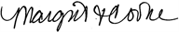
For more information, contact Victor Ortiz, Director of Problem Gambling Services, at victor.ortiz@state.ma.us

1

The following pages provide descriptions of each of OPGS’s budget categories, including FY23 focus areas and FY22 and FY23 funding level comparisons. The last page of the document includes a detailed budget table, showing funding levels of all budget categories and sub-categories.

Prevention and Health Promotion
OPGS continues its efforts to deliver comprehensive, community- centered, and culturally relevant prevention services.

Prevention services are aimed at youth, parents, and at-risk populations, and based on the recommendations of the Regional Planning Process, OPGS continued implementation of our two core prevention programs in FY22: Photovoice for youth and parents (5 sites) and the Ambassador Project for men of color with a history of substance misuse (4 sites).

FY23 Focus
In FY23, OPGS will expand Photovoice sites from five to eight and implement existing Ambassador Projects. During FY23, OPGS will also continue supporting the Asian-American and Pacific Islander (AAPI) Community Empowerment Initiative.
OPGS will significantly expand its Community Health Worker and Gambling Pilot in Springfield in FY23. Four new pilot sites will be initiated after a procurement process slated for Spring 2023.

Budget Category | FY22 | FY23
Prevention and Health Promotion | $7,175,265 | $7,827,072
Community | $3,880,265 | $4,527,072
Health Promotion | $2,020,000 | $2,025,000
Technical Assistance and Evaluation | $1,275,000 | $1,275,000

Treatment Support and Capacity Building
OPGS prioritizes treatment support and capacity building to support the continuum of care after prevention.

Intervention, treatment, and recovery supports programs are driven by community-centered and culturally-responsive approaches.

FY23 Focus
In FY23, OPGS will:
  - Maintain funding for Treatment Support, including Helpline Services and Project Build Up
  - Enhance data, clinical tools and resources, and capacity for problem gambling engagement and treatment services
  - Identify if there is a need for a Massachusetts gambling court and if so, how to establish one
  - Explore the intersectionality of problem gambling and other health issues in casino host communities, and determine the allocation of resources within these communities to mitigate harms associated with problem gambling
  - Maintain support for the Gambling Prevention Technical Assistance Center (Center) which provides resources and hands-on strategies to support communities and organizations seeking to launch or enhance existing gambling prevention services

Budget Category |  | FY22 | FY23
Treatment Support and Capacity Building |  | $1,900,000 | $1,950,000
 | Treatment Support | $900,000 | $900,000
 | Capacity Building | $1,000,000 | $950,000
 | Data Management | $0 | $100,000

Personnel
OPGS’s personnel are its most important asset. They include a growing team of staff that manage the work of the Office (including management, finance, budgeting, and programs).

OPGS also relies on consultants and other support staff that assist the office in its work.

FY23 Focus
In FY23, OPGS will maintain existing staff and and increase staff support provided by its trusted consultant partners.
Budget Category
FY22
FY23
Personnel $1,569,735 $1,980,301
2

Full FY23 Budget Table
Budget Item
FY22
FY23
Prevention and Health Promotion

Community: Photovoice Project $375,000 $800,000

Community: Ambassador Project
Community: CHW and Gambling Pilot: Springfield Community: AAPI Community Empowerment Initiative Community: Community Level Health Project
Community: Suicide and Gambling Community-based Activities
Community: Suicide and Problem Gambling Training for Suicide Prevention Workforce
Community: Problem Gambling and Community Initiatives
Community: Community Health Worker Trainings
Health Promotion: Communication Campaign Implementation
Health Promotion: Massachusetts Health Promotion Clearinghouse
Technical Assistance and Evaluation: Technical Assistance (TA) of Prevention Services
Technical Assistance and Evaluation: Stakeholder Listening Sessions
Technical Assistance and Evaluation: Evaluation of all Prevention Pilots
$387,000
$160,000
$100,000
$600,000
$60,000
$60,000

$1,988,265
$150,000
$2,000,000
$20,000
$900,000

$125,000
$250,000
$387,072
$1,000,000
$100,000
$600,000
$60,000
$60,000

$1,370,000
$150,000
$2,000,000
$25,000
$900,000

$125,000
$250,000

Sub-total: $7,175,265 $7,827,072

Treatment Support and Capacity Building

Treatment Support: Gambling Treatment Enhancements and Initiatives Treatment Support: MA Problem Gambling Helpline Services Treatment Support: Project Build Up
Capacity Building: IPAEP, Domestic Violence, Sexual Assault, and Gambling Services
Capacity Building: MA Technical Assistance Center
Capacity Building: Veterans and Problem Gambling Education
$300,000
$300,000
$300,000
$50,000

$700,000
$100,000
$200,000
$300,000
$400,000
$50,000

$700,000
$100,000

Capacity Building: Problem Gambling and Specialty Courts $150,000 $100,000
Data Management: Data Management Services $0 $100,000
Sub-total: $1,900,000 $1,950,000
Other
Strategic Planning $25,000 $0
Sub-total: $25,000 $0

Personnel

DPH Personnel: Director, Deputy, Contract Managers, Support Staff, Fringe (40%), Supplies, and Indirect Costs
$1,369,735 $1,430,301

Consultants $200,000 $550,000
Sub-total: $1,569,735 $1,980,301
TOTAL: $10,670,000 $11,757,373

For more information, contact Victor Ortiz, Director of Problem Gambling Services, at victor.ortiz@state.ma.us

