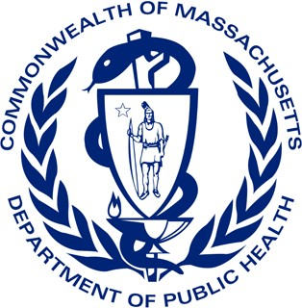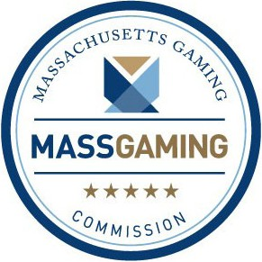
Problem Gambling Initiatives to Serve Asian American and Pacific Islander Communities
Massachusetts Department of Public Health Massachusetts Gaming Commission

Background
The 2011 Massachusetts Expanded Gaming Act established the Public Health Trust Fund, which was created to mitigate gambling’s negative health effects on communities in the Commonwealth. The Public Health Trust Fund is overseen by the Executive Office of Health and Human Services (EOHHS) and a strategic plan was adopted in 2016, which is implemented primarily by the Massachusetts Department of Public Health (MDPH) Office of Problem Gambling Services (OPGS) and the Massachusetts Gaming Commission (MGC). OPGS provides relevant public health programs and services and MGC conducts relevant research and responsible gaming activities.

Problem Gambling and Public Health
Problem gambling is a public health issue. Research demonstrates that some communities are disproportionately impacted by gambling, including individuals with mental health and substance use disorders and communities of color1,2,3, such as Asian American and Pacific Islander (AAPI) communities. For example, recent research demonstrated that residents of Boston’s Chinatown neighborhood at times depend on gambling as a source of recreation and relief from social isolation and concentrated poverty.4

OPGS and MGC: Working Together to Mitigate Harms
Together, the OPGS and MGC provide research, programs and services that provide a comprehensive public health approach to prevent and mitigate problem gambling in MA. Outlined below are initiatives particularly relevant for AAPI communities.

Research and Engagement

Community Engagement and Assessment (OPGS)
  - Everett Community Level Health Project: Led by Boston Chinatown Neighborhood Center, this project develops a plan with community partners to address a gambling-related health inequity that builds off a Community Health Improvement Plan from the greater Everett communities.

Community-Engaged Research (MGC)
  - Talking about Casino Gambling: Community Voices from Boston Chinatown: Examined the casino gambling practices of residents and workers in Boston Chinatown to learn about the trajectory and life context of individual participants’ gambling activity. Report translated into Traditional and Simplified Chinese.
  - The Asian CARES (Center for Addressing Research, Education and Services): Community-engaged research to address problem gambling among Asian ethnic communities through research, community education, and culturally relevant service provision.

Direct and Community-Based Services

Helpline Services (OPGS)
  - The Massachusetts Problem Gambling Helpline provides support and referrals to those impacted by problem gambling. Offers translation services in over 100 languages, including Mandarin and Cantonese, and is increasing capacity to enhance culturally appropriate services for AAPI communities.

Programmatic Support and Evaluation (OPGS)
  - Outpatient problem gambling treatment providers are available across the Commonwealth and the Massachusetts Problem Gambling Treatment Technical Assistance Center supports providers through training and technical assistance, including a focus on strengthening language and treatment services for AAPI communities.

(continued on the next page)

- Direct and Community-Based Services (continued)

Workforce and Training Supports (OPGS)
  - The Project Build Up grant program to strengthen capacity of outpatient treatment agencies to provide gambling treatment services. Activities during FY21 focus on increasing clinical capacity for AAPI workforce by training AAPI clinicians to provide problem gambling treatment services.

Community-Based Services (OPGS)
  - AAPI Empowerment Initiative works alongside AAPI communities in Greater Boston to provide problem gambling prevention education and awareness at the local level through material dissemination and community engagement.
Public Awareness (OPGS)
  - Translation: A general problem gambling brochure was translated into simplified Chinese and traditional Chinese and is being disseminated widely by community organizations.
  - Communications Campaign: A campaign focused on AAPI communities, currently in the planning stage, will be released in FY22.

Direct and Casino-Based Responsible Gambling Services

GameSense Program (MGC)
  - GameSense is an innovative and comprehensive responsible gaming program that encourages players to adopt and/or maintain positive behaviors and attitudes that reduce risk of gambling related harm. Each casino offers an on-site GameSense Info Center. GameSense staff, known as Advisors, represent diverse cultural and ethnic groups and possess various linguistic backgrounds, including Cantonese, and Vietnamese. Brochures are available in Traditional Chinese, Simplified Chinese, and Vietnamese.
  - GameSense Community Education: Designed to bring responsible gaming information and resources to the community, with a focus on communities at greater risk for experiencing gambling-related harm, including AAPI communities.
  - GameSenseMA.com: Website dedicated to promoting responsible and problem gambling resources. Offers digital brochures on responsible and problem gambling which are available in Vietnamese, Simplified and Traditional Chinese.

Voluntary Self-Exclusion Program (MGC)
  - Voluntary Self-Exclusion allows persons who struggle to control their gambling behavior the ability to voluntarily exclude from the gaming floor of all Massachusetts casinos. Brochures and required documents available in Traditional Chinese, Simplified Chinese, and Vietnamese.

Casino Employee Training Initiative (MGC)
  - Casino Employee Training provides education and support on how to respond to casino guests who are in distress and may be struggling with their gambling behavior. In the Spring of 2021, all Encore Boston Harbor staff will receive training on responsible gaming, gambling risk factors and culturally appropriate support resources specific to the AAPI community.

Next Steps
Looking forward, OPGS and MGC will continue to enhance existing services and research and collaborate – all while engaging AAPI communities – in order to further advance the goal of supporting communities disproportionately impacted by gambling.
For more information, please visit mass.gov/orgs/office-of-problem-gambling-services and massgaming.com.

1 Alegría, Petry, Hasin, Liu, Grant, & Blanco, 2009
2 Kessler, Hwang, Petukhova, Sampson, Winters, & Shaffer, 2008
3 Volberg, R. A., Williams, R. J., Stanek, E. J., Houpt, K. A., Zorn, M., Rodriguez-Monguio, R. (2017)
4 Wong & Li, 2019

