Notes
Quick Start Guide for
Online Medical Certifiers and Online Support Staff

Vitals Information Partnership (VIP)
Electronic Death Registration System (EDRS)
Revision July 1, 2014
Notes
Use this page to make notes about your own workflows and processes, which may differ by facility and practice.

Summary of Steps
You may want to print this page as a quick reference sheet. Note that these steps represent typical scenarios, and your workflow may vary by facility or practice. While statute requires completion “immediately,” a good guideline is to complete all information before or within 24 hours of death.
1 | Create a Case (DeathNew DeathCreate a Case) or choose a partially-completed record from the work queue by clicking on Process.
2a | For medical data entry staff only: first click on tab 12 (Records Actions) and choose a certifier from the pick list. Then:  For all: Click on tab 6, then complete tabs 6 through 9.
3 | Click Finish. Check that all medical items are complete on the VIPS Warning Page (except Certify). Use the [End] key to go to the bottom of the page and Save as Pending. This step is necessary to save the record and to perform a comprehensive validation edit.
4 | On the Successful Transaction page, click Return to Record.
5 | Review entries on tabs 6-9. Click on tab 12, check the Ready to Certify checkbox. Certifiers ready to certify may now click the Certify button. Medical data entry staff will not be able to click Certify, but will proceed to the next step.
6 | Click Finish; press the [End] key to go to the bottom of the page and Save as Pending.
7 | Repeat the process by clicking on Main Menu; or logout at the top right-hand corner of the VIP screen, then logout on the VG screen as well.

Accessing and Using EDRS
Summary of Steps, Accessing EDRS

The Electronic Death Registration System (EDRS) is a module of the larger Vitals Information Partnership (VIP) system that is hosted in the Commonwealth’s secure Virtual Gateway (VG) environment. If you have not yet applied for and received a VG account, please go to www.mass.gov/dph/vip to obtain enrollment information and forms.
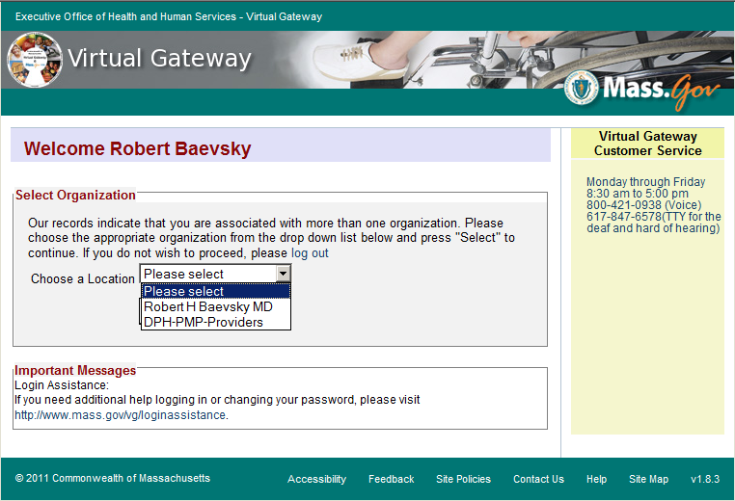
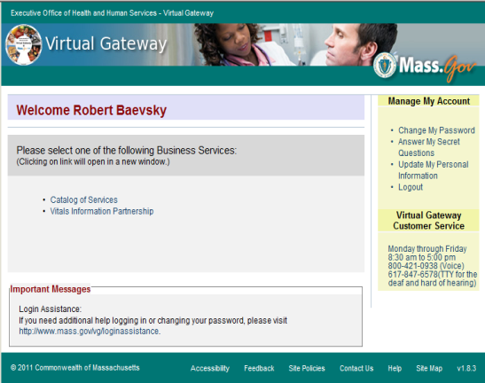
Access EDRS on the web. EDRS can be accessed anywhere you have a computer and internet access. The system works best with the Microsoft Internet Explorer (IE) browser or with Firefox. If you are a Mac user, it is recommended that you download the Firefox browser on your computer.

Anmole Sharma MD
Anmole Sharma
Log in at http://mass.gov/vg. You must have a valid Commonwealth Virtual Gateway account, as well as a VIP account to log in to EDRS. If you have a VG account for another application, you will then have a choice of applications when you log in. The VIP EDRS system will be contained under your name. Going forward any new VG applications that you enroll in will also be listed under your name, which is why the selection does not say “VIP EDRS.”
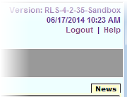
Logout at the top right-hand corner of the VIP screen. To completely exit the system, also logout on the right-hand panel of the VG screen.
Accessing & Using EDRS

Tips & Tricks
Save! – EDRS will time out after 15 minutes. While your portion of the death record should take less than five minutes to enter, if you expect to be interrupted or if you are just learning the system, click “Finish,” then “Save as Pending” frequently. You may then click “Return to Record” without risk of losing any information. EDRS does not save information automatically.
No abbreviations -- The system will prompt you if you use recognized abbreviations; you should spell out full medical terminology into each field. For example, on Tab 7**Certifier Cause of Death, spell out “COPD” as “Chronic Obstructive Pulmonary Disease.”
Tab & Mouse -- Use the Tab key on your computer keyboard to advance through each field in EDRS. You may also use your mouse to navigate tabs or to temporarily skip sections. Do not use Backspace or Enter, except within fields as necessary.
Alerts – Take advantage of system validation messages and warnings. Use the spell check icon on the Certifier Cause of Death tab. EDRS will help users get information in accurately and completely right from the start; this will save you from time-consuming corrections later.
Color Coding – White fields on each screen in EDRS will accept information; the yellow fields are disabled based on selections made in the system. A blue field indicates which field you are on now.
Shortcuts – EDRS accepts military time. Alt-T enters today’s date. Colons are not necessary in Time fields and slashes are not necessary in date fields. Enter the first few letters of a selection on a picklist to narrow the list quickly. “Next” will move you from tab to tab, but you can click on the tab labels as well.

Need Help?
Contact the Registry at vip@state.ma.us or 617-740-2600

Navigation
How you navigate the EDRS will depend largely on your facility or practice workflow. Online certifiers may create new cases or complete cases that have been started and assigned to you by medical staff or funeral directors. Note - if the wrong certifier was assigned a medical staff person can reassign, or the funeral home/certifier that started the record can reassign.
Navigation

EDRS has two general methods of navigation: work queues and a menu bar.
Work queues display records that are waiting for completion. For online medical certifiers, death records in a queue will usually be one of the following:
- Records that were started on the certifier’s behalf (by medical staff or funeral directors);
- Records that the certifier started, but did not yet finish; or,
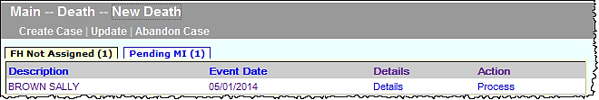
- Records that were returned for correction/modification. If you are an online certifier that creates new cases and certifies immediately, it is possible that you may never, or rarely, even see a queue.
The menu bar keeps navigation “bread crumbs.” You may click on any option within the trail to return to a previous step.
Click on the hyperlink “Process” to retrieve the record from a queue.
Records may temporarily appear in FH Not Assigned until a funeral home claims the record or the certifier/staff assigns.
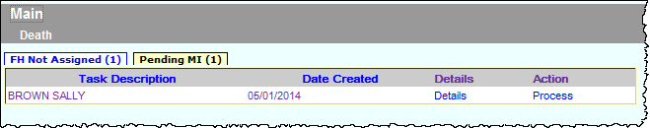

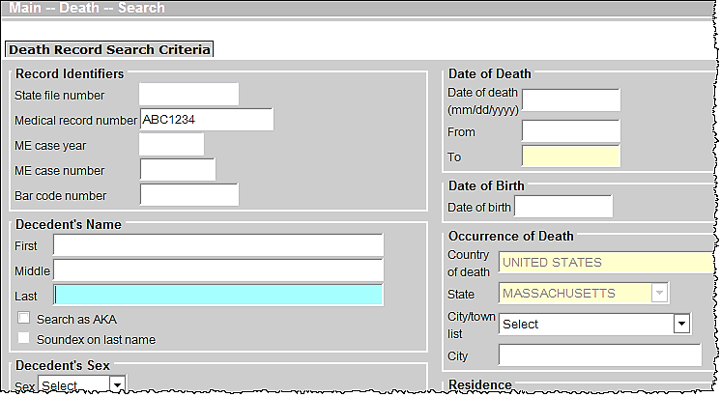
The gray menu bar allows access to all authorized EDRS functions for the user type that is logged in. For online certifiers and staff, the most common options will be “Create Case,” and “Print,” which will allow for printing of the “Attestation Copy” that can be provided to funeral directors (or authorized designees) for transport. The most common paths will be:
- DeathNew DeathCreate a Case (to start a new death record)
- DeathPrintAttestation Copy (to print a copy of the certified information for transport)
- DeathSearch (to view all authorized death records)

Create a New Case
The gray bar in VIP is a menu bar. Click on “Death” to access VIP menu options. To create a new case, click on Death, then New Death, then Create Case.
1
2
3
The menu bar keeps navigation “bread crumbs.” You may click on any option within the trail to return to a previous step.
Create a New Case
To begin a record you will need Decedent’s First and Last Name, Sex, Date of Death and Date of Birth. Enter this information into each field, then press Search.
Enter dates as MMDDYYYY or MM/DD/YYYY. For most date fields, “9”s are acceptable for unknown portions. E.g., 03991961 indicates unknown day.
When you start a new record in EDRS, the system runs a check to see if the record may have been started by another user, such as a funeral director or medical data entry staff person. The system will then display potential matches.
- If no matching records are found, you can begin the process of establishing a new record by choosing Create New Case.
- If a potential match is found, you may choose to “Continue” if this is your case. If the match is a different decedent, then choose “Create New Case.”
Depending on whether a match is found, these are examples of the two possible resulting screens:
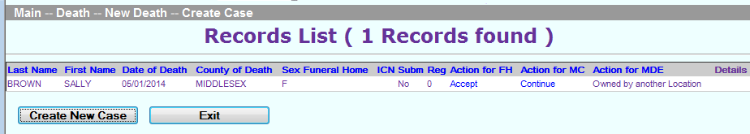

Entering medical information

Entering Medical Information
All authorized users may view all information “tabs” in a death record, and you will be brought to Tab 1 initially. However, as a medical certifier, you are responsible only for tabs 6 through 9 and relevant portions of tab 12. You may click directly on tab 6 to begin. Your required tabs are:
Certifiers are responsible for tabs 6-9 & 12 only.

6 - Place/Date/Autopsy, 7 – Certifier Cause of Death, 8 – Manner/Detail/Injury, 9 – Certification Info, and 12 – Records Actions.

Medical Data Entry Staff
Some certifiers may have authorized medical data entry staff that will enter all or some of the information in these sections. However, as the certifying or attending practitioner, you are the only one that can “certify” the death. If you have staff members that enter information on your behalf, it is your responsibility to review all required tabs for accuracy and completeness, and make changes as necessary. For instance, the medical staff may not have known that an autopsy was performed at the time they entered the information, but the certifier may have newer information.

Tab 6. Place/Date/Autopsy
Name and date of birth and death are pre-populated from information you entered when you created the case. On this tab, you provide information about the place of death, whether the medical examiner was notified, and whether there was a private or M.E. autopsy. Medical record number is useful for reference.
Select a Place of Death option to enter the type of location where the death took place. Then, choose the specific facility from the drop-down list. For hospital and nursing home medical staff doing data entry, the facility name and address are defaulted.
Place/Date/Autopsy
- Not on the list? If the facility where the death took place is not listed in EDRS, you can use the option “Check if location is not in list” to enter in a new location.
- Residence? For a death occurring at the decedent’s own residence, the address fields are all all open for editing. If medical staff or the funeral home entered information on tab 2, then you may check the “same as residence” checkbox to automatically populate residence address.
- Nursing Home/Assisted Living? If a decedent was living at a nursing home, assisted living or rest home, do not choose “decedent’s residence,” but choose the appropriate facility type instead. Look for facilities in other facility types, if not found on the pick list. What you may think to be a nursing home, may be licensed as assisted living.
- Hospice? If the decedent was receiving home hospice care in his/her own home, choose “decedent’s residence.” This category should only be used for hospice facilities.
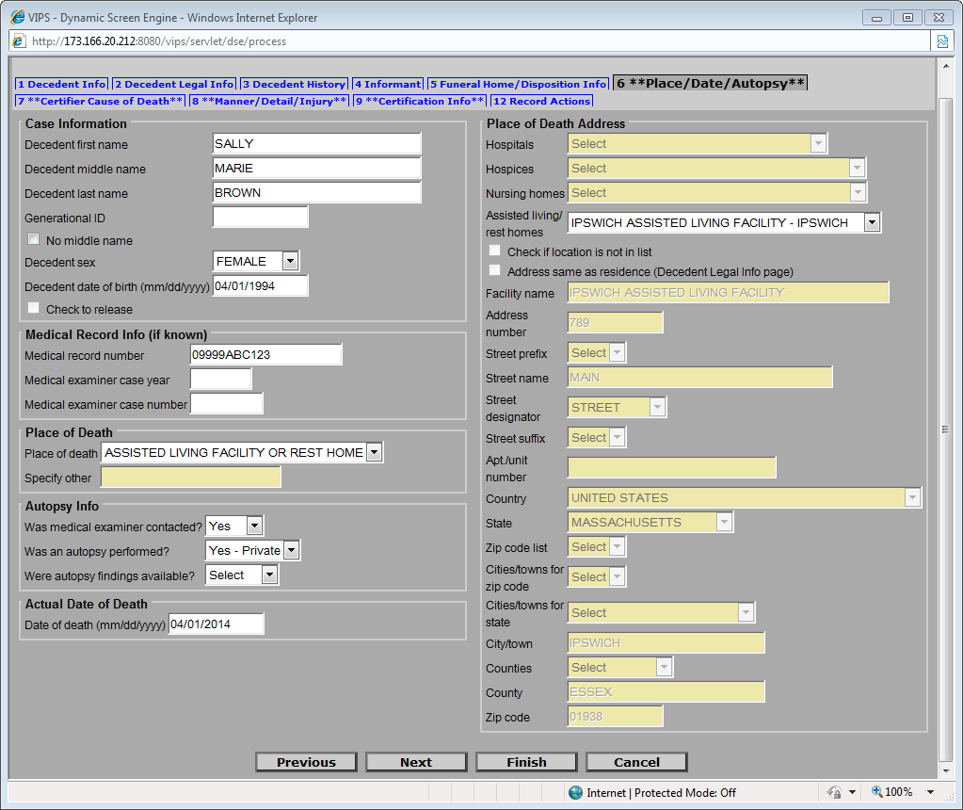
Certain selections in EDRS will cause other fields to become active. For example, if the decedent died in the hospital as an ER/Outpatient, a certifier will select the name of the hospital from the drop down list. EDRS lists hospitals, hospice care facilities, nursing homes, assisted living or rest homes, eliminating the need to type the name and address in most cases.
Shortcut: Type the first few letters to quickly select an item from a drop-down list. E.g., “IPS” would quickly narrow the list to “Ipswich Assisted Living Facility” in this example.
If you need to manually enter an address, note that each component of the address is separate so that geographic coding is more accurate. “Main Street South” is entered into three different fields.
Choose “other” when a pick list item does not describe the location. For someone else’s home, enter “Other residence” in the Specify text box.

Tab 7. Certifier Cause of Death
Certifier Cause of Death
Using information from medical records, and other sources, provide in Part I the most complete sequence of events that describes the immediate cause of death entered in line (a) as a result of intermediate and underlying causes in lines (b) through (d). Approximate intervals between onset and death help to complete the Other significant conditions that contributed to death, but were not directly part of the sequence of events are reported in Part II.
Information that you provide is based on your best medical opinion. Medical researchers and families seeking family health histories rely on your thoroughness and detail. Online cause-of-death training is available for continuing medical education credit. Please email vip@state.ma.us for more information.
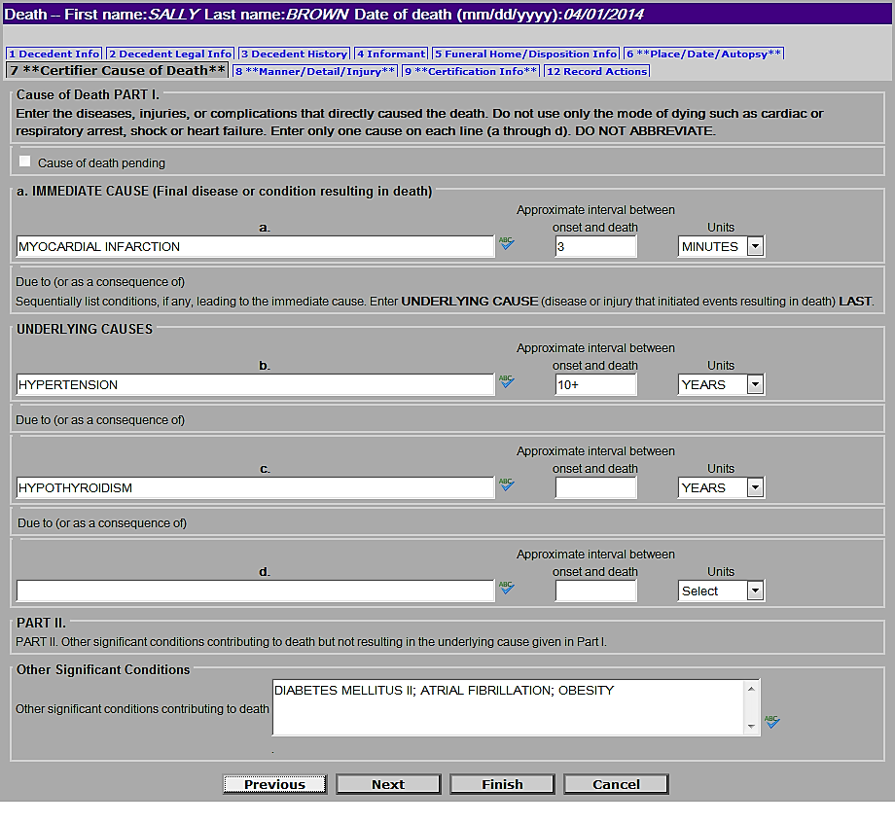
Take advantage of the built-in spell checker.
Intervals are always approximate; however, you may enter units without exact intervals when an estimate is not possible.
EDRS will prompt you to spell out abbreviations, elaborate on cancer sites, and help you to avoid writing improper mechanistic causes.
Enter other contributing factors in a continuous line, separated by semicolons (“;”).

Tab 8. Manner/Detail/Injury
Certifiers other than medical examiners will complete only three questions on this tab: Manner of Death, Pregnancy status at time of death, and Did tobacco contribute to death? The two new questions (about tobacco and pregnancy) are part of the national standard death certificate issued by the Centers for Disease Control and Prevention. The injury questions are completed only by a medical examiner.
Manner/Detail/Injury
Manner-- If the manner of death is not “Natural,” the medical examiner must take this case. Choose “Natural” from the Manner of Death by clicking it in the drop down list or typing “N” in the field.
Pregnancy Status-- In the Additional Death Details section, Pregnancy status at time of death must be answered if the decedent is female and within the ages of 5 and 75. The status options include pregnancies that may have been up to one year before death.
Tobacco -- Indicate whether tobacco use or tobacco exposure contributed to death. Even if you check this item “yes” or “probably,” do not exclude tobacco use from causes of death or other significant conditions, if appropriate.

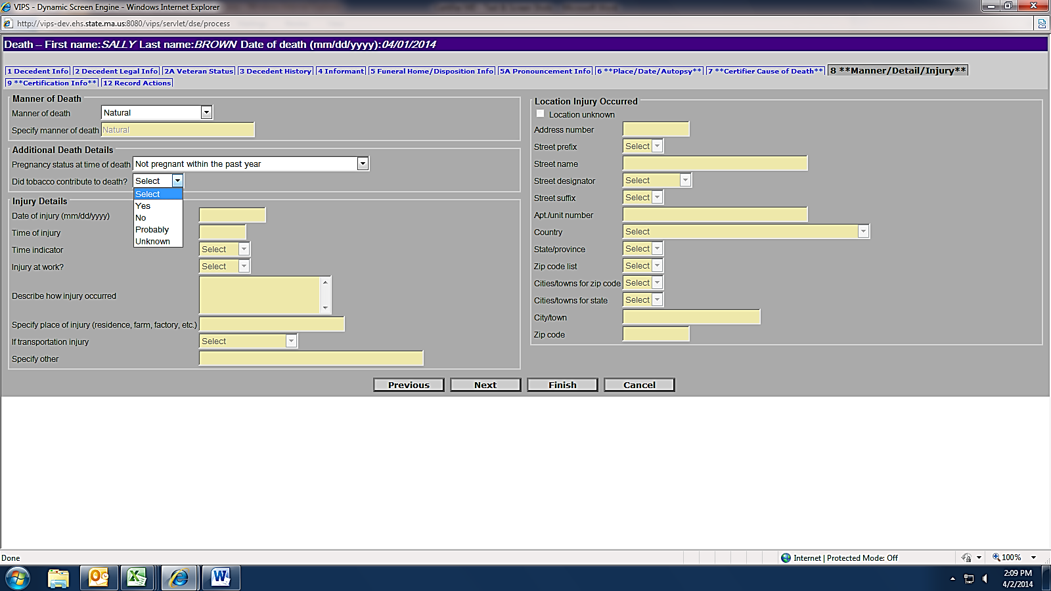
If not natural, contact the M.E.

Quick tip: Type Y, N or P to quickly populate the tobacco field.

Tab 9. Certification Info
Certification Info
Enter the Certifier designation. If you were the provider that pronounced death or were in attendance at the time of death, but were not part of the decedent’s own health care team, select “Certifier in Attendance at Time of Death” (Physicians) or “Nurse Practitioner in Attendance at the Time of Death.” Otherwise, choose either Physician or Nurse Practitioner in Charge of Patient’s Care.
Physician/ Nurse Practitioners pick list. For online certifiers entering their own data, EDRS will auto-populate name, title, license number, phone and fax number, and address.
For medical data entry staff -- First select a physician/ nurse practitioner certifier from tab 12 (Records Actions), which will then populate that information on tab 9. If the Certifier is not on the list (or if the information is incorrect on the list) -- Mark the checkbox Certifier not in list on tab 12, which will enable the name and address fields for data entry.
Generational ID is a last name suffix. E.g., “Jr.”
If the updated information should be a permanent change to the pick list, also mark the checkbox Update certifier info and flag for database change on tab 6.
Physician in charge of the patient’s care are fields that are enabled in most cases, unless the certifier designation is “Physician in Charge of Patient’s Care” The name of the decedent’s primary practitioner preceding death should be entered. If not on the pick list, then mark the checkbox Physician not in list. You may enter the physician’s name and title (or Nurse Practitioner, if applicable). If the decedent had no primary practitioner preceding death, then mark the checkbox No primary care physician provided.
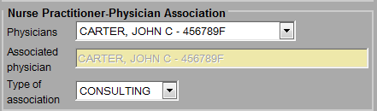
For nurse practitioners that are certifying death - their Associated Physician should be selected from the pick list when applicable, and the Type of association should be selected as either “Consulting” or “Supervisory.” The physician may or may not be the same as the Physician in Charge of Patient’s Care.
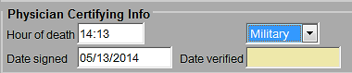
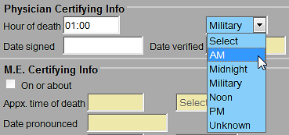
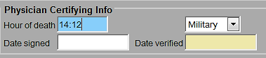
Hour of death may be entered as AM or PM, or as military time. Colons are not needed (e.g., 1412). If the hour of death is from 1300-2459, then the time designation is completed as military automatically. When entering 1200, select “Noon” or “Midnight.”
Certification Info
Date signed should be entered as numeric. It will be converted to formal format when the record is registered and printed by the City/Town Clerk. Enter as MMDDYYYY or MM/DD/YYYY.
Finish and Save prior to Certifying on the Records Actions tab -- When all information is completed, you must Finish and Save the record before you can certify. Both steps are necessary before you may certify the record. (The VIP system needs to validate all screens before it determines that it is ready to certify.)
- Click Finish at the bottom of the tab you are working on.
- You will then see the VIPS Warning page, at the bottom of which you will click on the Save as Pending button. (See next page).
Next, you will be on the “Successful Transaction” page, where there is a button labeled Return to Record if you are ready to certify. (See next page).

VIPS Warning Page
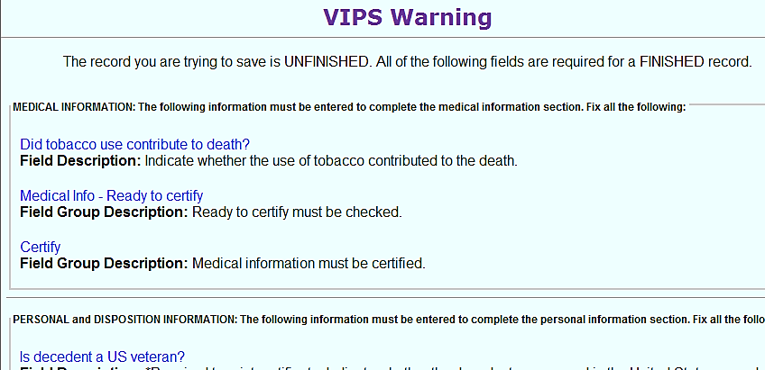
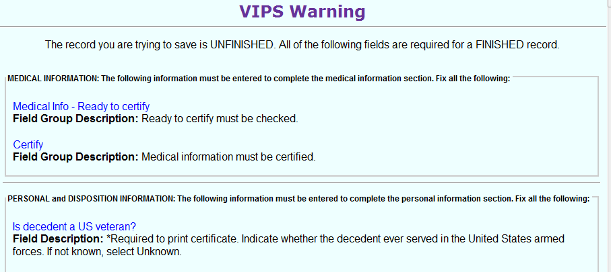
This page contains a list of all fields that still need to be completed. Certifiers and medical staff do not need to complete any items other than those that appear in the Medical Information section. Record is not saved until you “Save as Pending” -- Note that a record is not yet saved until the Save as Pending button is clicked at the bottom of this page. To quickly skip the non-medical items, press the [End] button on your keyboard to skip to the bottom of the page.
This record is not ready to be certified, as the tobacco question is not complete. To return to the appropriate tab, click the field name. To save the record for later, click Save as Pending at the bottom of the page.
This record will be ready to certify, but must be saved before these fields are enabled.
Certifiers and medical staff are not required to answer any items other than the Medical Information items.
VIP Warning Page, Successful Transaction
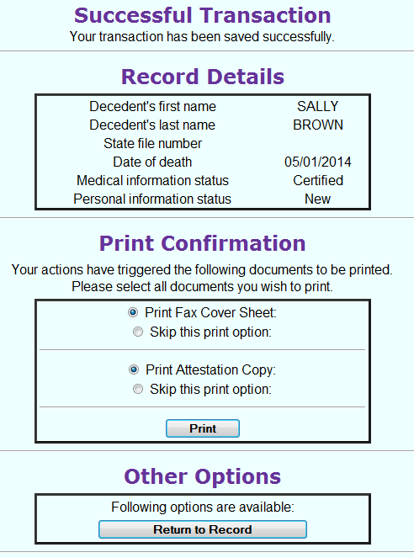
To save a record click Save as Pending at the bottom of the VIPS Warning page.

Successful Transaction Page
After clicking Save as Pending, the Successful Transaction Page will allow for the printing of the Fax Attestation Copy once medical certification is complete. This form can be filed in medical records and provided to funeral directors (or family designees) for transport. (It is rare that certifiers will need to use the Fax Cover Sheet option unless attaching additional documents).
Return to Record brings the user back into the record tabs. This will most commonly be used when returning to click Ready to Certify and Certify on the Records Actions tab.

Tab 12. Records Actions
For an online medical certifier - there are only two items required on this tab to complete your certification: the Ready to Certify checkbox and the Certify button (active only when tabs 6 through 9 are complete and the record has been previously finished and saved.) If the certifier has medical data entry staff completing information on his/her behalf, the certifier will simply review the information and click on the Certify button (the record will have already been saved and the Ready to Certify checkbox will already be marked). Then Finish and Save (as Pending).
Records Actions
Important note: Certifiers should never select a certifying physician or nurse practitioner, as the online certifier information is already pre-populated. If a certifier selects a new certifier, or even him/herself, all of the medical information will be reset to blank. Leave as “Select.”
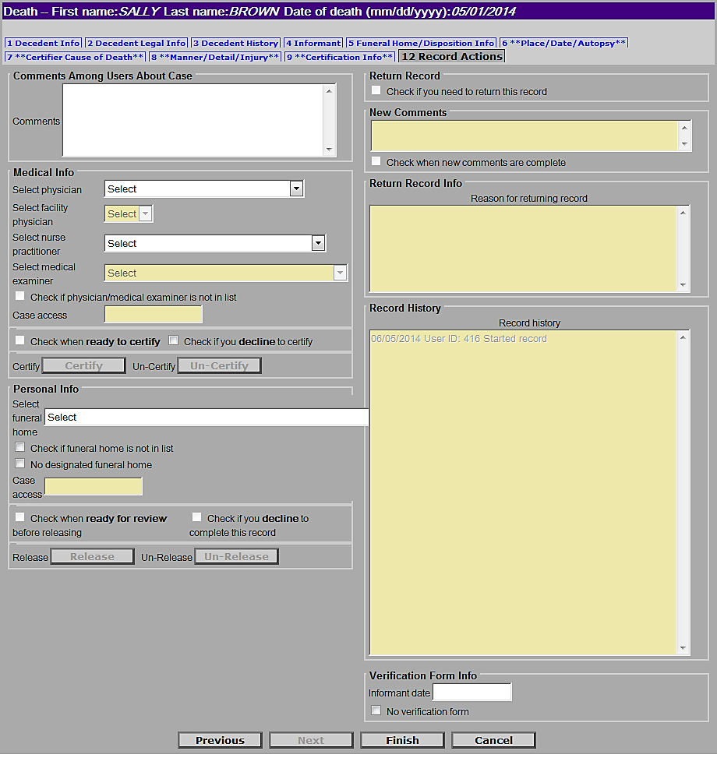
For the medical data entry staff member that enters on behalf of the online certifier, two different actions must be taken: selecting a physician (which should occur near the beginning of the process – do not select the same certifier again at the end of the process) and checking “Ready to Certify.” Note that once the certifier is selected, these fields will revert back to “select;” but do not select again unless you need to change the certifier that appears on tab 9.
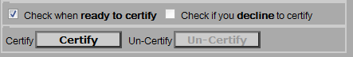
Certification is enabled only after Finish and Save as Pending, then Return to Record.
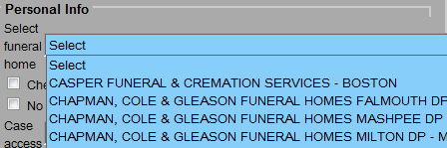
If 100 percent certain, certifiers or medical staff may optionally assign the funeral home. This will cause the record to appear on the funeral home’s “to do” queue in EDRS. Do not select if you are not completely sure.
Data entry staff select the physician or NP that will certify the record. Certifiers should never use this field unless they are reassigning a case (else tabs 6-9 will be reset to blank). Before selecting a certifier it is a good idea to check that tab 9 is not already complete, as the Select fields revert to and should remain as “Select” after leaving this page.
Funeral Home Info – It is recommended that certifiers and medical staff do not choose a funeral home, unless they are 100 certain of the funeral home that will handle the decedent. If incorrect, you will be called upon to reassign the funeral home, as the new funeral home will not have access.

