Notes
Quick Start Guide for Online Medical Staff:
Working with Offline Certifiers
and Fax Attestation

Vitals Information Partnership (VIP)
Electronic Death Registration System (EDRS)
Revision July 1, 2014
Notes
Use this page to make notes about your own workflows and processes, which may differ by facility and practice.

Summary of Steps
You may want to print this page as a quick reference sheet. Note that this summary includes steps for typical scenarios and your own process may vary somewhat depending on internal workflow or the order and manner in which you receive information about a decedent. While statute requires “immediate” reporting of death certificate information, a good guideline is to complete all information before or within 24 hours of death.
Summary of Steps, Accessing EDRS
1 | Obtain information for the record on the Death Certificate Certifier Worksheet, or other approved form used by your facility.
2 | Create new case (DeathNew DeathCreate Case) or update an existing case by selecting from the Pending MI (pending medical information) queue.
3 | Tab 1 is pre-populated; missing items will be completed by the funeral designee.
4 | Click on Tab 12 to assign certifier on a new case (or any other tab to continue work on an existing case).
5 | Enter Medical Information on tabs: Place/Date/Autopsy, Certifier Cause of Death, Manner/Detail/Injury (tabs 6, 7, 8).
6 | On tab 9 (Certification Info), enter Certifier designation, Physician in charge of patient’s care (if appropriate), Nurse practitioner/physician association (if appropriate) and Time of Death. Check if fax number is correct.
7 | Click Finish on tab 9, then Save (as Pending) on the VIPS Warning page to save and validate. (Only medical items need to be completed by medical staff; press the [End] key to skip the personal data items and go to the bottom of the page.)
8 | If ready to certify, click Return to Record on the Successful Transaction page and click on tab 12 (Records Actions).
9 | Click on Check When Ready to Certify. Finish and Save as Pending.
10 | Print or fax the Death Certificate Attestation form for the certifier’s signature.
11 | Certifier or medical staff fax the completed Attestation form to 617-887-8739.
12 | Return to record by selecting from the Fax Received queue, and check that Attestation form was signed and dated. Click Continue.
13 | Navigate to tab 9, and enter Date signed, then skip to tab 12 and click Certify.
14 | Finish, Save as Pending, and print Attestation Copy for transport and/or medical records.

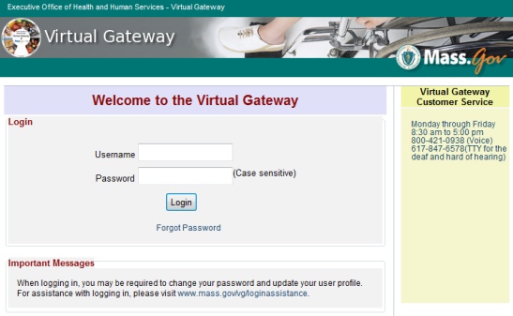
Accessing and Using EDRS
The Electronic Death Registration System (EDRS) is a module of the larger Vitals Information Partnership (VIP) system that is hosted in the Commonwealth’s secure Virtual Gateway environment. If you have not yet applied for and received a VG account, please go to www.mass.gov/dph/vip to obtain enrollment information and forms.
Access EDRS on the web. EDRS can be accessed anywhere you have a computer and Internet access. The system works best with the Microsoft Internet Explorer (IE) browser or with Firefox. If you are a Mac user, it is recommended that you download the Firefox browser on your computer.
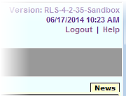
Log in at http://mass.gov/vg. You must have a valid Commonwealth Virtual Gateway account, to log in to EDRS. If you have a VG account for another application, you will then have a choice of applications when you log in. If you work for more than one facility or private-practice certifier, you may also change locations within EDRS in the top left-hand corner of the EDRS screen.
Logout at the top right-hand corner of the VIP screen. To completely exit the system, also logout on the right-hand panel of the VG screen.
Accessing & Using EDRS

Tips & Tricks
Save! – EDRS will time out after 15 minutes. While your portion of the death record should take less than five minutes to enter, if you expect to be interrupted or if you are just learning the system, click “Finish,” then “Save as Pending” frequently. You may then click “Return to Record” without risk of losing any information. EDRS does not save information automatically.
No abbreviations -- The system will prompt you if you use recognized abbreviations; you should spell out full medical terminology into each field. For example, on Tab 7**Certifier Cause of Death, spell out “COPD” as “Chronic Obstructive Pulmonary Disease.”
Tab & Mouse -- Use the Tab key on your computer keyboard to advance through each field in EDRS. You may also use your mouse to navigate tabs or to temporarily skip sections. Do not use Backspace or Enter, except within fields as necessary.
Alerts – Take advantage of system validation messages and warnings. Use the spell check icon on the Certifier Cause of Death tab. EDRS will help users get information in accurately and completely right from the start; this will save you from time-consuming corrections later.
Color Coding – White fields on each screen in EDRS will accept information; the yellow fields are disabled based on selections made in the system. A blue field indicates which field you are on now.
Shortcuts – EDRS accepts military time. Alt-T enters today’s date. Colons are not necessary in Time fields and slashes are not necessary in date fields. Enter the first few letters of a selection on a drop-down to narrow the list quickly. “Next” will move you from tab to tab, but you can click on the tab labels as well.
Slow? – It sometimes takes a few seconds to load PDF documents, and some slowness may occur intermittently depending on number of users on the system. Wait. Clicking repeatedly will boot you out of VIP. If this happens, close the white screen and log in again.
Need Help? Contact the Registry at vip@state.ma.us or 617-740-2600.

Navigation
How you navigate the EDRS will depend largely on your facility or practice workflow. You may work with both online and offline medical certifiers to create new cases or complete or update cases that have been started by others, including representatives from funeral homes.
Navigation

EDRS has two general methods of navigation: work queues and a menu bar.
Work queues display records that are waiting for completion. For online medical staff supporting offline certifiers, death records in a queue will usually be one of the following:
- Records that were started but not complete (Pending MI) (“pending medical information”);
- Records still waiting for an attestation (Pending MI) ;
- Records for which a fax attestation has been attached, but waiting on medical staff to review and release (Fax Received) ;
- Records that were returned for correction/modification (Pending MI); or
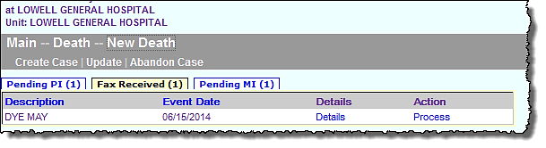
- Records that are still missing “personal information” are found in the Pending PI queue. Generally, you can disregard this queue as the funeral director (or town clerk on behalf of a family designee) will complete these items. Select records from the other queues, as Pending PI will not display Records Details or attachments. Send an email to vip@state.ma.us if a record stays in Pending PI for more than one week.
Click on the hyperlink “Process” to retrieve the record from a queue.
The menu bar keeps navigation “bread crumbs.” You may click on any option within the trail to return to a previous step.
The gray menu bar allows access to all authorized EDRS functions for the user type that is logged in. The most common options will be Create Case, Attest (to print/send an Attestation Form), and Print (which will commonly be used to print the “Attestation Copy” that can be provided to funeral directors, or authorized designees, for transport). The most common paths will be:
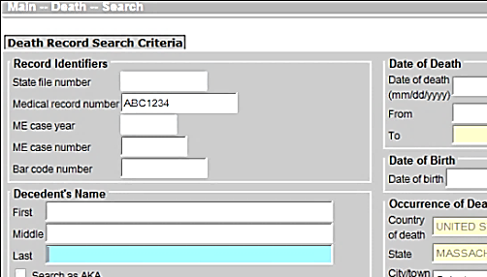
- DeathNew DeathCreate a Case (to start a new death record)
- DeathAttestFax Attestation (to print a fax attestation form rather instead of faxing)
- DeathPrintAttestation Copy (to print a copy of the certified medical information for transport)
- DeathSearch (to view all death records a user is authorized to see)

Entering Medical Information for Offline Certifiers
Offline medical certifiers will provide cause of death information on a Death Certificate Medical Certifier Worksheet (Certifier Worksheet) or a facility’s own form that collects all of the information required for the death certificate. The process of certifying a death starts with the proper completion of this worksheet, followed by entry of the information into EDRS.
Entering Medical Information
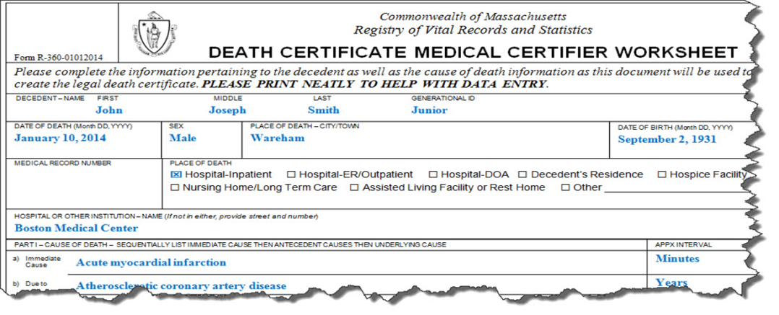
Sections of the Certifier Worksheet correspond to the information “tabs” in EDRS.
All authorized users may view all information tabs in a death record, and you will be brought to Tab 1 initially. However, as someone who assists offline medical certifiers, you are responsible for entering information into Tabs 6 through 9 and relevant portions of Tab 12. You may skip all other tabs.
You are responsible for tabs 6-9 & 12 only.

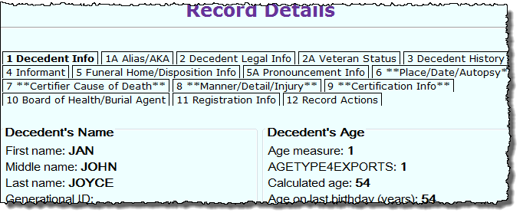
Records Details
Note: if you are retrieving a record that was already started, you will see Records Details tabs. These tabs are not editable, but you may review the information on all tabs and any attached documents prior to entering the editable record. This may be particularly useful if you are not sure if the record retrieved is the correct record. Clicking Cancel at the bottom of any Records Details tab (or any record tab), will allow you to exit the record without saving information not already saved.

Create a New Case (or Search for Existing)
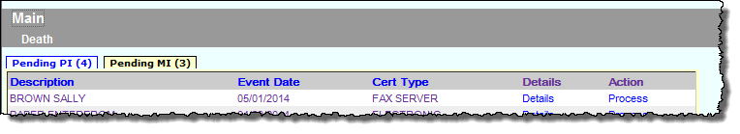
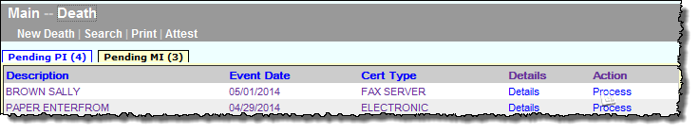
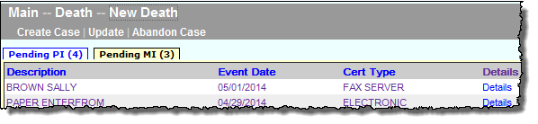
The gray bar in VIP is a menu bar. Click on “Death” to access VIP menu options. To create a new case, click on Death > New Death > Create Case.
1
2
3
The menu bar keeps navigation “bread crumbs.” You may click on any option within the trail to return to a previous step.
Create a Case
To begin a record, you will need information appearing at the top of the Certifier Worksheet: Decedent’s First and Last Name, Sex, Date of Death and Date of Birth. Enter this information into each field, then press Search. When you start a new record in EDRS the system runs a check to see if the record may have been started by another user, such as a funeral director or medical data entry staff person. The system will then display potential matches.
- If no matching records are found, you can begin the process of establishing a new record by choosing Create New Case.
- If a potential match is found, you may choose to “Continue” if this is the case you are working on. If the match is a different decedent, then choose “Create New Case.”
Enter dates as MMDDYYYY or MM/DD/YYYY. For most date fields, “9”s are acceptable for unknown portions. E.g., 03991961 indicates unknown day.
Depending on whether a match is found, these are examples of the two possible resulting screens:

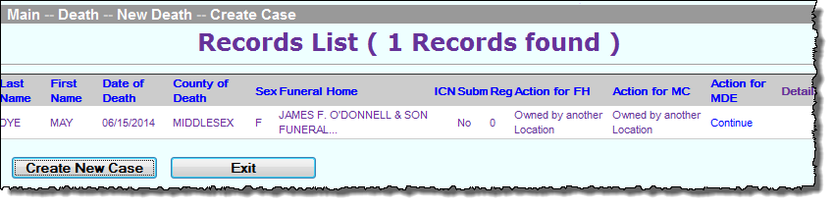
Tab 1. Decedent Information
Create a Case, Decedent Info
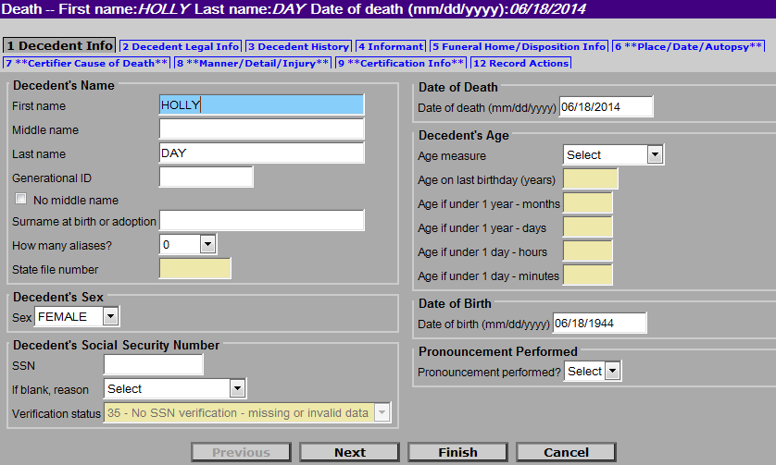
If you created the case, the search criteria you entered will be populated into Tab 1. There are other items on tab 1, but these are normally completed by the funeral director (or town clerk on behalf of a family designee). One exception might be to indicate that a nurse pronouncement form was completed, which will open a new data entry tab. In general, Click directly on tab 12 to assign the death record to an offline physician, which will pre-populate many items and enable the medical staff person to complete certification of the record on behalf of the offline physician once an attestation is received.
After Create a Case, a good practice is to go directly to tab 12 and assign the record to the offline certifier.
In some cases, a paper nurse pronouncement form may have been completed. While rare in a hospital setting, this is common for private practices. Select Yes, if you know that a nurse pronouncement was completed.
Note that “Pronouncement Performed” refers only to the RN/PA/NP Pronouncement form, which is completed in the absence of a physician or certifying nurse practitioner (typically used for deaths that occur at the decedent’s home or at nursing home/rest home/assisted living facilities where a physician may not be available).

Assign a Medical Certifier (using the Records Actions tab)
The first step to completing medical information for an offline certifier will be to assign a certifier to the record. While this may seem “out of order,” skip directly to Tab 12 (Record Actions) to select his/her name from the appropriate drop-down list. Once you leave tab 12, the field will revert back to “Select” but all certifier information will be pre-populated in tab 9. Do not reselect certifier on tab 12, if the information on tab 9 is correct.
Assign a Medical Certifier
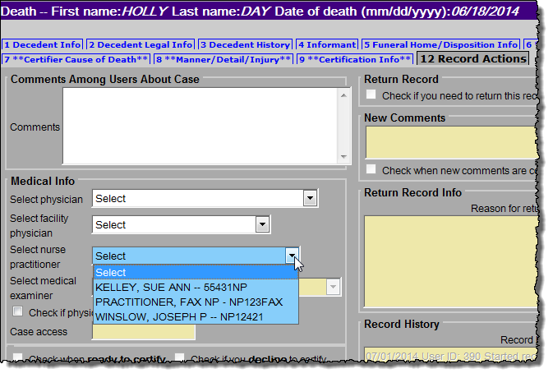
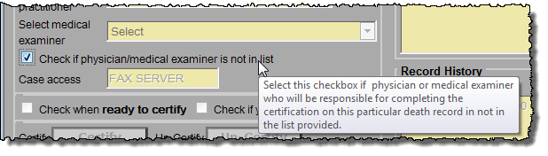
If the medical certifier is not on the list (or if the information is incorrect on the list) -- Mark the checkbox Check if physician is not in list to enable the name and address fields for data entry (Tab 9). On tab 9, you will also have the opportunity to indicate whether you want to add this certifier to the pick list for future records.
Select the name of the offline physician or NP certifier from a pre-populated list.
If the certifier is not in the pick list, mark the checkbox to enable manual entry on tab 9.

After selecting a certifier, begin entering the medical information by clicking on tab 6 (Place/Date/Autopsy).

Tab 6. Place/Date/Autopsy
Name and date of birth and death are pre-populated from information you entered when you created the case. Certain selections in EDRS will cause other fields to become enabled or pre-populate information elsewhere. For example, if you are working in a medical facility, the name and address will be pre-populated. But, if you are working in a private practice, selecting Hospice will enable the list of hospices in the pick list. EDRS provides lists of hospitals, hospice care facilities, nursing homes, assisted living or rest homes, eliminating the need to type the name and address in most cases (the address fields will become disabled).
Select a Place of Death type to enter the type of location where the death took place. Then, if necessary, choose the specific facility from the drop-down list.
Place/Date/Autopsy
- Not on the list? If the facility where the death took place is not listed in EDRS, you can use the option “Check if location is not in list” to enter in a new location. If the death occurred in your facility, but the name/address is not correct, contact RVRS.
- Residence? For a death occurring at the decedent’s own residence, the address fields are all open for editing. If the funeral home entered information on tab 2, then you may check the Same as Residence checkbox to automatically populate residence address.
- Nursing Home/Assisted Living? If a decedent was living at a nursing home, assisted living or rest home, do not choose “decedent’s residence,” but choose the appropriate facility type instead. Look for facilities in other facility types, if not found on the pick list. What you may think to be a nursing home, may be licensed as assisted living.
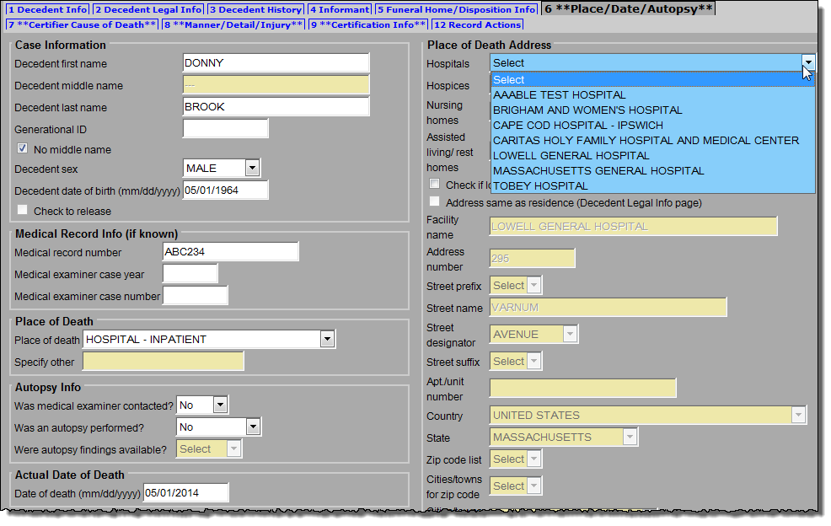
- Hospice? If the decedent was receiving home hospice care in his/her own home, choose “decedent’s residence.” This category should only be used for hospice facilities.
Place of death is pre-populated for facility staff, but if you are doing data entry from a private physician office, you may need to complete these fields.
If you need to manually enter an address, note that each component of the address is separate so that geographic coding is more accurate. “Main Street South” is entered into three different fields.
Medical record number is optional. (Note that the fax attestation does not go to a fax machine, but to a secure EDRS imaging server.) Entering medical record number may help you to retrieve the record later.
Check No middle name if none or unknown. (Or enter three dashes in the middle name field).

Tab 7. Certifier Cause of Death
Certifier Cause of Death
Using information from the Certifier Worksheet, enter information about cause of death in Parts I & II. Part I describes the immediate cause of death entered in line (a) as a result of intermediate and underlying causes in lines (b) through (d). Approximate intervals between onset and death help to complete the etiology. Other significant conditions that contributed to death, but were not directly part of the sequence of events are reported in Part II. Try to be as accurate as possible when entering information into the fields. When in doubt, ask the certifier for clarification of handwriting, a medical term, missing information or anything else that seems unclear.
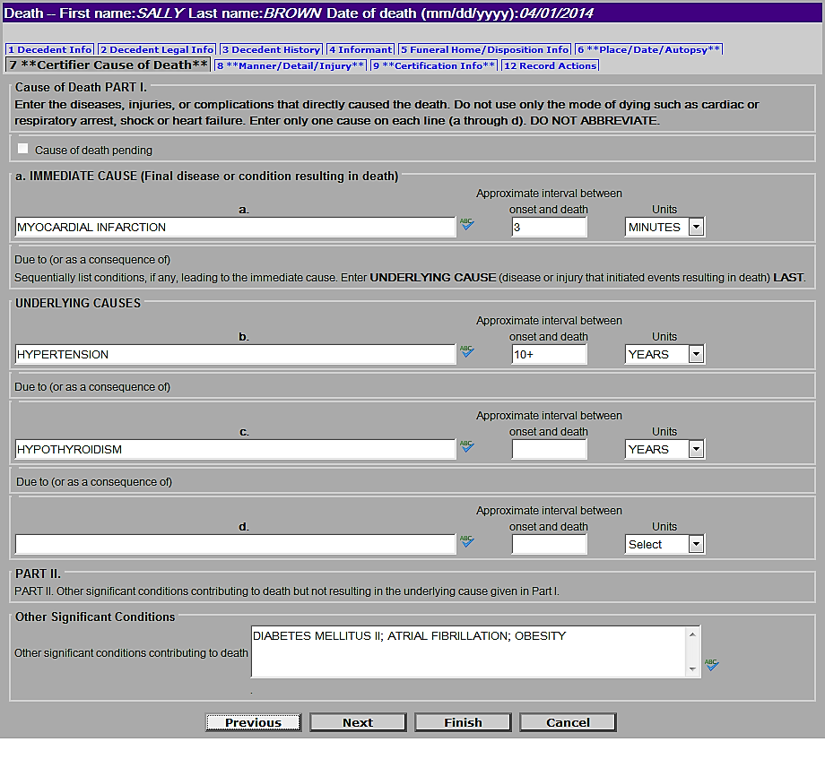
Enter in time intervals in seconds, minutes, hours, days, weeks, months or years.
Take advantage of the built-in spell checker.
EDRS will prompt you at the top of the screen to spell out abbreviations, elaborate on cancer sites, verify rare causes, and help you to avoid writing improper mechanistic causes.
Enter other contributing factors in a continuous line, separated by semicolons (“;”).

Tab 8. Manner/Detail/Injury
Certifiers other than medical examiners will complete only three questions on this tab: Manner of Death, Pregnancy status at time of death, and Did tobacco contribute to death?
Manner-- If the manner of death is not “Natural,” the medical examiner must take this case. (Follow your normal procedures for notifying the medical examiner.) Choose “Natural” from the Manner of Death by clicking it in the drop down list or typing “N” in the field.
Manner/Detail/Injury
Pregnancy Status-- In the Additional Death Details section, Pregnancy status at time of death must be answered if the decedent is female and within the ages of 5 and 75. The status options include pregnancies that may have been up to one year before death.
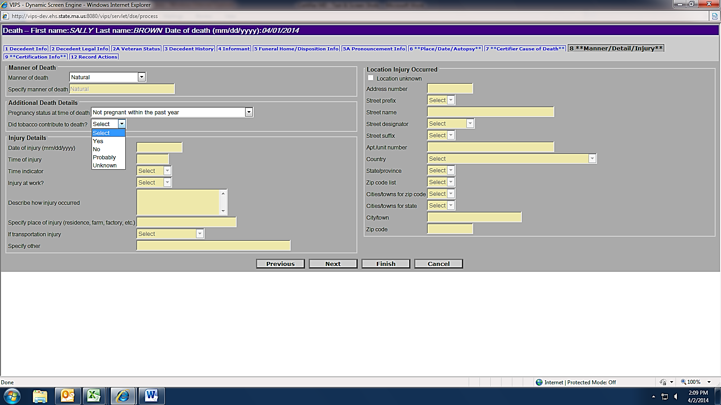
Tobacco -- Indicate whether tobacco use or tobacco exposure contributed to death.
Natural is the only selection for non-M.E. certifiers.
Tip: Type Y, N or P to quickly populate the tobacco field.

Tab 9. Certification Info
Certification Info
Enter the Certifier designation. If the certifier pronounced death or was in attendance at the time of death, but was not part of the decedent’s own health care team, select “Certifier in Attendance at Time of Death” (Physicians) or “Nurse Practitioner in Attendance at the Time of Death.” Otherwise, choose either Physician or Nurse Practitioner in Charge of Patient’s Care.
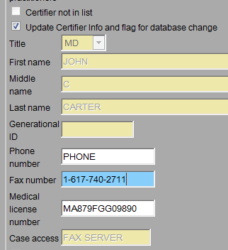
Physician/ Nurse Practitioners pick list. If you did not already do so, first select a physician/ nurse practitioner certifier from tab 12 (Records Actions – see page 9), which will then populate certifier fields for you on tab 9. If the Certifier is not on the list, mark the checkbox Certifier not in list on tab 12, which will enable the name and address fields for data entry. If the new certifier should be a permanent addition to the pick list, also mark the checkbox Update certifier info and flag for database change on tab 9. If you need to make a change only to the fax number, phone, address or license number, click only Update Certifier Info and flag for database change on tab 9. Enter fax and phone number in the format 1-nnn-nnn-nnnn.
Use this checkbox to update fax number or license number.
Physician in charge of the patient’s care are fields that are enabled in most cases, unless the certifier designation is “Physician in Charge of Patient’s Care” The name of the decedent’s primary practitioner preceding death should be entered. If not on the pick list, then mark the checkbox Physician not in list. You may enter the physician’s name and title (or Nurse Practitioner, if applicable). If the decedent had no primary practitioner preceding death, then mark the checkbox No primary care physician provided.
Note - Generational ID is a name suffix. E.g., “Jr.”
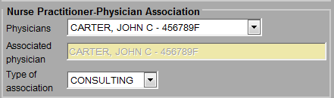
For nurse practitioners that are certifying death - their Associated Physician should be selected from the pick list when applicable, and the Type of association should be selected as either “Consulting” or “Supervisory.” The physician may or may not be the same as the Physician in Charge of Patient’s Care.
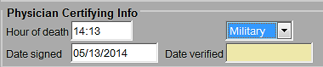
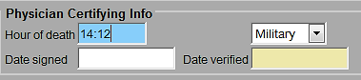
Hour of death may be entered as AM or PM, or as military time. Colons are not needed (e.g., 1412). If the hour of death is from 1300-2459, then the time designation is completed as military automatically. When entering 1200, select “Noon” or “Midnight.”
Certification Info, VIP Warning Page
Date signed, which will be entered later from the signed Attestation Form, should be entered as numeric. It will be converted to formal format when the record is registered and printed by the City/Town Clerk. Enter as MMDDYYYY or MM/DD/YYYY.

Finish & Save (as Pending)
When all the medical information is completed from the worksheet, you must Finish and Save the record before you can certify. Both steps are necessary before you may produce an attestation form or certify the record. (The VIP system needs to validate all screens before it determines that it is ready to certify.)
Click Finish at the bottom of the tab you are working on.

VIP Warning Page
You will then see the VIPS Warning page, at the bottom of which you may click on items to complete, or click on the Save as Pending button.
Record is not saved until you “Save as Pending” -- Note that a record is not yet saved until the Save as Pending button is clicked at the bottom of the VIPS Warning page. To quickly skip the non-medical items, press the [End] button on your keyboard to skip to the bottom of the page.
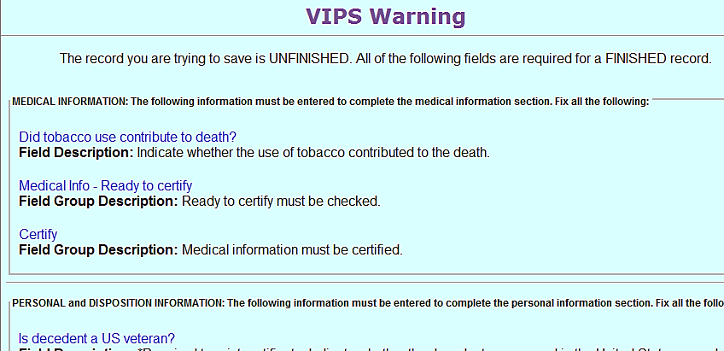
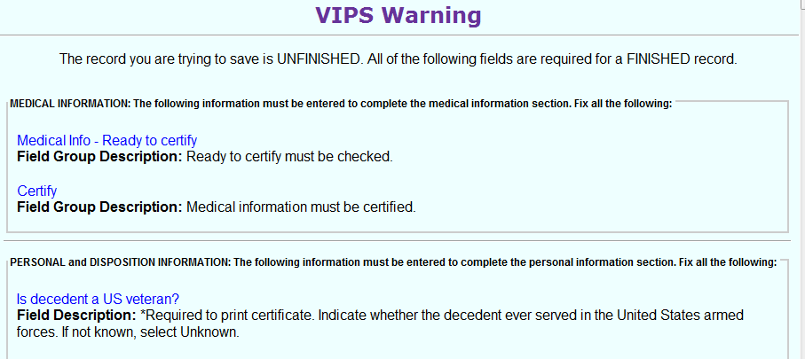
Successful Transaction Page
This record is not ready to be certified, as the tobacco question is not complete. To return to the appropriate tab, click the field name. To save the record for later, click Save as Pending at the bottom of the page.
This record will be ready to certify, but must be saved before certify fields are enabled.
Certifiers and medical staff are not required to answer any items other than the Medical Information items.
After clicking Save as Pending, the Successful Transaction Page will display. At this stage, the record has been saved and validated. You may immediately Return to Record after saving to continue data entry. You may fax a Preliminary Certifier Worksheet if the Certifier did not supply sufficient information to complete the record or if you already checked Ready to Certify (see Records Actions), you will be able to send or print a Fax Attestation form.
Successful Transaction Page

Return to Record (after Saving and Validating)
You will not be able to print or fax the Attestation form until you Return to Record and mark the Ready to Certify checkbox on the Records Actions tab 12 (see Records Actions section). Click Return to Record and click on tab 12. Return to Record is also used after saving during data entry (which is a good practice to prevent loss of information if you are interrupted while preparing the record).
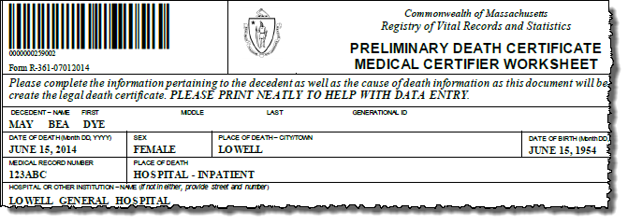
Optional - Preliminary Certifier Worksheet - If the record is not ready to certify because the certifier did not provide you with sufficient information, you may also print or send a fax Preliminary Certifier Worksheet to the certifier that will contain the items you entered, but leave blank the items that remain to be completed. (This form may also be printed through the menu path DeathPrintPreliminary Certifier Worksheet).

Printing/Faxing the Attestation form
Once the Ready to Certify checkbox is marked on tab 12 (Records Actions), EDRS will enable you to print or fax the Attestation form from the Successful Transaction page. You may also print/fax this form from the menu, if you are not ready to print at this time (DeathAttestPrint Attestation).
- If the fax number is not correct, Return to Record and go to tab 6 to Update Certifier Info and flag for database change.
Successful Transaction, Printing
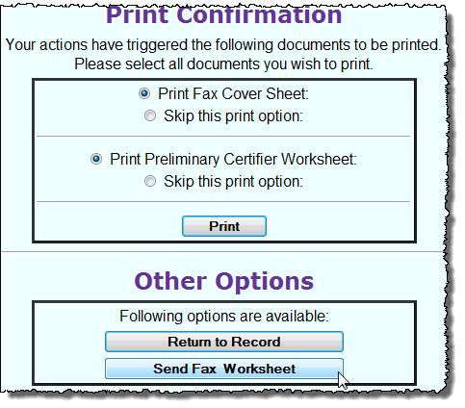
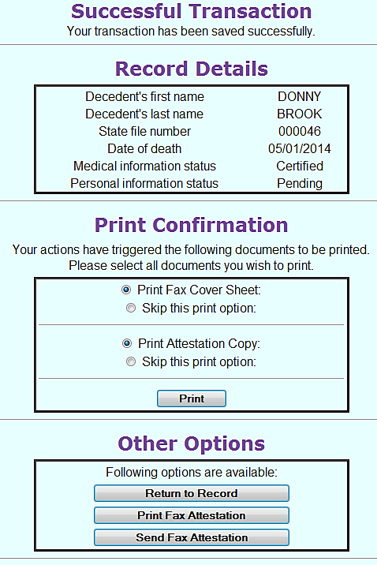
Depending on whether the record is incomplete, certified or not certified, you will receive different print options (as below).
Incomplete
Certified
If the certifier did not provide all information for the death record, you may provide a partially-filled worksheet for completion.

It is rare that medical staff will need to use the Fax Cover Sheet option unless attaching additional documents).

Attestation Copy Form
Later, when certification is complete, this screen will allow you to print the Attestation Copy form. This form can be filed in medical records and provided to funeral directors (or family designees) for transport. This form may also be printed from the menu (DeathPrintAttestation Copy Form).
Once

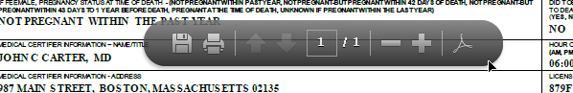
Printing
When printing from the Successful Transaction page or from the Print menu path, EDRS will display a Generate Document button. Clicking on Generate Document will load a PDF document that you will print from the Adobe Acrobat print function. Most users will find this function on a navigation bar at the top of the page or by enabling the hover menu near the bottom of the page.

Tab 12. Records Actions
This tab has several functions. Most often, you will use the Records Actions tab to initially select the offline certifier that will sign the Attestation form, then Check when ready to certify (allows for printing/faxing of the Attestation form) and to Certify once the Attestation form is completed and signed.
Note: Do not reselect a certifier once tab 9 (Certification Info) is complete. The Medical Info section reverts back to Select after leaving the page. Reselect only if the Certifier has changed.
Other functions that you will occasionally use are Record History (to view the status of a record) and Comments (to add your own comments, or to view an explanation of why a record was returned for correction and re-certification). It is recommended that certifiers and medical staff do not choose a funeral home, unless they are 100 percent certain of the funeral home that will handle the decedent. If incorrect, you will be called upon to reassign the funeral home, as the new funeral home will not have access.

Check When Ready to Certify
Once all the medical information is entered into EDRS, and you have clicked Finish and Save (as Pending) to validate and save, click Check when ready to certify on tab 12. Then, click Finish at the bottom of the page and then Save (as Pending) on the VIPS Warning page. The Attestation form will now be enabled for printing and/or faxing on the Successful Transaction page. Note that once a fax is received, the checkbox is cleared and must be checked again.
Records Actions
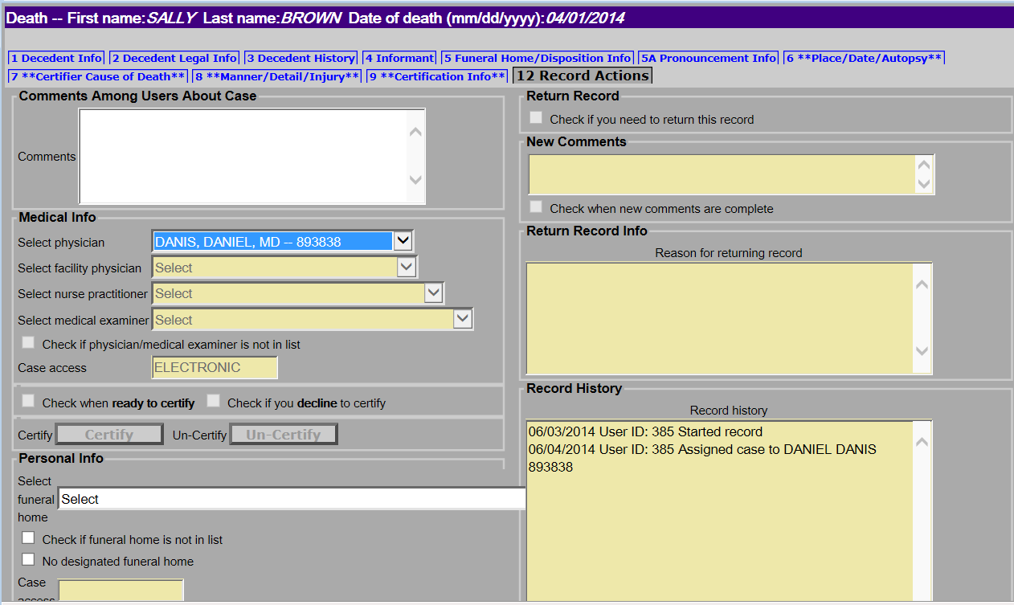
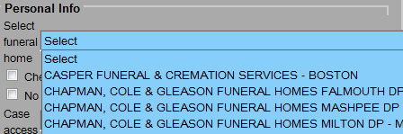
If you are 100 percent sure of the funeral home, you may optionally enter this information. This will cause the record to appear on the funeral home’s “to do” queue.
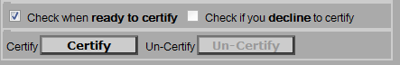
Check when ready to Certify is enabled only after Finish and Save as Pending, then Return to Record. The Certify button is enabled only after a fax is received and a Date signed is entered.
Select a certifier only once. The Medical Info section reverts back to Select after leaving the page. Reselect only if the Certifier has changed.

Death Certificate Attestation Form
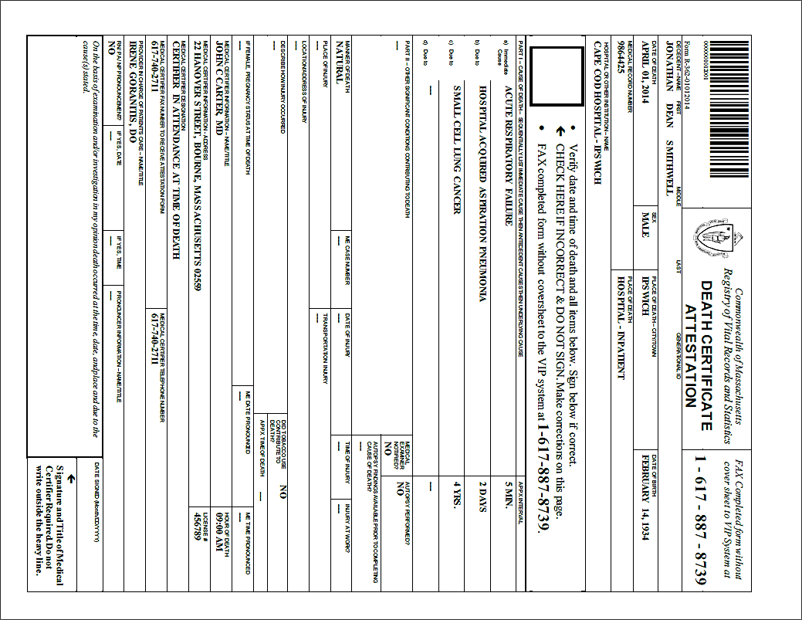
The Attestation form may be printed or faxed from the EDRS system to the fax number listed on tab 9 (See Certification Information section to correct a fax number). Your own internal workflow will determine whether you will be faxing or printing for the certifier’s review and signature. Printing and faxing can be done directly on the Successful Transaction page or through the gray menu bar after a complete record is marked ready to certify and saved (see the Successful Transaction section).
A signature here indicates that the certifier has attested to the accuracy of the I nformation in the EDRS (to his/her best medical opinion). Check also that the form is dated.

If this box is checked, corrections need to be made in the EDRS.

The Attestation form must be faxed to the EDRS fax server. The image is attached to the record and only authorized users may view. (This is not a “fax machine” but rather an automated imaging system.)

Attestation Form
If printed, it is a good idea to check your data entry against the Certifier Worksheet. You may Return to Record if the Successful Transaction screen is still up, or you may update the record by selecting on the Pending MI queue (or through the menu path DeathNew DeathUpdate).
Attaching Completed Forms – The certifier will review the form, sign and date. If the information is incorrect, the certifier will check the large checkbox near the top of the form to indicate that corrections need to be made in the EDRS.
The form must then be faxed back to the number at the top of the form (1-617-887-8739). This number sends the document to automated imaging system where the barcoded document image is attached to the electronic record. (This “fax” never arrives at an office fax machine, and the image can only be viewed by authorized EDRS users).
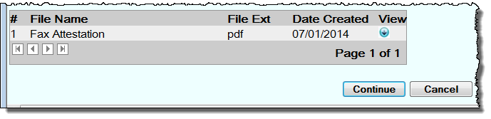
Viewing Completed Forms – Once the certifier or medical staff person faxes the form into EDRS, it may be viewed on the Records Details page. Click on Process on records that appear in your Fax Received queue. At the bottom of the Records Details page, you will see any attached documents. If there were multiple versions of the Attestation form due to corrections, you may see more than one. Click on the View button to view the PDF image. Check if the form was signed or marked for correction.

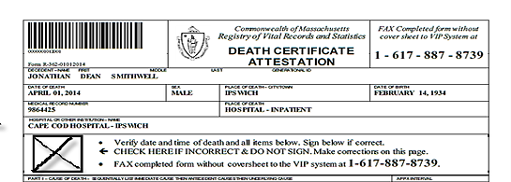
Corrections on the Attestation Form
If the certifier has discovered an error in the information entered into EDRS, he/she will mark the Attestation form checkbox that indicates that the information is incorrect.
To make corrections:
- Select the record from the Pending MI queue (if not already in the record) and make changes in the necessary fields;
- Repeat the actions of Finish, Save (as Pending) after you have made your changes;
Attestation Form Corrections, Certify
- Repeat the process of Check when ready to certify (Tab 12) and printing or faxing a new form from the Successful Transaction page;
- Transmit the corrected Attestation form to the offline certifier and request final approval with a signature and date; and
- The certifier or the medical staff person will then fax the new signed and dated Attestation form back to the VIP/EDRS system.

Certify
Once you have verified that the Attestation form is signed and dated, attached to the death record, and the information is completed accurately, you may return to the record by selecting it from the Pending MI queue. You will enter the date signed on tab 9 and then on tab 12, click Check when ready to certify, and then the Certify button.

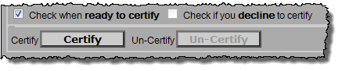
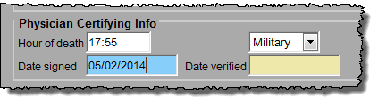
1. Enter Date signed on tab 9.
2. Click Certify on tab 12.

Then, Finish and Save (as Pending) (note that the terminology does not change, even for completed records).
The Attestation Copy may now be printed from the Successful Transaction page, or from the menu path DeathPrintAttestation Copy. This is the form that will typically be used to provide to a funeral home, or other family designee, for transport of the decedent. (See Successful Transaction for details).
Returned Records
Occasionally, a record that was completed and certified may re-appear in your queue. If you see a record that was previously completed, click Process from the Pending MI queue and on Records Details, click on Records Actions tab. Here, you will find comments and an explanation for the record’s return. In these cases you will need to make corrections to items as necessary and repeat the Attestation form process.
Returned Records
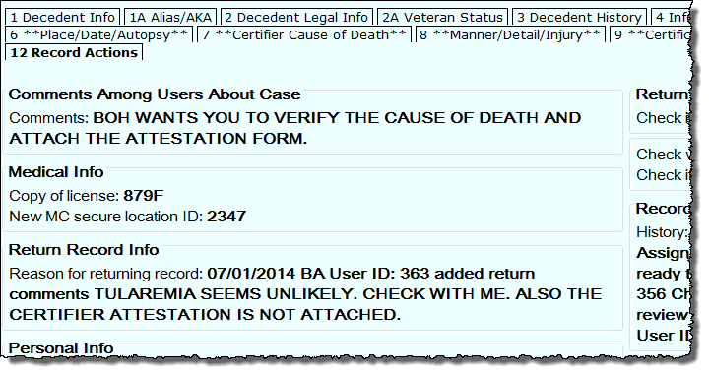

Reassigning a Certifier
If the certifier that intended to certify is no longer available in a timely manner to complete the Attestation Form, it might be necessary to reassign the record to a new certifier. The certifier authorized to substitute will depend on facility or practice policy; however, in general, any physician or nurse practitioner on the patient’s care team, supervising, covering, in attendance at death, or a medical officer may substitute for the intended certifier if necessary. Some facilities will assign a “core group” of certifiers to be available at different times of the day.
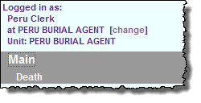
To reassign, call up the record through the Pending MI queue, and navigate to tab 12. Select a new certifier, and then skip to tab 6 to go through all tabs, updating any medical information as necessary for the new certifier. Then, follow the process outlined earlier in this guide to fax/print and receive an Attestation Form and complete the certification information.
Note: If you are a medical staff person in a private practice, once the record has been reassigned, you will need to change your access to the new certifier in order to access the record after saving. If you are facility staff (where death occurred), your access location does not need to be changed.

