Notes
Quick Start Guide for Offline Certifiers:
Fax Attestation

Vitals Information Partnership (VIP)
Electronic Death Registration System (EDRS)
Revision July 1, 2014
Notes
Use this page to make notes about your own workflows and processes, which may differ by facility and practice.

Summary of Steps
You may want to print this page as a quick reference sheet. Note that this summary includes steps for a typical scenario and your own process may vary somewhat depending on internal workflow. While Massachusetts General Law requires completion “immediately,” a good guideline is to have this process completed as soon as possible within 24 hours.
Summary of Steps
1 | Complete a Death Certificate Certifier Worksheet or similar approved form. The worksheet is available in a form-fillable PDF, or you may print very neatly for data entry.
2 | Deliver the worksheet to your medical staff (if they are online) or to the funeral home. (Your own facility/practice workflow may vary).
3 | Receive the Death Certificate Attestation form. You may receive this by fax or it may be printed and delivered depending on your facility or practice workflow. If a funeral director is doing the data entry, you are more likely to receive this by fax.
4 | Review the Attestation form.  - If the information on the Attestation form was correctly entered, sign and date the Attestation form.  - If the information on the Attestation form was incorrectly entered, mark the large checkbox on the form, write changes on the form, and do not sign.
5 | Fax the signed (or corrected) Attestation form to 617-887-8739. The fax is received by an automated document imaging system that attaches an image of the form to the electronic record. The image may only be viewed by authorized EDRS users. (In some facilities and practices, the medical staff will fax the form for you.)

About EDRS
The Electronic Death Registration System (EDRS) is a module of the larger Vitals Information Partnership (VIP) system that is hosted in the Commonwealth’s secure Virtual Gateway environment. The EDRS replaces the paper process for death certificates. Medical certifiers that do not have a VIP EDRS account will need to use the manual death certificate attestation process. It is highly recommended that “frequent” certifiers use the EDRS system online. The attestation process involves multiple steps, while online certifiers can usually complete a record in just a few minutes.
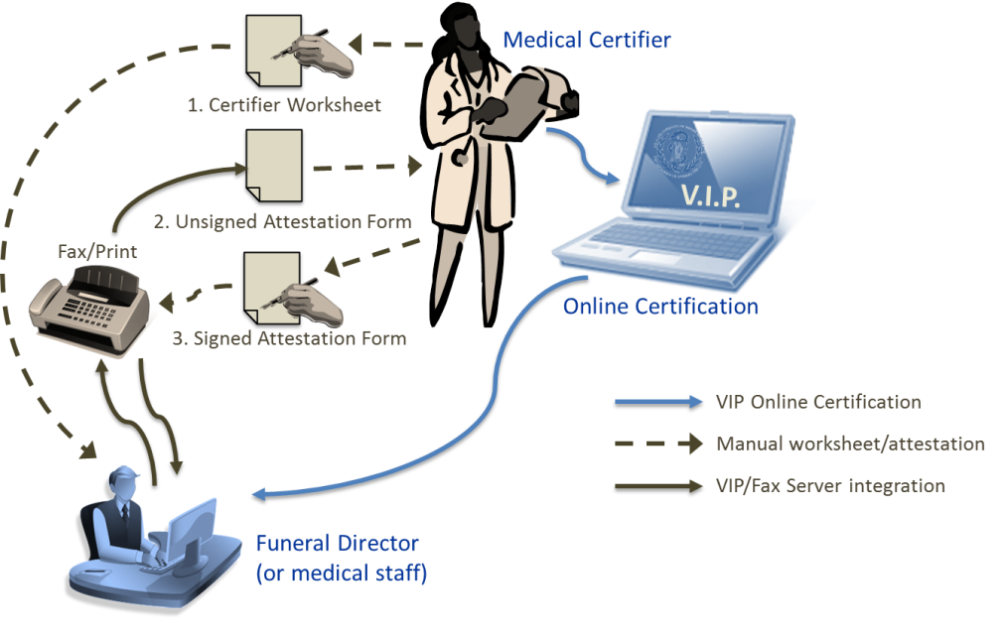

Death Certificate Medical Certifier Worksheet
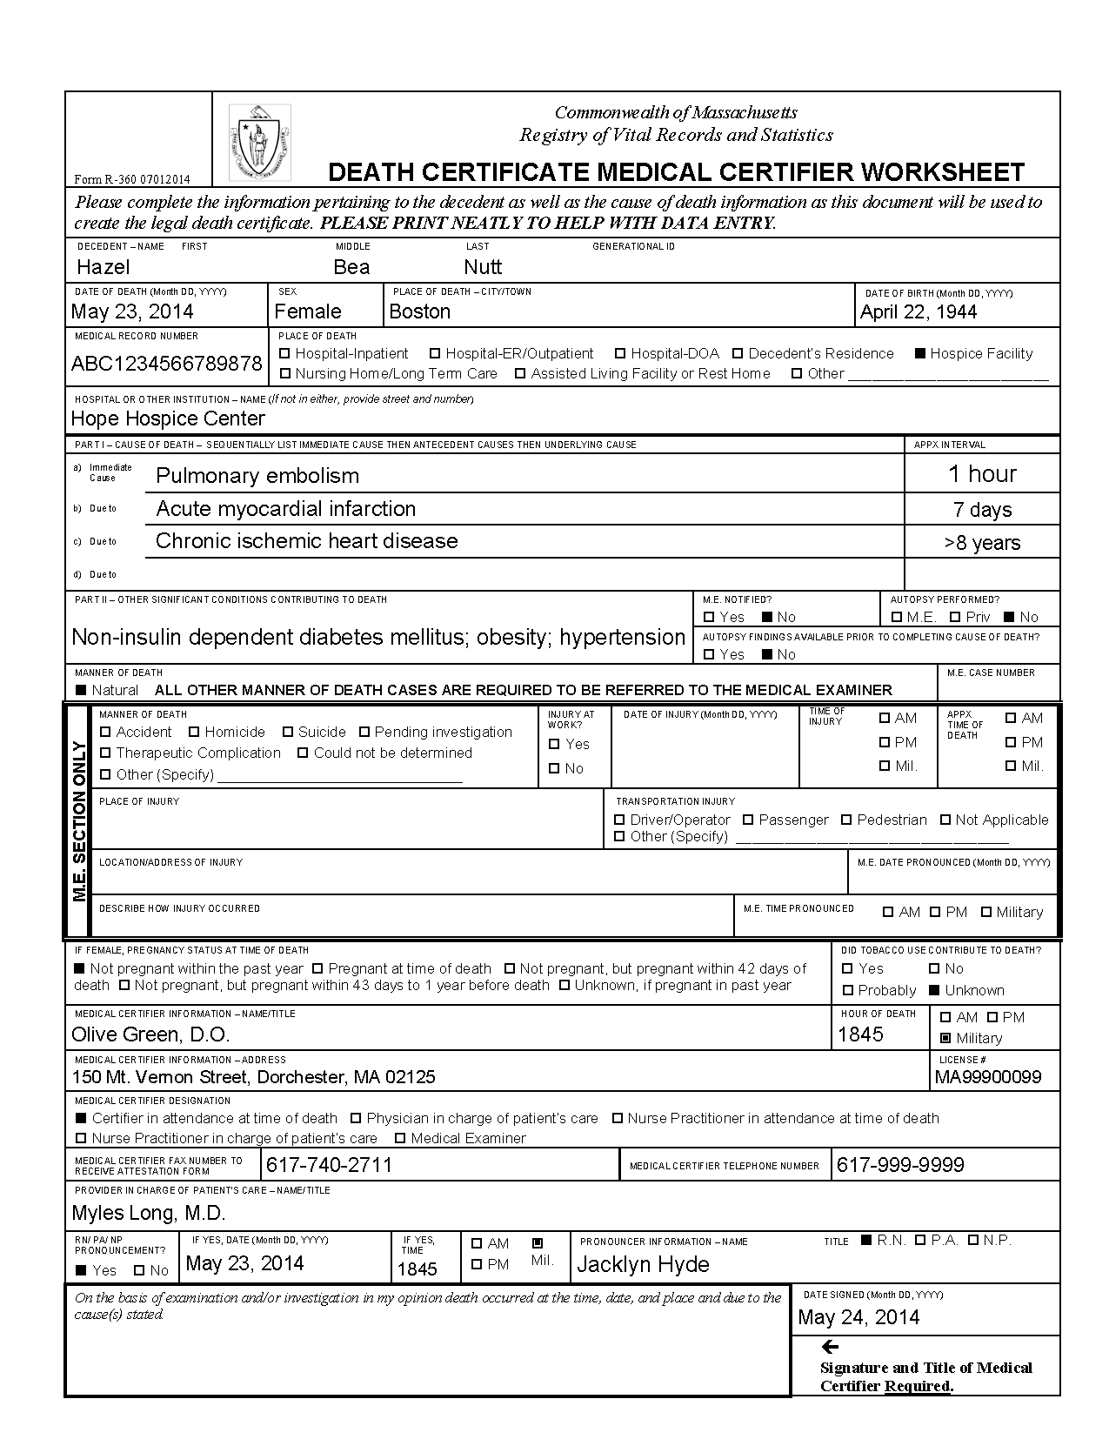
Download a form-fillable PDF version of this form at www.mass.gov/dph/vip. If handwritten, please print very neatly. This information must be data entered into the EDRS and you will later verify the accuracy on the Death Certificate Attestation form. Ideally, this 3-step process should only happen once – but, poor handwriting may result in multiple tries.
D.O.

Quick Guide to Worksheet Data Items
A more detailed guide to death certificate data items is available separately. In addition, a cause-of-death online training module is available for continuing education credits. The following summary provides basic information about completing selected worksheet items appropriately:
Name of Decedent | Enter the full legal name as you know it. Generational ID is a name suffix, such as “Jr.”
Date of Death | Preferably, enter as Month DD, YYYY, e.g., May 23, 2014, to avoid transcription error.
Sex | Female or Male.
Place of Death Town | Enter the proper city/town name where the death occurred. E.g., Boston not Roxbury.
Date of Birth | Enter as Month DD, YYYY. If any parts of the date are unknown, enter unknown values with “9”s. E.g., April 99, 1944.
Medical Record # | This field is optional, but useful for later look-up when necessary. Note that the “fax” to EDRS is an automated imaging system, and that the resulting image is viewable only to authorized EDRS users.
Place of Death – Type | Note that “Decedent’s residence” is to be used only for his/her own residence that is not a nursing home, hospice facility, assisted living or rest home. Home hospice may be entered as “Decedent’s residence.” Another person’s residence should be marked “Other.”
Hospital/Address | If death occurred in a medical/ long-term care facility/ assisted living or rest home, enter the name (e.g., Valley Nursing Home). Specify city/town on the worksheet, if necessary, to distinguish similar sounding facilities. If death occurred elsewhere, such as a private home, enter the full address, including zip code.
Cause of Death | List one cause of death per line in Part I, based on facts available to you and your best medical opinion. Line (a) should list the immediate (final) disease or complication directly causing death. Do not list mechanistic causes (e.g., cardiac arrest), as these do not describe the disease process. On line (b), enter the disease or complication that gave rise to the immediate cause. Continue the sequence on lines (c) and (d). Your last line should reflect the “underlying cause.” Squeeze in other lines, if necessary, writing “due to” between conditions.
Approximate Intervals | Intervals are almost always approximations. Enter an approximate interval for each condition listed in the cause of death sequence. You may enter in many different ways depending on the information available to you. E.g., “8 minutes,” “>10 years,” “Years.”
Other significant conditions | List other diseases and conditions that may have contributed to death, but do not directly belong in the sequence of conditions reported in Part I.
M.E. notified | Was the medical examiner notified of this case? Mark yes or no. Do not complete death records over which the M.E. took jurisdiction. If you were given a case number, enter in M.E. Case Number.
Autopsy Performed | If an autopsy was performed, mark whether private or whether done by the medical examiner. Private includes any non-M.E. autopsy. If there was no autopsy, mark “No.”
Autopsy findings available? | If you used autopsy findings to complete the death certificate mark “Yes,” if not, mark “No.”
Manner of death | Certifiers other than medical examiners must always mark “Natural.” Do not complete the manner of death fields in the Medical Examiner section of this form. “Natural” appears above the medical examiner section.
Pregnancy status | Enter whether a female was pregnant at death or any time in the last year. Specific checkbox categories break down the pregnancy intervals to “at death,” “within 42 days,” and “43 days to one year.” This is a new question to comply with CDC national standards.
Tobacco Use | Enter whether tobacco use contributed to death as “Yes,” “No” or “Probably.” Even if this item is checked “Yes,” do not exclude tobacco use from the cause of death.
Medical Certifier Information | Enter a full name, title and license number of the physician or nurse practitioner certifying death, and primary business address. (Generally this address will be your primary business address listed with the Board of Registration in Medicine). Use the same primary business address on every death certificate, as your information will be saved and pre-populated for ease in future data entry. Use a different address only if the primary address has changed.
Fax Number and Telephone Number | The medical staff or funeral home requires a fax number to send the Attestation form to as well as your primary business telephone number to contact you if there are questions about the worksheet or attestation form.
Medical Certifier Designation | In general, use the “Certifier in attendance at time of death” or “Nurse practitioner in attendance at time of death” if you are a physician or NP certifying death but not one of the lead individuals on the decedent’s care team. Use “Physician (or Nurse practitioner) in charge of patient’s care” if you were a key practitioner on the care team. This category might include the decedent’s oncologist, cardiologist, primary care provider, etc. This, to some extent, is dependent on your facility/practice policy.
Provider in charge of patient’s care | If you selected “Certifier (or Nurse Practitioner) in attendance at time of death,” you will need to also provide the name and title of the primary physician or NP that was in charge of the patient’s care.
RN/PA/NP pronouncement | If a Registry of Vital Records “nurse pronouncement” form was completed, complete information about the date pronounced, the time pronounced and the name/title of the pronouncer.
Signature/ Date | It is required that you sign and date this form.

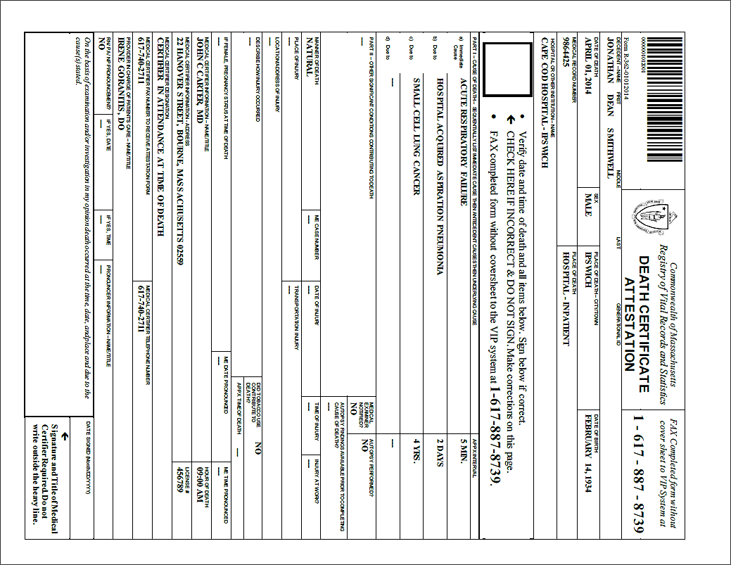
Death Certificate Attestation
Your signature and date here indicate that you have reviewed the information entered into EDRS and have found the data entry accurate.

Check this box if corrections need to be made or additional information should be added on the EDRS death record.

The Attestation form must be faxed to the EDRS fax server. The image is attached to the record and only authorized users may view. (This is not a “fax machine” but rather an automated imaging system.)

The Death Certificate Attestation form prints all information entered into EDRS on your behalf. You, as certifier, must review this form and attest to the accuracy of the data entry. This form may be printed or faxed from the EDRS system by online medical staff or the funeral director. Your own internal workflow will determine whether you will receive a fax or a printout.
Attestation Form
Returning Completed Forms – The certifier will review the form, sign and date. If the information is incorrect, the certifier will check the large checkbox near the top of the form to indicate that corrections need to be made in the EDRS.
The form must then be faxed back to the number at the top of the form (1-617-887-8739). This number sends the document to automated imaging system where the barcoded document image is attached to the electronic record. (This “fax” never arrives at an office fax machine, and the image can only be viewed by authorized EDRS users).

