Completing the Cause of Death (COD) Section
The cause of death section on a death certificate should tell a story about how a person died. Review the person’s medical history to identify the diseases or conditions that contributed to death and report them in the correct sequence of events using your best medical judgement. Part I contains the events leading to death and the time interval. Part II contains other significant conditions that contributed to but did not cause the death.
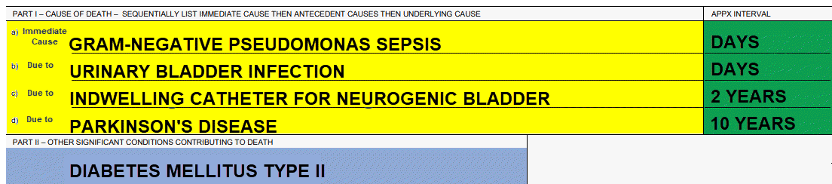 Sample Cause of Death Section
Part I  Chain of Events | Immediate Cause of Death: Report the most recent disease, condition, or injury that occurred right before the person died that directly resulted in death. In cases where a single disease or condition is responsible for the death, report it on line “a” as the sole cause of death.  Intermediate Cause of Death: After reporting the immediate cause of death, ask “What was the immediate cause due to?” If other diseases or conditions preceded the immediate cause of death, report these antecedent causes on the lines below the immediate cause of death.  Underlying Cause of Death: Report the disease or injury that started the chain of events leading to death. The underlying cause of death is reported on the last completed line in Part I.  Report the approximate time interval between onset and death for each disease, injury, or other condition reported above. Report the shortest interval on line “a”. Be as specific as possible.
Time Interval
Part II  Other Significant Conditions | Report all diseases or conditions that contributed to death but did not cause it – those that were not part of the chain of events leading directly to death in Part I. Include risk factors. If there are several conditions, list them in order of significance with a comma separating each condition.
Avoid a Non-Specific Cause of Death: When reporting the immediate cause of death do NOT report the mode of death (e.g., heart failure, cardiac arrest, failure to thrive, etc.). The mode of death is simply the last system in the body that stopped functioning before death. These and other modes of dying do not inform public health interventions because they don’t explain why the person died. The immediate cause of death is the final etiologic disease, injury, or complication that caused the cardiac/respiratory arrest or other mode of death.
Cause of Death Data and Public Health
Death certificate data is an important tool used to benefit public health. Make every effort to be accurate.
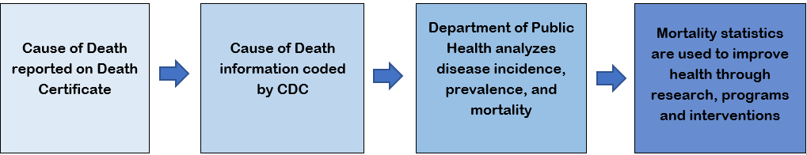
Case Studies | Incorrect  Non-specific Cause of Death Sequence | Correct  Specific Cause of Death Sequence
Case Study One  - Elderly man with Parkinson’s and diabetes  - Chronic indwelling catheter for a neurogenic bladder  - Catheter causes a urinary tract infection  - Urinary tract infection leads to a gram-negative pseudomonas sepsis  The first example is incorrect because it contains a non-specific cause of death and does not explain why the patient acquired gram-negative sepsis.  The second example is correct because it contains an accurate causal sequence of events that explains why the patient acquired gram-negative sepsis. | Part I  - Septic shock  due to or as a consequence of;  - Gram-negative sepsis  Part II | Part I  - Gram-negative pseudomonas sepsis  due to or as a consequence of;  - Urinary bladder infection  due to or as a consequence of;  - Indwelling catheter for neurogenic bladder  due to or as a consequence of;  - Parkinson’s disease  Part II  Diabetes mellitus type 2
Case Study Two  - 73-year-old obese woman with history of coronary artery atherosclerosis  - Complains of chest pain and collapses  - EMS arrives and she is asystolic.  - She dies and autopsy confirms significant coronary atherosclerosis  The first example is incorrect because it contains a non-specific cause of death and does not provide an accurate sequence of events that explains why the person died from respiratory arrest.  The second example is correct because it contains an accurate causal sequence of events that explains why the patient died of a probable acute myocardial infarction. | Part I  - Respiratory arrest  Part II | Part I  - Probable acute myocardial infarction  due to or as a consequence of;  - Coronary artery atherosclerosis  Part II  Obesity
Thank you for improving public health through better reporting!

