COMMONWEAL TH OF MASSACHUSETTS

Middlesex, ss Board of Registration in Medicine Adjudicatory No. 2024--017

)
In the Matter of )
) MICHAEL YAREMCHUK, M.D. )
Registration No. 41996 )

RESIGNATION

I, MICHAEL YAREMCHUK, being duly sworn, depose and state:

- I desire to resign my license to practice medicine and/or my inchoate right to renew said license in the Commonwealth of Massachusetts pursuant to the terms of243 CMR l.05(5)(a).

- My resignation is tendered voluntarily.

- I realize that this resignation is a final act that deprives me of all privileges of registration and is not subject to reconsideration or judicial review.

- I am not currently licensed to practice medicine in any other state and will make no attempt to seek licensure elsewhere.

- I understand that my resignation is a disciplinary action that is rep01iable to any national data-reporting agency, pursuant to G.L. c. 112, §2.

Signed under the penalties of perjury this 27th day of March , 2024.

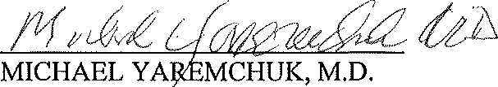

Then personally appeared before me the above-named, Michael Yaremchuk, M.D. who signed the foregoing resignation in my presence and acknowledged said resignation to be his free act and deed.
/'"-

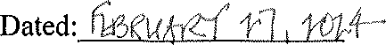
Signed by Tamara A. Huston
Notmy Public 1'"""-'

My Commission Exp
TAMARA A. HUSTON f'
Notary Public
COMMONWEALllf OF MASSACHUSEHS
My Commission Expires
October 25, 2024

