ATTACHMENT A
COMMONWEALTH OF MASSACHUSETTS
Middlesex, SS. Board of Registration in Medicine
Docket No. RM„20-0217
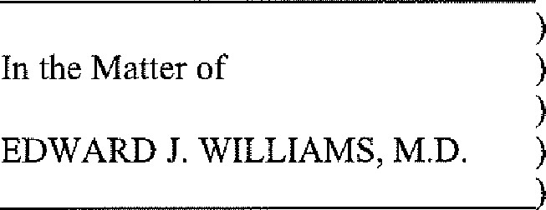

JOINT STIPULATION
Edward J. Williams, M.D. (the "Respondent"), the Respondent's attorney, and Complaint Counsel (hereinafter referred to jointly as the "Parties") agree that this Joint Stipulation shall be filed with the Administrative Magistrate for the Division of Administrative Law Appeals ("DALA") as a resolution of questions of material fact and law as set forth by the Statements of Allegations in the above matter. The Respondent admits to the Findings of Fact described below and agrees that the Administrative Magistrate and the Board of Registration in Medicine (the
"Board") may make the Conclusions of Law as set forth below.
FINDINGS OF FACT

BACKGROUND
L The Respondent was born on January 6, 1967, He is a 1993 graduate of the Georgetown University School of Medicine. The Respondent is certified by the American Board of Medical Specialties in Emergency Medicine. His practice specialty is Emergency Medicine. He was licensed to practice medicine in Massachusetts on June 26, 1996 under certificate number 150636.
2, The Respondent has held a license to practice medicine in New Hampshire and
West Virginia. His license to practice in West Virginia has lapsed.

STIPULATED FACTS
- On February 27, 2014, the New Hampshire Board of Medicine ("New Hampshire Board") received a copy of a Complaint ("Complaint") filed in Strafford County Superior Court against the Respondent and a physician's assistant ("PA") on the Wentworth-Douglas Hospital Emergency Department. The Complaint alleged that the Respondent and the PA were negligent in the treatment of Patient A and that their negligence resulted in patient harm. The civil proceeding that led to the New Hampshire Board's investigation was fully tried over approximately four days before Judge Stephen Hourak and a jury in the Stratford County Superior Court and resulted in a jury verdict in favor of the Respondent. Nonetheless, the New Hampshire Board conducted its own hearing, which lasted several hours, and then reprimanded the Respondent.
- On December 8, 2017 the New Hampshire Board found that the Respondent displayed medical practice that is incompatible with the basic knowledge and competence expected of persons licensed to practice medicine when he failed to recognize that the abnormal lab results for Patient A indicated something more serious than what was diagnosed. The Respondent's treatment of Patient A fell below the standard of care and was negligent. The New
Hampshire Board issued a Reprimand. A copy of the New Hampshire Medical Board's Final
Decision and Order is attached hereto as Attachment A and is incorporated herein by reference,
- The Respondent appealed the Final Decision and Order by the New Hampshire Board. On March 8, 2019, the New Hampshire Supreme Judicial Court upheld the New
Hampshire Board's Final decision and Ordere A copy of The State of New Hampshire Supreme Court ruling for Case No. 2018-0138 is attached hereto as Attachment B and is incorporated herein by reference.
The New Hampshire Medical Board's Final Decision and Order set forth the following facts:
  - On February 23, 201 1, Patient A presented to the Wentworth-Douglass Emergency Room after being ill for five days with fever, chills, vomiting, diarrhea, and upper abdominal pains. Patient A was first evaluated by the Physician's Assistant ("PA"), who was under the supervision of the Respondent. The PA ordered lab tests for Patient A and then conferred with the Respondent on
Patient A's symptoms and lab results.
  - The lab results revealed that Patient A had a low White Blood Cell Count
("WBC") and multiple organ dysfunction,
  - The Respondent suggested ordering influenza and hepatitis tests. The results of which came back negative.
  - The Respondent and the PA did not order imaging or any further studies. Patient A was treated for gastroenteritis and diagnosed with a viral syndrome. Patient A was discharged by the PA with prescriptions for a cough suppressant and antinausea medication.
  - Patient A returned to the Emergency Department the following evening and was diagnosed with bilateral pneumonia, acute respiratory distress syndrome, pleural effusions, pneumothoraxes which required surgical intervention, and a seven week hospitalization.

CONCLUSIONS OF LAW
A. The Respondent has violated 243 CMR I 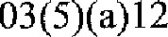 in that he has been disciplined in another jurisdiction in any way by the proper licensing authority for reasons substantially the same as those set forth in G.L. cr 112, 5 or 243 CMR 1.03(5)—specifica11y::
l . Pursuant to 243 CMR 1.03(5)(a)3, the Board may discipline a physician upon proof satisfactory to a majority of the Board, that said physician's conduct placed into question the physicians competence to practice medicine, including but not limited to gross misconduct in the practice of medicine, or practicing medicine fraudulently, or beyond its authorized scope, or with gross incompetence, or with gross negligence on a particular occasion or negligence on repeated occasions,

SANCTION AND ORDER
The Parties expressly acknowledge that the Board may impose sanctions against the Respondent based upon the above Findings of Fact and Conclusions of Law. The Parties hereby jointly agree to recommend to the Board that it impose the sanction set forth below. The Parties understand that the recommended sanction is not binding on the Board, and that the Board may wish to impose a different sanction on the Respondent,
At the time the Board considers this Stipulation, it will infom the Parties of its inclination as to sanction. If the Board's sanction is different from the one recommended by the Parties, the Respondent will be given an opportunity to either accept or reject the proposed sanction. If the Respondent rejects the proposed sanction, then the matter will continue through the adjudicatory process pursuant to Mass. Gen, Laws c. 30A and 801 CMR I .00 et seq.
The Respondent's license to practice medicine in the Commonwealth of Massachusetts is hereby reprimanded. These sanctions are imposed for each violation of law listed in the
Conclusions of Law section, above, and not a combination of any or all of them.

EXECUTION OF THIS STIPULATION
The Parties agree that the approval of this Stipulation is left to the discretion of the Administrative Magistrate and the Board. As to any matter this Stipulation leaves to the discretion of the Administrative Magistrate or the Board, neither the Respondent, nor anyone else acting on his behalf, has received any promises or representations regarding the same.
The signatures of the Parties are expressly conditioned on the Administrative Magistrate and the Board accepting this Stipulation.
If the Administrative Magistrate rejects any provision contained in this Stipulation, the entire document shall be deemed null and void and the matter will be scheduled for a hearing
pursuant to Mass. Gen. Laws c. 30A and 801 CMR 1.00 et seq.
If the Board rejects any provision in this Stipulation or modifies the Sanction and said modification is rejected by the Respondent, the entire document shall be null and void and the matter will be recommitted to DALA for appropriate proceedings and an eventual hearing
pursuant to Mass. Gen. Laws c. 30A and 801 CMR I .00 et seq.
Neither the Parties nor anyone else may rely on the Stipulation in either the proceedings or hearing referenced in the preceding paragraph or in any appeal therefrom,

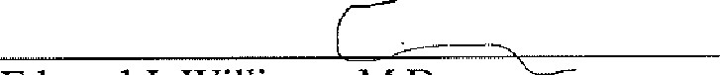
Edward J. Williams, M.D.
Respondent

9/24/2020

Date
John Cassidy  Attorney for Respondent | Date
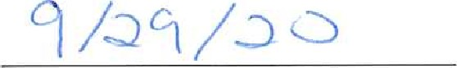
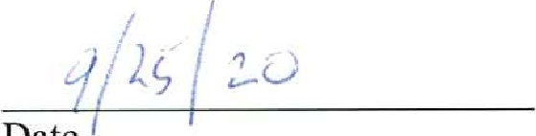
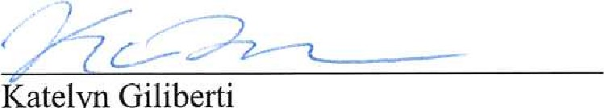atelyn Giliberti Date
Complaint Counsel

To obtain a copy of the out-of-state disciplinary order, please contact the appropriate state’s medical licensing board directly. A list of state medical boards and contact information is available at https://www.fsmb.org/contact-a-state-medica-board/. You may also obtain a copy of the out-of-state disciplinary order by submitting a public records request (PRR) with the Massachusetts Board of Registration in Medicine. PRR forms and additional information can be found at https://www.mass.gov/board-of-registration-in-medicine-public-records.

