Publication Date: March 1, 2021
Tutorial on Using the
Model Jury Instruction Template
This tutorial explains how to use the Superior Court’s Model Jury Instruction Template. This template is a Word document that contains all the settings you will need to format model jury instructions. It will let you use the Superior Court’s standard model jury instruction format without ever having to select a font, choose the print size, set the line spacing, or change any other format settings.
This tutorial will show you, step-by-step, how to use this template document to draft properly formatted model instructions.
Step One. Before you read any further in this tutorial, please read §§ 2.1 and 2.2 of the Superior Court’s Guidelines for drafting model jury instructions. Section 2.1 provides a short introduction to using Styles in Microsoft Word. Section 2.2 introduces the format settings contained in the Model Jury Instruction Template.
Step Two. Open the template. The file is called “Template – Model Jury Instruction.”
When you open the Model Jury Instruction Template, you will see a Word document that looks something like this, only full-sized: | 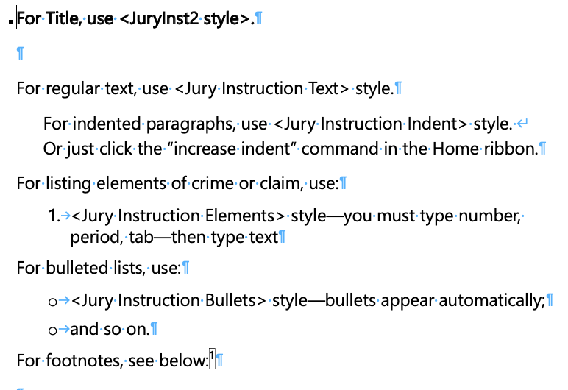
The text you will see when you first open the template is a set of reminders about which Style you should use for each part of a model instruction. When you use the template, you will type over or delete this text, as explained below.
Please note that the screenshot in the right-hand column above, like the similar screenshots below, has been reduced in size to fit into the column. The template itself will produce much larger print, like in the following sample:
Actual Appearance of Instructions Using the Model Template
What is proof beyond a reasonable doubt? The term is often used and probably pretty well understood, though it is not easily defined. Proof beyond a reasonable doubt does not mean proof beyond all possible doubt, for everything in the lives of human beings is open to some possible or imaginary doubt. A charge is proved beyond a reasonable doubt if, after you have compared and considered all of the evidence, you have in your minds an abiding conviction, to a moral certainty, that the charge is true. When we refer to moral certainty, we mean the highest degree of certainty possible in matters relating to human affairs—based solely on the evidence that has been put before you in this case.
* * *
Step Three. Save the template as a new file, with name of the model instruction you are drafting (e.g., “Wage Act Instr – Draft 1”).
Step Four. You are now ready to type the name or title of your instruction. To do so, use your cursor to select and highlight just the text in the first bolded line; do not highlight the paragraph mark at the end of that line. Then type your title in place of the text you just highlighted. Make sure you do not delete the paragraph mark at the end of the line.
If you cannot see the paragraph marks at the end of each paragraph, you need to toggle on the “Show/Hide ¶” button. You can do so as follows:
Click on the <Home> tab in the Word ribbon, near the top of the screen, to the left. | 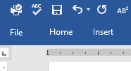

Find the <Paragraph> portion of the menu that opens in the ribbon — click on the ¶ symbol | 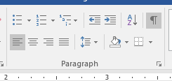
Once you can see the paragraph mark, then you may follow the directions above for typing the title of your instruction.
Once you have typed in the name of your instruction, the document should look like this, with your title on the top line:
The title of a model jury instruction should be a short enough to fit if copied into a table of contents in a complete set of jury instructions.
When you typed the name of the instruction over the bold text on the first line, you automatically used the “JuryInst2” style. That is important. You will know you did this correctly if the title you just typed is in bold print.
The civil and criminal master templates are designed to make it easy to generate a table of contents showing jurors where to find each part of the instructions. But this table of contents feature will only work if you use the JuryInst2 style for the title of each model instruction.
Step Five. Next, you can delete the remaining text. This tutorial and the Guidelines explain the tips you are about to delete. Leave the one blank line under your title. Delete everything starting with “For regular text…” through the end of the page.
Once you have deleted the remaining tips, you are ready to proceed
This simple document contains all of the Styles you will need to format the other possible parts of your instruction, as explained below.
Step Six. You may now start typing the text of your jury instruction. Do so in the blank line immediately under the title. This paragraph contains the proper formatting for jury instruction text.
As you begin typing an instruction, it should like something like this:
When you hit return, you will get additional paragraphs using the same “Jury Instruction Text” style. So at this point you can draft your jury instruction the way you normally draft a document in Word.
Step Seven. If your model includes a list of numbered elements, you should format them using the “Jury Instruction Elements” style, as explained below. Start by typing the introductory sentence to the list of elements in the way you have already practiced, with the same formatting as before.
The introduction to the elements of possession of a loaded firearm might look like this:
To create a numbered list, you will need to change the style of format of the next paragraph. Follow these steps:
Put your cursor in the first paragraph of the list.
Then click on the <Home> tab in the ribbon, near the top of the screen, to the left.

Find the <Styles> portion of the menu that opens in the ribbon — click on the tiny button to the right of the word “Styles” — it looks like an angle bracket with an arrow pointing down — this “dialog box launcher” opens the Styles Pane. | 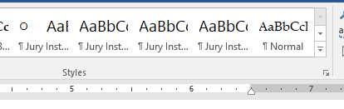
If you are using Word for Mac OS on an Apple computer, the way you access the Styles Pane is a little different. Click on the <Home> tab in the ribbon as shown above. Then, at the far right of the ribbon, click on <Styles Pane>.
The Styles Pane that just opened contains a list of available styles. The “Jury Instruction Text” style will be highlighted, because that is the style you have been using.  To change to the formatting for numbered elements, click on “Jury Instruction Elements” in the Styles Pane. | 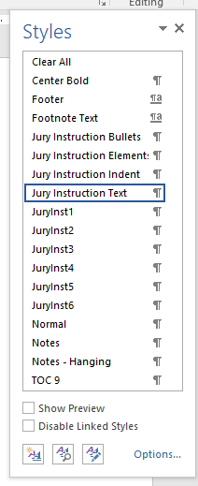
If you are using Word for MacOS, the Styles Pane will have a slightly different appearance, but you will use it the same way.
For each numbered element you need to type the number, a period, and a tab, and then summarize the element. The numbering is not automatic.
Using this style, a numbered list of elements of a crime would look like this (without the outline added here):

When you finish the last numbered item and hit return, you need to change the formatting style of the next paragraph back to regular text.  To do so, follow the steps above for selecting a new Style. After you open the Styles Pane, the “Jury Instruction Elements” style will be highlighted, because that is the style you have been using.  To change back to the formatting for regular text, click on “Jury Instruction Text” in the Styles Pane. | 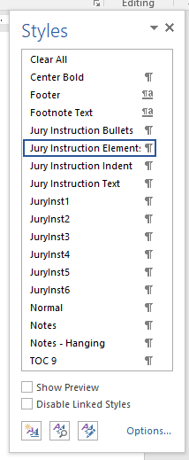
With the format and style reset to “Jury Instruction Text,” you are ready to continue drafting the instruction.
Step Eight. Sometimes it may be helpful to include a bulleted list of items inside a jury instruction. To do so, you can follow the instructions for numbered lists described in the prior step, but select the “Jury Instruction Bullets” style to format the items in the list.
Start by typing the introductory sentence to the list of elements using the regular “Jury Instruction Text” style. Then follow the instructions above for opening the Styles Pan, and click on “Jury Instruction Bullets.”
Using this style, a bulleted list would look like this:

When you finish the last bullet and hit return, you need to change the formatting style of the next paragraph back to regular text.  To do so, follow the steps above for selecting a new Style. After you open the Styles Pane, the “Jury Instruction Bullets” style will be highlighted, because that is the style you have been using.  To change back to the formatting for regular text, click on “Jury Instruction Text” in the Styles Pane. | 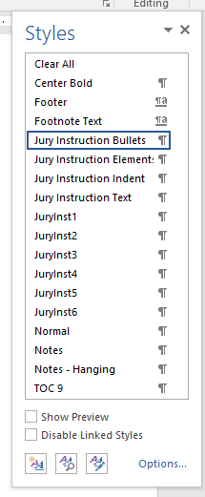
Step Nine: If you are using headings or subheadings within a model instruction, you need to use the appropriate style for that paragraph. The style for headings is called “JuryInst3.” The style for subheadings is called “JuryInst4”. If you use these styles, then your headings and subheadings will be formatted consistently and can automatically be rolled up into a table of contents in the civil and criminal master templates.
To format a heading or subheading using the proper style, do as follows.
Put your cursor in the first paragraph of the list.
Then click on the <Home> tab in the ribbon, near the top of the screen, to the left.

Find the <Styles> portion of the menu that opens in the ribbon — click on the tiny button to the right of the word “Styles” — it looks like an angle bracket with an arrow pointing down — this “dialog box launcher” opens the Styles Pane.
If you are using Word for Mac OS on an Apple computer, the way you access the Styles Pane is a little different. Click on the <Home> tab in the ribbon as shown above. Then, at the far right of the ribbon, click on <Styles Pane>.
The Styles Pane that just opened contains a list of available styles.
To change to the formatting for headings, click on “JuryInst3.”
To change to the formatting for subheadings, click on “JuryInst4.”
If you are using Word for MacOS, the Styles Pane will have a slightly different appearance, but you will use it the same way.
Once you have selected the proper style, type a short heading or subheading and hit return. | The next paragraph will automatically be formatted for regular text. You do not need to change the style back to “Jury Instruction Text;” that will happen automatically.

Your headings and subheadings should look like this:
Step Ten: Guidelines § 1.3.3 explains that any citations in model instructions should be put in footnotes. You can add a footnote the way you normally do in Word. (One way is to click on “References” in the Ribbon, and then click on “Insert Footnote.”) When the footnote opens, you must type a single “Tab” in the footnote before typing the rest of the footnote. The footnote text will wrap onto the next line with a small hanging indent; the reference number will be at the left margin, you then type a single tab, and all of the footnote text will be indented 2/10 of an inch. This helps set it off the footnotes and make a clearer visual distinction from body of the instruction.
Footnotes should look something like this—you must type a “Tab” after the number, before typing the footnote.

