Collective Bargaining Agreement

between the

Commonwealth of Massachusetts

and the

Coalition of Public Safety

July 1, 2018 – June 30, 2021

Table of Contents

SUBJECT PAGE

PREAMBLE 1

ARTICLE 1 RECOGNITION 2

ARTICLE 2 RULES & REGULATIONS 3
ARTICLE 3 UNION SECURITY 4

ARTICLE 4 AGENCY FEES 5

ARTICLE 5 UNION BUSINESS 6

ARTICLE 6 ANTI-DISCRIMINATION &
AFFIRMATIVE ACTION 9

ARTICLE 6A MUTUAL RESPECT 10

ARTICLE 7 WORKWEEK AND WORK SCHEDULES 11

ARTICLE 8 LEAVE 15

ARTICLE 9 VACATIONS 29

ARTICLE 10 HOLIDAYS 34

ARTICLE 11 EMPLOYEE EXPENSES 36

ARTICLE 12 SALARY RATES 38

ARTICLE 12A EDUCATION INCENTIVE PAY 41

ARTICLE 12B NIGHT SHIFT DIFFERENTIAL 43

ARTICLE 13 GROUP HEALTH INSURANCE CONTRIBUTIONS 44

ARTICLE 13A HEALTH AND WELFARE 45

ARTICLE 13B TUITION REMISSION 46

ARTICLE 14 SENIORITY 47

ARTICLE 15 CONTRACTING OUT 50

SUBJECT PAGE

ARTICLE 16 OUT OF TITLE WORK 51

ARTICLE 17 CLASSIFICATION AND RE-CLASSIFICATION 52

ARTICLE 17A CLASS RELALLOCATION 53

ARTICLE 18 NON-CIVIL SERVICE RECALL PROCEDURES 54

ARTICLE 19 SAFETY COMMITTEE 55

ARTICLE 20 EMPLOYEE LIABILITY 56

ARTICLE 21 EMPLOYEE PERSONNEL RECORDS 57

ARTICLE 21A PERFORMANCE EVALUATION 58

ARTICLE 22 UNION/MANAGEMENT COMMITTEE 60

ARTICLE 23 ARBITRATION OF DISCIPLINARY ACTION 61

ARTICLE 23A GRIEVANCE PROCEDURE 63

ARTICLE 24 COURT TIME 66

ARTICLE 25 MANAGERIAL RIGHTS/PRODUCTIVITY 67

ARTICLE 26 PAID DETAILS 68

ARTICLE 27 UNIFORMS 71

ARTICLE 28 DRUG TESTING 72

ARTICLE 29 PHYSICAL STANDARDS 73

ARTICLE 30 TECHNOLOGICAL CHANGE 75

ARTICLE 30A TECHNOLOGICAL RESOURCES 76

ARTICLE 30B TRAINING AND CAREER LADDERS 77

ARTICLE 31 NO STRIKES 79

ARTICLE 32 SAVING CLAUSE 80
SUBJECT PAGE

ARTICLE 33 DURATION 81

ARTICLE 34 APPROPRIATION BY THE GENERAL COURT 82

EFFICIENCY WORKING GROUP 83

SIGNATURE PAGE 84

SIGNATURE PAGE 85

SALARY SCHEDULES 86

APPENDIX A BUREAU OF SPECIAL INVESTIGATIONS 90

APPENDIX B MA PAROLE BOARD 91

APPENDIX C SUPPLEMENTAL AGREEMENT 92

APPENDIX D CIVIL SERVICE POSITIONS 93

APPENDIX E SUPPLEMENTAL AGREEMENT 94

APPENDIX F DEPARTMENT OF FISHERIES AND WILDLIFE 95

APPENDIX G MEDICAL SURVEILLANCE PROGRAM 97

APPENDIX H MEMORANDA OF UNDERSTANDING 98

COPS CODE OF CONDUCT 113

EMPLOYEE FMLA LEAVE 135

FAMILY MEMBER FMLA LEAVE 139

ATTACHMENT TO ARTICLE 17 144

EMERGENCY DAY 145

PREAMBLE

This Agreement is entered into this 22nd day of January 2019 by and between the Commonwealth of Massachusetts acting through the Commissioner of Administration and the Human Resources Division (“Commonwealth” or “Employer”) and the Coalition of Public Safety (“Coalition” or “Union”).

1

ARTICLE 1

RECOGNITION

Section 1. 1

The Commonwealth recognizes the Coalition as the exclusive collective bargaining representatives for employees of the Commonwealth in Bargaining Unit 5, as certified by the Massachusetts Labor Relations Committee in its certification of representation, Case No. SCR-2207, dated November 10, 1992.

It is understood that the Human Resources Division (“HRD”) has been designated by the Commissioner of Administration to represent the Commonwealth in collective bargaining and that all collective bargaining on behalf of the Commonwealth shall be conducted solely by the Human Resources Division.

Section 1.2

As used in this contract the term "employee" or "employees" shall

A. include full-time and regular part-time persons employed by the Commonwealth in job titles in Bargaining Unit Five.

B. exclusion:

(1) all managerial and confidential employees;

(2) all employees employed in short term jobs established by federal or state programs such as summer jobs for under-privileged youths; and

(3) all intermittent employees.

- A full-time employee is defined as an employee who normally works a full workweek and whose employment is expected to continue for twelve (12) months or more, or an employee who normally works a full workweek and has been employed for twelve (12) consecutive months or more.

D. A regular part-time employee is defined as an employee who is expected to work fifty percent (50%) or more of the hours in a work week of a regular full-time employee in the same title.

2

ARTICLE 2

RULES AND REGULATIONS

Section 2.1

If this Agreement contains a conflict between matters covered by this Agreement and the rules, regulations or orders of various agencies covered by this Agreement, the terms of this Agreement shall prevail.

Section 2.2

The Rules and Regulations governing Vacation Leave, Sick leave, Travel, Overtime, Military Leave, Court Leave, Other Leave, Charges and State Personnel, Accident Prevention, as authorized by Section 28 of Chapter 7 of the General Laws ("Red Book") and those Rules and Regulations governing Classifications, Salaries, Allocations, Individual Reallocations, Salary Increments as authorized by Section 45 (5) and Section 53 of Chapter 30 of the General Laws ("Gray Book") shall not apply to employees covered by this Agreement.

3

ARTICLE 3

UNION SECURITY

Section 3.1

The Union shall have the exclusive right to the check-off and transmittal of Union Dues on behalf of each employee.

Section 3.2

An employee may consent in writing to the deduction of Union dues from his/her wages and to the designation of the Union as the recipient thereof. Such consent shall be in a form acceptable to the Employer, and shall bear the signature of the employee. An employee may withdraw his/her Union dues check-off authorization by giving at least sixty (60) days' notice in writing to his/her Department head.

Section 3.3

An employee may consent in writing to the authorization of the deductions of an agency fee from his/her wages and to the designation of the Union as the recipient thereof. Such consent shall be in a form, acceptable to the Employer, and shall bear the signature of the employee. An employee may withdraw his/her agency fee authorization by giving at least sixty (60) days’ notice in writing to his/her Department head.

Section 3.4

The Employer shall deduct dues or an agency fee from the pay of employees who request such deduction in accordance with this Article and transmit such funds in accordance with Departmental policy as of July 1, 1976 to the Treasurer of the Union together with a list of employees whose dues or agency fees are transmitted provided that the State Treasurer is satisfied by such evidence that he may require that the Treasurer of the Union has given to the Union a bond, in a form approved by the Commissioner of the Department of Revenue, for the faithful performance of his/her duties, in a sum and with such surety or securities as are satisfactory to the State Treasurer.

4

ARTICLE 4
REPRESENTATION

Section 4.1

All members of the bargaining unit shall be entitled to representation and to all the rights and benefits provided under this agreement without regard to their membership status within the Union or its affiliates, pursuant to Massachusetts law.

5
ARTICLE 5

UNION BUSINESS

Section 5.1 Union Representation

Union representatives shall be permitted to have access to the premises of the Employer for the performance of official Union business, provided that there is no disruption of operations. Requests for such access shall be made at least one (1) day in advance of such use. The Union will furnish the Employer with a list of staff representatives and their areas of jurisdiction.

Section 5.2 Union Officers & Stewards

The President, Executive Vice President of the Coalition, Constituent Presidents or Union Stewards shall be permitted to have time off without loss of pay for the investigation and processing of grievances and arbitrations. The Union shall make every reasonable effort to request said time off at least seven (7) calendar days in advance. This request shall not be unreasonably denied.

The Union will furnish the Employer with a list of Union Stewards and their jurisdictions. Within six (6) months the Union shall delineate the jurisdiction of Union stewards so that no steward need travel between work locations or subdivisions thereof while investigating grievances.

Section 5.3 Union Leave of Absence

Leave of absence without loss of wages, benefits or other privileges to attend membership meetings, Massachusetts Police Association Convention, and monthly Board of Directors meetings of the Coalition may be granted to the Union officers, stewards, and elected delegates of the Union. Such leave will require approval of HRD and shall be in writing. The Union shall make every reasonable effort to request said time off at least seven (7) calendar days in advance.

Effective upon the execution of this Agreement, leaves of absence without loss of wages, benefits or other privileges shall be granted to members of the Environmental Police Officer's Association to attend eight (8) meetings held during the calendar year. Such approval shall be for fifteen (15) employees except in a special circumstance where HRD, if requested by the Director of the Division of Environmental Law Enforcement, may approve a higher total.

Time off without loss of wages, benefits, or other privileges may be granted to Coalition negotiating committee members for their attendance at negotiating sessions and related Union caucuses.

While on Union Leave, employees shall not utilize department issued equipment, except when authorized by the Director.

6

Section 5.4 Unpaid Union Leave of Absence

Upon request by the Union, an employee may be granted a leave of absence without pay to perform full-time official duties on behalf of the Union. Such leave of absence shall be for a period of up to one (1) year and may be extended for one or more additional periods of one (1) year or less at the request of the Union. Advance approval of the Human Resources Division is required for all such leaves of absence or the extension thereof.

Section 5.5 Attendance of Hearings

The President and two (2) officers/representatives of the Coalition may be granted leave of absence without loss of pay to attend hearings before the Legislature and State Agencies concerning matters of importance to the Union. Such leave will require prior approval of HRD and shall be in writing. The Union shall make every reasonable effort to request said time off at least seven (7) calendar days in advance.

Section 5.6 Union Use of Premises

The Union shall be permitted to use those facilities of the Employer for the transaction of Union business during working hours which have been used in the past for such purpose, and to have reasonable use of the Employer's facilities during off-duty hours for Union meetings subject to appropriate compensation if required by law. Requests for such access shall be made at least one (1) day in advance of such use.

This Section shall not be interpreted to grant an employee the right to carry on Union business during his/her own working hours, not granted elsewhere in the contract.

Section 5.7 Union Leave Requests

Notwithstanding the foregoing, in the event that it is impracticable to request leave within the time lines specified in this Article, such request shall not be unreasonably denied.

Section 5.8 Bulletin Boards

A. The Union may post notices on bulletin boards or an adequate part thereof in places and locations where notices usually are posted by the Employer for employees to read. All notices shall be on Union stationery, signed by an official of the Union, and shall only be used to notify employees of matters pertaining to Union affairs. The notices may remain posted for a reasonable period of time. No material shall be posted which is inflammatory, profane or obscene, or defamatory of the Commonwealth or its representatives, or which constitutes election campaign material for or against any person, organization or faction thereof.

7

B. The Coalition may provide and maintain bulletin boards for its own use within normal work areas.

Section 5.9 Employer Provision of Information

The Employer, upon request of the Union, shall be required to provide the Union with the following information:

- Every three (3) months, a list of all new employees, date of employment and classification.

- Every six (6) months, a list of all employees who have been terminated.

- Every six (6) months, a list of all employees who have been transferred.

- Every six (6) months, a list of all employees who have changed their classification including both titles and the effective date.

E. A list of all employees who withdraw check-off authorizations under ARTICLE 3, Section 3.2 and 3.3 within two (2) months of such withdrawal.

F. A list of employees in each department/agency by titles listed within each title in order of date of employment. Such lists shall be updated each six (6) months.

Where the Employer has been providing the above information to the Union at more frequent time intervals, the information shall continue to be furnished at such intervals.

Section 5.10 Orientation

Where the department/agency provides an orientation program for new employees, or within thirty (30) days of hire, one (1) hour shall be allotted to the Union and to the new employees during which time a Union representative may discuss the Union with the employee.

Section 5.11 Union Leave

With the exception of the above, no other union business may be performed during scheduled work hours unless approved by HRD.

8
ARTICLE 6
ANTI-DISCRIMINATION AND AFFIRMATIVE ACTION

Section 6.1

The Employer and the Union agree not to discriminate in any way against employees covered by this Agreement on account of race, religion, creed, color, national origin, sex, sexual orientation, age, ethnicity, or mental or physical disability, gender identity, military, or veteran status.

Section 6.2

The Union and the Employer agree that when the effects of employment practices, regardless of their intent, discriminate against any group of people on the basis of race, religion, age, sex, national origin, or mental or physical disability, gender identity, military, or veteran status, specific positive and aggressive measures must be taken to redress the effects of past discrimination, to eliminate present and future discrimination, and to ensure equal opportunity in the areas of hiring, upgrading, demotion or transfer, recruitment, layoff or termination, rate of compensation, and in-service or apprenticeship training programs. Therefore the parties acknowledge the need for positive and aggressive affirmative action.

Section 6.3

The Statewide Labor/Management Committee established pursuant to ARTICLE 22 shall give priority to the area of affirmative action. The Committee shall review affirmative action programs and shall devote its best efforts to alleviating any obstacles that are found to exist to the implementation of the policy and commitments contained in the Governor's Executive Order No. 116 dated May 1, 1975 or as subsequently amended.

Article 6.4

The provisions contained in ARTICLE 14 (Seniority, Transfers, Promotions, etc.) shall not be construed to impede the implementation of affirmative action programs developed by departments/agencies in accordance with the goals set forth in this Article.

Article 6.5

The Employer and the Union acknowledge that sexual harassment is a form of unlawful sex discrimination, and the parties mutually agree that no employee shall be subjected to such harassment. The term “sexual harassment” as used herein is conduct such as unwelcome sexual advances, requests for sexual favors, and other verbal or physical conduct of a sexual nature which constitutes sexual harassment when:

- Submission to such conduct is made either explicitly or implicitly a term or condition of an individual’s employment;

9

- Submission to or rejection of such conduct by an individual is used as the basis for employment decisions affecting such individual; or

- Such conduct has the purpose or effect of unreasonably interfering with an individual’s work performance or creating an intimidating, hostile or offensive working environment.

Article 6.6

A grievance alleging a violation of Section 5 of this Article shall be initially filed at Step II of the grievance procedure. Such action must be brought within twenty-one (21) days from the alleged act or occurrence. However, an employee who has filed a complaint alleging sexual harassment under the Commonwealth’s statewide sexual harassment policy may not file a grievance regarding those same allegations under this Section.

10

ARTICLE 6A
MUTUAL RESPECT

The Commonwealth and the Union agree that mutual respect between and among managers, employees, co-workers and supervisors is integral to the efficient conduct of the Commonwealth’s business. Behaviors that contribute to a hostile, humiliating or intimidating work environment, including abusive language or behavior, are unacceptable and will not be tolerated. Employees who believe they are subject to such behavior should raise their concerns with an appropriate manager or supervisor as soon as possible, but no later than ninety (90) days from the occurrence of the incident(s). In the event the employee(s) concerns are not addressed at the Agency level, whether informally or through the grievance procedure, within a reasonable period of time, the employee or the union may file a grievance at step 3 of the grievance procedure as set forth in Article 23. If an employee, or the union, requests a hearing at step 3, such hearing shall be granted. Grievances filed under this section shall not be subject to the arbitration provisions set forth in Article 23. No employee shall be subject to discrimination for filing a complaint, giving a statement, or otherwise participating in the administration of this program.

10
ARTICLE 7

WORKWEEK AND WORK SCHEDULES

Section 7.1 Scheduled Hours, Workweek, Workday

- The regular hours of work for the following employees shall be thirty-seven and one half (37 1/2) hours per week excluding unpaid meal periods and to the extent practicable the normal workweek shall consist of five (5) workdays followed by two (2) consecutive days off:

Alcoholic Beverages Commission employees
Public Utilities employees
Bureau of Special Investigations employees

Parole Board employees

B. The regular hours of work for Environmental Police Officers shall be an average of forty (40) hours per week including paid meal periods over a period of not more than eight (8) weeks, and to the extent practicable the normal workweek shall consist of four (4) workdays followed by two (2) consecutive days off. The regular workday for employees specified in this paragraph shall be eight (8) hours and thirty (30) minutes per shift, including paid meal periods. With the mutual agreement of Management and the Union, the Director may implement an alternative work schedule for the boat-based Environmental Police Officers.

Excepted from the regular four (4)-on, two (2)-off work schedule set forth for Environmental Police Officers shall be employees assigned to the Police Academy for recruit training, each of whom shall work five (5) consecutive days on, Monday through Friday (holidays excepted), prior to their being assigned to a four/two (4/2) work schedule pursuant to this Section. Also excepted from the regular four (4)-on, two (2)-off work schedule set forth above for Environmental Police Officers shall be employees assigned to an administrative four (4)-on, two (2)-off work schedule, who shall work five (5) consecutive days-on, Monday through Friday, and receive Saturday and Sunday off each week. Such employees, who shall be assigned to the Hazardous Waste Section, or as Training Officers, shall be entitled to receive the same number of days-off yearly as do employees working the regular four (4)-on, two (2)-off work schedule; such additional days-off shall be taken one (1) each three (3) weeks, as assigned by the Director.

The weekly work schedule of Environmental Police Officers shall set out the starting time for each tour of duty and such starting time may be subject to not more than one (1) change per four (4) day tour of duty, unless mutually agreed otherwise by the Director and the employee.

11

Environmental Police Officers may, voluntarily, subject to the approval of the Director, work a split work shift, not to exceed eight (8) hours and thirty (30) minutes in the aggregate, including a paid meal period, in a twenty-four (24) hour period. “Environmental Police Officers" shall include Supervisors.

Section 7.2 Overtime

- Any employee specified in Paragraph B of Section 7.1 of this Article shall be compensated at the rate of time and one half his/her regular rate of pay for authorized overtime work performed in excess of forty (40) hours per week as averaged over an eight (8) week period.

- Any employee specified in Paragraph A of Section 7.1 of this Article shall be compensated at his/her regular rate for authorized overtime work performed up to forty (40) hours per week that is in excess of his/her regular workweek and at the rate of time and one-half his/her regular rate of pay for authorized overtime work performed in excess of forty (40) hours per week.

C. Any employee specified in Paragraph A of Section 7.1 of this Article shall be compensated at the rate of time and one half his/her regular hourly rate of pay for authorized overtime work performed in excess of eight (8) hours in his/her regular workday. Any employees specified in Paragraph B of Section 7.1 of this Article whose regular workday is eight (8) hours and thirty (30) minutes shall be compensated at the rate of time and one-half his/her regular hourly rate of pay for authorized overtime work performed in excess of his/her regular workday.

D. Any employee specified in Paragraph B of Section 7.1 of this Article shall be compensated at the rate of time and one-half his/her regular rate of pay for authorized overtime performed in excess of forty-eight (48) hours in any six (6) day period, except as provided in Paragraph B of Section 7.1 with respect to sleep periods.

E. Upon the request of an employee, an appointing authority may grant compensatory time in lieu of payment for overtime at a rate not less than one and one-half hours for each hour of employment for which overtime compensation would be required under this Article. Such compensatory time shall not be accumulated in excess of one hundred and twenty hours and may be used in one half-hour increments. An appointing authority shall permit the use of compensatory time within a reasonable time from the employee's request, provided the use of compensatory time does not unduly disrupt the operation of a department or agency. Upon termination an employee shall be paid for all unused compensatory time at the final regular rate of pay.

12

The Employer shall not, for the purpose of avoiding the payment of overtime, curtail the scheduled hours of an employee during the remainder of a workweek in which the employee has previously worked hours beyond his/her normally scheduled workday.

- Effective upon signing, with the exception of paid sick leave, all time for which an
employee is on paid leave status shall be considered time worked for purposes of calculating overtime compensation. The only exception to the above shall be Environmental Police Officers assigned to Hunter Safety and Boating Safety Enforcement funded by federal monies.

An employee who is not eligible for overtime compensation at the time and one-half rate due to use of sick leave shall be paid at his/her regular rate for hours worked.

- There shall be no duplication or pyramiding of the premium pay for overtime work provided for in this Agreement.

- The Employer shall make every effort to compensate employees for overtime no later than the second payroll period following the period of the overtime worked. The employee shall make every reasonable effort to submit their overtime documentation within three (3) working days of working said overtime.

- Overtime shall be distributed as equitably and impartially as practicable among persons in each work location who ordinarily perform such related work in the normal course of their workweek. Each agency and Union representatives shall work out procedures for implementing this policy of distributing overtime work. The Employer shall maintain an overtime roster in each facility where members of Bargaining Unit 5 are employed.

- This Section shall not apply where there is:

(1) an exchange of tour of duty between two (2) employees by mutual agreement with the consent of their Appointing Authority or an out-of-turn tour of duty that is substituted for a regularly scheduled tour of duty by mutual agreement between the Appointing Authority and the employee;

(2) a course of study, training program or accreditation program, whether at a police training school or otherwise, attended by an employee;

(3) an employee on full travel status;

(4) a substitution of a regular tour of duty for another tour of duty for the purpose of (a) in-service training, (b) transporting prisoners, or (c) hearing before the Appointing Authority or his designee.

13

- Any time for which an employee is either compensated or given compensatory time off pursuant to Article 24 - Court Time shall not be considered time worked under this Agreement.

L. Any time on which an employee is working a paid detail pursuant to Article 26 - Details shall not be considered time worked under this Agreement.

Section 7.3 Call Back Pay

An employee who has left his/her place of employment after having completed work on his/her regular shift and is called back to work prior to the commencement of his/her next scheduled shift shall receive a minimum of four (4) hours' pay at his/her regularly hourly overtime rate. This section shall not apply to an employee who is called in to start his/her shift early and who continues to work that shift. Regular overtime rate shall only mean premium pay if the employee has exceeded eight (8) hours for their shift and are otherwise eligible for premium pay.

Section 7.4 Stand-by Pay

Effective the first full period in July of 2016, an Environmental Police Officer shall be entitled to $27.50 for each week of assigned Stand-by Duty ($55.00 bi-weekly). Effective the first full pay period in July of 2017, said payment shall be $30.00 per week ($60.00 bi-weekly). Payments under this Section shall be made bi-weekly and shall be included in base pay for the purpose of computing overtime, sick and injured leave pay, personal day pay, holiday pay, and vacation pay.

Section 7.5 Special Operations

Any officer who is promoted into an assignment or position under Special Operations including but not limited to, Boating Safety/OHV Bureau, Marine Theft Bureau, and Environmental Crimes Bureau, as well as promotion to Martha’s Vineyard or Nantucket, shall not be allowed to bid for another assignment for a period of twenty-four (24) months. This paragraph shall not prevent an officer’s ability to accept a promotion to a higher rank within the agency. The colonel may waive this requirement based on hardship or for the good of the agency.

14

ARTICLE 8

LEAVE

For the purpose of ARTICLE 8-Leave all paid leave time shall be prorated for regular part-time employees.

Section 8.1 Sick Leave

- A full-time employee shall accumulate sick leave with pay credits at the following for each bi weekly pay period of employment, commencing with the first full month of employment. An employee on any leave with pay or industrial accident leave/injured on duty leave shall accumulate sick leave credits. However, such sick leave credits accrued after the date of injury cannot be utilized until the employee returns from that particular Industrial Accident Leave, or any resumption thereof.

Scheduled Hours per Week Sick Leave Accrued
75 hours bi-weekly 4.326975 hours
80 hours bi-weekly 4.61544 hours

B. A regular part-time employee shall accumulate sick leave credits in the same proportion that his/her part-time service bears to full-time service.
C. Sick leave shall be granted at the discretion of the Appointing Authority, and shall not be unreasonably denied to an employee under the following conditions:

- When an employee cannot perform his/her duties because he or she is incapacitated by personal illness or injury.

- When the spouse, child, or parent of either the employee or his/her spouse or a relative living in the immediate household of an employee is seriously ill, the employee may utilize sick leave credits up to a maximum of sixty (60) days per calendar year. When an eligible employee and his/her spouse are both employees of the Commonwealth, they may be jointly granted a total of not more than sixty (60) days of accrued sick leave as set forth above for parental leave purposes or for the care of a seriously ill parent.

- When through exposure to contagious disease, the presence of the employee at his/her work location would jeopardize the health of others.

- An employee may use up to ten (10) days of accrued sick leave per calendar year for necessary preparations and/or legal proceedings related to foster care of DCF children, such as foster care reviews, court hearings and MAPS training for pre-adoptive parents. HRD may approve a waiver of the ten (10) day limit if needed for difficult placements. In addition, an employee may use the one day per month of paid leave available to employees for volunteer work under the Commonwealth’s SERV volunteer programs for the above cited foster care activities.
15
(5) An employee may use up to a maximum of sixty (60) days per calendar year for parental leave due to the birth or adoption of a child, to be concluded within twelve (12) months of the date of the birth or adoption. Eligible employees utilizing sick leave under this section shall not be required to submit a medical certification, unless the appointing authority has reason to believe that the birth or adoption claim was not genuine. This leave benefit shall be in addition to the ten (10) days of paid leave set forth in Section 8.7.A.7 below. Where an eligible employee and his/her spouse are both employees of the Commonwealth, they may be jointly granted a total of not more than sixty (60) days of accrued sick leave as set forth above for parental leave purposes or for the care of a seriously ill parent.

- An employee may use up to a maximum of ten (10) days of accrued sick leave in a calendar year in order to attend to necessary preparations and legal requirements related to the employee’s adoption of a child, except that in no event may an employee charge more than a total of sixty (60) days of accrued sick leave in a calendar year for adoption related purposes.

- A full-time employee shall not accrue full sick leave credit for any bi- weekly pay period in which he/she was on leave without pay or absent without pay. Instead the employee shall earn sick leave credits based on the hours worked or paid within the bi-weekly pay period.

E. A regular part-time employee shall not accrue full sick leave credit for any bi-weekly in which he/she was on leave without pay or absent without pay. Instead the employee shall earn sick leave credits based on the hours worked or paid within the bi-weekly pay period.

F. Upon return to work following a sick leave in excess of five (5) consecutive work days, an employee may be required to submit a return to work authorization form from a medical provider or undergo a medical examination at the Commonwealth’s expense, to determine his/her fitness for work. The employee, if he/she so desires, may be examined by a physician of his/her choice at the employee's expense.

G. Sick leave must be charged against unused sick leave credits in units of one-half hour or full hours, but in no event may the sick leave credits used be less than the actual time off.

H. Any employee having no sick leave credits who is absent due to illness may at the discretion of the employee be placed on other available paid leave. If there is no other paid leave available, such employee will be placed on leave without pay.

I. An employee who is reinstated or reemployed after an absence of less than three (3) years shall be credited with his/her sick leave credits at the termination of his/her prior employment. An employee who is reinstated or reemployed after a period of three (3) years or more shall receive prior sick leave credits, if approved by the Personnel

16
Administrator, which approval will not be unnecessarily withheld, where such absence was caused by:

- illness of said employee;

(2) dismissal through no fault or delinquency attributable solely
to said employee; or

(3) injury while in the employment of the Commonwealth in the line of duty, and for which said employee would be entitled to receive Workmen's Compensation benefits or injured on duty benefits as provided in Section L of this Article.

- Employees requesting sick leave under this Article must notify the designated representative of the Appointing Authority at least one (1) hour before the start of his/her work shift on each day of absence. Repeated violations of these notification procedures may result in the denial of sick leave. Such notice must include the general nature of the illness or injury and the estimated period of time for which the employee will be absent. Where circumstances warrant, the Appointing Authority or designee shall reasonably excuse the employee from such daily notification.

- Where the Appointing Authority has reason to believe that sick leave is being abused, the Appointing Authority may require satisfactory medical evidence from the employee. This request shall be made as promptly as possible. To the extent practicable, the employee shall receive prior notice that the Appointing believes he/she may be required to produce medical evidence for future use of sick leave.

In order to clarify existing practice, satisfactory medical evidence shall consist of a signed statement by a licensed physician, physician’s assistant, nurse practitioner, chiropractor or dentist that he/she has personally examined the employee and shall contain the nature of the illness or injury, a statement that the employee was unable to perform his/her duties due to the specific illness or injury (diagnosis not required) on the days in question; and the prognosis for the employee’s return to work. In cases where the employee is absent due to a family or household illness or injury, as defined in Section 1 (C) (2) of this Article, satisfactory medical evidence shall consist of a signed statement by medical personnel mentioned above indicating that the person in question has been determined to be seriously ill and needing care on the day in question. A medical statement provided pursuant to this Article shall be on the letterhead of the attending physician or medical provider as mentioned above and shall list an address and telephone number. Failure to produce such evidence within seven (7) days of its request may result, at the discretion of the Appointing Authority, in denial of sick leave for the period of absence.

17
The medical provider’s determination of the employee’s incapacitation for duty shall be based upon the provider’s assessment of the employee’s health condition for the period of sick leave utilized, and by reviewing the employee’s specific job duties and responsibilities as outlined in the Form 30 position description.

- Employees who are believed, by the employer, to have a serious medical condition qualifying for FMLA leave will obtain from their Healthcare Provider a completed “Certification of Healthcare Provider for Employee’s Serious Health Condition” form (G1). The employee will return this form within 15 days of receipt.

M. No employee shall be entitled to leave under the provisions of this Article in excess of the accumulated sick leave credits due such employee.

N. An employee whose service with the Commonwealth is terminated shall not be entitled to any compensation in lieu of accumulated sick leave credits. An Employee who retires shall be paid twenty percent (20%) of the value of his/her unused accrued sick leave at the time of his/her retirement. Upon the death of an employee who dies while in the employ of the Commonwealth, twenty percent (20%) of the value of the unused sick leave which the employee had personally earned and accrued as of the time of death shall be paid in the following order of precedence, as authorized by the Personnel Administrator upon request of the Appointing Authority of the deceased employee: first, to the surviving beneficiary or beneficiaries, if any, lawfully designated by the employee under the state employee’s retirement system; and second, if there be no such designated beneficiary, to the estate of
the deceased. It is understood that any such payment will not change the employee’s pension benefit.

O. Sick leave credits earned by an employee following a return to duty after a leave without pay or absence without pay shall not be applied to such period of time.

P. This Section shall apply to employees covered by this Agreement except employees covered by G.L. c. 21A section 10.J.

- Whenever an employee is incapacitated from duty because of injury sustained in the hazardous performance of his/her duty, the employee shall be entitled to leave with full pay, reduced by the amount provided by Chapter 152 of the General Laws (Workers’ Compensation) during the period in which he/she is unable to perform his/her full law enforcement duties, or until such time as he or she has been accepted for retirement by the Commonwealth’s Retirement Board.

- An employee shall be entitled to examination and treatment by a physician of his/her own choosing, and at the employee’s expense. The Employer may at any time require the employee to be examined by any physician it chooses, at the Employer’s expense.

18
- If the employee's physician and the Employer's physician disagree as to an employee's "fitness to return to full law enforcement duty", a physician shall be jointly selected by them from a list of panel physicians established or suggested by the Commissioner of Public Health for the Commonwealth of Massachusetts, upon which event such physician, at the Employer's expense, shall so examine the employee and render his opinion, that will be binding on both the employee and Employer. In no event will this Section of this Article be subject to arbitration.

- For the purposes of this section, hazardous performance of duty is defined as injuries sustained as follows:

- Making, aiding or assisting in an arrest;
- Handling of prisoners including the transportation of said prisoners;
- Active pursuit of someone violating the law;
- Injuries resulting from an assault sustained in the course of an investigation, and;
- Other injuries resulting from law enforcement activities/duties without fault on the part of the employee. Law enforcement activities/duties are those functions that are unique to the law enforcement community.

(5) The Employer reserves the right to withhold benefit payments or take disciplinary action against any employee who is found to have submitted a false claim for benefits covered in this Section or for working for another employer while receiving said benefits.

(6) If an employee is determined to be fit to return to full law enforcement duties, then the supplemental benefits set out in the section shall cease.

Q. In extraordinary circumstances, where the Appointing Authority, or the designated person in charge if the Appointing Authority is unavailable, has sufficient reason to believe that an employee has a mental or physical incapacity rendering him/her unfit to perform his/her job or which jeopardizes workplace safety or stability, the Appointing Authority or the designated person in charge may authorize the removal of such employee from the workplace. It is understood that the employee might not recognize or acknowledge such unfitness.

The employee shall be required to undergo a medical examination to determine his/her fitness for work. The employee, if he/she desires, may be represented by a physician of his/her own choice, in which case such verification and cost shall be the responsibility of the employee. However, the Appointing Authority shall reserve the right to obtain a second opinion from a Commonwealth-designated physician to determine fitness for work. Such cost shall be borne by the Appointing Authority.

19

Section 8.2 Paid Personal Leave

A. During the first full pay period in each January, full-time employees on the payroll as of December 31, 2012 will be credited annually with paid personal leave credits at the following rate:

Scheduled Hours per Week Personal Leave Credits

37.5 hours per week 37.500 hours
40.0 hours per week 40.000 hours
During the first full pay period in each January, full-time employees hired after December 31, 2012 will be credited annually with paid personal leave credits at the following rate:

Scheduled Hours per Week Personal Leave Credits

37.5 hours per week 22.500 hours
40.0 hours per week 24.000 hours

Such personal leave may be taken during the following twelve (12) months at a time or times requested by the employee and approved by his/her Appointing Authority. Full-time employees hired or promoted into the Bargaining Unit after July 1st of each year will be credited with personal leave in accordance with the following schedule:

Date of promotion/hire scheduled hours/week personal leave credits
January 1 - March 31 37.5 22.500 hours
40.0 24.000 hours
April 1 - June 30 37.5 15.000 hours
40.0 16.000 hours
July 1 - September 30 37.5 7.500 hours
40.0 8.000 hours
October 1 - December 31 37.5 0.000 hours
40.0 0.000 hours

Any paid personal leave not taken by the last Saturday prior to the first full pay period in January will be forfeited by the employee. Personal leave days for regular part-time employees will be granted on a prorata basis. Personal leave may be available in units of two (2) hours and may be used in conjunction with vacation leave.

B. Nothing in this Section shall be construed as giving more than three (3) days personal days (to employees hired after December 31, 2012) in a given year, or more than five (5) personal days (to employees on the payroll as of December 31, 2012) in a given year. Any employee who has used one (1) or more days leave while employed in state service shall have such time deducted from the formula contained herein.
20
Section 8.3 Bereavement Leave

Paid leave granted under this section shall be prorated for regular part-time employees.

A. Upon evidence satisfactory to the Appointing Authority of the death of a spouse or child, an employee shall be entitled to a maximum of seven (7) calendar days without loss of pay to be used at the option of the employee within thirty (30) calendar days from the date of said death. Under no circumstances will an employee be required to return to work the day of the funeral.

B. Upon evidence satisfactory to the Appointing Authority of the death of a parent, brother, sister, grandparent, grandchild, or parent of spouse, or person living in household, an employee shall be entitled to a maximum of four (4) calendar days without loss of pay to be used at the option of the employee within thirty (30) calendar days from the date of said death. Under no circumstances will an employee be required to return to work the day of the funeral.

Section 8.4 Voting Leave

An employee whose hours of work preclude him/her from voting in a town, city, state, or national election shall upon application or notice be granted a voting leave with pay, not to exceed two (2) hours, for the sole purpose of voting in the election.

Section 8.5 Civic Duty Leave

A. Employees summoned for jury duty will be granted a leave of absence with pay for time lost from their regular work schedule while on said jury duty upon presentation of the appropriate summons to the department head by the employee.

B. An employee who receives jury fees for jury service upon presentation of the appropriate court certificate of service shall either:

(1) retain such jury fees in lieu of pay for the period of jury service if the jury fees exceed his/her regular rate of compensation for the period involved; or

(2) remit to the Appointing Authority the jury fees if less than his/her regular rate of compensation for the period involved.

- Jury fees for the purpose of this Article shall be the per diem rate paid for jury duty by the court not including the expenses reimbursed for travel, meals, rooms, or incidentals.

21
- An employee on duty summoned as a witness in court or attending a related proceeding on behalf of the Commonwealth or any town, city or county of the Commonwealth or on behalf of the Federal Government or as a result of his employment during his/her regularly scheduled hours of work shall be granted court leave with pay upon filing of the appropriate notice of service with his/her department head except that this Section shall not apply to an employee who is also in the employ of any town, city or county of the
- Commonwealth or in the employ of the Federal Government or any private employer who is summoned on a matter arising from that employment.

E. All fees for court service except jury fees paid for service rendered during office hours must be paid to the Commonwealth. Any fees to an employee for court service performed during a vacation period may be retained by the employee. The employee shall retain expenses paid for travel, meals, rooms, etc.

F. An employee on court leave who has been excused by the proper court authority shall report to his/her official duty station if such interruption in court service will permit four (4) or more consecutive hours of employment. Court leave shall not affect any employment rights of the individual.

G. No court leave shall be granted when the employee is the defendant or is engaged in personal litigation, unless resulting from his/her employment.

Section 8.6 Military Leave

A. Subject to the provisions of C. 33, §59 of the General Laws, as amended, an employee shall be entitled during the time of his/her service in the Armed forces of the Commonwealth, under Sections 38, 40, 41, 42, or 60 of C. 33 of the General Laws, or during his/her Annual Tour of Duty of not exceeding 34 days in any state fiscal year, to receive pay therefore, without loss of his/her ordinary remuneration as an employee.

B. Subject to the provisions of C. 33, §59 of the General Laws, as amended, an employee shall be entitled, during his/her annual tour of duty of not exceeding seventeen (17) days in the federal fiscal year as a member of a reserve component of the armed forces of the United States, to receive pay therefor without loss of his/her ordinary remuneration as an employee.

C. An employee who is a member of a reserve component of the armed forces of the United States and who is called for duty other than the annual tour of duty not exceeding seventeen (17) days shall be subject to the provisions of Chapter 708 of the Acts of 1941 as amended, or of Chapter 805 of the Acts of 1950 as amended, or Chapter 671 of the Acts of 1966, and amendments thereto.

22
D. In accordance with Chapter 708 of the Acts of 1941, as amended, an employee who, on or after January first, nineteen hundred and forty, shall have tendered his/her resignation or otherwise terminated his/her service for the purpose of serving in the military or navel forces of the United States who does serve or was or shall be rejected for such service shall except as otherwise provided by Chapter 708 of the Acts of 1941, as amended, be deemed to be or to have been on military leave, and no such person shall be deemed to have resigned from the service of the Commonwealth or to have terminated such service until the expiration of two (2) years from the termination of said military or naval service by him/her.

- This Section shall be construed in conjunction with applicable law.

Section 8.7 Family and Medical Leave

- Family Leave

- An Appointing Authority shall grant to a full-time or part-time employee who has been employed for at least nine (9) consecutive months, an unpaid leave of absence for up to twenty-six (26) weeks in conjunction with the birth, adoption or placement of a child as long as the leave concludes within twelve (12) months following the birth or placement. The ability to take leave ceases when a foster placement ceases. For this leave, under the Family and Medical Leave Act, 29 U.S.C. 26111 et seq., and accompanying regulations, 29 C.F.R. part 825, the employer may request medical certification after the leave commences if the employer has reason to question the appropriateness of the leave or its duration. Said certification shall be in accordance with Section 8.1K of this Article.

- At least thirty (30) days in advance, the employee shall submit to the Appointing Authority a written notice of his/her intent to take such leave and the dates and expected duration of such leave, if thirty (30) days’ notice is not possible, the employee shall give notice as soon as practicable. The employee shall provide upon request by the Appointing Authority proof of the birth or placement or adoption of a child.

- If an employee has accrued sick leave, personal leave, compensatory leave, or vacation credits at the commencement of her/his family leave, the employee may use such leave credits for which she/he may be eligible under the sick leave, personal leave or vacation provisions of this Agreement. The Appointing Authority may, in his/her discretion, assign an employee to backfill for an employee who is on family leave. Such assignment may not be subject to the grievance procedure.

23
- At the expiration of the family leave, the employee shall be returned to the same or equivalent position with the same status, pay and length of service credit as of the date of her/his leave. If during the period of the leave, employees in an equivalent position have been laid off through no fault of their own, the employee will be extended the same rights or benefits, if any, extended to employees of equal length of service in the equivalent position in the Department.

- Employees taking an unpaid leave of absence under this provision will accrue sick and vacation leave benefits only for the first eight (8) weeks of such unpaid leave. Notwithstanding any other provision of the Agreement to the contrary, the family leave granted under this Article shall not affect the employee's right to receive any contractual benefits for which he/she was eligible at the time of his/her leave.

- During the time an employee is on family leave, the employee shall be entitled to group health insurance coverage benefits on the same terms and conditions in effect at the time the leave began, provided the employee continues to pay the required employee share of premium while on leave. If the employee fails to return from leave, the Commonwealth may recover, as provided under FMLA, the cost it incurred in maintaining insurance coverage under its group health plan for the duration of the employee's leave.

- During family leave taken in conjunction with the birth, adoption, or placement of a child, an employee shall receive his/her salary for ten (10) days of said leave, at a time requested by the employee. The ten days of paid family leave granted under this Section may be used on an intermittent basis over the twelve (12) months following the birth or adoption, except that this leave may not be charged in increments of less than one (1) day. For cases of foster placement, if the placement is less than 10 days, the number of paid days shall equal the number of work days that fall within the placement time period. In addition, if the employee has accrued sick leave, vacation leave, personal leave or compensatory leave credits available, the employee may use such credits for which he/she may otherwise be eligible under the sick leave, personal leave, or vacation leave provisions of this Agreement. Where an eligible full-time or part-time employee and his/her eligible spouse are both employees of the Commonwealth, they shall jointly be entitled to a combined total of not more than ten (10) days paid under the provisions of this Section. The ten (10) days of paid leave granted under this Section shall be prorated for regular part-time employees.

- Medical Leave

- An Appointing Authority shall grant to a full or part time employee who has been employed at least nine (9) consecutive months, an unpaid leave of absence for up to twenty-six weeks (26) weeks to care for a spouse, child or parent who has a serious health condition or for a serious health condition which prevents the employee from being able to perform the functions of her/his position. For this leave, under the
24
Family and Medical Leave Act, 29 U.S.C. 26111 et seq., and accompanying regulations, 29 C.F.R. Part 825, the employer will request medical certification at the time the employee gives notice of the need for the leave or within five business days thereafter, or in the case of the unforeseen leave, within five business days after the leave commences.

- Upon the submission of satisfactory medical evidence that demonstrates an existing catastrophic illness, the Appointing Authority shall grant the employee, on a one-time basis, up to an additional twenty-six (26) weeks of non-intermittent FMLA leave.

- At least thirty (30) days in advance, the employee shall submit a written notice of his/her intent to take such leave and the dates and expected duration of such leave. The employee shall utilize the medical certification recommended by the Department of Labor (29C.F.R. Section 825.306 (a)), when requesting medical leave or when requested to provide such medical evidence by the Appointing Authority. (See Attachment E and F, herein). If thirty (30) days’ notice is not possible, the employee shall give notice as soon as practicable. The employee shall provide, upon request by the Appointing Authority, satisfactory medical evidence. Under FMLA law, the Appointing Authority may obtain a second opinion at its own expense. In the event there is a conflict between the second opinion and the original medical opinion, the Appointing Authority and the employee may resolve the conflict by obtaining the opinion of a third medical provider, who is approved jointly by the Appointing Authority and the employee, at the Appointing Authority's expense.

- Intermittent leave usage and modified work schedules may be granted where a spouse, child, or parent has a serious health condition and is dependent upon the employee for care or for serious health condition which prevents the employee from being able to perform the functions of his/her position.

a. Effective January 1, 2017 employees who are on intermittent FMLA, or for new requests, must provide satisfactory medical documentation to support an intermittent FMLA and may utilize up to sixty (60) days of their FMLA allotment provided in Section 8 (B)(1) for intermittent absences.

b. Where intermittent or a modified work schedule is medically necessary, the employee and Appointing Authority shall attempt to work out a schedule which meets the employee’s needs without unduly disrupting the operations of the workplace.

25
c. Such modified work schedules may include full time continuous leave, a change in job responsibilities, an alternative work option or a continuation of the intermittent leave beyond the sixty (60) days if operations allow provided the employee has not exhausted the twenty (26) weeks of FMLA leave allowed within the previous fifty-two (52) week period.

d. At the expiration of the intermittent medical leave, modified work schedule, or job assignment that was agreed upon, the employee shall be returned to the same or equivalent position with the same status, pay and length of service credit as of the date of his/her leave.

e. In the event that no alternative is agreed upon and if the employer believes that operations are being unduly disrupted, the employer will give written notice to the Union and employee of the intent to terminate the intermittent leave.

f. In such an event, no employee who then requests full time continuous leave and who is otherwise eligible shall be denied such leave as long as they provide medical documentation supporting an FMLA qualifying illness. Such leaves will be limited to the remainder of the twenty-six (26) weeks of available FMLA leave and based upon their intermittent determination shall not be eligible for the Catastrophic leave extension.

g. The Appointing Authority shall maintain the ability to transfer an employee to an alternative position with no reduction of pay or benefits in order to avoid disruption of operations so as long as the transfer is reasonable and not meant to discourage the use of intermittent leave. Wherever practicable an employee who transfers pursuant to this paragraph shall be given ten (10) days’ notice of such transfer.

h. In the event that the employer gives notice of its intent to terminate the intermittent leave, and the affected employee does not wish to access any remaining full-time leave benefits as described above, the Union may request expedited impartial review by an arbitrator to determine whether the Agency has made a reasonable attempt to accommodate the need of the employee’s intermittent leave beyond the sixty (60) days and whether or not the leave unduly disrupts operations. Said review must be requested within ten (10) calendar days of the notification that the leave will be terminated. The status quo ante shall be preserved pending the decision of the arbitrator, unless the proceedings are unreasonably delayed due to the part of the Union or the Employee.

26
i. The parties shall meet upon execution of the agreement to establish the review/arbitration process noted above. Such proceedings shall be informal in accordance with the rules to be agreed upon by the parties. The parties shall develop a form to be used as notice to the Union and employee of the intent to terminate intermittent leave.

5. If the employee has accrued sick leave, personal leave, compensatory leave, or vacation leave credits at the commencement of his/her medical leave, that employee may use such leave credits for which he/she may be eligible under the sick leave, personal leave, compensatory leave or vacation leave provisions of this Agreement.

6. At the expiration of the medical leave, the employee shall be returned to the same or equivalent position with the same status, pay and length of service credits as of the date of her/his leave. If during the period of the leave, employees in an equivalent position have been laid off through no fault of their own, the Employer will extend the same rights or benefits, if any, extended to employees of equal length of service in the equivalent position in the Department

7. Between periods of unpaid medical leave, where an employee returns to the payroll for a period of less than two (2) weeks, when a holiday falls during that time, no holiday pay or compensatory time shall be granted for such holiday.

8. During the time an employee is on medical leave, the employee shall be entitled to group health insurance coverage benefits on the same terms and conditions in effect at the time the leave began, provided the employee continues to pay the required employee share of premium while on leave. If the employee fails to return from leave, the Commonwealth may recover the cost it incurred in maintaining insurance coverage under its group health plan for the duration of the employee's leave, in compliance with the requirements set forth under the FMLA and regulations thereunder.

Section 8.8 Non-FMLA Family Leave

A. Upon written application to the Appointing Authority, including a statement of any reasons, any employee who has completed his/her probationary period, or if there is no probationary period, who has been employed at least three (3) consecutive months who has given at least two (2) weeks prior notice of his/her anticipated date of the departure and who has given notice of his/her intention to return, may be granted non-FMLA family leave for a period not exceeding ten (10) weeks. Such leave shall be without pay or benefits for such period. The Appointing Authority may, in his/her discretion, assign an employee to back fill for an employee who is on non-FMLA family leave. Such assignment may not be subject to the grievance procedure. The purpose for which an employee may submit his/her application for such unpaid leave shall be limited to the need to care for, or to make arrangements for care of grandparent, grandchild, stepchild, sister or brother living in the same household.
27
B. Ten (10) days of non-FMLA leave may be taken in not less than one (1) day increments. However, such leave requires the prior approval of the Appointing Authority or his/her designee.

C. If an employee has accrued sick leave, personal leave, compensatory leave, or vacation leave credits at the commencement of her/his non-FMLA family leave, that employee may use such leave credits for which he/she may be eligible under the sick leave, personal leave, or vacation leave provisions of this Agreement.

D. Between periods of non-FMLA family leave, where an employee returns to the payroll for a period of less than two (2) weeks, when a holiday falls during that time, no holiday pay or compensatory time shall be granted for such holiday.

Section 8.9

A. Where an eligible full-time or part-time employee and his/her eligible spouse are both employees of the Commonwealth, they may jointly be granted a total of not more than twenty-six (26) weeks of leave under Section 8.7 of this Article to care for the employee’s parents with a serious medical condition; or in conjunction with the birth, adoption or placement of a child as long as the leave(s) conclude(s) within twelve (12) months following the birth or placement. The female employee is entitled to up to eight (8) of those combined twelve (12) weeks under M.G.L. Chapter 149, Section 105d for either maternity or adoptive purposes.

Section 8.10 Domestic Violence Leave

An employee may use up to a maximum of fifteen (15) paid days per calendar year for the purpose of arranging for the care of him/herself or his/her child(ren) or for attending to necessary legal proceedings or activities in instances where the employee or his/her child(ren) is a victim of domestic abuse and where the employee is not the perpetrator. Said 15 paid days are in addition to any other paid leave which the employee may accrue under the provisions of this Agreement.

Section 8.11

For the purpose of ARTICLE 8, LEAVE, ARTICLE 9, VACATIONS, and ARTICLE 10, HOLIDAYS, the term "day" in respect to employees who work an irregular workday or whose regular workday is longer than the normal seven and one-half (7.5) or eight (8.0) hour workday shall mean seven and one-half, eight hours, or eight hours and thirty minutes, whichever is appropriate.

28
ARTICLE 9
VACATIONS

For the purpose of Article 9 – Vacations all paid leave shall be prorated for regular part-time employees.

Section 9.1

The vacation year shall be the first full pay period in January through the last full pay period inclusive of December 31st of the same calendar year.

Section 9.2

A. Vacation leave with pay shall be credited to full-time employees employed by the Commonwealth at the end of each pay period as follows:

Length of Scheduled
Full-time Hours Vacation (Hours)
"Creditable Service" Per Bi-weekly Credit Bi-weekly

Less than 4.5 years 75.0 2.88465
80.0 3.07696

4.5 years, but less than 75.0 4.326975
9.5 years 80.0 4.61544

9.5 years, but less than 75.0 5.7693
19.5 years 80.0 6.15392

19.5 years or more 75.0 7.21155
80.0 7.69232

The monthly accrual of vacation shall begin on July 1, 1995 or as soon as is administratively feasible.

Vacations, if so requested by the employee, will begin at the expiration of his/her days off.

29
B. For determining vacation status under this Article, "creditable service" only shall be used.

All service beginning on the first working day at the beginning of a pay period in the state agency where rendered, and all service thereafter becomes "creditable service" provided there has not been any break of three (3) years or more in such service as referred to in Section 9.12 of this Article. Employees whose service commences during the middle of a mid bi-weekly pay period shall have vacation credits prorated accordingly. In computing an employee's vacation status all “creditable service" from the first working day in the state agency where rendered and ending on December 31st shall constitute the "creditable service" which shall be used to establish "vacation status" for the vacation year immediately following said December 31st.

"Creditable service" in the computation of vacation status shall include such prior service employees have in Massachusetts towns, cities, counties or districts, and/or Commonwealth employees who were formerly employed by or attached to either branch of the General Court or the Office of the Governor or Lieutenant Governor.

Commonwealth employees will be credited with such prior service towards Commonwealth vacation status, provided that such prior service did not occur three (3) or more years before the employees re-entered the service of the Commonwealth.

The affected employees must submit to their department/agency head a sworn statement of such prior service, executed by the appropriate official of the political subdivision, in order to credit such prior service toward the employees’ Commonwealth vacation status.

Section 9.3

A regular part-time employee shall be granted vacation leave in the same proportion that his/her part-time service bears to full-time service.

Section 9.4

A full-time employee on leave without pay and/or absent-without pay during the pay period shall not accrue full vacation credit(s). Instead the employee shall earn vacation leave credits based on the hours worked or paid within the bi-weekly pay period.

Section 9.5

An employee who is reinstated or reemployed after less than three (3) years shall have his/her prior service included in determining his/her continuous service for vacation purposes.

30

Section 9.6

The Appointing Authority shall grant vacation leave in the vacation year in which it becomes available, unless in his/her opinion it is impossible or impracticable to do so because of work schedules or emergencies. In cases where the vacation requests by employees in the same title conflict, preference, subject to the operational needs of the department/agency, shall be given to employees on the basis of seniority within the agency. The department head is charged with the responsibilities of seeing that vacation is taken in the succeeding year in order that the employee does not lose vacation credits. Each employee shall receive annually on or before October 1st, as of September 1st, a preliminary statement of the available vacation credits from the local office. A central office statement shall be forthcoming to each work location by October 30th for dissemination to each employee.

Unused vacation leave earned during the previous two (2) vacation years can be carried over to the new calendar year beginning with the first full pay period in January for use during the following vacation year. Annual earned vacation credit not used by the last full pay period inclusive of December 31st of the second year it was earned will be forfeited.

Section 9.7

Absences on account of sickness in excess of the authorized sick leave provided in this Agreement (or for personal reasons not provided for under said sick leave provisions), may be charged to vacation leave at the discretion of the employee.

Section 9.8

Employee’s vacation leave balances shall be charged on an hour-for-hour basis; e.g., one (1) hour charged for one (1) hour used. Charges to vacation leave may be allowed in units of not less than one-half (1/2) hour.

Section 9.9

Upon the death of an employee who is eligible for vacation under this Agreement, payment shall be made in an amount equal to the vacation leave which was earned in the vacation years prior to the employee's death, but which had not been used by the employee, and in addition, the vacation leave earned in the vacation year during which the employee died, up to the time of his/her separation from payroll, provided that no monetary or other allowance has already been made.

The Personnel Administrator shall, upon request of the Appointing Authority of the deceased person, authorize the payment of such compensation in the following order of precedence:

First: To the surviving beneficiary or beneficiaries, if any, lawfully designated by the employee under the state employees' retirement system, and

31
Second: If there be no such designated beneficiary, to the estate of the deceased.

Section 9.10

Employees who are eligible for vacation under these rules, whose services terminated by dismissal, through no fault or delinquency of their own, by retirement, or by entrance into the armed services, shall be paid an amount equal to the vacation allowance as earned in the vacation years prior to such termination which had not been used, and in addition that portion of the vacation allowance earned in the vacation year during which such termination occurred, up to the time of separation; provided, that no monetary or other allowance has already been made therefor.

Section 9.11

Employees who are eligible for vacation under this Agreement whose services terminated other than as provided in Section 9.10 and 9. 11 shall be paid an amount equal to the vacation allowance earned in the vacation year prior to such termination which had not been used; provided, that no monetary or other allowance has already been made therefor.

Section 9.12

Employees who are reinstated or who are reemployed shall be entitled to their vacation status at the termination of their previous service and allowed such proportion of their vacation under Section 9.2 as their actual service for the same vacation year, after reinstatement or reemployment, bears to a complete vacation year. No credit for previous service may be allowed where reinstatement occurs after absence of three (3) years unless approval of the Personnel Administrator is secured for any of the following reasons:

A. Illness of the employee;
B. Dismissal through no fault or delinquency attributable solely to the employee; or
C. Injury while in the service of the Commonwealth in line of his/her duties inclusive of authorized detail assignments paid or otherwise.

Section 9.13

Any employee who resigned or was granted a leave of absence to enter service in the armed forces of the United States, under the provisions of Chapter 708 of the Acts of 1941 as amended and who, upon honorable discharge from such service in said armed forces, has returned to the service of the Commonwealth, shall be paid an amount equal to the vacation allowance as earned in the vacation year prior to his/her entry into such service in said armed forces which had not been granted prior to military leave and, in addition, that portion of the vacation allowance earned in the vacation year during which he/she entered such service, up to the time of military leave; provided, that no monetary or other allowance has already been made therefor.

32

Section 9.14

Employees who are reinstated after military leave as referred to in Section 15 may be granted one (1) full year's vacation allowance for the year in which they returned or return; provided, that prior to such military leave, vacation had not been used or compensation paid in lieu thereof for the same year. If an insufficient period of time remains in the vacation year to permit the granting of a full allowance, the entire period remaining may be so used. Neither the above usage, nor absence due to military leave shall, in any way, affect vacation credits earned by such employees in the vacation year in which they return from military service.

Section 9.15

Vacation credits shall accrue to an employee while on a leave with pay status or on industrial accident/injured leave.

Section 9.16

Vacation leave earned following a return to duty after leave without pay or absence without pay shall not be applied against such leave or absence.

Section 9.17

If an employee is on industrial accident leave or injured leave and has available vacation credits which have not been used and who, because of the provision of Section 9.7 of this Article would lose such vacation credits, the Appointing Authority of such employee shall convert such vacation credits to sick leave credits in the new calendar year beginning with the first full pay period in January of the year in which such vacation credits would be lost if not taken.

33

ARTICLE 10

HOLIDAYS

Section 10. 1

The following days shall be holidays for employees:

New Year's Day
Martin Luther King Day
Washington's Birthday
Patriot's Day
Memorial Day
Independence Day
Labor Day
Columbus Day
Veterans Day
Thanksgiving Day
Christmas Day

Section 10.2

All holidays shall be observed on the Commonwealth's legal holiday unless an alternative day is designated by the Employer.

Section 10.3

When a holiday occurs on the regular scheduled workday of an employee, he/she, if not required to work that day, shall be entitled to receive his/her regular day's pay for such holiday.

Section 10.4

When a holiday occurs on a day that is not an employee's regular workday, he/she shall receive pay for the holiday at his/her regular rate of pay.

Section 10.5

An employee regularly scheduled to work on a holiday shall be entitled to pay for one (1) day at his/her regular rate of pay in addition to pay for the holiday worked.

Section 10.6

A part-time employee shall receive pay or compensatory time for a holiday in the same proportion that his/her part-time service bears to full-time service.

34
A part-time employee who is scheduled but not required to work on a holiday, who receives less holiday credit than the number of hours he/she is regularly scheduled to work, may use other available leave time, or upon the request of the employee and approval by the Appointing Authority, subject to operational needs, may make up the difference in hours that same workweek. The scheduling of these hours will be at a time requested by the employee and approved by the Appointing Authority, subject to operational needs.

Section 10.7

An employee who is on leave without pay or is absent without pay for any part of his/her scheduled workday immediately preceding or immediately following a holiday shall not receive holiday pay for that holiday.

Section 10.8

An employee who is granted sick leave for a holiday on which he/she is scheduled to work shall not receive holiday pay for that holiday.

Section 10.9

Employees who are entitled to receive pay for a holiday under Sections 10.3, 10.4 or 10.5 of this Article shall have the option to receive compensatory time in lieu of holiday pay. Said compensatory time shall be granted at the rate of one (1) hour of compensatory time for each hour of holiday pay to which the employee may be entitled. Said compensatory time must be taken within ninety (90) days following the holiday, at a time requested by the employee and approved by the Appointing Authority or his/her designee, which approval shall not be unreasonably withheld.

Section 10.10

Paid holidays shall be considered as regular compensation for pension purposes to the extent permitted by law.

35

ARTICLE 11

EMPLOYEE EXPENSES

All requests for reimbursement shall be submitted to the employee’s Appointing Authority within 60 days from which the employee incurred such expense(s).

Section 11. 1

- Effective October 28, 2007, when an employee is authorized to use his/her personal automobile for travel related to his/her employment, he/she shall be reimbursed at the rate of forty cents ($.40) per mile.

B. An employee who travels from his/her home to a temporary assignment rather than to his/her regularly assigned office shall be allowed transportation expenses for the distance between his/her home and his/her temporary assignment or between-his/her regularly assigned office and his/her temporary assignment, whichever is less.

- Employees shall not be reimbursed for commuting between their home and office or other regular work location. With the approval of the Personnel Administrator an employee's home may be designated as his/her regular office by his/her Appointing Authority for the purposes of allowed transportation expenses in cases where the employee has no regular office or other regular work location.

D. Effective October 28, 2007, reimbursements will be made for reasonable costs associated with parking and tolls.

Section 11.2

A. An employee who is assigned to duty on full travel status that requires him/her to be absent from his/her home more than twenty-four (24) hours shall be reimbursed for reasonable charges for lodging including reasonable tips and for meal expenses, including tips, not to exceed the following amounts:

Meals Maximum Allowance Applicable Period

Breakfast $2.50 3:01 to 9:00 A.M.
Lunch $4.00 9:01 to 3:00 P.M.
Supper $7.00 3:01 to 9:00 P.M.

Effective July 1, 1996, such meals allowances shall be paid as follows:

Breakfast $3.75
Lunch $6.50
Supper $9.50

36
B. On the first day of assignment to duty in excess of twenty-four (24) hours employees shall not be reimbursed for breakfast is such assignment commences after six a.m., for lunch if such assignment commences after twelve noon or for supper if such assignment commences after ten p.m.

C. On the last day of assignment to duty in excess of twenty-four (24) hours employees shall not be reimbursed for breakfast if such assignment ends before six a.m., for lunch if such assignment ends before noon or for supper if such assignment ends before six p.m.

D. For travel of less than twenty-four (24) hours commencing two (2) hours or more before compensated time employees shall be entitled to the above breakfast allowance. For travel of less than twenty-four (24) hours ending two (2) hours or more after compensated time employees shall be entitled to the above supper allowance. Employees are not entitled to the above lunch allowance for travel of less than twenty-four (24) hours.

Section 11.3

Employees who work three (3) or more hours of authorized overtime, exclusive of meal times, in addition to their regular hours of employment or employees who work three (3) or more hours, exclusive of meal times, on a day other than their regular workday shall be reimbursed for expenses incurred for authorized meals, including tips, not to exceed the following amounts and in accordance with the following periods:

Breakfast 3:01 a.m. to 9:00 a.m. $2.00
Lunch 9:01 a.m. to 3:00 p.m. $3.00
Dinner 3:01 p.m. to 9:00 p.m. $5.00
Midnight snack 9:01 p.m. to 3:00 a.m. $2.00

37
ARTICLE 12

SALARY RATES

Section 12.1

The following shall apply to employees on the payroll as of the signing date of this Agreement, subject to the provisions of paragraph D. of this Section:

- Effective the first full pay period in July of 2018 employees who meet the eligibility criteria provided in Section 2 of this Article shall receive a one percent (1%) increase in salary rate. Effective the first full pay period of July, 2018, employees who meet the eligibility criteria provided in Section 12.2 of this Article shall receive an additional one percent (1%) increase in salary rate due to the realization of the FY ‘18 tax revenue trigger threshold.

- Effective the first full pay period of July, 2019, employees who meet the eligibility criteria provided in Section 2 of this Article shall receive a two (2%) increase in salary rate.

- Effective the first full pay period of July, 2020, employees who meet the eligibility criteria provided in Section 2 of this Article shall receive a two (2%)increase in salary rate.

- Employees who receive a final overall rating of “Below” on their annual EPRS evaluation

shall not be eligible to receive the above salary increases nor any step increases. Such employees shall have their performance reviewed on a monthly basis and will become eligible for the salary and step increases previously denied effective upon the date of receiving a “Satisfactory” or “Exceeds” rating. There shall be an appeals procedure for any aggrieved employee receiving a “Below” rating. This appeal procedure is set forth in Article 21A, paragraphs D and E.

- An employee shall continue to advance under the terms of this Agreement to the next
higher salary step in his/her job group unless he/she is denied such step-rate increase by his/her appointing authority, after each fifty-two (52) weeks of creditable service in a step commencing from the first day of the payroll period immediately following his/her assignment to the job group until the maximum step is reached. In the event an employee is denied a step-rate increase he/she shall be given a written statement of the reasons therefor not later than five (5) days preceding the date when the increase would otherwise have taken effect. Time off the payroll is not creditable service for the purpose of step-rate increases.

38
- Whenever an employee receives a promotion to a position in a higher job grade, the
employee’s new salary rate shall be the next higher step in existence at the time of the promotion in the higher job grade. If, however, said salary rate would result in a salary increase for the employee which is less than the difference between rates in the higher job grade, the employee shall receive the next highest step in the higher job grade.

Section 12.2

- The salary rates of employees are set forth in this Agreement, which are attached hereto and hereby made a part of this Agreement.

- The salary rates set forth in the schedules shall remain in effect during the term of this Agreement. Salary rates shall not be increased or decreased except in accordance with the provisions of this Agreement.

- Employees shall be compensated on the basis of the salary rate for their official job classification.

D. A regular part-time employee shall be entitled to the provisions of this Article in the proportion that his/her service bears to full-time service.

Section 12.3

The salary rate for employees hired, reinstated or reemployed on or after July 1, 1992 shall be step 1 for the job group of his/her position except in cases where a new employee is hired by a department/agency at a salary rate, approved by the Personnel Administrator, above the hiring rate.

Section 12.4

Notwithstanding any contrary provision of this Article, no retired, deceased or laid-off person or any person still working for the Commonwealth, shall be denied any benefits due under the provisions of this Article because of delay in reaching this Agreement beyond its effective date of July 1, 1998.

Section 12.5

Effective July 1, 1999, or on such a later date as may be determined by the Employer, all employees covered by the terms and conditions of this Collective Bargaining Agreement shall be paid on a bi-weekly basis.

39
Effective July 1, 1999, or on such a later date as may be determined by the Employer, salary payments shall be electronically forwarded by the Employer directly to a bank account or accounts selected by the employee for receipt.

Section 12.6

When the Appointing Authority determines that an employee has been overpaid, it shall notify the employee of this fact and the reasons therefore. The Appointing Authority shall arrange to recover such overpayment from the employee over the same period of time in which the employee was overpaid [e.g., an employee who was overpaid by $5.00 per day period for six months shall refund the Appointing Authority at the rate of $5.00 per pay period for six months] unless the Appointing Authority and the employee agree to another arrangement. A repayment schedule requested by the employee shall not be unreasonably denied. The Appointing Authority shall ensure, through said recoupment that the affected employee shall neither be advantaged nor disadvantaged regarding leave accruals, retirement calculations, or other employee benefits.

40

ARTICLE 12A
EDUCATION INCENTIVE PAY

Section 12A. 1

There is hereby established an education incentive pay plan. The administration of the plan shall be carried out by the relevant Appointing Authority.

Section 12A.2

Effective July 1, 2001, Environmental Police Officers with full police powers who have earned or who shall earn a recognized degree in Law Enforcement or a recognized degree in the Environmental Sciences which is directly related to the duties of an Environmental Police Officer, shall be entitled to and shall receive, in addition to other compensation under this Agreement, an annual payment according to the following schedule:

Degree Earned Annual Payment

Associate $2,050.00

Baccalaureate $3,250.00

Masters or above $3,700.00

The determination of eligibility for “related” degrees shall be made by the Personnel

Administrator. All degrees earned must be earned in an educational institution

accredited by the New England Association of Colleges and Secondary Schools or by the

Board of Higher Education and credited in the manner specified in General Laws,

Chapter 41, Section 108L, as amended.

Section 12A.3

Effective July 1, 2001, employees other than Environmental Police Officers who have earned or earn a recognized degree in a career-related field will receive an annual payment according to the following schedule:

Degree Earned Annual Payment

Associate $1,250.00

Baccalaureate $2,250.00
Masters or above $2,500.00

A “career related field” shall be a field of study listed either as required or as an acceptable substitute for experience in the Minimum Entrance Requirements section of the official class specification for the employee’s title, or as otherwise determined by the Personnel Administrator. All degrees earned must be earned in an educational institution accredited by the New England Association of Colleges and Secondary Schools or by the Board of Higher Education and credited in the manner specified in General Laws, Chapter 41, Section 108L, as amended.

41

Section 12A.4

Payments under the Plan shall be made bi-weekly and shall be included in base pay for the purpose of computing overtime, sick pay, personal day pay, holiday pay, vacation pay and injured leave pay, and shall be considered as regular compensation for pension purposes to the extent permitted by law.

In the event that the provisions of said Chapter 41, Section 108L become applicable to Environmental Police Officers of the Division of Law Enforcement, then, as to such employees to whom said provisions become applicable, the provisions of this Article shall be superseded.

The determination of eligibility for “related” degrees shall be made by the Personnel Administrator. All degrees earned must be earned in an educational institution accredited by the New England Association of Colleges and Secondary Schools or by the Board of Higher Education and credited in the manner specified in General Laws, Chapter 41, Section 108L, as amended.

Article 12A.5

Grievances involving the interpretation or application of the provisions of this Article may be processed through Step III (HRD) of the grievance procedures as set forth in Article 23A, but may not be the subject of arbitration.

42

ARTICLE 12B

NIGHT SHIFT DIFFERENTIAL

Section 12B. 1

An employee who regularly works a shift, the majority of whose hours fall between 4 p.m. and 8 a.m., shall receive, in addition to his/her regular bi-weekly salary, a shift differential in the amount of $1.25 per hour ($50.00 per week).

Section 12B. 2

Employees whose workweek contains workdays as described in Section 12B.1 as well as workdays not covered by Section 12B. 1, shall receive the weekly night shift differential in a reduced amount, on a pro-rated basis.

Section 12B. 3

For the purposes of this Section 12B.3, hours worked between 6 a.m. and 6 p.m. shall be designated as "day hours". Employees who are not covered by Sections 12B.1 and 12B.2 above, whose regular workday contains both day hours and night hours shall receive the weekly shift differential, in a reduced amount, on a pro-rated basis, for all hours worked after 6 p.m. and before 6 a.m.

Section 12B.4

The night shift differential provided in Section 12B.1 shall be included in base pay for the purposes of computing overtime, holiday pay, personal day pay, vacation pay, sick and injured leave pay and pay for in-service training. The night shift differential provided in this Article shall be considered as regular compensation for pension purposes to the extent permitted by law.

43

ARTICLE 13

GROUP HEALTH INSURANCE CONTRIBUTIONS

Effective October 1, 1993, the Commonwealth and each covered employee shall pay the monthly premium rate for the Group Health Insurance Plan in a percentage amount determined by the General Court for the type of coverage that is provided for him/her and his/her department under the plan.

44
ARTICLE 13A

HEALTH AND WELFARE

Section 13A. 1 Creation of Trust Agreement

The parties have established a Health and Welfare Fund under an Agreement and Declaration of Trust drafted by the Employer and executed by the Coalition and the Employer. Such Agreement and Declaration of Trust (hereinafter referred to as the "trust agreement") provides for a Board of Trustees composed of an equal number of representatives of the Employer and the Coalition. The Board of Trustees of the Health and Welfare Fund shall determine in their discretion and within the terms of this Agreement and the Agreement and Declaration of Trust such health and welfare benefits to be extended by the Health and Welfare Fund to employees and/or their department.

Section 13A.2 Funding

Effective the first pay period in January 2013, the Employer agrees to contribute on behalf of each full-time employee the sum of thirteen dollars ($13.00) dollars per week. Effective the first pay period in January 2015, the Employer agrees to contribute on behalf of each full time employee the equivalent sum of $13.50 per calendar week. Effective the first pay period in June 2015 the employer agrees to contribute on behalf of each full-time employee equivalent the sum of $ 14.00 per calendar week. The contributions made by the Employer to the Health and Welfare Fund shall not be used for any purpose other than to provide health and welfare benefits and to pay the operating and administering expenses of the fund. The contributions shall be made by the Employer in an aggregate sum within forty-five (45) days following the end of the calendar month during which contributions were collected.

Section 13A.3 Non-Grievable

No dispute over a claim for any benefits extended by this Health and Welfare Fund shall be subject to the grievance procedure established in any collective bargaining agreement between the Employer and the Union.

Section 13A.4 Employer's Liability

It is expressly agreed and understood that the Employer does not accept, nor is the Employer to be charged with any responsibility connected with the determination of liability to any employee claiming any benefit from the Health and Welfare Fund. The Employer's liability shall be limited to the contributions indicated under Section 13A.2 above.

45

ARTICLE 13B

TUITION REMISSION

Full-time employees shall be eligible for tuition remission as follows: (For the UMass system, “tuition remission” is defined as the “student tuition credit”).

A. For enrollment in any state-supported course or program at the undergraduate level or graduate level at any Community College, State College or State University excluding the M.D. Program at the University of Massachusetts Medical School, full tuition remission shall apply;

B. For enrollment in any non-state supported course or program offered through continuing education at any Community College, State College or State University, excluding the M.D. Program at the University of Massachusetts Medical School, fifty percent (50%) tuition remission shall apply;

C. Remission benefit is subject to space available and usual and ordinary admission policies. It is also subject to the approval of the Board of Regents of Higher Education and the policies and procedures of same;

D. A committee shall be established to evaluate the experience of this program and to consider possible extension of the program and to make recommendations concerning both;

E. Grievances involving the interpretation or application of the provisions of this Article may be processed through Step III (HRD) of the grievance procedure as set forth in Article 23A, but may not be the subject of arbitration.

F. Effective September 1, 1998, spouses of full-time employees shall be eligible for the remission benefits contained in this Article and subject to the other provisions of this Article. It is understood that any program of spousal eligibility developed by the Board of Higher Education in conjunction with the Employer (HRD) require the subordination of spousal eligibility rights to those remission benefit rights extended to full-time state employees in different bargaining units as well as full-time employees covered by the provisions of this Agreement.

46

ARTICLE 14

SENIORITY

Section 14.1

Seniority when used in this Article shall be defined as follows: Length of service in the department/agency in job titles covered by this Agreement. For the purposes of employees in the Bureau of Special Investigation in Unit 5, seniority shall be defined as time in grade.

For the purposes of the transfer provisions of this Article, in the event that two or more employees of the Bureau of Special Investigations have the same time in grade, or two or more employees of the Alcoholic Beverages Control Commission or the Parole Board have the same length of service in job titles covered by this Agreement, the following tie breakers shall apply for transfer requests, in the following order:

- their civil service mark; if such mark is the same, or if there is no such mark, or if all such employees did not take a civil service examination for the position, then;

- the order of their appointment shall govern.

For employees of the Parole Board, the above seniority tie breakers shall apply for all purposes covered by this Agreement. If the order of their appointment does not resolve the tie, then length of total service in the Department /Agency shall govern. If the length of total service in the Department / Agency does not resolve the tie, then the length of total state service shall govern.

Section 14.2

For the purposes of this Article, seniority shall be defined as follows for all Environmental Police Officers:

1. Length of service in the Department/Agency.
2. Time in grade.
3. Civil Service score for that grade.
4. Time in next lower grade if applicable.
5. Civil Service score in next lower grade.
6. Civil Service entry score.
7. Academy ranking.

47

Section 14.3

A. A promotion shall mean an advancement to a higher salary grade within an employee's department/agency. This Article is applicable to all promotions except those reasonably anticipated to be for less than one (1) year and its application in all cases is restricted to employees who possess the educational, training, and/or experience requirements established by the Human Resources Division for appointment to the relevant position. The Article shall apply when promoting full-time employees to positions other than positions to be filled by (1) appointments from a civil service eligible list or (2) persons outside the department/agency.

In the event that a Civil Service examination for a position has been administered but scores have not been announced, the Appointing Authority shall initially restrict eligibility for application for promotion to such position to those employees who have taken the examination. In the event that Civil Service has published an eligible list of those who passed a Civil Service examination for a position but has not certified said list, the Appointing Authority shall initially restrict eligibility for application for promotion to such position to those who passed said examination.

B. The following factors in priority shall be used by the Appointing Authority or his designee in selecting the employee for a promotion:

1. Ability to do the job;
2. Education and training related to the vacant position;
3. Seniority;
4. Experience in related work;
5. Work History

C. For promotions made pursuant to this Article, the Appointing Authority shall consider applicants and post promotional opportunities within the department/agency for job titles covered by this Agreement.

D. Positions to be filled under the provisions of this Article shall be posted throughout the appropriate department/agency for ten (10) workdays. The Appointing Authority may reasonably determine the positions in which employees must be employed and/or the requisite experience the employees must possess in order to be eligible to apply for a given promotion. The job posting shall include the job title, salary grade, and other pertinent information.

46

E. 1. An employee promoted in accordance with this Article whose performance is
unsatisfactory may be returned to his/her previous job title under the jurisdiction of the Appointing Authority and to a job assignment as determined by the Department / Appointing Authority. If an employee's performance is determined to be unsatisfactory at any time during a nine (9) month probationary period such determination shall not be subject to the grievance procedure.

2. If the employee so requests within two (2) weeks prior to the midpoint of the above designated probationary period, his/her supervisor shall meet with the employee and a union representative to discuss the employee's performance in the position.

3. At any time prior to the mid-point of the above designated probationary period, an employee may request to return to his/her former job title under the jurisdiction of the Appointing Authority and such request will be granted to a job assignment as determined by the Department / Appointing Authority.

4. In the event an employee is returned to his/her former job title, and in the event that the assignment as determined by the Department / Appointing Authority results in the displacement of an employee, the employee displaced by such return shall be returned to his/her former job title. Where more than one position in the back-filled job title was filled pursuant to this Article, the employee last selected shall be the one displaced.

- If an employee is returned to his/her former job title pursuant to the provisions of paragraph E.l said employee will not be eligible for promotion pursuant to this sub-section 14.3 for a period of one (1) year, unless mutually agreed otherwise by the parties.

- Notwithstanding the above paragraphs, employees may return to their former job titles under these provisions provided there is a position available under the jurisdiction of the Appointing Authority, and in this event to a job assignment as determined by the Department / Appointing Authority.

F. Where the Union files a grievance over the non-selection of an employee(s), the Union shall be limited to advancing to arbitration the grievance of one (1) non-selected employee per vacancy. The Union shall specify such grievant in writing at the time of filing its demand for arbitration.

47
G. The Arbitrator shall not have the ability to select the successful candidate for the position. The limit on the remedial jurisdiction of the arbitrator shall not apply if the Appointing Authority re-selects the original successful candidate following an order to repost the position and the arbitrator finds a new violation of Article 14. If a redetermination of the selection process is ordered, it shall be limited to the original pool of applicants.

Section 14.4

Selection between employees seeking a transfer within the department/agency but without a change of job title shall be made on the basis of seniority within the agency from among those employees considered by the Appointing Authority to be able to adequately perform the duties of the position.

Positions to be filled under this Section shall be posted throughout the department/agency for ten (10) calendar days in advance of filling such vacancy. For parole employees, the term “posted” may include notification through electronic mail. An employee seeking a transfer within the department/agency pursuant to this Section shall submit a written request to the department/ agency head.

Notwithstanding the foregoing, the Division of Environmental Law Enforcement and the Bureau of Special Investigations shall each have two “Agency Selections” per calendar year and the Parole Board shall have two “Agency Selection” per calendar year. The Agency Selection will allow the Appointing Authority to select an employee, from amongst employees bidding for the transfer, regardless of the employee’s seniority. For the Division of Environmental Law Enforcement, all specialized bureaus, including, but not limited to “K9” and “Training LT”, will not be subject to the bidding process and will be selected at the sole discretion of the Director. Such picks will not be counted against his/her annual “Agency Selections”.

Unit 5 employees who bid for a transfer and are transferred, including Agency Selections, shall not be eligible for another voluntary transfer for a period of twelve (12) months, or for a period of six (6) months for employees of the Parole Board, unless, at the time of transfer, the employee submits a letter to the department/agency head, indicating a primary choice. In the event such primary choice shall become available within said twelve (12) month period, or six (6) month period for employees of the Parole Board, he/she may bid for said primary choice in accordance with the provisions of this Section.

Questions involving the interpretation or application of the provisions and language of this Section shall be subject to the grievance/arbitration procedure set out in this Agreement.

48

Section 14.5

If no transfer requests are received on a given position then such position will be filled by the least senior employee in that title within the department/agency.

Section 14.6

- The provisions of this Article are applicable to employees of the Parole Board except for the following proviso. The provisions of Sections 14.4 and 14.5 shall not be applicable to transfers or reassignments of parole employees into the positions of institutional parole officers or parole officers in a special assignment (i.e. MASSCAP, Pre-release, Special Operations and Intensive Parole Supervision or any new or pilot Parole programs) when such positions are initially filled. However, upon such positions being vacated the subsequent opening shall be filled according to the provisions of this Article which relate to filling of vacancies and/or transfers and reassignments. Such Parole employees, will be covered by Sections 14.4 and 14.5 when transferring out of such assignment.

- An Environmental Police Officer promoted in accordance with Civil Service Law from an eligible list but outside the 2n+1 rule because of special skills, knowledge or qualifications approved by the Human Resources Division may not bid for a transfer or reassignment pursuant to Article 14.4 of this Agreement if (1) his/her promotion eligible list is still in force and effect, and (2) there are other employees on said list whose names appear before the promoted employee on said list because of marks which would place said employee below the 2n+1 rule.

Section 14.7

Involuntary transfers may be made in accordance with departmental needs for the good of the department. However, involuntary transfers will not be made for the purpose of harassing employees.

49
ARTICLE 15

CONTRACTING OUT

When a department/agency contracts out work which will result in the layoff of an employee, who performs the function that is contracted out, the Union shall be notified and the Employer and the Union shall discuss the availability of similar positions within the department/agency, the availability of positions within the department/agency for which the laid-off employee is determined to be qualified and the availability of any training programs which may be applicable to the employee. In reviewing these placement possibilities, every effort will be made to seek matches of worker skills and qualifications with available, comparable positions.

50

ARTICLE 16

OUT OF TITLE WORK

Section 16.1 Work in a Lower Classification

While an employee is performing the duties of a position classified in a grade lower than that in which the employee performs his/her duties, he/she shall be compensated at his/her regular rate of pay as if performing his/her regular duties.

Section 16.2 Work in a Higher Classification

Any employee who is assigned by his/her Appointing Authority to a vacant position in a higher grade for a period of more than thirty (30) days shall receive the salary rate for the higher position from first day of the appointment, provided such appointment is made pursuant to civil service law when applicable.

Section 16.3 Overtime Compensation

A. An employee who performs overtime work in a higher classification shall have overtime compensation computed at the first step-rate of the higher classification. unless the employee's regular rate of compensation is higher, in which case the overtime compensation shall be computed at the employee's regular rate of compensation.

B. An employee who performs overtime work in a lower classification shall have overtime compensation computed at the employee's regular rate of compensation unless it is higher than the maximum of the grade in which overtime is rendered, in which case he/she shall be paid at the maximum rate for the grade in which service is rendered.

51

ARTICLE 17

CLASSIFICATION AND RE-CLASSIFICATION

Section 17.1 Class Specifications

The Human Resources Division shall determine:

- Job titles;
- Relationship of one classification to the others; and
- Job specifications.

The Employer shall provide the Union with a copy of the class specification of each title covered by this Agreement for which a specification exists.

Section 17.2

Each employee in the Bargaining Unit shall be permitted by the Employer to have access to examine his/her class specifications.

Section 17.3 Individual Appeal of Classification

Individual employees shall continue to have the same right to appeal the propriety of the classification of his/her position through the Human Resources Division or the Civil Service system in accordance with M.G.L. Chapter 30, Section 49 and such appeal may not be the subject of a grievance or arbitration under ARTICLE 23A herein.

52
ARTICLE 17A

CLASS REALLOCATION

Section 17A.1

Class reallocations may be requested by the President of Coalition of Public Safety whenever he believes a reallocation is justified by the existence of an inequitable relationship between the positions covered by the reallocation requests and other positions covered by this Agreement. If the Employer agrees that such an inequity exists, the Employer and the Union agree to jointly petition the General Court for such class reallocation. If, however, the parties are unable to reach agreement the matter shall not be subject to the grievance procedure.

Section 17A.2

The Employer and the Union agree that the procedure provided in Section 17A. 1 shall be the sole procedure for class reallocation for all classes covered by this Agreement and no other class reallocations shall be granted.

53

ARTICLE 18

NON-CIVIL SERVICE RECALL PROCEDURES

Section 18.1

A. In the event the department/agency shall layoff a non-civil service employee because of a reduction in force, the least senior employee in the title in the department/agency, with seniority defined as service in the department/agency, shall be laid off. The Employer and the Union agree to develop acceptable bumping procedures.

B. The department/agency shall maintain a recall roster from which laid-off employees will be recalled, to the title from which they were laid-off in accordance with their seniority.

C. A laid-off employee will remain on the recall roster for two (2) years except an employee who is offered recall to a position in the same job grade as the position from which he/she was laid-off and who refuses such offer shall be removed from the recall list and his/her recall rights shall terminate at that time.

D. Any laid-off employee, including a civil service employee, who is subsequently hired, recalled, or reemployed within two (2) years of his/her layoff, shall be credited with his/her prior service for purposes of determining his/her salary upon reentry under Article 12 of the Collective Bargaining Agreement.

54

ARTICLE 19

SAFETY COMMITTEE

A safety committee shall be established consisting of three (3) members designated by the Union and three (3) members designated by the Employer. This Committee shall meet once during each period of three (3) months. Its function shall be to review reports of accidents and injuries of employees and to recommend appropriate action to correct unsafe conditions and unsafe acts and practices.

An annual report shall be prepared by the Committee indicating the number and nature of disabling work injuries suffered by employees and summarizing corrective actions taken to prevent future injuries.

55

ARTICLE 20

EMPLOYEE LIABILITY

Employee liability will be determined in accordance with the M.G.L. Chapter 258, as amended.

56
ARTICLE 21

EMPLOYEE PERSONNEL RECORDS

Section 21.1

The members of the Bargaining Unit shall be entitled to inspect their personnel file at any reasonable time. The names, addresses and automobile registration numbers and phone numbers of the Bargaining Unit members shall be confidential and not released by the Employer or any of its agents without the written consent of the Bargaining Unit members unless applicable law requires otherwise.

Section 21.2

An employee shall have the right, upon request, to examine and copy any and all material, including any and all evaluations, concerning such employee contained in the employee's departmental personnel folder. The Union shall have access to an employee’s records upon written authorization by the employee involved.

Whenever any material, including evaluations, is inserted into the employee's departmental personnel folder, such employee shall be promptly notified and given a copy of such material.

The employee shall have the right to answer any material filed and his answer shall be attached to the file copy.

An employee may file a grievance based on a personnel evaluation or on any material either of which results in a negative action. Upon a determination at any step of the grievance procedure that such personnel evaluation is either inaccurate or improperly placed in such employee's personnel records, a copy of such determination shall be placed in the personnel file along with such evaluation. If, however, any other material placed therein is found to be inaccurate, such inaccurate material shall be removed from the file, together with any of the employee's statement or statements thereto. Such disputes shall be grievable up to Step III of the grievance procedure.

Any discipline less than a suspension that have been placed into the personnel record of an employee which are more than two and one half (2 ½) years old from the date of issuance of the discipline, provided there has been no subsequent discipline imposed, shall be removed from the personnel record.

57

ARTICLE 21A

PERFORMANCE EVALUATION

Section 21 A. 1 Performance Evaluation

A. In accordance with the provisions of Chapter 767 of the Acts of 1981, there shall be established a Performance Evaluation System for all employees covered by this Agreement. All performance evaluations conducted under the EPRS system shall be based upon an Exceeds, Meets or Below standard.

B. Said system shall permit variations in format within and between various departments and agencies. However, any format must meet the following criteria (subject to formal promulgation under M.G.L. Chapter 31, secs. 4 and 6A):

1. All employee evaluations shall be in writing and shall be included in the employee's official personnel file.

2. Evaluations shall be completed by the employee's immediate supervisor and be approved by a supervisor of a higher grade designated by the Appointing Authority (except in cases of potential conflict of interest or other legitimate reasoning).

3. Formal evaluations shall be completed once per year for each employee.

4. Prior to each evaluation period the supervisor shall meet with the employee and shall inform the employee of the general performance dimensions and procedures to be utilized in evaluating the employee's performance.

5. The performance dimensions shall be as objective and job-related as practicable.

6. At least once during the evaluation period, at or near its midpoint, the employee's supervisor shall meet with the employee to review the employee's progress.

7. At or near the end of the evaluation period, the supervisor shall meet with the employee and inform the employee of the results of the evaluation. The employee shall sign the evaluation and indicate whether he/she agrees or disagrees with the content thereof.

8. Following the employee's review and signature, the form shall be submitted to the higher level supervisor for final determination of ratings. The employee shall be given a copy of the completed form and shall have the right to file a written rebuttal which shall be affixed to the form.

58

C. There shall be established within each agency a labor/management committee consisting of not more than four (4) representatives of each party which shall meet at reasonable times to discuss any problems or issues surrounding the implementation of the Performance Evaluation System.

D. In the event that an employee receives a rating of "Below", he/she shall be entitled to have his/her evaluation reviewed by his/her Appointing Authority who shall review all the circumstances of said rating. If appropriate, the Appointing Authority shall re-determine the rating.

In the event the Appointing Authority does not re-determine the rating to a rating of “pass”, the employee may file, through COPS, an appeal of such rating at the Human Resources Division for review by a tripartite panel consisting of one (1) member designated by COPS, one (1) person designated by the Human Resources Division and one (1) person designated by the Chairperson of the Board of Conciliation and Arbitration.

The standards of review shall be whether the rating is arbitrary, discriminatory or clearly erroneous. The decision of the tripartite panel shall be final and binding.

E. Nothing in this Agreement shall be construed as limiting in any way any other appeal rights provided by law, except that the appeal procedures provided in this Agreement shall not be available to any employee who elects to appeal his/her evaluation rating under the provisions of M.G.L. c. 31, sec. 6C.

F. The Commonwealth shall establish a fund of ten thousand dollars ($10,000) for the purpose of providing materials, training and oversight for supervisors and employees concerning the employee performance review system.

59
ARTICLE 22

UNION/MANAGEMENT COMMITTEE

There shall be a Union/Management committee which shall consist of a reasonable number of representatives designated by the Union as defined in Article 5.2 of this Agreement and management representatives as designated by the Employer. The Committee shall meet bi-monthly each year or more frequently by mutual agreement. The purpose of this Committee is to provide a means for continuing communication between the parties and for promoting a climate of constructive employee relations. The topics discussed by the Committee shall relate to the general application of this Agreement and to other matters of mutual concern including improvement of employee/Employer relations and improvement of productivity.

The meetings of the Committee shall not be for the purpose of discussing pending grievances or for the purpose of conducting negotiations on any subject. The party requesting the meeting shall at the time of such request provide a written agenda of the subjects to be discussed.

The Union/Management Committee shall also meet to discuss and promote a Quality of Working Life Program which shall have as its objective the improvement of work life in the various agencies employing members of the Coalition.

The Committee may meet with other such "QWL" Committees now in existence to assist in developing a concerted approach to this program.

The parties agree that "QWL" Committees shall have no authority to add to, modify, change or subtract from the provisions of this Collective Bargaining Agreement.

60
ARTICLE 23

ARBITRATION OF DISCIPLINARY ACTION

Section 23.1

No employee who has been employed in the Bargaining Unit described in ARTICLE 1 of this Agreement for the length of the statutory probationary period or for twelve (12) consecutive months, if there is no probationary period, shall be discharged, suspended, or demoted for disciplinary reasons without just cause. An employee who severs his/her employment with an agency must serve an additional probationary period upon reemployment whether in the same or a different job title or the same or different agency.

Section 23.2

In the event that an employee is not given a departmental hearing prior to the imposition of discipline or discharge, then a grievance alleging a violation of Section 23.1 of this Article shall be submitted in writing by the aggrieved employee to his/her agency head within fourteen (14) calendar days of the date such action was taken. The grievance shall be treated as a Step II grievance and Article 23A - Grievance Procedure shall apply.

Section 23.3

In the event that an employee is given a departmental hearing prior to the imposition of discipline or discharge, a grievance alleging a violation of Section 23.1 of this Article shall be submitted in writing by the aggrieved employee to HRD within fourteen (14) calendar days of the date such action was taken. The grievance shall be treated as a Step III grievance and Article 23A - Grievance Procedure shall apply.

Section 23.4

If an employee files a charge of discrimination covered by Article 6 with a state or federal agency or state or federal court arising from termination of employment, the Commonwealth and the Union agree that the union waives its right to arbitrate any grievance based on a claim of a violation of Article 6 relating to the same claim of discrimination. If the employee withdraws his or her charge with prejudice, other than in the case of mutually agreeable settlement, the grievance shall be arbitrable if otherwise timely and appropriate. This waiver provision shall not apply to claims filed pursuant to MGL c. 150E or claims relating to the FMLA.

As a condition precedent to submitting a grievance alleging a violation of Section 1 of Article 22, the Union and the employee involved shall sign and give to the Employer, on a form agreed and incorporated as Appendix B, a waiver of any and all rights to appeal the disciplinary action to the Civil Service Commission. The waiver shall include a declaration that no disciplinary review has been commenced at the Civil Service Commission.

61

Section 23.5

Should the Union submit a grievance alleging a violation of Section 23.1 to arbitration pursuant to Article 23A, the arbitration shall be conducted on an expedited basis.

An employee and/or the Union shall not have the right to grieve, pursuant to Article 23 or 23A, disciplinary action taken as a result of the employee engaging in a strike, work stoppage, slowdown, or withholding of services unless the Union alleges that the employee did not engage in such conduct.

Section 23.6 Disciplinary Action

The Employer shall not require employees to submit to fingerprints or polygraph tests for alleged infractions of administrative rules and regulations, except where alleged infractions also constitute a criminal violation.

62

ARTICLE 23A

GRIEVANCE PROCEDURE

Section 23A. 1

The term “grievance" shall mean any dispute concerning the application or interpretation of the terms of this Collective Bargaining Agreement.

Section 23A.2

The grievance procedure shall be as follows:

Step I An employee and/or the Union shall submit a grievance in writing to the person designated by the agency head for such purpose not later than twenty-one (21) calendar days after the date on which the alleged act or omission giving rise to the grievance occurred or after the date on which there was a reasonable basis for knowledge of the occurrence. The person so designated by the agency head shall reply in writing by the end of seven (7) calendar days following the date of submission, or if a meeting is held to review the grievance by the end of twenty-one (21) calendar days following the date of submission.

Step II In the event the employee or the Union wishes to appeal an unsatisfactory decision at Step 1, the appeal must be presented in writing to the agency head for such purpose within ten (10) calendar days following the receipt of the Step I decision. The agency head or his designee shall meet with the employee and/or Union for review of the grievance and shall issue a written reply to the employee and/or the Union by the end of the fourteen (14) calendar days following the day on which the appeal was filed.

Step III In the event the employee or the Union wishes to appeal an unsatisfactory decision at Step II, the appeal must be presented to HRD within seventeen (17) calendar days of the receipt of the unsatisfactory decision. HRD shall issue a written reply by the end of the twenty-one (21) calendar days following the day on which the appeal was filed or if a conference is held by the end of the seventeen (17) calendar days following the close of the conference: every effort will be made to hold such conference within twenty-one (21) calendar days following the filing of the appeal.

Step IV Grievances unresolved at Step III may be brought to arbitration solely by the Union by filing with the Personnel Administrator within seventeen (17) calendar days of the receipt of the Step III decision a completed Request for Arbitration form. The arbitrator shall be selected by mutual agreement of the parties. If the parties cannot agree upon an arbitrator, the Coalition may request the American Arbitration

63

Association to provide the parties a panel list of arbitrators from which selection of a single arbitrator shall be made in accordance with its voluntary labor arbitration rules.

Section 23A. 3

The arbitrator shall have no power to add to, subtract from, or modify any provision of this Agreement or to issue any decision or award inconsistent with applicable law. The decision or award of the arbitrator shall be final and binding in accordance with Massachusetts General Laws Chapter 150C. Arbitrators will issue a decision within 30 days of receipt of the parties post-hearing brief or oral argument.

Section 23A. 4

Once arbitration has been requested by the Union, a hearing shall be held no later than nine (9) months from such request. If a hearing is not held within the nine (9) month period due to inaction of the Union, the grievance is thereby withdrawn with prejudice but without precedence.

Section 23A. 5

All fees and expenses of the arbitrator, if any, which may be involved in the arbitration proceeding shall be divided equally between the Union and HRD. Each party shall bear the cost of preparing and presenting its own case.

Section 23A. 6

If a decision satisfactory to the Union at any level of the grievance procedure other than Step IV is not implemented within a reasonable time, the Union may reinstitute the original grievance at the next step of the grievance procedure. A resolution of a grievance at either Step I or II shall not constitute a precedent.

Section 23A. 7

If the Employer exceeds any time limit prescribed at any step in the grievance procedure, the grievant and/or the Union may assume that the grievance is denied and invoke the next step of the procedure, except, however, that only the Union may request impartial arbitration under Step IV. However, no deadline shall be binding on the grievant and/or the Union until a required response is given.

Section 23A. 8

Any step or steps in the grievance procedure, as well as time limits prescribed at each step of this grievance procedure, may be waived by mutual agreement of the parties in writing at each step before the tolling of such time limits.
64

Section 23A. 9

Each Department/agency head, shall designate a person(s) to whom grievances may be submitted at Step I or II and each agency shall notify the Coalition of such designee.

Article 23A. 10

A Union representative or steward, whichever is appropriate, shall be notified of grievances filed by an employee on his own behalf and shall have the opportunity to be present at grievance meetings between the employee and the Employer held in accordance with the grievance procedure.

Article 23A.11

A Labor Management Committee shall meet and develop policies and implementation procedures for an Alternative Dispute Resolution (ADR) Program. This Program may include an option for mediation or a binding tri-partite panel at the Step III grievance level. The Committee shall make every effort to have this Program established within six months from the signing of this Agreement.

65

ARTICLE 24

COURT TIME

An employee on duty at night or on vacation, furlough or on a day off, who attends as a witness for the Commonwealth or in any other capacity in the performance of his duties in criminal case pending in a District Court including the Municipal Court of the City of Boston or any Juvenile Court or the Superior Court may be compensated at a time and one-half rate for all appearances as set out above.

It is agreed that such employees will be compensated with a three (3) hour minimum at the time and one-half rate and time and one-half thereafter if they are recalled pursuant to the conditions contained herein.

It is agreed that all such appearances are at the direction and control of the Department Head and employees need not attend said appearance unless so directed. It is further agreed that employees regularly scheduled to work may not on their own vary that regular schedule in order to be compensated for Court Time.

Overtime compensation shall be in lieu of the witness fee to which the employee would otherwise be entitled under M.G.L. c. 262 sec. 53.

66

ARTICLE 25

MANAGERIAL RIGHTS/PRODUCTIVITY

Section 25.1

Except as otherwise limited by an express provision of this Agreement, the Employer shall have the right to exercise complete control and discretion over its organization and technology including but not limited to the determination of the standards of services to be provided and standards of productivity and performance of its employees; establish and/or revise personnel evaluation programs; the determination of the methods, means and personnel by which its operations are to be conducted; the determination of the content of job classifications; the appointment, promotion, assignment, direction and transfer of personnel; the suspension, demotion, discharge or any other appropriate action against its employees; the relief from duty of its employees because of lack of work or for other legitimate reasons; the establishment of reasonable work rules; and the taking of all necessary actions to carry out its mission in emergencies.

Section 25.2

Delivery of services to the public in the most efficient, effective, and productive manner is of paramount importance to the Employer and the Union. Such achievement is recognized to be a goal of both parties as they perform their respective roles and meet their responsibilities.

Section 25.3

It is acknowledged that during the negotiations, which resulted in this Agreement, the Union had the unlimited right and opportunity to make demands and proposals with respect to all proper subjects of collective bargaining. Therefore, for the life of this Agreement, this Agreement shall constitute the total agreement between the parties and the Union agrees that the Employer shall not be obligated to any additional collective bargaining.

Section 25.4

Any prior agreement covering employees in these Bargaining Units shall be terminated upon the effective date of this Agreement and shall be superseded by this Agreement.

67
ARTICLE 26
PAID DETAILS

Section 26.1

The following provisions shall govern the assignment of paid police details for the Division of Environmental Law Enforcement, Executive Office of Environmental Affairs. Such provisions shall be utilized in conjunction with the “Memorandum of Understanding between the Commonwealth of Massachusetts and the Coalition of Public Safety, Unit 5, Regarding Law Enforcement Details” contained in this Agreement.

- The rate of pay shall be increased from $32.00 to $40.00 per hour, effective December 9, 2007. If a higher rate is paid to any other law enforcement officer working or offered work at the job site involved than the Environmental Police officers shall be paid that higher rate. When assigned to a paid detail for a state agency, other than DEM, the rate of pay shall be time and one-half the hourly rate for such employees.

- There shall be a minimum of four (4) hours work for each assignment.

- Effective December 9, 2007, details will be rounded to the next hour. (For example, if an EPO is assigned to a detail for 4 hours and 15 minutes, that EPO shall be paid for five hours at the detail rate.)

- Additional compensation at the rate of time and one-half the applicable Detail rate will be paid for all assignments in excess of eight (8) hours.

- The rates set for the in this article may be increased by mutual agreement of the parties, but in no event less than thirty (30) days from the signing of this Agreement.

- All employees will signify in writing their desire to accept or not accept paying police Details, and a current file in this subject will be maintained by the agency head or designee.

- Except as otherwise indicated, officers on full duty status may work Paid Details. An officer who utilizes such leave for their regularly scheduled shift shall not be eligible to work a Detail on that same day.

68

- No employee may work more than a total of sixteen and one-half (16.5) hours in any twenty-four (24) hour period. No employee shall work more than forty-two (42) hours in any seventy-two (72) hour period. Work shall be defined to include regularly scheduled duty, overtime, court time and Paid Details. No employee shall accept a Paid Detail if doing so would require that the employee not work regularly scheduled time or time for other work obligations (such as court appearances) of which the employee is aware. No employee shall receive any compensation for any hours worked in excess of the limits provided herein unless such hours of work have been approved, in writing, by the Director.

- In the event the Paid Detail exceeds the hours of work allowed in the twenty-four (24) hour period, which prevents the employee from reporting to his/her next assigned work shift on time, the employee shall not be allowed to alter the starting time of his/her next assigned work shift, but shall utilize accrued personal leave or vacation leave credits in place of any hour (s) missed out of the next regular work shift.

- Employees assigned to a Detail shall contact the person charged with administering Paid Details immediately in the event:

- that the Paid Detail hours exceed the hours worked in the twenty-four (24) hour period; or

- of an emergency.

- Any employee who must decline a Paid Detail assignment, or an opportunity to work an overtime shift solely due to the hour limitations of paragraph G of this Article, shall retain their position on the overtime or detail list.

- In the event a Paid Detail is extended, and such extension will exceed the hourly limitations of paragraph G of this Article, the employee shall notify their Captain, who shall act as the Director’s designee in deciding to waive the requirements of paragraph G of this Article.

- All assignments to paying police details shall be made by the Director of the Division of Environmental Law Enforcement or his designee for the equitable and fair distribution of such details. All paying police details will be distributed to employees, if available, fairly and equitably as to numbers. Employees available shall be given the maximum possible advance notice of paying detail assignments. Any employee on the detail list who refuses a paying police detail shall not be removed from the detail list, but any such refusal shall be recorded for the purposes of detail assignments as a detail actually worked under the heading “Detail Refusal”.

69

- A list showing the number of Paid Details assigned to each officer shall be maintained by the agency head and will be available to the Union upon request.

- In the case of employees of the Division of Environmental Law Enforcement, Executive Office of Environmental Affairs (i.e., Environmental Police Officers), Details will be distributed on a statewide basis. Details may be assigned to Environmental Police Officers at any time during their off-duty hours.

70

ARTICLE 27

UNIFORMS

Section 27.1

The department/agency shall furnish uniforms for employees who are required to wear uniforms. Uniformed employees will receive cleaning benefits in accordance with past practice.

Section 27.2 Cleaning Allowance

Effective January 1, 2017, and each January 1 thereafter, an annual payment of $750 shall be made to all Environmental Police Officers (EPO’s), including EPO’s who are assigned to investigative or educational bureaus, for the purpose of cleaning their work attire. Effective July 1, 2018, said payment shall be increased to $900. This annual payment shall wholly replace any cleaning benefits which EPO’s may have received under former provisions of this Article.

71

ARTICLE 28

DRUG TESTING

Section 28.1 Drug Testing

1. Subject to the provisions of this Article, an employee shall be subject to urinalysis drug testing (which shall be specific), if reasonable suspicion of drug use exists, as determined by the agency/department for which he/she works. At the agency/department’s discretion, and with the consent of the employee, alternative methods of testing may be used.

2. Such drug testing shall be administered by a testing laboratory of the Employer's choice.

Samples will be taken under the supervision of a qualified physician of the Employer's choice.

If the initial test of each sample is positive, a second method of testing shall be immediately administered. The second test shall employ a methodology different from the first.

All testing shall be at the Employer's sole expense.

3. In the event that both sample testings are positive and independent testing of the same sample, if employed by the employee, is not negative, then the employee will be relieved of duty with vacation, sick pay and/or other compensable leave pending completion by him of an employer-approved drug rehabilitation program. An employee's refusal in such event to participate in said program may result in his/her discipline up to and including termination.

After successful completion of the drug rehabilitation program and return to duty, the employee shall be subject to follow-up "random" drug testing for a period of two (2) years. If the employee is again found to have used the specified non-prescription drugs, he/she shall be subject to immediate disciplinary proceedings, including discharge.

4. In the event that the parties agree to establish an annual physical program (other than with respect to the health maintenance allowance) employees may be subject to non-prescription drug testing as part of that program.

5. Testing hereunder shall be subject to its constitutionality.

72
ARTICLE 29
PHYSICAL STANDARDS

Section 1 Intent of Fitness Standards

The Employer and the Union agree that it is mutually beneficial to ensure that each Environmental Police Officer is physically capable of performing the essential functions, as defined in the Americans with Disabilities Act, necessary for his/her service in a position covered by this agreement. The Employer and the Union further agree that the development of valid, job related medical and physical fitness standards, and the establishment of a program of regular medical and physical fitness examinations to determine compliance with said standards, is the best means of ensuring the physical capabilities of its employees as stated above.

Section 2 Initial Fitness Standards

The Union shall provide its full support and cooperation to the Human Resources Division (HRD) and/or HRD’s designee in the development of initial medical and physical fitness standards for Environmental Police Officers. Successful completion of said initial medical and physical fitness standards shall become a component of the selection process for the initial appointment of persons to Environmental Police Officer positions covered by this agreement. Said support and cooperation shall include assisting HRD in the identification of employees to serve as subject matter experts, as well as encouraging the full support and cooperation of said subject matter experts and other employees during job analysis testing necessary to establish baseline fitness data.

Section 3 In-Service Fitness Standards

Upon establishment of initial medical and physical fitness standards as described in Section 2 of this Article, the Union agrees to provide its full support and cooperation to HRD and/or HRD’s designee in developing and implementing in-service medical and physical fitness standards for a program of regular medical and physical fitness testing for employees hired pursuant to the Medical and Fitness Standards referenced in Section 2 of this Article. Such in-service medical testing shall not include the extraction of bodily fluids for the purpose of drug or HIV testing of an employee.

In the event that the Union does not agree with the test events and scores established pursuant to this Section, it may submit the dispute to a binding resolution by a neutral. The neutral shall be mutually selected by HRD and the Union and shall be a recognized expert in such matters, recognized by the American Psychological Association or a similar organization. In the event the Parties are unable to agree on the neutral, the neutral shall be selected by the American Arbitration Association (AAA). The AAA shall select a neutral possessing the required expertise and shall not be limited to selection from the Labor panel. The arbitration proceeding shall be commenced within thirty (30) days of the date of submission, concluded within sixty (60) days, and a decision rendered within ninety (90) days of the original submission. The Employer and the Union shall pay equal shares of the fees and expenses of the neutral. Test events on passing scores which have been challenged by the Union shall not be implemented until a decision has been rendered by the neutral. 73

Section 4 Labor-Management Committee on Fitness Standards

There is hereby established a Fitness Standards Committee, comprised of two (2) representatives from HRD and two (2) representatives from the Union. The purpose of said committee shall be to address any and all issues which pertain to the following:

- the development and implementation of in-service medical and physical fitness standards as indicated in Section 3 of this Article;

2) the implementation of an in-service medical and physical fitness testing program as indicated in Section 3 of this Article.

The Commonwealth and the Union agree to establish a funding vehicle for an employee fitness and wellness program.

Section 5. Grievances Arising Under This Article

The Union may process to grievance and to arbitration any issue as to the interpretation or application of this Article, except disciplinary issues. In any grievance or arbitration involving this Article, the Union and the Employer agree to solicit from the American Arbitration Association panels of prospective neutrals possessing the following credentials: experience in labor relations and labor agreement interpretations; and experience in physical fitness standards, physical training standards, and in physical testing standards. The Union and the Employer agree to use an arbitrator from such listing or any other mutually agreeable arbitrator in any such arbitration.

74
ARTICLE 30
TECHNOLOGICAL CHANGE

The Commonwealth and the Union recognize that automation and technological change are integral components of the way all departments and agencies better meet the challenges of effectuating business practices which ensure that they more effectively and efficiently attain their missions.

The Commonwealth and the Union recognize that the Commonwealth's Human Resources/Compensation Management System (HR/CMS) is the most comprehensive review of the business processes regarding payroll, personnel and other processes ever undertaken by the Commonwealth, replacing such current systems as PMIS and CAPS.

Therefore, the Commonwealth and the Union agree that HR/CMS shall become the cornerstone of the Commonwealth's payroll and personnel system.

To ensure that any of the changes required by HR/CMS are introduced and implemented in the most effective manner, the union agrees to support the Commonwealth's implementation and accepts such changes to business practices, procedures and functions as are necessary to achieve such implementation (e.g. the change from a weekly to bi-weekly payroll system). The Commonwealth and the Union will establish a special labor/management committee made up of an equal number of union representatives and management representatives. This committee shall be the sole forum for the parties to discuss any issues of impact to the Bargaining Unit arising from the implementation of HR/CMS.

The parties will continue to meet on an as needed basis to discuss any issues regarding the implementation of MassHR.

75

ARTICLE 30A

TECHNOLOGICAL RESOURCES

In order to clarify current practice, the Commonwealth and the Union specifically agree that all hardware, software, databases, communication networks, peripherals, and all other electronic technology, whether networked or free-standing, is the property of the Commonwealth and is expected to be used, as it has been used in the past, for official Commonwealth business. Use by employees of the Commonwealth’s property constitutes express consent for the Commonwealth and its Departments/Agencies to monitor and/or inspect any data that users create or receive, any messages they send or receive, and any web sites that they may access. The Commonwealth retains, and through its Departments/Agencies may exercise, the right to inspect and randomly monitor any user’s computer, any data contained in it, and any data sent or received by that computer.

Notwithstanding the foregoing, unless such use is related to an employee’s job, it is unacceptable for any person to intentionally use the Commonwealth’s electronic technology:

- in furtherance of any illegal act, including violation of any criminal or civil laws or regulations, whether state or federal;
- for any political purpose;
- for any commercial purpose;
- to send threatening or harassing messages, whether sexual or otherwise;
- to access or share sexually explicit, obscene, or otherwise inappropriate materials;
- to infringe upon any intellectual property rights;
- to gain or attempt to gain, unauthorized access to any computer or network;
- for any use that causes interference with or disruption of network users and resources, including propagation of computer viruses or other harmful programs;
- to intercept communications intended for other persons;
- to misrepresent either the Agency or a person’s role at the Agency;
- to distribute chain letters;
- to access online gambling sites; or
- to libel or otherwise defame any person.

76

ARTICLE 30B
TRAINING AND CAREER LADDERS

Section 1. General

The Employer and the Union recognize the importance of training programs, the development of career ladders and of equitable employment opportunity structures and seek here to establish a process for generating such program recommendations and their implementation.

Section 2. Committee

A. Toward those ends, the Employer and the Union agree to establish a Unit 5 Training and Career Ladders Committee consisting of two persons appointed by the Union and two persons appointed by the Employer. Such Committee shall function continuously throughout the life of this Agreement.

B. The Training and Career Ladders Committee shall meet when needed at times and places to be agreed upon by the Union and the Employer. The Committee shall be charged with the formulation of training and educational program proposals focusing on the development or improvement of programs:

- to facilitate individual career development and equitable employment opportunity
structures;

(2) which may be specifically related to or coordinated for Unit 5;

- which may involve the possible use of external educational resources as well as
in-service personnel in meeting relevant employee and agency training needs.

The Training and Career Ladders Committee shall in addition consider the recommendation of appropriate mechanisms for eliciting and encouraging employee-initiated ideas for relevant training programs.

C. The Unit 5 Training and Career Ladders Committee shall be responsible for developing and coordinating training programs in departments/agencies of the Commonwealth.

The Committee shall identify logical career ladders and determine a) the substance, kind, and priority of training and/or retraining programs, b) the location (i.e. on-site, regional, statewide) of such programs, and c) the criteria for selection of applicants, including the weight to be given to seniority.
77

D. The Unit 5 Training and Career Ladders Committee may seek to utilize the knowledge,
experience, and resources of independent experts in the development of training/retraining programs pursuant to the Article.

Section 3. Currently Available Educational Opportunities

Nothing in this Article shall be interpreted to suggest that the Training and Career Ladders Committee may not recommend the continuation or improvement of training and educational opportunities currently available to employees of the Commonwealth.

Section 4. Departmental Training and Career Ladders Committees

Within each department/agency there shall be established a Unit 5 Training and Career Ladders Subcommittee with the responsibility of reviewing existing training programs and career ladders in that department/agency and developing new training programs and career ladder recommendations for submission to the Unit 5 Training and Career Ladders Committee.

Section 5. Funding

Effective July 1, 2001, the Employer shall establish a fund in the amount of $35.00 per full time equivalent, and on July 1, 2002, shall add an equivalent amount to the Fund, per full-time employee equivalent, on the payroll to maintain the Statewide Training and Career Ladders program. In order to provide administrative support for this program, $2.00 per full time equivalent will be deducted from the said $35.00.

Section 6

- For all training programs-those occurring at a MEP location and those occurring elsewhere any distance away-officers may be assigned to a five (5) and two (2) schedule if the training is scheduled to be five (5) days or more.

- An officer’s placement on a 5/2 schedule shall commence the day the training begins. Officers shall be returned to their 4/2 schedule the Monday after the training ends.

- In the event this change in schedule results in an officer having less days off during the time period in which the training took place, then the officer will be entitled to make –up days off which that officer must use within thirty (30) days.

- In the event an officer gains days off, the officer shall be obligated to work the Monday and / or Tuesday upon return to the 4/2 schedule.

- The purpose of this provision is to ensure that an officer ends up with the same number of days off as his or her 4/2 schedule would have provided.

78
ARTICLE 31

NO STRIKES

Section 1

Neither the Union nor any employee shall engage in, induce, support, encourage or condone a strike, work stoppage, slowdown or withholding of services by employees.

Section 2

The Union shall exert its best efforts to prevent any violation of Section 1 of this Article and, if such action does occur, to exert its best efforts to terminate it.

79

ARTICLE 32

SAVING CLAUSE

In the event that any Article, Section or portion of this Agreement is found to be invalid or shall have the effect of loss to the Commonwealth of funds made available through federal law, rule or regulation, then such specific Article, Section or portion shall be amended to the extent necessary to conform with such law, rule or regulation, but the remainder of this Agreement shall continue in full force and effect. Disputes arising under this Article shall be discussed with the Human Resources Division and may be submitted by the Union to expedited arbitration.

80
ARTICLE 33

DURATION

This Agreement shall be for a three (3) year period July 1, 2015-June 30, 2018 and the terms contained herein shall become effective on the signing date of the Agreement(s), unless otherwise specified in this Agreement. Should a successor agreement not be executed by June 30, 2018, this Agreement shall remain in full force and effect until a successor agreement is executed or an impasse in negotiations is reached. At the written request of either party, negotiations for a subsequent agreement will be commenced on or before January 1, 2018.

81

ARTICLE 34

APPROPRIATION BY THE GENERAL COURT

The cost items contained in this Agreement shall not become effective unless appropriations necessary to fully fund such cost items have been enacted by the General Court in accordance with M.G.L. Chapter 150E, Section 7, in which case the cost items shall be effective on the date provided in the Agreement.

The Employer shall make such request to the General Court. If the General Court rejects the request to fund the Agreement, the cost items shall be returned to the parties for further bargaining.

82

Efficiency Working Group
The parties acknowledge the shared value associated with enhanced service delivery and improved operational efficiency. Continued public confidence in government, and public support for governmental activities, requires an ongoing focus on continuous improvement, and corresponding results. The parties also acknowledge that more efficient service delivery can provide opportunities to reinvest savings to benefit of those employees that contribute to such favorable outcomes.
In this light, the parties agree, in the course of this contract, to establish a working group that will be charged with identifying no fewer than two pilot programs focused on developing more efficient methods of service delivery in at least three (3) selected service areas. The parties further agree that these pilot programs will complete their work six months prior to the end of this agreement, and will produce report(s) detailing each initiative; the iterative steps taken to accomplish its purpose(s); and the service impacts resulting from the initiative. Finally, the parties agree that a portion of any cost savings that result from these initiatives will be returned to employees in the affected bargaining unit, in accordance with a formula determined in advance by mutual agreement of the parties.
The Commonwealth and the Union each agree to designate three (3) persons to be named to this working group no later than 30 days from the date of execution of this Agreement.

83

84

85

SALARY SCHEDULES
BU 05 Salary Plans (52A/B) Increase of 1% effective 7/8/2018
Grade | 1 | 2 | 3 | 4 | 5 | 6 | 7 | 8
16 | $2,043.24 | $2,395.86 | $2,461.96 | $2,528.07 | $2,594.17 | $2,646.06 | $2,725.97 | $2,780.70
17 | $2,113.89 | $2,489.58 | $2,559.92 | $2,630.28 | $2,700.68 | $2,754.69 | $2,837.87 | $2,894.85
18 | $2,242.63 | $2,642.75 | $2,717.69 | $2,792.55 | $2,867.50 | $2,924.83 | $3,013.17 | $3,073.65
19 | $2,379.35 | $2,804.99 | $2,886.01 | $2,967.08 | $3,048.09 | $3,109.07 | $3,202.97 | $3,267.27
20 | $2,505.12 | $2,952.05 | $3,037.04 | $3,122.07 | $3,207.11 | $3,271.28 | $3,370.06 | $3,437.72
20F | $2,607.54 | $3,054.47 | $3,139.46 | $3,224.49 | $3,309.53 | $3,373.70 | $3,472.48 | $3,540.14
21 | $2,611.99 | $3,081.26 | $3,170.60 | $3,259.91 | $3,349.22 | $3,416.21 | $3,519.37 | $3,590.03
22 | $2,749.34 | $3,242.03 | $3,335.75 | $3,429.54 | $3,523.27 | $3,593.77 | $3,702.29 | $3,776.61
22F | $2,851.76 | $3,344.45 | $3,438.17 | $3,531.96 | $3,625.69 | $3,696.19 | $3,804.71 | $3,879.03
23 | $2,960.79 | $3,478.12 | $3,576.60 | $3,675.03 | $3,773.52 | $3,848.99 | $3,965.22 | $4,044.82
24 | $3,031.37 | $3,574.66 | $3,677.94 | $3,781.25 | $3,884.62 | $3,962.31 | $4,081.99 | $4,163.94
24F | $3,133.78 | $3,677.08 | $3,780.36 | $3,883.67 | $3,987.04 | $4,064.73 | $4,184.41 | $4,266.36
25 | $3,176.46 | $3,746.84 | $3,855.35 | $3,963.88 | $4,072.38 | $4,153.81 | $4,279.26 | $4,365.17

86

BU 05 Salary Plans (52A/B) Increase of 1% + 1% Revenue Trigger effective 7/8/2018
Grade | 1 | 2 | 3 | 4 | 5 | 6 | 7 | 8
16 | $2,063.67 | $2,419.82 | $2,486.58 | $2,553.35 | $2,620.11 | $2,672.52 | $2,753.23 | $2,808.51
17 | $2,135.03 | $2,514.48 | $2,585.52 | $2,656.58 | $2,727.69 | $2,782.24 | $2,866.25 | $2,923.80
18 | $2,265.06 | $2,669.18 | $2,744.87 | $2,820.48 | $2,896.18 | $2,954.08 | $3,043.30 | $3,104.39
19 | $2,403.14 | $2,833.04 | $2,914.87 | $2,996.75 | $3,078.57 | $3,140.16 | $3,235.00 | $3,299.94
20 | $2,530.17 | $2,981.57 | $3,067.41 | $3,153.29 | $3,239.18 | $3,303.99 | $3,403.76 | $3,472.10
20F | $2,633.62 | $3,085.01 | $3,170.85 | $3,256.73 | $3,342.63 | $3,407.44 | $3,507.20 | $3,575.54
21 | $2,638.11 | $3,112.07 | $3,202.31 | $3,292.51 | $3,382.71 | $3,450.37 | $3,554.56 | $3,625.93
22 | $2,776.83 | $3,274.45 | $3,369.11 | $3,463.84 | $3,558.50 | $3,629.71 | $3,739.31 | $3,814.38
22F | $2,880.28 | $3,377.89 | $3,472.55 | $3,567.28 | $3,661.95 | $3,733.15 | $3,842.76 | $3,917.82
23 | $2,990.40 | $3,512.90 | $3,612.37 | $3,711.78 | $3,811.26 | $3,887.48 | $4,004.87 | $4,085.27
24 | $3,061.68 | $3,610.41 | $3,714.72 | $3,819.06 | $3,923.47 | $4,001.93 | $4,122.81 | $4,205.58
24F | $3,165.12 | $3,713.85 | $3,818.16 | $3,922.51 | $4,026.91 | $4,105.38 | $4,226.25 | $4,309.02
25 | $3,208.22 | $3,784.31 | $3,893.90 | $4,003.52 | $4,113.10 | $4,195.35 | $4,322.05 | $4,408.82

87
BU 05 Salary Plans (52A/B) Increase of 2% effective 7/7/2019
Grade | 1 | 2 | 3 | 4 | 5 | 6 | 7 | 8
16 | $2,104.94 | $2,468.22 | $2,536.31 | $2,604.42 | $2,672.51 | $2,725.97 | $2,808.29 | $2,864.68
17 | $2,177.73 | $2,564.77 | $2,637.23 | $2,709.71 | $2,782.24 | $2,837.88 | $2,923.58 | $2,982.28
18 | $2,310.36 | $2,722.56 | $2,799.77 | $2,876.89 | $2,954.10 | $3,013.16 | $3,104.17 | $3,166.48
19 | $2,451.20 | $2,889.70 | $2,973.17 | $3,056.69 | $3,140.14 | $3,202.96 | $3,299.70 | $3,365.94
20 | $2,580.77 | $3,041.20 | $3,128.76 | $3,216.36 | $3,303.96 | $3,370.07 | $3,471.84 | $3,541.54
20F | $2,686.29 | $3,146.71 | $3,234.27 | $3,321.86 | $3,409.48 | $3,475.59 | $3,577.34 | $3,647.05
21 | $2,690.87 | $3,174.31 | $3,266.36 | $3,358.36 | $3,450.36 | $3,519.38 | $3,625.65 | $3,698.45
22 | $2,832.37 | $3,339.94 | $3,436.49 | $3,533.12 | $3,629.67 | $3,702.30 | $3,814.10 | $3,890.67
22F | $2,937.89 | $3,445.45 | $3,542.00 | $3,638.63 | $3,735.19 | $3,807.81 | $3,919.62 | $3,996.18
23 | $3,050.21 | $3,583.16 | $3,684.62 | $3,786.02 | $3,887.49 | $3,965.23 | $4,084.97 | $4,166.98
24 | $3,122.91 | $3,682.62 | $3,789.01 | $3,895.44 | $4,001.94 | $4,081.97 | $4,205.27 | $4,289.69
24F | $3,228.42 | $3,788.13 | $3,894.52 | $4,000.96 | $4,107.45 | $4,187.49 | $4,310.78 | $4,395.20
25 | $3,272.38 | $3,860.00 | $3,971.78 | $4,083.59 | $4,195.36 | $4,279.26 | $4,408.49 | $4,497.00

88

BU 05 Salary Plans (52A/B) Increase of 2% effective 7/5/2020
Grade | 1 | 2 | 3 | 4 | 5 | 6 | 7 | 8
16 | $2,147.04 | $2,517.58 | $2,587.04 | $2,656.51 | $2,725.96 | $2,780.49 | $2,864.46 | $2,921.97
17 | $2,221.28 | $2,616.07 | $2,689.97 | $2,763.90 | $2,837.88 | $2,894.64 | $2,982.05 | $3,041.93
18 | $2,356.57 | $2,777.01 | $2,855.77 | $2,934.43 | $3,013.18 | $3,073.42 | $3,166.25 | $3,229.81
19 | $2,500.22 | $2,947.49 | $3,032.63 | $3,117.82 | $3,202.94 | $3,267.02 | $3,365.69 | $3,433.26
20 | $2,632.39 | $3,102.02 | $3,191.34 | $3,280.69 | $3,370.04 | $3,437.47 | $3,541.28 | $3,612.37
20F | $2,740.02 | $3,209.64 | $3,298.96 | $3,388.30 | $3,477.67 | $3,545.10 | $3,648.89 | $3,719.99
21 | $2,744.69 | $3,237.80 | $3,331.69 | $3,425.53 | $3,519.37 | $3,589.77 | $3,698.16 | $3,772.42
22 | $2,889.02 | $3,406.74 | $3,505.22 | $3,603.78 | $3,702.26 | $3,776.35 | $3,890.38 | $3,968.48
22F | $2,996.65 | $3,514.36 | $3,612.84 | $3,711.40 | $3,809.89 | $3,883.97 | $3,998.01 | $4,076.10
23 | $3,111.21 | $3,654.82 | $3,758.31 | $3,861.74 | $3,965.24 | $4,044.53 | $4,166.67 | $4,250.32
24 | $3,185.37 | $3,756.27 | $3,864.79 | $3,973.35 | $4,081.98 | $4,163.61 | $4,289.38 | $4,375.48
24F | $3,292.99 | $3,863.89 | $3,972.41 | $4,080.98 | $4,189.60 | $4,271.24 | $4,397.00 | $4,483.10
25 | $3,337.83 | $3,937.20 | $4,051.22 | $4,165.26 | $4,279.27 | $4,364.85 | $4,496.66 | $4,586.94

89
APPENDIX
Supplemental Agreements

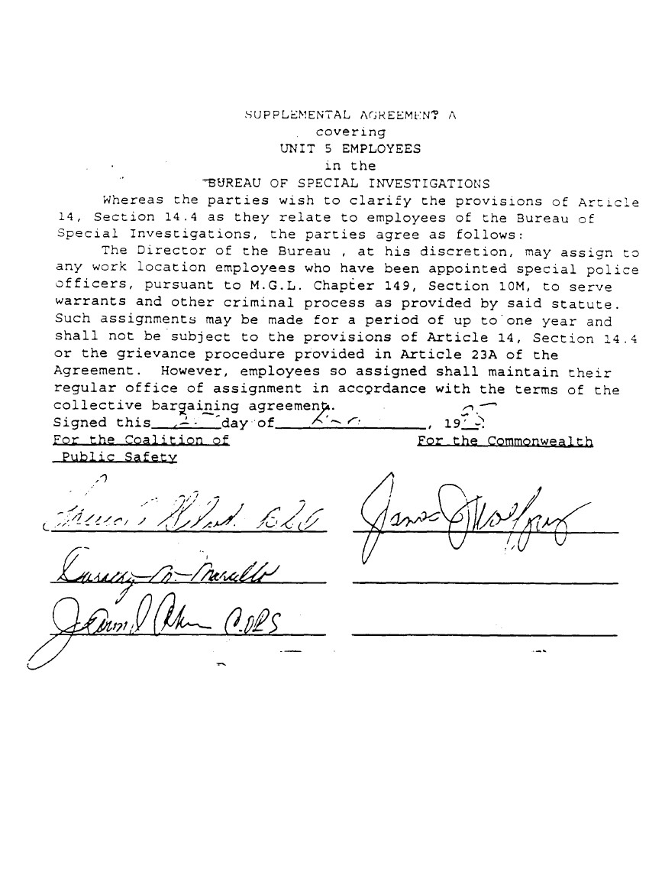

90

SUPPLEMENTAL AGREEMENT B
covering

UNIT 5 EMPLOYEES
in the
MASSACHUSETTS PAROLE BOARD

- Employees are required to maintain themselves ready and available during all off-duty hours in order to carry and respond to agency communication devices. The parties agree that compensation for this assignment has been included in their base salary rate.

- The following employees and/or employees assigned to the following units are required to maintain themselves and/or Parole Board issued vehicles ready and available during all off-duty hours in order to (including, but not limited to) respond to and serve warrants on parole violators; respond to agency communication devices; check office answering machines; make curfew checks as assigned; and/or conduct agency business in such regard while off-duty:

Warrant Unit

Intensive Parole Supervision
Mass. CAP
Assistant Parole Supervisors
Parole Supervisors

Effective the first full pay period in July of 2016, all such employees shall receive a supplement of thirty-one dollars ($31.00) per week in addition to their base salary, so long as they remain in the specific titles and/or assigned to the specific units listed herein. The Parole Board may assign any other employee to such status. Effective the first full pay period in July of 2017, said payment shall be thirty-seven dollars ($37.00) per week.

- Telephone calls made by employees covered by this Supplemental Agreement in response to the above-mentioned communication devices shall not qualify for Call Back Pay as provided in Section 7.3 of Article 7 of this Collective Bargaining Agreement.

- As part of their normal duties, employees may be assigned to administer Narcan, install electronic monitoring devices, replace said devices, maintain an inventory of said devices, clean said devices and respond to violations of said devices, in accordance with agency policy and procedure.

- Effective July 8, 2007, eliminate “$20 stand-by pay” and reduce “$55 stand-by pay” to $25/week. Eliminate separate ELMO weekly supplement for Parole Officer’s assigned to install electronic monitoring devices. Effective the first full pay period in July of 2016, said payment shall be thirty-one dollars ($31.00) and effective the first full pay period in July of 2017, said payment shall be thirty-seven ($37.00) per week. Employees may receive the supplement outlined in either paragraph 2 or 5, but not both.

For the Coalition of Public Safety: For the Commonwealth of Massachusetts:
91

SUPPLEMENTAL AGREEMENT C
DELETED

92

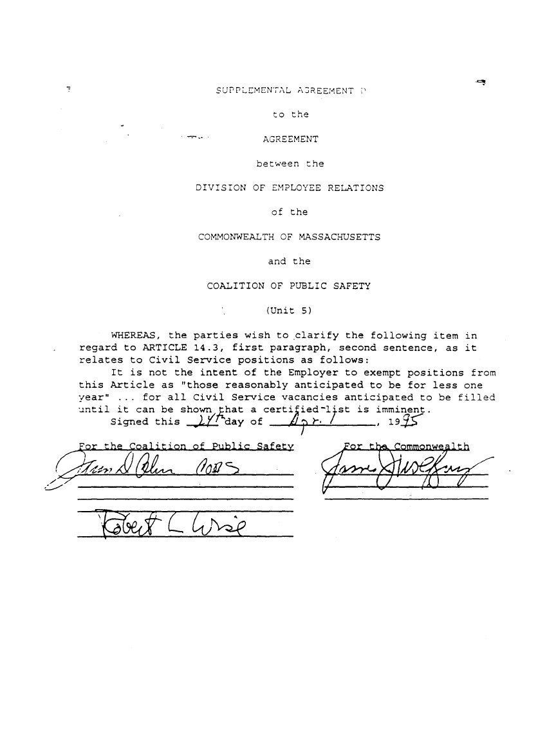

93

SUPPLEMENTAL AGREEMENT E

DELETED

94
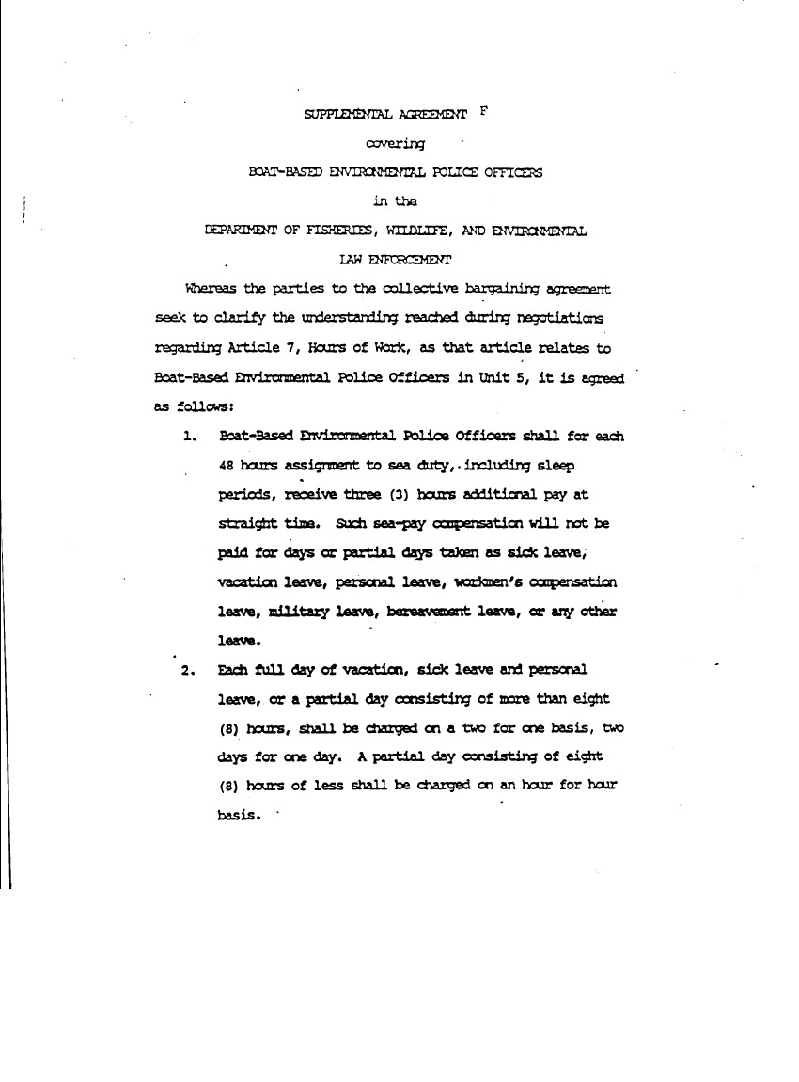

95

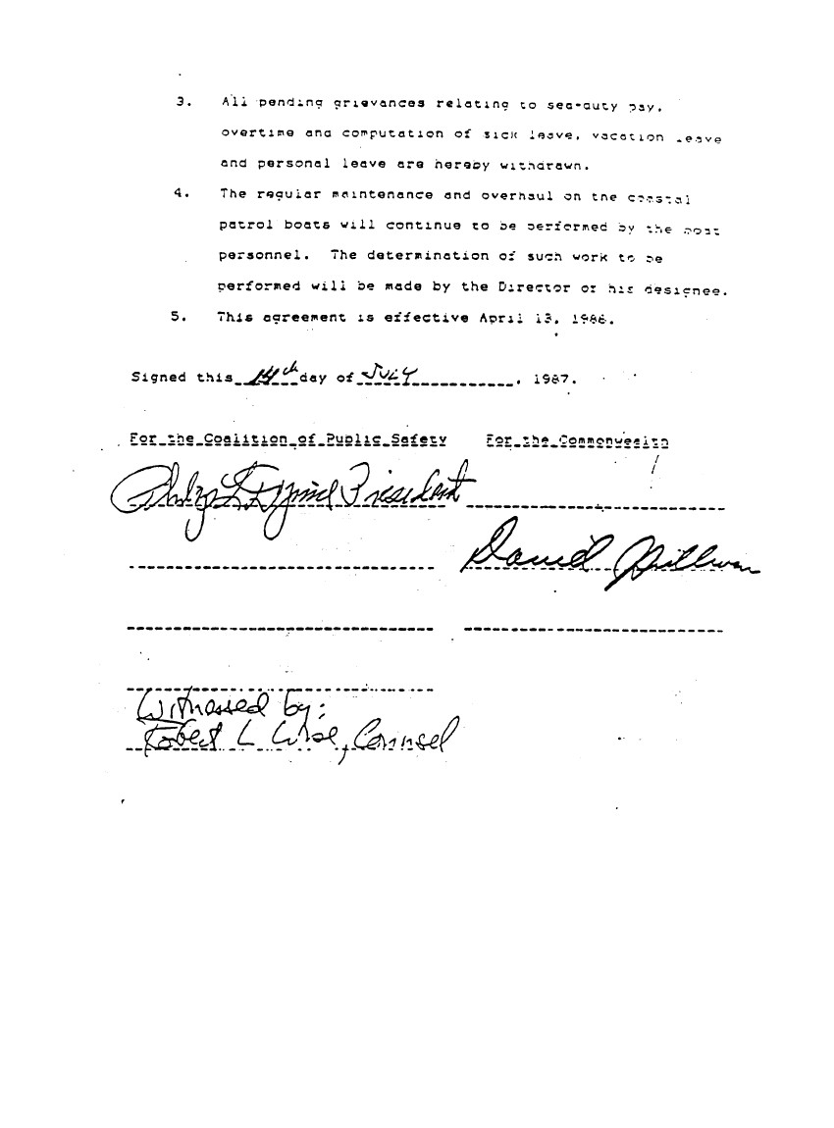

96

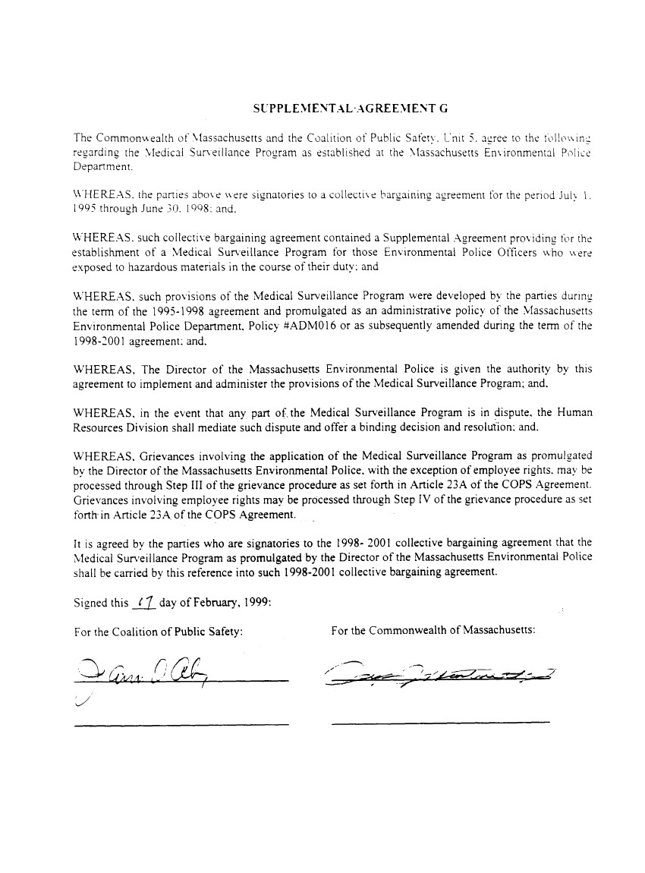

97

APPENDIX H

MEMORANDA OF UNDERSTANDING

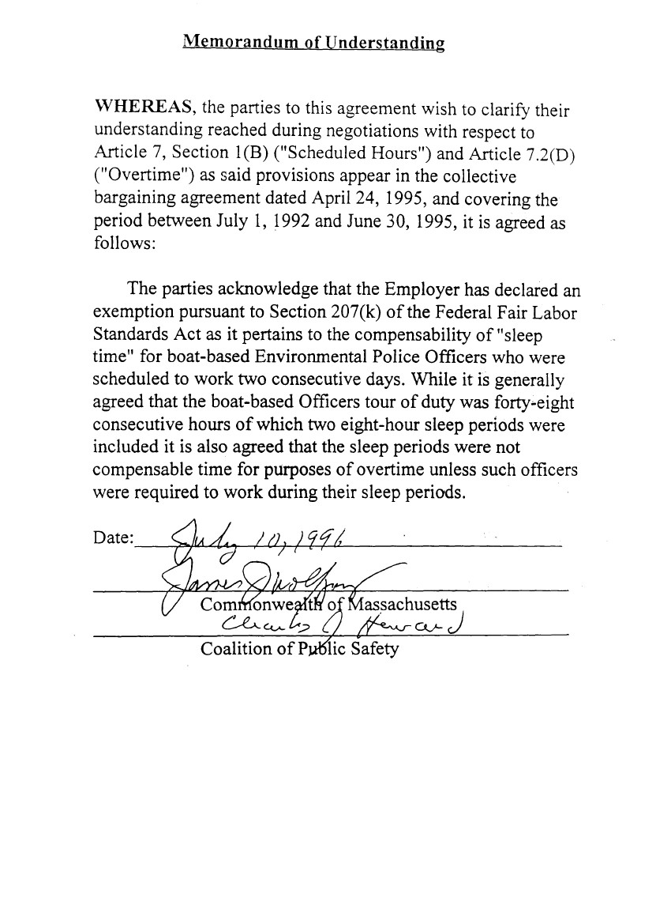

98

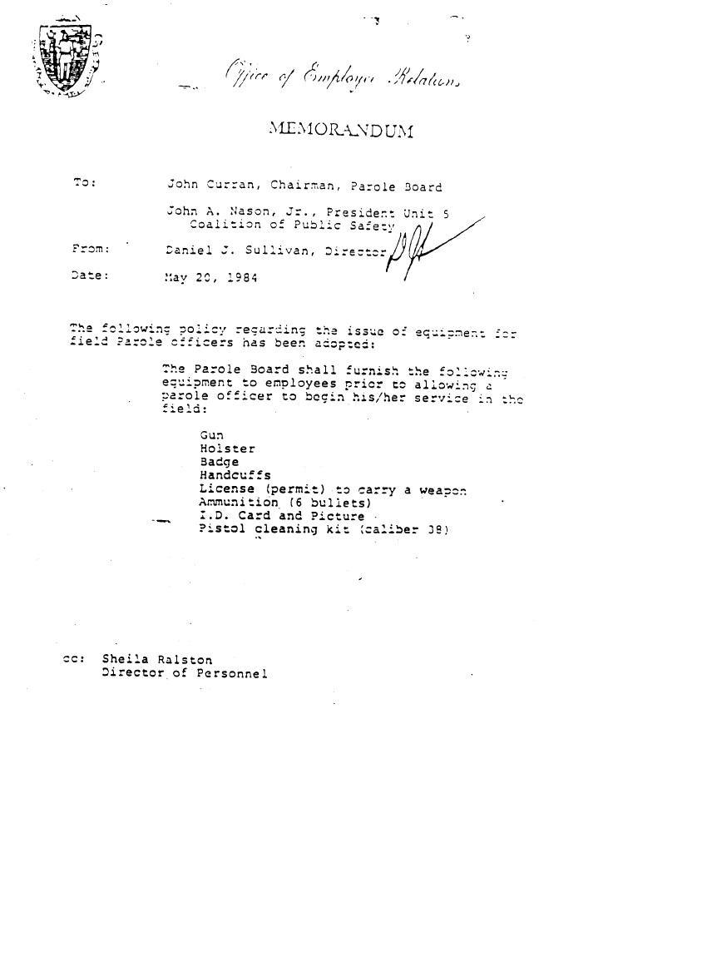

99

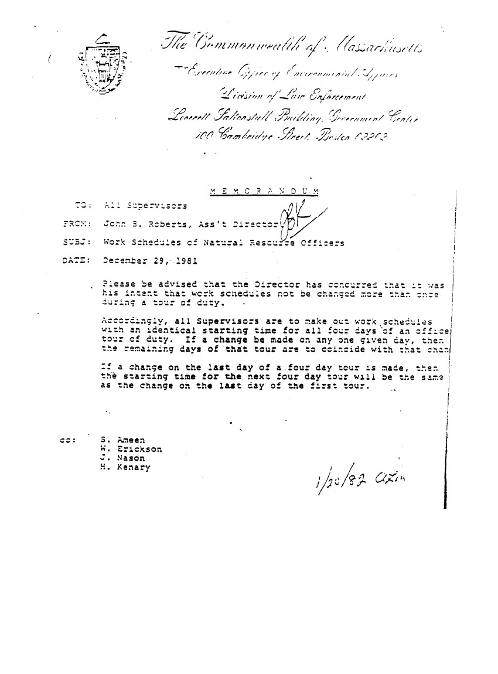

100
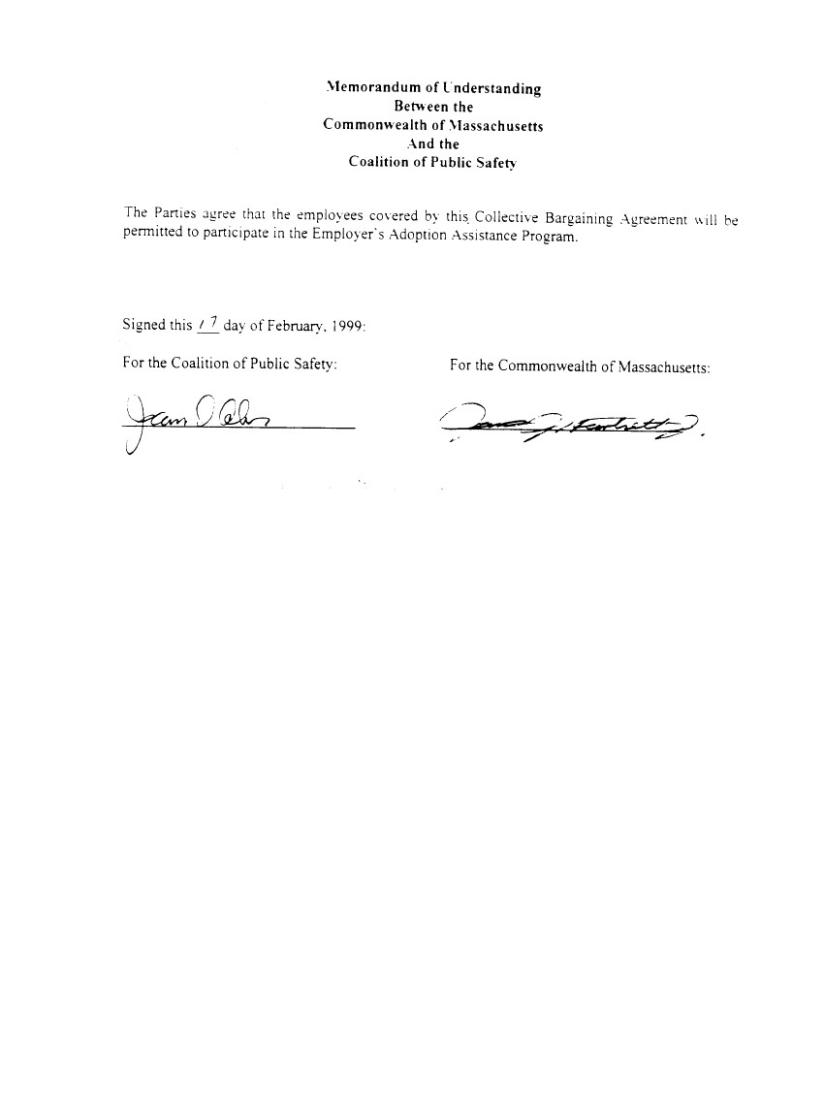

101
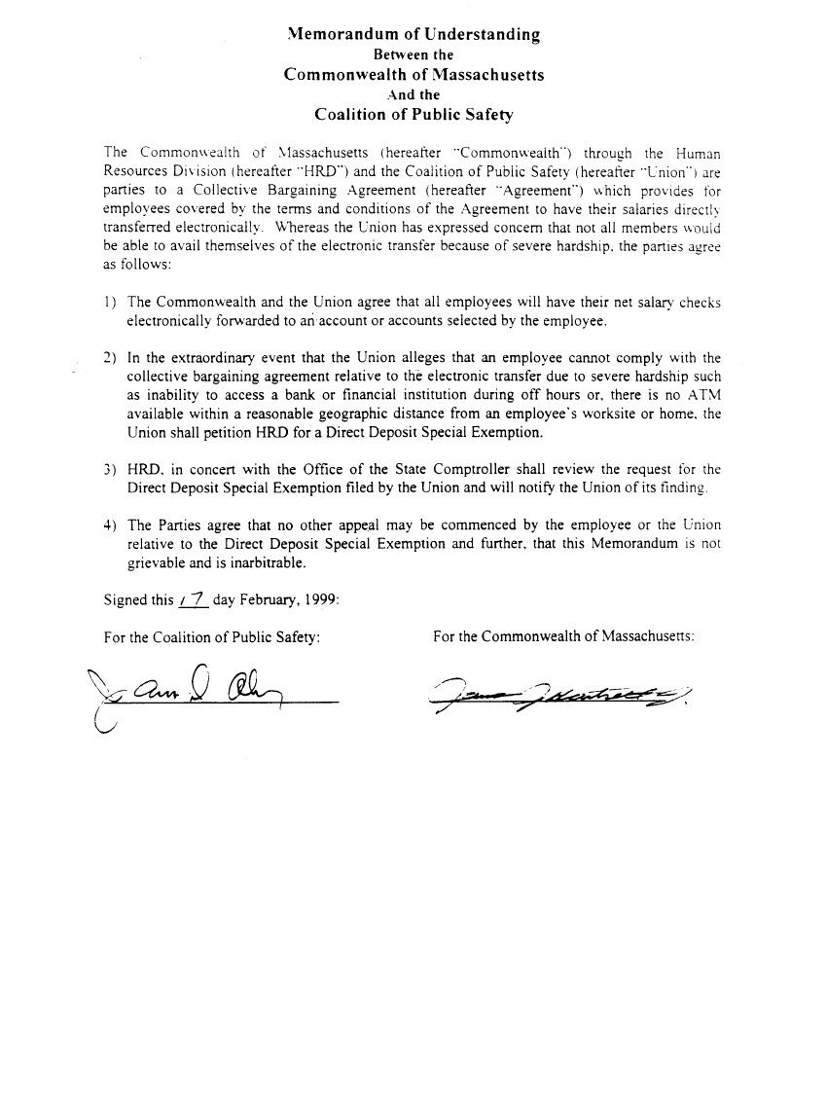

102
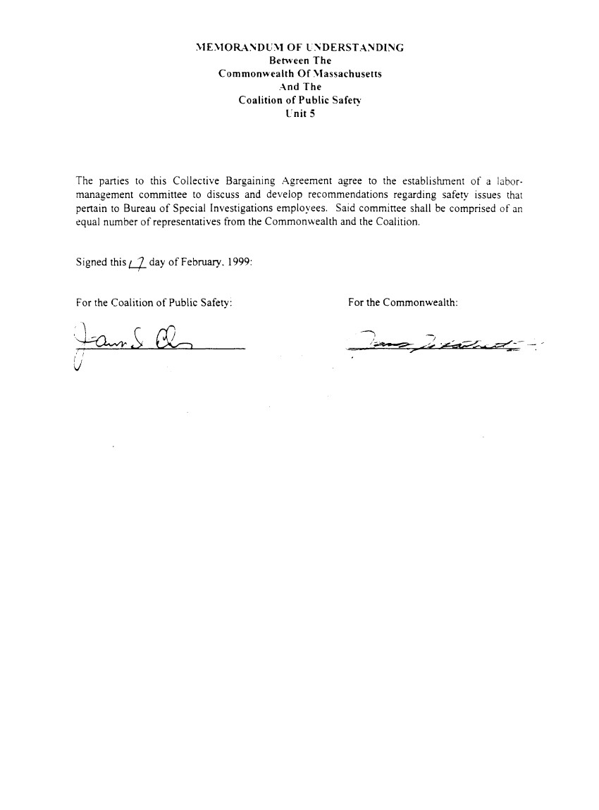

103
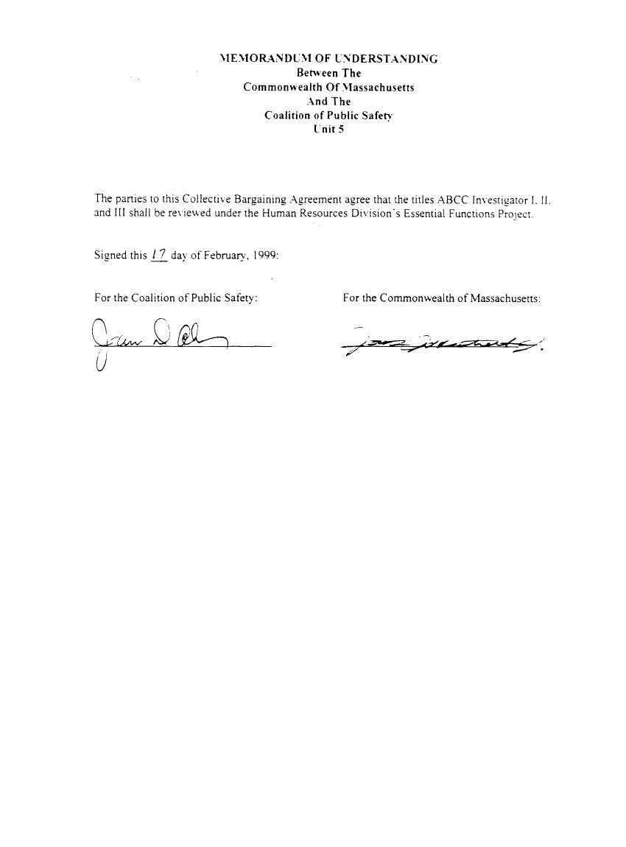

104

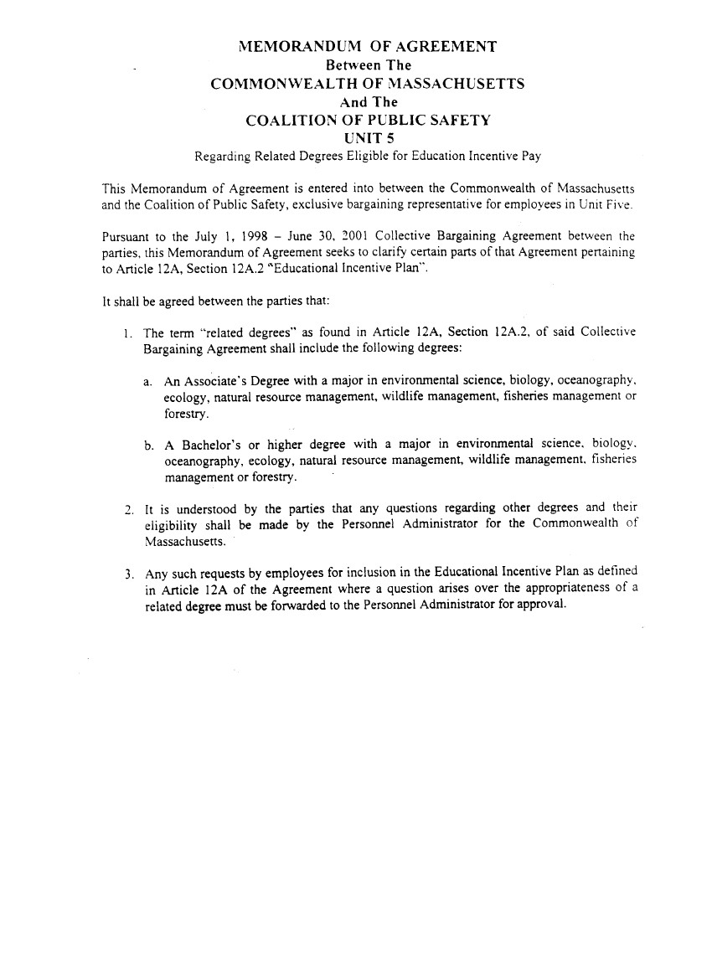



105
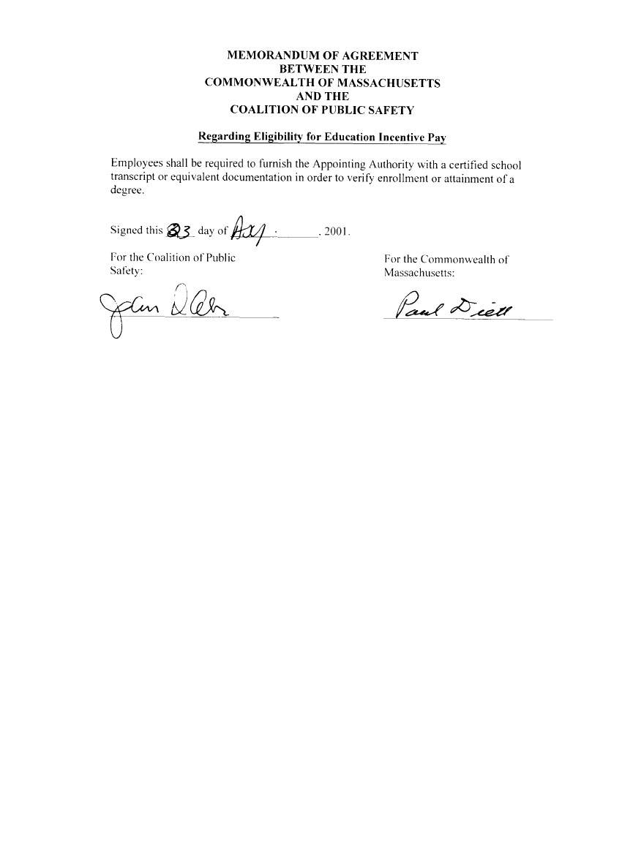

106
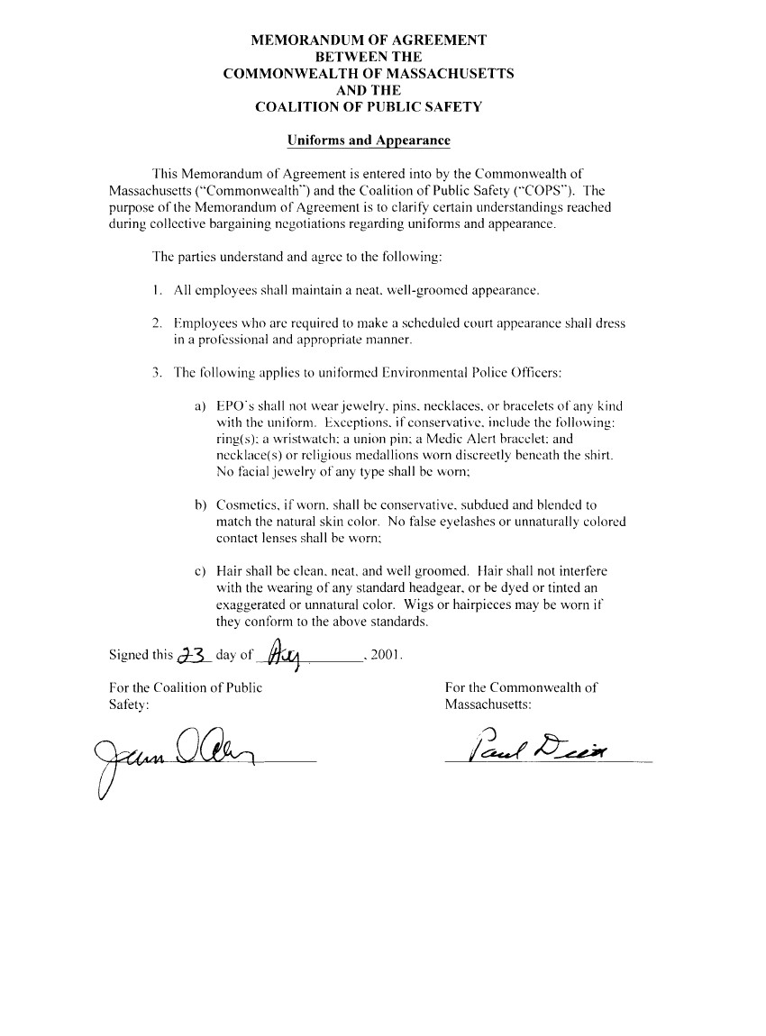

107
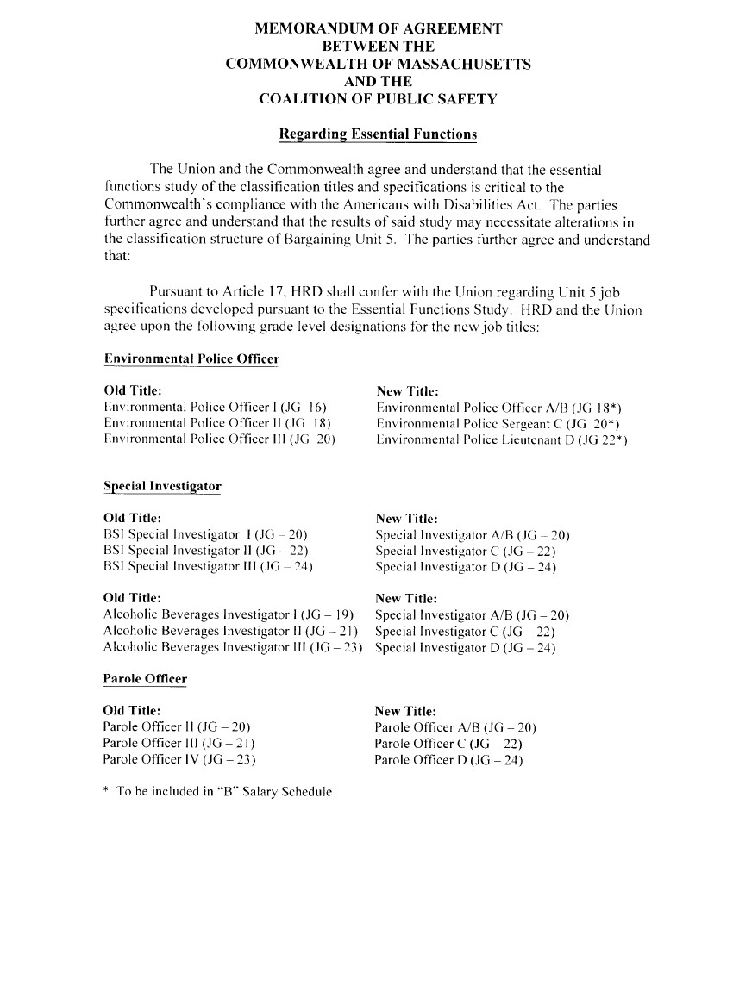

108
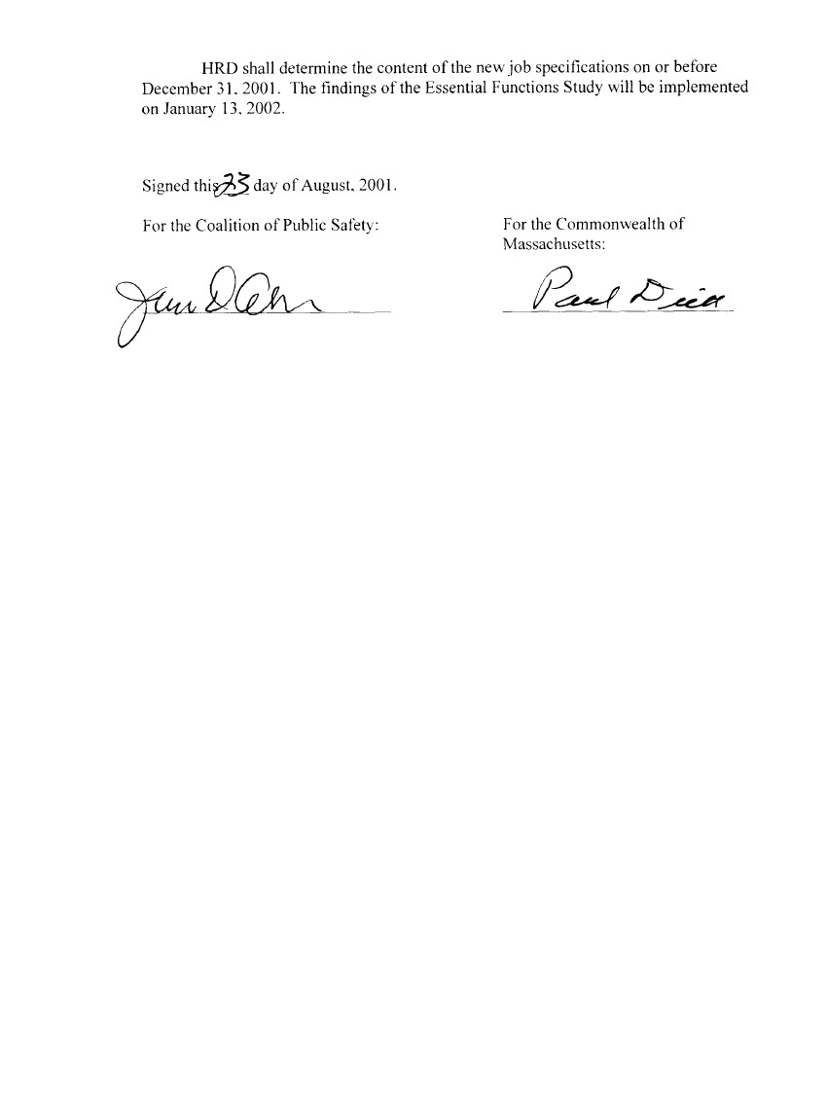

109

MEMORANDUM OF AGREEMENT
BETWEEN THE
COMMONWEALTH OF MASSACHUSETTS
AND THE
COALITION OF PUBLIC SAFETY

Boat-based EPO’s

As soon as administratively feasible, but not before January 1, 2008, all boat-based EPO’s will be assigned to a 4 and 2 work schedule.

The Boating Safety and Boating Theft Sections will be assigned to a 4 and 2 work schedule, but employees in these two sections as of the signing of this agreement shall retain their current schedules, including administrative days off, until they vacate said positions; employees in the Boating Safety Section may have their administrative work schedule changed to include weekend days of work in their five (5) days of work each week to accommodate accident investigations, public relation shows or volunteer training programs; but their work schedule shall not be changed to include more than eight (8) weekend days of work per year.

Employees whose schedules are changed will have a onetime ability to bid on a transfer to a vacant fillable position identified during negotiations. Affected employees will bid to these positions on the basis of seniority (i.e. the most senior EPO will select first and the least senior EPO will select last).

Signed this 22nd day of October, 2007

For the Coalition of Public For the Commonwealth of
Safety: Massachusetts:

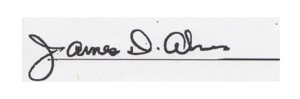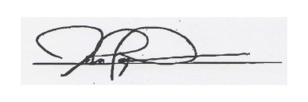

110

111

112
CODE OF CONDUCT
COMMONWEALTH OF MASSACHUSETTS
COALITION OF PUBLIC SAFETY

The italicized language only affects employees with the Massachusetts Department of Revenue whose fundamental mission is to foster, to the fullest extent possible, voluntary compliance with the Commonwealth’s revenue laws. Public confidence in the integrity and dependability of the Department and its employees is essential to achieving this goal.

- INTRODUCTION

This document constitutes a Handbook and Code of Conduct for all Bargaining Unit 5 employees of the Commonwealth of Massachusetts. This Code is designed to give all employees full and fair notice of their professional and ethical obligations.

We can maintain that confidence only to the extent that all of our official activities and all of our contact with the public reflect the highest ethical and moral standards. We must perform our duties with integrity and propriety. We must also do all in our power to ensure that none of your words or actions can be interpreted otherwise.

This Code is written for our own protection. It strives to impart three fundamental messages.

- Every employee must scrupulously avoid any actual conduct which constitutes a conflict of interest or conduct which gives the reasonable basis for the impression of a conflict of interest between his/her private interests, usually financial, and the public interest. The public interest must always take precedence;

- Every employee is prohibited from either taking some action, or failing to perform some duty, which would personally benefit himself/herself or give preferential treatment to any citizen;

- Every employee is prohibited from taking any action which would result in illegal receipt of public or private funds. Guidance – both on what we are expected to do and on what we are prohibited from doing – should help all of us understand generally what is expected of us. It should also help resolve particular situations we are faced with in our daily work.

Please read these rules carefully and abide by their spirit as well as their letter. Each of us can take pride in belonging to an organization which contributes much to the growth, strength and quality of life of the Commonwealth.

113

- DEFINITIONS:

As used in this Code, unless the context requires otherwise:

- “administrative inquiries” – means those occasions when an employee is required to respond to questions of importance to the agency/department when directed to do so by his/her appointing authority or that authority’s designee.

- “disciplinary action” – means any action taken by the appointing authority to discipline an employee, and where applicable in accordance with the provisions of the collective bargaining agreement or civil service law.

- “employees” – means any person in Bargaining Unit 5 on the current personnel roster of the agency/department. This shall include all bargaining unit workers; those who are on any form of leave of absence; workers who are serving suspension.

- “immediate family” – means the employee and his/her spouse and their parents, children, brothers and sisters.

- “nominal value” – means monetary worth not exceeding twenty-five dollars ($25.00).

- “official action” – means any activity performed or required to be performed by an employee in the course of his/her official duties.

- REGULATORY BASIS:

This Handbook and Code of Conduct is issued pursuant to the powers of the Commissioner of Administration, as set forth in Chapter 7, Section 4 of the General Laws, and in accordance with, but not limited to M.G.L. Chapter 268A; Opinions of the Attorney General, Ethics Commissions Rulings and applicable management rights provisions of any relevant collective bargaining agreements.

- GENERAL RULES:

- The Code Generally

- Applicability of Code

The Code applies to all Bargaining Unit 5 employees including those on any type of leave status (e.g., leave without pay, military leave, civic-duty leave, etc.) except that it shall not apply to employees in Unit 5 who are on unpaid union leave of absence to the extent allowed by law.

114

- Scope of Code

This Code is not to be considered all-inclusive. The absence of a specific published rule of conduct does not mean nor imply that any act of misconduct tending to discredit an employee is condoned or permissible or would not result in disciplinary action, up to and including termination.

- Knowledge of Code

Each employee is required to know the Code of Conduct and rules contained herein, to seek information from his/her appointing authority, the appointing authority’s designee or personnel office in case of doubt or misunderstanding as to their application.

Decisions in personnel matters involving disciplinary action will be based on the assumption that each employee has familiarized himself/herself with this Code and that he or she is aware of the obligation to abide by it.

- Effect of Code

Employees whose conduct does not conform to the rules and guidelines contained in the Code may be subject to disciplinary action, up to and including termination. Any disciplinary action taken will conform to civil service law and/or the provisions of the collective bargaining agreement.

- Distribution of Code

Each appointing authority or his/her designee will see that each employee receives a copy of this Code. Employees will acknowledge receipt of the Code by signing a Receipt of Code of Conduct Form (Form CC-3) in the space provided. In each instance, the signed Receipt Form will be returned to the employee’s appointing authority or his/her designee within ten days of receipt, and filed in the employee’s personnel folder. The employee’s signature on the Receipt Form is notice of his/her obligation to familiarize himself/herself with the contents of the Code of Conduct and to abide by it. (DOR has an audio tape of the Code and it shall be made available at no cost to any employee who reasonably requires it.)

Each appointing authority or his/her designee will be responsible for providing accurate information and guidance to his/her employees with regard to the specifics of the Code and may from time to time offer training sessions on the Code to his/her employees as the need arises.

115

- Effective Date of Code

The effective date of the Code shall be ten days after the Code of Conduct is distributed and the Code of Conduct Receipt Form is received by the employees.

- Conformance to Laws

Employees shall obey the laws of the United States and the Commonwealth of Massachusetts. Any employee who is convicted of a crime relating to his/her employment shall be subject to discipline.

Any employee who has been indicted or arrested for a serious crime supported by a judicial finding or probable cause in a preliminary hearing when the nature of the charge with its attendant publicity reasonably gives rise to legitimate fear for the safety of other employees, the property of the Commonwealth, or jeopardizes the public trust in the ethical standards of agency/departmental employees or undermines trust in the integrity of the Commonwealth’s system of tax administration or the administration of other laws of the Commonwealth, may also be subject to suspension without pay or other employee benefits, pending resolution of the case.

If the employee is found guilty, pleads nolo contendere, has his/her case continued without a finding, is granted immunity from prosecution or has his case filed, further disciplinary action, including termination, may be taken if the crime was related to his/her employment. If the employee is found not guilty, or the case is nolie prosequi or dismissed, the employee shall be immediately reinstated to employment retroactive to the date of suspension without loss of wages or other employee benefits.

C. Conformance to Policies, Procedures and Directives

Employees shall comply with all of the policies and operating procedures of the agency/department in which they work. This requirement includes, but is not limited to all agency/departmental policies and procedures. Employees shall respond forthrightly to the work-related directives of their supervisors.

D. Conduct, Attitude and Demeanor

Employees are expected to conduct themselves in their official relations with the public and with their fellow employees in a manner which will enhance public respect for, and confidence in, the employee and in the Commonwealth as a whole. They must not only perform their duties in a wholly impartial manner, but must avoid any conduct which gives the reasonable basis for the impression of acting otherwise.

116

Specifically, all employees shall avoid any action which may result in or create the reasonable basis for the impression of:

- using public office for private gain;
- giving preferential treatment to any citizen;
- making work-related decisions contrary to agency/departmental policy;
- using one’s official position to harass or intimidate any person or entity outside the course of official duties.

E. Administrative Inquiries

Employees must respond promptly and fully to administrative inquiries when directed to do so.

F. State Ethics Commission Financial Disclosure Requirements

Employees who are required to file a “Statement of Financial Disclosure” with the State Ethics Commission, under the provisions of M.G.L. Chapter 268B, shall do so in a timely manner as prescribed by the State Ethics Commission. The State Ethics Commission will notify each employee who is required to file such a statement.

All Department of Revenue employees who are required to file such a statement with the State Ethics Commission shall file a copy of the statement with the Commissioner of the Department of Revenue on or before the date such a statement shall be filed with the State Ethics Commission.

5. CONFLICT OF INTEREST

The necessity for the fair and impartial administration of state government of and the enforcement of its laws makes the avoidance of any conflict of interest of primary importance. A conflict of interest is a situation in which an employee’s private interest, usually financial, conflicts or raises a reasonable question of conflict with his/her official duties and responsibilities.

Chapter 268A of the General Laws provides criminal and civil penalties for conflict of interest violations. The following three general categories of prohibitions are to be used as guidelines for your information. (Chapter 268A of the General Laws offers specific details).

- No employee may request or receive, in any manner whatsoever, compensation or anything
else of value, except from the Commonwealth: (a) for performance of his/her duties; or (b) for influencing or appearing to influence such performance.

117

2. No employee may participate in any official action relating to any entity in which the employee or a member of his/her immediate family has a financial interest.

3. No employee may participate in any official action relating to any individual with whom or entity in which the employee has a substantial personal interest.

Employees have an obligation to avoid scrupulously the potential conflicts of interest which exist in their employment. They have a duty to disclose and report promptly the existence or possible existence of a conflict of interest to their agency head or his/her designee. They should request from their supervisor the transfer from their caseload of any case which involves their immediate family, close friend or any person with whom or entity in which they have some personal or financial involvement.

In addition, they have a right under law to have any questions relating to a possible conflict of interest confidentially reviewed and decided by the State Ethics Commission. Information regarding the filing of a conflict of interest request with the State Ethics Commission is available from the agency head or his/her designee or from the Ethics Commission directly.

In addition to the sanctions referred to above, M.G.L. Chapter 268A, Section 23 also prescribes and describes certain “Standards of Conduct”. Violations of these standards are subject to appropriate disciplinary action. All employees are required to abide by the spirit as well as the letter of these standards, which provide as follows:

“No current officer or employee of a state, county or municipal agency shall:

- accept other employment which will impair his independence of judgement in the exercise of his official duties;

- use or attempt to use his official position to secure unwarranted privileges or exemptions for himself or others;

- by his conduct give reasonable basis for the impression that any person can improperly influence or unduly enjoy his favor in the performance of his official duties, or that he is unduly affected by the kinship, rank, position or influence of any party or person.”

“No current or former officer or employee of a state, county or municipal agency shall:

- accept employment or engage in any business or professional activity which will require him to disclose confidential information which he has gained by reason of his official position or authority;

118

- improperly disclose materials or data within the exemptions to the definition of public records as defined by Section Seven of Chapter Four of the General Laws, and were acquired by him in the course of his official duties nor use such information to further his personal interests.” (See Massachusetts General Laws, Chapter 268A, Section 23).

These rules with respect to conflicts of interest are in addition to, and supplement, state policies and agency/departmental rules, regulations and operating procedures that may otherwise apply to the official actions of employees. (In the event that the appointing authority, or his/her designee, approves a particular activity and the Ethics Commission subsequently determines that such activity is a conflict of interest, the appointing authority will not discipline the employee for such activity. However, only the Ethics Commission, and formerly the Attorney General, have the authority to issue an opinion interpreting M.G.L. Chapter 268A, which is binding).

6. GIFTS AND GRATUTIES FROM OUTSIDE SOURCES

- General Limitations

Employees shall not solicit or accept, directly or indirectly, any gift, gratuity, favor, entertainment, loan, or any other thing of monetary value, from a person who or entity which, the employee knows or has reason to know:

- Has, or is seeking to obtain, contractual or other business or financial relations with his/her agency/department;

- Conducts business or other activities which are regulated or monitored by the agency/department, except as permitted by this Section or by agency/departmental directives; or

- Has interests that may be or give the reasonable impression of being substantially affected by the performance or nonperformance of the employee’s official duties.

B. Exceptions

The restrictions set forth in paragraph A of this Section do not apply to:

- Obvious family or personal relationships when the circumstances make it clear that those relationships, rather than the business or the persons concerned, are the motivating factors behind any gift or gratuity.

119

- The acceptance of food or refreshments of nominal value on infrequent occasions in the ordinary course of a breakfast, luncheon, dinner or other meeting attended for educational, informational or other similar purpose. However, agency/departmental employees are specifically prohibited from accepting free food or other gratuity except non-alcoholic beverages (coffee, tea, etc.), while on official business, from persons with whom they have contact in the performance of their official duties.

- The acceptance of loans from banks or other financial institutions on customary terms to finance proper and usual activities of employees, such as home mortgage loans, automobile loans, personal loans, etc., provided that the employee does not deal with that institution in the course of his/her official duties. However, if dealing with such banks or financial institutions is unavoidable, the employee must disclose such dealings to the appointing authority in writing prior to engaging in such dealings.

- The acceptance of unsolicited advertising or promotional materials such as pens, pencils, note pads, calendars, and other items of nominal value.

- The acceptance of an award or gift of nominal value for a speech, participation in a conference, or some public contribution or achievement given by a charitable, religious, professional, social, fraternal, educational, recreational, public service or civic organization, if such organization falls within Paragraph A above.

- Acceptance of reimbursement, in cash or in kind, for travel subsistence and other expenses incident to attendance at meetings, provided such attendance and reimbursement is approved by the appointing authority or his designee. Such reimbursement can be made directly to the employee. An employee on official business may not be reimbursed, and payment may not be made on his or her behalf, for excessive (e.g., reimbursement which exceeds actual cost) personal living expenses, gifts, entertainment, travel or other benefits. At no time shall an employee accept reimbursement from both the Commonwealth and another source for the same expenses.

7. OUTSIDE EMPLOYMENT AND BUSINESS ACTIVITY

A. Introduction: Principles

The Commonwealth seeks to give employees the maximum freedom possible to engage in outside employment or business activities consistent with the Commonwealth’s responsibilities. However, the extremely sensitive mission of the Commonwealth and its employees necessitates certain restrictions. Employees may engage in outside employment or business activity provided such activity is not prohibited by the Code or by any statute, regulation or departmental order.
120

An activity that is permissible for the occupant of one position may very well not be permissible for the occupant of another position. Therefore, in considering each case on its individual merits, the employee must satisfy the following principles:

- The outside activity would not place the employee in a situation where there is a conflict, or in a situation which gives the reasonable basis for the impression of a conflict, between his or her private interests and his or her official duties and responsibilities (see Section 5, above, “Conflict of Interest”, for additional guidance).

- The outside activity would not result in use, dissemination or disclosure to others of confidential information obtained in connection with the employee’s departmental duties or position.

- The nature of the employment or business activity or the hours to be devoted to such activity would not impair the employee’s availability, capacity or efficiency for the performance of his/her official duties as an employee of the Commonwealth.

- Employee shall not engage directly or indirectly in financial transactions as a result of, or primarily relying on information obtained through their employment. In particular, they shall not use confidential information obtained in the course of their employment with the Commonwealth to obtain benefits, financial or otherwise for themselves, their families or others.

- Activities Which Do Not Require Prior Notice

- Introduction

Employees are generally not required to submit written notice before engaging in outside activities which are not considered to be employment or business. Although it is not feasible to cover every specific activity of this nature, the general categories discussed below are furnished as basic guidelines.

- General Examples

- Membership and uncompensated services (including holding of office) in civic, scout, religious, educational, fraternal, social, community, veterans, or charitable organizations. Bookkeeping services provided to such organizations require prior written approval. (See Section 7(c)(1)(b)(3).)

- Services as a notary public or justice of the peace (except notarization of tax returns).

121
- Rental of employee-owned property, real or personal, to the extent such property is not rented to the Commonwealth of Massachusetts or any agency or subdivision thereof, or the lessee is not a subject of the employee’s official duties.

- Minor services and odd jobs for friends, relatives, or neighbors. These include a wide variety of activities, including: repair or maintenance work such as painting, yard work, carpentry, or services such as babysitting and carpools involving payment for transportation.

- Temporary (thirty days or less) assistance in a family enterprise, in the event of an emergency, such as the death or serious illness/accident to a member of the family engaged in that business.

- However, no employee shall without appropriate disclaimer stating that the employee does not speak for the agency/department, take an active part or become an advocate on behalf of a professional society in any conflict between such society and the agency/department.

C. Specific Prohibitions and Restrictions on Employment

- Outside Legal or Accounting Practice or Employment

- General Prohibitions

No outside legal or accounting practice is permitted which is in violation of M.G.L. Chapter 268A. Specifically, employees are prohibited from receiving compensation from or acting as agent or attorney for anyone other than the Commonwealth in relation to any particular matter in which the Commonwealth or a state agency is a party or has a direct and substantial interest. To the extent that outside legal or accounting practice is permitted, it must not interfere with the effective performance of an employee’s official duties.

The employee must give notice of outside legal or accounting practice to the Appointing Authority or his/her designee on Form CC-4, “Notice of Outside Legal or Accounting Practice” or Employment. Notice to the Appointing Authority or his/her designee does not mean or imply that such outside employment or practice is not in conflict with M.G.L. Ch. 268A.

122

- Exceptions

- An employee may render uncompensated legal or accounting service to an employee’s immediate family provided the service does not create a conflict of interest with the Department of Revenue or include representation of family members before the Department of Revenue, a state administrative agency or in the courts of the Commonwealth where the Commonwealth is a party.

- An employee may, with prior written approval from the Commissioner or his/her designee, and during off duty hours with or without compensation: acting as a power of attorney, act as trustee, guardian, conservator, executor, administrator and/or act as a resident agent for an employee’s immediate family as authorized by M.G.L. Ch. 268A, sec. 4. Such approval shall not be unreasonably denied.

- An employee may, with prior written approval from the Commissioner or his/her designee, act as a bookkeeper, accountant, or perform legal work for a civic, scout, religious, educational, fraternal, social, community, veterans, and/or charitable organization without compensation. In connection with any of the activities listed in Section 7(C)(1)(b)(1), (2) and (3), employees may not prepare or sign tax returns, advise or act in matters involving claims against the Commonwealth of Massachusetts or any agency thereof, or participate in matters which the Commonwealth of Massachusetts or agency thereof, is a party thereto or had direct and substantial interest, or which are subject of their official duties

- Outside preparation of Tax Returns and Other Forms

Preparation of tax returns and other forms required by the Department of
Revenue or the Internal Revenue Service, whether compensated or uncompensated, for a person other than a member of the employee’s immediate family, is not permitted.

- Outside Employment As An Assessor

Outside employment as an assessor consultant performing assessing or appraisal duties for a city or town or other political subdivision of the Commonwealth is prohibited. This restriction applies whether or not the employee is compensated for performing these services.

123

D. Activities Which Do Require Prior Written Notice

There are a number of areas in which employees, subject to the conditions and prohibition stated in part 7A, B, and C above, may engage in certain categories of outside employment/outside business provided they submit prior written notice on Form CC-2 to the Commissioner of his/her designee.

The categories of outside employment/outside business which require an employee to provide prior written notice are those which require the filing of state or federal tax returns and/or the collection of state or federal taxes.

Employees who are engaged in such outside employment/outside business at the time of implementation of this Code of Conduct shall submit such notice on Form CC-2 to the Commissioner or his/her designee within twenty (20) days of their receipt of this Code.

The Commissioner may disapprove of such outside employment/outside business if he/she determines that it violates M.G.L. Ch. 268A or this Code.

8. DUTY TO REPORT VIOLATIONS OF LAW AND CODE OF CONDUCT

Generally

Every employee is expected to maintain and uphold the integrity of the Department. In satisfying this requirement, it shall be the duty of every employee to report promptly and accurately violations of law that affect the administration of the Department or the tax laws that affect the administration of the Department or the tax laws of the Commonwealth to his or her agency/department head or designee. To the fullest extent possible, any such reports will be treated confidentially.

Tax Law Violation

Employees must report to their chief or the Commissioner’s designee (under circumstances involving an employee, directly to Internal Affairs) any knowledge they have of the violation of any tax law of the Commonwealth by any person.

124

Attempts to Bribe

Bribery and attempted bribery are claims which strike at the core of state government. Employees should be constantly alert to solicitations to accept money, consideration, or anything of value in return for acts or omissions involving their official functions. Such solicitations may be indirect and subtle. Any attempt to bribe a departmental employee shall be reported immediately to the proper agency authority. In the Department of Revenue, employees shall immediately report any attempts of bribery to the Office of Internal Affairs. After reporting, the employee shall thereafter cooperate with Internal Affairs in any ensuing investigation and avoid any unnecessary discussion of the case with others.

Threats, Harassment, Etc.

The physical, psychological and emotional well-being of all employees is of paramount concern to the Department. Any threats, physical or verbal harassment, including sexual harassment, or other actions designated to, or having the effect of interfering with tax administration shall be reported immediately by all employees who have information of such activities to the proper agency authority. In the Department of Revenue, employees shall report to their bureau chief or the Commissioner’s designee and to the Office of Internal Affairs. Those who receive such reports will maintain confidentiality of the source in a manner appropriate to the circumstances of the case.

Employee Obligations

Violations of any law relating to tax administration or the Code by any employee tends to bring discredit upon the entire Department of Revenue. The Department holds its employees responsible for cooperating in the identification of such violations. In meeting this requirement, it shall be the duty of every employee to bring to the attention of the Office of Internal Affairs knowledge of violations of any law relating to tax administration or any violations of any provisions of this Code which has or which, if unreported, would likely result in the commission of a crime. The identity of any employee bringing such knowledge to the attention of the Office of Internal Affairs will be kept strictly confidential, and such employees will not be required to participate further in any investigation or disciplinary proceeding against an employee arising from such investigation.

The Commissioner of Revenue shall recommend to the Commissioner of Administration and Finance that he/she file a bill, or take other appropriate action, to indemnify fully, including reasonably attorneys’ fees and costs, in accordance with the dollar limit set by M.G.L. Ch. 258 sec. 9, any Department of Revenue employee for any civil damages awarded by a court as a result of a report made pursuant to this section of the Code, and provided the Commissioner of Revenue determines the employee acted in good faith and within the scope of his/her official duties or employment.

125

9. OTHER STANDARDS OF CONDUCT

A. Timely Filing and Certification of Federal and State Tax Returns and Timely Payment of Taxes Due

The Mission of the Department of Revenue is to encourage and achieve the highest possible degree of voluntary compliance with our tax laws and regulations. In light of this mission, it is imperative that all employees comply fully with all applicable requirements of federal and state taxing authorities.

Therefore, all employees shall file all federal and state tax returns timely and pay any tax due in a timely manner or enter into a payment agreement, file in good faith an application for abatement or have an appeal pending before a tribunal of competent jurisdiction. A “tax due” as used in the preceding sentence, includes:

- A balance due on a federal or state return;
- A federal or state assessment where that agency’s statutes or regulations require immediate payment notwithstanding the fact that the tax assessment is being contested.

All employees will be required to file a “Certificate of Filing” with their bureau chief or the Commissioner’s designee certifying that they have timely filed their Massachusetts individual income tax return. This certificate will be due on or before May 1 of each year, certifying the filing of the prior year’s return or the existence of a valid extension of time to file.

B. False Statement

Proper functioning of the government requirements that the agency/department, the courts, other state agencies and the public be able to rely fully on the truthfulness of government employees in matter of official interest. An employee will be subject to disciplinary action up to and including termination for intentionally making false or misleading verbal or written statements in matters of official interest.

C. Recommending Professional Assistance

Employees may not recommend or suggest, specifically or by implication, to anyone that he/she obtain the services of any particular accountant, attorney or firm of accountants or attorneys, or any other person or professional or business organization in connection with any official business which involves or may involve the agency/department.

126

D. Tax Information to be Treated as Confidential

Employees may not publish, divulge or make known in any manner, except as provided or required by law, any information contained in any tax return or in any schedule, list or other statement designed to supplement or to become a part of a tax return. Employees also may not publish, divulge, disclose or make known in any manner or to any extent not authorized by law any information resulting from an examination or investigation or contained in any report, record or electronic data source, when the information concerns or relates to: trade secrets, processing, operations, style of work or apparatus, or relates to the identity, confidential statistical data, amount or source of any income, profits, losses, or expenditures of any person, firm, party, corporation, or association. When a question arises as to whether an item of information may be disclosed, the employee shall discuss the facts with his/her bureau chief or the Commissioner’s designee and, where appropriate, request an opinion from the Legal Bureau.

E. Public Records

All requests for public records should be directed to the appointing authority or his/her designee who shall determine whether the requested documents are public records in accordance with M.G.L., Chapter 4, Section 7, Cl. 26.

Drugs and Alcohol

While on duty no employee shall consume or use alcohol, intoxicants, narcotics, or controlled substances in any form. Similarly, no employee shall report for work under the influence of intoxicants, narcotics or controlled substances in any form. The only exception to this rule is the use of medication when prescribed for the treatment of the employee by a registered physician or dentist.

Departmental Identification Cards, Badges, Etc.

Agency/departmental identification cards, badges and other identification or access cards or documents are for use only in establishing identity, authority or access in connection with official duties.

Agency/departmental identification cards or badges may be used for personal identification purpose when cashing checks or as proof of employment, such as when applying for a loan, for credit or when renting an apartment.

Employees are responsible for the safeguarding and proper use of agency/departmental identification cards, badges and access cards, for promptly reporting their loss and for surrendering them on termination of employment or demand by proper agency/departmental authorities.

127

Cards, badges or documents, or an employee’s official position or status, are not to be used to exert influence or obtain, either directly or indirectly, personal privileges, favors or rewards for themselves or others. Photo identification badges must be worn while at work in any agency which requires them to be worn. The Department of Revenue photo identification badges must be worn by Department of Revenue employees while at any Department of Revenue facility.

H. Political Activity

Employees are prohibited from using their offices or official duties to interfere with, affect or influence the results of a nomination or election for public office. No such elected or appointed official may vote or act on any matter which is within the purview of the agency by which he/she is employed or over which such employee has official responsibility.” No employee shall use his/her official authority, directly or indirectly, to coerce, attempt to coerce, command, advise or prevent any person or body to pay, lend or contribute anything of value to any party, candidate or political committee.

No employee shall solicit or accept funds or anything of value for any party, political committee, agency, person or organization for political purposes.

Employees are not prohibited from contributing to the campaign committee or organization for nomination or election of any individual running for public office or to any committee, agency, or organization for political purposes.

Employees are prohibited from campaigning for political office for themselves or others during normal working hours. Employees are prohibited from being a candidate for federal, state or full-time municipal office while on active duty. Such employees must obtain a leave of absence to run for such offices.

Employees are prohibited from wearing a political campaign button while on official agency or departmental business.

Employees shall abide by the provisions of the following paragraph from M.G.L. Ch. 268A, Section 11 which provides:

“This section shall not prohibit a state employee from holding an elective or appointed office in a city, town or district nor in any way prohibit such an employee from performing the duties of or receiving the compensation provided for such office. No such elected or appointed official may vote or act on any matter which is within the purview of the agency by which he/she is employed or over which such employee has official responsibility.”

128
I. Firearms and Deadly Weapons

An employee shall not carry firearms or other dangerous weapons on his/her person during the performance of official duties or on work premises except as specifically authorized by the agency/department head or his/her designee. An employee authorized to carry a firearm is forbidden to display it unnecessarily in public.

J. Testimonial Dinners

Employees are prohibited from selling or accepting payment for tickets, admissions or contributions, for a testimonial dinner or function or any affair having a purpose similar to a testimonial dinner or function held on behalf of any employee of his/her agency/department. No employee shall participate in or accept contributions for or from any testimonial dinner or function or any affair having a similar purpose, held on his or her behalf while he or she is an employee if such dinner, function or affair is sponsored by a person or organization which is regulated by or has official business with the employee’s department or agency.

This section shall not prohibit the collective of sums of nominal value to cover the cost of small celebrations or other small events (such as birthday or holiday parties) held within agency/departmental offices.

- News Media and Publicity

All contacts concerning official departmental business with the media must be approved in advance by the Commissioner or the Director of Communications or follow specific guidelines established by them. All requests for information or documents from the news media should be referred to, and all correspondence to the news media must be mailed from, the Communications Office or follow specific guidelines for the handling of such material established by that Office.

To ensure the Department of Revenue speaks with one informed voice on the many sensitive matters that come before it, no news media release concerning Department of Revenue official business is to be issued by any employee unless first approved by the Director of Communication. These provisions shall not enlarge, abridge or interfere with a labor organization’s ability to speak out on issues covered by M. G. L. Chapter 150E, or an employee’s speech rights under the Federal Constitution.

L. Legal and Other Professional or Scholarly Publication

All employees are encouraged to publish articles in professional and scholarly journals. However, to protect the integrity of departmental letter rulings and other official documents of the Department of Revenue and to ensure application of clear and consistent legal policy within the Department, all legal, accounting, tax or tax-administration related publications authored by employees must bear the following caveat:
129
“This article represents the opinions and (legal) conclusions of its author(s) and not necessarily those of the Department of Revenue.”
Also, copies of all such articles published should be made available to the departmental library in the Legal Bureau.

M. Legislative Requests and Inquiries
All requests or inquiries from public officials or their staffs must be referred to the agency/department head or his or her designee before any action is taken, unless employees are directed to handle such requests otherwise by the agency/department head or his/her designee.

All requests or inquiries from legislators or other public officials or their staff must be referred to the Department of Revenue Problem Resolution Office before any action is taken by the employees, unless employees are directed to handle such requests otherwise by the Commissioner or his/her designee. This provision shall not enlarge, abridge or interfere with a labor organization’s ability to speak out on issues covered by M. G. L. Chapter 150E, or an employee’s speech rights under the Federal Constitution.

No employee shall use his/her official authority directly or indirectly to coerce, attempt to coerce, command, advise or prevent any person or body to pay, lend or contribute anything of value to any party candidate or political committee.

No employee shall solicit or accept funds or anything of value for any party, political committee, agency, person or organization for political purposes.

Employees are not prohibited from contributing to the campaign committee or organization for nominating or election of any individual running for public office or to any committee, agency, or organization for political purposes.

Employees are prohibited from campaigning for political office for themselves or others during normal working hours. Employees are prohibited from being a candidate for federal, state or full-time municipal office while on active duty. Such employees must obtain a leave of absence to run for such offices.

Employees are prohibited from wearing a political or campaign button while on official agency/departmental business.

Employees shall abide by the provisions of the following paragraph form M.G.L. Chapter 268A, Section 11 which provides:

“This section shall not prohibit a state or county employee from holding an elective or appointing office in a city, town or district nor in any way prohibit such an employee from performing the duties of or receiving the compensation provided for such office.”
130

MASSACHUSETTS DEPARTMENT OF REVENUE

Employee Certificate of Filing
FORM # CC-1

1.) I, Filed my MASSACHUSETTS INDIVIDUAL INCOME TAX

RETURN for the year on / / (date).

2.) I filed an EXTENSION OF TIME FOR FILING for the year on / / .

3.) I have not filed my MASSACHUSETTS INDIVIDUAL INCOME TAX RETURN for the year

for the following reasons:

4.) My INCOME TAX RETURN(S) is/are listed under the following:

NAME(S):

SOCIAL SECURITY NUMBER(S):

Signed under the pains and penalties of perjury;

______________________________________ ____________________
Name Date

131

MASSACHUSETTS DEPARTMENT OF REVENUE

Notice of Outside Employment or Outside Business
Form CC-2

1.) 2.)
Name of Employee Position

3.) 4.)
Date of Appointment Bureau

Please list and provide the following information on all corporations, companies, firms or other business enterprises, partnerships, trust or non-profit organizations other than the Department of Revenue for which you have a requirement to file state or federal tax returns, for which you must collect a state or federal tax.

Business of Employer # 1 Business of Employer # 2

Name:

Address:

Nature of Employment:

Position/Duties:

Hours of Employment: (specify)

Compensation Type:

Compensation Amount:

The employment listed above does not directly or indirectly involve association with taxpayers with whom I am in contact while performing official duties as an employee of the Commonwealth.

I hereby certify that the statements I have made are true, complete and correct to the best of my knowledge and belief.

_______________________________ ___________________
Signature Date

NOTE: If there are more than two employers, please attach an additional statement.

132

CODE OF CONDUCT
FOR
UNIT FIVE EMPLOYEES

Form CC-3

________________________________________________________________________

* * * RECEIPT * * *

I hereby acknowledge that I have received a copy of the Employee Code of Conduct for Unit 5 Employees. I also acknowledge that it is my responsibility as an employee of the Commonwealth to read this CODE OF CONDUCT and to comply with its terms and conditions.

_____________________________________ _______________________
Signature Date

_____________________________________

Printed Name

133

MASSACHUSETTS DEPARTMENT OF REVENUE

Unit One, Unit Five, Unit Six And All Non-Union Employees
Notice of Outside Legal or Accounting Practice or Employment
FORM # CC-4

1.) 2.)
Name of Employee Position

3.) 4.)
Date of Appointment Bureau

Nature of Employment (state duties in detail):

Hours of Employment (please specify):

The employment listed above does not directly or indirectly involve association with taxpayers with whom I am in contact while performing official duties as an employee of the Commonwealth, nor does it involve interests of any state agency.

I hereby certify that these statements I have made are true, complete, and correct to the best of my knowledge and belief.

__________________________ _________________
Signature Date

134
EMPLOYEE FMLA LEAVE

CERTIFICATION OF HEALTH CARE PROVIDER FOR EMPLOYEE’S SERIOUS HEALTH CONDITION (FMLA)

SECTION I: For Completion by the EMPLOYER
INSTRUCTIONS to the EMPLOYER: The Family and Medical Leave Act (FMLA) provides that an employer may require an employee seeking FMLA protections because of a need for leave due to a serious health condition to submit a medical certification issued by the employee’s health care provider. Please complete Section I before giving this form to your employee. Your response is voluntary. While you are not required to use this form, you may not ask the employee to provide more information than allowed under the FMLA regulations, 29 C.F.R. §§ 825.306-825.308. Employers must generally maintain records and documents relating to medical certifications, recertifications, or medical histories of employees created for FMLA purposes as confidential medical records in separate files/records from the usual personnel files and in accordance with 29 C.F.R. § 1630.14(c)(1), if the Americans with Disabilities Act applies.

Employer name and contact: ____________________________________________________________
Employee’s job title: ________________ Regular work schedule: ____________________________
Employee’s essential job functions: ____________________________________________________________________________________
Check if job description is attached: ______

SECTION II: For Completion by the EMPLOYEE
INSTRUCTIONS to the EMPLOYEE: Please complete Section II before giving this form to your medical provider. The FMLA permits an employer to require that you submit a timely, complete, and sufficient medical certification to support a request for FMLA leave due to your own serious health condition. If requested by your employer, your response is required to obtain or retain the benefit of FMLA protections. 29 U.S.C. §§ 2613, 2614(c)(3). Failure to provide a complete and sufficient medical certification may result in a denial of your FMLA request. 20 C.F.R. § 825.313. Your employer must give you at least 15 calendar days to return this form. 29 C.F.R. § 825.305(b).

Your name: __________________________________________________________________________________
First Middle Last

SECTION III: For Completion by the HEALTH CARE PROVIDER
INSTRUCTIONS to the HEALTH CARE PROVIDER: Your patient has requested leave under the FMLA. Answer, fully and completely, all applicable parts. Several questions seek a response as to the frequency or duration of a condition, treatment, etc. Your answer should be your best estimate based upon your medical knowledge, experience, and examination of the patient. Be as specific as you can; terms such as “lifetime,” “unknown,” or “indeterminate” may not be sufficient to determine FMLA coverage. Limit your responses to the condition for which the employee is seeking leave. Please be sure to sign the form on the last page.
135
Provider’s name and business address: __________________________________________________________________________________

Type of practice / Medical specialty: __________________________________________________________________________________

Telephone: (________)______________________________ Fax: (_________)____________________

Part A: MEDICAL FACTS

- Approximate date condition commenced: ____________________________________________________________________________

Probable duration of condition: ____________________________________________________________________________

Mark below as applicable:
Was the patient admitted for an overnight stay in a hospital, hospice, or residential medical care facility?_____ No _____ Yes. If so, dates of admission:

______________________________________________________________________________
Date(s) you treated the patient for condition:
______________________________________________________________________________
Will the patient need to have treatment visits at least twice per year due to the condition? No____ Yes
Was medication, other than over-the-counter medication, prescribed? _____ No _____ Yes
Was the patient referred to other health care provider(s) for evaluation or treatment (e.g. physical therapist)? _____ No _____ Yes If so, state the nature of such treatments and expected duration of treatment:
______________________________________________________________________________
- Is the medical condition pregnancy? ___ No ___ Yes If so, expected delivery date: ___________________

3. Use the information provided by the employer in Section I to answer this question. If the employer fails to provide a list of the employee’s essential functions or a job description, answer these questions based upon the employee’s own description of his/her job functions.

Is the employee unable to perform any of his/her job functions due to the condition: No ___ Yes____.

If so, identify the job functions the employee is unable to perform:

__________________________________________________________________________

136
4. Describe other relevant medical facts, if any, related to the condition for which the employee seeks leave (such medical facts may include symptoms, diagnosis, or any regimen of continuing treatment such as the use of specialized equipment):
______________________________________________________________________________
______________________________________________________________________________
______________________________________________________________________________
______________________________________________________________________________
______________________________________________________________________________
PART B: AMOUNT OF LEAVE NEEDED
- Will the employee be incapacitated for a single continuous period of time due to his/her medical condition, including any time for treatment and recovery? ___No ___ Yes

If so, estimate the beginning and ending dates for the period of incapacity: ________________

- Will the employee need to attend follow-up treatment appointments or work part-time or on a reduced schedule because of the employee’s medical condition? ___ No ___ Yes

If so, are the treatments or the reduced number of hours of work medically necessary? No __ Yes____

Estimate treatment schedule, if any, including the dates of any scheduled appointments and the time required for each appointment, including any recovery period:

______________________________________________________________________________

Estimate the part-time or reduced work schedule the employee needs, if any:

_____ hour(s) per day; _____ days per week from _________________ through ____________

- Will the condition cause episodic flare-ups periodically preventing the employee from performing his/her job functions? ___ No ___ Yes

Is it medically necessary for the employee to be absent from work during the flare-ups?
___ No ___ Yes. If so, explain:

____________________________________________________________________________

____________________________________________________________________________

Based upon the patient’s medical history and your knowledge of the medical condition, estimate the frequency of flare-ups and the duration of related incapacity that the patient may have over
the next 6 months (e.g., 1 episode every 3 months lasting 1-2 days):

Frequency: _____ times per _____ week(s) _____ month(s)

Duration: _____ hours or _____ day(s) per episode

137

ADDITIONAL INFORMATION: IDENTIFY QUESTION NUMBER WITH YOUR ADDITIONAL ANSWER:
_________________________________________________________________________________
_________________________________________________________________________________
________________________________________________________________________________
_________________________________________________________________________________
_________________________________________________________________________________
_________________________________________________________________________________
_________________________________________________________________________________
_________________________________________________________________________________
_________________________________________________________________________________
_________________________________________________________________________________
_________________________________________________________________________________
_________________________________________________________________________________
_________________________________________________________________________________
_________________________________________________________________________________
_________________________________________________________________________________
_________________________________________________________________________________
_________________________________________________________________________________
_________________________________________________________________________________
_________________________________________________________________________________
_________________________________________________________________________________
_________________________________________________________________________________
_________________________________________________________________________________
_________________________________________________________________________________
_________________________________________________________________________________
_________________________________________________________________________________
_________________________________________________________________________________
_________________________________________________________________________________
_________________________________________________________________________________

_____________________________________________ _______________________
Signature of Health Care Provider Date

138
FAMILY MEMBER FMLA LEAVE
CERTIFICATION OF HEALTH CARE PROVIDER FOR FAMILY MEMBER’S SERIOUS HEALTH CONDITION (FMLA)

SECTION I: For Completion by the EMPLOYER

INSTRUCTIONS to the EMPLOYER: The Family and Medical Leave Act (FMLA) provides that an employer may require an employee seeking FMLA protections because of a need for leave to care for a covered family member with a serious health condition to submit a medical certification issued by the health care provider of the covered family member. Please complete Section I before giving this form to your employee. Your response is voluntary. While you are not required to use this form, you may not ask the employee to provide more information than allowed under the FMLA regulations, 29 C.F.R. §§ 825.306-825.308. Employers must generally maintain records and documents relating to medical certifications, recertifications, or medical histories of employees’ family members, created for FMLA purposes as confidential medical records in separate files/records from the usual personnel files and in accordance with 29 C.F.R. § 1630.14(c)(1), if the Americans with Disabilities Act applies.

Employer name and contact: _____________________________________________________________________
_____________________________________________________________________

SECTION II: For Completion by the EMPLOYEE

INSTRUCTIONS to the EMPLOYEE: Please complete Section II before giving this form to your family member or his/her medical provider. The FMLA permits an employer to require that you submit a timely, complete, and sufficient medical certification to support a request for FMLA leave to care for a covered family member with a serious health condition. If requested by your employer, your response is required to obtain or retain the benefit of FMLA protections. 29 U.S.C. §§ 2613, 2614(c)(3). Failure to provide a complete and sufficient medical certification may result in a denial of your FMLA request. 29 C.F.R. § 825.313. Your employer must give you at least 15 calendar days to return this form to your employer. 29 C.F.R. § 825.305.

Your name: __________________________________________________________________________

Name of family member for whom you will provide care_____________________________________________________________________________
First Middle Last
Relationship of family member to you: ________________________________________________________________________________

If family member is your son or daughter, date of birth:____________________________________________________________________________

Describe care you will provide to your family member and estimate leave needed to provide care:
139
_________________________________________________________________________
__________________________________________________________________________
______________________________________________________________________________Employee Signature Date

SECTION III: For Completion by the HEALTH CARE PROVIDER

INSTRUCTIONS to the HEALTH CARE PROVIDER: The employee listed above has requested leave under the FMLA to care for your patient. Answer, fully and completely, all applicable parts below. Several questions seek a response as to the frequency or duration of a condition, treatment, etc. Your answer should be your best estimate based upon your medical knowledge, experience, and examination of the patient. Be as specific as you can; terms such as “lifetime,” “unknown,” or “indeterminate” may not be sufficient to determine FMLA coverage. Limit your responses to the condition for which the patient needs leave. Page 3 provides space for additional information, should you need it. Please be sure to sign the form on the last page.

Provider’s name and business address:__________________________________________________________________________

Type of practice / Medical specialty: _________________________________________________________________________________

Telephone: (________)____________________Fax:(_________)______________________________________

PART A: MEDICAL FACTS

1. Approximate date condition commenced: __________________________________________

Probable duration of condition: _____________________________________________________
Was the patient admitted for an overnight stay in a hospital, hospice, or residential medical care facility? ___ No ___ Yes . If so, dates of admission: ______________________________________
Date(s) you treated the patient for condition: _____________________________________________ Was medication, other than over-the-counter medication, prescribed? ___ No ___ Yes.
Will the patient need to have treatment visits at least twice per year due to the condition? No ____ Yes___.
140

Was the patient referred to other health care provider(s) for evaluation or treatment (e.g., physical therapist)?___No ____Yes. If so, state the nature of such treatments and expected duration of treatment:
_________________________________________________________________________________

_________________________________________________________________________________

- Is the medical condition pregnancy? ___No ___Yes. If so, expected delivery date: _______________

- Describe other relevant medical facts, if any, related to the condition for which the patient needs care (such medical facts may include symptoms, diagnosis, or any regimen of continuing treatment such as the use of specialized equipment):

___________________________________________________________________________

___________________________________________________________________________

___________________________________________________________________________

PART B: AMOUNT OF CARE NEEDED: When answering these questions, keep in mind that your patient’s need for care by the employee seeking leave may include assistance with basic medical, hygienic, nutritional, safety or transportation needs, or the provision of physical or psychological care.

4. Will the patient be incapacitated for a single continuous period of time, including any time for treatment and recovery? ___ No ___ Yes

Estimate the beginning and ending dates for the period of incapacity: ________________________

During this time, will the patient need care? ___ No ___ Yes

Explain the care needed by the patient and why such care is medically necessary:
_________________________________________________________________________________

_________________________________________________________________________________

_________________________________________________________________________________

_________________________________________________________________________________

5. Will the patient require follow-up treatments, including any time for recovery? ___ No ___ Yes

Estimate treatment schedule, if any, including the dates of any scheduled appointments and the time
required for each appointment, including any recovery period:
141
_________________________________________________________________________________

Explain the care needed by the patient, and why such care is medically necessary:_______________

_________________________________________________________________________________

6. Will the patient require care on an intermittent or reduced schedule basis, including any time for recovery? ___ No ___ Yes

Estimate the hours the patient needs care on an intermittent basis, if any:

_____ hour(s) per day; _____ day(s) per week from _______________ through ______________

Explain the care needed by the patient, and why such care is medically necessary:

_________________________________________________________________________________
_________________________________________________________________________________

_________________________________________________________________________________

7. Will the condition cause episodic flare-ups periodically preventing the patient from participating in normal daily activities? ___ No ___ Yes

Based upon the patient’s medical history and your knowledge of the medical condition, estimate the
frequency of flare-ups and the duration of related incapacity that the patient may have over the next 6
months (e.g., 1 episode every 3 months lasting 1-2 days):

Frequency: _____ times per _____week(s) _____ month(s)

Duration: _____ hours or _____day(s) per episode

Does the patient need care during these flare-ups? ___ No ___ Yes

Explain the care needed by the patient, and why such care is medically necessary:
_________________________________________________________________________________

_________________________________________________________________________________

_________________________________________________________________________________

ADDITIONAL INFORMATION: IDENTIFY QUESTION NUMBER WITH YOUR ADDITIONAL ANSWER:

_________________________________________________________________________________

__________________________________________________________________________________

142
__________________________________ _____________________
Signature of Health Care Provider Date

143

APPENDIX TO ARTICLE 17
CLASSIFICATION AND RE-CLASSIFICATION

Class Specifications

The Commonwealth and the Union agree that during the term of this agreement, July 1, 2015 through June 30, 2018, the Commonwealth shall retain the unreserved right to implement revised job specifications for job titles certified to bargaining unit 5 except when:

• The revised job specification will require a change in minimum entrance requirements that would adversely affect promotional opportunities for employees in bargaining unit 5.

OR

• The revised job specification contains level distinguishing characteristics that are more restrictive than current and prevailing employment practices.

In the event the union believes either of the above are true, the matter shall be submitted to expedited arbitration in a forum agreed to by the parties. The issue(s) to be reviewed by the neutral shall be limited to an affirmative or negative assessment of the union’s claim under the above standards. Should the arbitrator agree with the union’s position, the parties acknowledge the implementation of the specification shall be subject to ordinary bargaining obligations.

144

Emergency Comp Day eff. 2/4/2019

Any employees designated as emergency personnel who are required to physically report to a work location when non-emergency personnel are directed to stay home, shall be provided with one (1) emergency day effective the first full pay period in January. Said emergency day must be taken within the calendar year it was granted at a time requested by the employee and approved by the Appointing Authority. Any emergency leave not taken by the last Saturday prior to the first full pay period in January will be forfeited by the employee

145

