
Notes
Quick Start Guide for
City and Town Clerks:
Administrative Amendments

Vitals Information Partnership (VIP)
Electronic Death Registration System (EDRS)
Revision August 20, 2014
Notes
Use this page to make notes about your own workflows and processes, which may differ by community.

Summary of Steps
You may want to print the summary of steps for quick reference. Note that this summary includes steps for typical scenarios and your own process may vary somewhat depending on internal workflow.
Summary of Steps
1 | Gather necessary evidence. (Refer to the RVRS Evidence Guide for Death Amendments, currently under modification as of August, 2014).
2 | Begin the administrative amendment process by clicking through the menu path DeathsModifyAdmin Amendment.
3 | Search for the record to be amended by entering sufficient criteria. You must select “Town of occurrence.”
4 | Select record from the Results list and review Record Details to be certain that the record is correct. Click Continue.
5 | Enter a Basis and Reason that describes the amendment type and fields to be corrected. Click Finish.
6 | On the Evidence screen, enter the evidence that you will be using to document the amendment. The last evidence entry should be information about the deponent: Select “Other” evidence, and enter, at minimum, in the comment box “Deponent: Deponent name, Relationship” (e.g., Deponent: Mary Smith, Spouse). You may enter as much information as you feel necessary. Click Finish.
7 | Click on the tab that contains the field(s) that need to be amended, and make the correction within the field(s). Then, Finish, and Save (as Pending) on the VIPS Warning page to validate the information on the record.
8 | Click Continue on the Modify Record-Confirm screen. The VIPS Warning page will list Must be released for registration and Verification Form info as missing. That is OK.
9 | Print the Verification form for the deponent to verify the information that will be amended. Also print a Fax cover sheet to attach evidence to the electronic record. Use the DeathPrint menu path to access these documents. Fax any evidence into the VIP system to the EDRS fax number: 1-617-887-8739.
10 | Retrieve the partially amended record by clicking through the menu path DeathsModifyContinue Mod. Search and select as before (steps 3 and 4).
11 | Review basis, reason, and evidence, and make changes as necessary. Click through these screens as before (steps 5 and 6).
12 | Click on the Records Actions tab. Enter the Verification form signature date (or checkbox if no verification form). Then, click the Release button. Finish. Click Continue on the Modify Record-Confirm screen (and Ignore, if you receive the duplicate warning screen).
13 | Select the record to register from the Death: Register Amendments queue or use the menu path DeathRegister to search for the record you wish to register.
14 | Review Records Details information tabs and check that your evidence was attached correctly. Click Continue.
15 | If you are ready to Register the record, go to Tab 11: Registration Info by clicking on the tab label or selecting the Next button. Select Ready to register? = Yes. Select the current Clerk’s Name, enter Amendment Date. Volume, Page and Deposition number are optional. (Resident communities must also check Check to acknowledge notification of this amendment).
16 | If you registered the record, on the Successful Transaction Page, make sure Print Archival Copy is selected. Click on the Print button, then on the Generate Document button to print the PDF from Adobe Acrobat.

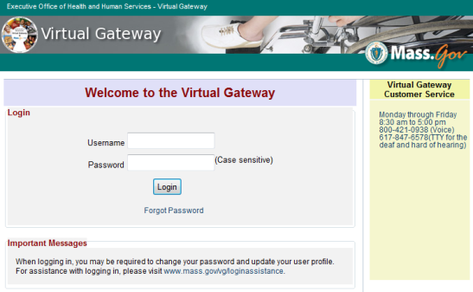
Accessing and Using EDRS
The Electronic Death Registration System (EDRS) is a module of the larger Vitals Information Partnership (VIP) system hosted in the Commonwealth’s secure Virtual Gateway environment.
Access EDRS on the Web. EDRS can be accessed anywhere you have a computer and Internet access. The system works best with the Microsoft Internet Explorer (IE) browser or with Firefox. If you are a Mac user, it is recommended that you download the Firefox browser on your computer.
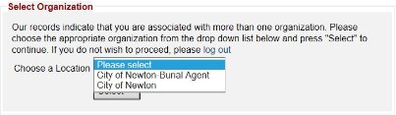
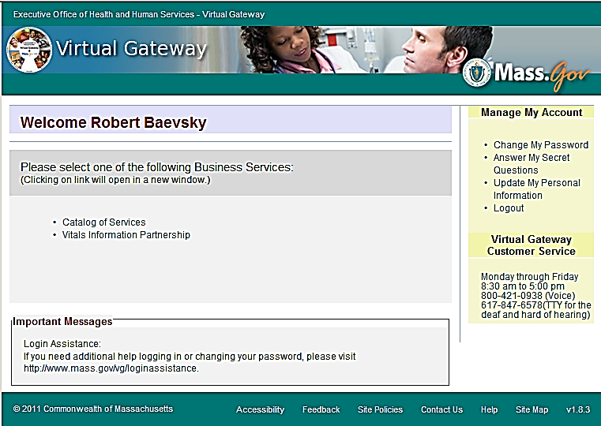
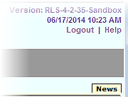
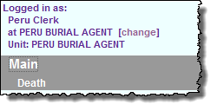
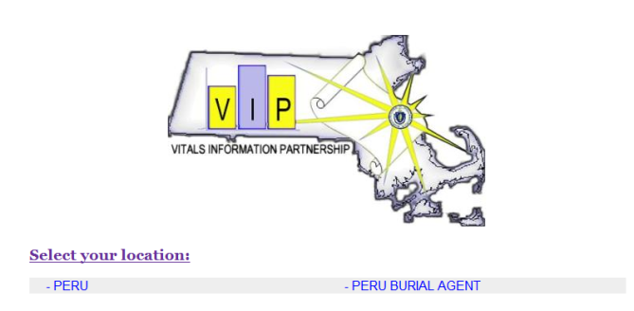
Log in at http://mass.gov/vg. You must have a valid Commonwealth Virtual Gateway account, as well as a VIP account to log in to EDRS. If you have a VG account for another application, you will then have a choice of applications when you log in. If you are a City or Town Clerk that is also a burial agent, then you will get a choice of role.

Additionally, City and Town Clerks that are burial agents may “Change” role within VIP (at the top left corner).
Logout at the right-hand corner.

Tips & Tricks
Accessing & Using EDRS
Save! – EDRS will time out after 15 minutes. While your portion of the death record should take less than five minutes to enter, if you expect to be interrupted or if you are just learning the system, click “Finish,” then “Save as Pending” frequently. You may then click “Return to Record” without risk of losing any information. EDRS does not save information automatically.
No abbreviations -- The system will prompt you if you use recognized abbreviations; you should spell out full medical terminology into each field. For example, on Tab 7**Certifier Cause of Death, spell out “COPD” as “Chronic Obstructive Pulmonary Disease.”

Tab & Mouse -- Use the Tab key on your computer keyboard to advance through each field in EDRS. You may also use your mouse to navigate Tabs or to temporarily skip sections. Do not use Backspace or Enter, except within fields as necessary.
Alerts – Take advantage of system validation messages and warnings. Use the spell check icon on the Certifier Cause of Death Tab. EDRS helps users get information in accurately and completely from the start.
Color Coding – White fields on each screen in EDRS will accept information; the yellow fields are disabled based on selections made in the system. A blue field indicates which field you are on now.
Shortcuts – EDRS accepts military time. Alt-T enters today’s date. Colons are not necessary in Time fields and slashes are not necessary in date fields. Enter the first few letters of a selection on a drop-down to narrow the list quickly. “Next” will move you from Tab to Tab, but you can click on the Tab labels as well.

Support
By email: vip@state.ma.us

By phone:
For technical problems using VIP or for enrollment help, call 617-740-2675.
For forms, data entry, or policy and procedure help, call 617-740-2674.
For forgotten usernames and passwords, call Virtual Gateway at 1-800-421-0938.

Navigation
How you navigate the EDRS will depend largely on your office workflow. Records that you access, create or amend may also be accessed and viewed by authorized burial agents, medical certifiers, hospital support and data entry staff, as well as representatives from designated funeral homes. When you log in as a city or town clerk, EDRS features two general methods of navigation: work queues and a menu bar.
Log in & Navigation

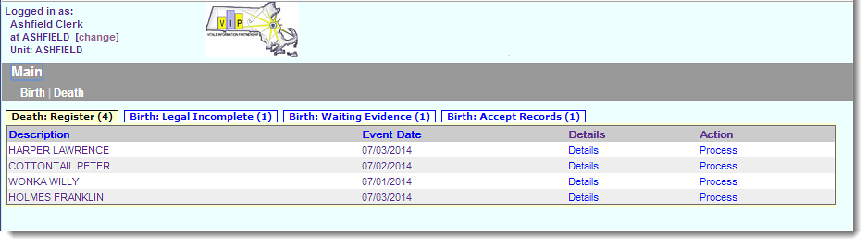
Work queues display records that are waiting for completion. For city and town clerks, death records in a queue may be listed alongside those for births (depending on the number of records awaiting attention). Death Queues are prefaced by “Death” and Birth Queues are prefaced by “Birth.” All records in your Death Queues are awaiting some action by you, such as registering or accepting a record.
Click on the hyperlink “Process” to retrieve the record from a queue. On search results screens, you will click Details.
The gray menu bar allows access to all authorized EDRS functions for the user type that is logged in. The most common options will be Search, Register, Modify and Print.
Amendments Guidelines
The Print menu option allows you to print EDRS forms including the Archival and Certified Copies of the registered death certificate. The most common paths will be:
- Death Search (to locate and view (read-only) an existing death record)
- DeathSearchRegister (to register the record)
- DeathSearch Modify (to adjust or amend a record)
- DeathSearchPrint (to print Archival and Certified Copies of the death certificate as well as the Fax Coversheet for evidence)

General EDRS Amendments Guidelines
- Amend Administrative is to be used for amending personal items about the decedent, usually those found on tabs 1-5.
- Amend Medical is only to be used when medical information needs to be corrected (tabs 6-9). Do not use Amend Medical for administrative amendments, unless you also have a personal item to correct. Amend Medical will require attestation (by fax or electronically) by the certifier.
- Adjustments are to be used to correct local registered numbers only, and can only be used prior to registration by RVRS. After RVRS registers a record or an amendment, adjustments must be made by RVRS staff.
- Use the EDRS only to amend records that were registered in EDRS. Unlike the VIP births module, the VIP death module does not have functionality to enter older deaths. For older deaths, use a paper process, although you may use the new fillable-PDF death certificate form rather than an Affidavit and Correction form.
- The EDRS does not have an electronic review process, as in the VIP births module. If you need assistance beyond this guide, email vip@state.ma.us or contact the RVRS help line (617-740-2674).
- Fax all evidence to the VIP EDRS fax number to attach a PDF image to the electronic record. Note that the death fax number is different than the birth fax number. When complete, you will still mail the original evidence to RVRS as usual.

Gather Evidence
Before starting an amendment in EDRS, you should make sure that you have the necessary evidence. Although it is possible to abandon an unfinished amendment (call RVRS if you need help with this), it is better to wait until you have all the evidence before beginning the electronic amendment. If you need help determining what evidence is appropriate, please refer to the RVRS Evidence Guide for Death Amendments, or contact RVRS.

Retrieve the Record to be Amended
If you are searching for a record to amend, register, or to print a form, the search screen will always look similar. Enter at least a few fields to narrow down the search. This will help EDRS find the record easily and improve system performance for all users.
Retrieve Record
The menu path to retrieve an Administrative Amendment is: DeathModifyAmend Administrative.
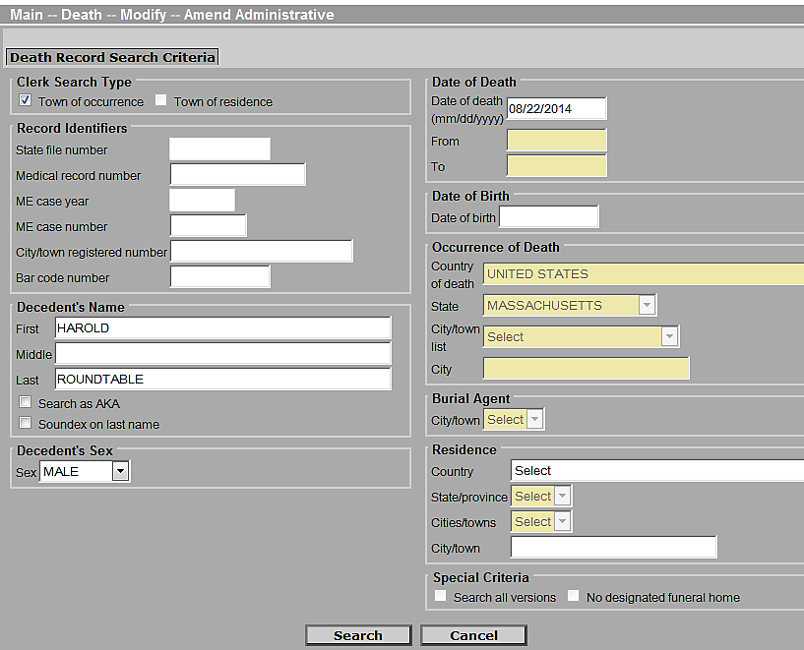
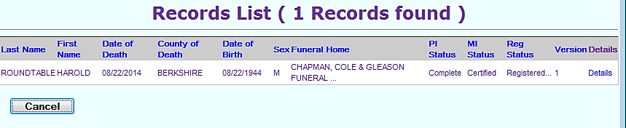
Select the record from the Records List, by clicking on the Details hyperlink. Review the information on the Records Details tabs to make sure you have the correct record, then click Continue at the bottom of the screen.
Soundex will help find last names that sound alike but are spelled differently. If you are not sure if the decedent’s last name is Smith or Smythe, check the Soundex checkbox.
Click on Details to bring up the Records Details screen, where you can verify that the record that you about to retrieve is the correct one.
Enter at least a few fields to narrow the search. This will improve system performance.
Note that version number increases with each adjustment and amendment. An original record is version 0; therefore, we can tell that this example record has been already amended once.

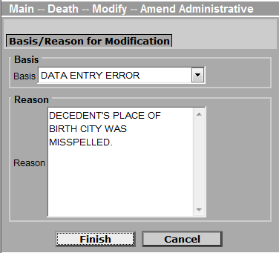
Basis, Reason, Evidence
Enter a Basis and Reason for the amendment. For most administrative amendments, the basis will be a correction of information, a data entry (clerical) error, or a court order. However, you may also choose “Other,” if you would like to describe it differently. The reason provides more detail about what is being amended. If the correction is by court order, enter docket# and court in this field.
Basis, Reason, Evidence, Editing
Then, click Finish.
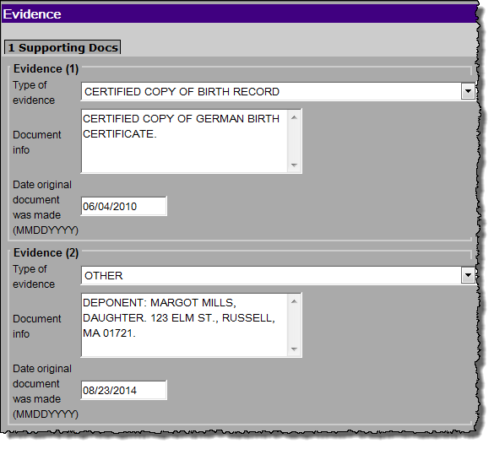
The Evidence screen allows entry of several pieces of evidence. Note that only the first six entries will print on the death certificate, so you may want to lump all evidence exceeding six into the sixth field.
Deponent – EDRS does not have a field for deponent information. Therefore, you will enter the deponent information into the last evidence entry. At minimum, enter the name of the deponent and their relationship to the decedent into the Document info field. You may enter more, as appropriate.
The evidence fields will print on the reverse of the death certificate.
Click Finish when done.

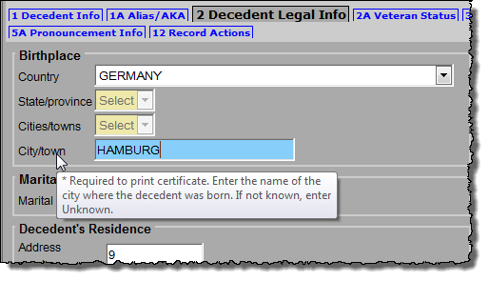
Editing fields
Make corrections to those fields for which you have evidence. Amend Administrative will display only those tabs that may be edited. Medical information tabs are not displayed when making an administrative amendment.
Delete the incorrect information already in the field, and then enter the correct information. Most fields have “mouse-over” hover text help for basic information about each field.

Validate the Record and Print Verification and Fax Cover Sheet Forms
Before you finish modifying the record, EDRS must validate the fields entered. You will also want to print a verification form in most cases, so that the deponent can review the information you entered and sign that they have done so.
Validate Record

When you have made the amendments to the field(s), click Finish. EDRS will verify the changes that were made, and occasionally send a duplicate check warning.

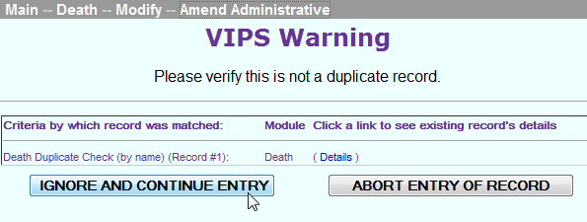
Duplicate record check
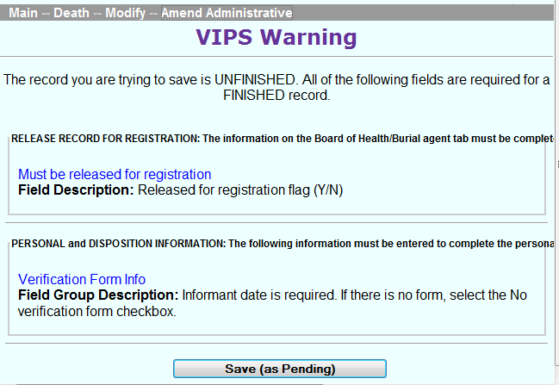
Occasionally, you will see a message from EDRS to verify that the record you are working on is not a duplicate. It happens most frequently when a record has been amended and/or adjusted more than once. Simply Ignore and Continue Entry, then click Finish again.
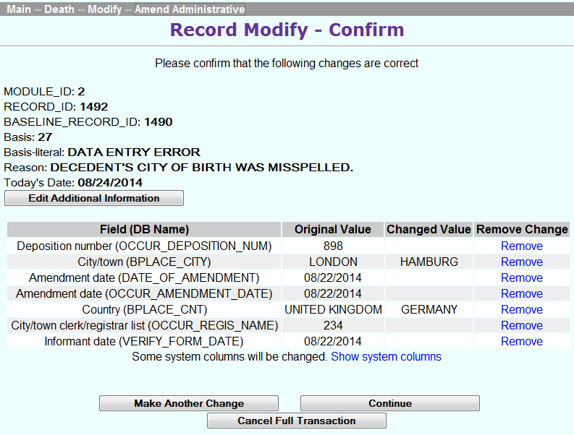
You should expect to find two missing fields at this point: Must be released for registration and Verification Form info. Then Save (as Pending) to complete the EDRS validation.
EDRS will then confirm the fields that were modified on the Record Modify-Confirm screen. In most cases, you will Continue; but, you do have the opportunity to make other changes or cancel the amendment at this point.
At this point, you will see the Successful Transaction page, which indicates that the record was successfully saved.

At this point in the process, it is advisable to print a verification form such that the deponent can review and verify the information that you changed on a record. You will also want to print a Fax Cover Sheet to attach electronic images of additional evidence.

Verification Form
Print an informant verification form through the menu path: DeathPrintVerification Form. This form is useful for Clerk review and especially for review by the deponent, as it contains all information that will be printed on the amended death certificate. By asking the informant for a signature, they are more likely to read it carefully, thereby avoiding further amendments. This form is bar-coded and specific to this version of the record. Note that for amendments, the Verification Form can be printed only when a record is in a Pending Amendment or released for registration state. Once registered, it is no longer possible to print a verification form.
Verification Form, Faxing

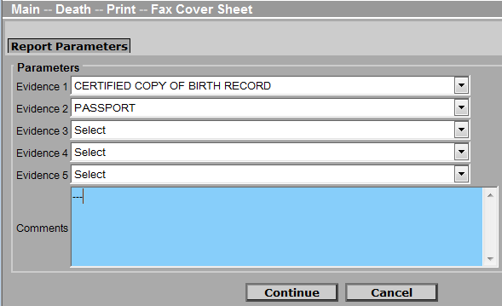
Fax Cover Sheet
All evidence that is not generated from VIP with a record-specific bar code will need a cover sheet. The VIP cover sheet generates a unique bar code for each version of a record. Access the Fax Cover Sheet through the menu path: DeathPrintFax Cover Sheet. Select evidence from the pick list fields and add any additional comments. The comments field is required, so if there are no comments to be added, enter three dashes. Then, Continue.
After printing from the generated PDF, place non-bar-coded documents behind the cover sheet and fax into the VIP system. All documents sent with a fax cover sheet will be imaged into one PDF file; individual pieces of evidence do not need to be faxed separately, but it is advisable to break them up if there are more than 10 pages.

Faxing Evidence
Fax documents to 1-617-887-8739, which is an automated imaging system that attaches a PDF to the electronic record. (This “fax” never arrives at an office fax machine, and the image can only be viewed by authorized EDRS users). It generally takes 5-15 minutes for the attachment to appear.
- Forms with bar codes do not need cover sheets.
- A fax cover sheet must be printed for any non-bar-coded documents, such as copies of social security cards or birth certificates for evidence.
- It is recommended that you fax all evidence into the system prior to registration, so that you will be able to verify that the documents were attached correctly.

Continue Mod, Release for Registration
When you have entered the necessary field correction(s), saved the record to allow for EDRS validation, and printed/faxed the necessary forms and evidence; you will be ready to complete the amendment and release it for registration.

Continue Mod
Continue Mod, Release for Registration
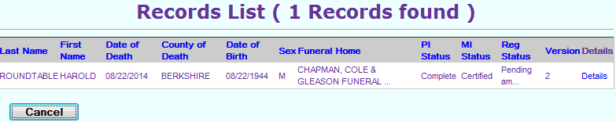
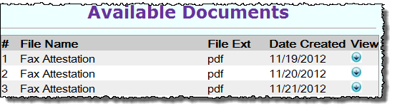
To retrieve the amendment in progress, navigate through the menu options DeathModifyContinue Mod. Search for and select the record as before. You will notice on the Records List that your record is “Pending Amendment” and has a higher version number. Click on Details.
Note that in version 4.2x, all documents are labeled Fax Attestation. This will be corrected in a later release.
On the Records Details tabs, check that your evidence was attached correctly in the Available Documents section. Then, click Continue.
Review the Basis and Reason for any necessary changes; then, click Finish.
Review the Evidence listed and make any necessary changes; then click Finish.

Verification date signed, Release for Registration
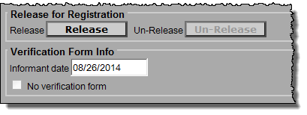
To complete the amendment in progress, click on Tab 12 (Records Actions). If there was an Informant Verification form signed by the deponent, enter that date at the bottom left-hand corner of the screen (Informant date). If, for some reason, such as an amendment by court-order, there is no verification form, then click on the No verification form checkbox.
Use the [Tab] key to move off of the Informant date field, and the Release button will now be enabled. If you are sure that you are ready to release this record for registration, click on the Release button. Then click Finish.
You will again encounter the Record Modify-Confirm screen and occasionally the duplicate record check as described on page 9. Click through these screens, as before, to arrive at the Successful Transaction page.
The amended record should now appear in the Death: Register-Amendment queue.

Register Amendment
The completed and released amendment should appear in your Death: Register Amendment queue.

Review the Record
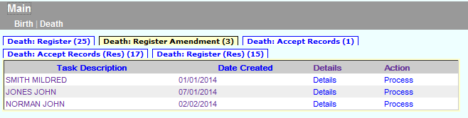
After clicking on the Process link, the Record Details will be displayed. By default, you will be on Tab 1, but you may review any tab. Check that the evidence is attached in the Available Documents and if not, fax the evidence into the VIP system as described on page 10.
Click on the Process link to access the record for registration.
Register
The attached documents will be in PDF format for you to view. Click on the button on the right to view the PDF.
Press the Continue button at the bottom of the Records Details page to continue to the Registration tabs.

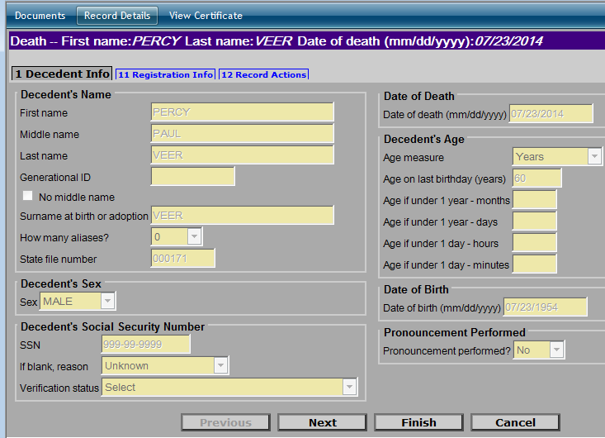
Registration Tabs
Click on the link at the top of the page to review the attached Documents, the Record Details Page, or to View Certificate to see a preview of the death certificate.

The registration tabs are limited to tabs 1 (Decedent Info), 11 (Registration Info) and 12 (Record Actions). The blue bar at the top of the screen also allows you to review the attached documents, Records Details tabs, and to preview the amended death certificate.
Proceed to tab 11, if you are ready to register the record; or to tab 12 add a comment. Amendments may not be returned to a funeral home.
If you notice a mistake at this point, you will still need to register the record. A new amendment must be initiated to make further corrections.

Registration Info tab
Select “Yes” in Ready to register record. Selecting “Yes” will enable the City/Town of Occurrence section and fields to become active. Select the current City or Town Clerk. Leave Registration number and Date of record with original information. [Tab] through the fields, and at minimum enter the Amendment date. Volume, Page and Deposition number are optional.
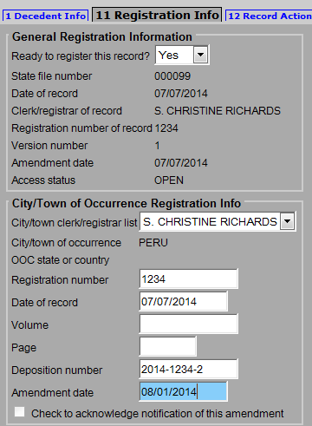
Once you have entered in all the information, click the Finish button. This will result in a Successful Transaction page, where you will have the option to print an archival copy of your record as you have processed it through registration.
Selecting “Yes” will enable registration fields.
Select the current Clerk. Then [Tab] to move to the next fields.
Leave the original Registration number and Date of Record. [Tab] through and enter the Amendment date. Volume, Page and Deposition number are optional.
Archival Copy, Resident Copy
Archival Copies

When you return to your work queues, you will notice that the record is no longer listed in your Register Amendment queue. The record is now available to the Clerk of Residence (if applicable) and the Registry.

Print an Archival Copy
Once you pressed Finish, you will have the option to print an Archival Copy of the record that you have registered.
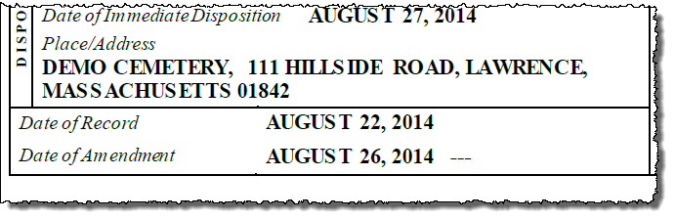
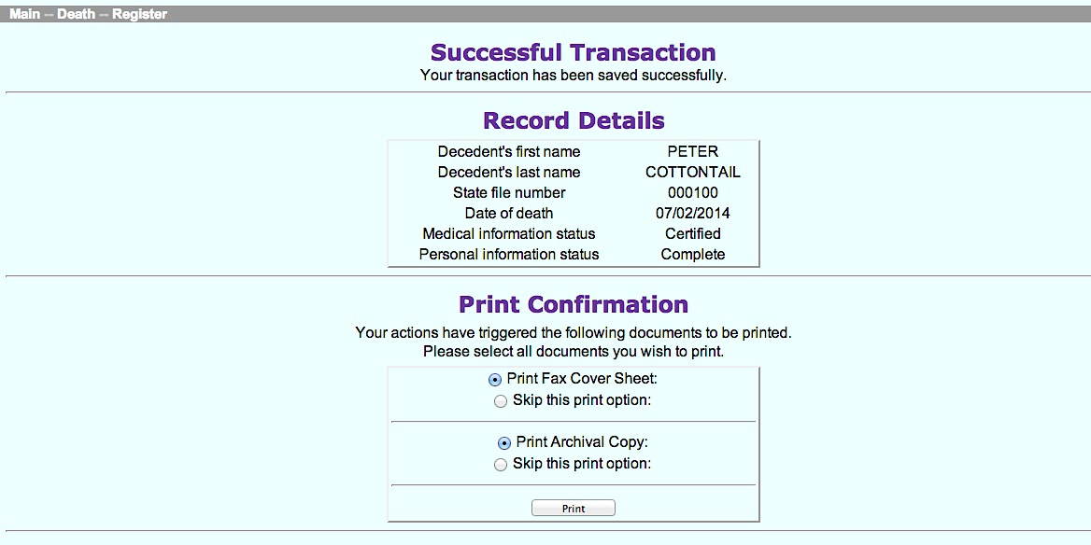
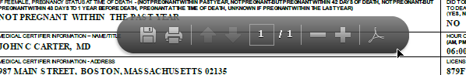
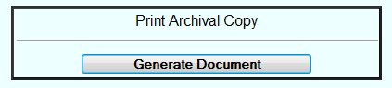
When printing from the Successful Transaction page, EDRS will display a Generate Document button. Clicking on Generate Document will load a PDF document that you will print from the Adobe Acrobat print function.
Most users will find the print function within Adobe Acrobat on a navigation bar at the top of the page or by hovering the cursor near the bottom of the page.

Residence Copy Registration
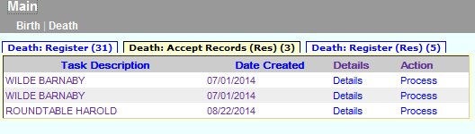
Amendments that have been registered by the Clerk of Occurrence will appear in the Register queue for the Clerk of Residence (if the decedent died in a city or town that was not his/her residence).
These amendments are residence community copies.
If multiple amendments were done before residence registration, you may find more than one in a queue.
The process for registering the record as the Clerk of Residence is almost the same, except that the fields that will be open for editing are City/Town of Residence Registration Info.
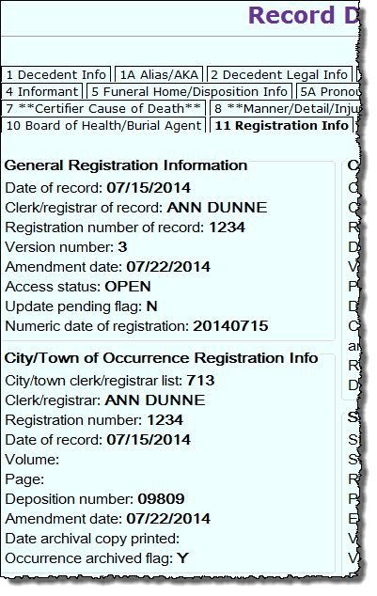
It is worthwhile to note that occasionally amendments may be done in rapid succession or there may be an amendment and then and adjustment for registration information before you register the record. If this is the case, you may find more than one of the same record in the queue. Check the Records Details tab 11, Registration Info, to see the Version number and Amendment date to determine the order in which you will register.
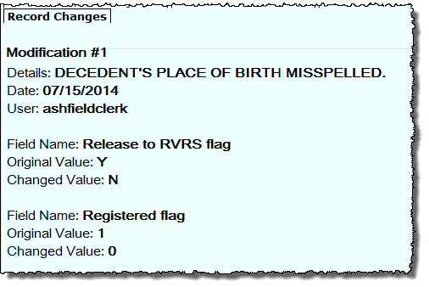
The Records Details also contains a new tab for amended records that shows the history of changes, which is useful to determine the purpose of the amendment or adjustment.
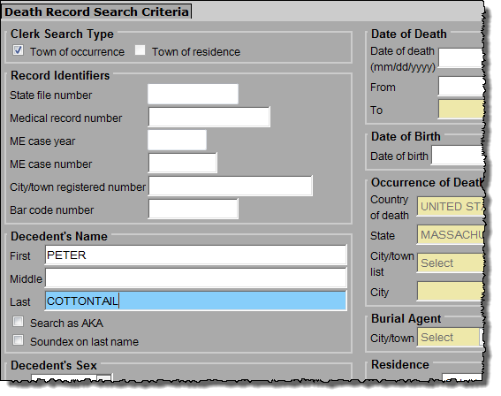

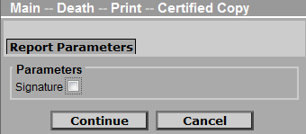
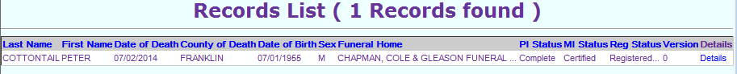
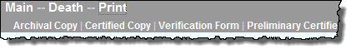
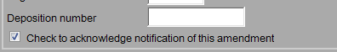
On the Registration Info tab, select that the record is Ready for registration. If your local registration info is missing because an amendment or adjustment was made prior to residence community registration of the original record, enter that as well. Volume, Page and Deposition number are optional. It is possible that there are no fields to enter for a residence registration, but you will always mark the checkbox Check to acknowledge notification of this amendment. Finish, and print an Archival Copy as described earlier.
Print Certified Copies
To print, use the menu path Death Print Certified Copies. Specify search criteria to find the record. Select the record by clicking on the Details link. On the Record Details Page scroll to the bottom of the page and click Continue.
Certified Copies

Click on the Signature box to print the attestation and signature at the bottom of the Certified Copy. If you do not want this printed, leave the checkbox blank. EDRS will load a PDF document that you will print from the Adobe Acrobat print function (as described in the Archival Copy section).

