DEVAL L. PATRICK PETER J. FORBES
GOVERNOR COMMISSIONER

JOHN POLANOWICZ SECRETARY

COMMONWEALTH OF MASSACHUSETTS
DEPARTMENT OF YOUTH SERVICES

STRATEGIC PLAN
2012-2014

DYS Strategic Plan 2012-2014

Table of Contents
Introduction 3
DYS Vision and Values 4
DYS Mission and Strategic Goals 5
DYS Vision, Mission, Goals and Values Alignment 6
Stakeholder Engagement, Survey Results and Themes 7
Goals, Target Measures and Strategies 11
Measures to Track Progress 14
System for Reviewing Performance 16

MASSACHUSETTS DEPARTMENT OF YOUTH SERVICES INTRODUCTION

Massachusetts created the nation's first juvenile correctional system in 1846 when it opened the first reform school. The reform school was built on the premise that juveniles were more likely to be rehabilitated than adults, and therefore, should not be treated in adult institutions. In 1969, the Division of Youth Services was established as a separate agency operating under the Executive Office of Health and Human Services.
During the early 1970's, several of the original training schools were closed. In an effort to separate the property offenders, runaways and truants from the more serious and violent population, the Commonwealth's first secure treatment units were created. Concurrently, a diverse range of private agency service providers became the foundation of the community‐centered partnership system utilized to this day.
As of January 2012, there were 1,115 committed youth being served by DYS – a 65% decrease since 2000. The overall population decrease was fueled by a decrease in juvenile crime nationally and a decrease in the number of juveniles committed to DYS by the Courts.
DYS employs a "continuum" model of services and supervision. As of this writing the continuum consists of 84 programs. These include 56 residential facilities, ranging from staff secure group homes to highly‐secure locked units, and 28 community‐based sites that service youth living in the community. DYS divides the state geographically into five regions. Each region has its own continuum of services and supervision. The goal is to serve youth as close to their home communities and families as possible.
The service continuum supports a continuing trend to have more DYS youth in the community – enhancing their opportunities to achieve positive outcomes. In 2009, DYS implemented a new community casework model designed to promote pro‐social behavior in DYS youth through improved community collaborations and linkages. At the start of 2012, 61% of the DYS committed population had completed their residential treatment placements and were under supervision in the community, living in the community with a parent, guardian, foster parent, or residing in an independent living program.
As the Department looks to 2014, there will be a continuing development of the service continuum to ensure that the youth that come to DYS have better outcomes and that communities are safer. The Department’s strategic vision is to support youth in making progress towards their educational, behavioral, vocational and relational goals and to sustain the gains they make while in the care of DYS.
Achieving this vision requires investing in and supporting staff that create positive relationships with youth, families, providers and communities. It is through these positive relationships that DYS and its partners will continue to improve and collectively contribute to youth success every day. As the many success stories of DYS alumni vividly demonstrate, it is through these partnerships that youth can reach their potential and become successful, productive and positive members of their communities.

DEPARTMENT OF YOUTH SERVICES VISION
Every young person served by DYS will become a valued, productive member of their community and lead a fulfilling life.

DEPARTMENT OF YOUTH SERVICES VALUES
We are unwavering and persistent in the pursuit of the positive development of youth in our care.
We believe that every youth has the capacity for positive change. We are committed to providing positive opportunities, supports and experiences as a way to change the trajectory of their lives.
We promote safer communities by providing prevention, intervention and rehabilitation services.
We believe that when youth have the prevention, intervention and rehabilitation services they need, they become constructive and productive members of their communities and are no longer a risk to themselves and others.
We actively engage and support youth, families and communities as our partners.
We believe families are youths’ most important teachers, caregivers and role models. We engage families and communities to provide the environment and support every youth’s need to succeed. We collaborate with youth and their families in the development of the youths’ individual service plans.
We actively support a safe and healthy environment for our diversified and highly skilled workforce.
We are committed to ensuring that staff operates in a safe and secure environment, and we promote continuous learning by offering training and career development opportunities for all staff.
We work collaboratively with our public and private partners.
We believe that collaboration with public and private partners will build the effective continuum of services that youth need to succeed in school, work and life.
We adhere to the highest ethical and professional standards in all our work.
We conduct our work with the greatest respect for the public’s trust and interest. We perform our duties guided by the most current science, evidence and promising practices.
We respect and embrace diversity.
We conduct our work and fulfill our mission in a manner that demonstrates respect for the values, preferences, beliefs, culture and identity of youth, families, staff and community in all that we do.

DEPARTMENT OF YOUTH SERVICES MISSION

As the juvenile justice agency for the Commonwealth of Massachusetts, the Department of Youth Services promotes positive change in the youth in our care and custody.
Our mission is to make communities safer by improving the life outcomes for youth in our care. We achieve our mission through investing in highly qualified staff and a service continuum that engages youth, families and communities in strategies that support positive youth development.

STRATEGIC GOALS
The Department has made significant progress over the past five years. With fewer youth in detention and more community alternatives and effective interventions, DYS is recognized nationally as an agency effective in its mission to change the developmental trajectory of youth in its care ‐ making communities safer as youth become positive, pro‐ social and productive young adults.

However, there is more to be done to ensure continued progress towards a future where youth are successful and communities are safer. The Department has adopted three goals to ensure that:
The right youth are in the right system placements for the right reasons
Youth success is improved through a continuum of services grounded in the most current science and evidenced based and promising practices
After discharge from DYS, youth sustain the gains they made while in DYS custody
The Department recognizes that these three goals can only be achieved if there is a fourth goal:
To strengthen the operational capacity and physical infrastructure needed to support staff in their work.

Together these four goals embody the Department’s values and are the vehicle for achieving a future where:
Youth in the Department’s care achieve their maximum potential in school, work and life;
Families are supported;
Communities are safer; and,
DYS staff and partners are valued and recognized for their dedication, skill and professionalism.

The ultimate mission of DYS is to strengthen and increase the safety of Massachusetts communities by supporting young people in becoming law‐abiding and productive citizens who lead fulfilling lives.
The following diagram illustrates how the four goals align with and support the achievement of the Department’s mission and vision.

DYS VISION
Every young person served BY DYS will become a valued, productive member of their community and lead a fulfilling life.

DYS MISSION
As the juvenile justice agency for the Commonwealth of Massachusetts, the Department of Youth Services promotes positive change in the youth in our care and custody.

Our mission is to make communities safer by improving the life outcomes for youth in our care. We achieve our mission through investing in highly qualified staff and a service continuum that engages youth, families and communities in strategies that support positive youth development.

Goal 1:
Ensure the “right youth is in the right place for the right reasons” through juvenile justice reform strategies that engage public, private, community and family partners.
Goal 2:
Improve youth success through a continuum of services based on the science of adolescent development and proven and promising practices in juvenile justice
Goal 3:
Youth sustain the gains they made while in DYS custody through improved discharge planning and continuing community supportive partnerships.

Goal 4: (supports Goals 1‐3)

Develop and focus DYS’ human, physical and organizational capacity necessary to execute the various strategies to efficiently and effectively achieve the agency’s operational goals and, ultimately, its stated mission.

DYS VALUES
We are unwavering and persistent in the pursuit of the positive development of youth in our care.

We promote safer communities by providing prevention, intervention and rehabilitation services.

We actively engage and support youth, families and communities as our partners.

We actively support a safe and healthy environment for our diversified and highly skilled workforce.

We work collaboratively with our public and private partners.

We adhere to the highest ethical and professional standards in all our work.

We respect and embrace diversity.

ENGAGEMENT: A PATH TO ACHIEVING POSITIVE OUTCOMES FOR YOUTH AND SAFETY FOR COMMUNITIES

The Massachusetts Department of Youth Services Strategic Plan 2012‐2014 is the product of a three‐month development and engagement process. In May and June, 2012 agency staff articulated the agency’s mission, vision and values and formulated the goals and strategies needed to achieve that mission and vision.

In July, the Department invited stakeholders – youth, families, staff, providers and other system stakeholders
− to participate in an electronic survey and share their reactions to the mission, vision, values, goals and strategies. Over 500 responses were received. Focus groups ‐ one each for youth and families, staff, and providers ‐ were convened to discuss the survey results and further explore stakeholders’ reactions and thoughts about the Department’s strategic plan.

This strategic plan reflects this process of engagement and development. For the Department, this strategic plan is just the beginning of an ongoing process of engagement. Over the next two months, the strategic plan and the survey results will be shared with stakeholders and the Department will continue to find opportunities to engage the spectrum of stakeholders as partners in further refining and making progress towards the Department’s mission and vision.

STAKEHOLDER PERSPECTIVES
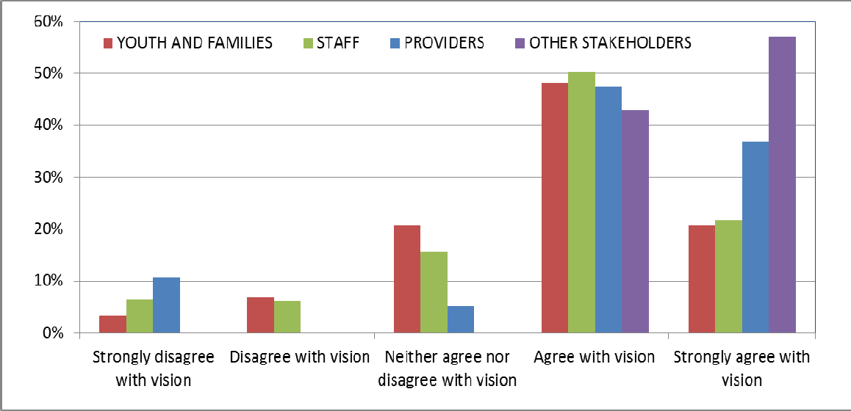
The information solicited from stakeholders directly informed the development of the Department’s strategic plan. For example, there was strong agreement across stakeholder groups for the Department’s vision of youth reaching their potential as productive, constructive members of their communities.
Our stakeholders also perceived that some progress has been made on achieving the mission.
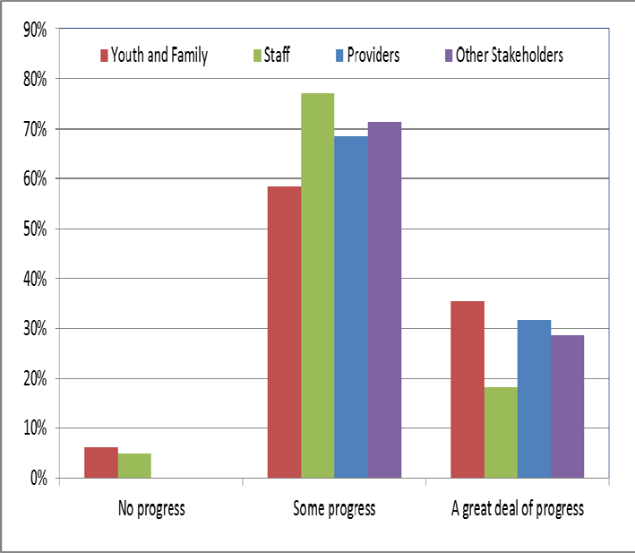
Fig. 2: Stakeholder assessment of progress made in achieving the mission.

Crosscutting Themes
The surveys and the stakeholder convenings illuminated four crosscutting themes that informed the development of strategies. Those themes were:

Strengthening and enhancing the implementation of the Positive Youth Development framework to ensure that all youth make progress and sustain gains;
Increasing the vocational and job‐related education and preparation that youth need for successful employment;
Increasing the effectiveness of connections to housing, health, education and relational resources in the community; and expanding staff training and professional career opportunities.
Enhancing Positive Youth Development

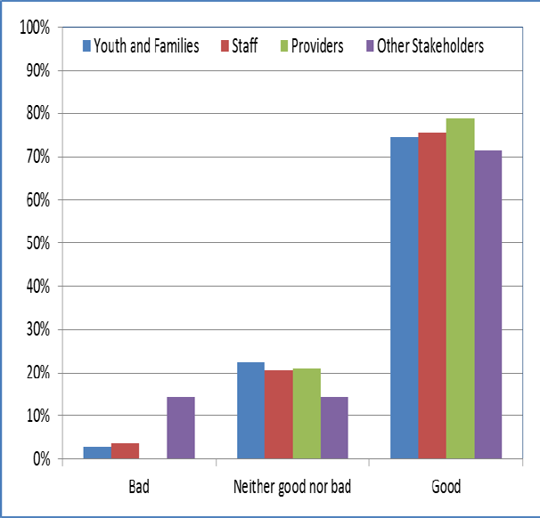
All stakeholder groups showed support for the Positive Youth Development approach. However, as the comments from stakeholders and the focus groups illuminated, there is more work to be done for a common definition of Positive Youth Development to be the foundation of all interaction with youth, families and communities. The development and support of the Positive Youth Development approach is a part of all four strategic planning goals.
Fig. 3: Stakeholder assessment of the value of positive youth development.

Focusing on Vocational Skills, Jobs and Career Success

Youth, families, staff and providers gave the highest priority to strengthening and expanding the resources needed for youth to have the vocational skills training, job placement opportunities and support for the education and credentials necessary for successful and meaningful employment.
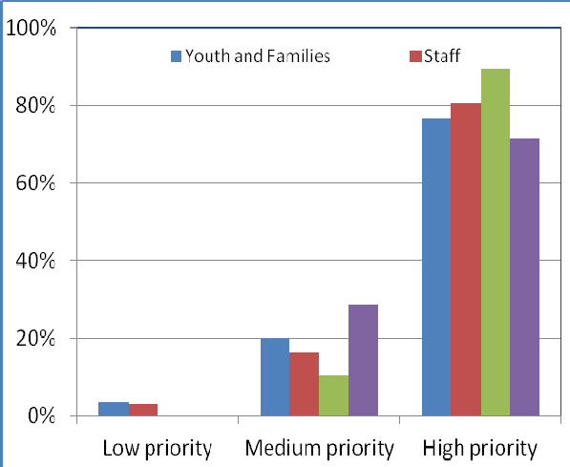
Fig. 4: Stakeholder prioritization of strategies to enhance vocational skills and job placement opportunities for youth job and career success.

Building Connections to Community Services

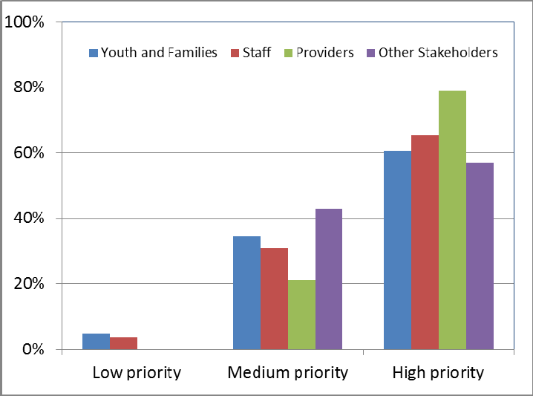
A key element of youth success is the connection to services they need to develop and be safe and healthy in their communities. The stakeholders in both the focus groups and through the survey prioritized the need to develop the resources and to better connect youth to those resources.
Fig. 5: Stakeholder prioritization of strategies to expand the linkages between youth and community services, i.e., medical, housing, job, education, etc.

Valuing and Developing Staff
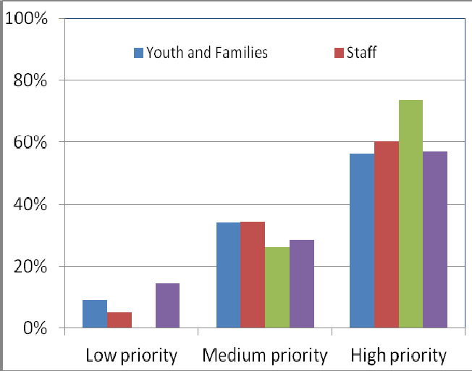
All the stakeholder groups recognized the importance to youth success of being supported by well trained and highly professional staff. The expansion of professional development and training strategies will be a continuing priority for the Department.
Fig. 6: Stakeholder prioritization of strategies to expand staff training and professional development opportunities.

GOALS, MEASURES, AND STRATEGIES

The Department has developed twenty separate strategies to achieve the four goals. The initial development of the goals and strategies was informed by an analysis of the Department’s strengths, weaknesses, opportunities and challenges and discussions with providers. The four goals are structured to focus on:
The “front end” – or the alignment of the policies, practices, services and programs that form the Commonwealth’s system response to youth behaviors prior to youth coming into the Department’s care. (Goal 1);
The intervention and rehabilitative services that is the core of the Departments work (Goal 2);
The services that support youth reentry and provide a safety net to sustain continued youth success after release from agency care (Goal 3); and,

The infrastructure of human and physical resources that are the foundation of the Department’s capacity to fulfill its mission.

All of these goals in combination are intended to move the Department towards the vision of positive youth development.

GOAL #1 – Ensure the “right youth is in the right place for the right reasons” through juvenile justice reform strategies that engage public, private, community and family partners.
The mandate of the Department is to ensure that “right youth is in the right place for the right reason” with the most appropriate services. It can be harmful and costly when youth are not appropriately assessed and supported with the services and in the environment that best meets their needs. This goal invests in improving the Department’s own practices and working collaboratively with the schools and other system partners that work with youth before they come into the Department’s care to provide youth with what they need to be successful.

TARGET MEASURES:
Reduce % of low to moderate risk youth in locked secure detention.
Reduce the # of youth involved in the child welfare system from entering DYS care.
Reduce the # of youth with school‐based offenses from entering DYS care.

STRATEGIES:
Expand Juvenile Detention Alternative Initiative (JDAI) statewide to reduce the reliance on hardware secure detention for low and moderate‐risk youth.
Completion: January 2014
Implement system, community and family partnerships to reduce number of youth involved in the child welfare system (i.e. DCF) from entering and further penetrating the juvenile justice system.

Completion: September 2014
Implement system and community partnerships to reduce the number of youth entering the juvenile justice system through school based offenses or school based practices that exclude high‐risk youth from school and place them on a trajectory towards the juvenile justice system.
Completion: September 2014

GOAL #2 – Improve youth success through a continuum of services based on the science of adolescent development and proven and promising practices in juvenile justice.
The primary activity of the Department is to guide and shape the development of the adolescents placed in its care and custody. For many, DYS is often the last best chance to affect a negative life trajectory. This goal strengthens the strategies that concentrate on helping youth develop pro‐social behaviors, coping mechanisms and linkages to family and community that enable them to become capable and productive young adults.

TARGET MEASURES:
Increase the % of youth who graduate from high school or receive a GED.
Increase the % of youth with vocational certifications and career employment.
Increase the length of stay of youth in the community.
Decrease % of youth who are re‐arrested and/or recommitted to DYS.

STRATEGIES:
Implement a Positive Youth Development based communication and training program to establish a uniform and evidence based set of expectations for youth, family, staff and other stakeholders. Completion: September 2013
Implement an educational program that offers multiple pathways and standards to increase the number of youth who achieve educational success.
Completion: September 2014

Implement vocational skills and job readiness and job placement programs to increase the number of youth with vocational certificates and employment.
Completion: September 2014

Enhance residential treatment programming to improve youth skill development for better youth outcomes in the community.
Completion: September 2014

Continue to support a community case management model that supports the continued development of youth with an emphasis on sustained success in the community.
Completion: September 2014

Improve youth‐ and family‐directed service delivery planning and implementation for increased overall success of youth in the community.
Completion: September 2014

GOAL #3 ‐ Youth sustain the gains they made while in DYS custody through improved discharge planning and continuing community supportive partnerships.
Many youth who leave DYS with a positive plan in place have very little by way of a community support structure to sustain them after discharge. All too often this lack of support contributes to reoffending behavior after discharge. This goal encompasses strategies that provide a safety net to youth released from care and prevent youth from engaging in behaviors that lead to adult criminal justice involvement. Youth benefit from the time, attention and resources they receive while in the Department’s care; this goal includes strategies to continue a level of support necessary to sustain that success in the community. These strategies strengthen the discharge planning process and reinforce the Department’s role in sustaining the gains made by youth while in care.
TARGET MEASURES:
Increase % of youth discharged with connections to housing, health services, and education/employment.
Reduce recidivism rate.

STRATEGIES:
Implement an individualized service plan to support the youth’s success and self‐sufficiency after DYS discharge.
Completion: September 2013

Link the Empower Your Future life skills curriculum and discharge planning to ensure youth have a successful transition with appropriate community supports.
Completion: September 2013

Ensure that voluntary services through the Department’s assent of ward option is offered to all discharging youth to provide a continuity of supports and services leading to stable housing and self‐ sufficiency.
Completion: January 2014

Enroll discharging DYS youth in opportunities for housing, employment, education, training, medical and behavioral healthcare, health insurance and other support services to increase their sustained success in the community.
Completion: September 2014

GOAL #4 – Develop and focus DYS’ human, physical and organizational capacity necessary to execute the various strategies to efficiently and effectively achieve the agency’s operational goals and, ultimately, its stated mission.
To be successful in achieving its first three goals and, ultimately, its mission, the Department needs to fully utilize the resources available – its staff, its physical plants, its funding and its organizational capacity. DYS is obligated to be a responsible steward of public assets and transform those assets into public value. It is the responsibility of the Department to align and fulfill its obligations and achieve its objectives in furtherance of the DYS mission. The success of the strategic plan is dependent on many different groups of people working together across disciplines effectively and collaborating on a daily basis in a coordinated and focused fashion. A well‐supported staff, committed to the agency’s values and working towards the agency’s goals is essential to accomplishing the DYS mission. Communication and the use of information are key to successful collaboration. Strategies in these areas will shape how DYS engages, builds relationships, shares ideas and creates solutions internally and externally. The Department sees opportunity for improvement and is committed to implementing strategies to improve the efficiency and effectiveness of its operations.

TARGET MEASURES:
Reduce # of client assaults on staff.
Increase % of staff very satisfied with DYS employment.
Reduce maintenance response time.
Increase % of staff very satisfied with DYS training and career opportunities.
Increase % of youth with individualized and well‐resourced case plans.
Increase % of youth with access to resources for education, health, vocational and recreational resources.

STRATEGIES:
Support staff through effective recruitment, training, evaluation, and recognition to develop and retain a diverse, skilled and experienced workforce and create a safe and secure environment for youth and staff.
Completion: September 2014

Implement a comprehensive communications strategy to improve information sharing internally and externally.
Completion: September 2013

Use strategic planning, internal controls and data for continuous quality improvement to better meet the needs of youth and staff and improve youth outcomes and safeguard public assets.
Completion: September 2013

Implement the DYS Capital Improvement Plan and Facilities Master Plan to address critical deferred maintenance needs so that youth and staff can live and work in a safe and sanitary environment that is conducive to supportive and positive interventions. Completion: Sept. 2013

Create and implement a data development agenda to meet strategic and annual action plan requirements to enable DYS to effectively measure areas of improvement and success for the agency and the youth we serve.
Completion: September 2013

Develop budget and spending plans that are aligned with the Department’s strategic priorities and manage the procurement of goods and services to fulfill the agency’s goals. Completion: January 2013

MEASURES TO TRACK PROGRESS
The Department has set targets in all goal areas to measure progress towards positive youth outcomes and community safety. The following data points1 will be used to monitor agency performance in meeting our goals:

MEASURE NAME | FREQUENCY | RELATED  GOAL(S) | DATA  SOURCE | IN EHS  RESULTS
Positive Youth Outcomes
% reduction of RED (racial and ethnic disparity) admissions in the detention population* | Annually | 1 | DYS | No
% increase in # of community alternatives to detention programs* | Annually | 1 | Multiple stakeholders linked to JDAI (DCF, DYS,  Probation, etc.) | No
% reduction in number of child welfare youth  entering the detention system | Quarterly | 1 | DYS | No
% of youth passing MCAS | Annually | 2 | DYS/DESE | Yes
% of eligible youth graduating from high school | Annually | 2 | DYS/DESE | Yes
% of eligible youth receiving GEDs | Annually | 2 | DYS/DESE | Yes
% of youth with vocational certifications and career employment | Annually | 2 | DYS/DESE | No

1 Further development of our data collection mechanisms are required in order to collect and monitor all of the data points identified in the chart. Those measures have been identified with a (*).

MEASURE NAME | FREQUENCY | RELATED  GOAL(S) | DATA  SOURCE | IN EHS  RESULTS
% of Youth gainfully employed subsidized vs. unsubsidized* | Bi‐annually | 2 | DYS | No
% of youth with continuous job‐labor market participation for more than six months | Bi‐annually | 2 | DYS | Yes
% of Youth identified utilizing and maintaining health and or behavior health services in the community i.e. at 6‐month and 12‐month mark | Bi‐annually | 2 | DYS | No
% increase in uninterrupted length of time in the  community for youth prior to discharge* | Bi‐annually | 2 | DYS | No
% of youth discharged connected with housing, health services, and education/employment | Quarterly | 2 | DYS | No
% AOW youth able to secure their own housing*  % AOW youth completing education goals*  % AOW youth securing permanent job placement (over one year)*  % of youth connected to Pay‐For‐Success prior to discharge  % of youth enrolled in Pay‐For‐Success program  % of youth utilizing and maintaining health and or behavior health services in the community at 6‐ month and 12‐month post‐discharge* | Biannually For youth connected to Pay‐For‐  Success, begin in Year 2 | 3 | Youth exit survey (to be developed) and follow‐up surveys; Pay for success provider | No
% of youth who feel safe, supported and fulfilled at 6‐months and 12‐months post discharge* | Biannually | 3 | Survey (to be developed) | No
Community Safety
% reduction of low and medium Detention Placement Instrument (DPI) detention admissions | Quarterly | 1 | DYS | No
# of detention admissions placed in an Alternative To Detention (ATD) that return to court for their schedules court appearance on time* | Monthly | 1 | DYS | No
# of detention admissions placed in a ATD that do not offend during the period of detention assignment* | Monthly | 1 | DYS | No
% of revocations | Monthly | 2 | DYS/CORI | No
% Client Re‐Arrest Rate While in Custody at 6 and 12‐months post discharge for AOW, non‐AOW and Pay for Success  % Client Re‐Arrest Rate @ six months post‐ discharge for AOW, non‐AOW and Pay‐for Success youth  % Client Re‐Arrest Rate @ one year post‐discharge for AOW, non‐AOW and Pay‐for Success youth | Biannually For youth connected to Pay‐For‐  Success, begin in Year 2 | 1 |  | Yes
% decrease in annual recidivism rate | Annually | 3 | CORI | Yes

MEASURE NAME | FREQUENCY | RELATED  GOAL(S) | DATA  SOURCE | IN EHS  RESULTS
Organizational Capacity
% improvement in completing internal control goals for FY 2013 | Annually | 4 | DYS | No
% of successful completion of annual strategic planning review by annual target date | Annually | 4 | DYS | No
% increase in maintenance response time as measured via CAMIS data | Quarterly | 4 | DYS | No
% satisfaction rate in completion of annual staff and stakeholder surveys | Annually | 4 | Survey (tbd) | No
% of goals achieved in annual communication strategies and projects* | Annually | 4 | Survey (tbd) | No
% public satisfaction with DYS mission accomplishment* | Annually | 4 | Survey (tbd) | No

SYSTEM FOR REVIEWING PERFORMANCE
The data that will be used to measure the progress being made to meet the goals of this strategic plan will be maintained by DYS. The DYS Juvenile Justice Enterprise Management System (JJEMS) will be the predominant source of information to track youth outcomes. However, as JJEMS is a relatively new system, DYS is actively making adjustments to the database to improve its reporting capabilities to fulfill its potential effectiveness. As part of this plan, one of the first priorities is to create a data development agenda that will identify and assess the other data sources available and those that will need to be developed to inform this overall effort.

Achieving the goals set out in this plan will require ownership and full integration into the day‐to‐day work of staff at all levels. Responsibility for monitoring and review of the measures will fall to managers at the program, regional and central office levels. This process for review will be developed in the implementation plan that will be a companion document to the DYS strategic plan.

