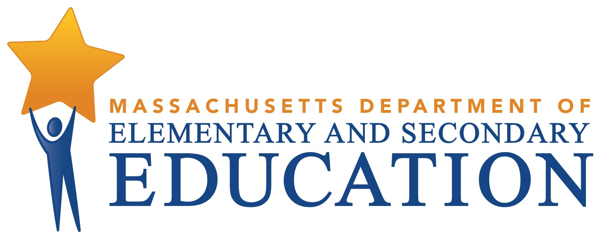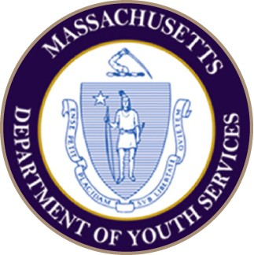FISCAL YEAR 2018

DYS Comprehensive Education Partnership Report

A System-Wide Approach for Providing High Quality Education to DYS Clients

Massachusetts Department of Youth Services Massachusetts Department
of Elementary and Secondary Education Special Education in Institutional Settings

TABLE OF CONTENTS

Executive Summary
- Engaging Teaching and Learning Supported by High Quality Professional Development 7
Overview of Curriculum and Instruction 7
Overview of the Professional Development System 12
- Student Performance Data 16
- Postsecondary Programming 25
- Special Education 28
- Transition System 30
- The Bridging the Opportunity Gap (BOG) Initiative 31
- College and Career Readiness: Empower Your Future and Future Ready Initiatives 37
- The DYS Arts Initiative 39
- Social Enterprise 42
- Family and/or Caregiver Engagement 43

A System-Wide Approach
for Providing High Quality and Effective Education to DYS Clients

EXECUTIVE SUMMARY
Beginning in 2003, the Massachusetts Department of Youth Services (DYS) undertook an unprecedented reform of its education programs. This continuous improvement process, referred to as the “Education Initiative,” has created access to high quality education and employment opportunities for youth in the care and custody of DYS. Over the last several years, DYS, in conjunction with the Department of Elementary and Secondary Education (DESE), has provided an annual summary of activities related to the Education Initiative to the Massachusetts State Legislature. This report is pursuant to Chapter 133 of the Acts of 2016 DESE line item 7028-0031 and DYS line item 4200-0010.
This report reflects the breadth and depth of the Massachusetts juvenile justice education system through the DYS contract with the Commonwealth Corporation (CommCorp) and the Collaborative for Educational Services (CES), referred to as the Comprehensive Education Partnership (CEP) Initiative.

The Department of Youth Services believes that one of the most important and powerful activities supported and delivered by our Department is education. In order for youth to be successful, in the short and longer term, they have to be able to achieve academically, make a successful transition to the community in an educational and/or vocational placement, and formulate realistic plans for their future. At DYS, we are uniquely positioned to support and guide our youth in that process.
Each year, many of our youth attain their high school diplomas or its equivalent (HiSET®), complete meaningful training programs, participate in postsecondary college or training courses, earn industry recognized credentials, and achieve other milestones on their way to successful adult lives. These successes are made possible through the hard work and collaboration of a cast of caring adults, including teachers, education and career counselors, group workers, clinicians, administrative officers, caseworkers, program directors, district managers, provider staff, and community supports. We also continue to strive to engage parents, guardians, family members, and other community supports as partners in the rehabilitative process.
To enhance our educational programming, we offer exploratory learning opportunities for youth in art, poetry, 3-D printing, music, video, horticulture, music production, coding, fiber-optics, small-engine repair, silk screening, and other areas of interest. These activities are critically important as youth grow and find healthy interests and outlets. The 6th Annual DYS Youth Showcase was an incredible example of the talent that DYS-involved youth possess. To the extent that we are able to facilitate youth discovery of their creative and intellectual assets, hidden talents, and cultivate their strengths, positive life outcomes follow.
The achievements outlined throughout this report are the result of the combined leadership efforts of the education staff at DYS, ESE, CommCorp (the fiscal agent and workforce development partner), and CES.

The Partnership continues to provide multifaceted support and strategic direction for innovative teaching and learning in DYS residential programs and effective educational and workforce development services for DYS clients residing in the community. The approach is aligned with the DYS Strategic Plan and the explicit goal of sustaining the gains youth make while in the care and custody of DYS and seeks to guide youth into a variety of education and employment pathways as they return to their communities.
This report provides an overview of the many accomplishments and positive outcomes resulting from specific efforts DYS undertook in FY 2018. It is organized to highlight the progress and impact of key initiatives and demonstrate our comprehensive approach toward providing a range of education and workforce learning opportunities for the Commonwealth’s most troubled youth and, as a result, contribute to safer communities.
These initiatives include:

- Engaging Teaching and Learning supported by High Quality Professional Development
- Multiple Pathways to Educational Attainment and Student Outcomes
- Postsecondary Programming
- Transition Planning
- Understanding How Special Education Contributes to the Educational Environment
- Bridging the Opportunity Gap (BOG) Career Development and Employability
- College and Career Readiness, including Social Enterprise
- Arts Integration
- Family Engagement

ENGAGING TEACHING AND LEARNING
SUPPORTED BY HIGH QUALITY PROFESSIONAL DEVELOPMENT

The DYS approach to teaching and learning is comprised of the following three (3) core components:
  - Access for All
All students have access to the curriculum and a high quality education. Providing effective access to the general education curriculum for ALL students requires several approaches including, but not limited to, planning instruction using Universal Design for Learning (UDL) principles, differentiation, culturally responsive practices, as well as coordination with the Special Education in Institutional Settings (SEIS) program special educators to understand the impact of a student’s disability, if any, on his or her access to the general education curriculum.

Personalization
Our personalized approach in DYS is defined as a learning process between students, educators, and other caring adults in which students are helped to assess their strengths and aspirations, plan for and make demonstrated progress toward their own purposes, and work cooperatively with others to accomplish challenging tasks. As such, teachers are supported in carrying out efforts that connect teaching and learning to student strengths, needs, and interests. These efforts are based on a variety of research based academic assessment and progress monitoring tools and strategies; the purposeful review of prior school records; and strategic relationship building practices designed to foster respect, rapport, and caring. They use these data and tools to co-plan lessons, and continuously monitor and adjust instruction to meet students’ needs and support academic growth.

Curriculum and Instruction
All curricula are grounded in the Massachusetts Curriculum Frameworks aligned with the Common Core State Standards and teachers use research-based high impact instructional strategies that are rigorous, grade level appropriate, and relevant.

OVERVIEW OF CURRICULUM AND INSTRUCTION IN DYS
The DYS curriculum is grounded in the Massachusetts Curriculum Frameworks aligned with Common Core State Standards. This approach ensures students are exposed to rigorous content that would be provided in their home districts. There are four core content area DYS Instructional Guides: English Language Arts, Mathematics, Science, U.S. History I and II, as well as the Empower Your Future (college and career readiness) curriculum. For each core content area, the curriculum guides are developed using research- based principles of Understanding by Design (UbD) and Universal Design for Learning (UDL), and they support teachers in personalizing curricula to meet the needs of all learners. This year, we completed the DYS Mathematics Instructional Guide that aligns with the revised 2017 Massachusetts Department of Elementary and Secondary Education Mathematics Framework. Each of the Science and Mathematics Instructional Guides encompasses three subject areas within the discipline: the Science Instructional Guide provides content and pedagogical guidance for Biology, Chemistry, and Physics; and the Mathematics Instructional Guide provides guidance for Algebra I, Geometry, and Algebra II. The Guides’ instructional units feature strong connections between content knowledge and skills needed for college and career readiness, and support teachers’ efforts to personalize instruction for youth attending school in a DYS

setting. We have begun work on the DYS History Instructional Guide, which will include alignment to the Massachusetts 2018 History and Social Science Framework. Also this year, we provided teachers and students with new (© 2018) core content texts and digital resources for Algebra I and American History, placing emphasis on civics education using digital resources such as icivics.org.
DYS has developed an official DYS Program of Studies to guide the selection and provision of classes available to youth and to ensure credit recovery or attainment for students returning to their home districts. The menu of studies offers opportunities for differentiated instruction, technology integration, and blended learning. Students may access courses through technology software or the internet. Also, students work toward success on MCAS; HiSET®/GED®; the Accuplacer Placement Test, which determines whether students need to take remedial classes in college before they can take courses that count towards their major; college course completion, vocational certifications, and other postsecondary goals.
DYS recognizes the importance of actively engaging youth in understanding their academic progress and goal setting. Teachers implement an intentional and detailed process to welcome youth into the DYS classroom, build rapport, and to learn about youth’s education and career goals. Teachers use this early data and conference with youth regularly using conferencing guidelines adapted from the Harvard Graduate School of Education, using a system-wide conferencing protocol. The process encourages student reflection and dialogue, links student progress directly to their academic work, and provides the opportunity for students to revisit their academic and Future Ready goals.
Consistent with the Department of Elementary and Secondary Education (DESE), DYS seeks to ensure that youth are “future ready” and thereby prepared for the demands of further education and a 21st century workplace. In an effort to further personalize the educational experience while in DYS, our teachers strive to develop relationships and trust through student-teacher conferencing, use student performance data to drive planning and instruction, develop education and career plans, and offer curricular options that align with youth’s career interests and educational goals. To help youth identify transferrable skills, DYS created and implemented a common rubric. The rubric helps teachers and youth to assess together employment readiness in three future ready skills areas: effective communication, initiative and self-direction, and productivity and accountability. These skills are woven into content instruction, and practiced and mastered as youth proceed through the DYS continuum of care.
Annually, DYS strives to increase opportunities for youth to participate in project-based, skills-oriented learning that can lead to industry-based certifications, such as OSHA, C-TECH®, and ServSafe®. This year, through our professional development and curricular offerings, we increased the number of vocational opportunities available to students so they can become aware of, explore, and experience first-hand some of their career interests which have included CPR, facilities maintenance, veterinary technician certification, coding, sound engineering, robotics, copper wiring, construction, 3D design and printing, horticulture, small engine repair, and silk screening. This year, we added a C-TECH course in Green Technology. This exploratory 30-hour course is designed to give students a thorough understanding of the Green Technologies Industry. These courses teach students about environmental responsibility and familiarize them with Green Technology including Green Technology Systems, Energy Generation, and Green Action Plans. As well, we are piloting an exploratory activity in Virtual Welding. Using a virtual reality welding simulator students will learn to rapidly refine basic welding skills, learn proper welding technique and explore welding career paths in a safe, virtual environment, without the need for consumables like metal and gas.
So that students have a clear understanding of their progress, DYS developed and implemented a quarterly Academic Growth Report (AGR) that teachers and students discuss during the student-teacher conference. Teachers and students use the report to dialogue about what progress students have made toward

mastering content and Future Ready skills development, and what they need to do to continue their growth moving forward. Iterations of the AGR template have been tailored to meet the needs of youth across the four concentrations of study we support: high school, HiSET®, postsecondary, and career readiness so that students receive information about progress that is specific to their personalized education goals.
To communicate students’ progress to caring adults across the DYS continuum, we designed and implemented a protocol for sharing the AGR at each youth’s monthly treatment meetings. As a part of the formal meeting agenda, youth and their teacher evidence progress in academic and Future Ready skill development. Meeting attendees include caseworkers, clinicians, program staff, family members, and other caring adults. Data show that youth appreciate and benefit from the opportunity to conference with their teachers and share their progress with other caring adults outside of the classroom.
As part of the comprehensive literacy initiative, DYS continued using the reading curriculum, On the Record, in detention, assessment and revocation sites and ID: vision, voice and identity in treatment sites. This curricula is based on four social justice platforms: (a) defining self, (b) becoming resilient, (c) engaging others, and (d) building capacity. This curriculum and accompanying units engage students using real-life stories drawn from informational texts. Also, across all treatment programs, we piloted LightSail, a digital library that provides access to more than 4,500 assessed texts across all topics and genres. Accessing the LightSail app using a Chromebook, students take an initial adaptive assessment, and LightSail presents text options to students in their own personalized library, differentiated based on their own reading levels. As a student reads and takes LightSail’s in-text assessments, the library adapts based on the student’s newly calibrated Lexile measures and new Power Texts are featured. LightSail libraries are designed to actively promote the reading practices that support students’ engagement and learning.
To further embed literacy instruction across all programs, DYS continues using Keys to Literacy, a set of strategies that help students build comprehension, vocabulary and writing skills. Keys to Literacy “routines” are aligned with the Common Core and are a reliable way to implement the standards across all subjects and grades.
In addition to adding relevance, rigor, and inquiry to reading instruction, we continue to provide basic skills instruction for students at the beginning levels of reading and to embed literacy across all the content areas. In service of this, and consistent with the revised Massachusetts Curriculum Framework for English Language Arts & Literacy that requires increasing proficiency in disciplinary literacy, the DYS mini-unit plan template includes a section entitled “Literacy Across Content Areas” (Reading, writing, speaking, listening, and language).
Culturally responsive practice continues to be a focus in all curriculum development initiatives. Along with using a rigorous lens when choosing curriculum, we are intentional in selecting materials that represent the diversity present in DYS youth. To encourage students to become life-long readers, each year we provide high interest reading selections in hard copy for classroom libraries that present relevant stories and appeal to students’ interests. As well as ensuring that reading materials include protagonists representing members of the Global Majority, we chose specific literature selections that feature characters who identify as LGBTQ, and provided training and instructional units for Health and Wellness teachers around issues specific to the LGBTQ community. This year we will partner with the Boston Public Health Commission to pilot the Halls curriculum in Health and Wellness classes. The program is “designed to engage young men in the conversation to end gender based violence against women and girls. The Boston Public Health Commission seeks not only to work to prevent gender based violence but to also promote healthy relationships amongst adolescent populations.”

To support mathematics literacy, which is a significant area of need for our youth and emerging as a significant area of focus, the Algebra Project continues to provide training on specific instructional strategies designed to facilitate youth success in Algebra, considered a gateway to overall high school success and college readiness. In addition to the new Algebra 1 text and accompanying digital resources, teachers and students in treatment programs will have access to ALEKS MATH, a research and web-based, artificially intelligent assessment and learning system. ALEKS uses adaptive questioning to quickly and accurately determine exactly what a student knows and doesn't know in a course. ALEKS then instructs the student on the topics the student is most ready to learn. Resources like ALEKS MATH, combined with computer-based instruction in keyboarding and ELA skills, prepares students for both high stakes testing and future career and college opportunities.
Math literacy means having the ability to problem-solve, reason and analyze information. Math literacy goes beyond language literacy: it is the ability to use numbers to help solve real-world problems. In addition to knowing math, students need to learn how to read questions so that they can demonstrate their mathematical understanding. Literacy Specialists will collaborate with math teachers in order to make the math curriculum accessible to our Title I and EL students. By teaching and having access to the content language students improve their mathematical literacy and skills.
DYS aggressively pursues teachers’ and students’ integration of technology in the classroom. To accomplish this goal, DYS employs several strategies. First, all statewide and regional professional development includes modeling of the authentic use of technology to meet the learning objectives. Secondly, webinars are delivered to teachers for their use in order to supplement the wide range of learning needs that exist in any one classroom. Lastly, two Instructional Technology Coaches provide small group and one to one experiential learning and instructional modeling to faculty throughout the year on the range of technology tools available for use to increase student success.
Through a partnership with the Center for Educational Excellence in Alternative Settings (CEEAS), DYS expanded the number of programs and faculty using Chromebooks and the Google Apps for Education to greater personalize education and career readiness experiences. All participating programs have seen an increase in student engagement as the teachers and students explore a variety of technology tools that support blended learning. Students have been involved in coding, building robots, designing printing 3D products, creating poems and digital stories through a restorative justice lens, and writing book reviews for authentic audiences. This year, a cohort of teachers received training in how to apply Design Thinking to Makerspace projects. Using the Design Thinking core principles: empathize, define, ideate, prototype, and test, teachers learned how to infuse their instruction with inquiry-based projects designed to engage learners and promote reflection and problem solving throughout the learning process.
This comprehensive approach to supporting effective, engaging, teaching and learning across our programs is all in service of positive youth development, inclusive of identity development and personal agency. Youth express this growth in a myriad of ways, some more traditional, such as academic attainment and the earning of vocational certifications, and some less so, such as the creative arts.

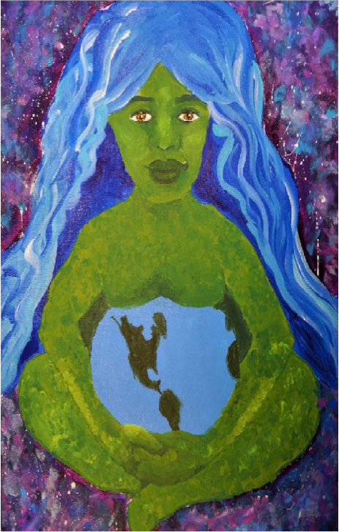

Mother Earth, Cheyenne, Showcase 2017

OVERVIEW OF THE FY 2017-2018 DYS PROFESSIONAL DEVELOPMENT SYSTEM

Highly Qualified Faculty
DYS dedicates considerable resources toward professionalizing its education workforce. Research consistently demonstrates that highly qualified teachers are the key to successful learning for all youth. To this end, DYS places a heavy emphasis on attracting, hiring, training, and retaining the most highly qualified teachers who share a commitment to work with this population. In 2008, DYS established the goal that 95% of CES instructional staff be licensed, in possession of a waiver, or have documentation demonstrating adequate progress in working toward licensure. In FY 2018, 100% of the CES instructional staff met this goal. Moreover, 61% of teachers held more than one license and almost half (48%) held a professional license, the highest level attainable in Massachusetts.
Additionally, as our English Language Learner (ELL) population continues to grow, hovering at 13% and almost 5% higher than the state average, many of our dedicated teachers and educational administrators have elected to take classes in order to earn their Sheltered English Immersion endorsement. In FY 2018, 99 of the 124 (80%) education staff who were required within 2 years of having an ELL in their classrooms had earned their Sheltered English Immersion (SEI) endorsement.

Professional Development Goals
Educators in DYS participate in high quality professional development provided and coordinated by CES. During the 2017-2018 academic year, educators participated in a set of systematic, purposeful, and coherent learning experiences over the course of the year with the dual goal of improving teacher practice resulting in improved student outcomes. Further, both in terms of structure and content, the PD promulgates high yield research-based instructional practices and relates to educators’ assignments and professional responsibilities in the planning and implementation of consistent high quality instruction for detained and committed youth in DYS. It also provides opportunity for teachers to learn from one another and gain effective knowledge and skills relevant to provisioning for learning given the diverse needs of the DYS population.
The overarching professional development goals for SY 2017-2018 included the following: Educators will:
    - Understand how Future Ready skill development will be embedded into curriculum planning, instruction, and assessment across all content areas
    - Collaborate, implement, and reflect on the use of effective co-planning practices
    - Use technology-based resources to create blended learning opportunities that create access to the general education curriculum for all students

These professional development goals were designed to increase the likelihood that faculty would be successful in fulfilling the expectations outlined in the CES Teacher Evaluation System performance rubrics, referred to as the DYS Standards and Indicators of Effective Teaching:
- Curriculum, Planning, and Assessment
- Teaching All Students
- Family and Community
- Professional Culture
We maintained the professional development theme from our prior year, “Future Ready: Personalizing Teaching, Learning, and Transition Planning,” in order to provide new and returning educators the opportunity to dive deeper into the theme and build connections across the DYS Continuum of Care throughout all four integrated PD components: Launch Day, Content PD Series, Specialized PD Series, and the New Teacher Induction Program. The professional development series increased teachers’ subject matter and professional knowledge and skills about statewide and regional initiatives underway in DYS while continuing to focus on four (4) strategic areas for professional growth:
    - Creating a personalized approach to teaching and learning in DYS schools
    - Promoting Future Ready postsecondary and career development skills in young people
    - Providing guidelines for effective instructional planning, including co-planning in DYS/SEIS settings
    - Expanding infrastructures for technology integration and Blended Learning
The professional development series launched the school year with an overview of the Future Ready and postsecondary initiatives, both from a national and state perspective. Following the launch day, two content release days and two specialized release days provided multiple opportunities for teachers to apply postsecondary prep and future ready skills to their content and pedagogy. Additionally, new teachers participated in a comprehensive five-day New Teacher Induction Program (NTIP), intended to support their long-term success in the variety of program types throughout the Continuum of Care.

Professional Development Implementation
The SY 2017-2018 general and special educator professional development series heightened educators’ awareness of the need to personalize transition planning for postsecondary and career ready experiences and opportunities for youth committed to DYS. With this in mind, DYS showcased the successful deployment and implementation of Future Ready tools and resources introduced in SY 2016-2017 and provided explicit instruction and modeling in how to apply tools, resources, and strategies for personalizing with youth across all program types.
DYS also implemented the CES Job-Embedded Instructional Coaching Framework for DYS Settings, which is grounded in research on schools as “professional communities of practice,” in which PD is most effective when it: includes job-embedded components; uses deliberate, authentic practices allowing for follow-up and continuous feedback; and focuses on student learning and connections to actual curriculum and practice.
Instructional coaching was tailored based on the three coaching modalities, including:

Residency Coaching
Instructional Coach spends consecutive and/or multiple days – potentially over several weeks – at a program with the teacher or teachers.

Rotation Coaching
Instructional Coach works with a teacher for all or part of a day for a specific, timely coaching request. Multiple visits may be scheduled to address the area of identified professional need and complete the cycle of collaborative inquiry.

Virtual Coaching
Instructional Coach assists teacher(s) with one or more specific practices by phone, email, webinar, Google Drive, or Edmodo.
DYS also hosted region-wide Content-Based Learning Team (CBLT) meetings four times during the school year. These structured-inquiry processes involved learning experiences from content-alike teachers. CBLTs created professional learning communities for teachers to share practices, analyze student data, discuss feedback on mini-units, and lesson activities to enhance classroom teaching and learning. SEIS teachers and literacy specialists also participated in quarterly CBLTs. Based on self-reported data, most teachers stated that they valued CBLTs because they provided additional opportunities for them to collaborate with their content-alike colleagues around instructional planning, curriculum and technology resources, and modeling new instructional strategies for content. Several teachers assumed leadership in the successful design and implementation of CBLTs and facilitated the learning connections for their colleagues.
The chart below outlines the scope of training opportunities during the year to support teacher growth and student engagement in learning.

PD Event Title | Description/Target Audience | Number of days/hours
New Teacher Induction Program | Teachers new to DYS | 27.5 hours
Future Ready | Professional development for all DYS General Education staff | 5.5 hours
Content PD Series | Professional development provided for each content area: ELA, History, Math, Science, Art, Health/Wellness-All DYS General Education staff | 2 days
Specialized PD Series | Professional Development provided on a variety of specialized topics-all DYS General Education staff | 2 days
Education Career Counselor | Tailored professional development for Education Career Counselors | 27.5 hours
Google Apps for Education/E- portfolio | Training for specified treatment programs | 15.5 hours

PD Event Title | Description/Target Audience | Number of days/hours
Professional Learning Communities (PLCS) | Art teachers (16.5 hours) Literacy Specialists (16.5 hours)  Health/Wellness teachers (16.5 hours) | 3 days each
Content Based Learning Teams (CBLTs) | CBLTs provided 4 times per region in each content area:  - ELA-4 days  - History-4 days  - Math-4 days  - Science-4 days | 4 days
Teaching Coordinator Meetings | TC meetings provided by program type 3 times during the year and within the region one time | 20 hours
Empower Your Future | Training for each program type and new teachers | 5.5 hours
Reading | PD provided for reading teachers via webinar and face to face trainings | 11 hours
Edgenuity | Training for all TCs | 7.5 hours
Science Guide | Training provided for all science teachers in DYS | 11.5 hours
Vocational Training | Small Engine-targeted programs | 11 hours
New Teaching Coordinator Training | New TCs in DYS | 9 hours
Coordinator Training | Training for DYS REC/ARECs: Evidence Based Observation | 4 days
CES Orientation | All DYS General Education staff-via webinar | 1 hour (offered 4 times)
Regional Training on Postsecondary Programming Guide | DYS regional leadership, district managers, caseworkers, community providers, facilities managers, program directors, clinical directors, CES leadership, education coordinators, education and career counselors, instructional coaches and teaching coordinators | 18 sessions
Job-Embedded Instructional Coaching | All teachers | ongoing

STUDENT PERFORMANCE DATA
DYS is dedicated to facilitating the academic and 21st century skill development of all our youth. DYS recognizes that each student in our care is in a different place along their college and career readiness pathway. As such, the DYS educational model provides students with multiple pathways to academic and vocational growth, including opportunities for youth to pursue and obtain a high school equivalency diploma (the GED® or HiSET®), earn credits toward a high school diploma, earn college credits, achieve success in MCAS, and gain 21st century skills and knowledge.
In order to provide context for the following charts reflecting student performance outcomes in MCAS, it is important to highlight several characteristics of our population influenced in part by “Raise the Age” legislation passed by the Legislature in 2013. First, our student population is highly transient and, relatedly, has significant gaps in formal schooling. Most of the youth who participate in MCAS testing while in our care are enrolled in a DYS education program for less than a full school year and in many cases, less than 90 days. As a consequence, DYS has limited time, sometimes as little as a week, to close significant gaps in their prior academic knowledge. What’s more, the average age of the newly committed population is now hovering at 17. This age group presents unique challenges to the Department, insofar as they are far more likely to be behind in school (44% are 2+ years behind) than their peers who are committed at age 16 or younger (6% are 2+ years behind). This combination of being older and further behind has a profound impact on the intrinsic motivation of youth, both in terms of returning to high school as well as the type of educational and vocational programming they seek to engage. Secondly, the composition of youth placed in any given classroom has notably changed since the passing of the “Raise the Age” legislation. Whereas prior to this legislation there were only a handful of youth with a diploma or its equivalent placed in classes across the state, this no longer holds true. As a consequence, teachers must both prepare to deliver rigorous and engaging instruction to youth readying to earn their diploma or its equivalent across multiple grade spans, while also planning for and supporting youth success in college and vocational programming. Thirdly, DYS adheres to the regulations set forth for participation in the MCAS as determined by DESE and therefore the number of students who participate in each subject area test differs. Lastly, the sending school district is responsible for determining eligibility of students for Special Education. As a consequence, the population of students with disabilities also fluctuates from year to year.
With this context in mind, DYS is generally encouraged by the Massachusetts Comprehensive Assessment System (MCAS) proficiency data in ELA, the number of students earning their high school diploma or HiSET®/GED®, and the number of youth taking and completing postsecondary courses and/or earning industry recognized certificates reflected in this section. However, we recognize we have a unique opportunity to facilitate youth growth and development across academic, social, and vocational domains and continue to push forward with innovations that serve to maximize this opportunity. Innovations, described throughout this report, seek to demonstrate the wide range of strategies DYS has leveraged to realize our mission.

MCAS Performance Outcomes (2017-2018)

GENERAL AND SPECIAL EDUCATION

Student Academic Performance 2018 Results
10th Grade English Language Arts | In the spring of 2018, 45 students completed the 10th grade MCAS ELA competency exam while in the care and custody of DYS. 42 of these students (93.3%) passed, a 3.1 percentage point increase over the 2017 results for 61 students.
10th Grade Mathematics | In the spring of 2018, 50 students completed the 10th grade MCAS Mathematics competency exam while in the care and custody of DYS. 31 of these students (62%) passed, an 18.5 percentage point increase over the 2017 results for 62 students.
High School Science | In the spring of 2018, 122 students completed a high school MCAS science competency exam (Biology, Physics, or Technology/Engineering), while in the care and custody of DYS.  62 of these students (50.8%) passed, a 5.9 percentage point increase over the 2017 results for 147 students.

Technical Note: This report includes results for students whose Test Stat was recorded as T (‘tested’), TR (‘tested retake’), and any NTO (‘not tested/partially tested other’) that was an accountable partial test.

ENGLISH LANGUAGE ARTS

2018 Student Academic Performance Overview
Results: General Education | 11 general education students took the 10th grade MCAS in English Language Arts in the spring of 2018. 100% of these youth passed, including those who scored in the Needs Improvement, Proficient, and Advanced categories.
Results: Students with Disabilities | 34 students with disabilities took the 10th grade MCAS in English Language Arts in the spring of 2018. 91.2% of these youth passed, including those who scored in the Needs Improvement, Proficient, and Advanced categories.

10th Grade ELA MCAS Results: DYS General Education Students
 | 2014 (N=35) |  | 2015 (N=28) |  | 2016 (N=36) |  | 2017 (N=20) |  | 2018 (N=11)
 | # | % | # | % | # | % | # | % | # | %
Failing | 2 | 5.7 | 1 | 3.6 | 0 |  | 0 |  | 0
Needs Improvement | 8 | 22.9 | 4 | 14.3 | 13 | 36.1 | 5 | 25.0 | 4 | 36.4
Proficient | 21 | 60.0 | 21 | 75.0 | 19 | 52.8 | 13 | 65.0 | 6 | 54.5
Advanced | 4 | 11.4 | 2 | 7.1 | 4 | 11.1 | 2 | 10.0 | 1 | 9.1

10th Grade ELA MCAS Results: DYS Students with Disabilities
 | 2014 (N=45) |  | 2015 (N=44) |  | 2016 (N=42) |  | 2017 (N=41) |  | 2018 (N=34)
 | # | % | # | % | # | % | # | % | # | %
Failing | 6 | 13.3 | 4 | 9.1 | 4 | 9.5 | 6 | 14.6 | 3 | 8.8
Needs Improvement | 22 | 48.9 | 17 | 38.6 | 15 | 35.7 | 14 | 34.1 | 19 | 55.9
Proficient | 15 | 33.3 | 21 | 47.7 | 22 | 52.4 | 19 | 46.3 | 11 | 32.4
Advanced | 2 | 4.4 | 2 | 4.6 | 1 | 2.4 | 2 | 4.9 | 1 | 2.9

Number & Percent of Students Passing* 10th Grade ELA MCAS
 | 2014 |  | 2015 |  | 2016 |  | 2017 |  | 2018
 | # | % | # | % | # | % | # | % | # | %
General Education | 33 | 94.3 | 27 | 96.4 | 36 | 100.0 | 20 | 100.0 | 11 | 100.0
Students with Disabilities | 39 | 86.7 | 40 | 90.9 | 38 | 90.5 | 35 | 85.4 | 31 | 91.2
* Includes students in the Needs Improvement, Proficient, and Advanced categories

MATHEMATICS

2018 Student Academic Performance Overview
Results: General Education | 16 general education students took the 10th grade MCAS in Mathematics in the spring of 2018. 81.3% of these youth passed, including those who scored in the Needs Improvement, Proficient, and Advanced categories.
Results: Students with Disabilities | 34 students with disabilities took the 10th grade MCAS in Mathematics in the spring of 2018. 52.9% of these youth passed, including those who scored in the Needs Improvement, Proficient, and Advanced categories.

10th Grade Math MCAS Results: DYS General Education Students
 | 2014 (N=34) |  | 2015 (N=31) |  | 2016 (N=27) |  | 2017 (N=21) |  | 2018 (N=16)
 | # | % | # | % | # | % | # | % | # | %
Failing | 9 | 26.5 | 8 | 25.8 | 2 | 7.4 | 8 | 38.1 | 3 | 18.8
Needs Improvement | 12 | 35.3 | 12 | 38.7 | 14 | 51.9 | 9 | 42.9 | 6 | 37.5
Proficient | 12 | 35.3 | 9 | 29.0 | 8 | 29.6 | 2 | 9.5 | 7 | 43.8
Advanced | 1 | 2.9 | 2 | 6.5 | 3 | 11.1 | 2 | 9.5 | 0

10th Grade Math MCAS Results: DYS Students with Disabilities
 | 2014 (N=51) |  | 2015 (N=54) |  | 2016 (N=55) |  | 2017 (N=41) |  | 2018 (N=34)
 | # | % | # | % | # | % | # | % | # | %
Failing | 26 | 51.0 | 24 | 48.9 | 23 | 41.8 | 27 | 65.9 | 16 | 47.1
Needs Improvement | 19 | 37.3 | 14 | 28.6 | 28 | 50.9 | 6 | 14.6 | 11 | 32.4
Proficient | 4 | 7.8 | 10 | 20.4 | 1 | 1.8 | 7 | 17.1 | 5 | 14.7
Advanced | 2 | 3.9 | 1 | 2.0 | 3 | 5.5 | 1 | 2.4 | 2 | 5.9

Number & Percent of Students Passing* 10th Grade Math MCAS
 | 2014 |  | 2015 |  | 2016 |  | 2017 |  | 2018
 | # | % | # | % | # | % | # | % | # | %
General Education | 25 | 73.5 | 23 | 74.2 | 25 | 92.6 | 13 | 61.9 | 13 | 81.3
Students with Disabilities | 25 | 49.0 | 28 | 51.9 | 32 | 58.2 | 14 | 34.1 | 18 | 52.9
* Includes students in the Needs Improvement, Proficient, and Advanced categories

SCIENCE/TECHNOLOGY/ENGINEERING

2018 Student Academic Performance Overview
Results: General Education | 39 general education students took a High School End of Course MCAS exam in Science (Biology, Physics, or Technology/Engineering) in the spring of 2018. 61.5% of these youth passed, including those who scored in the Needs Improvement, Proficient, and Advanced categories.
Results: Students with Disabilities | 83 students with disabilities a High School End of Course MCAS exam in Science (Biology, Physics, or Technology/Engineering) in the spring of 2018. 45.8% of these youth passed, including those who scored in the Needs Improvement, Proficient, and Advanced categories.

High School Science MCAS Results: DYS General Education Students
 | 2014 (N=33) |  | 2015 (N=34) |  | 2016 (N=25) |  | 2017 (N=53) |  | 2018 (N=39)
 | # | % | # | % | # | % | # | % | # | %
Failing | 10 | 30.3 | 9 | 45.0 | 10 | 30.3 | 26 | 49.1 | 15 | 38.5
Needs Improvement | 19 | 57.6 | 9 | 45.0 | 19 | 57.6 | 22 | 41.5 | 23 | 59.0
Proficient | 4 | 12.1 | 2 | 10.0 | 4 | 12.1 | 3 | 5.7 | 1 | 2.6
Advanced | 0 |  | 0 |  | 0 |  | 2 | 3.8 | 0

High School Science MCAS Results: DYS Students with Disabilities
 | 2014 (N=65) |  | 2015 (N=70) |  | 2016 (N=69) |  | 2017 (N=94) |  | 2018 (N=83)
 | # | % | # | % | # | % | # | % | # | %
Failing | 28 | 43.1 | 25 | 41.7 | 28 | 43.1 | 55 | 58.5 | 45 | 54.2
Needs Improvement | 34 | 52.3 | 31 | 51.7 | 34 | 52.3 | 36 | 38.3 | 31 | 37.3
Proficient | 3 | 4.6 | 4 | 6.7 | 3 | 4.6 | 3 | 3.2 | 7 | 8.4
Advanced | 0 |  | 0 |  | 0 |  | 0 |  | 0

Number & Percent of Students Passing* High School Science MCAS
 | 2014 |  | 2015 |  | 2016 |  | 2017 |  | 2018
 | # | % | # | % | # | % | # | % | # | %
General Education | 23 | 69.7 | 21 | 61.8 | 14 | 56.0 | 27 | 50.9 | 24 | 61.5
Students with Disabilities | 37 | 56.9 | 23 | 32.9 | 20 | 29.0 | 39 | 41.5 | 38 | 45.8
* Includes students in the Needs Improvement, Proficient, and Advanced categories

Technical Note: All four science tests—Biology, Chemistry, Physics, Tech/Engineering—are offered in June. Biology is also offered in February; the February results are included here with June results.

MCAS Improvements While In Residence (2011-2018)
DYS’s Youth Outcomes Project (YOP) is a longitudinal study of the characteristics and experiences of youth before, during, and after commitment to DYS settings. It is tracking five ‘cohorts’ of youth, defined by being committed for the first time in each of the fiscal years (July 1 to June 30) 2012 through 2016. Among the YOP’s primary objectives is to understand the paths youth take to secondary and postsecondary attainments and employment, recognizing the considerable academic hurdles they tend to face when they arrive in DYS programs. One way to mark DYS’s contribution to supporting students on a secondary attainment path is to track how many youth pass the 10th grade MCAS or improve their 10th grade MCAS score while under DYS care, relative to their MCAS performance prior to commitment.
NOTE: The tables below reflect only on Youth Outcomes Project youth—those who had been committed for the first time at some point between July 1, 2011, and June 30, 2016—for whom we had pre-commitment MCAS scores (for any grade level) AND who took the 10th grade MCAS while in residence under DYS care.

Performance Overview
ELA | Between November 2011 and June 2018, of 122 students who had failed the English MCAS prior to commitment, 104 (85.2%) passed while in residence.  Of 297 students who had previously scored Fail, Needs Improvement, or Proficient, 178 (59.9%) improved their performance level to Needs Improvement, Proficient, or Advanced.
Math | Between November 2011 and June 2018, of 255 students who had failed the Math MCAS prior to commitment, 146 (57.2%) passed while in residence.  Of 328 students who had previously scored Fail, Needs Improvement, or Proficient, 172 (52.4%) improved their performance level to Needs Improvement, Proficient, or Advanced.

GAIN Performance Outcomes (2017-2018)
The General Assessment of Instructional Need (GAIN) was adopted in February 2018 to more quickly diagnose gaps in math skills and tailor instructional accordingly. Below are pre/post data for the limited number of youth who were administered both the pre-and post-test during this period.

Performance outcomes
English | Between February and June 2018, 20 students took the General Assessment of Instructional Need pretest, followed by a post-test at least 64 days later. 9 of these students (45.0%) increased their grade level equivalent (GLE) score from the pretest to the posttest. Among those whose GLE scores increased, the average increase was 1.2 (equivalent to improving skills by a little over one year).
Math | Between February and June 2018, 20 students took the General Assessment of Instructional Need pretest, followed by a post-test at least 64 days later. 10 of these students (50.0%) increased their grade level equivalent score from the pretest to the posttest. 1 student’s score did not change. Among those whose GLE scores increased, the average increase was 2.7 (equivalent to improving skills by nearly three years).

High School Equivalency Assessment Test (HiSET®/GED®) and High School Diploma
Following are the HiSET®/GED® attainment and High School Diploma data from the past five (5) years. In addition, as a result of our collaboration with DESE, we set up five HiSET® testing sites for youth in secure residential treatment who are unable to test at a community based HiSET® testing site. It is noteworthy that while the overall population of youth committed to DYS has declined over the past several years, our students continue to attain success in this indicator at rates higher than the rest of the state.

HiSET®/GED® Attainment and High School Diploma Data for the Past Five Years
 | High School Diploma | HiSET®/GED®
2017-2018 | 89  6 Certificates of Completion | 72
2016-2017 | 60  2 Certificates of Attainment | 78
2015-2016 | 74 | 86
2014-2015 | 73 | 72
2013-2014 | 69 | 73

In 2017–2018, Education and Career Counselors registered 88 committed youth for 413 individual subject matter tests. 77 took the complete battery of tests, of which 61 passed and earned a HiSET® Diploma.

HiSET® Pass Rate 2017-2018
 | Total Batteries Completed * | Pass | Pass Rate
DYS | 77 | 61 | 79%
Massachusetts | 3939 | 2977 | 75%
All HiSET® States | 56,06 | 42,851 | 76%

*committed youth

HiSET® Average Scores by Subject 2017–2018
 | Math | Social Studies | Science | ELA Reading | ELA Writing
DYS | 11.6 | 12 | 12.9 | 10.4 | 10.7
MA | 9.8 | 11.9 | 12.4 | 10.1 | 10.6
All HiSET® States* | 10.0 | 12.0 | 12.5 | 10.4 | 10.7

HiSET® is accepted as a High School Equivalency in California, Colorado, Hawaii, Illinois, Iowa, Louisiana, Maine, Massachusetts, Michigan, Mississippi, Missouri, Montana, Nevada, New Hampshire, New Jersey, New Mexico, North Carolina, Ohio, Oklahoma, Pennsylvania, Tennessee, Texas, and Wyoming.

Postsecondary Programming
DYS is committed to preparing youth to be college and career ready and to offering a menu of postsecondary and career exploration opportunities to youth who have a high school credential, who are prepared to take the HiSET® exam, and to youth who are ready to be dual enrolled in high school and college. Throughout the year, we expanded and enhanced our partnerships with Institutions of Higher Education throughout the Commonwealth and beyond that are dedicated to providing access to higher education and certifications for youth who are involved in the juvenile justice system. This outreach effort, coupled with the expansion of technology rich environments, resulted in an increased menu of postsecondary and career readiness options for youth both in residential care and in the community. During SY 2017-2018 DYS’ focus on the Postsecondary Initiative included:

Postsecondary Education

- An Early College partnership proposal, including signed MOUs, was developed with Bunker Hill Community College, Urban College of Boston, Holyoke Community College and Quincy College. Early college offers youth the opportunity to earn up to twelve (12) college credits before earning a high school diploma. This partnership has enhanced our postsecondary programming by offering youth access to college advisers, enrollment in college courses and degree programs aligned with career interests and labor market trends, and participation in college level courses taught in residential programs by adjunct college faculty. Youth with a high school credential are able to matriculate toward an associate’s or bachelor’s degree.
The chart below reflects the exponential growth of both interest and success in postsecondary education of youth in residence as evidenced by a 145% increase in enrollment since 2015-2016.

2018
2017
2016
50%
65%
25%
Increasing numbers of DYS students are enrolled in and completing postsecondary courses
Source: Education and Career Counselors

Enrollments Completions

120%
66%
16
8
20
13
44
29

- Enrollment of ninety-eight (98) youth in postsecondary education:
  - Fifty-four (54) in the community: 37% (20) of these youth successfully completed their courses.
  - Relative to 2016/2017, these data represent an increase of twenty-eight (28) youth in the community enrolled in college coursework.
  - One student earned a BA. Two students earned industry recognized licenses.
  - Forty-four (44) in residential care: 66% (29) of these youth successfully completed their courses.
  - Relative to 2016/2017, these data represent an increase of twenty-four (24) youth in residence enrolled in college coursework.
  - Nine youth successfully completed courses across multiple semesters.
- Administration of ACCUPLACER test to 47 youth in residential care programs in all 5 regions. Relative to 2016/2017, these data represent an increase of twenty-eight (28) youth in residence ACCUPLACER testing. The ACCUPLACER is an integrated system of computer-adaptive assessments designed to evaluate students’ skills in reading, writing, and mathematics. It is used to determine student placement in introductory college courses.
- Continued participation in a partnership with the Center for Educational Excellence in Alternative Settings whereby youth in residential programs learn college level content and prepare to take a College Level Exam Program (CLEP), which, if a youth earns a passing score at the end of the class, may result in the awarding of college level credits by colleges and universities across the Commonwealth. Through this partnership, two (2) campus based sites were added as approved CLEP test centers, resulting in a total of four (4) CLEP test centers state-wide. Twenty-nine (29) youth enrolled in college level classes, learned what to expect in terms of the demands of college level coursework, and demonstrated to themselves and their peers that college is within their reach.

Career Readiness

The table below describes the number of attainments earned during SY18.

Industry Recognized Career Readiness Attainments Earned in Residence | SY18
American Screen Printers Association Certificate Screen Printer | 8
CPR Infant, CPR Child, CPR Adult, First Aid | 112
OSHA 10-Hour, General Industry; Construction, Health | 28

Industry Recognized Career Readiness Attainments Earned in Residence | SY18
C-TECH Copper Wiring | 17
Customer Service | 4
ServSafe | 7
Grand Total | 176

In order to create access to these postsecondary and credentialing opportunities, as well as the vast learning needs and testing requirements (e.g. online MCAS testing) of our high school aged youth, the Department has invested in technology and the technology infrastructure throughout our programs in the following ways:

Mobile Technologies and Google Apps for Education
- Google Apps for Education (GAFE) and Google Classroom were expanded to all short term and long term treatment programs (20), covering all five regions.
- Uniquely designed laptops were purchased to expand access for youth placed in secure treatment facilities to a vast array of rich learning resources during residential hours. These specialized laptops allow for youth to access online content, such as Khan Academy and Wikipedia, as well as a host of free, open source college (Saylor Academy), career and literacy software, without actually going on the internet, thus reducing the potential risks that come with access to the internet.
- Computer hardware was refreshed to ensure readiness for statewide online MCAS testing across all program sites.

College Now and College Board CLEP Testing Sites
- All regions were outfitted with technologies to allow youth to take classes with a virtual professor in preparation to take a College Board’s College Level Exam Program (CLEP®) test and earn transferable college credits.

HiSET® Testing Sites
- All 5 DYS regions have been approved for administration of the High School Equivalency Test (HiSET®) and the Educational Supervisors for each region have passed the exam allowing them to administer the HiSET to youth in residence.

Safety and Security
- Classroom monitoring software has been installed at all DYS programs. In addition, all installations have been updated to the latest available version, which offers additional functionality in web blocking and stability.

D Y S C O M P R E H E N S I V E E D U C A T I O N P A R T N E R S H I P R E P O R T | F Y 2 0 1 8
- The Collaborative for Educational Services promotes responsible digital citizenship as part of our deployment of new mobile technologies through the use resources provided through the online platform Common Sense Media and the requirement of a signed Responsible Use Policy by all youth who use technology as part of their learning. By adding these features to our education programming, we help youth to learn about what it means to be a responsible digital citizen.

Bandwidth Upgrades
- Internet bandwidth is essential for both individual student online learning and educator
instruction. After analyzing bandwidth usage at all sites, it was decided to increase the site-to-site E- Rate bandwidth from 10Mbps to 50Mbps at four additional residential sites in Lowell, Springfield, Methuen, and Worcester. These updates were performed in July, and bandwidth will continue to be monitored and upgraded where necessary.

Aspen Student Information System
- The Aspen Student Information System is the education management system that CES manages under its contract with DYS. The system allows the student to have a digital education record that follows them from program-to-program and ensures that teachers working with the youth have access to information about all of their educational needs. The youth’s educational progress and achievements are tracked and a transcript report is created to get credit for their academic work from their home district, or to track their post-secondary or vocational progress. Using the system gives decision-makers immediate access to aggregated data about students on a regional and statewide basis.

SPECIAL EDUCATION
The Department of Youth Services’ (DYS) Educational Services Program and the Department of Elementary and Secondary Education’s (DESE) Special Education in Institutional Settings (SEIS) division continue their joint efforts to provide collaborative approaches and greater consistency to Special Education service delivery for DYS youth.
DYS and SEIS are committed to mutually developing and supporting a culture in DYS Educational Programs that supports special education students’ access to the general curriculum and personal learning success.
The following activities supporting that commitment took place during the past year.
- Professional development offerings focusing on the year’s theme of Future Ready: Personalizing Teaching, Learning and Transition Planning, were jointly provided for SEIS and DYS educators. Application of Future Ready Skills was emphasized. Presentations demonstrated how to integrate these skills into content curriculum and instruction and familiarized teachers with a variety of related supplemental resources. Models of co-planning, station learning, whole group, and independent learning were embedded throughout. Additionally, DYS and SEIS educators shared in selected specialized trainings on teacher identified topics aligned with the year’s professional development theme.

D Y S C O M P R E H E N S I V E E D U C A T I O N P A R T N E R S H I P R E P O R T | F Y 2 0 1 8

- Learning Teams, comprised of DYS and SEIS staff, continued to meet regularly in all DYS educational programs. These teams work to develop shared knowledge and understanding of individual student needs to promote a more inclusive and personalized educational program for DYS youth. This is especially helpful for students eligible for special education.
- Co-planning by special and general educators using designated tools and processes was fully implemented across all assessment and short and long-term treatment education programs in DYS during the school year. Continued evaluation of co-planning implementation has indicated consistent use by DYS and SEIS educators and an improved instructional planning process.
- A Detention Co-planning process was piloted in a few programs and tools and processes adjusted, based on feedback from the pilot process. Plans were established for implementation in all Detention Programs during the next school year.
- The Agency Coordination Process for special education eligible students detained or committed to DYS was reviewed and updated to reflect any programmatic or regulatory changes or changes in DYS educational program practice. These joint agency guidelines reflect best practice and support more effective and efficient procedures for communication, service provision planning and inclusion of special education students in the general education program.
- Student data sharing procedures between DYS and SEIS continued to be refined and updated to best utilize a shared software system for managing student data. This student information management system enables SEIS staff to identify students eligible for special education at the earliest stages of detention and for all educators to be more informed about the needs of students in order to effectively and efficiently provide services for youth while in detention and later in treatment programs.
- DYS general education teachers and SEIS teachers use a shared student management software system that continued to provide access to and analysis of student data by all those involved in addressing the educational needs of DYS youth, enhancing individualized planning for youth in the general education setting and for future transitions.
- A standardized screening process for students not identified, but who may need to be evaluated for special education eligibility, continued.
- Regional Educational Transition Teams, that include DYS and SEIS staff, met monthly in all regions to provide a consistent method of ensuring alignment of educational services and transition planning processes for youth throughout the DYS continuum of care.
DYS and SEIS work jointly to improve administrative procedures and processes to benefit students eligible for special education.
- Both agencies continued working in partnership with DESE’s Student Assessment Services Unit to support optimal MCAS and ACCESS test administration for special education students and more functional reporting mechanisms to support effective planning for individual students.
- IEP and service delivery data monitoring and analysis are ongoing activities undertaken by both agencies, to identify problematic areas in administrative procedures and in the provision of special education services. SEIS and DYS continue to work with school districts to enhance ways in which

D Y S C O M P R E H E N S I V E E D U C A T I O N P A R T N E R S H I P R E P O R T | F Y 2 0 1 8
we can more effectively address those administrative procedures, as well as promote smooth transitions.
Both agencies will continue their collaborative efforts to promote an educational environment that provides quality special education services for all eligible students.

Transition System
In DYS, our transition system exemplifies “think exit upon entry” and provides a personalized plan for each youth to help ensure a smooth transition as the young person moves through our continuum of care and to successful reentry back into the community.
When youth are committed to DYS, they are immediately assigned to one of twelve Education and Career Counselors (ECC) on the basis of their home district. This allows ECCs to foster strong collaborative relationships with caring adults in students’ home schools, which increases the odds of a successful re- entry. ECCs have an average caseload of 56 youth, including an average of 13 Youth Engaged in Services (YES) youth per ECC.
The ECC reviews all of a newly committed youth’s records as soon as they are committed, using them to do a credit audit and prepare a Graduation Grid, which goes into the ASPEN Student Management System and allows Teaching Coordinators to know what courses students need in order to graduate or attain a credential.
The ECC schedules an “ECC Intro Meeting” during the third week of the youth’s stay in Assessment. ECCs introduce themselves, listen to youth and their concerns, and discuss a preliminary plan for the youth to follow during Treatment and after their return to the community. Last year, 232 ECC Introduction Meeting notes were recorded in ASPEN. Then, in the Initial Staffing, the ECC collaborates with the youth, parents and guardians, the caseworker, clinician, and other caring adults in the creation of a treatment plan.
Each month, ECCs visit every program in their region, meeting with youth and TCs to discuss academic progress, address concerns, praise growth, and plan action steps for each youth in preparation for reentry. In the coming years, while the EYF curriculum is refreshed, we will be working to increase collaboration with EYF teachers to leverage the ECCs’ insight and knowledge in personalizing the EYF experience for each young person.
Also monthly, each region convenes a Regional Education Transition Team Meeting (RETT), led by the Assistant Regional Coordinator, in order to discuss plans for each youth transitioning from one program to another and those reentering the community within 90 days. The SEIS School District Liaison also attends, as do other caring adults, on an “as needed basis.” This collaborative planning process is structured to maximize the potential of easing the transition process for youth.
An important part of an Education and Career Counselor’s work is to increase College and Career Readiness in their caseload of youth. Shortly after a youth arrives in Treatment, the ECC schedules a meeting in order to administer the College and Career Readiness Motivational Interview (CCRMI), an assessment designed by Dr. Rich Lapan at the University of Massachusetts to determine a youth’s strengths in 10 areas that are correlated with college and career readiness: Agency; Creating Effective Goals; Positive

D Y S C O M P R E H E N S I V E E D U C A T I O N P A R T N E R S H I P R E P O R T | F Y 2 0 1 8
Beliefs; Workforce Readiness Behaviors; Becoming a Successful Student; Knowing Yourself; Follow Your Interests; Support Networks; States of Change; and Strategic Self-Presentation.
The CCRMI helps the ECC personalize their counseling based on the individualized needs of each youth. Last year, 303 students had CCRMI recorded in ASPEN. This year, we are piloting a new web application that will help ECCs choose specific interventions based on a student’s strengths and needs. This tool will allow for youth to document their own progress and chart their own actions in growing and becoming more College and Career ready.
Starting this year, every student in Treatment will develop an e-Portfolio. Containing the College and Career Plan, as well as charting goals and displaying student work and art, the e-Portfolio will allow for each individual student’s voice to guide their educational experience in DYS and can serve as a valuable tool to show potential employers or post-secondary educators.
The ECCs also presented lessons in a treatment program in all five regions about labor market information specific to their regions. They are currently facilitating sessions in district offices about the process for seeking funding assistance for postsecondary and vocational training programs.
The ECCs plan and operationalize College and Career Fairs in all five regions, and continue to make sure student voice is an important part of the planning process.
ECCs are instrumental in helping plan a youth’s successful re-entry into the community. Working closely with the case management team as they attend youths’ 90, 60, and 30-day meetings, ECCs plan and attend school re-entry meetings for their youth engaged in an education program. They work to find allies and other caring adults in those schools and make explicit what steps will be taken to support the youth both in school and in the district office, increasing the odds that they will experience success at their school.
In the community, ECCs prioritize their attendance at students’ school meetings, including all Special Education meetings and discipline hearings. Trained in both Special Education law and Massachusetts School Discipline law, ECCs are strong advocates for students’ due process rights. Because of their presence in these meetings and their close connection to youth in the community, they are able to quickly alert managers at DYS and CES when students need more support, be it legal, emotional, or academic. As a result, students are more likely to remain in their schools and receive their high school credentials along with their non-DYS peers.

Bridging the Opportunity Gap (BOG)

Overview
The Bridging the Opportunity Gap Initiative provides funding for workforce development programming that supports youth committed to the Department of Youth Services (DYS). The BOG initiative is funded from July 1, 2017 through June 30, 2018.
The BOG initiative is based on a positive youth development model that is asset-based, culturally responsive, and delivered by personnel with experience in operating youth programs. Programming should be interactive and engaging to youth, and be delivered in a way that addresses a variety of learning styles.

D Y S C O M P R E H E N S I V E E D U C A T I O N P A R T N E R S H I P R E P O R T | F Y 2 0 1 8
The BOG initiative is based on a ‘tiered’ program model in which youth move to advanced levels of the program as they gain work readiness competencies and meet specific performance benchmarks. Within each tier, youth will experience a combination of career development activities (including classroom trainings) and a range of field experiences where they can gain exposure, test out new skills. When youth demonstrate readiness, they move up to the next tier. The highest level, Tier Four, represents unsubsidized employment, where the youth continues to receive post-employment supports from the BOG staff. BOG grantees work with Commonwealth Corporation to build and expand services and resources that result in access to a variety of employment pathways for youth involved with DYS.

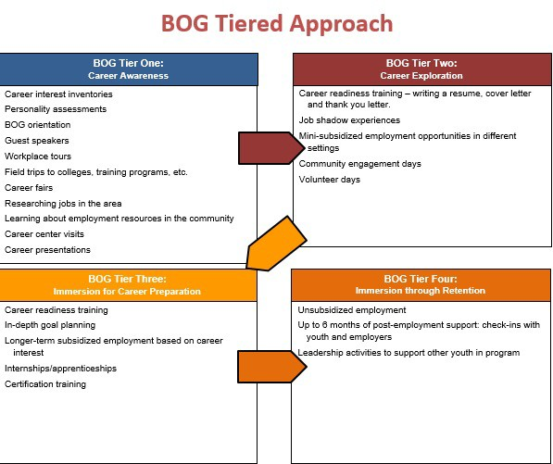

Youth Participation
During fiscal year 2018, a total of 233 youth were enrolled in BOG programming. Youth participated in a wide variety of career readiness training and field experiences as they worked through the tiers. The charts below represent the average hours youth spent in each tier for career readiness training and field experiences.

Average number of hours
Tier 3
Tier 2
Tier 1
Youth spend varying amounts of time in career readiness training as they progress through tiers.
7
13
11
In Tier 1 while youth are trained on program expectations, workplace documentation, definitions of soft skills and the importance of them in the workplace, workplace etiquette, and finding their career interests. While in Tier 2, youth continue with career readiness training and develop a career portfolio. In Tier 3, youth use the tools in the career portfolio and the skills developed in interview preparation and put them to use.

Tier 3
Tier 2
Average number of hours
Tier 1
Youth spend increasingly more time in field experiences as they progress through tiers.
105
45
11

In Tier 1 youth participate in workplace tours to raise their awareness as part of their field experience. As they start to explore their interests in Tier 2, youth are exposed to a variety of field experiences such as job shadows and mini-subsidized work placements. The opportunities in Tier 2 set the youth in place to receive a longer term subsidized placement in Tier 3.
Youth spent an average of 6 hours participating in job shadows, 60 hours participating in mini-subsidized employment, and 165 hours in subsidized employment.
During fiscal year 2018 approximately 28 youth gained subsidized employment.

Youth Outcomes
While youth are participating in the career readiness training and field experiences provided throughout the tiers, they are working towards meeting specific outcomes. A breakdown of the outcomes reached during fiscal year 2018 is listed below:

Tier One: Career Awareness - Outcomes

Outcome | % of youth Completed | % of youth not Completed
Youth identify a field of interest to explore | 97% | 3%
Youth can define one example of how each soft skill is important | 88% | 12%
Youth can articulate education/training needed for field of interest | 88% | 12%
Youth give examples of accepted workplace etiquette | 90% | 10%

Tier Two: Career Exploration - Outcomes

Outcome | % of youth Completed | % of youth not Completed
Youth use field experiences to identify a career to pursue | 92% | 8%
Youth demonstrate soft skills they have learned | 83% | 17%
Youth understand importance of career portfolio | 81% | 19%
Youth demonstrate workplace norms | 86% | 14%
Youth give examples of individual skills and interests related to a career choice | 91% | 9%

Tier Three: Career Immersion for preparation - Outcomes

Outcome | % of youth Completed | % of youth not Completed
Youth identify future education and career opportunities | 96% | 4%
Youth demonstrate soft skills in workplace | 87% | 13%
Youth actively apply for jobs – to transition to unsubsidized employment | 91% | 2%

In addition to the outcomes, youth are also expected to increase their skills in attendance, punctuality, engagement, and professionalism as they work through the tiers. The table below shows the increase in FY18:
TIER | Average of % BOG Meetings Punctual | Average of % BOG Meetings Professional | Average of % BOG Meetings Engaged | Average of % BOG Meetings Attended
1 | 65 | 62 | 66 | 74
2 | 73 | 73 | 74 | 84
3 | 74 | 75 | 77 | 86

Youth Non-cognitive Skill Gain
BOG Assessment
The BOG Work Readiness Assessment Form assesses attitudes and behaviors demonstrated by youth during BOG programming. It was completed on a weekly or bi-weekly basis by grantee staff members who work directly with youth. Youth were evaluated as long as they were provided services during that time frame. Youth were assessed based on how often they demonstrated nine non-cognitive skills: Perseverance, Optimism, Self-control, Tolerance, Discipline, Collaboration, Confidence, Communication, and Critical Thinking. Youth were rated on a scale ranging from one (never) to five (always). Youth were rated a one if they did not exhibit the skill during the week and a five if they always exhibited the skill.

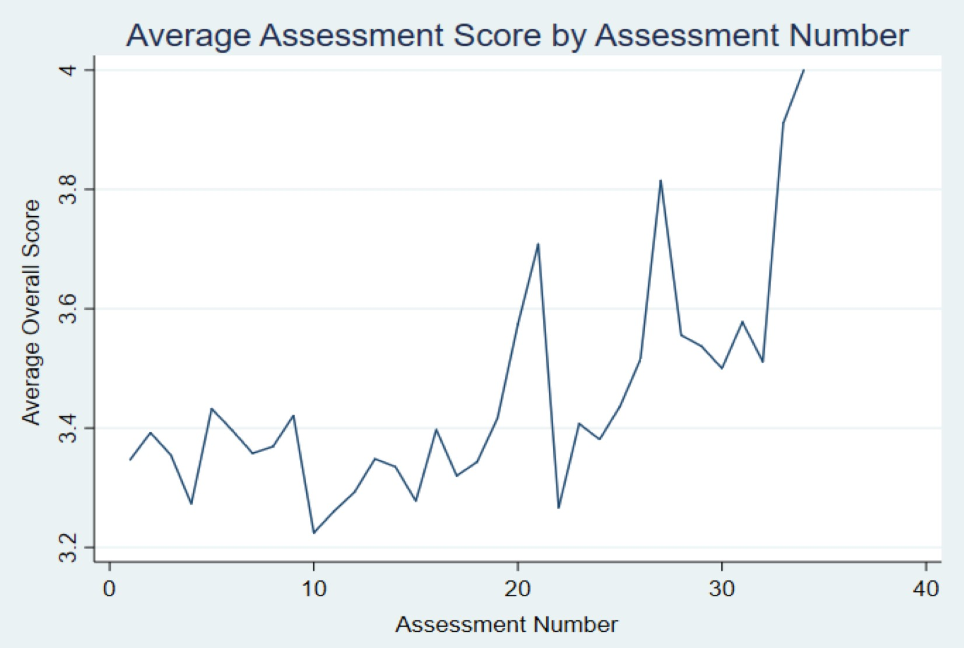FY18 Non-Cognitive Assessment

This graph is showing the average assessment score across all youth by assessment number. The average score across the FY18 cohort at the initial assessment was about 3.3. Over time the scores increased as a whole. For youth in the cohort who reached their 35th assessment their average score was 4. 181 youth showed a 21% improvement in overall soft-skills during FY18.

COLLEGE AND CAREER READINESS: EMPOWER YOUR FUTURE AND FUTURE READY INITIATIVES

Empower Your Future
The Empower Your Future (EYF) initiative is supported by a series of curricula designed to help youth take more control of their future outcomes by strengthening their voice and developing their academic, technical, workplace readiness, and social competencies as outlined in the Massachusetts Career Development Benchmarks. During FY18, the following actions were implemented to build upon the existing curriculum, integrate comprehensive youth directed services, and increase the impact of the initiative:
- Educational staff received further training and support related to implementing the EYF curriculum through:
  - New Teacher EYF Professional Development Training
  - Ongoing Technical Support from the EYF Program Manager
  - Collaboration between the EYF Program Manager and CES Instructional Coaches
  - Creation of an onboarding packet for new teachers
  - Expansion of the EYF Google Site (accessible by all CES staff) that provides access to electronic resources, training materials, teacher-created materials, and additional information to support EYF across the DYS continuum of care
  - Creation of an EYF Teacher Forum which serves as a communication platform for sharing resources and information
- DYS staff (including Clinical Directors, Casework Advisory, Program Directors) received updates on revisions to the EYF curricula and overall initiative based on the data from surveys for youth, teachers, supervisors, Education and Career Counselors, community and residential staff
- Continued collaboration with DYS staff to finalize new EYF curriculum units list and to identify opportunities to align with clinical services, residential programming, and community services through real-world application opportunities
- Work began on the creation of new EYF curriculum units and revisions to existing curriculum. The new design reflects the data from surveys and focus groups and addresses the need for more rigorous curriculum, a modular scope and sequence, and more flexibility for teachers to select units that support students’ needs and discharge planning
- Collaboration to support the integration of EYF connections embedded within the Science Instructional Guide

Future Ready
Building on the implementation of the EYF Initiative, in FY18, DYS continued to expand efforts to increase college and career readiness for youth with continued alignment to the Massachusetts Department of Elementary and Secondary Education’s Future Ready initiative; whereby all students acquire the knowledge, skills, and experiences required to enter an institution of postsecondary education or training, and are prepared to navigate the workplace and function as contributing citizens.
Being Future Ready in DYS means youth having the knowledge, skills and attitudes to complete whatever education and training they need to achieve their goals in school, work and life. The central goal of education in DYS is for students to make progress towards demonstrating the knowledge, skills and abilities that are necessary to successfully complete entry-level, credit-bearing college courses and/or participate in certificate or workplace training programs and ultimately enter economically viable careers. In order to meet this goal, DYS has developed and will continue to add Future Ready experiences to expose youth to future education and career options and provide opportunities for skill development and mastery over time. These experiences complement and enrich the acquisition of academic common core competencies.

FY18 Implementation and Development
In FY18, the Comprehensive Education Partnership continued to implement new or strengthened ideas to support this emerging body of work, including:
- Implementation of the Education Orientation process across all Treatment programs and the additional development of a pilot Education Orientation process for Detention settings
- Distribution of the Future Ready-aligned Math Instructional Guide through professional development for use in all program types across the Commonwealth and supplemented with intensive professional development
- A revised and expanded set of tools that outlines communication protocols, procedures and resources to support personalized Future Ready programming was implemented in all program types. The tools include a document “Future Ready Scheduling Guidance” that provides guidance to the field regarding scheduling learning activities for the diverse range of learners placed throughout DYS programs, including those youth still pursuing a high school credential as well as those who have already attained a high school credential and may seek to focus on postsecondary education and/or career readiness opportunities.
- Expansion of the E-Portfolio, in collaboration with the Google Apps for Education initiative, at 11 treatment programs (the E-Portfolio replaces the EYF Treatment Unit 10 project)
- Reinforced Future Ready connections in community reentry through collaborative work with the DYS Director of Community Operations using federal funds from the Office of Juvenile Justice and Delinquency Prevention Programs (OJJDP), including a pilot of the following:
  - Employer Outreach Services in the Metro Region to support and train community staff in securing career pathways for youth
  - Employer Advisory Committee in the Metro Region

D Y S C O M P R E H E N S I V E E D U C A T I O N P A R T N E R S H I P R E P O R T | F Y 2 0 1 8
  - Developed an employability resource training series for Community Staff that can be expanded for use across the state. The training includes connections to Labor Market Information, the use of the Massachusetts Career Information System (MassCIS) to support youth employment, and reviews all the future ready work including Empower Your Future that youth have access to while in the case of DYS.

THE DYS ARTS INITIATIVE
DYS has continued to make arts programming for DYS youth a priority. DYS has endeavored to refine and support system-wide structures for all arts programming; draw connections between youth success in the arts and youth success in workforce development/career readiness; and prioritize opportunities for youth to showcase their voices through the arts. In FY18 the Arts Initiative consisted of:

Visual Art Education
CES employed six (6) art teachers for the DYS residential programs – two part time teachers serving the Metro region, and one full time art teacher for all other regions. These teachers help students and teachers use the arts to improve teaching and learning, to recognize and validate the creativity of our youth, and to develop workplace readiness skills, such as creative problem solving.

Artist Residencies
Twenty-nine (29) artist residencies were conducted, engaging 19 teaching artists and taking place in 21 different programs across the state. Professional teaching artists/arts organizations are placed in residential programs across the state for residencies ranging from 6–12 weeks. Students engaged in focused, often self-reflective projects crossing many media (improvisation, drumming, poetry, drawing and painting, music production and lyric writing, theater, and more).

Arts Internships
Youth in community and residential settings across the state worked independently and in small groups with artists and arts organizations to refine their Showcase performances, create commissioned artwork, and engaged in other requested performance opportunities with community partners or at DYS events.

6th Annual Statewide Youth Showcase: “Share Your Art–Share Your Voice”
Guests gathered to celebrate youth voice through the arts; BOG and community programming; and residential programming. The DYS Showcase was the culmination of months of preparation and rehearsals by youth; their art teachers; artists in residence; participating program staff, clinicians, teachers, and management; community programs, and DYS community staff and caseworkers. Highlights from the 6th Annual Statewide DYS Showcase include:
- 134 youth visual artists submitted over 272 pieces of art and 15 youth performed
- Over 266 pieces of youth visual art on display including: 2D paintings, drawings, and prints; 3D sculptures, and wearable arts with most pieces available for sale

- A ‘Visual Arts Leaders’ initiative was piloted in which four youth artists from across the state had their work highlighted in focused display areas
- Six programs from across the state created special projects for this year’s Showcase:
  - Youth grown plants and decorative hangings curated by youth participating in the Central Region horticulture program were sold
  - Woodworking projects crafted by Northeast Region youth were raffled with proceeds being donated to Cradles to Crayons
  - Youth from the two Exclusive Tees silk screen shops printed all Showcase T-shirts
  - Young men from Harvard House provided Health and Wellness information
  - 3-D printing projects created by the technology class at Southeast Secure Detention were on display
- Three Bridging the Opportunity Gap programs attended the event and/or had work on display and for sale; two arts partner organizations had tables with information on community program opportunities.
- Over 70 youth attendees from residential programs and the community including:
  - 11 residential programs in attendance with youth
  - 8 District Offices in attendance with youth
- There were approximately 450 statewide attendees, including case workers, teachers, legislators, clinicians, program directors, provider partners, community organizations, families, and direct care staff attendees from the DYS.
Last year, youth artwork was used as the cover for Senate Committee on Ways and Means Fiscal Year 2019 Budget Recommendations (see next page), demonstrating the importance and value of the creative expression in their development as engaged citizens.

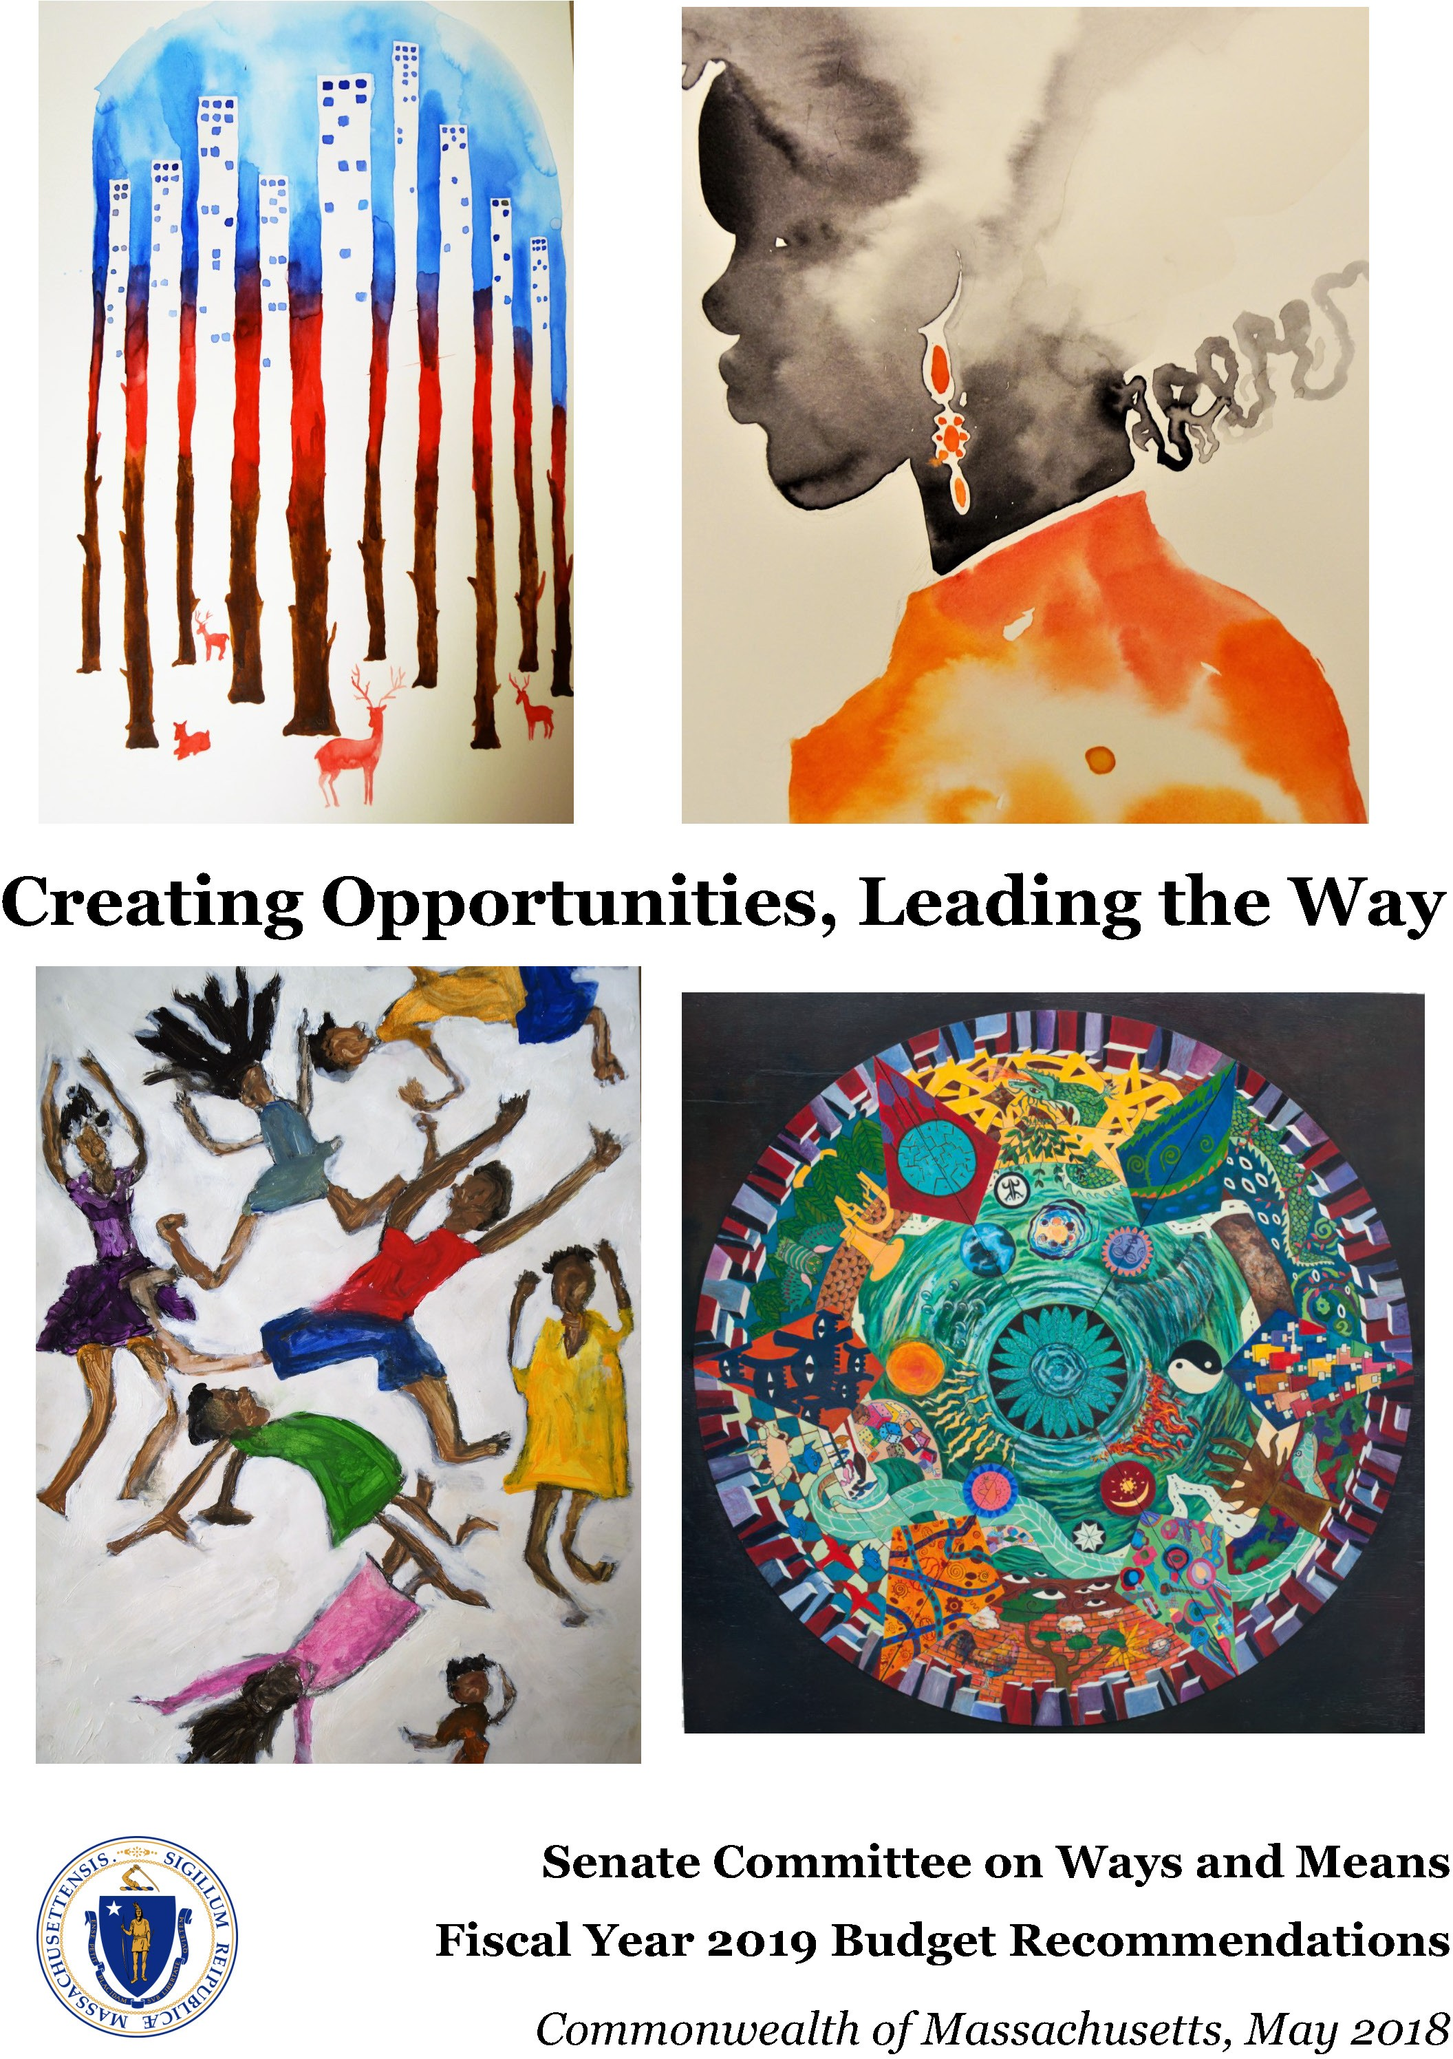

The cover images were created by Massachusetts youth artists participating in the Department of Youth Services Arts Education program. DYS is committed to effective and creative engagement strategies with youth in its care and custody, and the Arts Education program has been a proven motivator for DYS youth. The annual DYS Statewide Showcase “Share Your Art, Share Your Voice” event is made possible through a partnership between DYS, Commonwealth Corporation and the Collaborative for Educational Services.
Clockwise from top left: Deer in the City, Derek, 2016; Deep Stress, Aldo, 2017; Mandala, Youth at Westfield Youth Service Center Performance Project, 2015; Jump for Joy, Ben, 2016

SOCIAL ENTERPRISE
In 2013, DYS supported the development and operation of a small silk screening social enterprise. The silk screen social enterprise program has been designed to provide youth the opportunity to gain ‘real world’ job experience by engaging in the operations of a business. The business, called Exclusive Tees, employs youth to work as a team to fulfill custom orders, allowing them to gain workplace skills, build self-confidence, and set goals for success before transitioning into mainstream employment. Exclusive Tees has two shop locations, both within secure residential facilities, in Springfield and Taunton.

Marketing and Sales
Exclusive Tees is guided by customer orders, so that real-world scenarios guide learning experiences. The success of our business ensures that our shops have a high volume of work for youth to experience the demands of the workplace. Our sales increased by 17% in FY18, to over $55,000.
Exclusive Tees continues to receive an abundance of orders from DYS stakeholders, as well as non-profits, local businesses, individuals, and churches, most of whom have either placed multiple or sizeable orders. Our largest order in FY18 was for 1,600 shirts for the Girl Scouts of Central and Western Massachusetts.
Using an online sales platform, Exclusive Tees successfully partnered with four Massachusetts businesses to host online storefronts. These storefronts feature branded garments and bags that the businesses’ customers can view and purchase online. This endeavor yielded an extra $1,000 in sales in FY18 and helps ensure the Exclusive Tees shops have consistent orders that other businesses market for on their behalf.

Youth Development and Impact
The size of the shop space and need for hands-on skill development allows for a maximum of six youth to participate in the program at a time. The Exclusive Tees shops employed 95% more youth in FY18 than in FY17. Eight youth were certified screen printers with the American Screen Printing Association.
The Exclusive Tees shop has been a place youth can come, put aside differences, and work together toward the goal of completing an order. Work is hands-on and fast-paced. Youth see a finished product in a short amount of time, allowing them to recognize the value of their efforts and to be proud of them.
Facility staff sees increased maturity, as well as inter- and intra-personal growth, with youth on a regular basis during and after their participation in the silk screen program.
We give youth formalized feedback about their technical skills and we focus on the development of four main soft skills below. Program staff saw increased mastery in each of the soft skills on a scale from 1-5 in FY18.

Soft Skill | Initiative | Dependability | Communication | Collaboration
Beginning | 3.6 | 3.9 | 3.9 | 3.7
After 3 Months | 4.6 | 4.8 | 4.0 | 3.8

D Y S C O M P R E H E N S I V E E D U C A T I O N P A R T N E R S H I P R E P O R T | F Y 2 0 1 8
“I reached a milestone…I learn quickly and could work without having to be reminded what to do.”
– Youth Participant

FAMILY AND/OR CAREGIVER ENGAGEMENT
The DYS Strategic Plan establishes the goal of increasing family and/or caregiver engagement. The premise is that when we are able to successfully involve families with their child’s treatment and education at DYS, youth will be more likely to make progress in attaining their future goals. With System-wide attention to this goal among all partners and the support of the Center for Juvenile Justice Reform at Georgetown University, opportunities for families and/or caregivers to be involved continues to increase. Among the successes this past year include:

The 2018 Youth Showcase
Held at WGBH in Boston, the showcase brought together families and caregivers along with members of the extended DYS community to celebrate the creative skills, talents, and interests of our youth. This year, over 450 people, inclusive of youth, attended this celebration.

Open Houses and Parent-Teacher Conferences
Programs throughout the state work with education staff to host events that serve to showcase the comprehensive education programming underway in DYS, including opportunities for families to meet teachers, review the academic and career development of their and, whenever possible, hear from the students themselves about their college and career development. Last year, 123 events were held in programs throughout the state that served to engage families, caregivers, and community partners in supporting youth in DYS and their educational and career pursuits.

Graduation Ceremonies
All five (5) regions host an end of year graduation ceremony to celebrate those youth who have successfully attained their High School Diploma or its equivalent (HiSET®). These ceremonies mark a transformative milestone in the lives of many of our youth that DYS works hard to make sure that families and caregivers are able to join. Additionally, for youth who are unable to attend the community event, or whose attainment of a Diploma or its equivalent occurs during the school year, ECC’s work closely with school districts to ensure recognition of this milestone occurs in the program and with family and caregivers alike. This year, many of our graduations included former graduates who were once involved in DYS and have gone on to work, college, and a successful life.

Academic Growth Reports
The Academic Growth Report is operational across all regions and is tailored to the range of learners within any program. This report, shared at treatment meetings, showcases youth academic progress and development of future ready skills deemed critical to success in work, school, and in life. Meeting attendees include caseworkers, clinicians, program staff, family members, and other caring adults. Data show that youth appreciate and benefit from the opportunity to conference with their teachers and share their progress with other caring adults outside of the classroom.

D Y S C O M P R E H E N S I V E E D U C A T I O N P A R T N E R S H I P R E P O R T | F Y 2 0 1 8

College and Career Fairs
Each region held a college and career fair whereby youth in residence as well as in the community were provided opportunities to connect with employers in their region. This year, the Education and Career Counselors visited programs prior to these events and delivered a lesson on how to prepare for success when attending such an event.

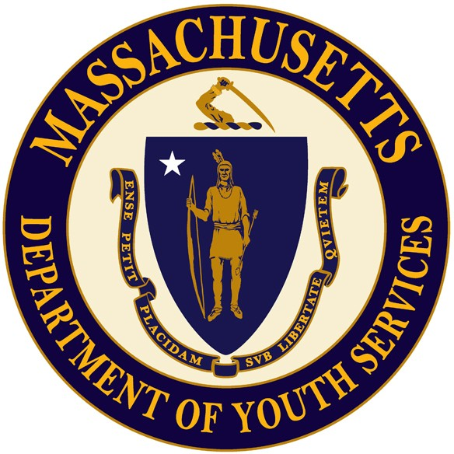

FOR INFORMATION ABOUT THE COMPREHENSIVE EDUCATION PARTNERSHIP:

Renee Heywood
Director of DYS Educational Services 617.960.3324
renee.g.heywood@state.ma.us

Massachusetts Department of Youth Services 600 Washington Street, 4th Floor
Boston, MA 02111

Commonwealth Corporation www.commcorp.org
Collaborative for Educational Services collaborative.org

