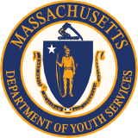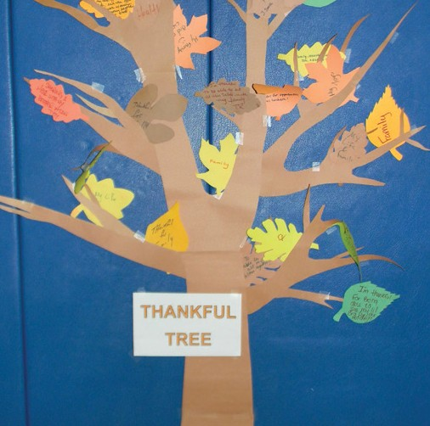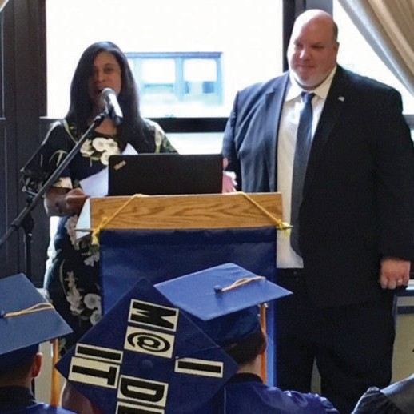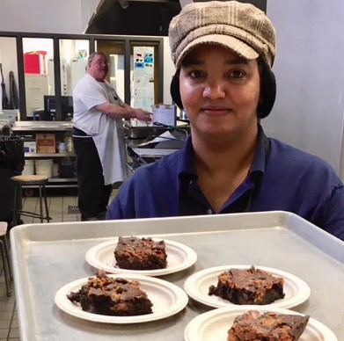

FY 2017
Annual
Report

MASSACHUSETTS DEPARTMENT OF
YOUTH SERVICES

www.mass.gov/dys | 600 Washington Street, 4th Floor | (617) 727-7575

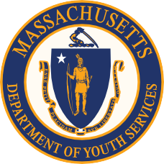

INTRODUCTION FROM THE COMMISSIONER

Every day, in many ways, more than 800 Department of Youth Services employees and 1,500 provider employees work to improve life outcomes for youth in our care. Bringing to their respective jobs and work locations unique expertise and years of experience, our staff promote positive change for our youth.
This Fiscal Year 2017 Annual Report showcases how DYS is strategically engaging youth, families and communities to promote positive youth development and helping keep Commonwealth communities safer. Highlighting our positive youth outcomes, our FY 2017 successes include:

Highlights

140 DYS youth earned High School Diplomas, HiSET, GED or Certificates of Attainment in School Year 2016-2017

82% HiSET pass rate among DYS youth who took the test (78% in Massachusetts overall)

52 DYS youth enrolled in post- secondary education
The numbers reveal only part of the story. You’ll find the rest of the story in the joy of youth who against all odds earned their High School Equivalency... in the candor of family members who share feedback on ways we can work together to improve services for their children... in the pride of a youth whose artwork earned compliments at our Youth Arts Showcase... in the encouraging words of a caring staff member... and more.
This report shows our agency’s progress in reducing recidivism, embracing best practices, improving youth outcomes in the community, supporting youth educational attainment, and providing effective community transition services to enhance public safety.
We are committed to building on this progress in collaboration with youth and families, our employees, our providers and our stakeholders.
Sincerely,
Peter J. Forbes

CONTENTS

4 WHO WE SERVE
5 Committed Youth
7 Detained Youth
10 Youth Engaged in Services (YES)

12 OUR INVESTMENTS
- DYS Budget
- Investing in Youth
16 Bridging the Opportunity Gap (BOG)
18 Recidivism
20 Investing in Staff
22 Training
24 Staff Safety, Development and Recognition

28 INNOVATING & IMPROVING
29 Engagements, Grants and Initiatives

WHO WE
SERVE

Committed Youth (as of the 1st of each year)

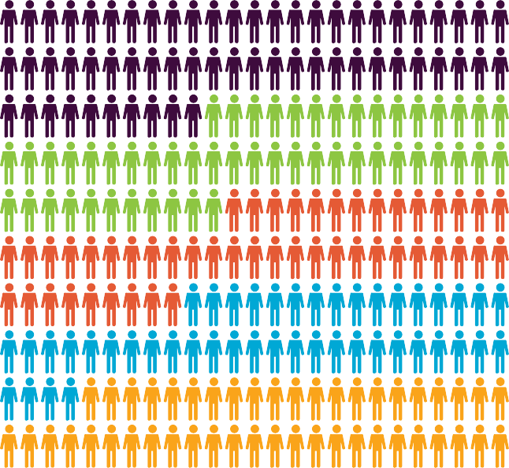

DYS First-Time Commitments (300)

2013 (836)

2014 (717)

2015 (675)

2016 (626)

2017 (651)

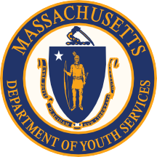Race/Ethnicity Age
Committed Youth

 |  | 17 | aged 14 & younger
 |  | 54 | aged 15
44% | Hispanic | 66 | aged 16
27% | African American | 163 | aged 17 & older
25% | Caucasian
3% | Other
<1% | Asian American
Gender
Male Female
13%

38
262
87%

WHO WE SERVE 5

DYS First-Time Commitments by Grid Level
140
120
100
80
60
40
20

0
11
6

25

50

73
135

DYS assigns each youth a Grid Level reflecting the most serious offense for which they’ve been committed. Grid Levels range from one (least severe) to six (most severe). DYS uses the
Grid Level in the classification process to determine both the recommendation for time in the initial residential setting as well as whether the youth will be placed in a community-based or secure setting.

Grid 1

Grid 2

Grid 3

Grid 4

Grid 5

Grid 6

Typical Offenses Corresponding to DYS Grid Levels

Grid 1:
Operating a MV with a suspended license, marijuana possession
(over 1 ounce), shoplifting, disorderly conduct, trespass.

Grid 2:
OUI liquor or drugs, possession of heroin, assault, assault & battery, tagging, breaking & entering.
Grid 3:
Robbery, stalking, burning buildings (arson).
Grid 4:

Indecent A&B on a child, assault to murder or maim, assault & battery with dangerous weapon (ABDW) with significant injury, armed robbery, carjacking, kidnapping.
Grid 5:

Involuntary manslaughter, A&B on a child with substantial injury, attempted murder, armed robbery with firearm, assault to murder (armed), armed carjacking.
Grid 6

Manslaughter, home invasion, rape of child under 16 with force, trafficking firearms (20+ weapons).

In Calendar Year 2017, 70% of the most serious
offenses related to first-time commitments were below Grid 4; 62% were Grid Levels
2 and 3.

6 DYS Annual Report FY 2017

Detention Admissions by FY & Race/Ethnicity
Hispanic
Black
White

FY 2014 FY 2015 FY 2016 FY 2017
Other
Asian

Detention Admissions by FY & Age at Admission
800

700

600

500

400

300

200

100

0
900

The increase in detentions of 17-year-olds in FY 2015 is due to Raise the Age legislation enacted late in the previous FY.
0
100
200
300
400
500
600
700
800

13 & under 14 15 16 17 & older
Detained Youth
FY 2014 FY 2015 FY 2016 FY 2017

WHO WE SERVE 7

Detention Admissions by FY & Grid Level

Offenses for which a juvenile could be adjudicated by DYS are categorized by one of six Grid Levels that correspond to specific offenses (see page 6 for Grid). In FY 2017, over 80% of detained youth were Grids 2, 3 and 4.

FY 2014 FY 2015 FY 2016 FY 2017

Grid 1 | 188 | 168 | 129 | 104
Grid 2 | 1167 | 1012 | 931 | 749
Grid 3 | 448 | 462 | 435 | 312
Grid 4 | 231 | 299 | 381 | 300
Grid 5 | 104 | 94 | 95 | 100
Grid 6 | 41 | 64 | 57 | 53

Detention Admissions by FY & DYS Region

All Regions have trended down during the past four fiscal years. From FY 2016 to FY 2017, the greatest percentage decreases were in the Central (25%) and Metro (29%) Regions.

FY 2014 FY 2015 FY 2016 FY 2017

Central | 474 | 364 | 386 | 292
Metro | 402 | 353 | 454 | 325
Northeast | 365 | 523 | 388 | 301
Southeast | 517 | 414 | 426 | 371
Western | 427 | 453 | 383 | 333

8 DYS Annual Report FY 2017

YOUTH IN CUSTODY PRACTICE MODEL

In FY 2017, DYS was selected to join the inaugural cohort of the Youth in
Custody Practice Model (YICPM) Technical Assistance and Training Program. This
18-month engagement with Georgetown University’s Center for Juvenile Justice Reform and the Council of Juvenile Correctional Administrators provided technical and training assistance to DYS to improve the quality and safety of secure residential services.
DYS chose four areas to focus on
improving:
- Racial & Ethnic Disparity
- Behavioral Supports
- Family Engagement
- Case Planning

ADDRESSING RACIAL & ETHNIC
DISPARITY
To enhance outcomes for all youth, DYS examined the extent to which disparities exist, collected and analyzed relevant data, and worked on developing strategies to eliminate any such inequities.

BEHAVIORAL SUPPORTS
Statewide meetings were held with the operations and clinical teams to review and evaluate behavioral support practices in DYS programs. The meetings identified recommendations for standards for behavioral supports; training is ongoing.
FAMILY ENGAGEMENT
The Family Engagement Workgroup developed and updated policies and guidelines for increased family
involvement in all aspects of the DYS continuum. Family surveys were gathered and analyzed to provide feedback for
the proposed policy changes and for the upcoming statewide trainings on increasing family engagement.

CASE PLANNING
To ensure that each DYS youth has an individualized case plan that adequately addresses their individual needs, the Case Planning Workgroup focused on identifying gaps in case planning and devised a plan to bridge those gaps.
The Workgroup 1) created a standard for attendees and agendas for monthly treatment meetings, making sure the
agenda encourages genuine participation by youth and their families; 2) enhanced Case Planning to ensure levels of supervision are commensurate with levels of risk; 3) established a consistent review process to ensure youth are working toward their respective goals.

WHO WE SERVE 9

Average Daily YES Participation Compared to Committed and Detained Youth Population, FY 2013–FY 2017

800

700

600

500

400

300

200

764

141

696
660 652 640

182 191 191 154
In FY 2013, DYS began offering YES services to DYS discharged youth. From FY 2013 to FY 2017, the percentage of youth opting for YES services has steadily increased.

FY 2017

359
DYS youth on YES status

100

0 65
134 143

138
151
210
New YES cases

FY 2013 FY 2014 FY 2015 FY 2016 FY 2017

Committed Detained YES
151
Average daily YES population

Through the Youth Engaged in Services (YES) Program, DYS offers voluntary, post- discharge services and case management support to youth beyond their DYS commitment until their 22nd birthday.
Statewide, the average duration of a YES engagement is just over six months. This is significant because DYS’ annual Recidivism Report indicates that of youth who were reconvicted for offenses committed within one year of discharge, most were reconvicted
within the first six months of being discharged from DYS. According to preliminary data, when compared with a like group of youth who did not opt into YES, YES youth were less likely to be arrested within the initial six months following discharge. Youth may opt in to a YES agreement as part of their discharge planning process; youth who opt out at discharge have a 90 day window in which they can request YES services.

In FY 2017, approximately half of all youth discharging from DYS opted to engage in a YES agreement.

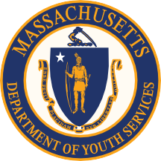

Youth Engaged in Services (YES)
10 DYS Annual Report FY 2017

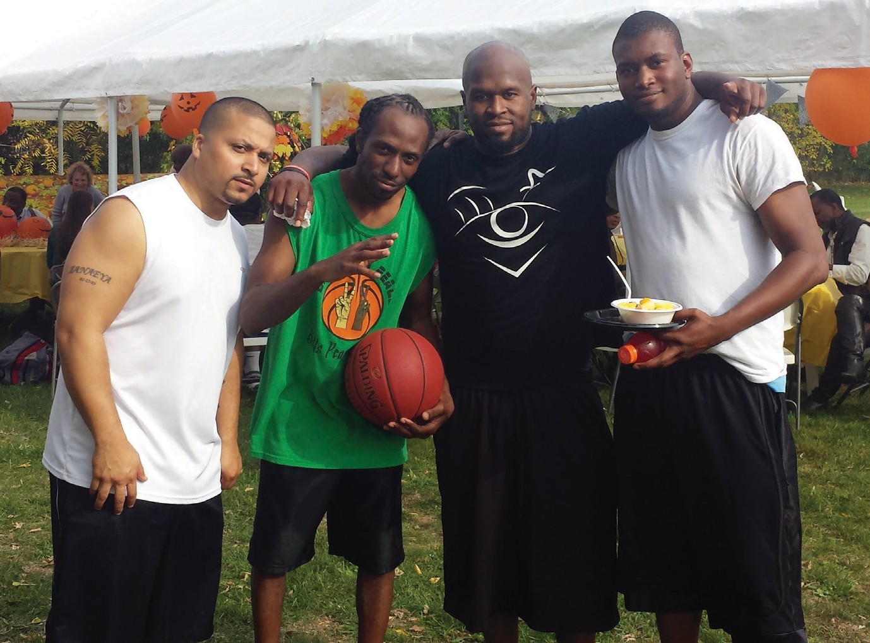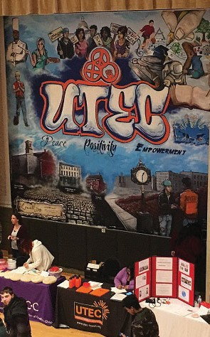

“If you treat an individual as if he were what he ought to be and could be, he will become what he ought to be and could be.”

Johann Wolfgang von Goethe

Average Total Days in YES (FY 2017)

194 193.0
192
190
188
Number of Days
186
184
182
180
18
178
176
174 5
.3
17

9.3

1
.1
18

Fiscal Quarter

FY 2017

WHO WE SERVE 11

OUR INVESTMENTS

Dollar Distribution

176,924,231

Committed Residential
$116,373,492
Detained Residential
$27,633,139
Committed Non-Residential
$23,179,824
Administration and Operations
$4,375,287
Teacher Salaries
$3,154,187
Alternative Lockup
$2,258,302

How DYS’ Budget Serves Massachusetts
66%
Percentage of FY 2017 budget for residential services & committed youth
2%
Percentage of FY 2017 budget for DYS administration and operations
16%
Percentage of FY 2017 budget for residential services & detained youth
2%
Percentage of FY 2017 budget for teacher salaries
13%
Percentage of FY 2017 budget for community services & committed youth
1%
Percentage of FY 2017 budget for the Alternative Lockup Program (ALP)
OUR INVESTMENTS
13

DYS Budget

HiSET/GED Attainment and High School Diploma Data, School Years 2012-13 through 2016-17

Since 2003, DYS has collaborated with Commonwealth Corporation (CommCorp) and the Collaborative for Educational Services (CES) to deliver quality educational services through the Comprehensive Education Partnership. Understanding that education improves life outcomes for youth in our care, DYS provides educational services in all our residential programs. Educational services are
provided year round, five days a week, with 5.5 hours of instructional services daily.

Although the number of committed youth is decreasing each school year, the percentage achieving educational attainment is increasing.

Youth Educational Attainment
400
350
Number of Youth
 |  |  | 78
300 | 60
250 |  |  | 86
 | 74
200
 |  |  | 72
150 | 73
100 |  |  | 73
 | 69
50
 |  |  | 80
 | 63
0

High School Diploma HiSet or GED

2012-13 2013-14 2014-15
2015-16 2016-17
School Year 2016–17
140
DYS youth earned High School Diploma, HiSET, GED or Certificates of Attainment in School Year 2016-17
82%
Pass rate among DYS youth who took the HiSET test (78% in Massachusetts)
52
DYS youth enrolled in post- secondary education
14
DYS Annual Report FY 2017

Investing in Youth

Technology Facilitates Blended Learning & Career Readiness

Through a partnership with the Center for Educational Excellence in Alternative Settings (CEEAS), DYS grew the number of programs and faculty using Chromebooks and Google Apps for Education to greater personalize education and career readiness experiences. All participating programs have increased student engagement as teachers and students together explore technology that supports blended learning. Students have coded, built robots, designed and printed 3D products, created poems and digital stories with a restorative justice lens, and written public books.

All five DYS regions are approved to administer the High School Equivalency Test (HiSET) in our secured residential settings. Each region has Educational Supervisors who can administer the HiSET to youth in residence.

“As a human being and an African American man, I have always thought it important to conduct one’s self in a positive manner and model behavior that is right and just. Each day, I strive to lead by example at work, at home and in the community. I hope that in some small way I may affect the lives and character of individuals I encounter.”

Leroy G.
Detention Coordinator

OUR INVESTMENTS 15

DYS’ Bridging the Opportunity Gap (BOG) initiative is operated by our partner, Commonwealth Corporation. During FY 2017, 299 youth were enrolled in BOG programming.
BOG offers youth workforce development, training, education (HiSET and tutoring), arts and culture and mentoring programming, with a special focus on those returning to their home communities following residential treatment.

BOG Participation by Fiscal Year

Through BOG, DYS youth receive comprehensive employability services including training in career and vocational readiness and leadership and youth development. They can gain workforce certifications and subsidized employment experience.

400

350

300
Number of BOG Participants

250

259

268

299

200

210

150

100

50
366

0
FY 2013

FY 2014

FY 2015

FY 2016

FY 2017

Bridging the Opportunity Gap (BOG)
16 DYS Annual Report FY 2017

BOG Facts

BOG participants earn credentials and certificates as they train in specific vocational and entrepreneurship tracks. While some programs (such as art produced for the annual Statewide Youth Arts Showcase and silk- screening through Exclusive Tees) offer youth the opportunity to earn money, all help them develop and hone leadership, teamwork, and communications skills.

BOG programs include:

Horticulture (Western and Central Regions)
Silk-screening (Metro and Western) 3D Printing (Central)
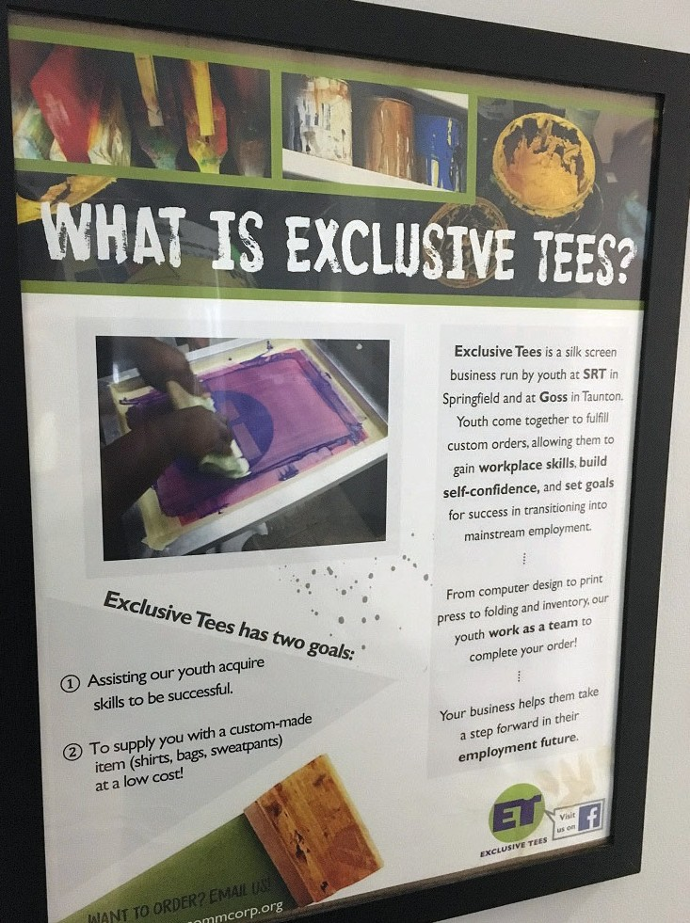
Carpentry and Woodworking (Northeast) Fitness Trainer Certification (Southeast) Culinary Arts (Western)
Professionals deliver BOG in ways that take into account diverse learning styles; delivery is based on DYS’ asset-based and culturally responsive Positive Youth Development (PYD) model.

259
Youth enrolled in subsidized employment

25
Youth enrolled in arts and cultural activities

15
Youth enrolled in technical skills training

OUR INVESTMENTS 17

DYS’ strategic planning process prioritizes education, vocational training, and employment for youth in our care and custody. Our agency’s sustained focus on positive youth outcomes is a strategy to interrupt the delinquency trajectory and help our youth become productive and
law-abiding citizens upon returning to their communities.
Recidivism* is generally the most common measure used to determine the effectiveness of interventions with juvenile offenders. This page shares recidivism data for a sample of 357 DYS youth who were discharged during calendar year 2013.

Of the 357 youth in the sample, 14% were convicted within the first six months of their discharge.
Youth at high risk for conviction as adults tended to be males who had been committed to DYS custody for violent offenses.
Each year, our agency studies a different DYS discharge group. After discharge, we track the youths’ offense histories for two years; an additional year is needed to resolve the court cases. We then analyze the data and write a report, accounting for the four years.

*This report defines recidivism as a conviction in the adult system for an offense committed within one year of discharge from DYS.

Recidivism by Gender

28%
Recidivism rate among males discharged from DYS in 2013
11%
Recidivism rate among females discharged from DYS in 2013

Recidivism

18 DYS Annual Report FY 2017

Recidivism by Offense Type

43%
Recidivism by Ethnicity
White
African American Hispanic
Other
18%
25%
24%
33%
Highest & Lowest Recidivism
Person
15%
17%
Property
Drugs
23%
14%
13%
17%
Motor Vehicle Weapons
Public Order
OUR INVESTMENTS
19
Recidivism rate associated with youth who had been adjudicated for assault
19%
Recidivism rate associated with youth who had been adjudicated for breaking and entering

Employee Demographics

229
Female DYS Employees (27%)
610
Male DYS Employees (73%)
27%
73%

839
Full Time DYS employees

69%
DYS employees who have worked less than three years in our agency

40.3
DYS employee average age
396
DYS employees (male/ female) who self-identified as minorities

55
DYS employees (female/ male) who self-identified as veterans

Investing in Staff

20 DYS Annual Report FY 2017

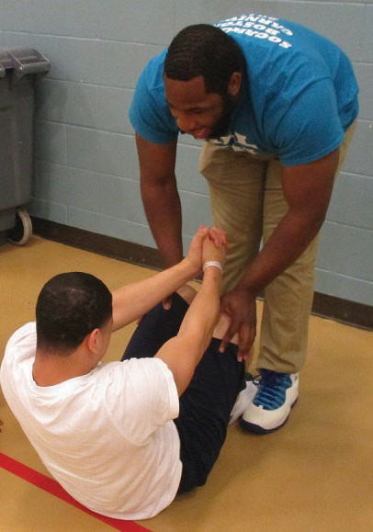
More than 80% of the DYS workforce is employed in a direct care role in the following titles:
Youth Services Group Worker Youth Services Caseworker Clinician
Institutional Security Officer Detention Coordinator Transportation Officer Apprehension Officer
Whether it’s encouraging physical fitness or planning and holding fun family events, DYS and provider employees in direct care roles are engaged and invested in the lives of our youth.

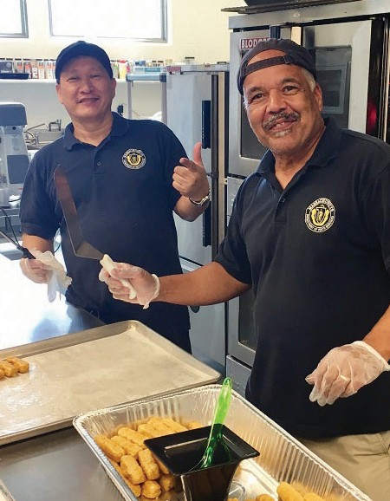
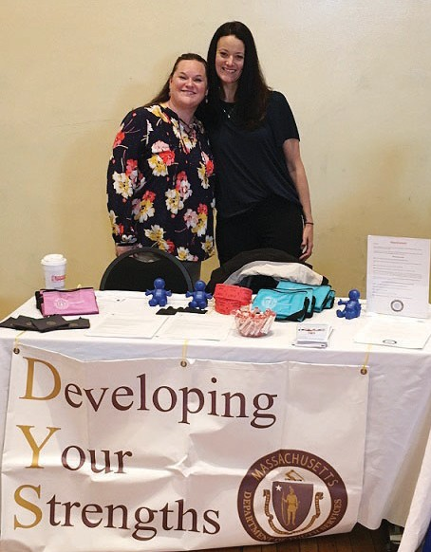

OUR INVESTMENTS 21

Training

All new DYS staff complete three weeks of Basic Training, two of which are at the DYS F. Robert Brown Training Center. Many provider staff also attend Basic Training at the Training Center.

750
700
650

57
Number of Trainees
600
550
500
450
400
350

3

2012

60

2013

716

2014

1

672

2015

718

2016

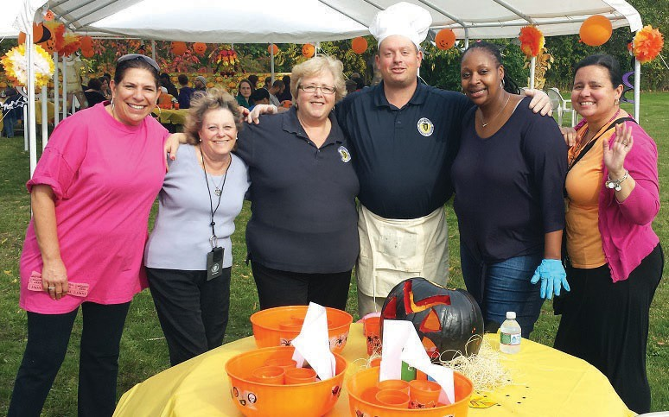

“Thank you to DYS for giving me the opportunity to serve my community and thanks to my Southeast Region family for their continuous support.”

Okeno S.
Group Worker II

22 DYS Annual Report FY 2017

495
DYS and provider employees trained in LGBTQI-GNC
250
DYS and provider employee Narcan Responders trained
92
DYS and provider employees completed state-wide Trauma Informed Care training

Prison Rape Elimination
Act (PREA)

PREA is a Federal law that requires states to comply with a comprehensive set of standards focused on safety from sexual assault for all individuals confined in correctional settings, including youth confined in DYS secure residential settings.
In 2017, DYS successfully completed the first round of the second three-year PREA audit cycle. For the fourth consecutive year, DYS achieved the highest rating of compliance with the standards for the Massachusetts juvenile justice system.

“In Massachusetts I observed such a seamless and coordinated implementation of the PREA standards that I could not tell the difference between a vendor provider and DYS operated program. All used the same language, knew the same policies and procedures, received the same high quality training and had the same commitment to keeping youth safe.“

(PREA Inspector letter)

OUR INVESTMENTS 23

Staff Safety, Development
and Recognition

Efforts to improve workplace safety are yielding positive results, and we aspire to continue that trend by bringing together staff at all levels to strengthen our safety culture. Between FY 2016 and FY 2017, both Notice of Injury (NOI) and Lost Time (LT) Workers’ Compensation claims decreased by 17%.

NOTE: NOI claims are all reported workplace injuries. LT claims are reported workplace injuries that resulted in five or more days lost from work.

DYS Workers’ Compensation Claims Frequency

 | FTE Counts | NOI Claims | LT Claims
FY 2015 | 873 | 199 | 125
FY 2016 | 822 | 212 | 126
FY 2017 | 834 | 176 | 104

24 DYS Annual Report FY 2017

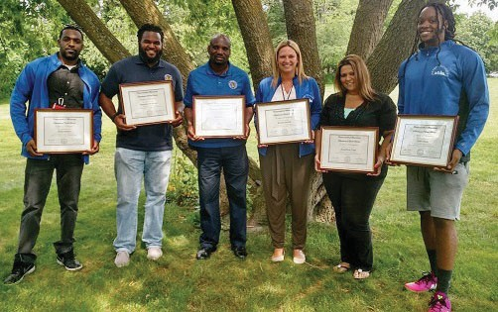
DYS Workers’ Compensation Claims/100 FTEs

26 25.8
24
22 | 22.8
20 |  | 21.1
18
16
14
12 | 14.3 15.3 12.5
10
8
6
4
2
0

Internal Resources Propel Staff Development
Number of Claims/100 FTEs

FY 2015 FY 2016 FY 2017

Notice of Injury (NOI) Claims Lost Time (LT) Claims

Comparing the Notice of Injury claims to the Lost Time claims shows a correlative increase in percentage in FY 2016 over FY 2015, and a reduction of both claims percentages from FY 2016 to FY 2017.
The percentage reductions in FY 2017 lowered the strain on the DYS budget and decreased the agency’s use of additional personnel and overtime to fill gaps in staff coverage in secure residential facilities.
Metro University is a pilot program for employees working in the Greater Boston area. Conceived and designed by employees for employees, Metro University’s courses provide staff with understanding and skills that can help reduce/eliminate violence by youth against other youth and staff. Program designers engaged staff to identify common themes that connect across job titles, such as mediation, communications, leadership, creative thinking, respect, and recognizing racial and ethnic disparities in our work. Upon completing
the 10-15 hours of coursework, students representing residential and community staff were awarded Certificates of Completion in June 2017.

OUR INVESTMENTS 25

Recognizing Outstanding Performance

DYS PREA Team
Earns Prestigious Commonwealth Award

Massachusetts Governor Charlie Baker awarded the DYS PREA Team the Carballo Award for Excellence in Public Service in recognition of the successful PREA audit and work of the DYS implementation team.

Commonwealth Performance Recognition Program at the State House

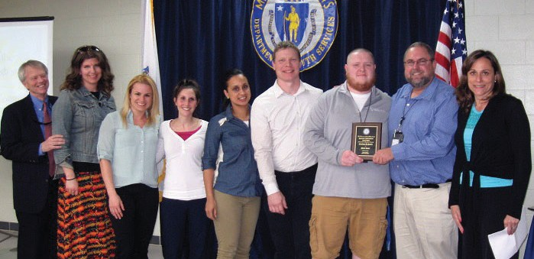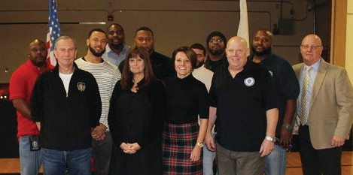

Metro Region Performance Recognition

Western Region Performance Recognition

Central Region Performance Recognition
26 DYS Annual Report FY 2017

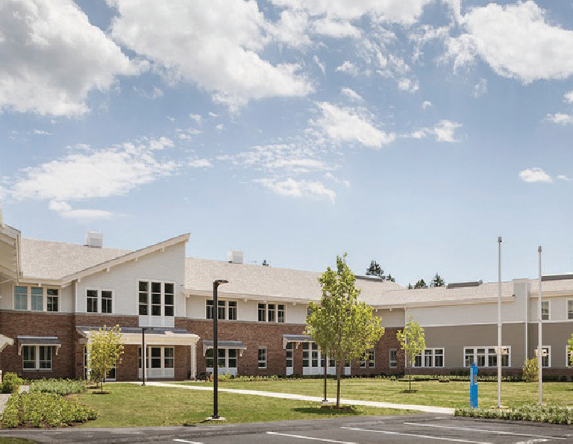
Updating & Modernizing DYS Facilities

Designed to safely serve juvenile justice involved youth in residential settings and provide rehabilitation, DYS opened a new Northeast Youth Services Center in Essex County (photo right) in FY 2017.
The state-of-the-art, $47M secure facility has modern classrooms, counseling spaces for individuals and groups, an outdoor track and recreation area, and vocational training areas. It earned LEED Silver certification.
DYS also invested more than $1M to improve the power infrastructure and water quality at the Southeast Region’s Youth Forestry Camp in Brewster and $350,000 to improve water quality and circulation at Westborough and Worcester facilities.

In the Western Region headquarters in Springfield, DYS improved facility safety by removing obsolete and potentially hazardous materials.
DYS also enhanced facility safety and living conditions at the Metro Region headquarters in Dorchester by improving drainage and ventilation.

Transporting Youth & Staff Reliably, Safely & Comfortably

In FY 2017, DYS updated and modernized our fleet, adding Ford T250 Transit vans. Custom safety enhancements included: backup cameras, backup alerts and improved visibility. Inside, the vans are equipped with interior cameras that use subtle infrared lighting.
A custom compartment design allows staff to reliably, safely and comfortably transport youth to and from DYS locations and courthouses, medical appointments and programming activities.

OUR INVESTMENTS 27

INNOVATING & IMPROVING

Engagements, Grants
and Initiatives

Focus on Racial & Ethnic
Diversity

In FY 2017, DYS began examining gaps in how we identify and address racial and ethnic disparities in our work. One of five agency strategic priorities, this ongoing introspection involves staff, youth, family and community voices.
DYS Regions developed “RED Action Plans” that set measurable deliverables in the areas of policy and practice, training, performance evaluations and quality assurance.
Also in 2017, DYS (in partnership with JDAI) delivered “Seeing RED,” a training video designed to increase awareness of racial and ethnic disparities in our work. These tools prompt constructive dialogue about RED throughout DYS.

Engaging Families

Seeking to improve family engagement and the family experience throughout the DYS continuum, the Family Advisory Council (FAC),
comprised of families of current and former DYS involved youth, meets regularly to offer DYS staff and fellow family members feedback and advice.
As part of DYS’ Second Chance Act Smart on Juvenile Justice Grant (see page 30), the FAC ensures that families’ unique perspectives and experiences are both heard and integrated as appropriate into DYS programming.
The FAC provides valuable input on issues impacting service delivery and advice that can help ease the journeys of other parents, family members, or guardians of DYS involved youth.

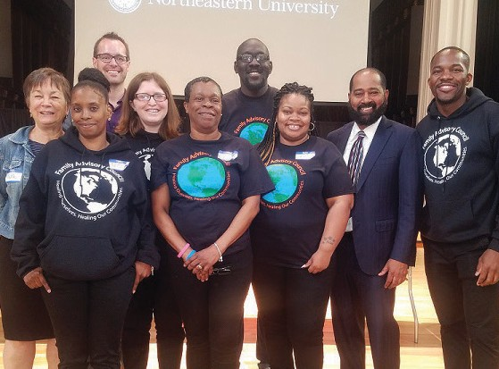

INNOVATING & IMPROVING 29

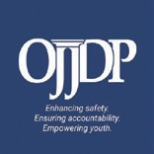 OJJDP “Second Chance” Grant
In FY 2017, DYS received a $413,598 Community Supervision Implementation Grant from The Office of Juvenile Justice and Delinquency Prevention. The grant funded DYS implementation of the Community Supervision Reform Strategic Plan. This plan leveraged adaptable, evidence-based practices to reduce revocations by creating and implementing Graduated Responses Systems, addressing racial and ethnic disparities, improving family engagement and inclusion, and
increasing educational and employment opportunities for DYS committed youth. DYS has received two such grants as “lead agency” and a third as a co-recipient.

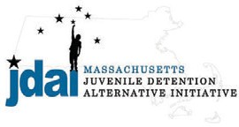 Juvenile Detention Alternative Initiative (JDAI)
JDAI is a national public safety partnership that seeks to reduce the unnecessary and harmful use of secure detention for low-risk juveniles. In Massachusetts, JDAI ensures that “the right youth, is in the right place, for the right reason.” DYS began participating as a JDAI agency partner in 2006. Since then, detention admissions in Massachusetts have dropped by 57%. More importantly, JDAI has changed the culture of how we support young people, engage families and communities that we serve, and work together to serve youth.

Lookout Foundation Grant Funds JDAI

In FY 2017, DYS received a three-year $894,960 grant from the Boston- based Lookout Foundation, Inc. that enabled Massachusetts to enhance and replicate the JDAI model beyond the original six Massachusetts counties. The grant funded expansion of the Commonwealth’s county- level JDAI work and added two staff (JDAI local coordinators), a part-time JDAI data analyst, and a Probation Service JDAI Coordinator who will work with Probation Chiefs to implement reforms.

30 DYS Annual Report FY 2017

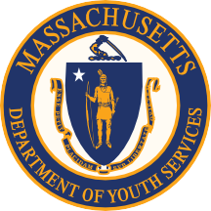
DEPARTMENT OF YOUTH SERVICES

VISION

Every young person served by the Department of Youth Services (DYS) will become a valued, productive member of their community and lead a fulfilling life.

MISSION

As the juvenile justice agency for the Commonwealth of Massachusetts, the Department of Youth Services promotes positive change in the youth in our care and custody. Our mission is to make communities safer by improving the life outcomes for youth in our care. We achieve our mission through investing in highly qualified staff and a service continuum that engages youth, families, and communities in strategies that support positive youth development.

VALUES

- We are unwavering and persistent in the pursuit of the positive development of youth in our care.
- We promote safer communities by providing prevention, intervention, and rehabilitation services.
- We actively engage and support youth, families, and communities as our partners.
- We actively support a safe and healthy environment for our diversified and highly skilled workforce.
- We work collaboratively with our public and private partners.
- We adhere to the highest ethical and professional standards in all our work.
- We respect and embrace diversity.

GOALS

- Ensure the “right youth is in the right place for the right reasons” through juvenile justice reform strategies that engage public, private, community and family partners.
- Improve youth success through a continuum of services based on the science of adolescent development and proven and promising practices in juvenile justice.
- Youth sustain the gains they made while in DYS custody through improved discharge planning and continuing community supportive partnerships.
- Develop and focus DYS’ human, physical, and organizational capacity necessary to execute the various strategies to efficiently and effectively achieve the agency’s operational goals and, ultimately, its stated mission.

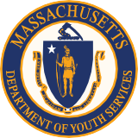
MASSACHUSETTS DEPARTMENT OF
YOUTH SERVICES

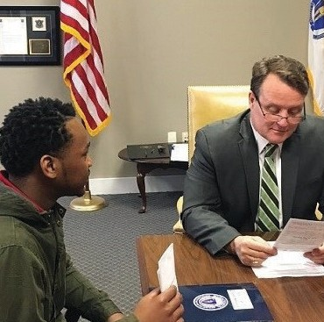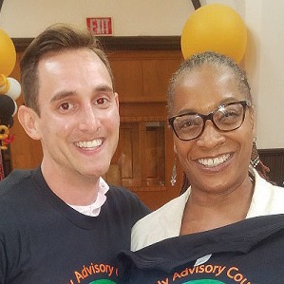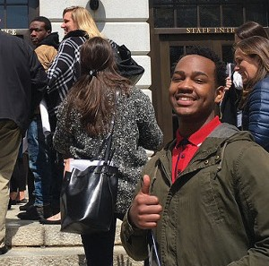www.mass.gov/dys | 600 Washington Street, 4th Floor | (617) 727-7575

@mass_dys mass_dys
@mass_dys
Massachusetts DYS

