 | Commonwealth of Massachusetts
 | Executive Office of Health and Human Services
 | Department of Youth Services
 | Official Policy

Policy Name: | Policy Administration
Policy #: | 01.01.01(c) | Effective Date: | September 15, 2015
Repeals: | 01.01.01(b)
References: | DYS Internal Control Plan
Signature: | 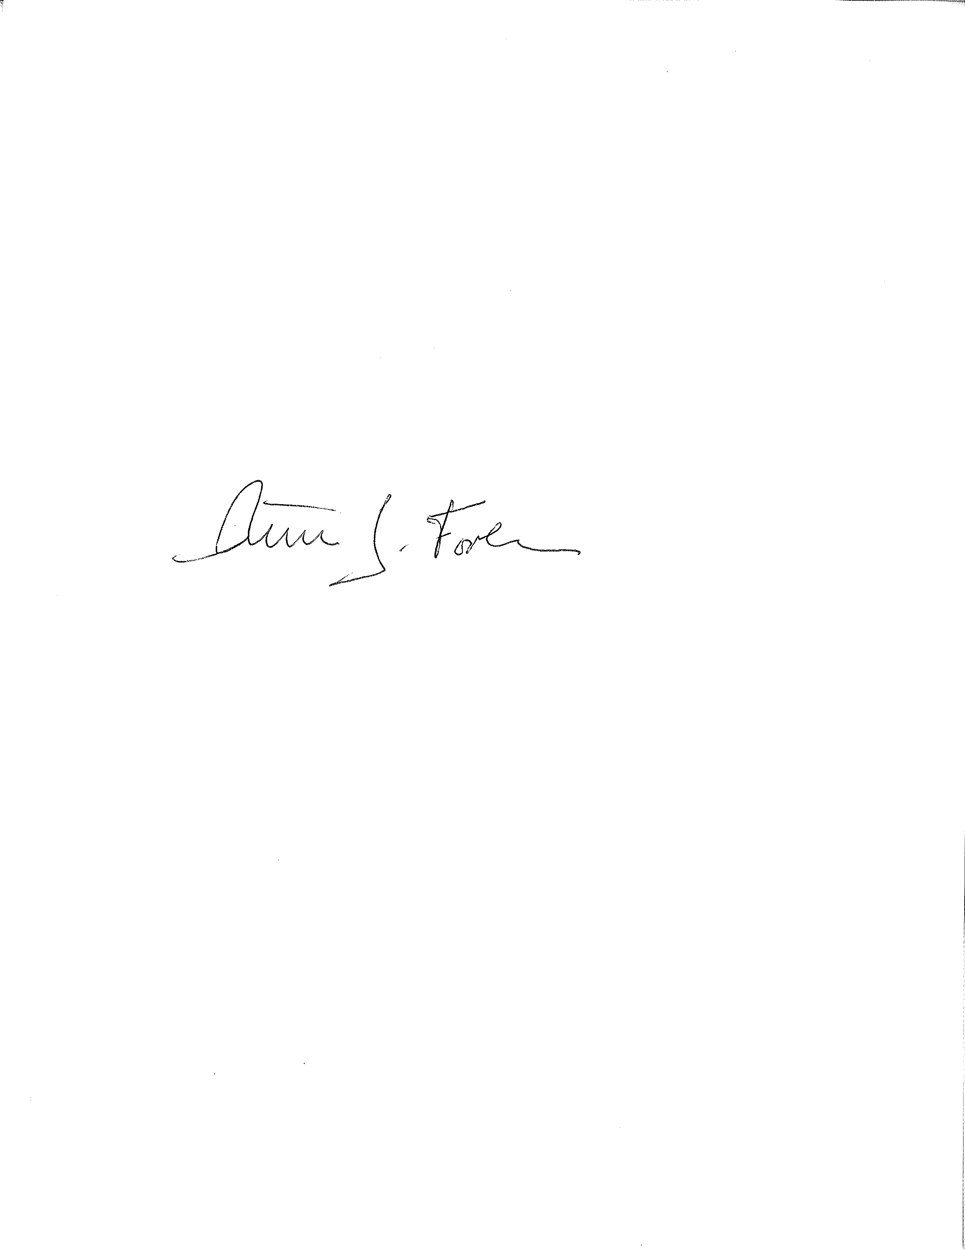  Peter J. Forbes, Commissioner |  | 9/2/2015
Applicability: | This policy shall apply to DYS state employees.

Policy

It is the policy of the Department of Youth Services (DYS) to establish and maintain a comprehensive approach to the development, review, and revision of policy to ensure effective implementation, dissemination, compliance, and quality assurance. DYS Policy shall prescribe the rules and practices for the operation of DYS; assign responsibilities and required action; and dispense information needed to carry out the duties of DYS, its facilities, programs, services and operations.

Review and approval of all policy within DYS shall occur on a systematic basis. All policies shall be issued in the official format and approved in writing by the Commissioner in accordance with these procedures.

All bulletins, directives, orders, notices, rules or regulations regarding operations of the central office, regional level, residential program or community service operations shall be consistent with DYS policy and procedure.

All new and revised policies shall be disseminated to all state employees, contracted provider employees, volunteers, and, when appropriate or required by policy, youth and families. Supervisors shall notify the employees who directly report to them of new or revised policies and document such notification. Location Managers shall provide access to the policy manual for all employees either through electronic or written means.

Procedures

- Definitions
- The following definitions shall have the meanings assigned to them in this policy for purposes of interpreting this policy.
Executive Staff: Individuals within the Central Office with the titles of Commissioner, Deputy Commissioner, Assistant Commissioner, General Counsel and Chief Financial Officer.

Performance Measure: An identified outcome that gauges productivity or effectiveness and is established to ensure quality, accountability and compliance.

Policy: A definite course of action, direction or principle adopted or pursued by the agency that guides and determines present and future decisions, actions and activities toward the attainment of stated objective. A policy leads to compliance with standards and the overall goals of the Agency.

Policy Director: Individual designated by title responsible for overseeing policy development for the Department.

Standard: A model, rule, guideline and/or criteria of a definite principle.

- Terms that are defined in Policy #01.01.04, “Policy Definitions” shall have the meanings assigned to them in that policy, unless a contrary meaning is clearly intended.
- Terms not defined in Policy #01.01.04 or in this policy shall have the meanings assigned to them by reasonably accepted standard dictionary definitions of American English.
B. Policy Steering Committee

- The Policy Steering Committee, in conjunction with the Policy Director, shall review all proposed policies including the substance, expected performance measures, and resources necessary for development and implementation.

- The Policy Steering Committee shall consist of representatives from Central Office, each Region, residential services, community services, union membership, program services, contracted providers and representatives in the topic area of the policy being reviewed. Additional members may be added to the Steering Committee based on the policy being considered. Failure of any of the representatives to attend policy steering meetings shall not affect the ability of the steering committee to meet and review policy.

C. Policy Formulation and Review Process

- As prioritized by the Executive Staff, the Director of Policy in conjunction with the Policy Steering Committee shall coordinate the development, review, approval and dissemination of DYS policy and procedure.

- All employees, agencies and providers that work for or with DYS are encouraged to make suggestions for policy, including the purpose, goals, and expected outcomes.

- Any suggestions for new or revised policy shall be submitted to the appropriate supervisor and then to the Director of Policy in draft form with the reason for the proposal.

- All proposed new or revised policies submitted to the Director of Policy shall be reviewed by the Policy Steering Committee and Executive Staff to determine next steps at the next available policy steering committee meeting.

- Upon a determination that the policy shall move forward, the Director of Policy and Policy Steering Committee shall complete the following process:

  - Review the policy drafts;
  - Distribute drafts, as needed, to individuals whose area of responsibility is affected or who have expertise in specific areas of concern and other interested parties, which may include any employee of DYS or others from another public or private agency;
  - Consider feedback and comments that have been timely received;
  - Depending on the policy topic, send draft for Commissioner/designee review for input during this process;
  - Submit a final draft of the new or revised policy to the General Counsel for legal review.

- Once legal review is complete, the policy shall be submitted to the Executive Staff for review with a distribution and training plan.

- Upon approval by Executive Staff, the policy shall be signed by the Commissioner.

- Policy drafts not recommended for approval by Executive Staff shall be returned to the individual who submitted the proposal.

- Revised policies shall supersede all previous DYS policy statements, bulletins, directives, orders, notices, advisories, or rules regarding operations that are inconsistent with newly promulgated policy.

- All policy shall follow the approved format as directed by the Policy Director.

- All policy shall comply with all Federal and State laws, regulations including those for licensing, and other applicable requirements.

D. Numbering System

- The Policy Director is responsible for establishing and monitoring the numbering system.

- A three part numbering system shall be used to identify policies as follows:

- Part one: Indicates four content areas including General Admin; Continuum of Care; Daily Living; or Community.

- Part two: Indicates which section within the content area.

- General Administration, which may include: Fiscal Management; Legal; Human Resources; Technology; and Volunteer.
ii. Continuum of Care, which may include: Admission/Intake; Clinical; Education; Health Services; and Casework Services.
iii. Daily Living, which may include: Facilities, Security; General living; and Personal Property.
iv. Community Operations, which may include: Reintegration and Discharge.

- Part three: Indicates the subsection of the specific section.

E. Approval and Effective Date

- The Commissioner is the approving authority for all policies.

- A policy is effective upon signature of the Commissioner and at midnight on the effective date specified in the policy itself. No policy shall be effective before being signed by the Commissioner, regardless of the effective date specified in the policy.

- Upon the effective date, the policy supersedes any conflicting provisions or directives which were issued at an earlier time.

F. Distribution and Documentation of Policy

- Upon approval and effective date, new or revised policies shall be posted on the DYS public website, and internal facing DYS electronic system.

- The Policy Director in consultation with the Policy Steering Committee shall notify all state employees, providers pursuant to contract requirements, and other interested parties of new and revised policies.

- Location Managers, or their designees, upon notification of a new or revised policy shall distribute and review all new or revised policies with their employees including volunteers at their location prior to the effective date of the policy unless specific training by the Training Center is required by policy.

- For new employees, Location Managers or their designees shall review all current policies directly relevant to the new employee’s job duties during their Basic Training On the Job Training week and sign the On the Job Training Checklist documenting that each new employee was provided the information and confirmed that they understand the information.

- Location Managers or their designee shall document their distribution and review of a new or revised policy with an individual sign off or through a staff meeting roster and keep such records within the appropriate location file and as otherwise required by the individual policy.

G. Annual Review Process

- In accordance with the DYS Internal Control Plan, all current policies shall be reviewed annually by a designee assigned by the Commissioner and Policy Director.

- As part of the annual review process, the designated individuals shall review relevant policy for consistency with current DYS practice, and other DYS policy, and compliance with other standards or model practices.

- Upon completing the annual review process, such individuals shall give written confirmation on or before April 1st of each year to the Policy Director that they reviewed the policy and consider it to be in good standing.

- If the policy needs revision, the designated individual shall submit the policy to the Policy Director in accordance with Section C.

- The Policy Director shall oversee a legal review of policies in consultation with the General Counsel’s Office to determine whether there have been any changes in statute, regulation, case law or other sources of law that require amendments to the policy.

- Upon completing the legal review, the Policy Director shall give written confirmation that the policy is either in good standing or must be submitted through the policy review process for revision or amendment in accordance with Section C.

H. Availability of Policies, Policy Manuals and Official Records

- The Policy Director and Legal Unit shall maintain the official record for DYS Policy and Procedures in printed and electronic format.

- Such record shall be maintained in electronic format through the public facing DYS website and internal electronic systems for DYS employees.

- Policies shall be available to all employees on the computer network at their work locations where such access is possible.

- Any location that does not have access to the electronic version of the DYS Policies and Procedures shall have a printed format available to all employees at their work location.

- Policy and Procedures may be made available to youth in each location at the discretion of the Location Manager or as required in the specific policy.

I. Applicability

- All policy and procedures shall designate the applicability of the policy.

- Unless otherwise stated in the individual policy, DYS Policies and Procedures apply to all state employees, contractors, employees of contracted providers, and volunteers/interns.

J. Performance Measures: Employees shall refer to the performance measures established for this policy and maintained by the DYS Policy Director to determine if they are meeting the expectations of the policy.

