 | Commonwealth of Massachusetts
 | Executive Office of Health and Human Services
 | Department of Youth Services
 | Official Policy

Policy Name: | Repeal of Policies
Policy #: | 01.01.03(a) | Effective Date: | September 15, 2015
Repeals: | 01.01.03
References: | None
Signature: | 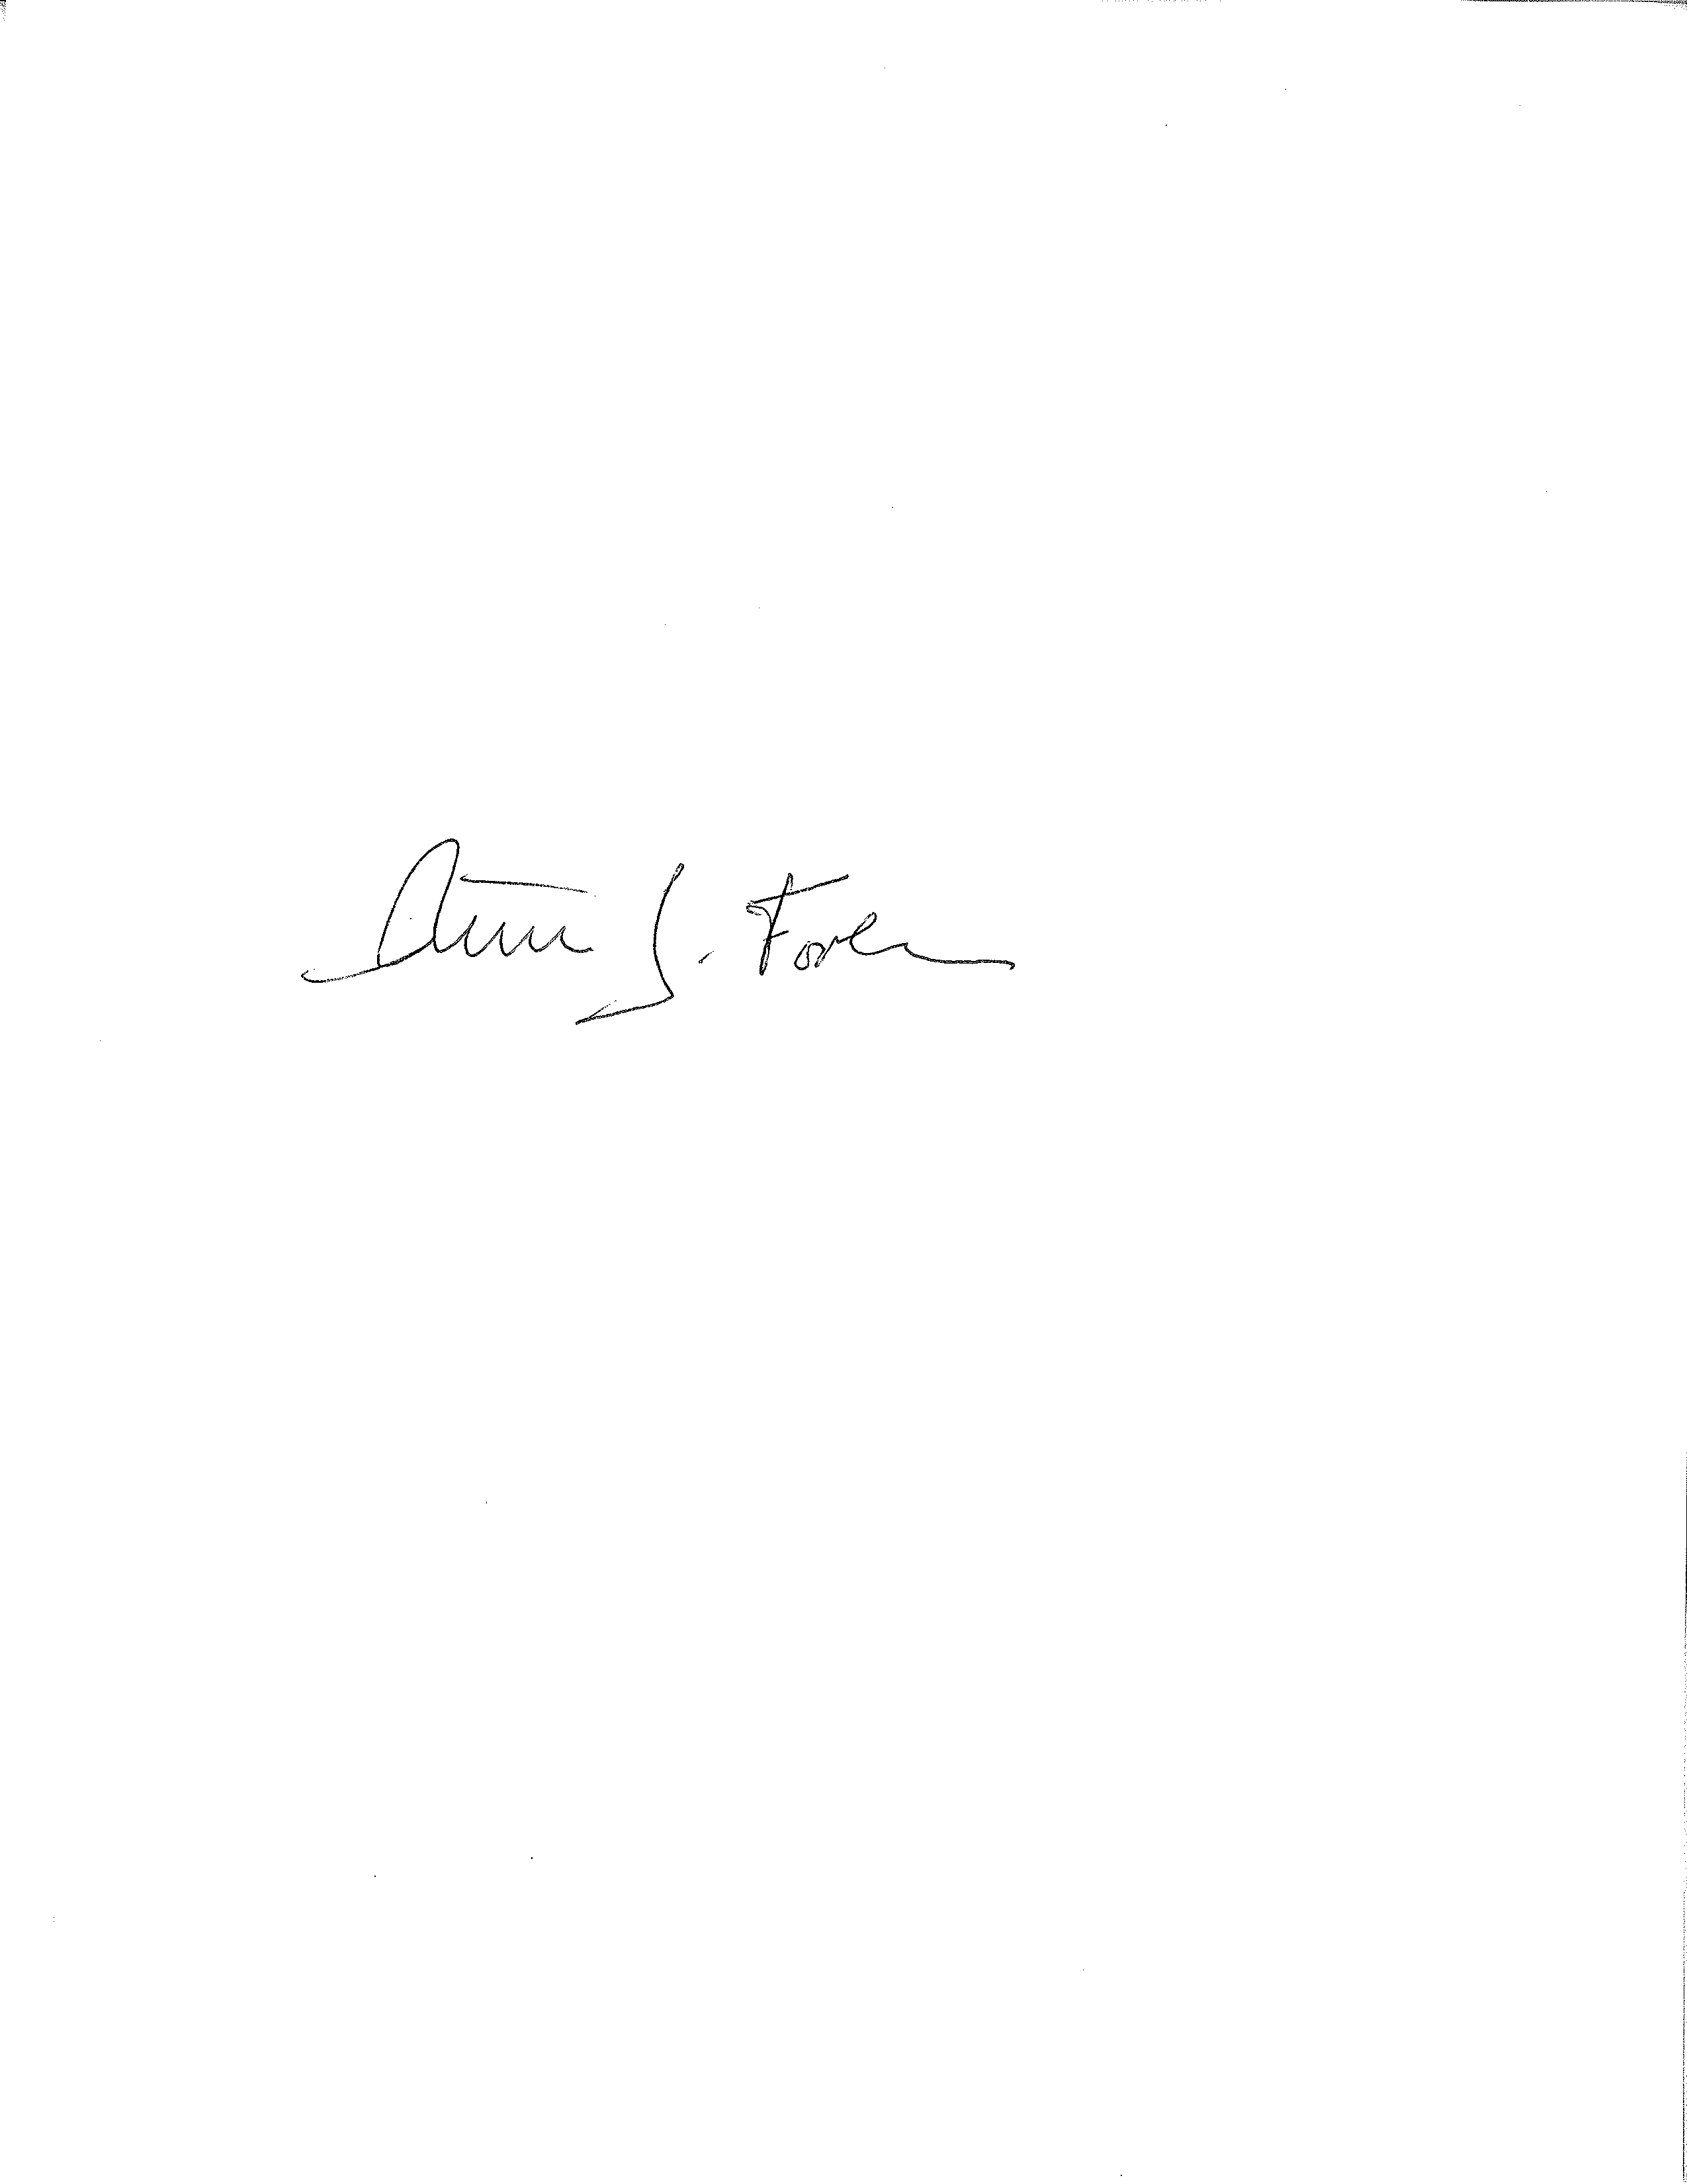  Peter J. Forbes, Commissioner |  | 9/2/2015
Applicability: | This policy shall apply to DYS directly.

Policy

It is the policy of the Department of Youth Services (DYS) to repeal policies that are no longer current, whether superseded by new or revised policy, other legal action, or by order of the Commissioner. Policies that are no longer current shall be repealed in accordance with the following procedure.

Procedure

A. Definitions

- The following definitions shall have the meanings assigned to them in this policy for purposes of interpreting this policy.
No additional Definitions.
- Terms that are defined Policy #1.1.4, “Policy Definitions” shall have the meanings assigned to them in that policy, unless a contrary meaning is clearly intended.
- Terms not defined in Policy #1.1.4 or in this policy shall have the meanings assigned to them by reasonably accepted standard dictionary definitions of American English.
B. Policies and Procedures Specifically Repealed

- Policies and procedures that do not follow the format prescribed in the Policy Administration policy are hereby repealed.

- Any policy or procedure signed into effect before January 1, 1999 is hereby repealed, unless specifically maintained in the current list of active policies.

C. Order of Precedence in Law, Regulation, Policy and Procedure.

- An Act or Resolve (whether incorporated as a General or Special Law) takes precedence over any Regulations of the department that may be in conflict with the Act or Resolve.

- A Regulation of the department (as codified in 109 CMR) takes precedence over any Policy of the department that may be in conflict with the Regulation.

- A Policy of the department (as codified in the Department’s volumes on “Performance-Based Standards and Policies” and as may otherwise still be active) takes precedence over any unit-specific procedure or other directive that may be in conflict with that Policy.

D. Order to Repeal

- Any individual who believes a policy may not be current shall submit such policy to the Policy Director for review.

- Upon review, the Policy Director shall submit a request to repeal such policy to the Policy Steering Committee for its review.

- If determined to be no longer current by the Policy Steering Committee, the Policy Director shall submit a request for review and an order of repeal from the Commissioner with the reasons why such policy is no longer current.

- Upon repeal, the order of repeal signed by the Commissioner shall be posted in place of the prior policy on the DYS website and internal portal for at least one year.

E. Performance Measures: Employees shall refer to the performance measures established for this policy, attached to this policy and maintained by the DYS Policy Director to determine if they are meeting the expectations of the policy.

