 | Commonwealth of Massachusetts
 | Executive Office of Health and Human Services
 | Department of Youth Services
 | Official Policy

Policy Name: | Financial Compliance of Contracted Services
Policy #: | 01.02.05(c) | Effective Date: | November 3, 2015
Repeals: | 01.02.05(b)
References: | MGL c.29, s.23A  808 CMR 1.00: Compliance, Reporting and Auditing for Human and Social Services  801 CMR 21.00: Procurement of Commodities or Services, including Human and Social Services  DYS Fiscal Policy and Procedure Manual
Signature: | 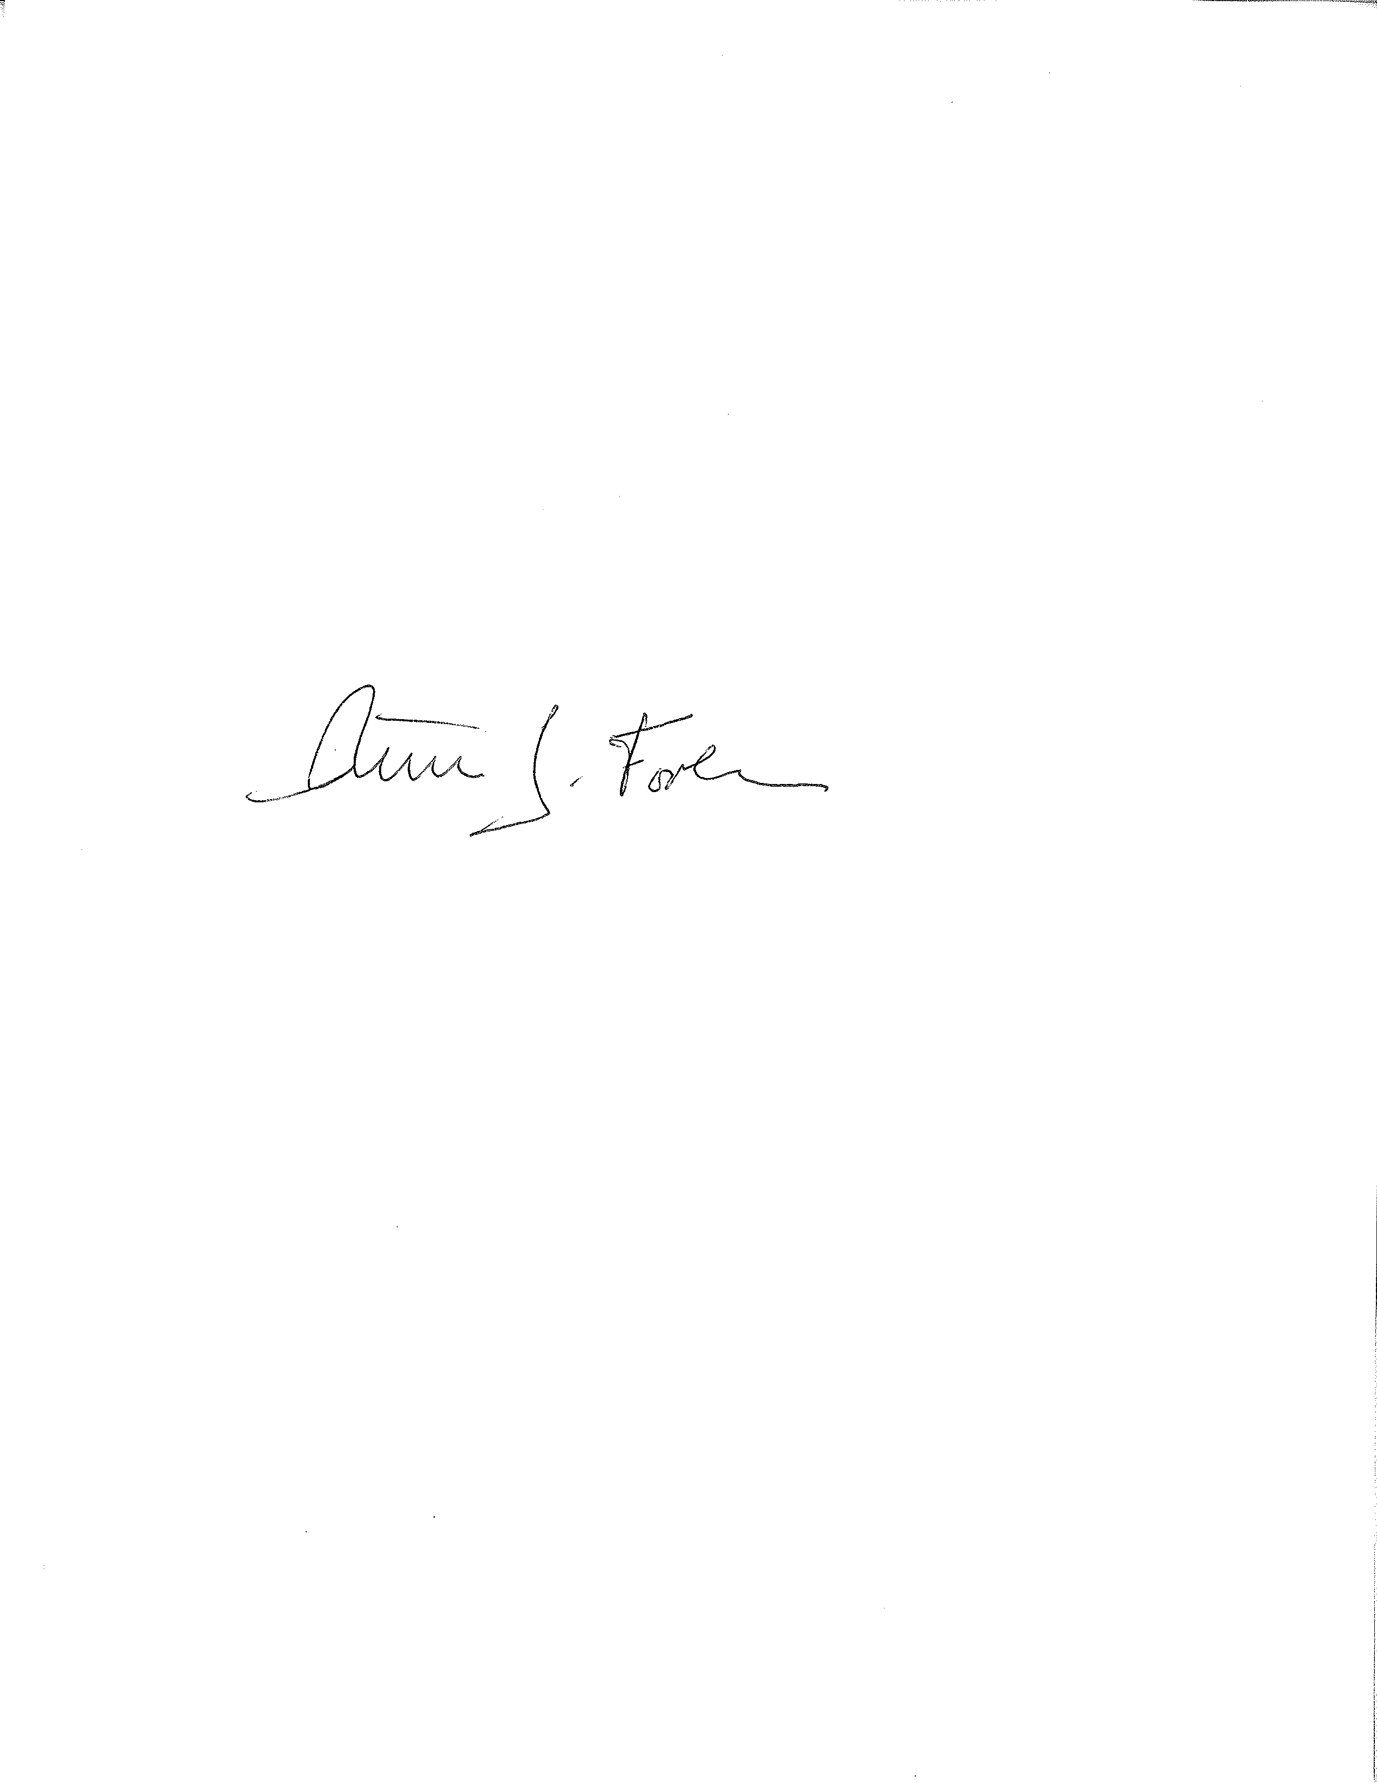  Peter J. Forbes, Commissioner |  | _10_/_5_/ 2015
Applicability: | This policy shall apply to DYS.

Policy
It is the policy of the Department of Youth Services (DYS) to perform compliance reviews on all contracted services to ensure such contracts are in compliance with applicable policy, procedure, regulations and law.

The Fiscal Department shall perform such compliance reviews upon the receipt of information regarding potential issues affecting service delivery or as otherwise scheduled by the Executive Team or their designee.

These reviews shall be accomplished by examining relevant financial and other supporting documentation at either the DYS facilities, the program site or provider administrative offices as applicable.

All contract compliance reviews performed shall result in the preparation of a written report detailing the results, evaluative information, and any appropriate corrective action plan. Copies of Fiscal Department Financial Compliance Reviews will be kept in DYS Central Office.

Procedures
Please refer to DYS Fiscal Policy and Procedure Manual for the definitions and detailed internal procedures for the Competitive Procurement of Client Services.

