 | Commonwealth of Massachusetts
 | Executive Office of Health and Human Services
 | Department of Youth Services
 | Official Policy

Policy Name: | Hiring of Staff
Policy #: | 01.05.06(a) | Effective Date: | January 15, 2012
Repeals: | 01.05.06
References: | Summary of DYS Background Check Procedures
Signature: | 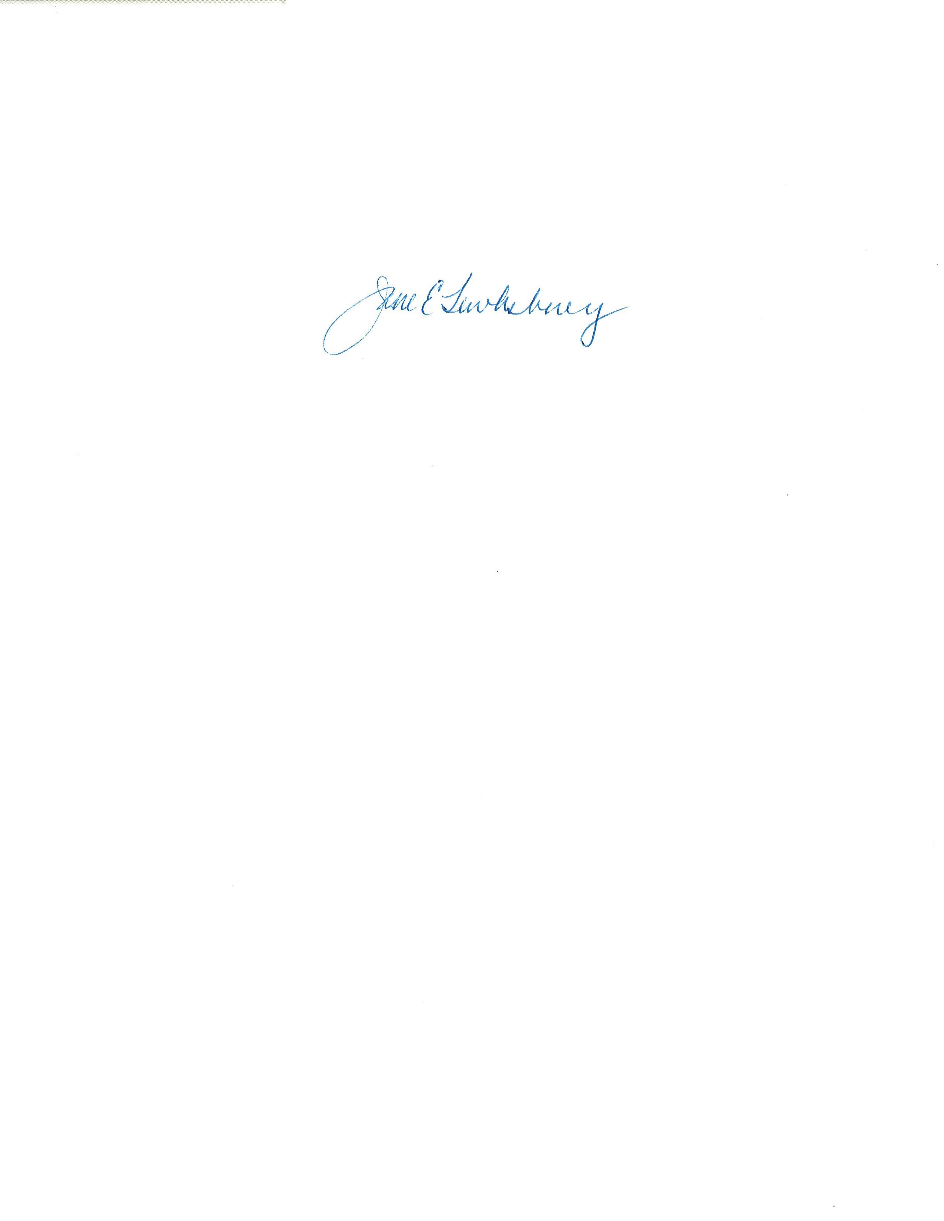 |  | 1/3/2012
Applicability: | This policy applies to Department of Youth Services state employees.

Policy
DYS shall offer an equal opportunity in all personnel actions including, but not limited to affirmative action recruitment, hiring, promotions, and transfers.

New applicants selected as the final candidate shall be subject to DYS Background Check Procedures, reference checks, and pre-employment screening.

New applicants selected as the final candidate for direct care positions are required to also successfully complete a physical abilities test (PAT) at the direction of the Director of Human Resources.

Upon hiring, new employees shall attend the next scheduled DYS Basic Training.

Final candidates for promotions shall be subject to DYS Background Check Procedures and reference checks but not pre-employment screening or the PAT.

Procedure
- Definitions
- The following definitions shall have the meanings assigned to them in this policy for purposes of interpreting this policy.
Background Check Procedures: Process as described in the DYS Summary of Background Check Procedures to request and review the following for a Final Candidate for hire or promotion: the criminal offender record information (CORI) at the Criminal History System’s Board (CHSB), including out of state inquiries; the abuse and neglect records of the Department of Children and Families (DCF); the sex offender registry information (SORI) of the Sex Offender Registry Board (SORB); and the driving records of the Registry of Motor Vehicles.
Basic Training: Curriculum offered through the DYS Training Academy that consists of specialized juvenile justice modules, on the job training and state mandatory trainings.
Behavioral Interview Questions: Competency based questions used in the interview process that elicit detailed information on the circumstance(s), action(s) and result(s) of prior experiences.
Children, Youth and Families (CYF): Human Resources Office at the Executive Office of Health and Human Services (EOHHS) which oversees the hiring process for DYS.
Direct Care Staff: State employees with the title of program director, assistant program director, district manager, assistant district manager, apprehension officer, group worker, caseworker, transportation officer, detention coordinator, maintenance worker, food service worker, institutional security officers or any other staff who works in the same or similar capacities or has the same or similar duties of the above titles on a fulltime or part time basis.
Group Worker I Candidates’ Pool: Group of interviewed applicants for the Group Worker I posting who should be considered as candidates for current or future vacancies.
Hiring Coordinator: The individual from CYF listed on a job posting who is responsible for overseeing the hiring process for the vacant position.
Hiring Manager: DYS supervisory staff responsible for filling a vacant position.
Minimum entrance requirements (MER): Minimum requirements established by the Commonwealth’s Human Resources Division for each job classification.
Physical Abilities Test (PAT): The portion of the hiring process for Final Candidates of direct care positions to demonstrate sufficient endurance, strength, flexibility and cardiovascular fitness to safely meet the demands of the essential functions of the job. Due to the safety issues involved in performing the essential functions of the job, the test is a simulated exercise of an actual emergency situation. The test is performed in an obstacle course format, requiring the candidate to go through the sequence of test items without stopping.
Pre-employment Screening: The portion of the hiring process for Final Candidates that includes a drug screen, psychological screen and medical examination.
Reference Checks: Process for the Hiring Manager to request and review references supplied by the Final Candidate to determine suitability for the job.
- Terms defined in Policy #1.1.4, “Policy Definitions” shall have the meanings assigned to them in that policy, unless a contrary meaning is clearly intended.
- Terms not defined in Policy #1.1.4 or in this policy shall have the meanings assigned to them by reasonably accepted standard dictionary definitions of American English.
- Approval to fill a Vacancy
- The Hiring Manager shall consult with the DYS Director of Human Resources or designee to determine the availability of a position and the date the position is available for hiring.

- The DYS Director of Human Resources or designee shall consider Equal Employment Opportunity/Affirmative Action for all vacancies.

- State Office of Affirmative Action (SOAA) Compliance
- The protected group members, as defined by SOAA guidelines are:
  - Minorities;
  - Women;
  - Persons with disabilities; and
  - Veterans of the Vietnam, Gulf and Middle East wars.

- DYS shall seek demographic parity as it applies to protected group members to achieve SOAA goals.

- Targeting of vacancies may be used to achieve parity ratios for protected groups.

- Procedure for Job Postings
- The DYS Group Worker I job title is an open and continuous job posting. Refer to Section L of this policy for specific hiring procedures for the Group Worker I position.

- Hiring Managers shall submit a written request to post any position vacancy other than the Group Worker I, to the DYS Human Resources Unit.

- The DYS Human Resources Unit shall review requests to post positions and, if approved, forward to CYF for posting.

- All vacancies, including intern and contract positions, shall be posted for a minimum of 14 days on the Commonwealth’s Employment Opportunity (CEO) website. Any exception, such as the hiring of a temporary position, requires approval from the DYS Director of Human Resources and the Chief of Staff.

- The Hiring Manager or designee shall be responsible for ensuring that all job postings are posted in a conspicuous place designated by the work location such as on a staff bulletin board.

- Establishing a Hiring Package
- CYF shall receive all resumes and prepare a hiring package.

- The CYF Hiring Coordinator shall forward the hiring package with the required forms and resumes to the DYS Hiring Manager.

F. Establishment of Interview Panels

- The Hiring Manager or designee shall establish first and second round interview panels and identify a panel chairperson. First and second round interviews are required for all positions.

- The Hiring Manager is responsible for the interview process and all required written notifications to applicants.

- The first round interview panel shall consist of at least three members. One panel member shall be in a higher-grade position than that of the vacant position with remaining panel members of equal or higher grades.

- The second round interview panel shall consist of at least three members and must include two panel members who did not participate in the first round interview panel and may include one member from the first round panel.

- Panel members shall conduct all interviews in each round and no one may be substituted for an original panel member during the round.

- To the extent possible, the panels shall be diverse, and include a member in a protected group status.

- For vacancies in management positions, the panel may include a member external to DYS in the field of expertise.

G. Resume Screening Process

- All resumes shall be reviewed and screened by members of the first round interview panel to determine a candidate’s eligibility based upon the qualifications listed in the job posting.

- A DYS-approved resume screening form shall be used to ensure a fair and consistent screening process to determine who shall receive a first round interview. See DYS Forms, DYS Screening Form.
- At least three qualified candidates shall be selected for a first round interview. If there are fewer than three qualified candidates, the Hiring Manager shall contact the DYS Director of Human Resources.

- An applicant identified as a Veteran who meets the minimum entrance requirements shall be selected for a first round interview.

H. Interview Questions

- The Hiring Manager shall establish written questions to be asked of all candidates during the first and second round interviews. There shall be different questions for each round.

- Candidates shall not be asked intrusive or discriminatory questions.

- When interviewing for Caseworker and Group Worker positions, questions shall be selected from the prepared list of behavioral interview questions available through the DYS Human Resources Unit.

I. Interview Process

- Within each round candidates shall be asked the same questions and may be required to complete a writing exercise prior to or at the conclusion of the interview.

- When interviewing for Caseworker and Group Worker II-III positions, the following forms shall be completed by each panel member during the first and second round of interviews:

  - Candidate Rating and Interview Notes Form for GW II, III or CW.
See DYS Forms; and
  - Interview Assessment Form for GW II, III or CW. See DYS Forms.

- When interviewing for all other positions, a CYF Interview Assessment Form shall be completed by each panel member during the first and second round of interviews. See DYS Forms, CYF Interview Assessment Sheet.

- A DYS-approved interview scoring sheet shall be completed by the panel chairperson to document the panel’s score for each candidate during the first and second round of interviews. See DYS Forms, Interview Scoring Sheet.

- After the first round of interviews, the panel chairperson shall review the scores with the panel and by consensus determine which candidates should be selected for a second round interview. It is preferred that up to 3 candidates be referred to the Hiring Manager for a second round interview. If there are no candidates recommended for a second round interview, the Hiring Manager may submit a request to repost the position through the DYS Human Resources Unit.

- The Hiring Manager shall notify all unsuccessful candidates by letter of non-selection for a second round interview. See DYS Forms, Non-Selection Letter, Candidate.

- After the second round of interviews, the panel chairperson shall review the scores with the panel and by consensus determine which candidates should be selected as finalists.

- The Hiring Manager shall notify all unsuccessful candidates by letter of non-selection as a finalist. See DYS Forms, Non-Selection Letter, Candidate.

J. Selection of the Final Candidate

- The Hiring Manager shall complete 3 reference checks for each finalist before selecting the Final Candidate.

- Upon selection of the Final Candidate by the Hiring Manager, the Hiring Manager shall complete a Final Candidate letter indicating their selection, See DYS Forms, Final Candidate Letter for Civil Rights Officer Review.

- The Hiring Manager shall return the completed hiring package to the DYS Human Resource Unit for review by the Civil Rights Officer.

- The Civil Rights Officer will review the hiring package and approve the candidate for hire, and forward the hiring package to CYF for approval.

- Upon receipt of preliminary approval from CYF, the DYS Human Resources Unit will conduct a background check and schedule the Final Candidate for the pre-employment screening.

K. Job Offer

- Upon the successful completion of the Background Check process, the Hiring Manager may make a conditional offer to hire a Final Candidate. The Hiring Manager must indicate that the conditional job offer is subject to the DYS Director of Human Resources approving the requested salary and the results of the Pre-Employment Screening.

- All Final Candidates for management positions M5 and above, must receive approval from the Governor’s Office before a final written offer can be made. The Hiring Manager may make a conditional offer before this approval. See DYS Forms, Conditional Offer of Employment Letter.

- Final job offers must be made in writing by the DYS Hiring Manager with a salary approved by the Director of Human Resources. See DYS Forms, Offer of Employment Letter.

L. Hiring Procedures for Youth Services Group Worker I Positions

- Screening and Interview Process
  - Each Region shall have an open and continuous job posting for Youth Services Group Worker I positions in anticipation of future vacancies and have such positions posted in each region.

  - All applicants must send a completed state job application and resume to the specific regional Hiring Manager to be considered for employment. See DYS Forms, Employment Application.

  - The Regional Director of Residential Services or designee shall review each application and resume within 14 days of submission for the minimum and preferred qualifications as stated on the job posting. Those applicants determined to be the most qualified may be scheduled for a panel interview. See DYS Forms, Interview Letter.

  - The Director of Residential Services or designee shall determine how many of the eligible applicants will be interviewed based on the number of interviewed applicants in the Group Worker I Candidates’ Pool.

  - Applicants screened out of the process shall receive a DYS-approved letter of non-selection by the Regional Director of Residential Services or designee. See DYS Forms, Non-Selection Letter, Applicant.

- Establishment of Panels
- The Regional Director of Residential Services or designee shall designate supervisory staff to receive training on Behavioral Interviewing and serve on rotating interview panels.

- The Regional Director of Residential Services or designee shall develop a schedule to ensure three-member panels are available to conduct interviews every two weeks or as otherwise needed to maintain a pool of interviewed and highly-qualified applicants. To the extent possible, panel members will serve for two consecutive sessions with a new third member being added to each panel. For example, A, B, and C interview on the first panel. B, C and D interview next. C, D and E interview next, etc.

- Each panel will have a chairperson who is responsible for coordinating the panel interview process and ensuring the results are provided to the Regional Director of Residential Services or designee.

- To the extent possible, panels shall be diverse and include a member in a protected group status. All panel members must receive training on Behavioral Interviewing through the DYS Training Academy.

- Interview Process
- The DYS Human Resources Director will provide the Regional Director of Residential Services or designee with the prepared list of behavioral interview questions for the selection process.

- The Regional Director of Residential Services or designee will select the predetermined number of questions from each competency area to be used by the panels. To ensure continuity, the same questions are to be used by each of the panels for three consecutive months.

- Each applicant will be required to complete a written exercise either prior to or at the conclusion of the interview. Panel members shall select one question from the prepared list of behavioral interview questions for the written exercise.

- Each panel member shall complete a DYS Group Worker I Candidate Rating and Interview Notes Form after the interview. See DYS Forms, Candidate Rating and Interview Notes Form for GW I.

- The panel chair shall review the scores with the panel and by consensus determine the final scoring of the applicant. The panel chairperson shall record the scores on a DYS Group Worker I Interview Assessment Form. See DYS Forms, Interview Assessment Form for GW I.

- The written exercise shall be attached to the Group Worker I Interview Assessment Form for review by the Hiring Manager.

- The panel shall recommend all successful first round candidates to the Regional Director of Residential Services or designee for further consideration. All related documents, such as the Group Worker I Candidate Rating and Interview Notes Form, Interview Assessment Form and Interview Questions shall be forwarded to the Director of Residential Services or designee.

- All successful candidates will be placed into the Group Worker I Candidates’ Pool and sent notification. See DYS Forms, Applicant Pool Acceptance Letter, GW I.

- The panel chairperson shall notify candidates that are not chosen for the Candidates Pool. See DYS Forms, Non-Selection Letter, Candidate.

4. Selection of the Final Candidate
- When there is a vacancy, the Hiring Manager will obtain the list of the applicants from the Group Worker I Candidates’ Pool who have been interviewed by the panel(s) along with the scores for each applicant.

- The Hiring Manager may request a name from the highest scoring applicants for consideration without a further interview. As an alternative, the Hiring Manager may hold a second interview with an applicant or applicants.

- If a second interview occurs, the Hiring Manager and at least one other trained interviewer shall conduct the interview using questions designed for the second round interview process. After this round, the Hiring Manager shall review the scores from the Interview Assessment Form to determine the Final Candidate.

- The Hiring Manager shall notify by letter all unsuccessful candidates who interviewed for this position of nonselection as a Final Candidate. See DYS Forms, Non-Selection Letter, Candidate.

- The Hiring Manager shall complete 3 reference checks on the Final Candidate and forward the name of the Final Candidate to the DYS Human Resources Unit.

- The DYS Human Resources Unit shall complete the DYS Background Check Procedures.

- Upon successful completion of the background check, DYS Human Resources will schedule the Final Candidate for the pre-employment screening.

  - Job Offer

- Upon the successful completion of the Background Check process, the Hiring Manager may make a conditional job offer to hire a Final Candidate.

- The Hiring Manager must indicate that the conditional job offer is subject to the DYS Director of Human Resources approving the requested salary and the pre-employment screening results. If a salary above the entry level is requested, the Hiring Manager must obtain approval from the DYS Director of Human Resources prior to making a conditional job offer.

- Final job offers must be made in writing by the DYS Hiring Manager with a salary approved by the DYS Director of Human Resources as indicated above and upon receiving notice of the pre-employment screening results. See DYS Forms, Offer of Employment Letter.

- Establishment of a Database

a. The Regional Director of Residential Services or designee shall create and maintain a database for the Group Worker I Candidates’ Pool.

b. The Regional Director of Residential Services or designee shall review the Candidates’ Pool every six months. Candidates who have been in the pool for six months or longer shall be sent a DYS approved letter requesting to verify their continued interest in the position. See DYS Forms, Candidate Pool Active Consideration Letter, GW I.

c. If there are no current vacancies, candidates in the pool may be sent an approved letter for reapplication, See DYS Forms, Reapplication Letter, GW I, or a referral to a provider program, See DYS Forms, Provider Referral Letter, GW I.

