 | Commonwealth of Massachusetts
 | Executive Office of Health and Human Services
 | Department of Youth Services
 | Official Policy

Policy Name: | Tobacco Free Campus
Policy #: | 01.05.12(b) | Effective Date: | January 15, 2012
Repeals: | 01.05.12(a)
References: | Massachusetts General Laws Chapter 270, §22  Office of Vehicle Management Policies and Procedures  Executive Office of Health and Human Services (EOHHS)  Order Establishing Tobacco Free Campuses, Sept. 28, 2009
Signature: | 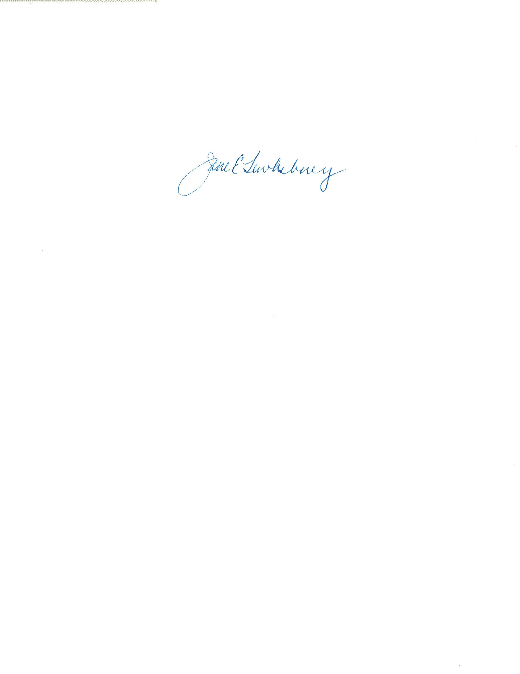
Applicability: | This policy shall apply to DYS employees, clients, volunteers, visitors and contractors at any location including buildings and grounds owned, leased, used, or otherwise under the control of DYS. This policy also shall apply to provider programs and their employees co-located with DYS programs. Providers with stand alone programs are expected to have their own tobacco free policy consistent with this topic area.

Policy

It is the policy of the Department of Youth Services (“DYS”) to prohibit the use of tobacco products on all locations owned, leased, used, or otherwise under the control of DYS by employees, volunteers, clients, guests, interns, contractors, providers contracting with DYS and visitors. The purpose of this policy is to ensure a safe, clean and healthy environment for all, as well as to comply with G.L. c. 270, §22, smoking in public places. Tobacco use is allowed by any individual while inside their personal vehicle while on DYS premises. Use of tobacco products is prohibited at all times in state owned vehicles and in any vehicle when a DYS client is present.

Procedure

- Definitions
- The following definitions shall have the meanings assigned to them in this policy for purposes of interpreting this policy.
Buffer Zone: any outdoor area that is at least twenty (20) feet from all exterior walls, windows, doors and vents of a building, program, facility, or unit operated by DYS or operated by a contracted provider while co-located with a DYS facility.
Campus: DYS location including the surrounding grounds. Surrounding grounds may include, but are not limited to grassy areas, patios, sidewalks, and parking lots.
Location: any building, program, facility, or unit owned, leased, used, or otherwise under the control of DYS, including any contracted provider programs co-located with a DYS facility, and extending to all common areas and outdoor areas including but not limited to entranceways, sidewalks, patios, parking lots and grounds.
Tobacco Use Prohibition Signs: an approved sign that is obtained in its entirety or by template from EOHHS, the Department of Public Health or the local Board of Health or a sign that is approved by the aforementioned entities. Approved signs are available through the DYS Portal.
Tobacco Products: any product that contains tobacco including, but not limited to, cigarettes, cigars, pipe tobacco, chewing tobacco, snuff, and nicotine delivery products used as alternative tobacco products, such as e-cigarettes. Nicotine replacement products approved by the FDA for use as smoking cessation products, such as gum, patches and oral medications, are exempt from this definition.
- Terms that are defined Policy #01.01.04(a), “Policy Definitions” shall have the meanings assigned to them in that policy, unless a contrary meaning is clearly intended.
- Terms not defined in Policy #01.01.04(a) or in this policy shall have the meanings assigned to them by reasonably accepted standard dictionary definitions of American English.
- Guidelines
- DYS Locations without a Campus: The Regional Director, or designee, of a location with minimal or no surrounding grounds, such as those in urban areas, shall establish, to the extent possible, a tobacco product free buffer zone where use of tobacco products shall be prohibited except for tobacco use inside non state owned vehicles.
- DYS Locations with a Campus: Buffer zones or designated smoking areas are not allowed at any campuses. Such campuses shall be entirely tobacco free except for tobacco use inside non state owned vehicles.
- Locations that share space with only other EOHHS agency locations: This policy shall be in effect for these locations unless a single policy exists for that location that already prohibits the use of tobacco products.
- Locations not used exclusively by EOHHS agencies: The Regional Director, or designee, shall establish, to the maximum extent possible, a tobacco product free buffer zone around the entire building or, for those with a campus, a tobacco free campus. Every effort shall be made to negotiating a tobacco free policy for the premises or phase in a more restrictive policy when renegotiating the lease.
- Employees, volunteers, visitors, interns, and contracted providers are discouraged from smoking in front of clients at all times.
- The Regional Director, or designee, shall post this policy and Tobacco Use Prohibition signs at each location including common areas, office areas, entrances, and outdoor places that were formerly designated smoking areas. Signs providing information about cessation services and possible insurance coverage shall be posted with the Tobacco Use Prohibition Signs.
C. Enforcement
- Employees and clients may be subject to discipline for any violation of this policy.
2. Contracted providers, interns, visitors and volunteers who violate this policy may be barred from a location.

