 | Commonwealth of Massachusetts
 | Executive Office of Health and Human Services
 | Department of Youth Services
 | Official Policy

Policy Name: | Information Security Policy
Policy #: | 01.08.02 | Effective Date: | September 15, 2009
References: | Executive Order 504  G.L. c. 93H and G.L. c. 93I  G.L. c. 66A  DYS Code of Conduct, Policy No. 01.05.04(d)
Signature: | 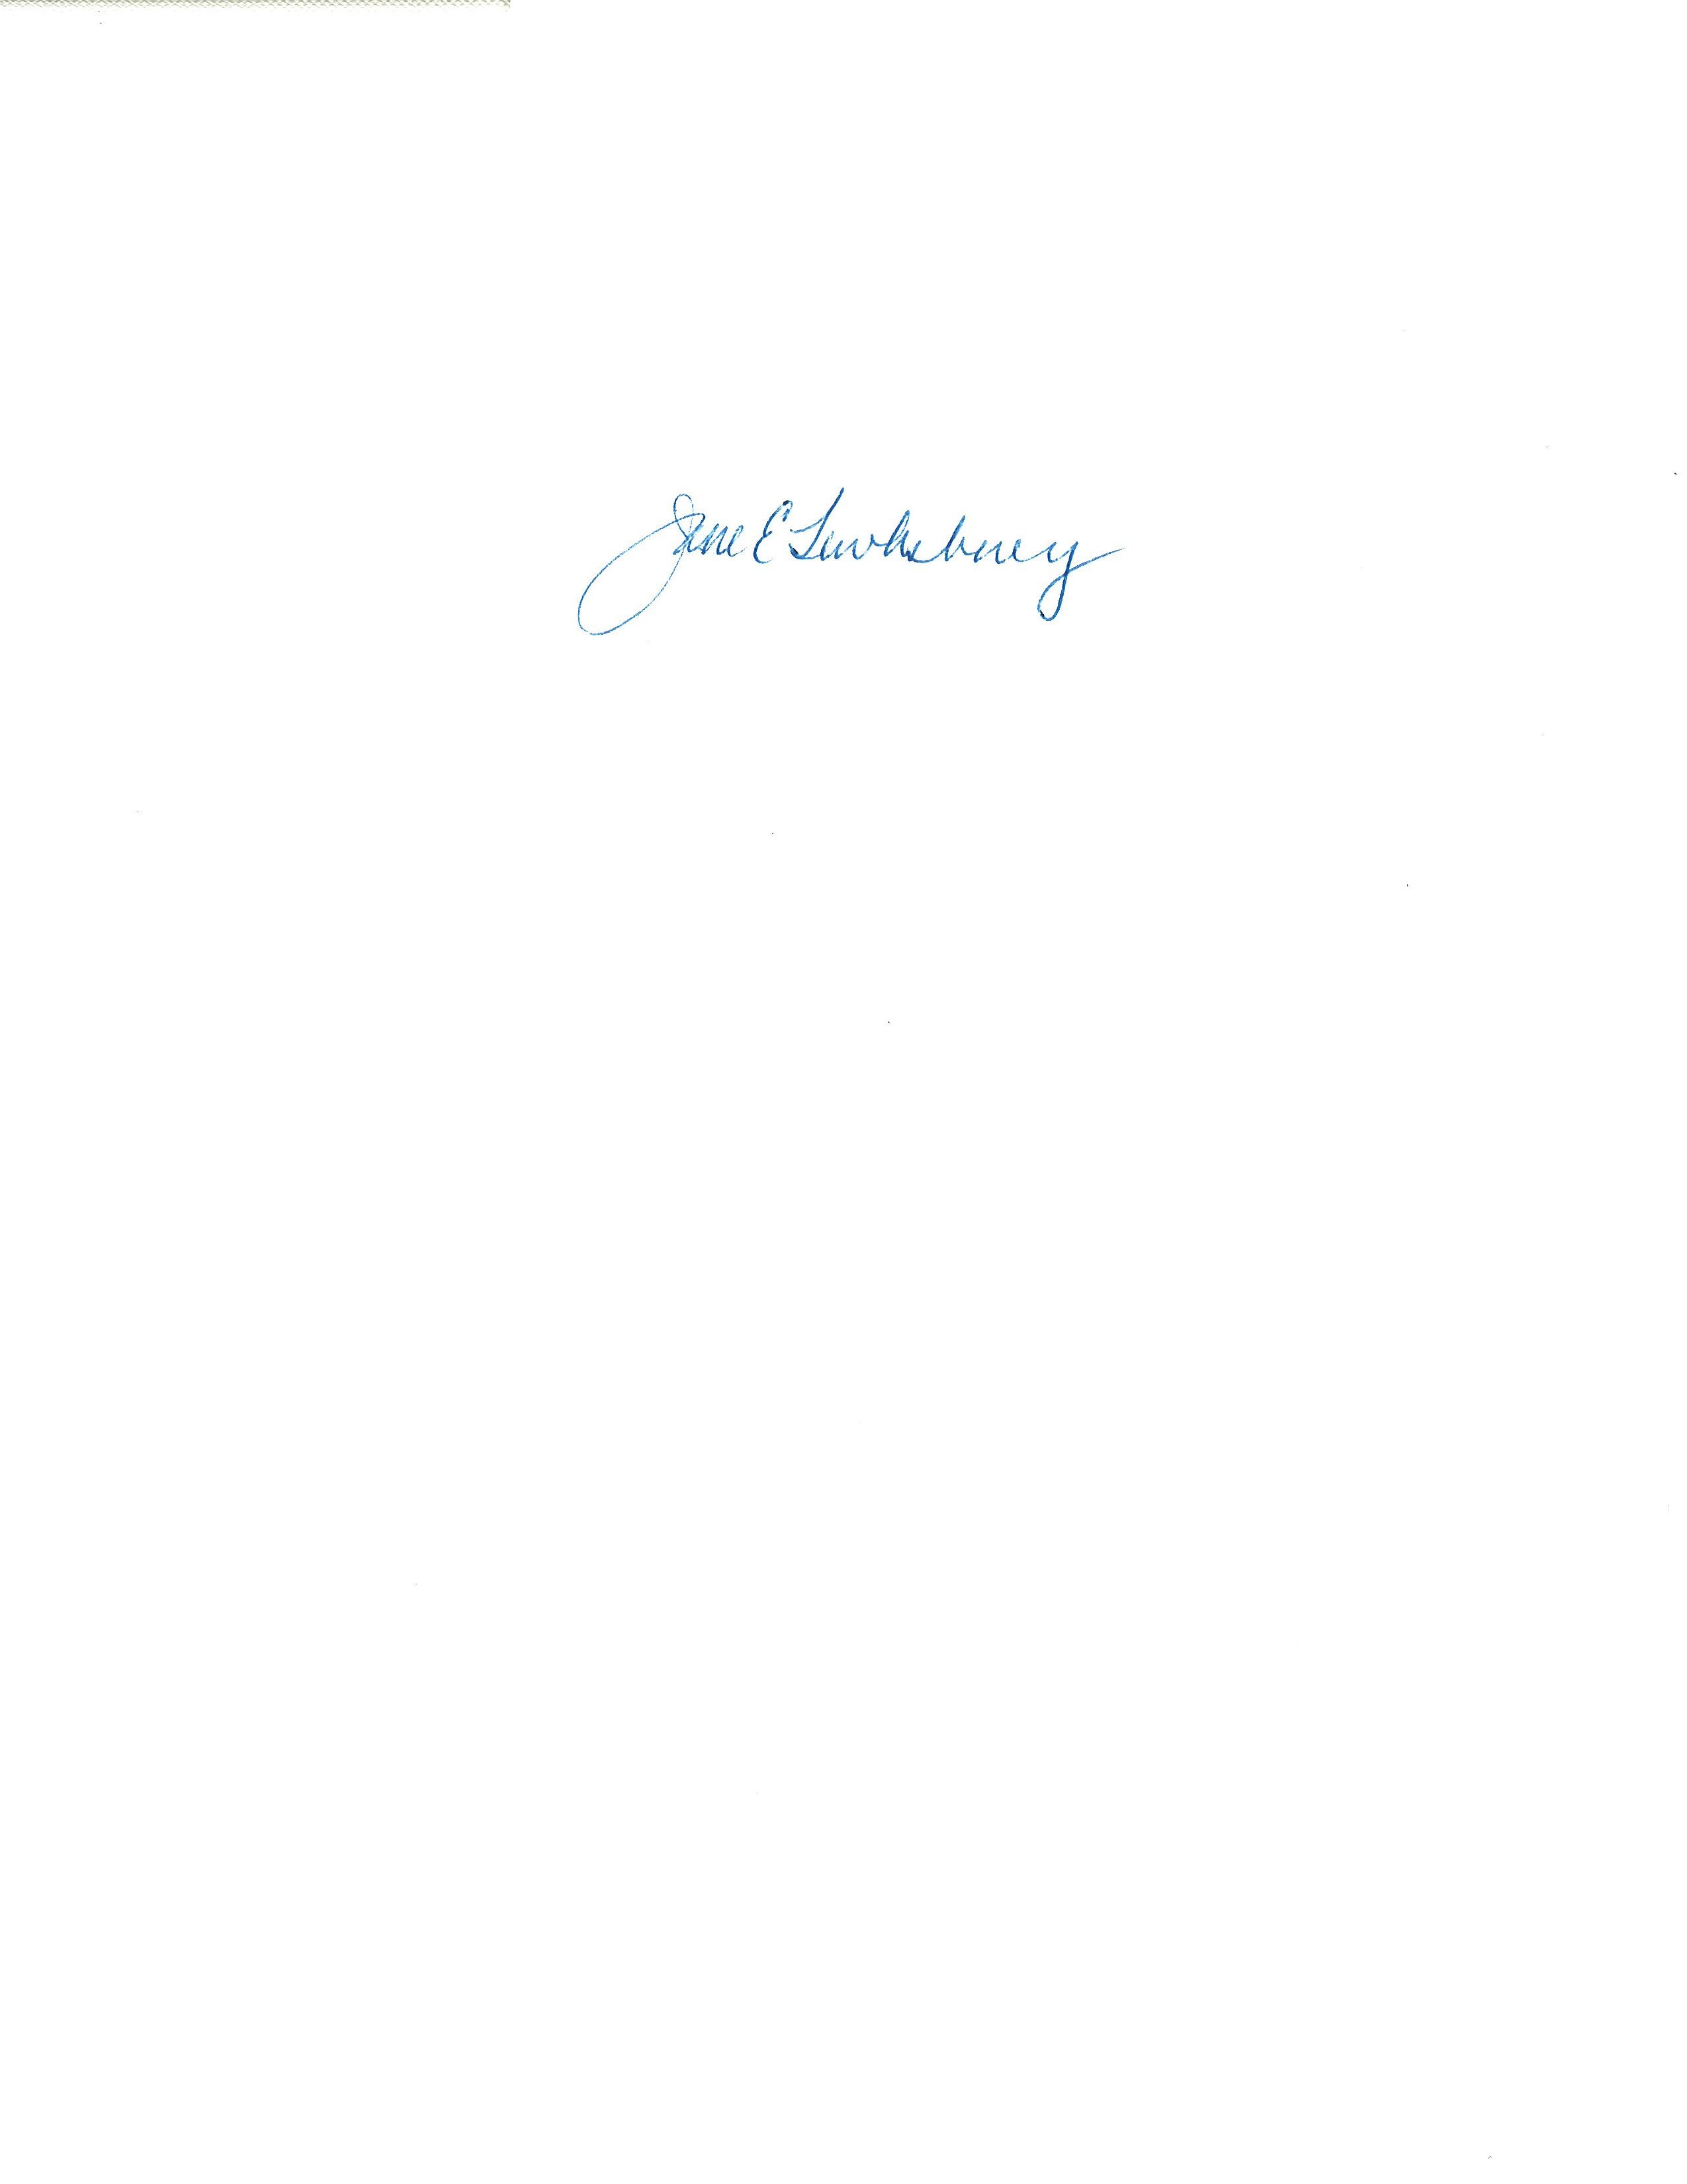 |  | August 5, 2009
Applicability: | This policy shall apply to DYS employees. DYS Providers are expected to comply with this policy and the above-cited laws, or have their own more stringent policy covering this topic area.

Policy

It is the policy of the Department of Youth Services (“DYS”) to create and maintain strict controls to protect the personal information of its clients and staff in compliance with Executive Order 504 and G.L. c. 93H and 93I. To meet this goal, DYS is developing an Information Security Program (“ISP”) to institute measures to ensure the integrity, confidentiality, and security of the personal information the agency collects, uses, stores, and disposes. DYS will train every staff member to be aware of and utilize these safeguards. DYS will rely on its managers to exercise due diligence to achieve compliance with the ISP in each DYS-funded location.

Procedure

- Definitions
- For the purposes of interpreting this policy, the terms below shall have the following meanings.
Executive Order 504: a measure signed by the Governor which requires all agencies within the Executive Branch of the Commonwealth, and their providers, to enhance measures to safeguard personal information.
G.L. c. 93H: known as the “Identity Theft” law, this statute protects Massachusetts citizens in the event their personal information is acquired by an unauthorized person, used for an unauthorized purpose, or information assets are compromised leading to a substantial risk of unauthorized access or use.
G.L. c. 93I: known as the “Trash Disposal” law, this statute protects Massachusetts citizens by setting minimum standards for safe and secure disposal of personal information in both paper and electronic form.
Information Assets: any IT resources, including but not limited to, desk top computers, laptop computers, telephones, fax machines, mobile devices (such as PDA’s, flash/thumb drives, Blackberries, cell phones), servers, cables or connecting wires, antennae, video conferencing equipment, video surveillance equipment, tapes, VPN certificates, the DYS Portal and website.
Information Security: measures which protect personal information that DYS collects, uses, stores and disposes.
Information Security Program (“ISP”): measures DYS has taken or will take in compliance with various laws and other authorities that govern and protect how the agency collects, uses, stores and disposes of personal information.
Institutional Security Officer (“ISO”): the Commissioner’s designee for all issues related to information security; at DYS, the General Counsel is the ISO.
Personal Information: information in DYS’ possession that readily identifies an individual (typically clients, their families or staff members) and is not otherwise publicly available, including name, identifying mark or description, social security number, date of birth, driver’s license number, state issued identification number, or financial account number.
Reasonable Assurance: achieving the lowest practical level of acceptable risk.
Risks: potential threats to information security or information assets, internal or external, deliberate or accidental, including interruptions to the availability of data, loss of data, breaches of security, unauthorized access to or unauthorized use of personal information.
Security Breach: a break in information security which exposes DYS to any of the risks listed above.

Unauthorized Person, Access or Use: an intentional or accidental security breach which results in a person having personal information without authorization, or when a person authorized to access personal information uses it for a purpose outside of the scope of his or her duties.

- Terms that are defined Policy No. 01.01.04, “Policy Definitions” shall have the meanings assigned to them in that policy, unless a contrary meaning is clearly intended.
- Terms not defined in Policy No. 01.01.04 or in this policy shall have the meanings assigned to them by reasonably accepted standard dictionary definitions of American English.
- General Principles
1. All Massachusetts citizens, including DYS clients and employees, should be able to expect that government agencies will take reasonable precautions to reduce the risk of identity theft and invasion of privacy through the improper collection, usage, storage and disposal of personal information.
2. To accomplish this goal at DYS, the agency and each of its employees shall undertake measures to protect personal information.
- DYS’ Information Security Program (“ISP”)
DYS is creating an ISP to protect personal information and information assets from risks. DYS has taken or will take protective measures, including but not limited to the following:
  - Appoint an ISO;
  - Conduct an assessment of risks to its personal information and assets;
  - Develop internal controls to address identified risks to a level of reasonable assurance;
  - Train employees on the agency’s ISP;
  - Perform an annual self-audit to monitor compliance with the ISP;
  - Develop a program to manage and maintain DYS’ information assets (such as passwords, logins, encryptions, access reviews, antivirus software, firewalls, data back ups, systems synchronization, data continuity, and disaster recovery);
  - Study ways to ensure that only the minimum quantity of reasonably necessary client and employee information is collected, stored, and used to conduct the agency’s business;
  - Design a reporting system for security breaches;
  - Institute measures to permanently dispose of personal information; and
  - Institute any other information protection measures deemed to be reasonably necessary to protect personal information.

- Responsibilities of All DYS Employees
All DYS employees shall safeguard the integrity, confidentiality and security of personal information and information assets.
1. DYS employees shall use personal information only for authorized purposes.
2. DYS employees shall not leave personal information unattended or unsecured (paper or electronic), or use it in conversation where unauthorized persons may overhear the content of the conversation.
3. DYS employees shall not share their passwords to any information asset, email or voicemail account and shall not leave a computer without logging off.
4. DYS employees with access to the DYS client case management system, HRCMS, MMARS, CJIS, CHSB or Serious Incident database shall not share their passwords or leave the computer without logging off.
5. DYS employees sending personal information to printers, fax machines, xerox machines, via email, overnight or regular mail shall make sure to send the information to the right location/recipient.
6. DYS employees disseminating personal information shall disclose only the minimum quantity reasonably necessary to conduct the agency’s business.
7. DYS employees shall not save voicemail with personal information unless it is necessary and then only for as long as necessary. When forwarding voicemails, employees shall make sure to send voicemail to the right recipient.
8. DYS employees shall not remove personal information from any work location, without the authorization of a supervisor, and shall not store personal information in any non-work location.
9. DYS employees shall separate paper trash with personal information and shred it before disposing of it.
10. DYS employees shall not copy or share building keys, access codes, or access cards, or leave windows or doors unsecured in areas where information assets or personal information are located.
E. Security Breaches

In the event of a breach or suspected security breach, the employee shall immediately report relevant information to the Location Manager. The Location Manager shall complete a DYS Information Security Incident Report (see attached and available on the DYS Portal) and submit it electronically, as soon as practical after discovery of the breach, to the DYS General Counsel’s Office. After reviewing the Report, DYS will make any required notifications, and may deny access to or intentionally disable any of its information assets.

- Policy Violations
Any DYS employee who intentionally violates this or any other DYS information security policy or procedure may be subject to discipline.

