 | Commonwealth of Massachusetts
 | Executive Office of Health and Human Services
 | Department of Youth Services
 | Official Policy

Policy Name: | Volunteer and Intern Services
Policy #: | 01.10.01(a) | Effective Date: | June 16, 2014
Repeals: | 01.10.01
References: | DYS Background Check Procedures for New Hires, Volunteers and Foster Parents, revised March 1, 2013
Signature: | 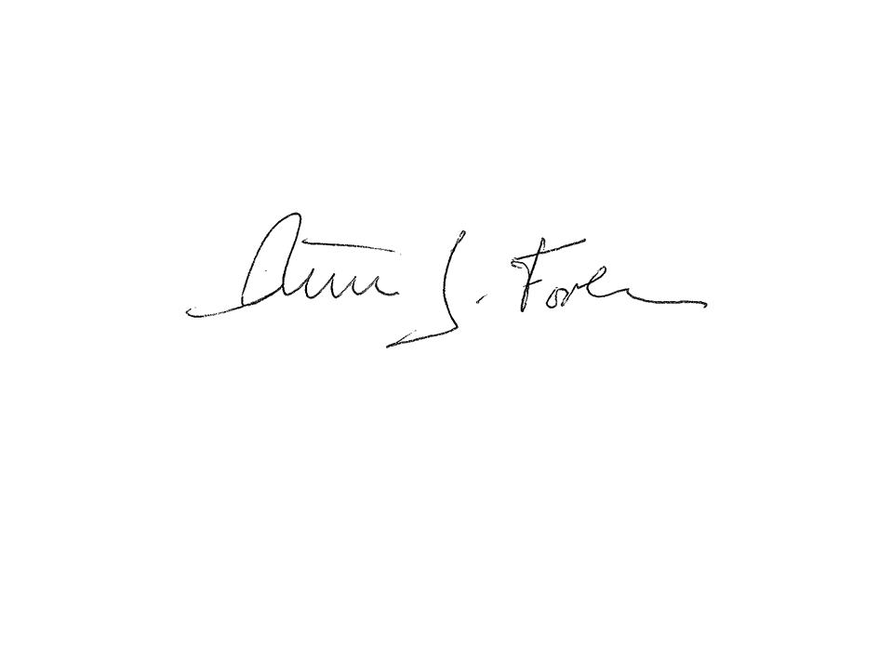  Peter J. Forbes, Commissioner |  | 5/23/2014
Applicability: | This policy shall apply to DYS for individuals who apply for a volunteer or intern positions through DYS state or contracted provider locations.

Policy
It is the policy of the Department of Youth Services (DYS) that all individuals acting as paid or unpaid interns or volunteers complete the DYS volunteer/intern application, Background Procedures, and training in accordance with these procedures.

A Volunteer/Intern Coordinator for each Region and the Central Office shall coordinate the application, hiring, training, and supervision of the intern or volunteer.

Individual interns or volunteers shall not have unsupervised contact with DYS youth unless such contact is part of the application process and such individual is approved for this type of contact.

Volunteer or intern services for a DYS location or youth include but are not limited to administrative duties, employment, education, clinical, recreational, and/or cultural activities.

DYS shall immediately prohibit contact by the volunteer or intern with youth and/or discontinue any volunteer or intern activity that threatens the security or the safety of a youth, employee, and/or the volunteer including acts that are in violation of this policy or fail to follow the applicable training.

Procedure

- Definitions
- The following definitions shall have the meanings assigned to them in this policy for purposes of interpreting this policy.
Background Check: Review of criminal history in accordance with DYS or Provider guidelines which shall include a CORI, Department of Children and Families (DCF), and Sex Offender Registry (SOR) check.

Faith Based Individual or Organizations: Individual or organization affiliated with, supported by, or based on a religion or religious group who are not required to complete the Volunteer/Intern application or training if they are providing faith based services and will not be unsupervised with youth. Such individuals/organizations shall be notified and acknowledge in writing that they are aware of the DYS Policy on Prevention of Sexual Abuse and Sexual Harassment and the Youth Grievance Process through the program.

Guest: A person who, on a one-time basis, without any expectation of or entitlement to future employment, voluntarily undertakes to visit a location or provide programming or service, will not have unsupervised contact with the youth and are not required to complete the Volunteer/Intern application or training. Guests are distinguished from visitors, who are persons visiting a particular youth.
Intern: A student or graduate gaining supervised practical experience through the provision of services.
Unsupervised Contact: Any activity where a volunteer or intern is not accompanied with a DYS state or provider employee while with a youth. Even if approved for unsupervised contact, volunteers or interns shall always remain within sight and sound of others so he or she would be heard by employees if assistance is needed.
Volunteer: A person who regularly, without remuneration or any expectation of or entitlement to future employment by DYS, provides programming or services.
- Terms that are defined Policy #01.01.04, “Policy Definitions” shall have the meanings assigned to them in that policy, unless a contrary meaning is clearly set forth.
- Terms not defined in Policy #01.01.04 or in this policy shall have the meanings assigned to them by reasonably accepted standard dictionary definitions of American English.
- Screening and Selection: The Volunteer/Intern Coordinator may assist in the identification of potential volunteers as needed by DYS locations including the location, screening and selection of volunteers and interns. The screening and selection of interns and volunteers shall allow for recruitment from all cultural and socioeconomic parts of the community.
- Application and Training Requirements
  - All interns and volunteers shall complete the DYS Volunteer and Intern Application and the DYS Volunteer and Intern Training with the Volunteer/Intern Coordinator prior to starting the assignment. Such training shall include but is not limited to the following:

  - Confidentiality and Information Security policies;
  - Ch. 51A Mandatory Reporting of Abuse and Neglect requirements; and
  - Safety and security information including youth movement, emergency procedures, and interaction with DYS youth; and
  - Protections under PREA, the Prevention of Sexual Abuse and Sexual Harassment of Youth and Youth Grievance Process;

2. Volunteers and interns shall provide evidence of all required credentials, certifications and/or licenses within the application process if they will be performing a professional service that requires a license or certification. Tutoring or teaching of a craft or hobby is not usually considered a professional service requiring such license or certification.
3. College student interns seeking credit for their internship shall provide documentation that they are enrolled in an educational institution.
- Interns/volunteers under the age of 21 must receive prior approval by the Regional Director or in the case of interns/volunteers at the Central Office level by the subject matter Director.
- Each Volunteer/Intern Coordinator shall maintain a list of the current interns and volunteers in the Region or Central Office and their completed applications including the completed policy sign off sheet and a copy of any required certifications.
- All volunteers and interns shall attend additional training such as specific courses as required by the Volunteer Coordinator and individual supervisor of that intern or volunteer based on the services they provide and level of contact that they have with the youth. Additional training for interns and volunteers may include but are not limited Basic Training courses on PREA, Suicide Awareness and Prevention, Drug and Alcohol Awareness, Positive Youth Development and Prevention of Discrimination and Harassment.
- Upon completion of the required training, the Volunteer/Intern Coordinator shall forward a request for a DYS ID to the Training Academy using the ID Request Form. The ID will have a year expiration date and will specify “intern/volunteer” in the job category.
- No volunteer or intern may supervise a state or provider employee in the performance of his/her official duties.
- Any modification of the intern and volunteer application shall be made through the Volunteer/Intern Coordination.
- Additional Requirements for Volunteers and Interns for Clinical Services
1. All applications by interns for clinical services with the Regions shall be submitted to the Volunteer/Intern Coordinator and the Regional Clinical Coordinator or Director of Clinical Services for Central Office positions.
2. The Regional Clinical Coordinator shall review the options and potential placement based on the intern’s interests, school requirements and program’s availability. Second year (or higher) Master’s level students may be placed in any type of residential programs including treatment programs. First year (or higher) Master’s level students may be placed in a detention, assessment, or a revocation programs but not treatment programs. Bachelor level students are not eligible for clinical internships.
3. The Regional Clinical Coordinator and Program Clinical Director shall conduct interviews of the intern.
4. The clinical intern shall provide, in addition to the completed DYS Volunteer/Intern application, a resume and three references, with one being the primary academic supervisor and proof of insurance coverage either individually or through their school.
5. Upon being selected, the clinical intern and Clinical Director shall complete a school agreement and learning contract.
6. The clinical intern shall complete the DYS Volunteer and Intern Training with the Volunteer/Intern Coordinator and, at a minimum, the DYS Basic Training courses in PREA, Suicide Assessment and Prevention, DBT De-escalation Techniques and Prevention of Discrimination and Harassment prior to unsupervised contact with the youth.
7. The supervising Clinical Director shall review the intern’s JJEMS note entries for the first two months of the internship. Upon successful completion of two months of supervision, the supervising Clinical Director may request JJEMS access for the clinical intern through the Regional Clinical Coordinator. JJEMS access shall not be granted if the intern has difficulty with the note entries.
8. Intern’s JJEMS access shall be terminated through the JJEMS Regional Support Staff, with notification to the RCC and Volunteer/Intern Coordinator, upon the last day of the internship. The Clinical Director shall confirm access has been terminated on the next business day.
9. Doctoral interns may act as a primary therapist to a youth only if the intern’s qualifications match the qualifications of the clinicians at that location, the intern has their Master’s level or is license eligible (intern has a master’s degree in a mental health field that meets licensing requirements). All other clinical interns may act as a supplement but not as a primary therapist to a youth in the following duties:
a. Addressing the youth’s behavior management plan in the milieu;
b. Completing the youth’s DBT homework;
c. Reviewing the youth’s relapse plan; and
d. Assisting or acting as co-lead with unit clinician(s) in group therapy.

