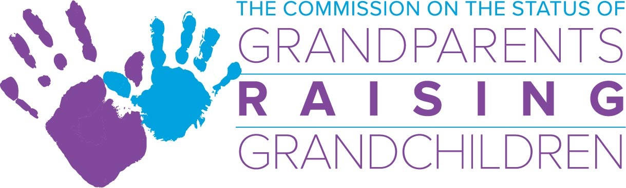

January 9, 2019 Commission Meeting, 2-4 p.m. .
One Ashburton Place 5th Floor Boston, Ma.
Commission Bridge Number: 240-454-0887
Meeting Access Code: 731860817

Agenda

- Welcome and Introduction of BC MSW Graduate student intern, Katrina Lund

- Acceptance of December meeting minutes
*Action required

- Financial Report/Budget
- GP Commission budget update:
  - Discussion of proposed changes/amendments to FY’19
  - *Action required
- MCOA budget
- Study: Abby AGO + OCA proposal, update

- Sub-Committee Updates:
- Information and Referral Sub-Committee: Skip
  - GP Commission brochures
  - Agency collaboration meeting
  - Tip Sheet Review
- Support Group Sub-Committee: Margo/Deb
  - 2019 Conference - save-the-date: June 5, 2019
  - March support group training
  - Statewide resource network
- Legal Sub-Committee: Lynn
  - H2274 Legislation update
  - Child Care Advocacy
  - Masshealth/school lunch
  - Legislative Breakfast
- Resource Development Sub-Committee: Ilene
  - MCOA/SIG grant update
  - Grand-Families FUNd pilot program

- Directors Report: 2018 End of Year Report

- Chairwoman’s Report

- Other Business:
- Event with Jarrett Krosoczka and Eric Carle Museum 4/20/19
- Spring Workshops: No. Attleboro, Holyoke, Gloucester, Harwich, New Bedford, and Framingham.

