 | Commonwealth of Massachusetts
 | Executive Office of Health and Human Services
 | Department of Youth Services
 | Official Policy

Policy Name: | Client-Centered Medication Administration
Policy #: | 02.05.15(c) | Effective Date: | January 30, 2010
Repeals: | 2.5.15(b)
References: | 105 CMR 700.003, DPH Regulations  Psychotropic Medication Policy No. 02.05.16
Signature:  Attachments: | 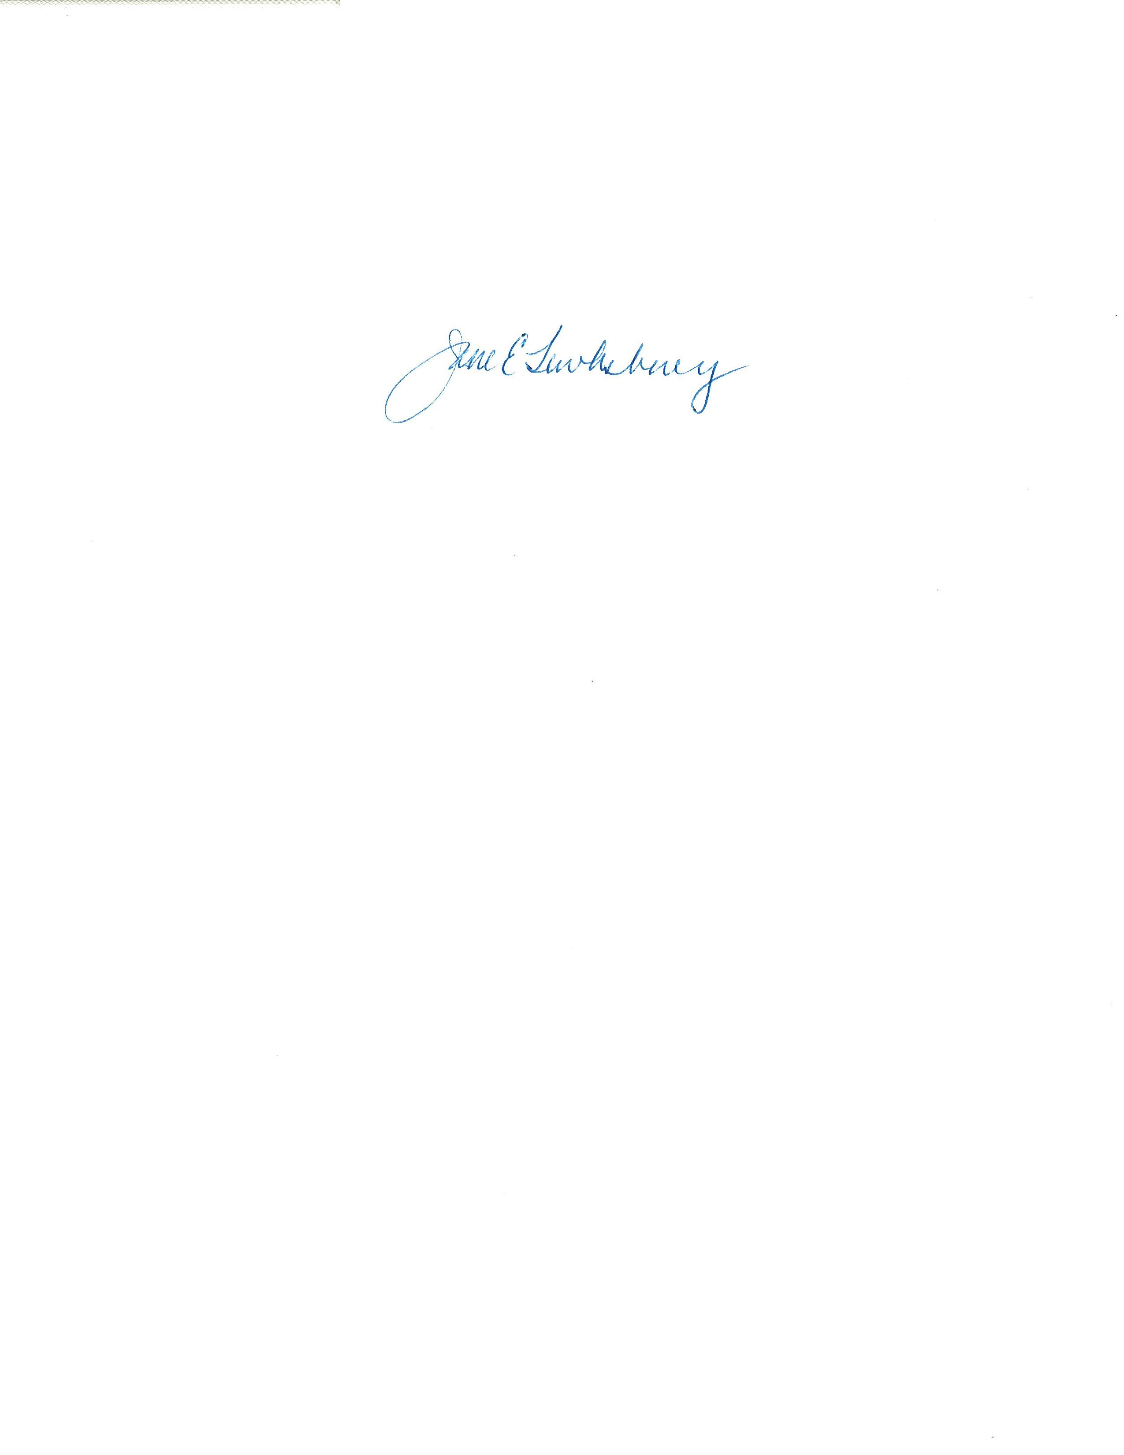  Client Consent Treat and Medical Release  OTC Medication Administration Form  Prescription Medication Administration Form  Medication Count Form  Medication Disposal Form  Medication Occurrence Report |  | 11/17/2009
Applicability: | This policy shall apply to DYS employees and provider staff working within a DYS facility. Providers are expected to have their own policy consistent with the principles articulated in this policy and approved by the DYS Director of Health Services, and must comply with all the safety-related principles in this policy.

Policy
It is the policy of the Department of Youth Services (“DYS”) that:

- All DYS residential facilities and community programs will use the uniform procedures in this policy to order, store, administer, record and report on the use of all client medications;
- The Client-Centered Medication Administration System (CCMS) will be managed by CCMS staff who have been trained according to DYS protocol;
- It is presumed that all clients are capable of self-administering all their medications;
- Before clients are allowed to self-administer, a client’s parent or guardian must have provided consent for the client’s routine medical treatment, or the client must be age eighteen or older and provide his or her own consent;
- For safety, CCMS staff as designated in these procedures will supervise that the right client receives the right medication, at the right dose, at the right time, by the right route;
- CCMS staff as designated in these procedures will be responsible for the custody of the medication until the moment the client identifies the medication as his or her own and takes it; and
- Problems arising with self-medication, including a client’s refusal, will require the intervention of Health Services staff or the medication prescriber.

Procedure

I. Definitions
1. The following definitions shall have the meanings assigned to them in this policy for purposes of interpreting this policy.
Client-Centered Medication Administration System (“CCMS”): A system in which trained staff monitor medication self-administration by DYS clients.
CCMS Staff: includes Program Directors, Assistant Program Directors, Shift Administrators, Shift Supervisors, Clinical and Health Services staff, who have been trained in the DYS Client-Centered Medication Administration System.
Clinical Staff: A psychologist or trained mental health professional employed by or contracting with DYS or a provider to perform services in a clinical capacity.
Community District and Satellite Offices: A community site at which DYS provides committed clients with case management, supervision, and services.
Consent: For clients under the age of 18 to self-administer medications, parents or guardians must give DYS consent for the client’s routine medical care. For clients 18 years or older, a consent form signed by the client gives DYS consent for the client’s routine medical care. A separate consent must be given for psychotropic medications, in accordance with DYS Policy No. 02.05.16.
Five R’s Check: A safety measure to ensure that the right client receives the right medication, at the right dose, at the right time, via the right route of medication administration. The right route includes, but is not limited to, an oral, topical, inhalation, or injection method of delivery.
Five R’s Cross-Check: CCMS staff will perform a cross-check of the medication orders with the pharmacy label and the Medication Administration Record.
Health Services Staff: A Physician, Physician Assistant, Nurse Practitioner, Licensed Practical Nurse, Registered Nurse, Dentist, DYS Director of Health Services, and any medical specialist employed by or contracting with DYS who is involved in the client’s health care.
Medication Administration: The act of a health services staff administering the medication to a client when a client cannot be trained to self-administer medication.
Medication Administration Record: Client self-administration shall be documented on the attached DYS approved form. There shall be a separate form for each medication for each client. Listed on the form are the name of the client, medication, strength, and dosing schedule. There is a separate form for prescription and over the counter (OTC) medication.
Medication Count: Tracking medication and recording on the Medication Count Form. Medication counts are to be conducted by CCMS staff whenever control of the medication key passes and at the start and end of each shift.

Medication Destruction: All prescription medications that are outdated, spoiled, dropped, not administered due to a change in the prescription, stop order, or client release, shall be destroyed and recorded using the DYS Medication Disposal form.

Medication Dosing Window: A period of time that includes an hour before and an hour after the prescribed time the dose ordinarily is to be administered.
Medication Hold: The process of suspending client centered medication administration until proper consents for treatment have been obtained, and the identity of the client is verified. No medications shall be withheld if doing so would endanger the client’s life, i.e. medication for diabetes, cardiac illness, seizure disorders, or asthma.
Medication Information form: A form provided by the pharmacy or by medical reference software, approved by DYS, which includes the brand name and generic name of the drug, instructions on its use, cautions and side effects.
Medication Loss: Any event explained or unexplained, suspicious or non-suspicious, that results in a loss of any portion of a client’s medication. Losses may include dropped medication, spills, inaccurate counts, and theft.
Medication Occurrence: An event that involves a breach of one of the Five Rs.
Medication Occurrence Report: A form used to report a Medication Occurrence which does not result in medical treatment, illness, injury or death.
Medication Prescriber: Any person licensed to prescribe controlled substances. This includes those prescribers who may not be affiliated with DYS, but who may have prescribed medication to a DYS client in the past.
Medication Self-Administration: The act of a client taking or applying his or her own medication under the supervision of a CCMS staff member.
Prescription Requisition form: A form that is used to record the medications or devices that have been requisitioned from a designated pharmacy for a client.
Tamper Resistant Pack: A type of packaging for oral medications which allows for the dispensing of an individual dose of the medication.
2. Terms defined in Policy No. 01.01.04, “Policy Definitions” shall have the meanings assigned to them in that policy, unless a contrary meaning is clearly intended.
3. Terms not defined in Policy No. 01.01.04 or in this policy shall have the meanings assigned to them by reasonably accepted standard dictionary definitions of American English.
II. SECURE AND Residential Programs

A. Verification of Consent

- Before allowing a client to self-administer medication, CCMS staff shall verify that the parent or guardian has given written consent for the client’s routine medical or dental care, or that the client, 18 years or older, has given consent.
- CCMS staff shall note on the Medication Administration Record that written consent has been obtained. The original, signed, written consent form shall be maintained in the client’s file.
- If no written consent has been obtained, the Program Director, Assistant Program Director, Clinical or Health Services staff shall call the parent or guardian. A parent or guardian’s verbal consent is sufficient temporarily and must be documented on the Medication Administration Record and in the client’s main file by the staff hearing the consent. Staff should note the date, time, telephone number, name of person giving consent, and, as possible, the exact language used in giving consent. Written consent should be obtained as soon as possible.
- Health Services staff shall write a “hold medication” order pending receipt of consent, unless withholding the medication could endanger the client’s health.
- If consent cannot be obtained within 24 hours, or the client’s health would be endangered by waiting to obtain consent, CCMS staff should contact the On-Call Health Services staff for instructions on how to proceed.
- For psychotropic medications, the medication prescriber will obtain written consent from the parent or guardian. Psychotropic Medication Policy, 02.05.16.
B. Transcription of Medications
- Health Services staff shall transcribe each medication order onto a Medication Administration Record and shall train the client on self-administration procedure.
- When Health Services staff are unavailable for transcriptions, CCMS staff shall transcribe the order. If a CCMS staff other than health services has done the transcription, the Health Services staff, as soon as next available, must verify its correctness by signing or initialing it. Alternatively, two CCMS staff may verify its correctness. If incorrect, health or CCMS staff shall void the Medication Administration Record by writing “faulty transcription” next to the transcription.
- If a Medication Administration Record is voided, the CCMS staff should complete a new one. Voided records shall be removed from the current medication administration records and placed in the client’s medical file.
- In the event of a faulty transcription, health or CCMS staff also shall determine if there was a violation of any of the Five Rs, and, if so, shall complete a Medication Occurrence Report, and submit it to the DYS Director of Health Services, in accordance with Section L(2) of this policy.
C. Change in Medication Orders
Program Director, Assistant Program Director, Clinical or Health Services staff shall verify with the medication prescriber that a prior order is to be discontinued whenever there is a change in the prescription of a given medication. CCMS staff shall request that the change be written as a new order.
D. Training of Clients
- Health Services shall train clients to self-administer medications. The fact that a client has been trained shall be documented in the client’s medical file and on the initial Medication Administration Record.
- Training includes ensuring that the client understands why he or she needs the medication, what it is for, agrees to take it as prescribed, and understands the procedures for self administration as described in Section E.
E. Monitoring Client-Centered Medication Administration
- The shift administrator or shift supervisor shall perform the following duties. Where the shift administrator or shift supervisor are absent, the Program Director designates the appropriate other CCMS staff for these duties.
  - Perform the Five R’s Check every time that a client self-administers medication.
  - Insure self-administration occurs within the medication dosing window, unless noted otherwise on the Medication Administration Record.
  - Insure that each of these procedures in observing client self-administration are followed:
    - Determine which clients are in need of medication at the appointed time;
    - Compare the information on the pharmacy label with the client’s Medication Administration Record, and the medication order, in accordance with the Five Rs cross-check, to verify that the information matches exactly;
    - Call the client to the medication administration area;
    - Identify the client by asking for his or her complete name. If two or more clients have the same name, request the client’s date of birth;
    - Have the client compare the medication label on the tamper resistant pack or other medication package to the Medication Administration Record;
    - Select the correct medication and while maintaining control of the medication container, assist the client in accessing the medication dose;
    - If oral medication, observe the client swallow the medication. To verify that the client did not “cheek” the medication, staff shall (1) closely inspect the client's hands, (2) instruct the client to stick out his or her tongue, (3) inspect the mouth carefully, including under the tongue and all crevices in the mouth, and (4) prompt the client to swish and swallow water, if necessary;
    - If a client requests assistance with self-administering medication, staff may assist; and
    - Have the client initial the Medication Administration Record acknowledging having taken the medication.
4. Clients who need to self-administer a suppository, or apply ointment shall be afforded privacy in the act of self-administration.
F. Clients who Refuse Medication
1. When a client refuses to take prescribed medication, the shift administrator or shift supervisor shall ask the client the reason, document it on the Medication Administration Record, and notify the Health Services staff or medication prescriber using a Medication Occurrence Report. Where the shift administrator or shift supervisor are absent, the Program Director designates the appropriate other CCMS staff for this duty and those duties in this section E.
2. Under no circumstances may any staff alter the medication or medication order to achieve compliance without an order from a member of the Health Services staff.
- If the client still refuses, such staff should notify the On-Call Health Services staff or the medication prescriber to determine whether the client needs to be evaluated, in a time frame appropriate to the client’s condition.
G. Documentation of Medication Self-Administration
1. The shift administrator or shift supervisor shall record on the Medication Administration Record that the medication was taken and the number of pills that remain. This step must be performed by the staff member who observed the client self-administer. Where the shift administrator or shift supervisor are absent, the Program Director designates the appropriate other CCMS staff for this duty and those duties in this section G.
2. Such staff shall ask the client to initial the Medication Administration Record documenting that he or she self-administered the medication. If the client refuses to sign, such staff shall note the refusal and initial it.
3. Such staff shall insure that the Medication Administration Record and Medication Information forms are kept together in the medication storage location, sorted by client’s last name.
H. Storage and Disposal
1. Program Director for each location shall designate a specific area dedicated to the storage of all client medications, as follows:
  - All medications must be double locked, i.e. a locked box within a locked cabinet; and
  - Only CCMS staff assigned the duty of assisting the clients in self-administration during their shift may have possession of the medication key.
2. All medications that are outdated, spoiled, dropped, or not administered due to a change in the prescription, stop order, or client release shall be destroyed by Health Services staff.
3. Destruction shall occur in the presence of at least two witnesses and be documented on the attached DYS approved Medication Destruction form.
I. Medication Refills
1. The shift administrator or shift supervisor shall monitor a client’s medication supply and follow the next step of this policy when it is running low (less than five days of medication). Where the shift administrator or shift supervisor are absent, the Program Director designates the appropriate other CCMS staff for this duty and those duties in this section I.
2. Such staff shall notify the Health Services staff and Program Director that the medication is running low and a refill may be necessary.
3. Health Services staff, or the Program Director if Health Services staff is unavailable, shall contact the medication prescriber and pharmacy as necessary.
J. Shift Change and Medication Count Procedures
- At the beginning and end of each shift at every shift change, both the outgoing and incoming shift administrator or shift supervisor shall complete their own medication count and review as follows:
  - Review all medication orders and the Medication Count Form;
  - Confirm all medication counts using the Medication Count Form, as well as the time of the count;
  - Verify the identity of each client on medication; and
  - Place a “medication hold” on any client whose identity cannot be verified.
- If at any time there appears to be an incorrect amount of medication, such staff shall report a Medication Loss in accordance with Section K of this policy.
- Where the shift administrator or shift supervisor are absent, the Program Director designates the appropriate other CCMS staff for these duties in this section J.
K. Medication Losses
1. For losses of any portion of a client’s medication, CCMS staff must fill out a Medication Occurrence Report and have it verified by a supervisor. The completed Medication Occurrence Report should be submitted to the Location Manager, Health Services staff, and the DYS Director of Health Services.
2. At first discovery of suspicious or unexplained losses, supervisory staff also must report the loss immediately to the Central Office CIC, in accordance with the DYS Serious Incident policy, No. 01.03.05(d).
L. Medication Occurrences
1. A Medication Occurrence which is followed by medical treatment, illness, injury or death is reportable immediately to the Central Office CIC, in accordance with the Serious Incident Reporting Policy, 01.03.05(d). The Occurrence must also be reported to Health Services staff, and the DYS Director of Health Services.
2. A Medication Occurrence which does not result in medical treatment, illness, injury or death should be treated seriously. Supervisory staff must complete a Medication Occurrence Report, and submit it to the DYS Director of Health Services and Health Services staff.
M. Medication Transportation
1. During change of placement, the client’s medication and medication documentation will be transported in the custody of the staff transporting the client to another location.
2. Upon arrival at the next placement, the Health Services staff or if unavailable, the receiving CCMS staff must create a new Medication Administration Record.
3. If necessary, staff shall consult with Health Services to determine if medication should be transported during temporary changes of location.
N. Training of Staff
1. Location Managers shall ensure that their CCMS staff are trained in CCMS procedures. DYS will provide CCMS training in these ways:
  - Initial training will include a practical skills demonstration test, including the transcription of medication orders; and
  - Annual review training.
2. The DYS Director of Health Services may direct further training as a result of medication occurrences, medication losses or specific needs of clients.
III. Community DISTRICT AND SATELLITE OFFICES

A. Applicability

- It is DYS’ expectation that it will be a rare occurrence that a client will need to self-administer medication at a community district or satellite office. It is DYS’ expectation that a client’s parent, legal guardian, or foster parent will supervise the administration of a client’s medication while the client is living in the community.
- In those rare cases when a client needs medication while attending a community program, the procedures below shall apply:
  - Upon entering a community program, a client will be asked to surrender any medication, except an inhaler or an Epi-pen, to the District Manager or designee for storage;
  - The District Manager or designee shall be responsible for storing client medications securely while the client is in the location;
  - Clients will be required to take their medications with them when they leave the location; and
  - If medication questions arise while the client is in the community program, location staff should call the parent or guardian and document the information in the client’s file.

