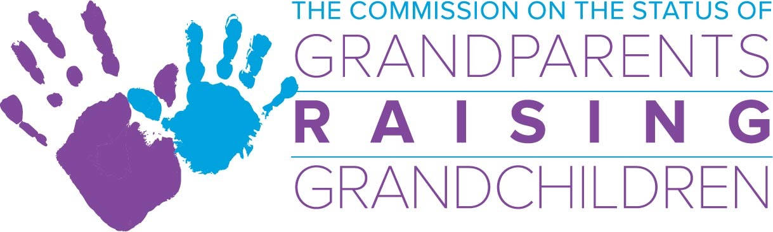

Wednesday, February 13, 2019
GRGC Commission Meeting
2:00 -4:00 p.m.
One Ashburton Place - 5th Floor
Boston, Ma. 02108
Manning Conference Room

Agenda

- Acceptance of meeting minutes
*Action required

- Financial Report/Budget
- GP Commission budget

- Sub-Committee Updates:
- Information and Referral Sub-Committee:
- Support Group Sub-Committee:
- Legal Sub-Committee:
- Resource Development Sub-Committee:

- Directors Report

- Chairwoman’s Report

- New Business

