 | Commonwealth of Massachusetts
 | Executive Office of Health and Human Services
 | Department of Youth Services
 | Official Policy

Policy Name: | Youth Grievance Process
Policy #: | 03.04.01 | Effective Date: | January 6, 2014
Repeals: | None
References: | Prevention of Sexual Abuse and Sexual Harassment of Youth Policy
Signature: | 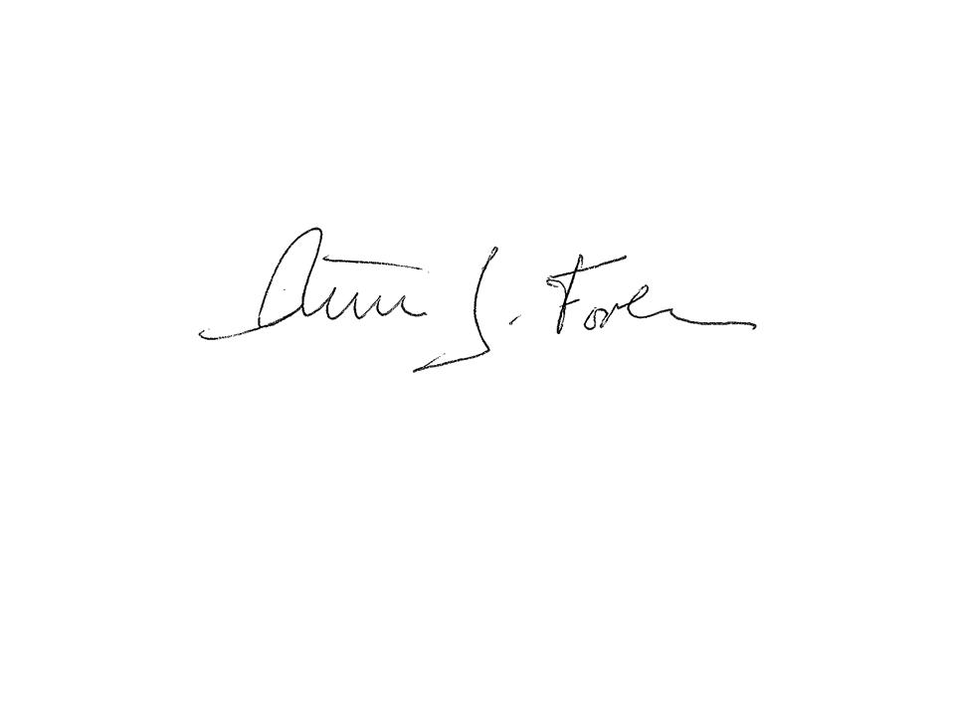  Commissioner Peter Forbes |  | November 11, 2013
Applicability: | This policy shall apply to DYS staff, contracted providers, youth, volunteers, and interns.

Policy

It is the policy of the Department of Youth Services (DYS) that youth under the care of DYS and third party individuals on behalf of such youth have the right to file a grievance at any time for any inappropriate conditions or behavior of staff or other youth in accordance with these procedures.

Any youth or third party who reports a grievance shall not be subjected to any adverse action, discipline, or retaliation pertaining to the filing of a grievance. Employees or youth who attempt to retaliate against a youth for utilizing the grievance process will face disciplinary measures.

All phases of the grievance process shall remain confidential to only those parties who need to know about the grievance.

Topics that are not subject to the youth grievance process include but are not limited to placement decisions, grid level decisions, issues currently in litigation or pending litigation, actions or decisions by any agency other than DYS, and any other category where a process currently exists to resolve that issue.

Procedure

- Definitions
- The following definitions shall have the meanings assigned to them in this policy for purposes of interpreting this policy.
Emergency Grievance: Any complaint alleging that the youth believes he or she is at substantial risk of imminent sexual abuse.
First Clinical Session: First scheduled meeting a youth has with his/her assigned clinician or clinical designee following the completion of the Intake Procedures, and occurs within 72 hours of admission to DYS custody.

Grievance: An allegation by a youth or third party on behalf of a youth based upon actual, perceived or alleged circumstances concerning a violation of this or other policies, or conditions of confinement.
Grievance Box: Locked drop box labeled ‘grievance box’ to collect completed grievance forms.
Grievance Form: Standardized forms that youth or employee or third party, on behalf of a youth, may use to submit a youth grievance.
Grievance Review Team (GRT): Two person team that includes two of the following: For residential placement, the location’s PREA Compliance Manager, Program Director, Assistant Program Director, Clinical Director, Program Clinician, Provider Executive Operational Employees and/or Regional Senior Staff Employee(s). For community placement, the District Manager, Director of Community Services, Provider Contract Managers, Provider Executive Operational Employees and/or Regional Senior Staff Employee(s). For alternative lockup programs (ALP), the two person team can be anyone within this definition.
Grievance Box Log: A bound book that is used to record the grievances filed in the grievance box including the date, time, signatures of the team emptying the box, number of grievances in the box and if the grievance is related to PREA.

PREA: Prison Rape Elimination Act, Federal juvenile standards, that provide requirements for DYS to prevent, detect and respond to allegations of sexual abuse, sexual harassment or retaliation by employees or youth for reporting such conduct.
PREA Compliance Manager: A DYS state or contracted provider employee assigned to coordinate a location’s efforts to comply with the PREA juvenile standards. Such individual has the title of Facility Administrator of a set of programs located within one or more buildings or Program Director for locations that physically stand alone and do not share a building or campus with DYS or other provider.
PREA Coordinator: Upper level statewide DYS employee who develops, implements and oversees agency efforts to comply with the PREA juvenile standards in all DYS residential programs.
Third Parties: Individuals who can report a grievance on behalf of a youth or assist a youth in filing a grievance including other youth, employees, family members, attorneys, and outside advocates.

Youth Orientation Materials: Information presented to youth that shall include but is not limited to the DYS approved pamphlet on ‘How to Conduct Yourself’ including the Department of Children and Families Child at Risk Hotline 1- 800-792-5200; postings of Rape Crisis Centers.

Youth Education Materials: Information presented to youth that shall include but is not limited to the following: the DYS approved intake presentation; Policy on the Youth Grievance Process; Policy on the Protections of Youth Under PREA; notification of the Department of Children and Families Child at Risk Hotline 1- 800-792-5200, and numbers for the MA Rape Crisis Programs.

- Terms that are defined Policy #01.01.04, “Policy Definitions” shall have the meanings assigned to them in that policy, unless a contrary meaning is clearly intended.
- Terms not defined in Policy #01.01.04 or in this policy shall have the meanings assigned to them by reasonably accepted standard dictionary definitions of American English.
- Notification of the Grievance Process to Youth and Third Parties
1. Within 24 hours of arriving at the location and during the DYS Intake Process, employees shall notify all youth using the youth orientation materials that they have the right to file a grievance. Youth shall sign that they have been informed of the above information with a copy of the acknowledgement kept within the youth intake packet and scanned into JJEMS.

- At the first scheduled clinical session, clinical employees shall review the Youth Grievance Process as part of the youth education materials. Such information shall include:

  - Youth’s right to file a grievance at any time;
  - Instructions on how to fill out a grievance form;
  - Location of the grievance boxes and forms;
  - How to file a grievance in community placement;
  - Disciplinary sanctions for youth who intentionally make false allegations;
  - Clinicians shall document that youth have received the youth education materials by noting such in the JJEMS clinical progress notes.

- This policy, procedures and grievance forms shall be posted at two or more areas visible to:

  - Youth such as in the library, bathrooms, school, cafeteria and clinical offices; and
  - Third parties outside the youth living areas such as in the visiting locations, bathrooms, entrance areas and waiting rooms.

- Information on the Youth Grievance Process shall be provided in formats accessible to all youth including those who are limited English proficient, deaf, visually impaired, or otherwise disabled, as well as to youth who have limited reading skills. Staff seeking alternative formats shall notify the regional clinical coordinator immediately upon identifying this need.

- Filing a Youth Grievance
1. Employees shall be available to youth to listen to their concerns and take appropriate action to resolve a concern whenever possible without filing a grievance.
2. Grievances may be filed in a grievance box using a grievance form in alternative lockup programs (ALP) and residential placement locations. Employees shall provide assistance to youth when they believe a youth seeks to use a grievance form but is unable to adequately complete the grievance form.
3. Youth in an ALP and residential placement shall not be required to use the grievance box to file a complaint or concern but may use other means verbally or in writing to report a grievance to employees or third parties.
4. Grievance boxes will not be placed in community locations. Youth in community placement and third parties may submit a grievance verbally or in writing to employees.
- Grievance Boxes, Forms and Log
1. All ALP and residential locations shall have a clearly marked ‘grievance box’ in any area that is easily accessible to youth, where youth are on a daily basis and where the grievance forms can be dropped in order to maintain confidentiality.
2. Location Managers shall place blank grievance forms at multiple locations within the program allowing youth unobstructed access to the forms such as in classrooms, clinical offices, cafeteria or general living areas. Youth may be allowed to write out a grievance at any reasonable time.
3. Grievance boxes shall be immediately repaired or replaced if damaged.
4. The Grievance Review Team (GRT) shall open the grievance box together once per day Monday through Friday. No other staff shall open the grievance box.
5. Grievance forms may be accepted by any employee on behalf of a youth without using the grievance box. Upon receiving a written grievance form, the receiving employee shall follow the procedure outlined in Section E.
6. Each grievance form shall be reviewed by both members of the GRT and entered into the Grievance Log upon receipt.
7. The Grievance Log shall include: the date and time the grievance was received, and the name and signatures of the employees checking the grievance box and the number of grievances in the box.
8. If a grievance form refers to one or more of the GRT, the alternative member(s) of the GRT shall continue the review process.
9. Within 24 hours of receipt of the grievance form, the GRT reviewing the form(s) shall:
a. Confirm receipt of the grievance form with the youth who filed the grievance, if known and if the youth is still within DYS care and custody;
b. Refer to the appropriate place depending on the grievance in accordance with Section E.
- Determination of Type of Grievance
1. Any grievance in writing or verbally that alleges sexual boundary violations, sexual abuse and/or sexual harassment as defined by the Prevention of Sexual Abuse and Sexual Harassment of Youth Policy shall be referred immediately to the Location Manager who shall act in accordance with such policy.
2. Any grievance that alleges that a youth is subject to a substantial risk of imminent sexual abuse will be considered an emergency grievance and referred immediately to the Location Manager who shall act in accordance with the Prevention of Sexual Abuse and Sexual Harassment of Youth Policy.
3. Any grievance via a verbal complaint or written form that alleges any other serious incident including but not limited to, discrimination, harassment and/or retaliation by or against any DYS staff or youth, shall be referred immediately to the Location Manager in accordance with the Serious Incident Policy.
4. Any grievance on any other topic shall be referred to 2 members of the GRT for that location for a determination on whether a review shall be conducted in accordance with these procedures in Section F.
F. Review of a Grievance Not Considered a Serious Incident
1. Within four calendar days of receiving a written grievance that is not a serious incident, two members of the GRT will review the grievance to determine if the issue should be reviewed or closed.
2. A verbal grievance may be referred by an employee to a member the GRT to determine whether to take additional steps to review the issue or close the matter. If closed, no other action is required.
3. Upon determining whether to conduct a review of a verbal or written grievance, one member of the GRT shall conduct an interview with the complaining youth, if known, and employee named in the grievance, witnesses involved in the matter, and collect any evidence associated with the grievance.
4. All information obtained from the review shall be documented in writing.
5. A recommendation for resolution or denial of the grievance shall be issued within ten calendar days after the review commences and submitted to the Administrative Team.
6. A member of the GRT shall review the final proposed resolution with the youth and shall document such conversation in the JJEMS progress notes. The proposed resolution needs to clearly identify the corrective measure(s), if any, which will be taken so that the youth understands what remedy is being provided.
7. Any youth who files frivolous or fabricated grievances may be subject to discipline based on the recommendation of the GRT. A youth will not be denied a Grievance Form at any time.
8. If a youth has been transferred after a grievance is filed but not resolved, the GRT shall determine whether to keep the grievance at the originating location or refer to the new location. If the youth is no longer within DYS care or custody, the GRT can determine whether or not to continue the review of such grievance.
9. At any point during the grievance process a youth may withdraw the grievance. The GRT can determine whether or not to continue the review of such grievance with or without the youth. The GRT should consider whether or not the withdrawal was due to retaliation felt by the youth.
10. At any time during the review, the GRT can refer the grievance to the Director of Investigations for questions or additional review.
11. All documentation on any grievance not considered a serious incident shall be filed in a Grievance Review Log maintained by the Program Director or District Manager. Such documentation shall include but is not limited to the grievance form, interview notes, evidence used in the review and any written recommendation.
12. The Administrative Team shall review grievances filed on a weekly basis summarizing in the monthly report any trends and patterns.
G. Training: DYS Basic Training will include information on the DYS Youth Grievance Process and Procedure.

