
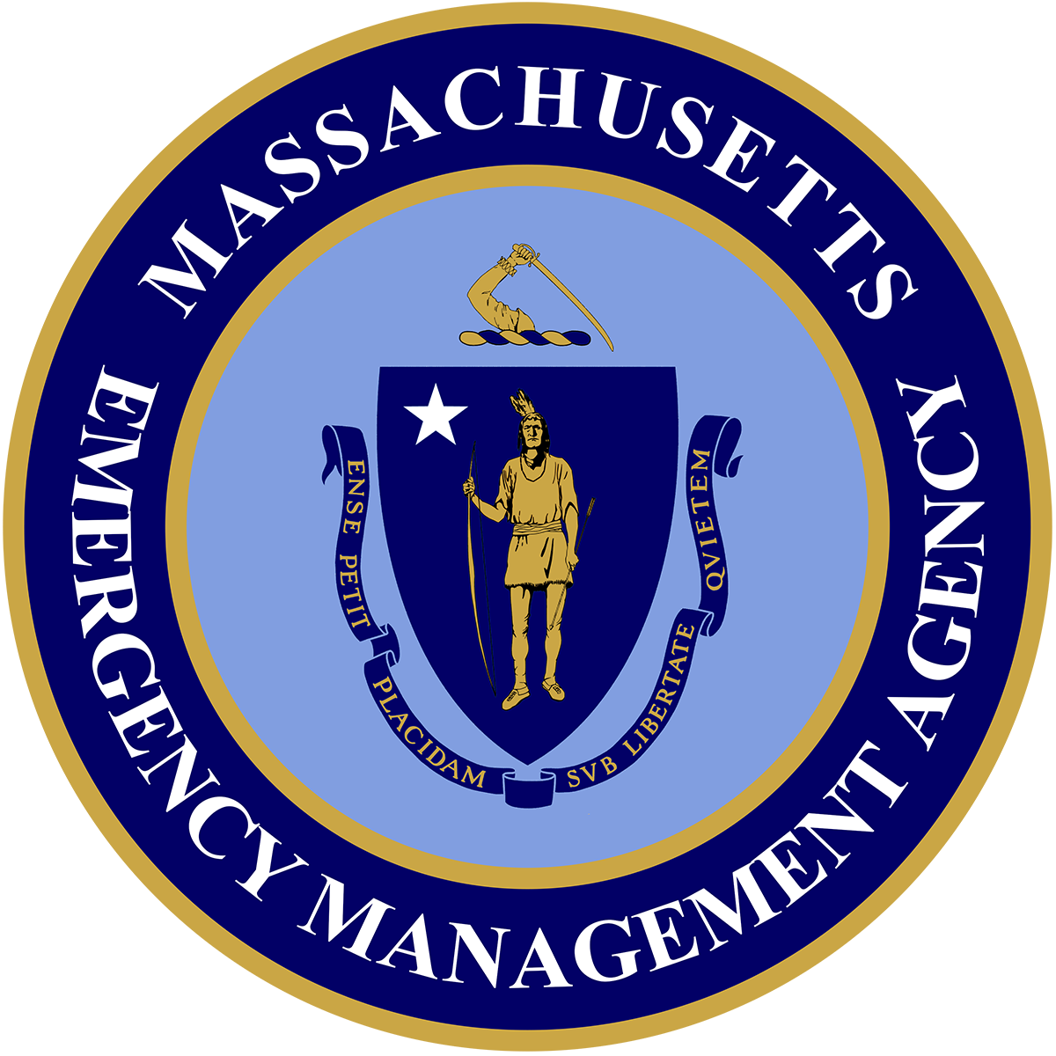
THE COMMONWEALTH OF MASSACHUSETTS
EXECUTIVE OFFICE OF PUBLIC SAFETY AND SECURITY
_____________________________

MASSACHUSETTS EMERGENCY MANAGEMENT AGENCY
400 Worcester Road Framingham, MA 01702-5399
Tel: 508-820-2000 Fax: 508-820-2030

Maura T. Healey
Governor

Kimberley Driscoll
Lt. Governor

Terrence M. Reidy
Secretary

Dawn Brantley
Acting Director
Website: www.mass.gov/mema

SERC MEETING MINUTES – 03/13/2023

In Attendance: Pat Carnevale; Michael Josti; Bud McDonough; Martha Middlestatedt; Ally Sleiman; Thomas Walsh; Captain Anthony Perella; Andy Goldberg; Charles Colley; Andrew Beaulieu; Kenyi Suarez; John Viveiros; Lorri Gifford; John Mulveyhill; Michael Castro; Robert Farmer; Jack Illingworth; Allen Phillips; Cameron Happer; Jeff Trask; Cathy Kiley

Welcome:
John Viveiros welcomed the group, thanked the folks that could make the in-person meeting. The quorum was met.

Review and Approve Meeting Minutes:

John asked for a vote on the previous meeting minutes.

Meeting minutes for 12/13/22 were approved

SERC Overview Presentation:

John Viveiros presented to the group a power point presentation with updates on SERC improvements and to demonstrate the progress of the SERC.

John showed the group how to access our SERC registration through MEMA’s website, he also showed the results and specific questions/comments people/communities have sent in so far.

We are seeking to hire a vendor or a contractor for the purpose of meeting EPCRA requirements. We would like to conduct two workshops strategically located throughout the state. The workshops will focus on the provisions of EPCRA. We are working on the scope and as it is finalized, we will be sharing it with the group.

We would like to start receiving Hazmat Plans and are working to establish a team to review these plans.
If a community has a Hazmat plan which is not completed the SERC will still review it and send it back with comments.
The concept is to review and comment on hazmat plans as required by EPCRA

Kathy asked how often a community submit these plans?
John V. they need to review their plans annually but update as necessary.

Jeff Trask would like to congratulate John V. and Lorri G. for the work they have put into this program and thanked them for their hard work.

John Mulveyhill asked for the EPCRA requirements for Hazmat plans.

Tier II Reporting: We just finished with the Tier II reporting period from January 1st – March 1st. This was a very busy year, we received approximately 7500 – 8000 reports this year. We received more than what we have received in the past. Massachusetts now becoming a delegated state to OSHA has increased the number of reports we are receiving.

MEMA purchased 75 additional licenses for local EPCs to have access to our Tier II Manager system. We have worked with the regional offices to identify communities who are best suited to have access to these licenses and we submitted that information to our vendor to update the system.

We will be working with our training department to come up with a training plan for this communities on how to work with the system on how to set up an account with Tier II Manger system. It might be a series of webinars or something similar, this will teach communities on how to view reports etc.

We will be having a meeting with Hazconnect in April, we will share that information with the group.

We have not distributed the 75 licenses as of today; we will follow up with communities requesting licenses for their use.
Mike Castro asked Kenyi S. with the increase reporting have you seen any state organizations or entities submit reports.
Kenyi S. yes, but not many.

HMEP Grants: – Lorri Gifford

FFY2021-2022 Status update
Twelve (12) projects remain opened
- Four (4) projects closed 12/31/2023; reimbursements are due 3/31 or we will close with no activity and repurpose funds
- Eight (8) projects close 6/30/2023

FFY2022-2023 (Year 1) Status update
We received a total of 27 application.
- One (1) was received after the due date
- One (1) was deemed ineligible as their exercise was not transportation related.
- Some award amounts were adjusted as not all activities were deemed allowable.
- Award notifications were sent out to LEPCs 3/10 along with contracts to be signed.

As a condition to these awards, LEPCs will be required to submit their HazMat Emergency Response Plan to the SERC for review and comment. For HazMat Plans that have not been reviewed/updated since 2021, they will also be required to review and update prior to being submitted to the SERC. MEMA will not process your reimbursement until this condition has been met. If LEPC chooses not to comply with these conditions, they must notify my office as soon as possible so we can repurpose the funds elsewhere.

LEPC/REPC | Community | Award | Planning | Exercise | Training | Conference
Northern Berkshire REPC | North Adams | $ 9,880.00 |  | x | x
Blackstone Valley REPC | Grafton | $ 7,000.00 | x | x
East Longmeadow | East Longmeadow | $ 4,676.00 |  |  |  | x
South Wachusett REPC | Holden | $ 10,000.00 | x | x
/Southeastern MA REPC | New Bedford | $ 4,908.00 |  | x |  | x
Brookline | Brookline | $ 5,000.00 | x
Quincy | Quincy | $ 5,000.00 | x
Norfolk REPC | Sharon | $ 10,000.00 | x |  | x
Hanover | Hanover | $ 5,000.00 |  | x |  | x
Waltham | Waltham | $ 5,000.00 | x
Southern Berkshire REPC | Fairview Hospital | $ 10,000.00 | x | x
Sturbridge | Sturbridge | $ 400.00 |  | x | x
was part of Mystic REPC | Watertown | $ 5,000.00 | x
Fall River | Fall River | $ 4,195.00 |  |  | x
Springfield | Springfield | $ 2,509.00 |  |  | x
Tri-EPIC REPC | Charlton | $ 10,000.00 | x | x
West Springfield | West Springfield | $ 3,160.00 |  |  |  | x
Greater Lowell REPC | Wilmington | $ 9,500.00 |  |  | x
Needham | Needham | $ 5,000.00 |  |  | x
Central Berkshire REPC | Pittsfield | $ 5,000.00 |  | x
Hudson | Hudson | $ 5,000.00 |  |  | x
Mystic REPC | Somerville | $ 3,539.00 |  |  |  | x
Athol | Athol | $ 5,000.00 |  |  |  | x
Leicester | Leicester | $ 5,000.00 | x |  | x
Shrewsbury | Shrewsbury | $ 1,750.00 |  |  |  | x

FFY2023-2024 (Year 2) Status update
MEMA application is due 3/24/2023. This year we have a total decrease of $32,006 so we will need to decrease our subgrants:

 | Year 1 | Year 2
LEPC | $ 127,231.00 | $ 127,231.00
DFS | $ 132,000.00 | $ 132,000.00
MAHMT | $ 51,812.00 | $ 19,806.00
TOTALS | $ 311,043.00 | $ 279,037.00

It is our recommendation that the decrease be applied to the level of support we provide to the MAHMT Conference

We are looking for a motion to approve our recommendation:
Motion to approve: Pending SERC Decision

Bylaws

We would like to update the bylaws. The last update was in 2019. The have distributed the bylaws to SERC members and ask that they review them. We would also like to have a meeting between now and the next SERC meeting in Agawam with all voting and non-voting members to go over their comments and to review comments that we might have, we will incorporate all of those comments into a draft – bylaws. We will discuss all the comments and potential revisions, we anticipate more feedback at that meeting. We will finalize them and at the September meeting we will put them up to the SERC for vote.

Facilitated Discussion

The goal for the next 12 months, is to have the registration system in place; increase Tier II manager with more licenses; to establish workshops; and to begin reviewing Hazmat plans.

Ohio incident –
How ready are we as a State to respond to an incident that big?
No right answer

Ally Sleiman asked what does EPCRA law says about releasing Tier II information?
John V. the SERC states that all information is required to be public information, as it falls under the Community Right to Know Act.

End of Meeting:

Motion to adjourn:
Cathy Kiley motioned to approve and John Mulveyhill 2nd the motion.

Next SERC meeting in-person date is in-person on June 14th, 2023, at MEMA West, Agawam, MA.
10 AM to 11:30 AM.

