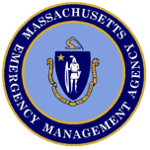
Massachusetts State Emergency Response Commission
400 Worcester Road
Framingham, MA 01702
508-820-2001

Announcement of Commission Meeting

The Massachusetts State Emergency Response Commission will be holding a quarterly meeting on March 13, 2024.

The Meeting is open to the public. If you require an accommodation, please contact us at 508-820-2001

Date: March 13, 2024
Time: 10:00 – 11:30
Location: Massachusetts Emergency Management Agency
Headquarters
400 Worcester Road
Framingham, MA 01702

