
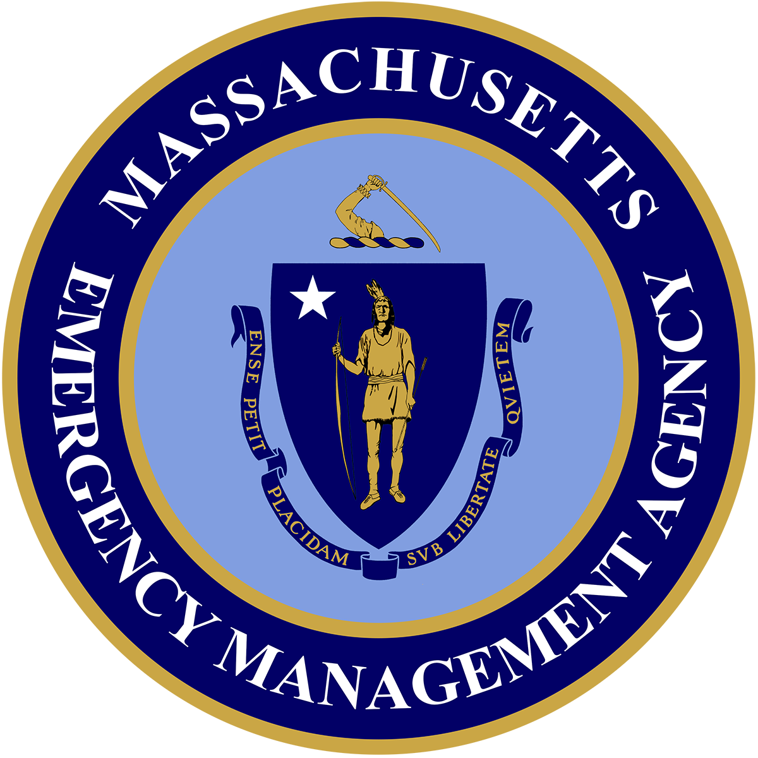
THE COMMONWEALTH OF MASSACHUSETTS
EXECUTIVE OFFICE OF PUBLIC SAFETY AND SECURITY
_____________________________

MASSACHUSETTS EMERGENCY MANAGEMENT AGENCY
400 Worcester Road Framingham, MA 01702-5399
Tel: 508-820-2000 Fax: 508-820-2030

Maura T. Healey
Governor

Kimberley Driscoll
Lt. Governor

Terrence M. Reidy
Secretary

Dawn Brantley
Acting Director
Website: www.mass.gov/mema

SERC MEETING MINUTES – 06/14/2023

In Attendance: Michael Josti; Bud McDonough; Charles Colley; Andrew Beaulieu; Kenyi Suarez; John Viveiros; Lorri Gifford; John Mulveyhill; Jack Illingworth; Jeff Trask; Dale Glenn, Nate Cocheran; Christian Cunnie

Welcome:
John Viveiros welcomed the group and explained that we are having SERC meetings out in the regional offices to connect to the local communities. John thanked the folks that made it to the meeting today and were able to see our regional office. We did not meet the quorum to be able to vote on minutes and anything else we had on the agenda. We will wait to vote on the minutes in our next meeting in September in Franklin.

Review and Approve Meeting Minutes:

The meeting minutes for 03/13/23 will be voted on at September’s meeting.

SERC Overview Presentation:

John Viveiros presented a PowerPoint presentation to the group on SERC roles and responsibilities.

We have found that even some of our SERC members are unclear about what SERC’s role and responsibilities are. The main role is to establish Planning Districts in Massachusetts. We have established every local community as its own Emergency Planning District. Some communities, especially out in the west, have regionalized to create Regional Emergency Planning Districts.

It is the role of the SERC to establish Local Emergency Planning Districts. SERC’s role is to provide guidance, tools, and information to emergency planning committees. This could be subject matter expertise and HMEP funding. SERC can also support communities in developing their own emergency planning committees. Another responsibility is to review and comment on hazmat plans. Even though there is no requirement that local communities submit their hazmat plans to us for approval, we do require them to submit them for review and comments. If communities do not have a plan, we can help with some funding using HMEP money. SERC’s goal is to help the communities to work on their plan.

John Viveiros spoke on how SERC was established in Massachusetts and that the Governor was assigned as the chair of the Emergency Response Commission.

John Viveiros explained that at some point SERC had an application certification process, which would be given to the local community to fill out. The application contained different forms to fill out and communities needed to collect different signatures, then present it to the SERC for approval to become certified. We have now moved from this certification process to a registration process. The registration is a link in MEMAs website, this link takes you to a form with several questions to fill out and once you are done, you are registered with us and that qualifies you for an HMEP grant. We have about 40 registrations; this includes local and regional registrants.

Local communities need to be aware that the chief elected official is the chair by default; unless they designate someone else, whether they register or not, by Federal Law they are already responsible for what happens in their community when a hazmat disaster happens.

Christian Cunnie – In the past, we have spoken about hiring a consultant to do these workshops, what if they record a workshop for Mass Municipal Association to educate those elected officials who are responsible. We have gotten requests from towns who are not aware of their responsibility. This is SERCs responsibility to also educate those elected officials.

John Viveros mentioned that we have an RFP in place and that, we can work on Christian Cunnie’s idea when the contractors are hired.

Tier II Reporting:

We have purchased 75 new licenses that are ready to roll out to local communities. We are working on the distribution list; they’ll be distributed at the end of this year.

Christian Cunnie mentioned that some states have all their Tier II facility’s reports that the state gets of their facilities available on their state website. Their Tier II Manager has a public-facing feature – where anyone can get this information right from the website and see what is in their community.

Lorri Gifford – Any citizen should be able to go to their LEPC and be able to get this information. It is the local’s responsibility to inform their citizens of the hazards in their communities.

HMEP Grants: – Lorri Gifford

We are working on the development of 23-24 HMEP NOFO and Application. This year we are estimating $127,000 in available funds which will roll out as competitive. We do not foresee any major changes from last year and will maintain the following priorities:

1. Planning
2. Exercises
3. Training
4. Conferences

It is our goal to release the 23-24 HMEP NOFO and application sometime in the Fall of 2023.

Bylaws:

We have revised our bylaws and have submitted them for review to everyone. We would like to go over the bylaws at our next meeting for approval.

Facilitated Discussion:

Goals:

- To establish SERC membership, voting, and non-voting. Primary and secondary.
- Revise our bylaws
- Increase SERC registrations
- Do SERC workshops
- Begin review of hazmat plans

End of Meeting:

The next SERC meeting in-person date is on September 13th, 2023, at MEMA East, Franklin, MA.
10 AM to 11:30 AM.

