COMMONWEALTH OF MASSACHUSETTS
State Building Code (780 CMR) Appeals Board
Board’s Ruling on Appeal

Docket No. 10-838
Appellant(s): Steven Steinberg vs. Appellee(s):City/Town of Acton
Building Official Frank Ramsbottom

Procedural History

This matter came before the State Building Code Appeals Board (“Board”) on the Appellant’s appeal filed pursuant to 780 CMR 122.1. In accordance with 780 CMR 122.3, the Appellant requested that the Board grant a variance from the 7th Edition of 780 CMR 1208.2 for the property at 87 Great Road, Acton, MA. In accordance with M.G.L. c. 30A, §§10 & 11; M.G.L. c. 143, §100; 801 CMR 1.02 et. seq.; and 780 CMR 122.3.4, the Board convened a public hearing on February 4, 2010 where all interested parties were provided with an opportunity to testify and present evidence to the Board.
Steven Steinberg, Frank Ramsbottom, E.J. Rempelakis, and Tracy Cronin appeared for the hearing as noted on the sign in sheet which is on file at the Department of Public Safety.
Discussion
A motion was made to grant the Appellant’s request for a variance from 780 CMR 1208.2, with conditions. Section 1208.2 of 780 CMR requires, in pertinent part: “occupiable spaces, habitable spaces and corridors shall have a ceiling height of not less than seven feet six inches (2286 mm).” The Appellant requests a variance of this provision as he intends to add a storage area to an existing commercial space. The property exists in a zoning district, East Acton Village, which requires that the storage addition ceiling height be less than six feet. The storage addition’s plans, according to the Appellant, have been approved by Boards with jurisdiction over the property. The Appellant requests the variance based on the hardship that if he is required to comply with 780 CMR 1208.2, he will be in violation of the local zoning ordinance and will not be able to add the proposed storage space. The motion to grant a variance of 780 CMR 1208.2 is contingent on the following conditions: 1) the second egress door must be installed with a minimum of thirty-six (36) inches, 2) signage must be added to any and all entrances to the mezzanine storage space signifying this hazardous height, 3) there must be recessed lights and wall fixtures, 4) storage must comply with NFPA 13 requirements, with an architect making the height determination, and 5) this space will be used for storage only, and if the use ever changes this variance will be null and void. There was a second on the motion and board vote was taken, which was unanimous.
Conclusion
The Appellant’s request for a variance from 780 CMR 1208.2 is hereby granted with the conditions noted, as described in the discussion above, and so ordered.

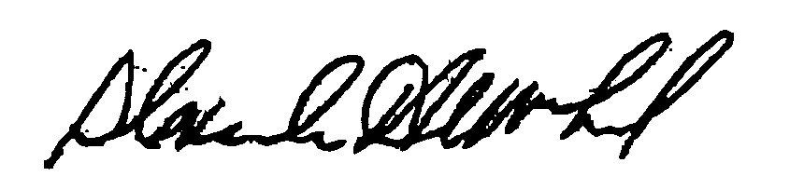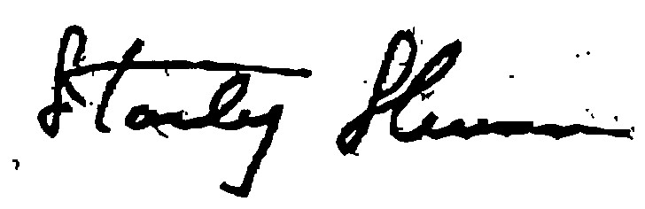
________________________ _______________________ _______________________
Alexander MacLeod Douglas Semple Stanley Shuman

Date: July 14, 2010

This is a concise version of the Board’s decision. You may request a full written decision within 30 days of the date of this decision. Requests must be in writing and addressed to: Department of Public Safety, State Building Code Appeals Board, program Coordinator, One Ashburton Place, Room 1301, Boston, MA 02108.
The Appellant, in his appeals application form, states the storage space plans have been approved by “the Design Review Board, the licensing board, the Alcoholic Beverage Control Commission, the Board of Health, the Fire Department, and the Conservation Commission.”
In accordance with M.G.L. c. 30A, § 14, any person aggrieved by this decision may appeal to the Superior Court within 30 days after the receipt of this decision.

