COMMONWEALTH OF MASSACHUSETTS

SUFFOLK, ss. BUILDING CODE APPEALS BOARD DOCKET NO.: 10-840
______________________________
)
John Lawrence, )
Appellant )
)
v. )
)
Town of Wellesley, )
Appellees )
______________________________)

BOARD’S RULING ON APPEAL

Introduction

This matter came before the State Building Code Appeals Board (“Board”) on appellant’s appeal filed pursuant to G.L. c.143, §100 and 780 CMR 122.1. In accordance with 780 CMR 122.3 the appellant petitioned the Board to grant a variance based on the Sixth Edition of the Massachusetts State Building Code (“Code”). For the following reasons, the variance is hereby GRANTED.

The appellant requested that the Board grant a variance from 780 CMR Section 5305.1, Exceptions #1 and #5. Ronald Searles testified on behalf of the appellant. Michael Grant, Building Inspector for the Town of Wellesley testified on behalf of the appellee. All witnesses were duly sworn.

Procedural History

The Board convened a public hearing on February 16, 2010, in accordance with G.L.c. 30A, §§10 & 11; G.L.c. 143, §100; 801 CMR 1.02; and 780 CMR 122.3. All interested parties were provided with an opportunity to testify and present evidence to the Board.

Findings of Fact

The facts of this matter are largely not in dispute. Instead, this matter turns on the review of the applicable provisions of the State Building Code. The Board bases the following findings upon the testimony presented at the hearing. There is substantial evidence to support the following findings:

- The property at issue is located at 41 Leighton Road, Wellesley, MA 02482.
- The subject property was originally built in 1929 with a low ceiling in the basement, approximately 6 feet 8 inches or 6 feet 9 inches.
- The renovation to the heating system to install an HVAC system required new duct work.
- The area of the subject property in question will be used primarily as a child’s playroom.

Analysis

- Jurisdiction of the Board

There is no question that the Board has jurisdiction to hear this case. The governing statute provides that:

Whoever is aggrieved by an interpretation, order, requirement, direction or failure to act by any state or local agency or any person or state or local agency charged with the administration or enforcement of the state building code or any of its rules and regulations, except any specialized codes as described in section ninety-six, may within forty-five days after the service of notice thereof appeal from such interpretation, order, requirement, direction, or failure to act to the appeals board. G.L. c.143, §100.

The issues giving rise to this matter directly implicate provisions of the Code. As such, this Board has jurisdiction to decide this case pursuant to G.L. c. 143, §100.

- State Building Code requirements

The issue is whether to grant a variance to 780 CMR 5305.1, Exceptions #1 and #5. The relevant provisions of the regulations state, “1. Beams and girders spaced not less than four feet (1219 mm) on center may project not more than six inches (152 mm) below the required ceiling height.” 780 CMR 5305.1, Exception 1, and “5. Ceiling heights in habitable basements, including drop ceilings, shall be a minimum of six feet eight inches (2032 mm).” 780 CMR 5305.1, exception 5.

The appellant testified that due to the new heating system the duct work caused the height clearance issues. The appellant asserted that they were able to remedy the problem in one area by putting the piece of duct work in the floor because the ducts were running in the same direction but that it is not possible in the other area. The appellant also stated the area in question will not be used as a bedroom and is going to be used as a child’s playroom.

The building inspector testified that he had no opposition to the granting of the appeal and that the rest of the basement met Code requirements.

Conclusion

A motion was made by Alexander MacLeod and seconded by William Middlemiss to Grant the variance to 780 CMR Section 5305.1, Exceptions #1 and #5 to the existing portion of the building for running the new duct work based on the fact that the area is not being used as a bedroom and is only used as a playroom and because the building official had no objection.

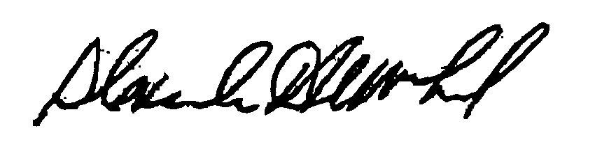
_______________________ _______________________ __________________
Doug Semple Alexander MacLeod William Middlemiss

Any person aggrieved by a decision of the State Building Code Appeals Board may appeal to Superior Court in accordance with G.L. c.30A, §14 within 30 days of receipt of this decision.

DATED: December 29, 2010

